

Final Data Analysis Report
Project Number FOMC-17924/300101 FRODO

Tsute Chen, Bruce Paster, Matthew Bronstad, Hatice Hasturk
The ADA Forsyth Institute
245 First Street, Cambridge 02142

December 9th, 2024

Table of Contents
I. Overall Summary 7
II. Data Download Links 8
1. Raw Sequence Data 8
16S rRNA V1V3 amplicon sequences 8
Meta-transcriptome shot-gun sequences 8
2. Analysis Results 8
16S rRNA V1V3 Bioinformatics Analyses (FOMC Pipeline) 8
Meta-transcriptomic Analyses (CosmosID Pipeline) 8
3. Final Report – this document 8
III. Project Workflow 9
IV. Analyses Overview 10
V. Objectives and Endpoints 11
VI. Methods 12
4. FOMC 16S rRNA V1V3 Amplicon Analysis Pipeline 12
Sequence Data Processing 12
Taxonomy Assignment 12
Taxonomy bar plots 12
Alpha diversity 12
Beta diversity 12
Differential abundance 12
LEfSe 13
Heat map 13
References 13
5. CosmosID-HUB Meta-transcriptomics Analysis Pipeline 13
Relative Abundance Stacked Bars 13
Heatmaps 14
Alpha Diversity Boxplots (with Wilcoxon Rank-Sum) 14
Beta Diversity PCoA (with PERMANOVA) 14
LEfSe 15
References 15
VII. Results 16
6. Summary Statistics 16
7. Week 6 vs Baseline Comparison – Bacterial Compositions 18
Section summary 18
Product A V2 vs Product A V3: 18
Comparison 1: All sites 18
Comparison 5: Saliva 18
Comparison 9: Tongue 18
Comparison 13: Supragingival 18
Comparison 17: Subgingival 18
Product B V2 vs Product B V3: 19
Comparison 2: All sites 19
Comparison 6: Saliva 19
Comparison 10: Tongue 19
Comparison 14: Supragingival 19
Comparison 18: Subgingival 20
8. Week 6 vs Baseline Comparison – Activities 21
Product A V2 vs Product A V3: 21
Comparison 1: All sites 21
Comparison 5: Saliva 21
Comparison 9: Tongue 21
Comparison 13: Supragingival 22
Comparison 17: Subgingival 22
Product B V2 vs Product B V3: 23
Comparison 2: All sites 23
Comparison 6: Saliva 23
Comparison 10: Tongue 23
Comparison 14: Supragingival 24
Comparison 18: Subgingival 24
9. Product A vs B at Week 6 – Bacterial Composition 26
Comparison 4: All sites 26
Comparison 8: Saliva 26
Comparison 12: Tongue 26
Comparison 16: Supragingival 26
Comparison 20: Subgingival 26
10. Product A vs B at Week 6 – Activities 27
Comparison 4: All sites 27
Comparison 8: Saliva 27
Comparison 16: Supragingival 27
Comparison 16: Supragingival 28
Comparison 20: Subgingival 28
11. Bacterial Compositions of Oral Sites at Baseline (V2) 30
Comparison 3: Product A V2 vs Product B V2 (All Sites) 31
Comparison 7: Product A V2 SAL vs Product B V2 SAL (Saliva) 31
Comparison 11: Product A V2 TNG vs Product B V2 TNG (Tongue) 31
Comparison 15: Product A V2 SUPG vs Product B V2 SUPG (Supragingival) 31
Comparison 19: Product A V2 SUBG vs Product B V2 SUBG (Subgingival) 31
VIII. Appendix 32
Appendix A – 16S rRNA V1V3 Analysis Figures and Charts 32
Comparison 1: Product A V2 vs Product A V3 32
Comparison 3 Product A V2 vs Product B V2 54
Comparison 4. Product A V3 vs Product B V3 68
Comparison 5. Product A V2 SAL vs Product A V3 SAL 81
Comparison 6. Product B V2 vs Product B V3 88
Comparison 7. Product A V2 SAL vs Product B V2 SAL 97
Comparison 8. Product A V3 SAL vs Product B V3 SAL 106
Comparison 9. Product A V2 TNG vs Product A V3 TNG 117
Comparison 10. Product B V2 TNG vs Product B V3 TNG 124
Comparison 11. Product A V2 TNG vs Product B V2 TNG 132
Comparison 12. Product A V3 TNG vs Product B V3 TNG 143
Comparison 13. Product A V2 SUPG vs Product A V3 SUPG 152
Comparison 14. Product B V2 SUPG vs Product B V3 SUPG 162
Comparison 15. Product A V2 SUPG vs Product B V2 SUPG 177
Comparison 16. Product A V3 SUPG vs Product B V3 SUPG 190
Comparison 17. Product A V2 SUBG vs Product A V3 SUBG 204
Comparison 18. Product B V2 SUBG vs Product B V3 SUBG 215
Comparison 19. Product A V2 SUBG vs Product B V2 SUBG 225
Comparison 20. Product A V3 SUBG vs Product B V3 SUBG 237
Appendix B. CosmosID-HUB Metatranscriptomic Analysis 248
Comparison 1: Product A V2 vs Product A V3 248
Gene Ontology 248
Enzyme Commission 250
MetaCyc Pathways 254
Comparison 2: Product B V2 vs Product B V3 257
Gene Ontology 257
Enzyme Commission 260
MetaCyc Pathways 263
Comparison 3: Product A V2 vs Product B V2 267
Gene Ontology 267
Enzyme Commission 270
MetaCyc Pathways 274
Comparison 4: Product A V2 SAL vs Product A V3 SAL 277
Gene Ontology 277
Enzyme Commission 280
MetaCyc Pathways 284
Comparison 5: Product A V3 vs Product B V3 288
Gene Ontology 288
Enzyme Commission 291
MetaCyc Pathways 293
Comparison 6: Product B V2 SAL vs Product B V3 SAL 297
Gene Ontology 297
Enzyme Commission 299
MetaCyc Pathways 302
Comparison 7: Product A V2 SAL vs Product B V2 SAL 306
Gene Ontology 306
Enzyme Commission 308
MetaCyc Pathways 310
Comparison 8: Product A V3 SAL vs Product B V3 SAL 314
Gene Ontology 314
Enzyme Commission 316
MetaCyc Pathways 319
Comparison 9: Product A V2 TNG vs Product A V3 TNG 321
Gene Ontology 321
Enzyme Commission 324
MetaCyc Pathways 330
Comparison 10: Product B V2 TNG vs Product B V3 TNG 334
Gene Ontology 334
Enzyme Commission 336
MetaCyc Pathways 339
Comparison 11: Product A V2 TNG vs Product B V2 TNG 342
Gene Ontology 342
Enzyme Commission 344
MetaCyc Pathways 347
Comparison 12: Product A V3 TNG vs Product B V3 TNG 349
Gene Ontology 349
Enzyme Commission 352
MetaCyc Pathways 355
Comparison 13: Product A V2 SUPG vs Product A V3 SUPG 358
Gene Ontology 358
Enzyme Commission 360
MetaCyc Pathways 363
Comparison 14: Product B V2 SUPG vs Product B V3 SUPG 366
Gene Ontology 366
Enzyme Commission 369
MetaCyc Pathways 372
Comparison 15: Product A V2 SUPG vs Product B V2 SUPG 377
Gene Ontology 377
Enzyme Commission 379
MetaCyc Pathways 384
Comparison 16: Product A V3 SUPG vs Product B V3 SUPG 387
Gene Ontology 387
Enzyme Commission 389
MetaCyc Pathways 393
Comparison 17: Product A V2 SUBG vs Product A V3 SUBG 397
Gene Ontology 397
Enzyme Commission 399
MetaCyc Pathways 403
Comparison 18: Product B V2 SUBG vs Product B V3 SUBG 407
Gene Ontology 407
Enzyme Commission 411
MetaCyc Pathway 415
Comparison 19: Product A V2 SUBG vs Product B V2 SUBG 420
Gene Ontology 420
Enzyme Commission 422
MetaCyc Pathways 425
Comparison 20: Product A V3 SUBG vs Product B V3 SUBG 429
Gene Ontology 429
Enzyme Commission 432
MetaCyc Pathways 437

Overall Summary
A total of 408 clinical oral samples were collected for two types of next generation sequencing (NGS) – 1) 16S rRNA V1V3 gene amplicon sequencing and 2) Shot-gun meta-transcriptomic RNA sequencing. The 16S rRNA sequencing can help answer the question regarding what bacterial species are in the samples and comparing the species profiles of different sample group can help answer whether a product or a treatment impact the microbial composition. The meta-transcriptomic sequencing determines the RNA levels for the genes expressed in the samples and helps to answer the functional related question and compare different levels of microbial activities in different sample groups.
The 16S rRNA V1V3 NGS sequences were assigned to species level taxonomy using the FOMC reference set (https://microbiome.forsyth.org/ftp/refseq/) and provides the best specie-level taxonomy assignment. Based on the species-level sequence abundance results, overall, the microbiomes were modified more with treatment Product B. In general with the exception of subgingival microbiomes, there appeared to be a microbiological benefit with this treatment.
The metagenomic shotgun sequences were processed with CosmosID-Hub’s Host-Agnostic Functional Profiling Pipeline for functional/activity inferencing. Alpha and beta diversities of functional profiles (Gene Ontology, Enzyme Commission and MetaCyc Pathways) were affected by Product A for samples from individual sites - saliva and tongue samples. No significant differences were detected for combined sites, supra- and sub-gingiva sites. For Product B, functional diversities were affected when samples of 4 sites were combined, as well as tongue and supragingival samples. No significant effects were observed for saliva and subgingival samples. When Product A and B were directly compared for effect of treatment, significant differences between these two products were observed for combined and subgingival samples, but not for individual saliva, tongue and subgingival samples. This is also true for bacterial composition analysis. Finally, bacterial compositions and functional profiles for the baseline group differ between the saliva/tongue and supragingival/subgingival grouping. There were only two significant differences in functional diversity between Product A and B at baseline.

II. Data Download Links

Raw Sequence Data

16S rRNA V1V3 amplicon sequences
Raw sequence reads can be downloaded from a link in the FOMC 16S report:
https://microbiome.forsyth.org/ftp/fomc/FOMC_project/haleon/ef8268d4-4bde-4eb7-94c8-09aabee1e8bf

Meta-transcriptome shot-gun sequences
Meta-transcriptome shot-gun reads can be downloaded from this link:
https://microbiome.forsyth.org/ftp/fomc/FOMC_project/haleon/b0eb797b-ac3d-43d5-9958-7d86868ad149

Analysis Results

16S rRNA V1V3 Bioinformatics Analyses (FOMC Pipeline)
https://microbiome.forsyth.org/ftp/fomc/FOMC_project/haleon/ef8268d4-4bde-4eb7-94c8-09aabee1e8bf

Meta-transcriptomic Analyses (CosmosID Pipeline)
https://microbiome.forsyth.org/ftp/fomc/FOMC_project/haleon/48b41065-dd02-49db-9ebe-da0e7d463cdf

Final Report – this document
This report can also be downloaded (and shared) online from this link:
https://microbiome.forsyth.org/ftp/fomc/FOMC_project/haleon/d6e5a990-c912-4a4b-8573-b877c3072f37

III. Project Workflow
Figure 1 shows the overall project workflow that was performed by FOMC starting from the clinical samples.
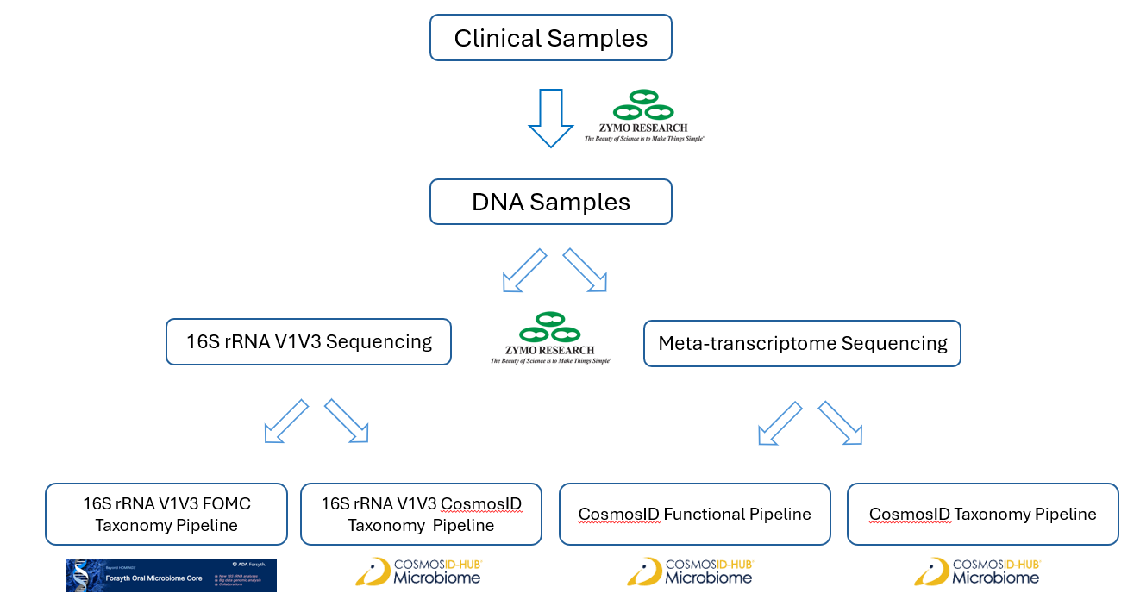
Figure 1. Overall experimental and analytic workflow

IV. Analyses Overview
Figure 2 depicts the number of combinations of sample types, visits and oral sites of all samples. A total of 20 comparisons were performed and the comparison IDs and labeling are listed in Table 1. The VII. Results section focuses on the 4 major questions described in the section V. Objectives and Endpoints. The figures and tables for all the comparison are shown in the Appendix section.
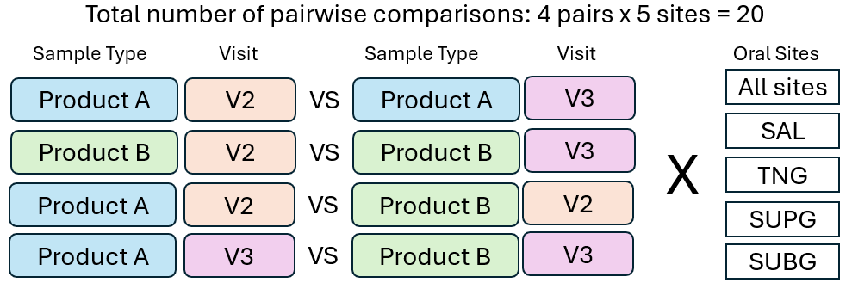
Figure 2. Comparative analyses performed in this study

Table 1. List of all comparative analyses
Comparison List
1. A V2 vs A V3 ALL | 9. A V2 TNG vs A V3 TNG | 17. A V2 SUBG vs A V3 SUBG
2. B V2 vs B V3 ALL | 10. B V2 TNG vs B V3 TNG | 18. B V2 SUBG vs B V3 SUBG
3. A V2 vs B V2 ALL | 11. A V2 TNG vs B V2 TNG | 19. A V2 SUBG vs B V2 SUBG
4. A V3 vs B V3 ALL | 12. A V3 TNG vs B V3 TNG | 20. A V3 SUBG vs B V3 SUBG
5. A V2 SAL vs A V3 SAL | 13. A V2 SUPG vs A V3 SUPG | A: Product A  B: Product B  V2: Baseline  V3: 6 Weeks | All: All sites  SAL: Saliva  TNG: Tongue  SUPG: Supragingival  SUB: Subgingival
6. B V2 SAL vs B V3 SAL | 14. B V2 SUPG vs B V3 SUPG | A: Product A  B: Product B  V2: Baseline  V3: 6 Weeks
7. A V2 SAL vs B V2 SAL | 15. A V2 SUPG vs B V2 SUPG | A: Product A  B: Product B  V2: Baseline  V3: 6 Weeks
8. A V3 SAL vs B V3 SAL | 16. A V3 SUPG vs B V3 SUPG | A: Product A  B: Product B  V2: Baseline  V3: 6 Weeks

V. Objectives and Endpoints
- Describe and compare the bacterial composition by different areas of the mouth at week 6 compared to baseline by treatment.
Results related to this objective are depicted in the illustration below and described in section 7. Week 6 vs Baseline Comparisons – Bacterial Composition.
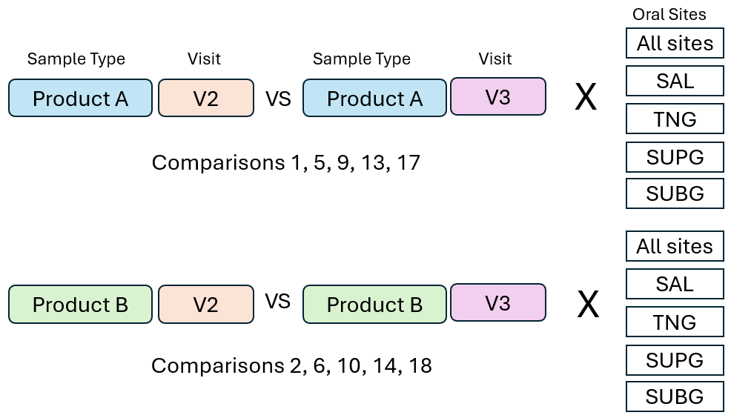
- Describe and compare the bacterial activity by different areas of the mouth at week 6 compared to baseline by treatment.
Results related to this objective are depicted in the illustration above and described in section 8. Week 6 vs Baseline Comparisons – Activities.
- Compare the bacterial composition and activity by different areas of the mouth at week 6 between treatment A and treatment B.
Results related to this objective are depicted in the illustration below and are described in sections 9. Products A vs B at Week 6 vs– Bacterial Composition and 10. Products A vs B at Week 6 vs– Activities.
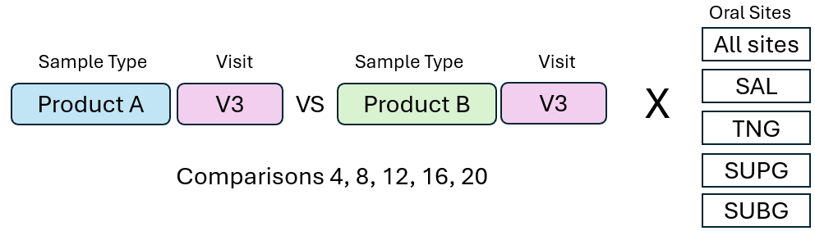
- Describe the bacterial composition of the different areas of the mouth at baseline.
Results related to this objective are depicted in the illustration below and are described in section 11. Bacterial Compositions of Oral Sites at Baseline.
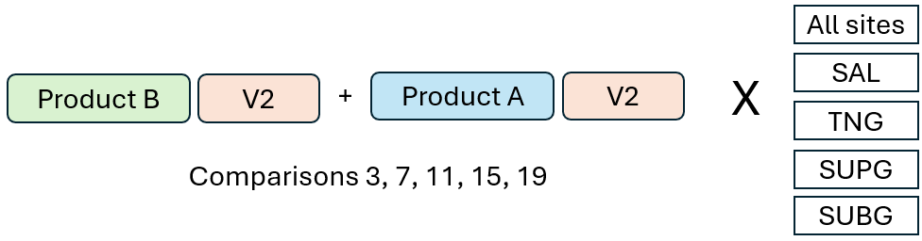

VI. Methods

FOMC 16S rRNA V1V3 Amplicon Analysis Pipeline

Sequence Data Processing
Raw 16S V1V3 amplicon sequences obtained from Zymo Research were quality-filtered, denoised, pair-end merged, and chimera removed with the DADA2 tool [1].

Taxonomy Assignment
Amplicon sequence variants (ASVs) generated by DADA2 were subjected to species level taxonomy assignment based on the approach developed by Al-Hebshi et. al. (2015) [2] against the FOMC Reference Sequence Set (https://microbiome.forsyth.org/ftp/refseq) that consists of 1,015 full-length 16S rRNA sequences from HOMD V15.22, 356 from MOMD V5.1, and 22,126 from NCBI, a total of 23,497 sequences. Altogether these sequences represent a total of 17,035 oral and non-oral microbial species.

Taxonomy bar plots
Graphically displays differences between groups—a good visual aid. Only shown for the first comparison for illustrative purposes. If desired, taxonomy plots can be provided for all comparisons. Dynamic taxonomy bar plot is available in the original analysis report (https://microbiome.forsyth.org/ftp/fomc/FOMC17924_haleon_16S_full/qiime/data_ mc100/qiime2/barplot/index.html ) using QIIME2 package [3].

Alpha diversity
Alpha diversity (α-diversity) is the mean species diversity in sites or habitats. Data are presented in 3 measurements: 1) number of species (observed), 2) Shannon index, and 3) Simpson index. p values were calculated for these metrics. Alpha diversity was calculated with QIIME2 package [3] and R [4] “phyloseq” package [5]. Alpha diversity significance tests were evaluated with QIIME2’ “alpha-group-significance” function [3].

Beta diversity
Compares the similarity (or dissimilarity) of entire microbial profiles between different groups of samples. Presently in dot graphs and p-values are calculated. Best diversity significance tests were evaluated with QIIME2’ “beta-group-significance” function [3].

Differential abundance
ANCOMB-BC2 was used to test significance of differential abundance between two test groups [6]. ANCOM-BC2 (Analysis of Compositions of Microbiomes with Bias Correction) provides the following: (a) statistically valid test with appropriate p-values, (b) provides confidence intervals for differential abundance of each taxon, (c) controls the False Discovery Rate (FDR), (d) maintains adequate power, and (e) is computationally simple to implement. Key here is that p-values are calculated for specific taxa.

LEfSe
Linear discriminant analysis LDA Effect Size (LEfSe), a 2-stage statistical analysis [7]. It uses the non-parametric factorial Kruskal-Wallis (KW) sum-rank test to detect features with significant differential abundance with respect to the class of interest and then biological significance is determined using a set of pairwise tests among subclasses using the (unpaired) Wilcoxon rank-sum test. For the output, LEfSe uses Linear Discriminant Analysis to estimate the effect size of each differentially abundant feature. These data clearly illustrate key microbiological differences among groups. P-values cannot be calculated for Lefse, but I use the p-values as determined from the differential abundance data.

Heat map
Graphically displays differences between groups - a visual aid. Heat maps were done using R’s “gplots” function [4].

References
- Callahan BJ, McMurdie PJ, Rosen MJ, Han AW, Johnson AJ, Holmes SP. DADA2: High-resolution sample inference from Illumina amplicon data. Nat Methods. 2016 Jul;13(7):581-3. doi: 10.1038/nmeth.3869. Epub 2016 May 23. PMID: 27214047; PMCID: PMC4927377.
- Al-Hebshi NN, Nasher AT, Idris AM, Chen T. Robust species taxonomy assignment algorithm for 16S rRNA NGS reads: application to oral carcinoma samples. J Oral Microbiol. 2015 Sep 29;7:28934. doi: 10.3402/jom.v7.28934. PMID: 26426306; PMCID: PMC4590409.
- Bolyen et al. Reproducible, interactive, scalable and extensible microbiome data science using QIIME 2. Nat Biotechnol. 2019 Aug;37(8):852-857. doi: 10.1038/s41587-019-0209-9. Erratum in: Nat Biotechnol. 2019 Sep;37(9):1091. doi: 10.1038/s41587-019-0252-6. PMID: 31341288; PMCID: PMC7015180.
- R Core Team (2021). R: A language and environment for statistical computing. R Foundation for Statistical Computing, Vienna, Austria. URL https://www.R-project.org/.
- McMurdie PJ, Holmes S. phyloseq: an R package for reproducible interactive analysis and graphics of microbiome census data. PLoS One. 2013 Apr 22;8(4):e61217. doi: 10.1371/journal.pone.0061217. PMID: 23630581; PMCID: PMC3632530.
- Lin H, Peddada SD. Analysis of compositions of microbiomes with bias correction. Nat Commun. 2020 Jul 14;11(1):3514. doi: 10.1038/s41467-020-17041-7. PMID: 32665548; PMCID: PMC7360769.
- Segata N, Izard J, Waldron L, Gevers D, Miropolsky L, Garrett WS, Huttenhower C. Metagenomic biomarker discovery and explanation. Genome Biol. 2011 Jun 24;12(6):R60. doi: 10.1186/gb-2011-12-6-r60. PMID: 21702898; PMCID: PMC3218848.

CosmosID-HUB Meta-transcriptomics Analysis Pipeline

Host-Agnostic Functional Profiling
Initial QC, adapter trimming and preprocessing of metagenomic sequencing reads are done using BBduk [1]. The quality controlled reads are then subjected to a translated search against a comprehensive and non-redundant protein sequence database, UniRef 90. The UniRef90 database, provided by UniProt [2], represents a clustering of all non-redundant protein sequences in UniProt, such that each sequence in a cluster aligns with 90% identity and 80% coverage of the longest sequence in the cluster. The mapping of metagenomic reads to gene sequences are weighted by mapping quality, coverage and gene sequence length to estimate community wide weighted gene family abundances as described by Franzosa et al [3]. Gene families are then annotated to MetaCyc [4] reactions (Metabolic Enzymes) to reconstruct and quantify MetaCyc [4] metabolic pathways in the community as described by Franzosa et al [3]. Furthermore, the UniRef_90 gene families are also regrouped to Enzyme Commission Enzymes and GO Terms in order to get an exhaustive overview of gene functions in the community. Lastly, to facilitate comparisons across multiple samples with different sequencing depths, the abundance values are normalized using Total-sum scaling (TSS) normalization to produce "Copies per million" (analogous to TPMs in RNA-Seq) units.

RelativeAbundance Stacked Bars
Stacked Bar figures were generated using phylum, genus, species, and strain-level filtered matrices for bacteria from CosmosID-HUB. Stacked bar figures for each group were generated using the R package ggpubr [5,6].

Heatmaps
Heatmaps were created using the pheatmap R package [7] generated using the phylum, genus, species, and strain matrices for bacteria from CosmosID-HUB. Hierarchical clustering and dendrograms are generated using the hclust and dist functions from the R stats package [8,9], with default parameters using euclidean distance and complete linkage.

Alpha Diversity Boxplots (with Wilcoxon Rank-Sum)
Alpha diversity boxplots were calculated from the phylum, genus, species, and strain level abundance score matrices from CosmosID-HUB analysis. Species or Chao1, Simpson, and Shannon alpha diversity metrics were calculated in R using the R package Vegan [9,10]. Wilcoxon Rank-Sum tests were performed between groups using the R package ggsignif [11]. Boxplots with overlaid significance in p value format were generated using the R package ggpubr [6].

Beta Diversity PCoA (with PERMANOVA)
Beta Diversity Principal Coordinate Analyses were calculated from phylum, genus, species, and strain-level matrices for bacteria from CosmosID-HUB. Bray-Curtis dissimilarity was calculated in R using the vegan package with the function vegdist, and PCoA tables were generated using ape’s function pcoa [12]. PERMANOVA tests for each distance matrix were generated using vegan’s [10] function adonis2, and beta dispersion was calculated and compared using the anova method for the betadisper function from vegan [10]. Plots were visualized using the R package ggpubr [6].

LEfSe
Linear Discriminant Analysis Effect Size figures were generated using the LEfSe tool [13] from the Huttenhower lab implemented in the R package lefser [14], based on phylum, genus, species, and strain matrices for bacteria from CosmosID-HUB. LEfSe is calculated with a Kruskal-Wallis alpha value of 0.05, a Wilcoxon alpha value of 0.05, and a logarithmic LDA score threshold of 2.0. In the LEfSe figures, red bars to the left convey that the feature in that group is more associated with the “red” group than the other. Blue bars to the right convey that the organism is more associated with the “blue” group.

References
- Bushnell, B. (2021). BBDuk Guide - DOE Joint Genome Institute. Retrieved 1 August 2021, from https://jgi.doe.gov/data-and-tools/bbtools/bb-tools-user-guide/bbduk-guide/
- UniProt: the universal protein knowledgebase. (2016). Nucleic Acids Research, 45(D1), D158-D169. doi: 10.1093/nar/gkw1099
- Franzosa, E., McIver, L., Rahnavard, G., Thompson, L., Schirmer, M., & Weingart, G. et al. (2018). Species-level functional profiling of metagenomes and metatranscriptomes. Nature Methods, 15(11), 962-968. doi: 10.1038/s41592-018-0176-y
- Caspi, R., Foerster, H., Fulcher, C., Kaipa, P., Krummenacker, M., & Latendresse, M. et al. (2007). The MetaCyc Database of metabolic pathways and enzymes and the BioCyc collection of Pathway/Genome Databases. Nucleic Acids Research, 36(Database), D623-D631. doi: 10.1093/nar/gkm900
- Alboukadel Kassambara (2020). ggpubr: ‘ggplot2’ Based Publication Ready Plots. R package version 0.2.5.
- H. Wickham. ggplot2: Elegant Graphics for Data Analysis. Springer-Verlag New York, 2016.
- Raivo Kolde (2019). pheatmap: Pretty Heatmaps. R package version 1.0.12. https://CRAN.R-project.org/package=ggpubr https://CRAN.R-project.org/package=pheatmap
- R Core Team (2021). R: A language and environment for statistical computing. R Foundation for Statistical Computing, Vienna, Austria. Kassambara (2020). https://www.R-project.org/
- Lou Jost (2006). Entropy and diversity. Oikos. 13.2 (2006): 363-375
- Jari Oksanen, F. Guillaume Blanchet, Michael Friendly, Roeland Kindt, Pierre Legendre, Dan McGlinn, Peter R. Minchin, R. B. O’Hara, Gavin L. Simpson, Peter Solymos, M. Henry H. Stevens, Eduard Szoecs and Helene Wagner (2019). vegan: Community Ecology Package. R package version 2.5-6. https://CRAN.R- project.org/package=vegan
- Constantin Ahlmann-Eltze (2019). ggsignif: Significance Brackets for ‘ggplot2’. R package version 0.6.0. https://CRAN.R-project.org/package=ggsignif 8. Paradis E. & Schliep K. 2019. ape 5.0: an environment for modern phylogenetics and evolutionary analyses in R. Bioinformatics 35: 526-528. https://cran.r project.org/package=ape
- Alboukadel Kassambara (2020). ggpubr: ‘ggplot2’ Based Publication Ready Plots. R package version 0.2.5. https://CRAN.R-project.org/package=ggpubr
- Nicola Segata, Jacques Izard, Levi Waldron, Dirk Gevers, Larisa Miropolsky, Wendy S Garrett and Curtis Huttenhower. Metagenomic biomarker discovery and explanation. Genome Biol. 2011 Jun 24;12(6):R60. doi: 10.1186/gb-2011-12-6-r60.
- Asya Khleborodova (2020). lefser: R implementation of the LEfSE method for microbiome biomarker discovery. R package version 1.0.0. https://github.com/waldronlab/lefser

VII. Results

Summary Statistics
The impact of the treatments/products on microbiome composition and functional profiles can be evaluated in two ways: 1) diversity measures, including both alpha and beta diversities and 2) by the number and significance of the features (i.e., species for composition and GO/EC/pathways for metatranscriptomic functional profiles).
We performed a wide range of statistical tests evaluating the significance of differences between the two groups in each of the 20 comparisons listed in Table 1. p values of all the tests were listed in Table 2 to indicate whether there are significant differences between two groups measured by the diversity indices listed in the column “Measurement” of Table 2. When p values are ≤ 0.05 they are highlighted in green - the smaller p values the darker green shading is used. Gray shading (from white to dark gray) was used for when p values are > 0.05, the larger the darker gray. Thus Table 2 shows where the most significant results are for various types of comparisons.
When many statistical tests were performed (620 in Table 2), naturally some results can be false positive, depending on the confidence level chosen. We did not perform the FDR adjustment because Microbiome studies such as this project, are exploratory in nature. So original p values were presented to allow more flexible interpretation of the significance.
However, we did observe that, unlike simulations of randomly generated data, which result in uniform distributions of p values, the p values in Table 2 do not follow a uniform distribution. The significant results are twice as numerous as would be expected by chance, which indicates a lower likelihood that these results are false positives (Figure 3).
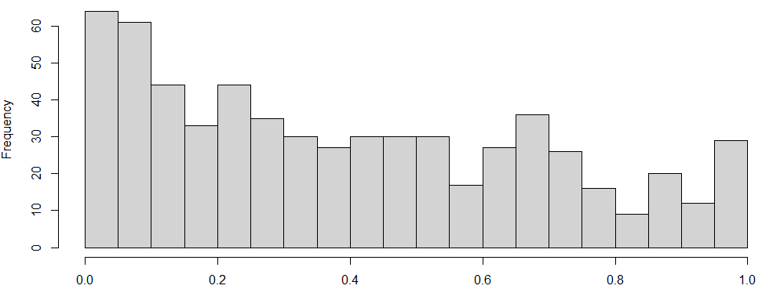
Figure 3. Distribution of all 620 p values for various type of comparisons.

With the exploratory purpose in mind, we can begin to examine the table for the most significant results. Notably comparison 5 (Product A V2 vs V3 saliva) and 6 (Product B V2 vs V3 saliva) show significant differences in alpha and beta diversity between V2 and V3 in MetaCyc Pathway profiles. This indicates that both products impacted metabolic pathways after treatment in the saliva samples.
Sections 7 to 11 are focused result presentation addressing the 4 objectives listed in Section V. Not all comparisons in Table 2 were described in this report.

Table 2. Statistical p values of all pairwise comparisons

The excel file of this table can be downloaded with this link (file name Haleon_Comparisons_pvalues.xlsx)
https://microbiome.forsyth.org/ftp/fomc/FOMC_project/haleon/48b41065-dd02-49db-9ebe-da0e7d463cdf/

Week 6 vs Baseline Comparison – Bacterial Compositions

Section summary
Based on the species-level sequence abundance results, overall, the microbiomes were modified more with treatment Product B. In general with the exception of subgingival microbiomes, there appeared to be a microbiological benefit with this treatment.

Product A V2 vs Product A V3:

Comparison 1: All sites
  - No significant differences in Alpha diversity and Beta diversity
  - Little or no change in Differential abundance and Lefse analyses
  - Additional species composition and abundance charts are provided in Appendix A Comparison 1

Comparison 5: Saliva
- Very little change in all analyses. No trends were observed with Differential abundance and LefSe analyses
- Treatment did not affect the microbiome.
- Additional species composition and abundance charts are provided in Appendix A Comparison 5

Comparison 9: Tongue
- No significant differences in Alpha diversity and Beta diversity
- Minimal trends were observed with Differential abundance. No change in LefSe analyses
- Treatment A had little or no effect on tongue microbiomes
- Additional species composition and abundance charts are provided in Appendix A Comparison 9

Comparison 13: Supragingival
- No significant differences in Alpha diversity and Beta diversity
- No or few trends were observed with Differential abundance and LefSe analyses
- Treatment did not appreciably affect the supragingival microbiome
- Additional species composition and abundance charts are provided in Appendix A Comparison 13.

Comparison 17: Subgingival
- No significant differences in Alpha diversity and Beta diversity
- Subgingival microbiomes were significantly altered with treatment A. higher levels of putative pathogens were observed. Eg., Fusobacterium, Treponema, Selenomonas and Prevotella. However, Streptococcus spp were reduced after treatment
- Additional species composition and abundance charts are provided in Appendix A Comparison 17

Product B V2 vs Product B V3:

Comparison 2: All sites
- No significant differences in Alpha diversity and Beta diversity
- Many differences in Differential abundance and Lefse
- Some health associated species were prevalent after treatment, e.g., Streptococcus gordonii, Slackia spp, Abiotrophia defectiva. However, a few putative pathogens were also more prevalent after treatment, e.g., Dialister invisus and species of Aggregatibacter
- Treatment B modified the microbiome as compared to Treatment B baseline
- Additional species composition and abundance charts are provided in Appendix A Comparison 2

Comparison 6: Saliva
- No significant differences in Alpha diversity. However, there was a significant difference in Beta diversity with a p value of 0.027
- Trend observed with a few species using differential abundance, but significance was lost after multiple comparisons
- Lefse indicated reduced levels of a putative pathogen, Aggregatibacter and increased levels of the health-associated Streptococcus gordonii
- Treatment B had more modifications than with treatment A with an apparent health associated profile
- Additional species composition and abundance charts are provided in Appendix A Comparison 6.

Comparison 10: Tongue
- No significant differences in Alpha diversity and Beta diversity
- Minimal trends were observed with Differential abundance. Not statistically significant.
- As shown in salivary microbiome analyses, Lefse showed a reduction in Aggregatibacter, a putative pathogen
- Treatment B was more effective than Treatment A. Not as effective as compared to treatment of the salivary microbiomes
- Additional species composition and abundance charts are provided in Appendix A Comparison 10

Comparison 14: Supragingival
- No significant differences in Alpha diversity and Beta diversity. However, statistical differences approached significance at 0.09 in each.
- Differential abundance indicated several differences, although not significantly different
- Many differences indicated using Lefse. The health-associated Streptococcus gordonii again was more prevalent after treatment. Again Aggregatibacter sp were reduced after treatment with B.
- Modulations of other species are difficult to interpret. However, it is clear that treatment B modified the supragingival microbiome
- Additional species composition and abundance charts are provided in Appendix A Comparison 14

Comparison 18: Subgingival
- No significant differences in Alpha diversity and Beta diversity
- Differential abundance indicated several differences, although not significantly different. Not as many with Treatment A.
- Aggregatibacter reduced as before
- Difficult to assess biological significance. These results conflict with data from other sites. B had fewer modifications as compared to A
- Additional species composition and abundance charts are provided in Appendix A Comparison 18

Week 6 vs Baseline Comparison – Activities

Product A V2 vs Product A V3:

Comparison 1: All sites
Summary: No significant difference after product A treatment based on diversity assessment (all p values > 0.05). Based on differential abundance analysis (LEfSe), there are 6 Gene Ontology terms, 22 enzymes (Enzyme Commission) and 27 metabolic pathways (Metacyc Pathways) that are significantly affected (p value < 0.05).
The top-most (based on LDA scores) increased functions by Product A are:
- hydrolase activity
- Pyridoxal 5'-phosphate synthase
- fatty acid biosynthesis initiation (mitochondria)
The top-most reduced functions by Product A are:
- NADPH:quinone reductase activity
- 1,4-alpha-glucan branching enzyme
- glycogen biosynthesis I (from ADP-D-Glucose)
Detail analysis results are shown in Appendix B. Comparison 1.

Comparison 5: Saliva
Summary: In saliva samples, product A significantly affected the bacterial pathways listed in MetaCyc, when measured by alpha diversity Chao1 (p = 0.003), Shannon (p = 0.034) but not Simpson. This indicates that functions with lower read abundance (low expression level) were impacted. Enzyme activities were also affected when measured with alpha index Chao1 (p = 0.039).
A total of 5 GO terms, 4 enzymes, and 20 pathways were impacted based on LEfSe differential abundance analysis.
The top-most (based on LDA scores) increased functions by Product A are:
- DNA replication
- Alanine--tRNA ligase
- fatty acid β-oxidation I (generic)
The top-most reduced functions by Product A are:
- NADPH:quinone reductase activity
- Glutamine synthetase
- superpathway of anaerobic sucrose degradation
Detail analysis results are shown in Appendix B. Comparison 5.

Comparison 9: Tongue
Summary: On tongue, alpha diversity was significantly affected by Product A based on Chao1 measurement (p = 0.013) of GO terms. Alpha diversity of enzyme profile was also impacted when measured with Shannon and Simpson indexes (p=0.008 and 0.042 respectively). This means medium to higher abundant enzymatic gene expression were affected by Product A. Beta diversity of enzyme activities was affected with marginal significance by Product A (p=0.053). Alpha diversity of pathways was also affected when measured with Chao1 (p=0.026).
A total of 11 GO terms, 52 enzymes, and 28 pathways were impacted based on LEfSe differential abundance analysis.
The top-most (based on LDA scores) increased functions by Product A are:
- metal ion binding
- Formate C-acetyltransferase
- gondoate biosynthesis (anaerobic)
The top-most reduced functions by Product A are:
- hydrolase activity
- Glutamine synthetase
Detail analysis results are shown in Appendix B. Comparison 9.

Comparison 13: Supragingival
Summary: Alpha and Beta diversity of bacterial activities of supragingival samples were not significantly affected by the treatment of Product A.
A total of 17 GO terms, 5 enzymes, and 3 pathways were impacted based on LEfSe differential abundance analysis.
The top-most (based on LDA scores) increased functions by Product A are:
- mitochondrion
- Pyridoxal 5'-phosphate synthase
- UMP biosynthesis
Only one function was significantly reduced by Product A:
- Formimidoyltetrahydrofolate cyclodeaminase

Detail analysis results are shown in Appendix B. Comparison 13.

Comparison 17: Subgingival
Summary:: Alpha and Beta diversity of bacterial activities of subgingival samples were not significantly affected by the treatment of Product A.
A total of 17 GO terms, 28 enzymes, and 18 pathways were impacted based on LEfSe differential abundance analysis.
The top-most (based on LDA scores) increased functions by Product A are:
- periplasmic flagellum
- 3-hydroxybutyryl-CoA dehydrogenase
- fatty acid biosynthesis initiation (mitochondria)
The top-most reduced functions by Product A are:
- phosphoenolpyruvate-dependent sugar phosphotransferase system
- 1,4-alpha-glucan branching enzyme
Detail analysis results are shown in Appendix B. Comparison xxx.

Product B V2 vs Product B V3:

Comparison 2: All sites
Summary: Beat diversity of MetaCyc pathway profile was significantly affected by Product B (p = 0.007). Alpha Simpson diversity of Gene Ontology has significant difference (p=0.049) after Product B treatment.
A total of 4 GO terms, 21 enzymes, and 38 pathways were impacted based on LEfSe differential abundance analysis.
The top-most (based on LDA scores) increased functions by Product B are:
- extracellular region
- Galactose-6-phosphate isomerase
- glycolysis IV
The top-most reduced functions by Product B are:
- cell outer membrane
- Bacterial non-heme ferritin
- Calvin-Benson-Bassham cycle
Detail analysis results are shown in Appendix B. Comparison 2.

Comparison 6: Saliva
Summary: Alpha and Beta diversity of bacterial activities of saliva samples were not significantly affected by the treatment of Product A.
A total of 3 GO terms, 0 enzymes, and 48 pathways were impacted based on LEfSe differential abundance analysis.
The top-most (based on LDA scores) increased functions by Product B are:
- glyceraldehyde-3-phosphate dehydrogenase (NAD+) (phosphorylating) activity
The top-most reduced functions by Product B are:
- riboflavin biosynthetic process
- superpathway of glucose and xylose degradation
- glycolysis IV
Detail analysis results are shown in Appendix B. Comparison 6.

Comparison 10: Tongue
Summary: On Tongue, Alpha diversity of both GO and Enzymes profiles were significantly affected by Product B, measured by Chao1 index (p=0.031 and 0.045, respectively). Beta diversity was not significantly affected.
A total of 6 GO terms, 14 enzymes, and 4 pathways were impacted based on LEfSe differential abundance analysis.
The top-most (based on LDA scores) increased functions by Product B are:
- 6-phosphofructokinase
- Rubisco shunt
The top-most reduced functions by Product B are:
- porin activity
- Nitrite reductase (NO-forming)
- phosphatidylglycerol biosynthesis I (plastidic)
Detail analysis results are shown in Appendix B. Comparison 10.

Comparison 14: Supragingival
Summary: Alpha diversity of GO profiles was affected significantly by Product B, measured with Chao1 (p=0.037), Shannon (p=0.011) and Simpson (p=0.008). Beta diversity of GO and MetaCyc profiles were significantly affected by Product B (p=0.031, and 0.044, respectively).
A total of 25 GO terms, 41 enzymes, and 28 pathways were impacted based on LEfSe differential abundance analysis.
The top-most (based on LDA scores) increased functions by Product B are:
- cytoplasm
- Triose-phosphate isomerase
- UMP biosynthesis II
The top-most reduced functions by Product B are:
- integral component of membrane
- Transaldolase
- Calvin-Benson-Bassham cycle
Detail analysis results are shown in Appendix B. Comparison 14.

Comparison 18: Subgingival
Summary: Alpha and Beta diversity of bacterial activities of subgingival samples were not significantly affected by the treatment of Product B.
A total of 17 GO terms, 28 enzymes, and 18 pathways were impacted based on LEfSe differential abundance analysis.
The top-most (based on LDA scores) increased functions by Product B are:
- periplasmic flagellum
- 3-hydroxybutyryl-CoA dehydrogenase
- fatty acid biosynthesis initiation (mitochondria)
The top-most reduced functions by Product B are:
- phosphoenolpyruvate-dependent sugar phosphotransferase system
- 1,4-alpha-glucan branching enzyme
- glucose and glucose-1-phosphate degradation
Detail analysis results are shown in Appendix B. Comparison 18.

Product A vs B at Week 6 – Bacterial Composition

Comparison 4: All sites
- Data indicated that the microbiomes of the subject populations were not similar. Many differences were observed.
- Longitudinal data should be used to evaluate, as in Comparison 2
- Additional species composition and abundance charts are provided in Appendix A Comparison 4

Comparison 8: Saliva
- No significant differences in Alpha diversity and Beta diversity
- Differential abundance indicated many differences, but statistical significance was lost after multiple comparisons.
- Lefse also indicated many differences. Many health associated species had increased levels in B, e.g. S. gordonii, Gemella hemolysans, Abiotrophia defectiva, Granulicatella elegans. In contrast, species of Campylobacter, putative pathogens, were reduced in B
- Treatment B appeared to be beneficial
- Additional species composition and abundance charts are provided in Appendix A Comparison 8.

Comparison 12: Tongue
- No significant differences in Alpha diversity and Beta diversity
- Differential abundance indicated several differences, although not significantly different between the subject populations
- Very few differences with Lefse analysis. Campylobacter sp (putative pathogens), were again reduced with Treatment B.
- Additional species composition and abundance charts are provided in Appendix A Comparison 12

Comparison 16: Supragingival
- No significant differences in Alpha diversity. However, there was a significant difference in Beta diversity with a p value of 0.023
- As expected, many differences observed with both differential abundance and Lefse
- Longitudinal data, and not these cross-sectional data should be used to evaluate
- Additional species composition and abundance charts are provided in Appendix A Comparison 16

Comparison 20: Subgingival
- No significant differences in Alpha diversity and Beta diversity
- Many differences in differential abundance and Lefse, as expected
- Longitudinal analyses would be a better assessment
- Additional species composition and abundance charts are provided in Appendix A Comparison 20

Product A vs B at Week 6 – Activities

Comparison 4: All sites
Summary: When all sites combined, alpha and beta diversities of MetaCyc pathway profiles are significantly different after 2 weeks of treatment between Product A and Product B. Alpha diversities measured with Shannon and Simpson indexes have p values of 0.033 and 0.004 respectively. Beat diversities of MetaCyc pathway profiles differed at a significant level with p =0.005.
A total of 12 GO terms, 45 enzymes, and 41 pathways were impacted based on LEfSe differential abundance analysis.
The top-most (based on LDA scores) increased functions by Product A are:
- cytolysis
- DNA-directed RNA polymerase
- gondoate biosynthesis (anaerobic)
The top-most increased functions by Product B are:
- glutamine biosynthetic process
- 6-phospho-beta-galactosidase
- glycogen biosynthesis I (from ADP-D-Glucose)
Detail analysis results are shown in Appendix B. Comparison 4.

Comparison 8: Saliva
Summary: For saliva samples, alpha and beta diversity of bacterial activities were not significantly different between the treatment of Product A and B at week 6.
A total of 14 GO terms, 2 enzymes, and 4 pathways were impacted based on LEfSe differential abundance analysis.
The top-most (based on LDA scores) increased functions by Product A are:
- metal ion transport
- Bacterial non-heme ferritin
- gondoate biosynthesis (anaerobic)
The top-most increased functions by Product B are:
- nucleus
- sucrose biosynthesis II
Detail analysis results are shown in Appendix B. Comparison 8.

Comparison 16: Supragingival
Summary: For supragingival samples, alpha and beta diversity of bacterial activities were not significantly different between the treatment of Product A and B at week 6.

A total of 14 GO terms, 7 enzymes, and 5 pathways were impacted based on LEfSe differential abundance analysis.
The top-most (based on LDA scores) increased functions by Product A are:
- cytolysis
- [Formate-C-acetyltransferase]-activating enzyme
- palmitate biosynthesis (type II fatty acid synthase)
The top-most increased functions by Product B are:
- integral component of membrane
- glucose and glucose-1-phosphate degradation
Detail analysis results are shown in Appendix B. Comparison 16.

Comparison 16: Supragingival
Summary: In supragingival samples, alpha diversity of the MetaCyc Pahtways profiles differ between the treatment of Product A and B at week 6 for the most abundant features. The Simpson index differed with a p value of 0.009 and the beta diversity differed at p = 0.003.
A total of 16 GO terms, 23 enzymes, and 34 pathways were impacted based on LEfSe differential abundance analysis.
The top-most (based on LDA scores) increased functions by Product A are:
- integral component of membrane
- tRNA (guanine(37)-N(1))-methyltransferase
- Calvin-Benson-Bassham cycle
The top-most increased functions by Product B are:
- oxidoreductase activity, acting on the aldehyde or oxo group of donors, NAD or NADP as acceptor
- Glucose-1-phosphate adenylyltransferase
- glycogen biosynthesis I (from ADP-D-Glucose)
Detail analysis results are shown in Appendix B. Comparison 16.

Comparison 20: Subgingival
Summary: for subgingival samples, alpha and beta diversity of bacterial activities were not significantly affected between the treatment of Product A and B at week 6.
However, numerous functional features had differential abundance between the treatment of Product A and B at week 6. A total of 40 GO terms, 72 enzymes, and 32 pathways were impacted based on LEfSe differential abundance analysis. Product A triggered higher expression for 72 enzymes and 23 pathway related genes. This suggests that Product B affects the bacterial activities more than Product A does.
The top-most (based on LDA scores) increased functions by Product A are:
- translation
- DNA-directed RNA polymerase
- fatty acid biosynthesis initiation (mitochondria)
The top-most reduced functions by Product B are:
- extracellular exosome
- glycolysis III (from glucose)
Detail analysis results are shown in Appendix B. Comparison 20.

Bacterial Compositions of Oral Sites at Baseline (V2)
Summary. Bacterial compositions differ most significantly by sites. Saliva and tongue samples have similar compositions and supra- and sub-gingival samples are similar to each other. At baseline (V2) the difference in compositions was driven by sample source (sites) instead of the two product groups. As Figure 4 shows, the saliva and tongues samples have marked differences than supra- and sub-gingival ones, as measured by both alpha (data not shown) and beta diversity analysis (Figure 4). The microbiome profiles between saliva/tongue and supr-/sub-gingival samples are distinct at any stage of the samples, both at baseline and after the treatment of products. This distinction between saliva/tongue and supra-/sub-gingival samples was also observed in the meta-transcriptomic data for all the samples (Figure 5, all p values are significant for pairwise and group comparisons). This is expected and the distinct microbiome profile separation by sites indicates that the sequence quality was adequate to show this distinction.
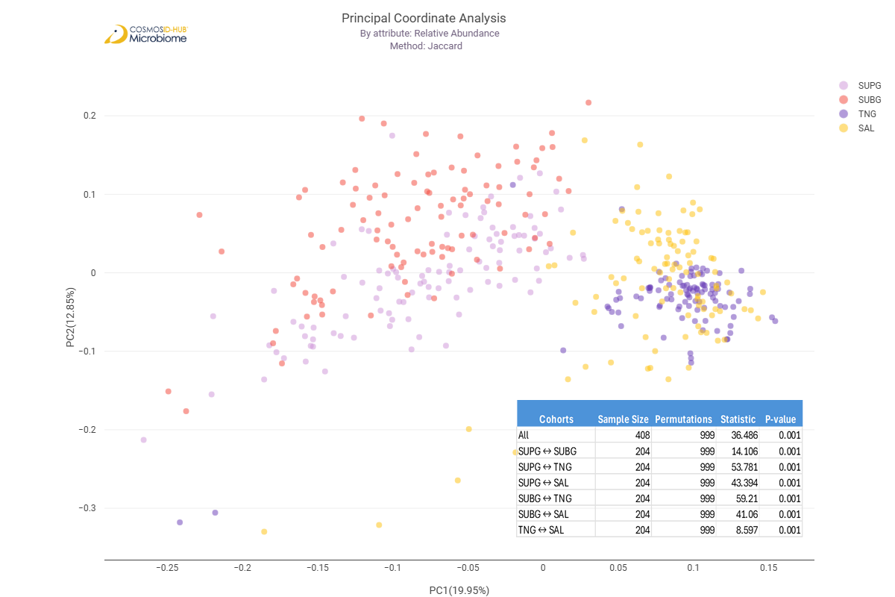
Figure 5. Beta diversity ordinate plots of all samples.
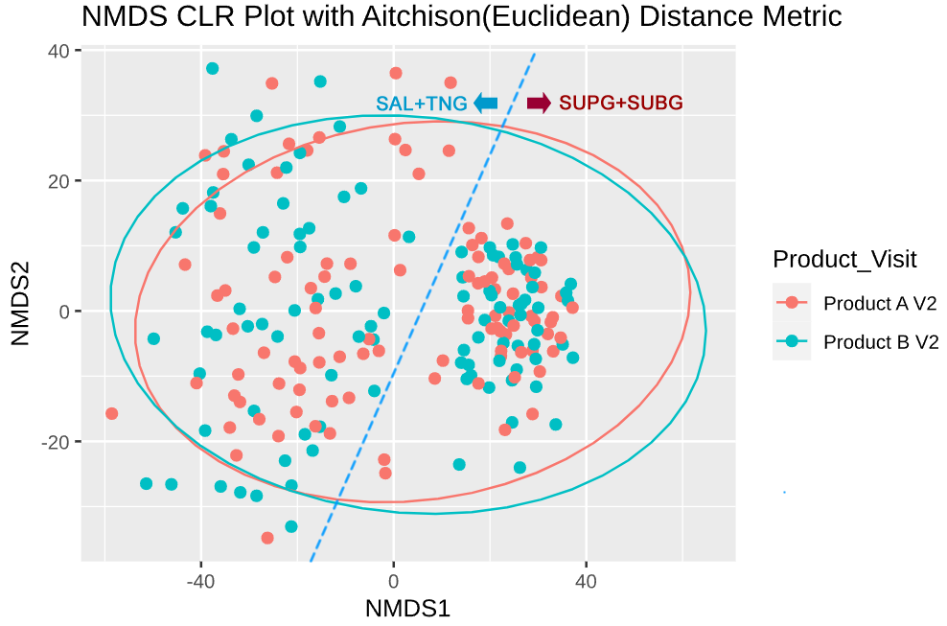
Figure 4. Beta diversity ordinate plots of samples at baseline (V2).

Comparison 3: Product A V2 vs Product B V2 (All Sites)
  - Data indicated that the microbiomes of the subject populations were not similar. Many differences were observed.
  - Longitudinal data should be used to evaluate, as in comparison 1
  - Additional compositional and abundance charts are available in Appendix A Comparison 3

Comparison 7: Product A V2 SAL vs Product B V2 SAL (Saliva)
  - No significant differences in Alpha diversity and Beta diversity
Only minor differences in Differential abundance and Lefse
  - Data indicates that the salivary microbiomes of subjects in A were similar to those in subjects in B. A good control.
  - Additional compositional and abundance charts are available in Appendix A Comparison 7

Comparison 11: Product A V2 TNG vs Product B V2 TNG (Tongue)
  - No significant differences in Alpha diversity and Beta diversity
  - Differential abundance indicated many differences, although not significantly different between the subject populations. Many differences observed using Lefse
  - Longitudinal analysis would be the preferential comparison (5 and 6 above)
  - Additional compositional and abundance charts are available in Appendix A Comparison 11

Comparison 15: Product A V2 SUPG vs Product B V2 SUPG (Supragingival)
  - No significant differences in Alpha diversity and Beta diversity.
  - Differential abundance indicated several differences, although not significantly different
  - many differences observed with Lefse. Several pathogens were observed, eg., Treponema spp., Tm7, and Prevotella.
  - These data indicate that there are differences in the 2 populations—longitudinal data should be used to determine the effectiveness of treatment
  - Additional compositional and abundance charts are available in Appendix A Comparison 15

Comparison 19: Product A V2 SUBG vs Product B V2 SUBG (Subgingival)
- No significant differences in Alpha diversity and Beta diversity
- Differential abundance indicated several differences, although not significantly different
- Microbiomes are reasonably similar and serve as an adequate control
- Additional compositional and abundance charts are available in Appendix A Comparison 19

VIII. Appendix

Appendix A – 16S rRNA V1V3 Analysis Figures and Charts

Comparison 1: Product A V2 vs Product A V3
- Taxonomy bar graph

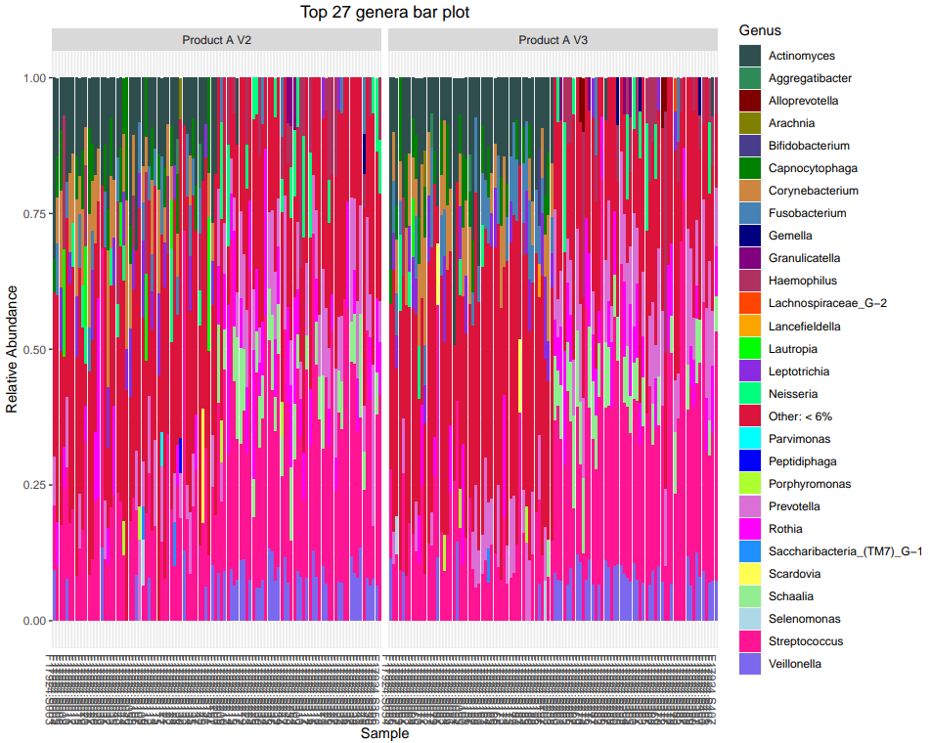
Too crowded to visualize, but can detect the differences in the different sites

- Alpha diversity
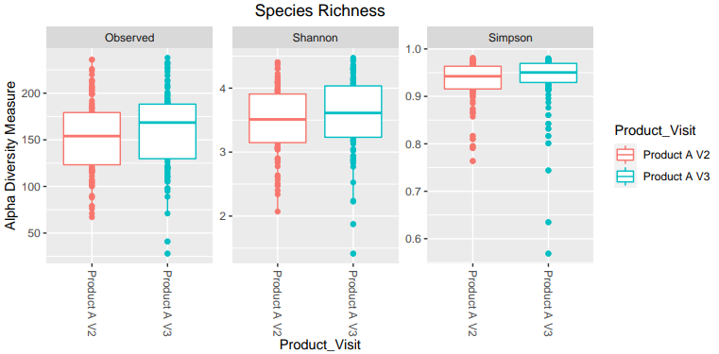
No statistical differences

Simpson is p=0.09

- Beta diversity
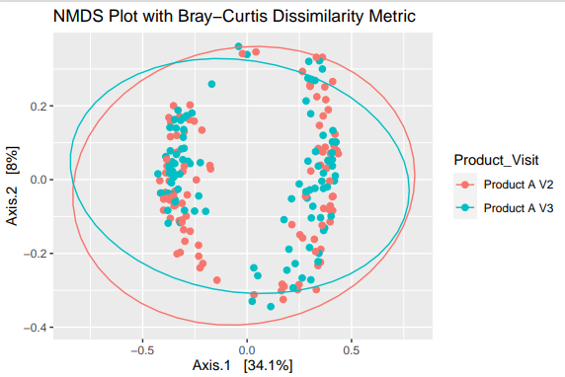

Can see the different sites

Not significantly different.

- Differential abundance
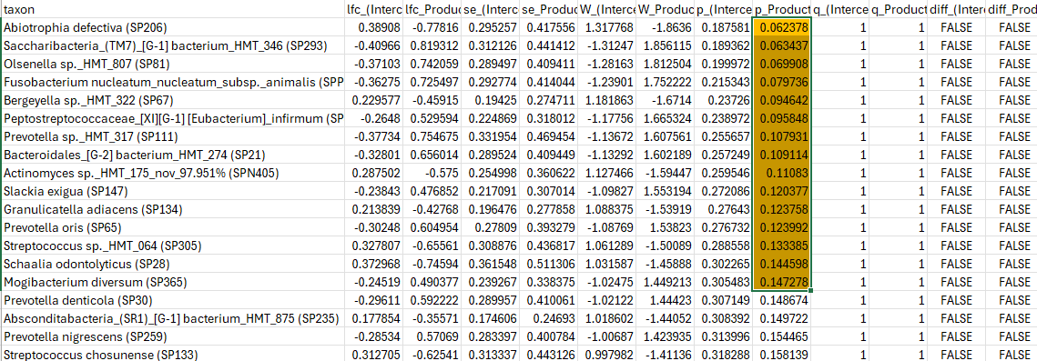
Little or no difference after treatment

- Lefse
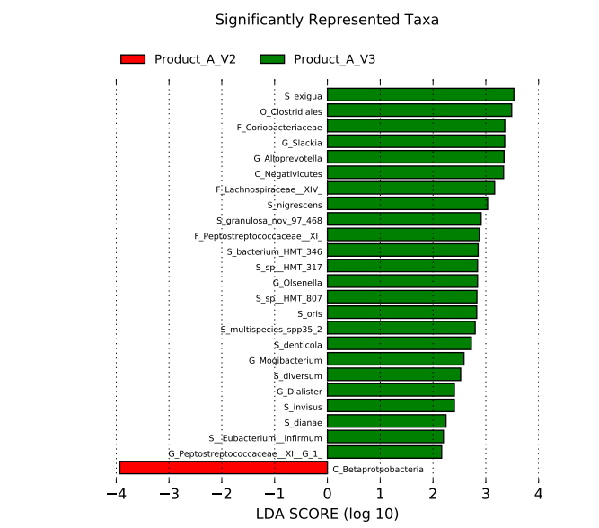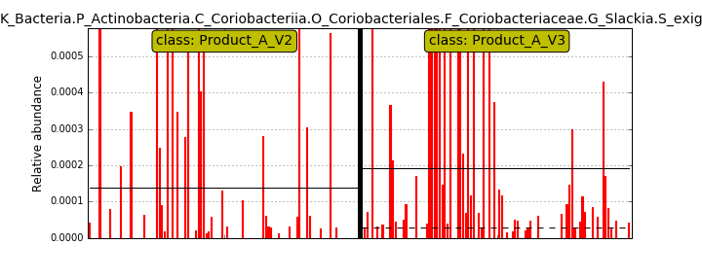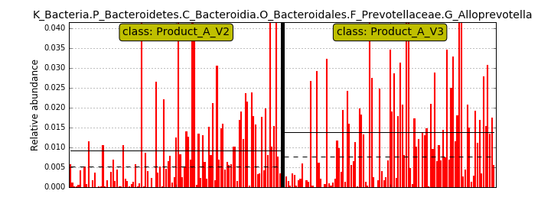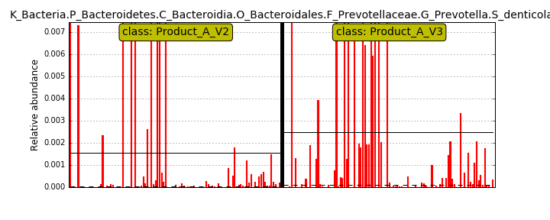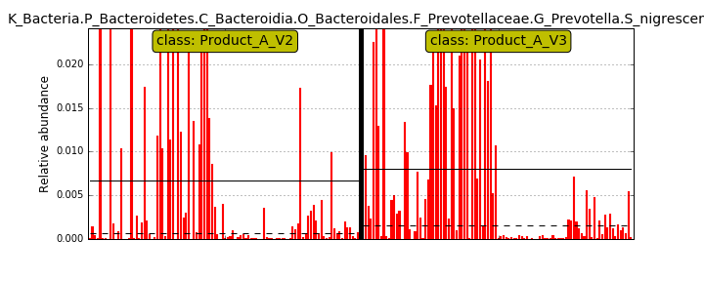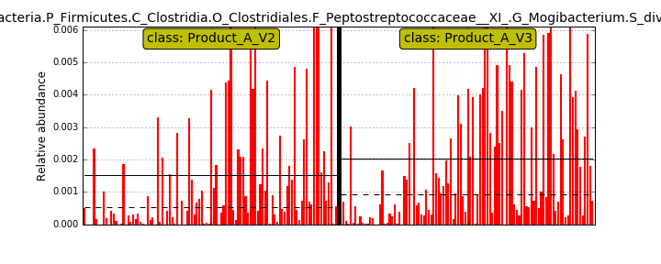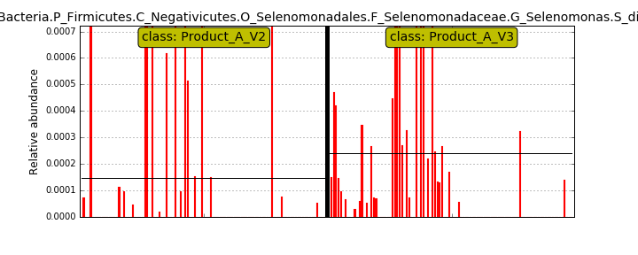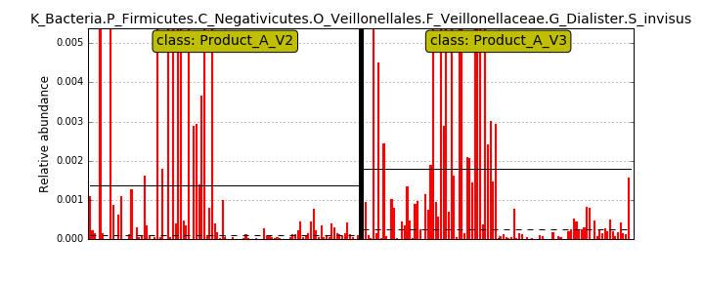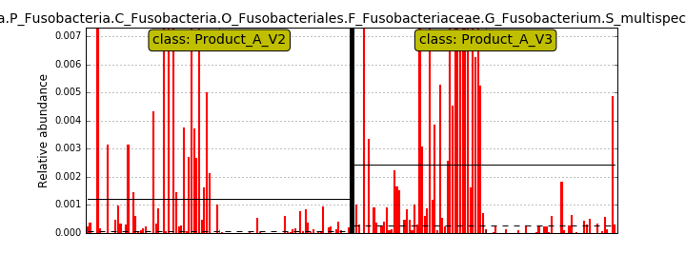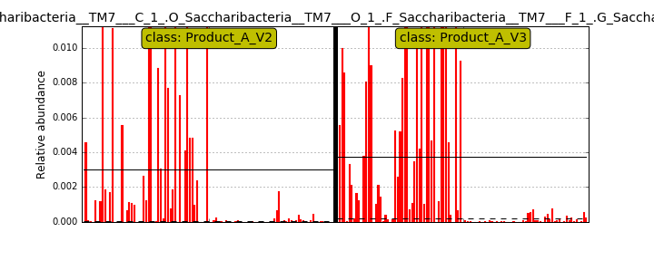

- Heat maps
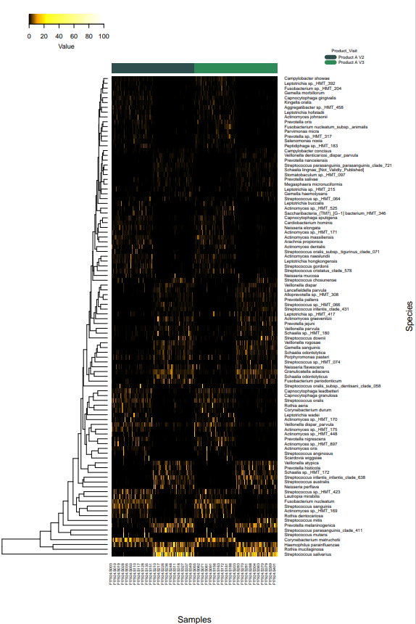
Different sites are clearly seen

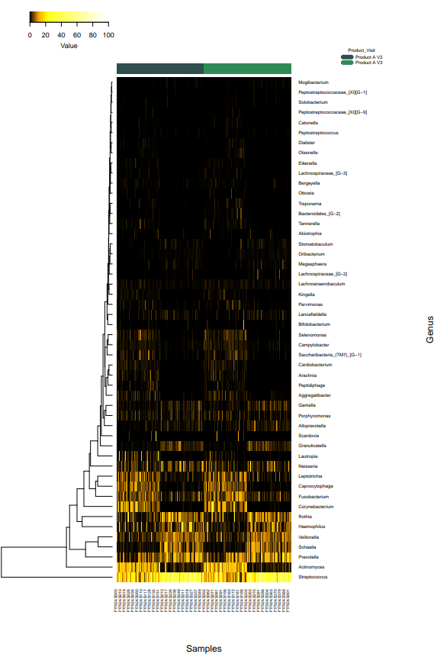

Comparison 2. Product B V2 vs Product B V3

- Taxonomy bar graphs
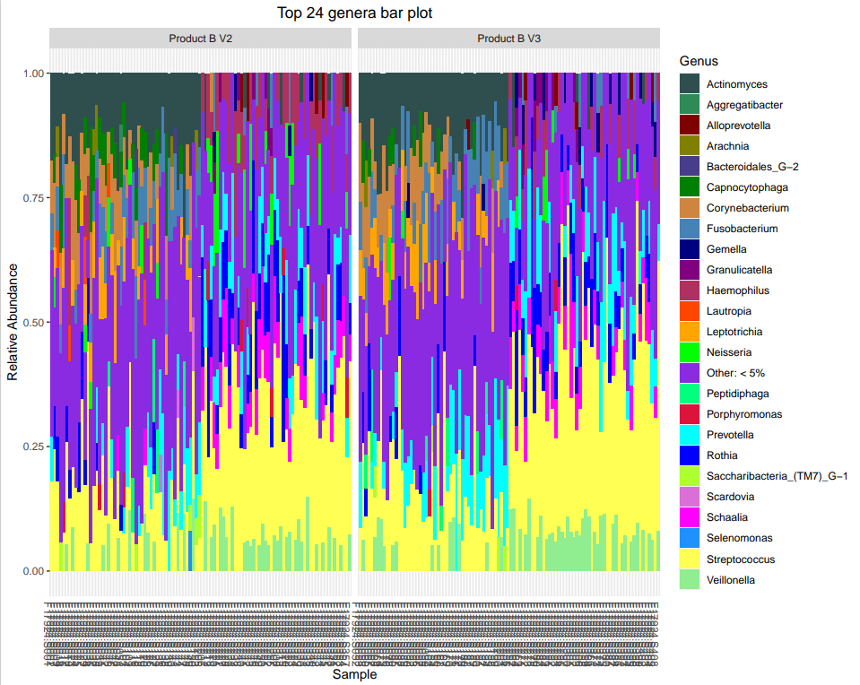

- Alpha diversity
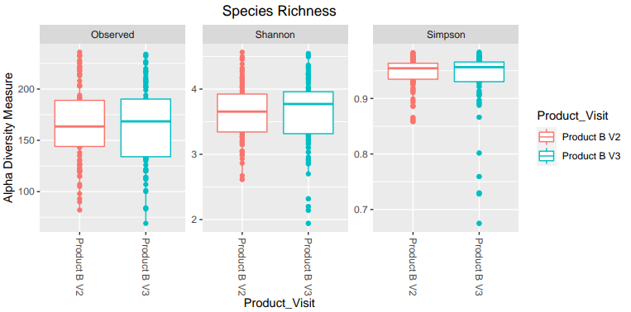

No significant differences

- Beta diversity

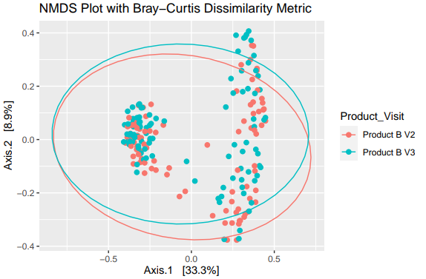

Not significant, but p-value = 0.092

- Differential abundance

Red, more prevalent in baseline (V2)
Green, more prevalent after treatment (V3)

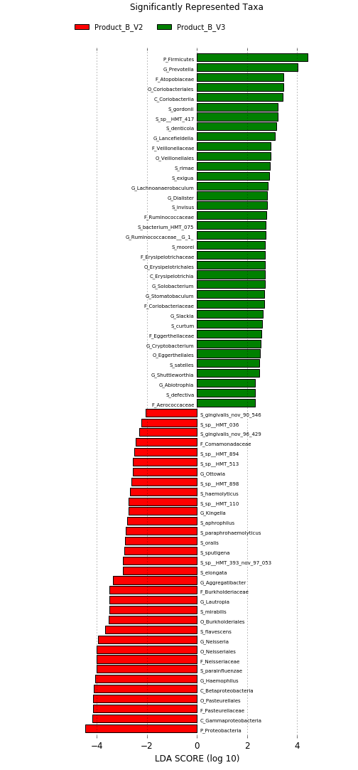
- Lefse

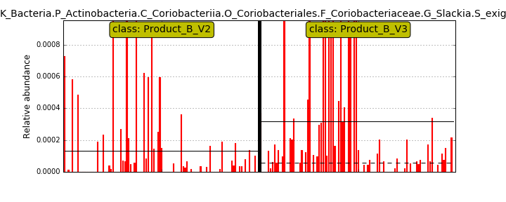Health associated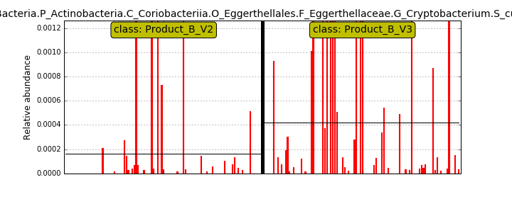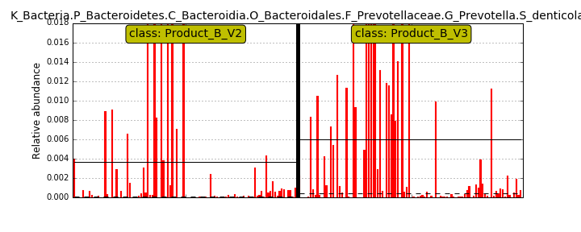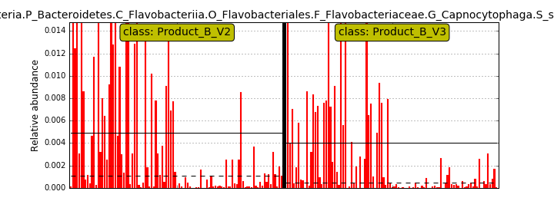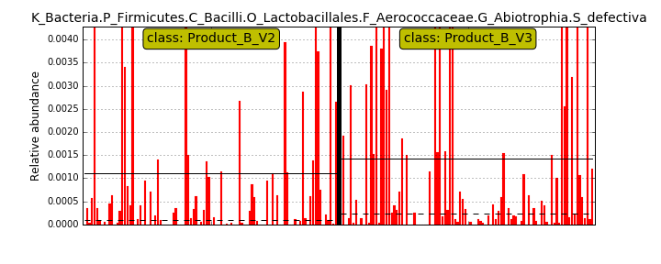Health associated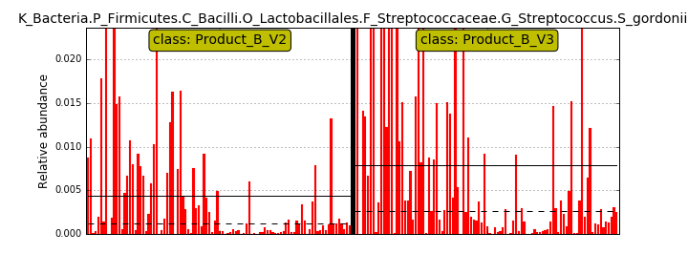health-associated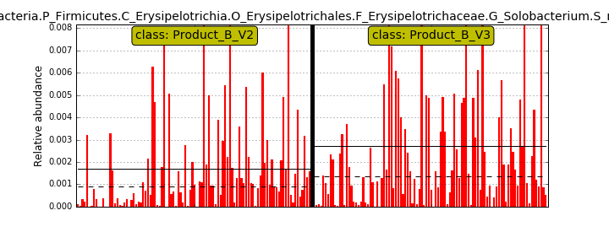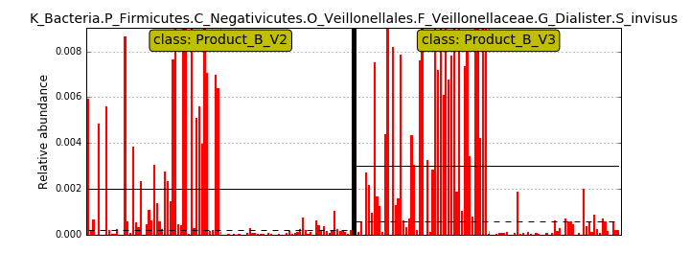considered periodontal pathogen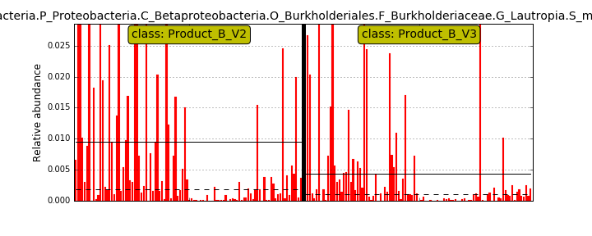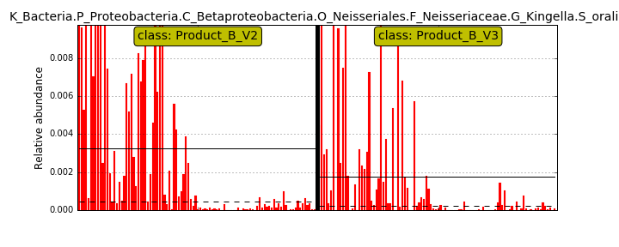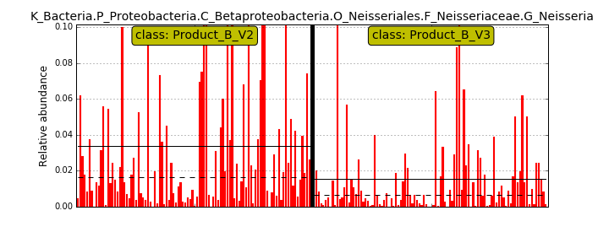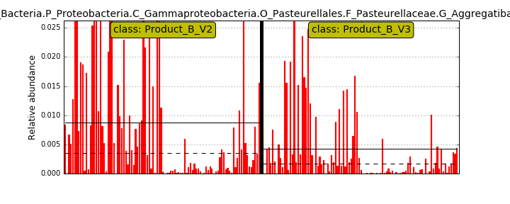putative pathogen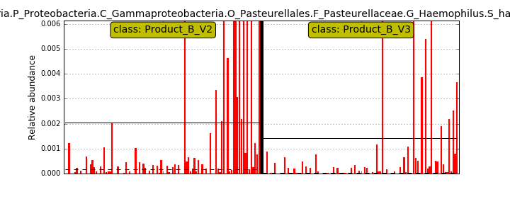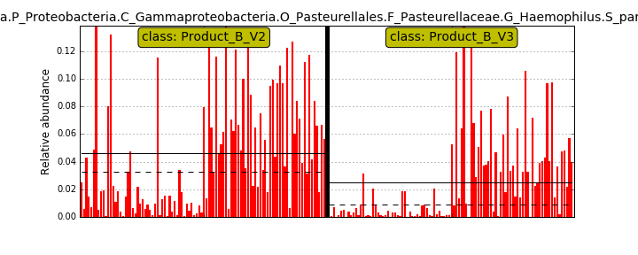

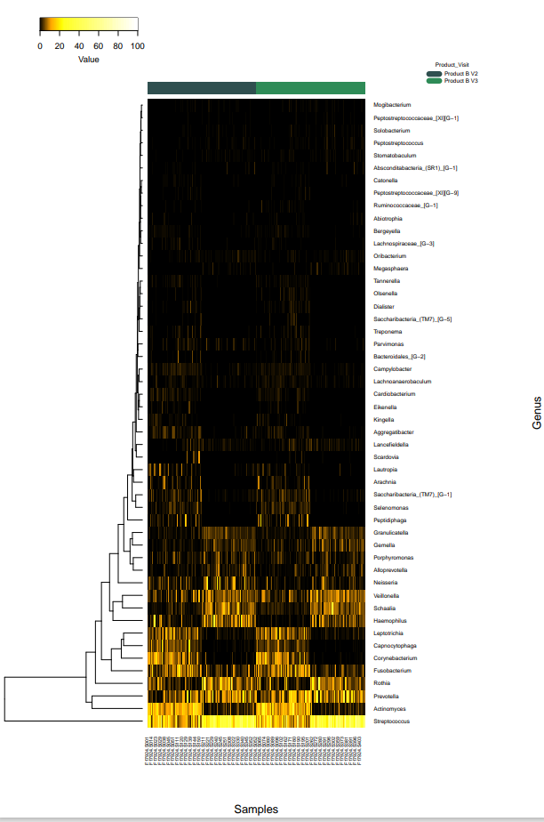
- Heat maps

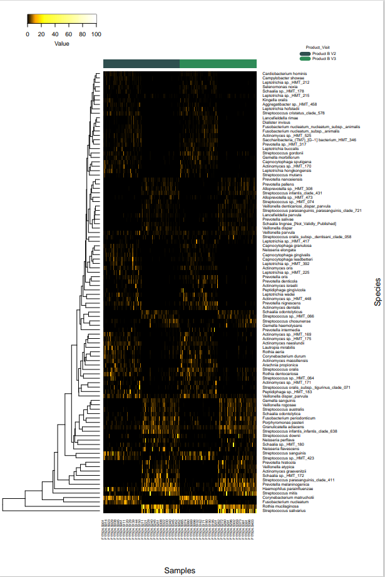

Comparison 3 Product A V2 vs Product B V2

- Taxonomy barplots
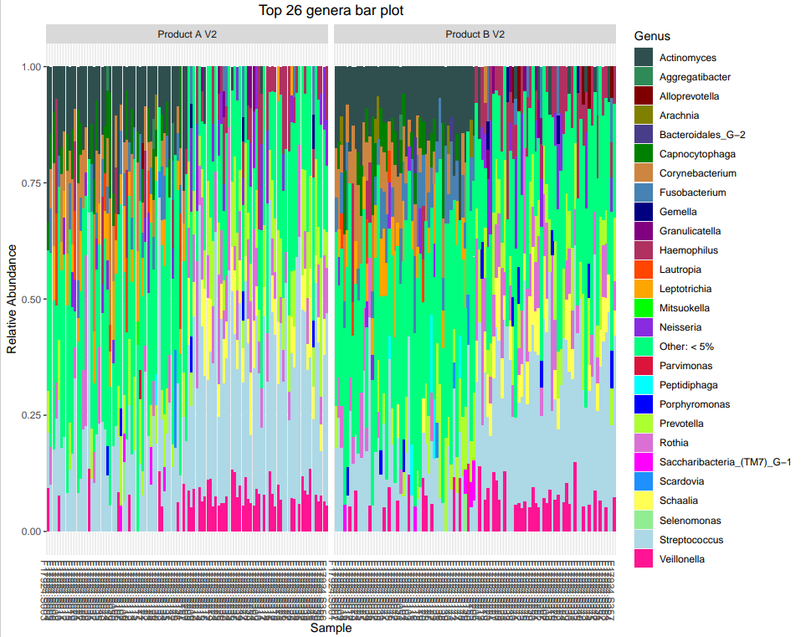

- Alpha diversity

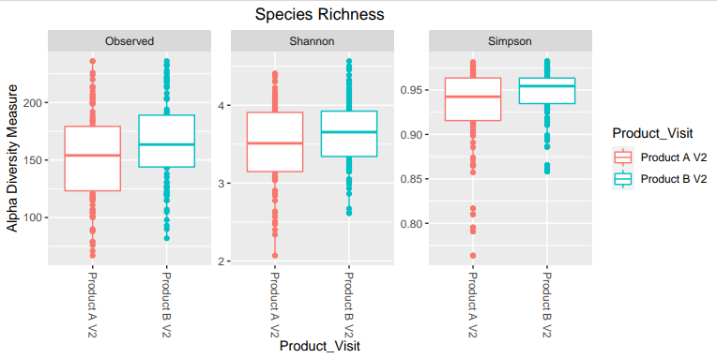
Significant differences—indicates that the populations were different microbiologically at baseline
Observed p= 0.027
Shannon p= 0.049

Simpson p= 0.034

- Beta diversity
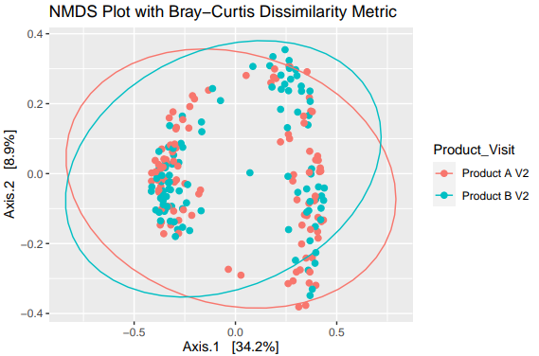

No significant differences

- Differential abundance

Many differences. Indicates that the 2 subject populations were not similar at baseline.

Red, more prevalent in B at baseline
Green, more prevalent in A at baseline

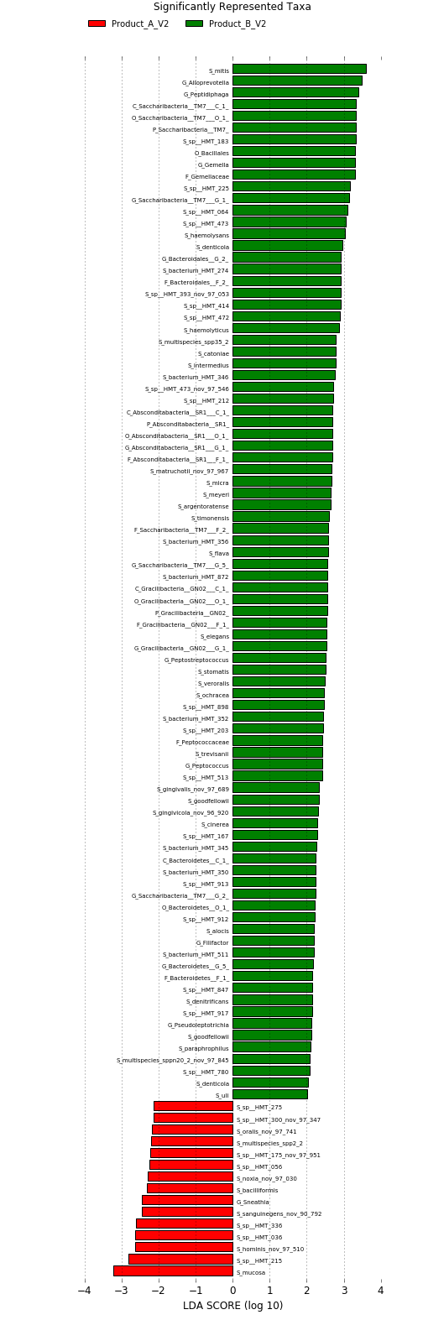
- Lefse—Many differences

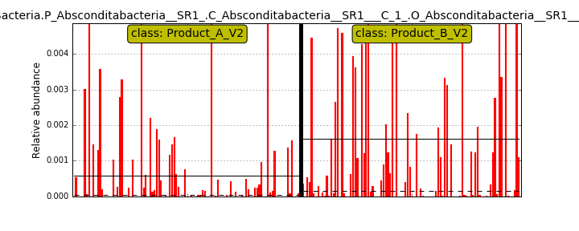 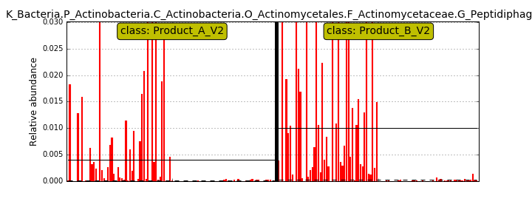 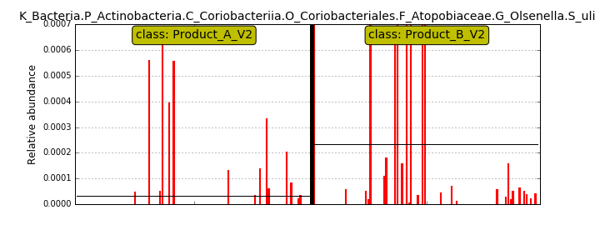 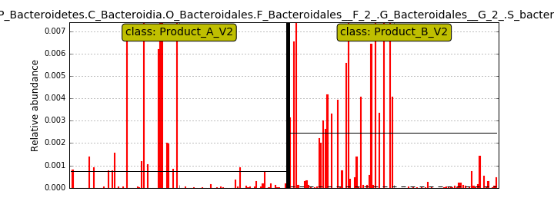HMT274 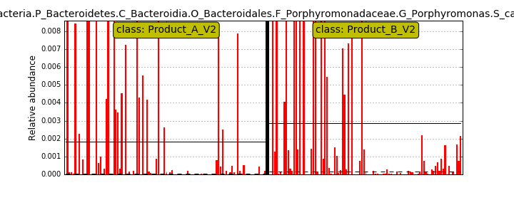 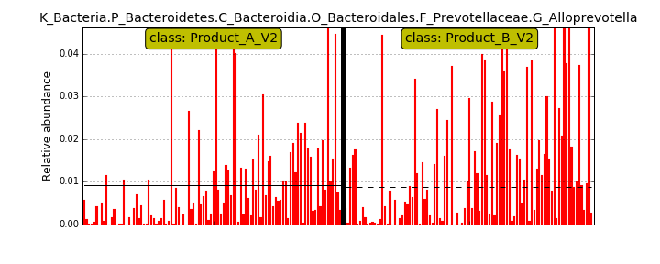 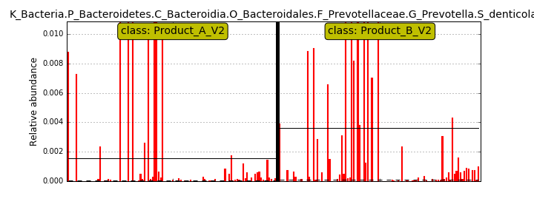 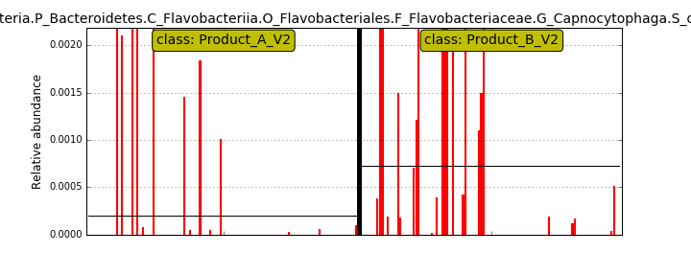 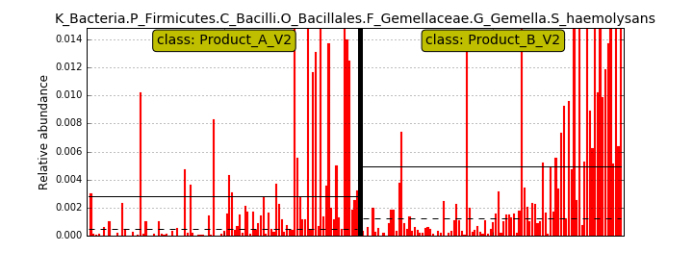 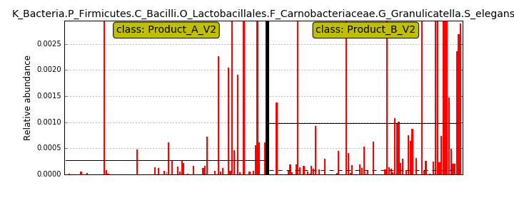 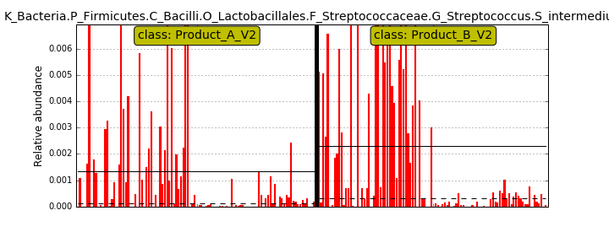 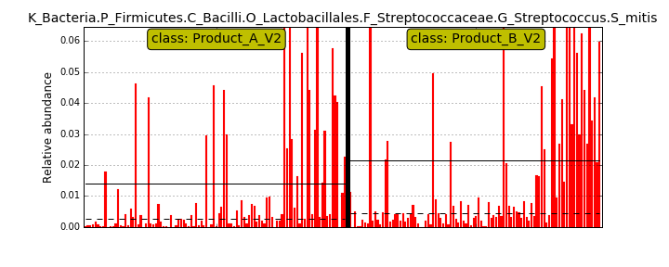 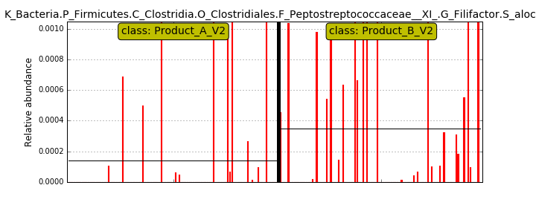 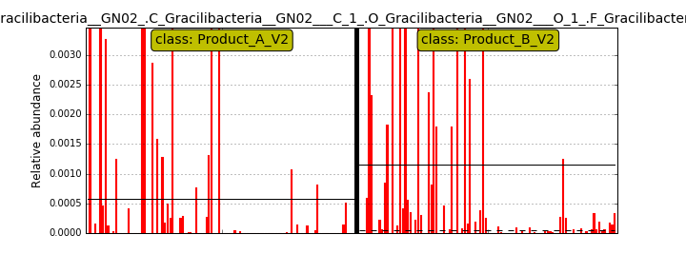 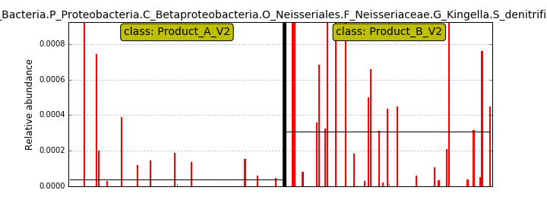 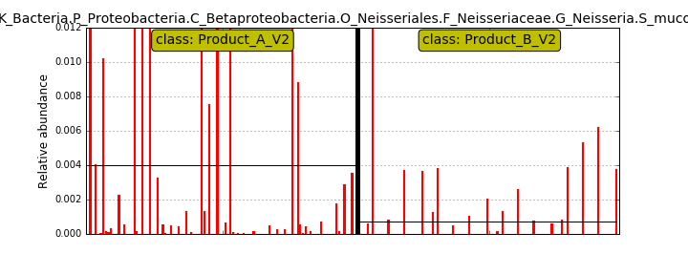 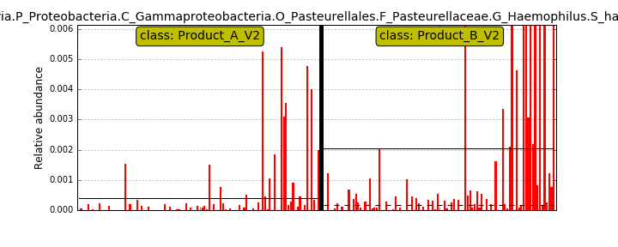 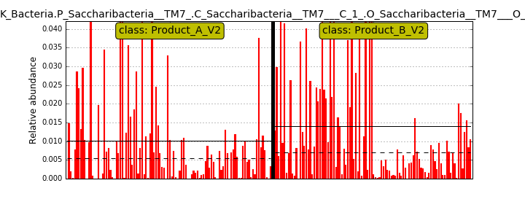 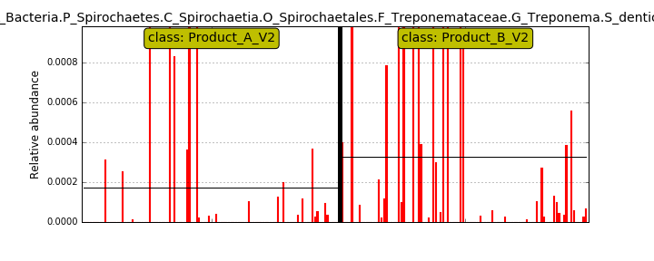

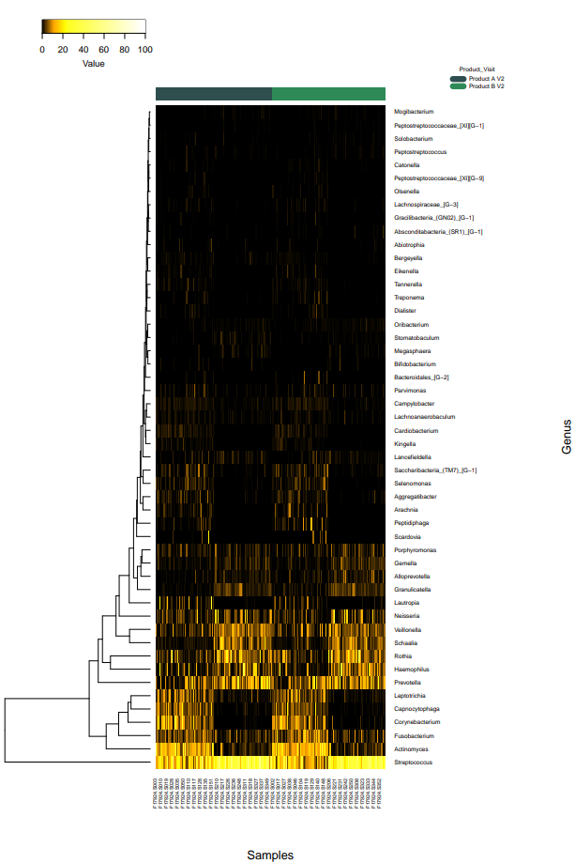
- Heat maps

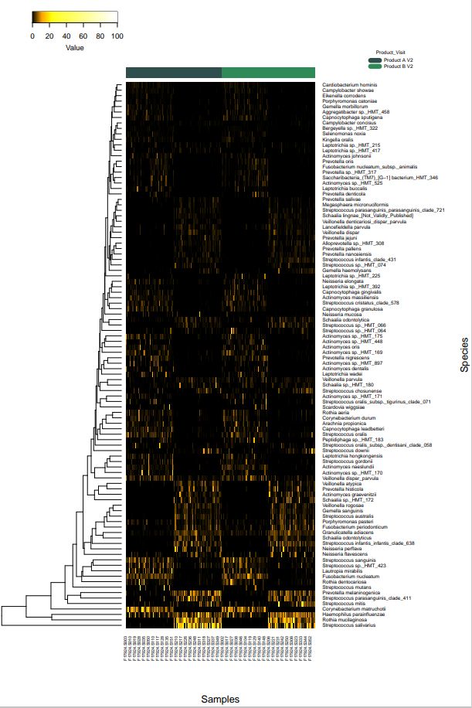

Comparison 4. Product A V3 vs Product B V3

- Taxonomy barplots
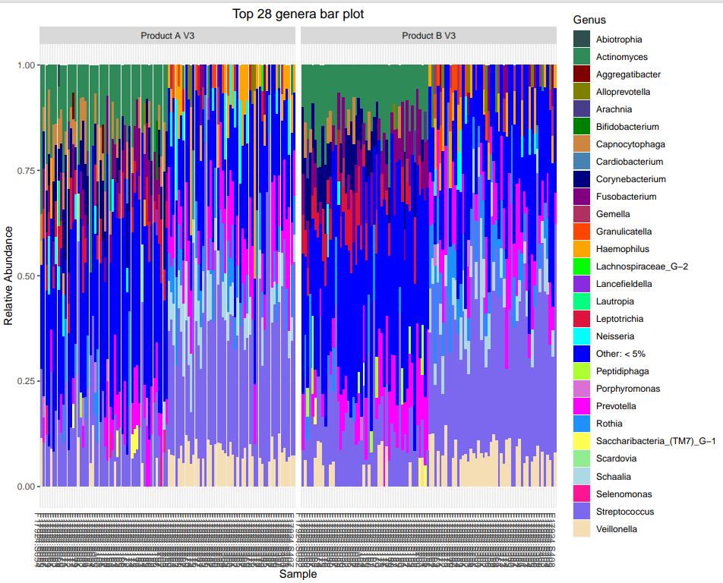

- Alpha diversity

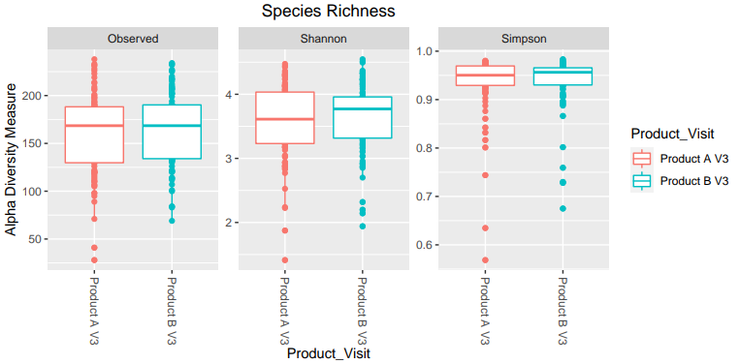

No significant difference

- Beta diversity

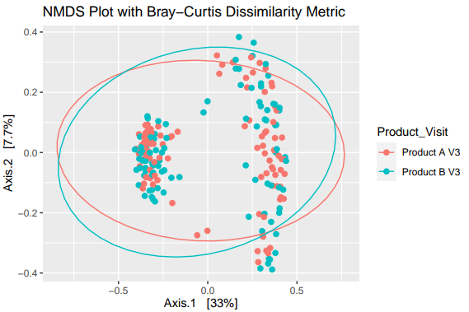

P= 0.11

- Differential abundance

Green, more abundant in B after treatment
Red, more abundant in A after treatment

- Lefse—as expected, many differences
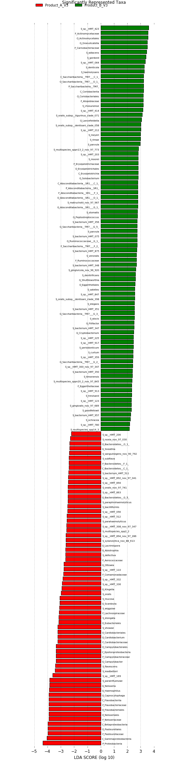

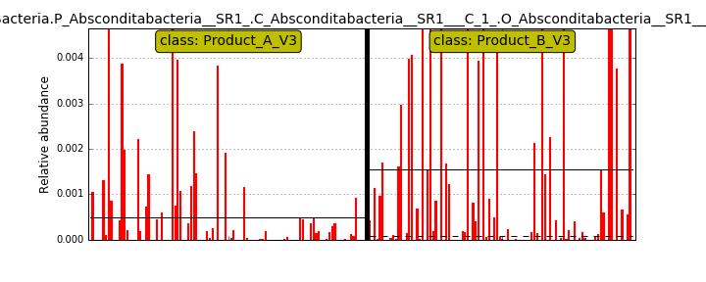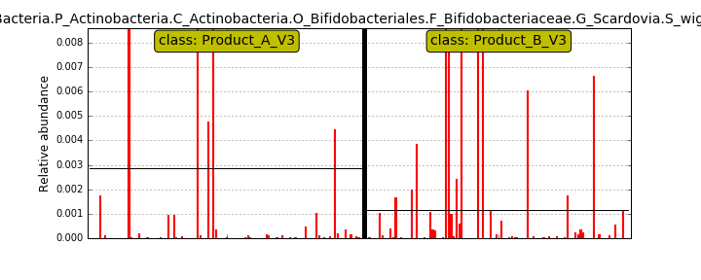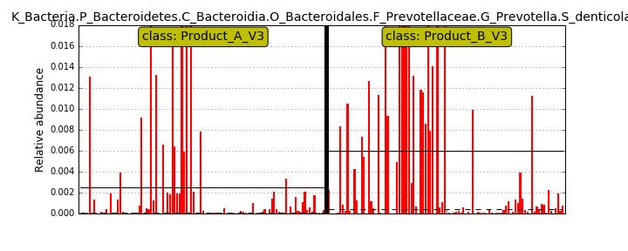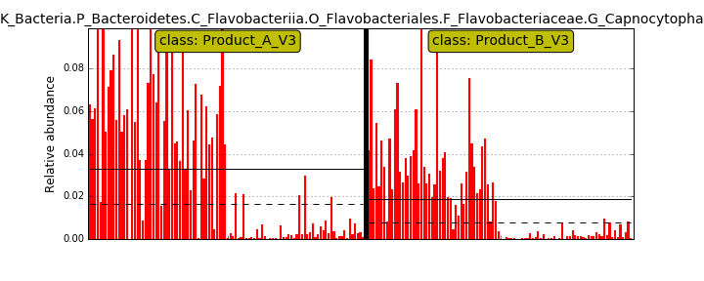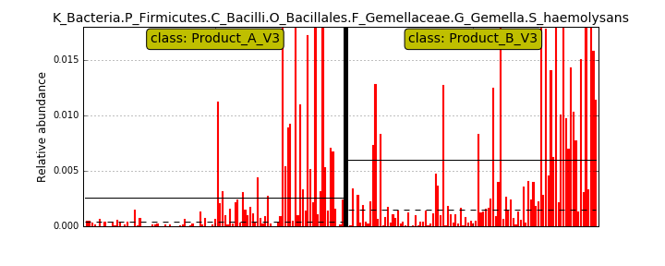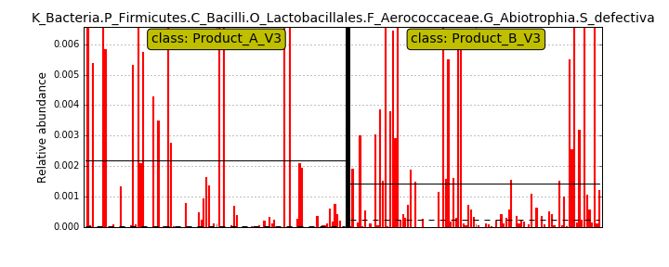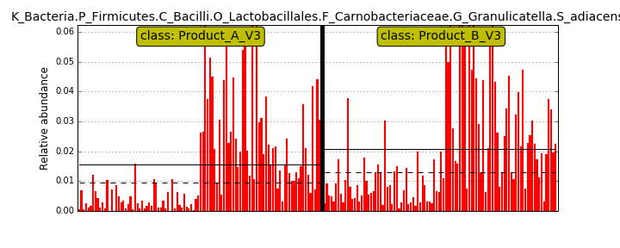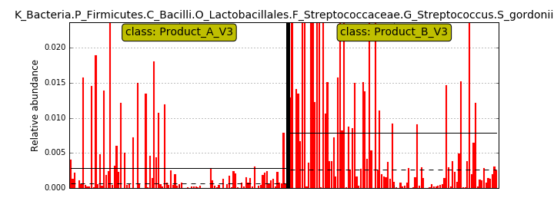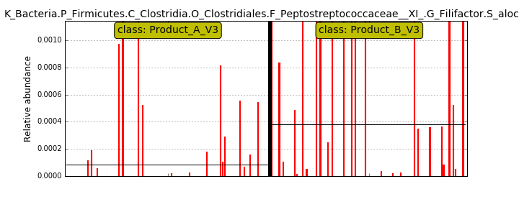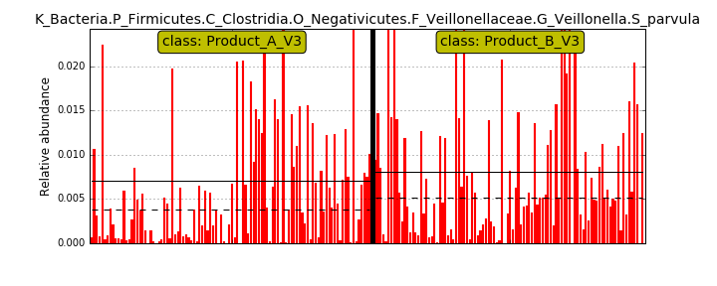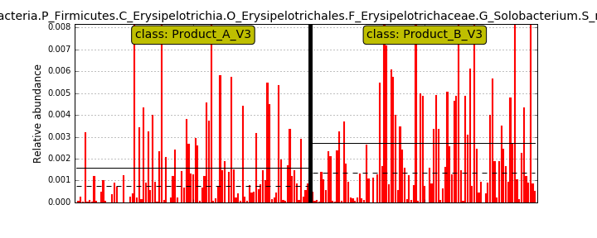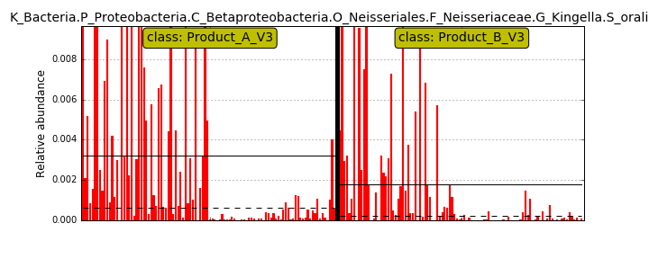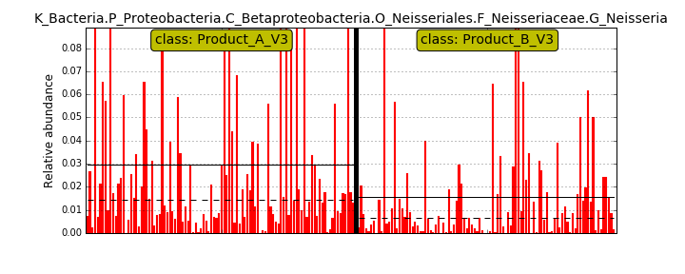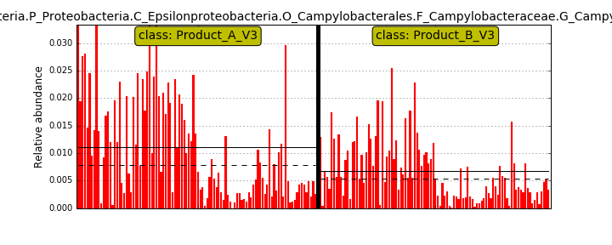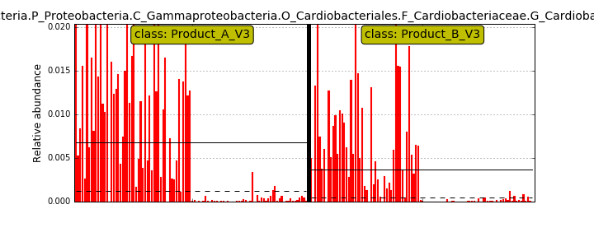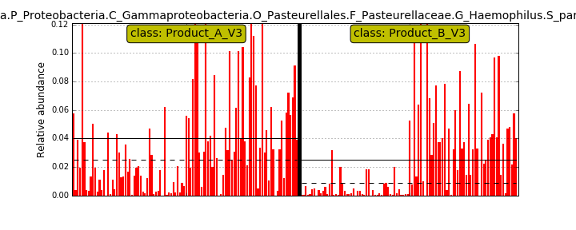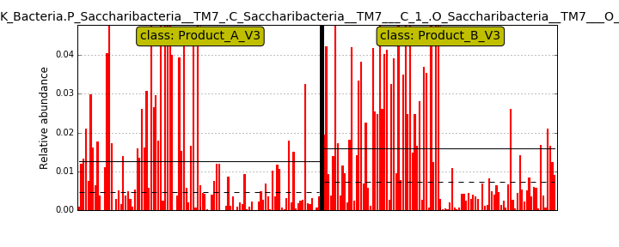

- Heat maps

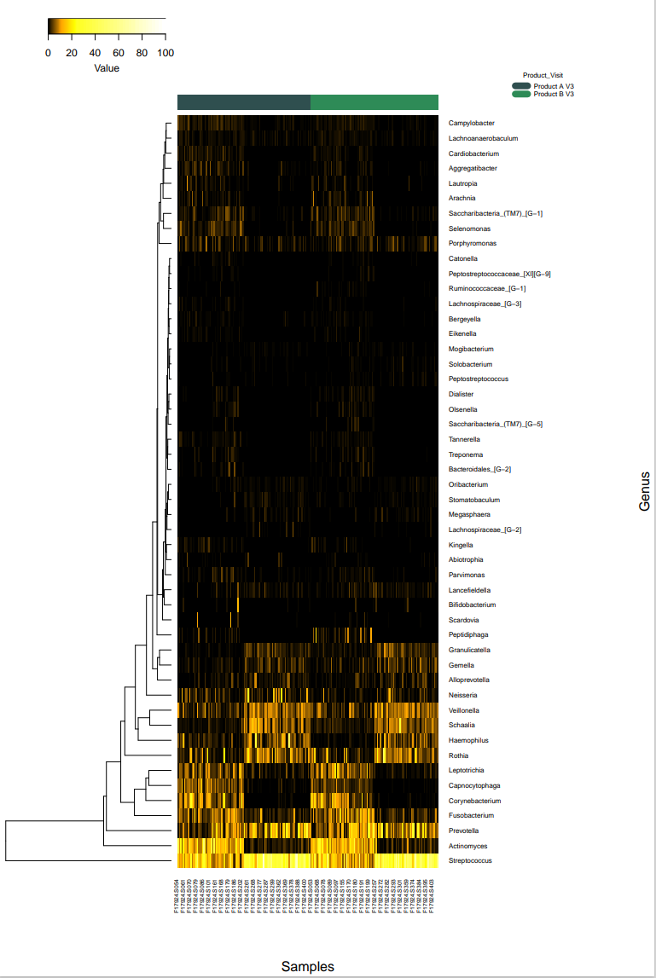
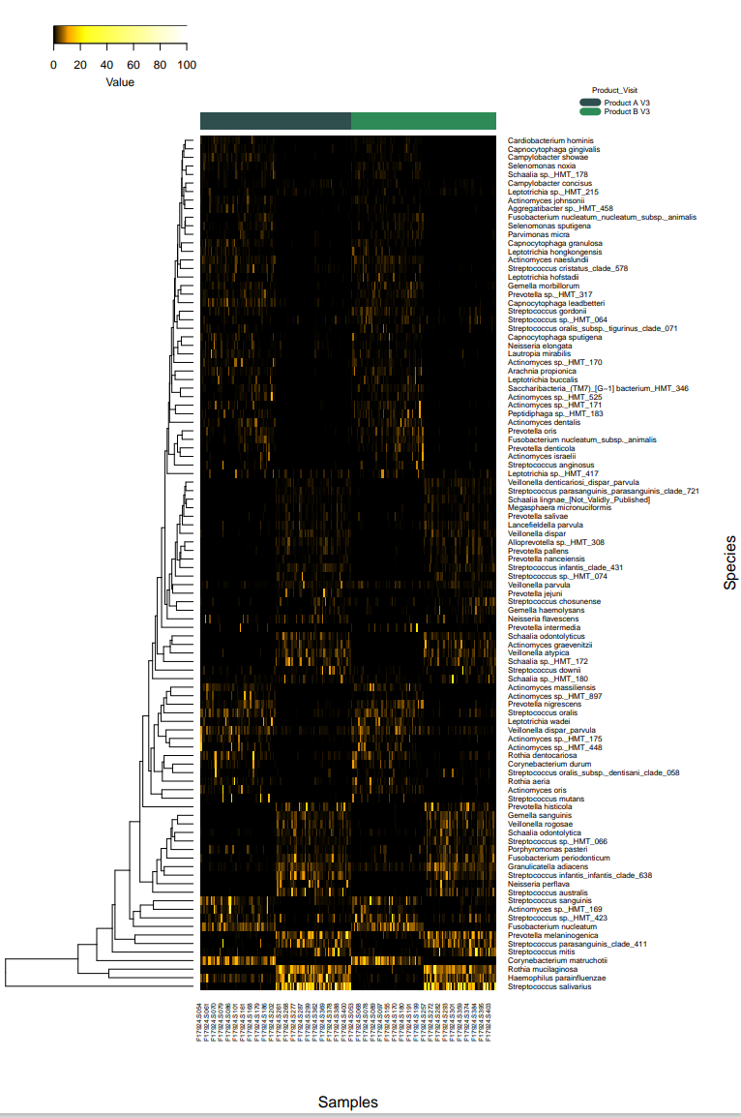

Comparison 5. Product A V2 SAL vs Product A V3 SAL

- Taxonomy bar plots
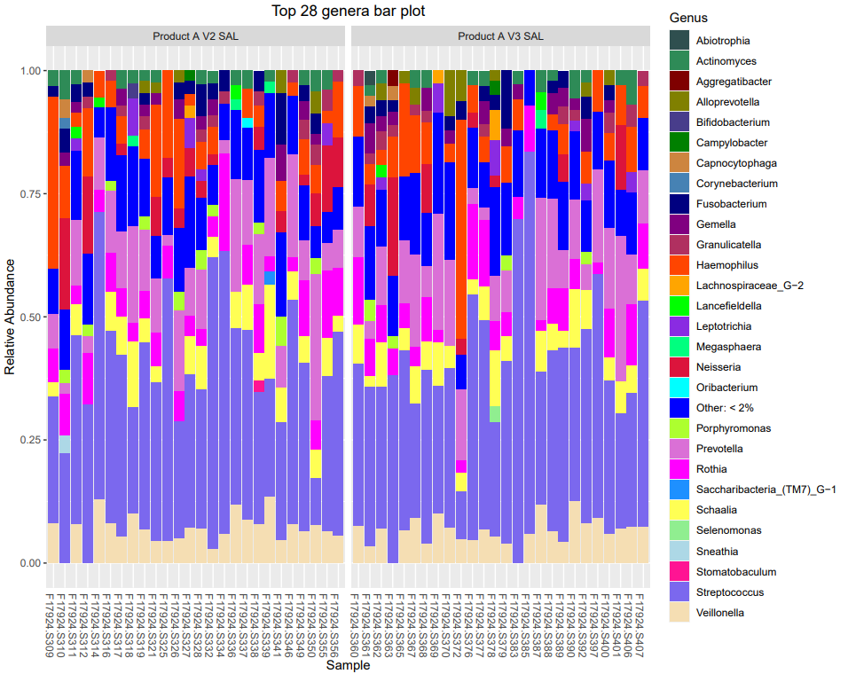

Difficult to see any major differences. However, expected taxa are present. Will see specific taxa in subsequent analyses.

- Alpha diversity

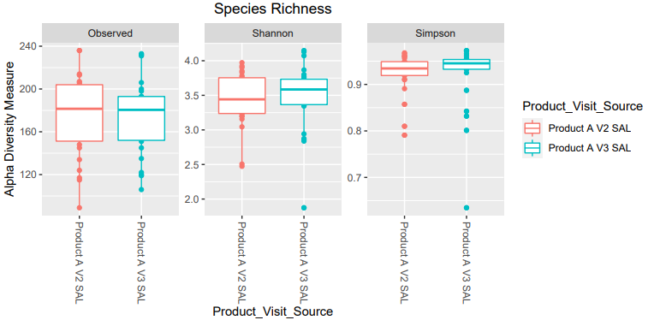

Not Statistically significant

- Beta diversity

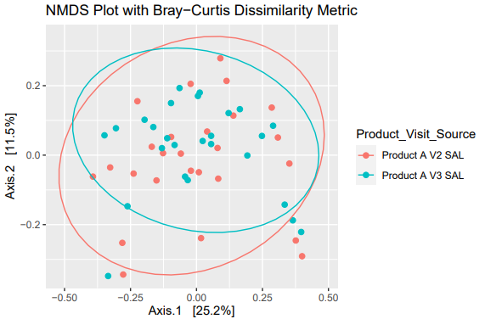

Not Statistically significant

p=0.259

- Differential abundance

No statistically significant differences

- Lefse—only 2 species that differentiated—no clear differences—product A had little or no effect

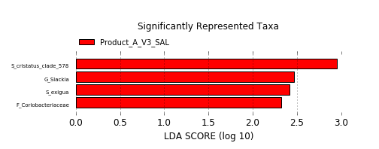

Differences can be better seen in the following graphs for individual taxa
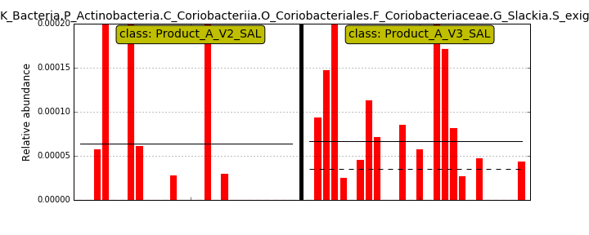
very low levels. Likely not biologically significant
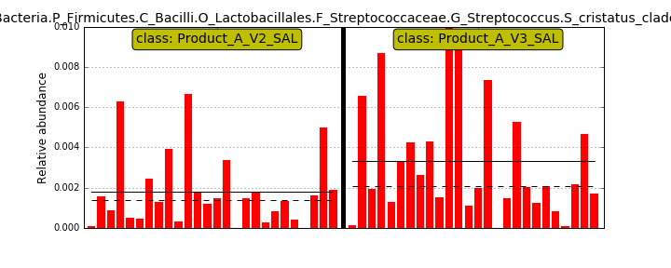

- Heat maps—difficult to see, visualization of the differences at the species and genus levels is

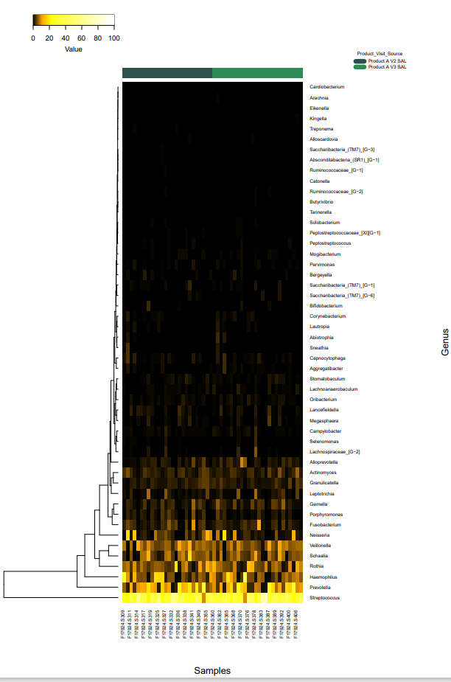

shown below.
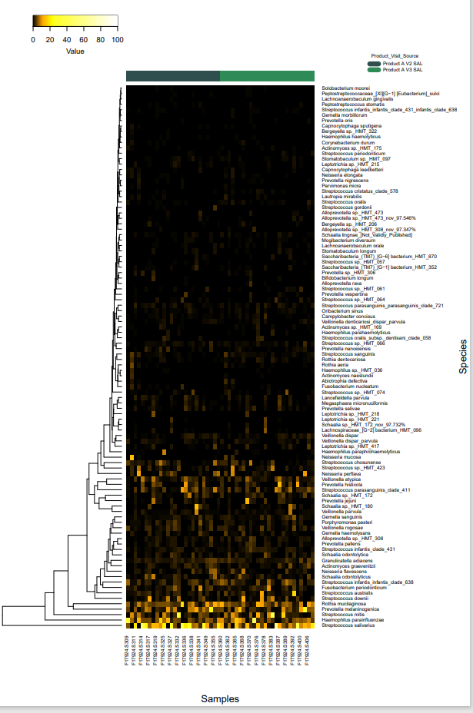

.

Comparison 6. Product B V2 vs Product B V3

- Taxonomy barplots

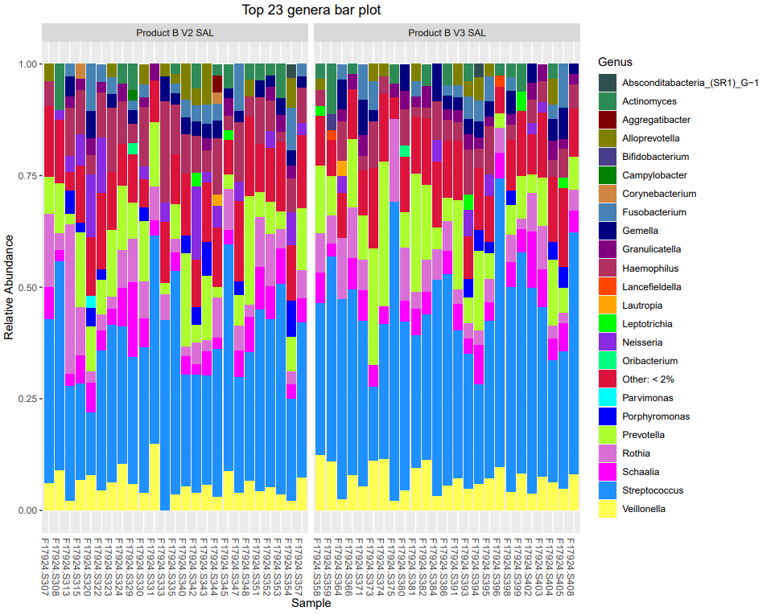

- Alpha diversity
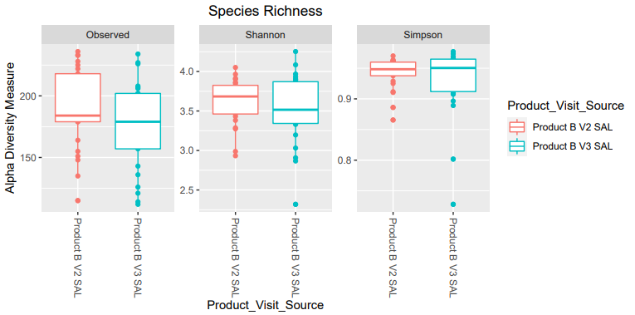

No significant differences

- Beta diversity

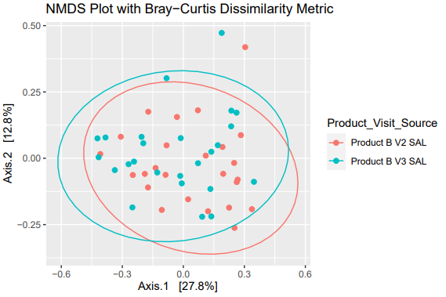

Significant difference
Group 1 | Group 2 | Sample size | Permutations | pseudo-F | p-value
Product B V2 SAL | Product B V3 SAL | 50 | 999 | 2.081426 | 0.027

- Differential abundance

Not significantly different, but a trend. P value is no longer significant after multiple comparisons.

- LefSe
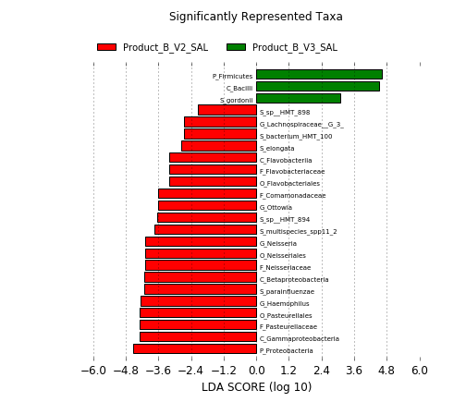

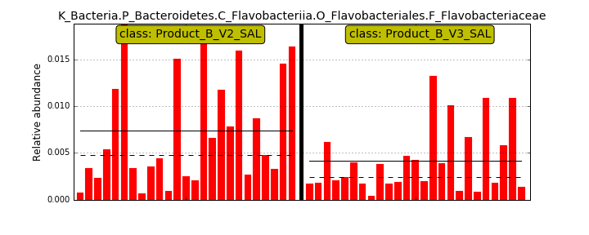
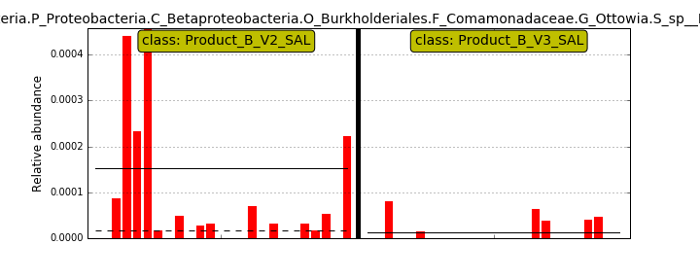
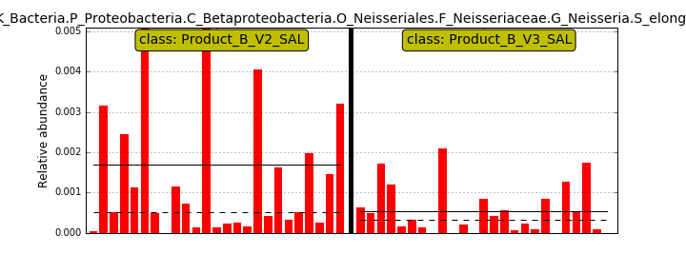
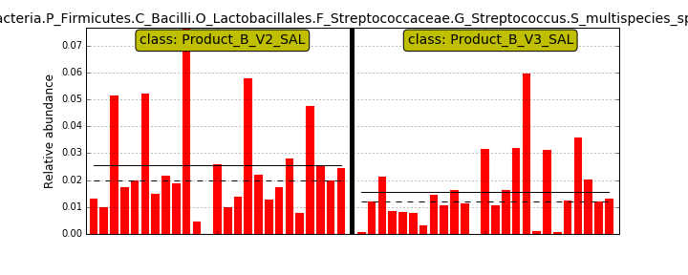
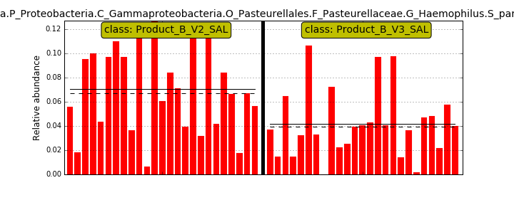
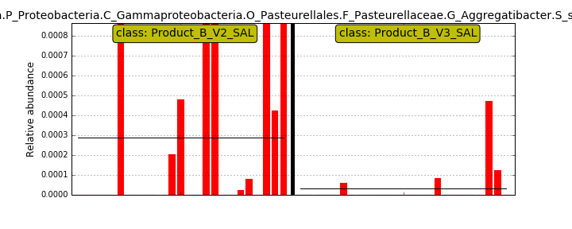
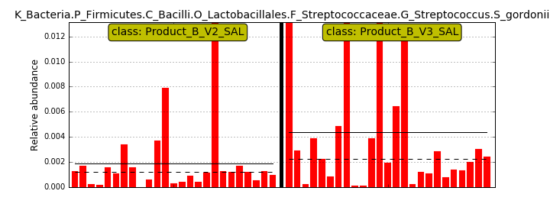

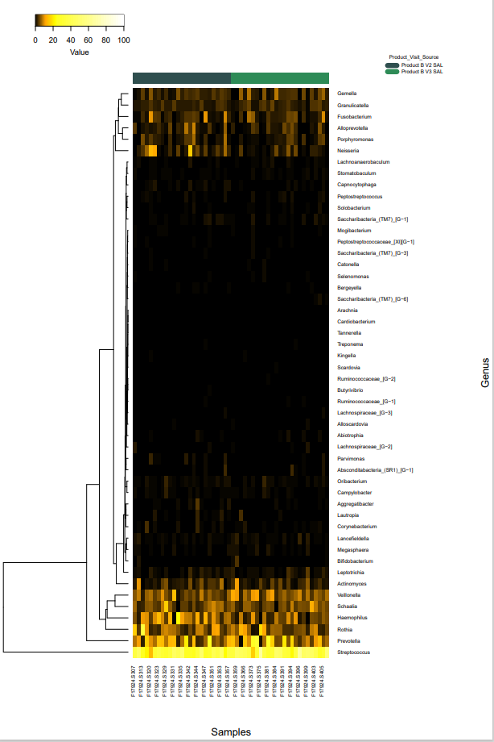
- Heat maps

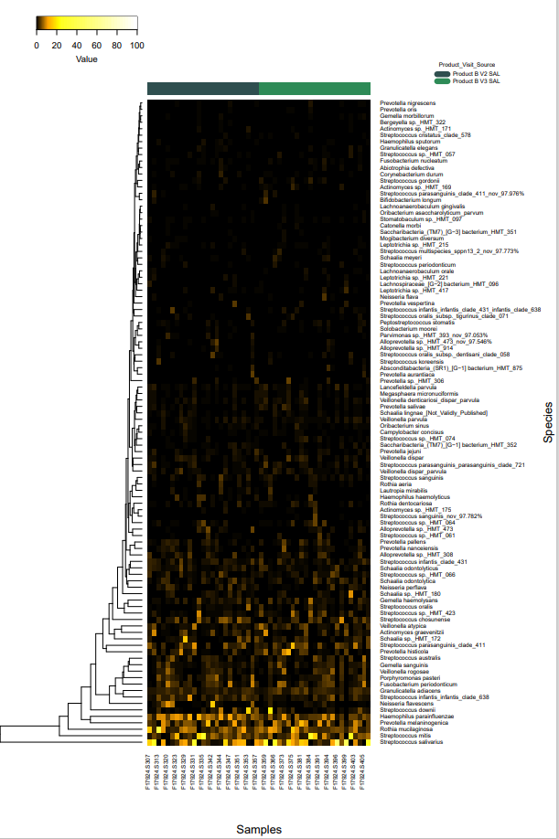

Comparison 7. Product A V2 SAL vs Product B V2 SAL

- Taxonomy Barplots

- 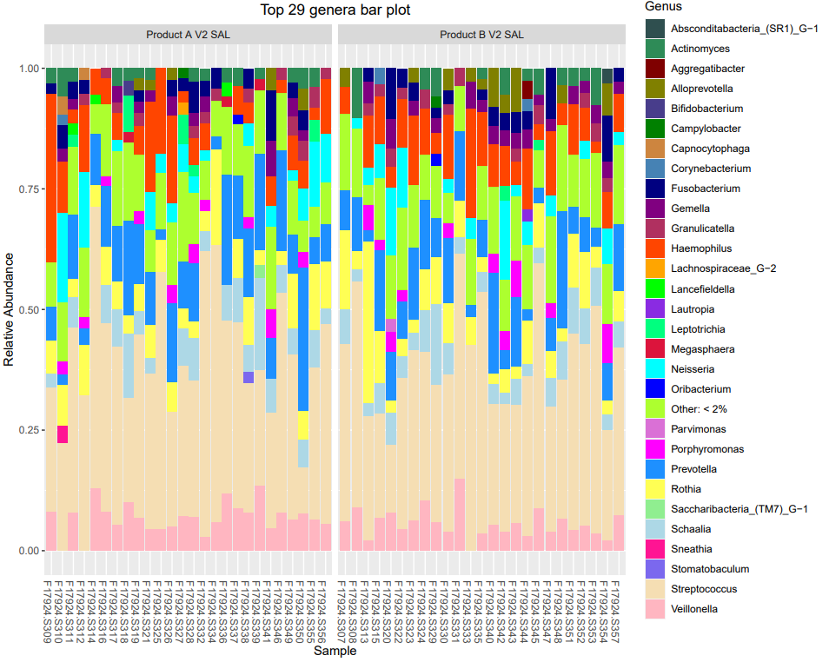
- Alpha diversity

- 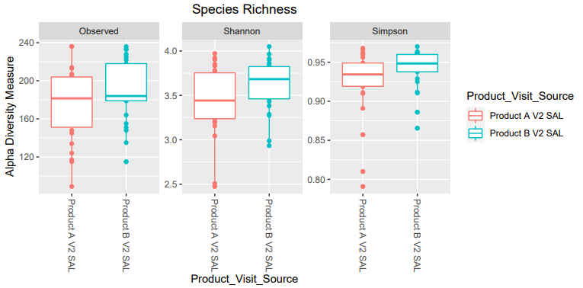

No significant differences in observed and Shannon

Simpson

No Significant difference but close to significance

Group 1 | Group 2 | H | p-value | q-value
Product A V2 SAL (n=26) | Product B V2 SAL (n=25) | 3.479645 | 0.062128 | 0.062128

- Beta diversity
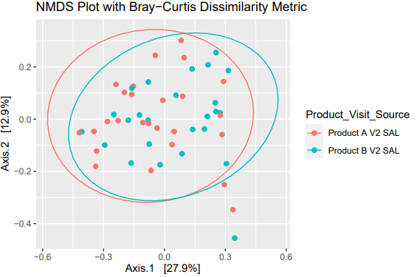

No Statistically significant differences
- Differential abundance

No statistically significant differences. Similar results with Lefse
Lefse will show better.

- LefSe -Individual plots will show better

Overall, only minor differences

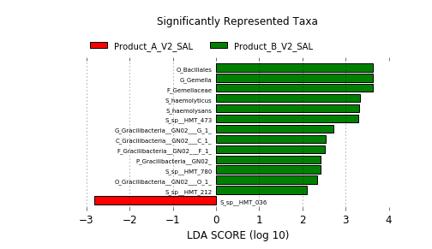 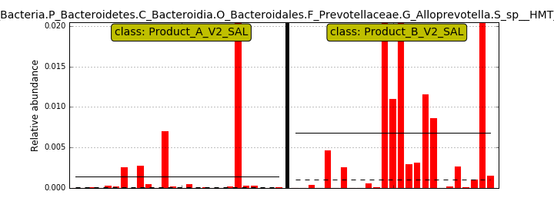 HMT473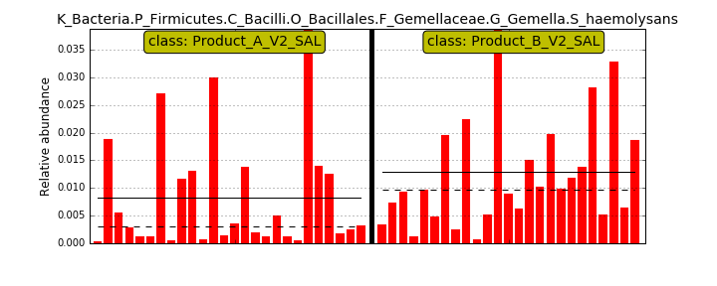 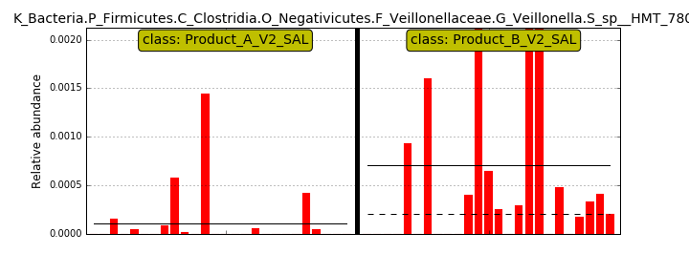
- 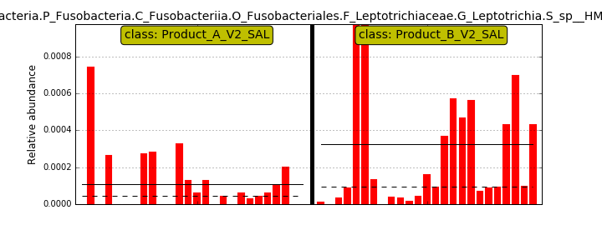HMT212 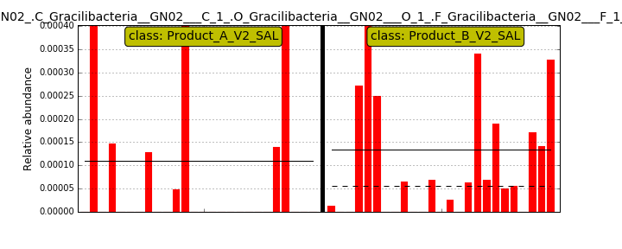very low levels 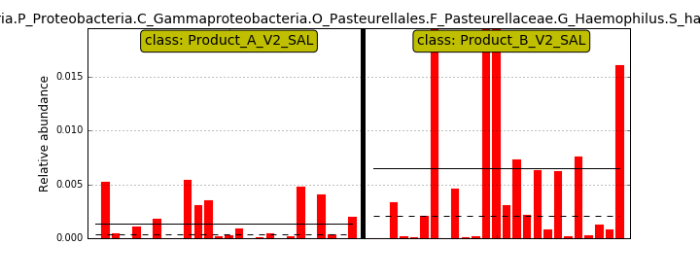 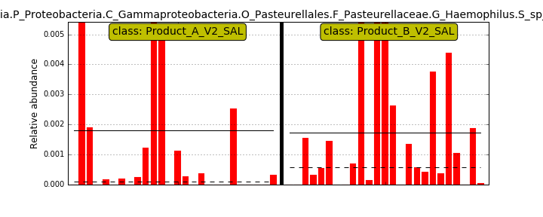

- Heat maps
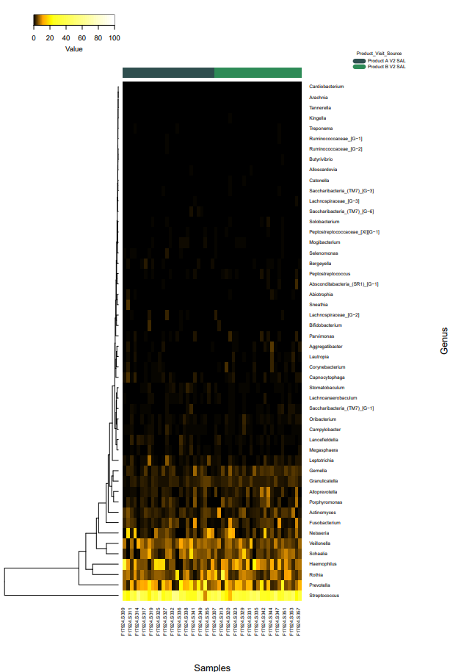

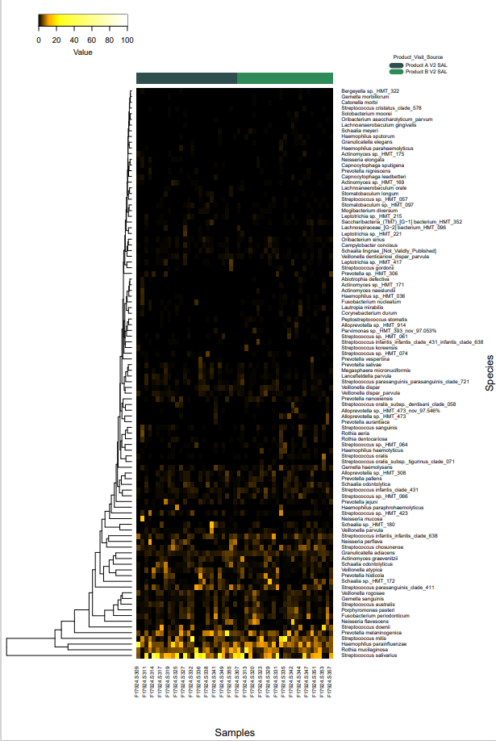

Comparison 8. Product A V3 SAL vs Product B V3 SAL

- Taxonomy bar graphs

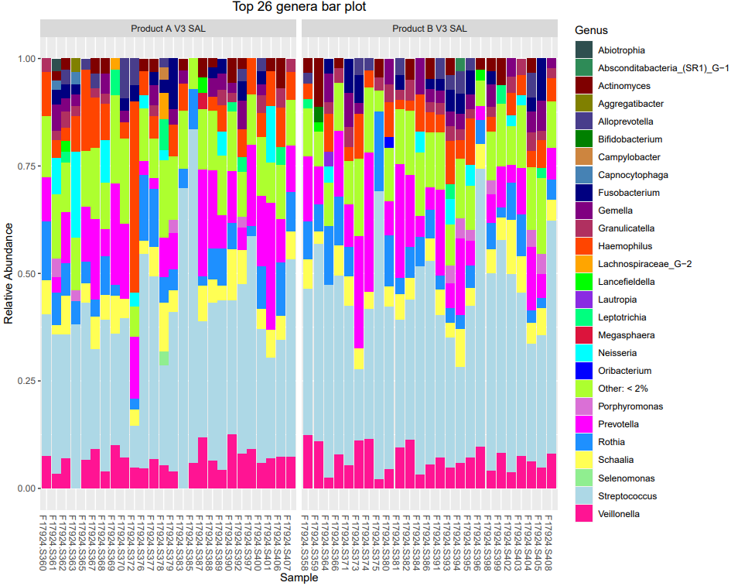

Difficult to see major differences. These will be ID’d in subsequently analyses

- Alpha diversity

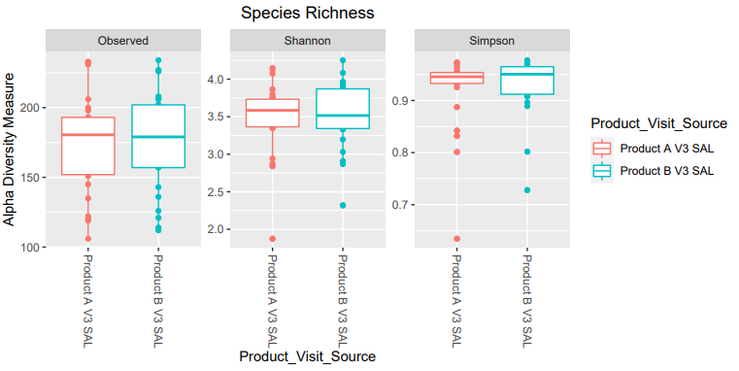

No significant differences

- Beta diversity

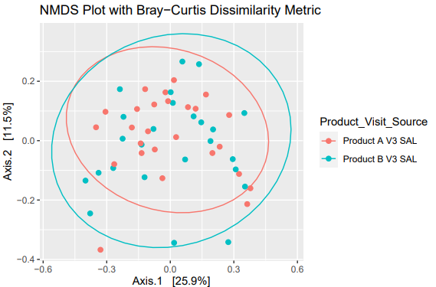

No Significant differences.

- Differential abundance

No significant differences, but lost after multiple comparisons.

Similar results in Lefse

- Lefse

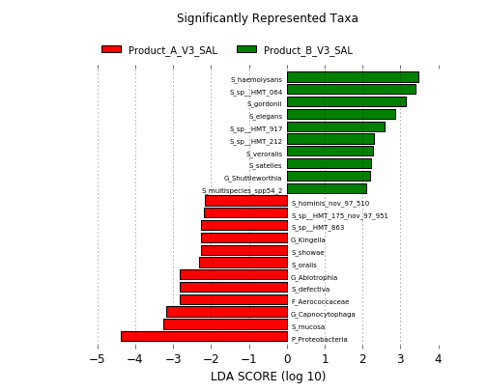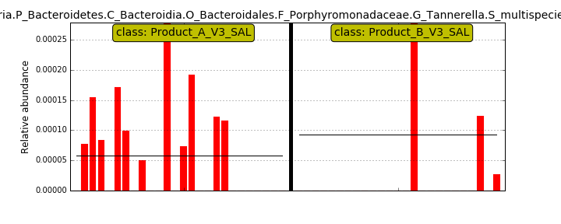
very low levels 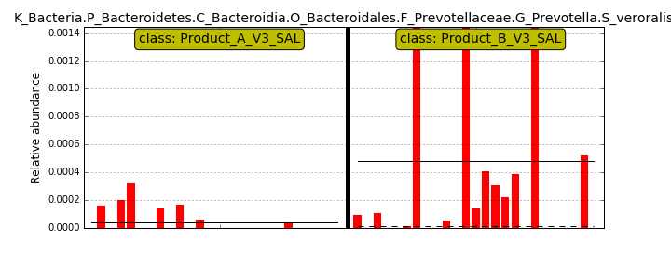 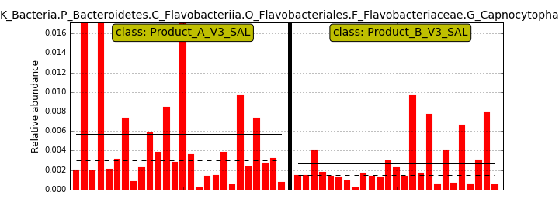 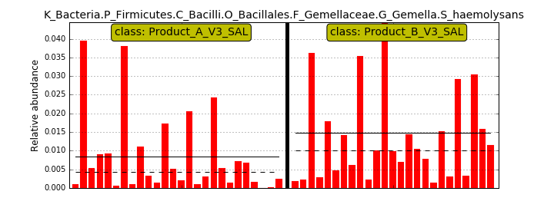 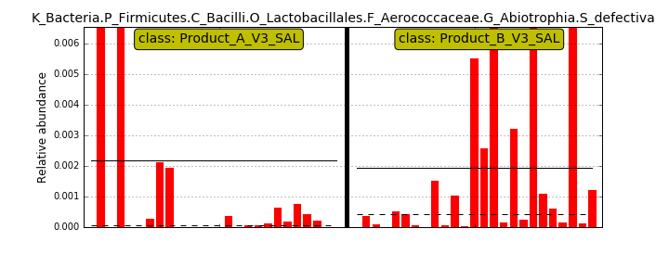 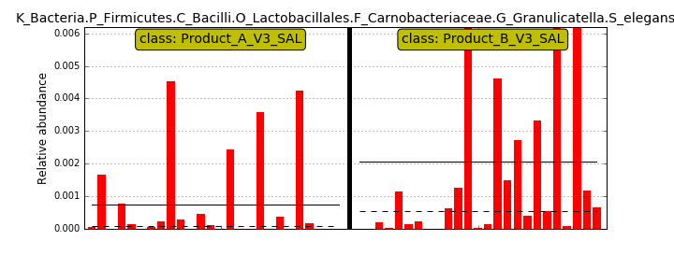

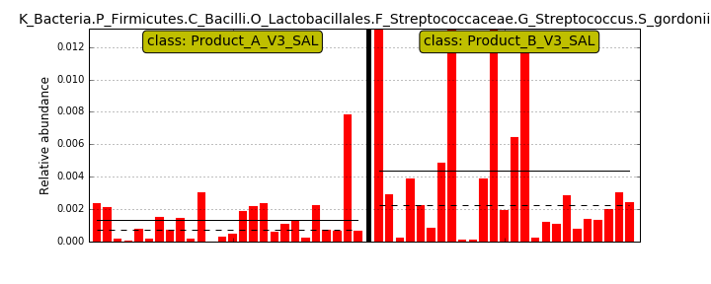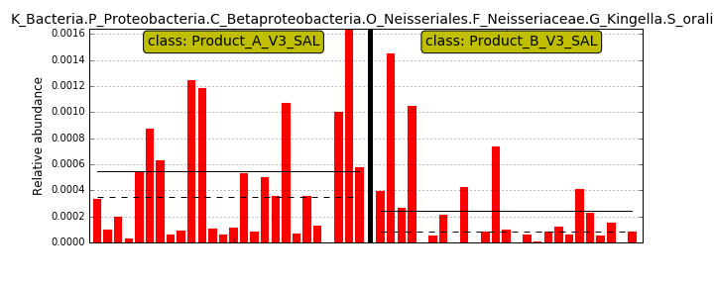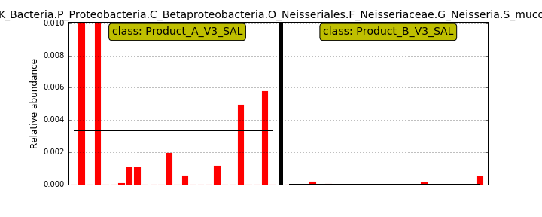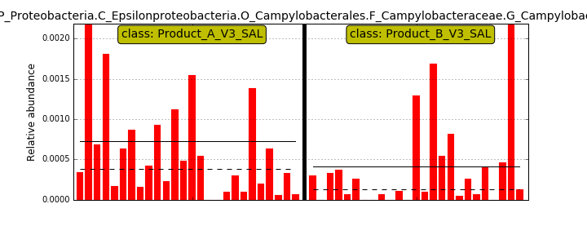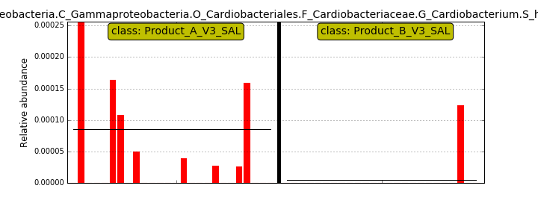

- heat maps –difficult to see consistent differences
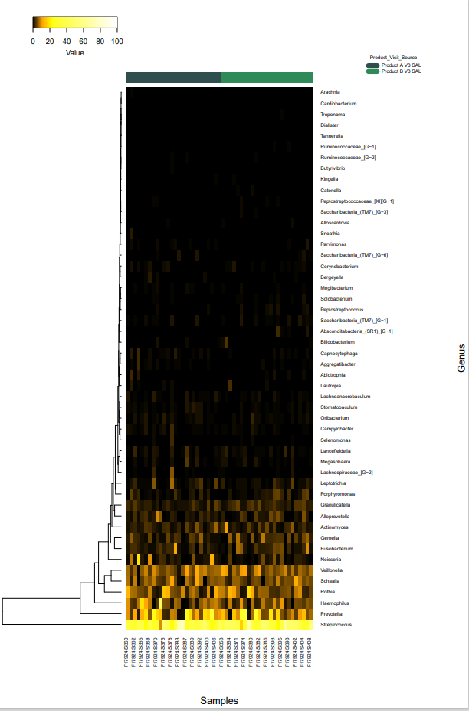
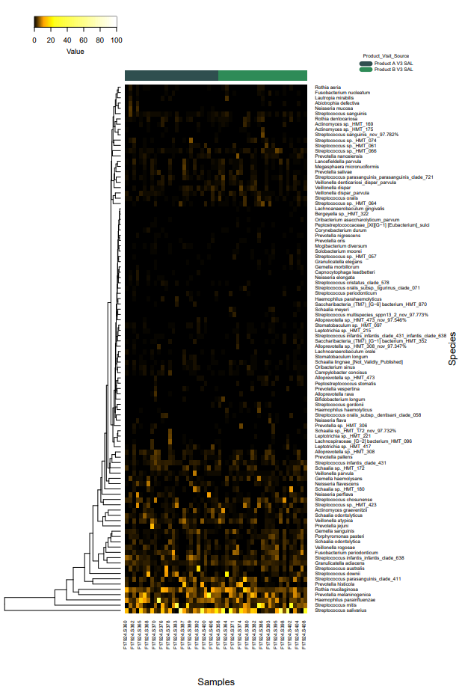

Comparison 9. Product A V2 TNG vs Product A V3 TNG

- Taxonomy bar graphs

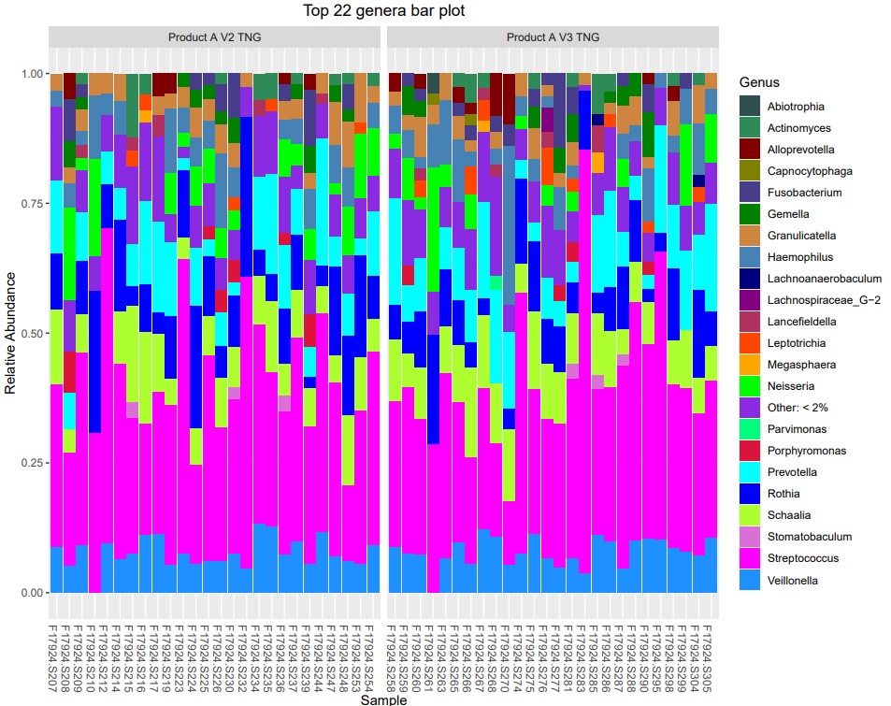

Some differences can be seen, but analyses below will be more informative.

- Alpha

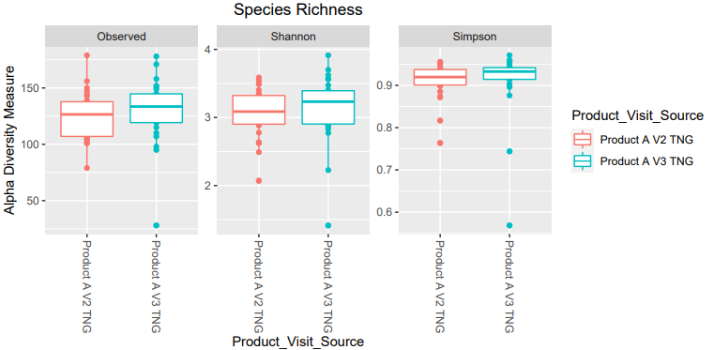

No significant differences

- Beta

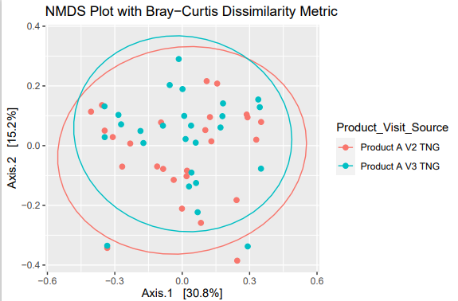

No significant differences

- Differential abundance

No differences

- Lefse

. NO differences –graph was not produced

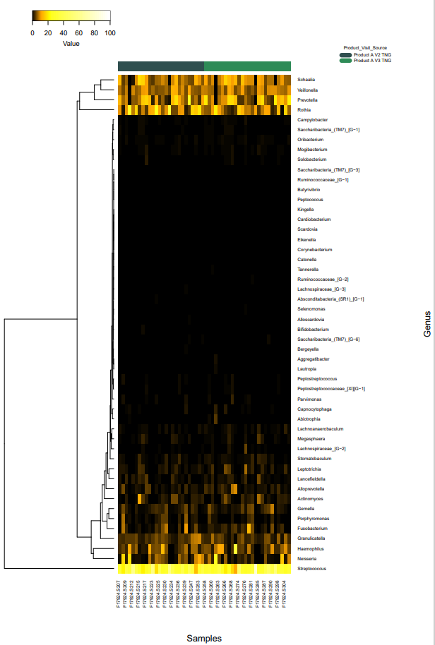
- Heat maps
- 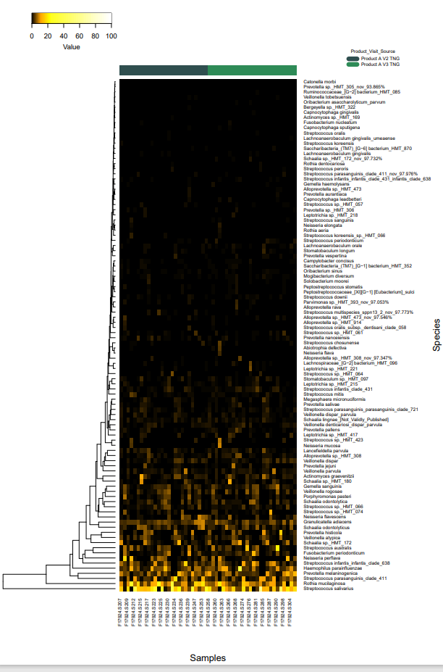

Comparison 10. Product B V2 TNG vs Product B V3 TNG

- Taxonomy bar graphs
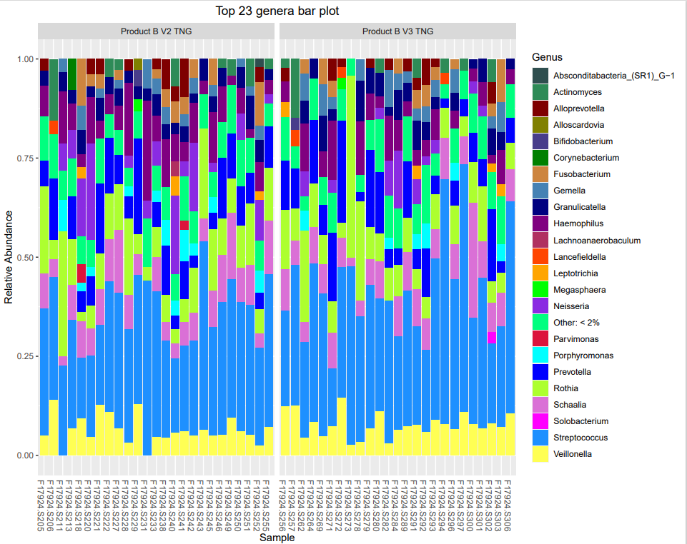

- Alpha

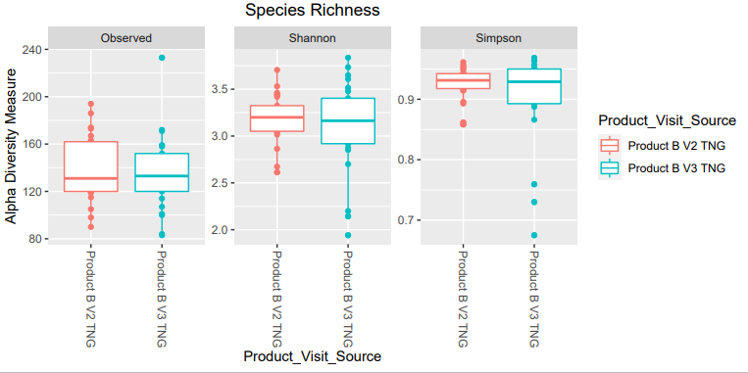

No significance

- Beta diversity

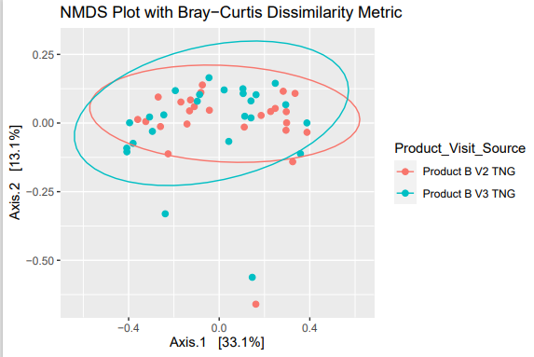

Not significant

- Differential abundance

Nothing significant but some trends as also shown in Lefse

- Lefse
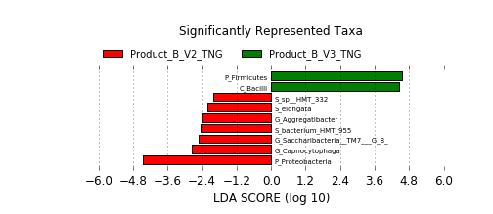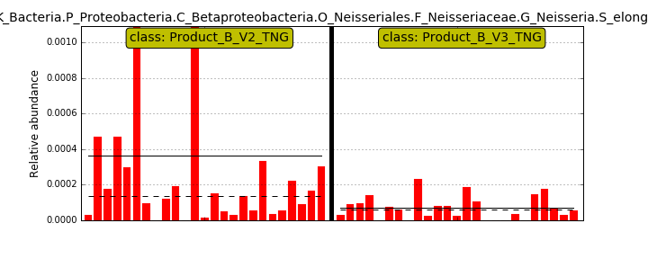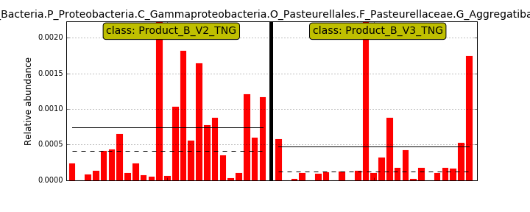 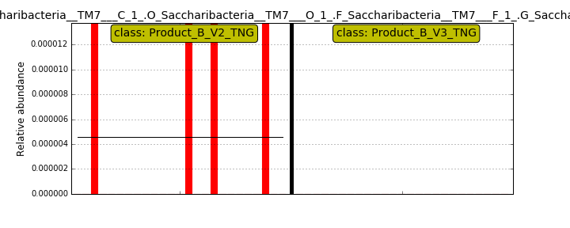very low levels

- Heat map. Difficult to see differences

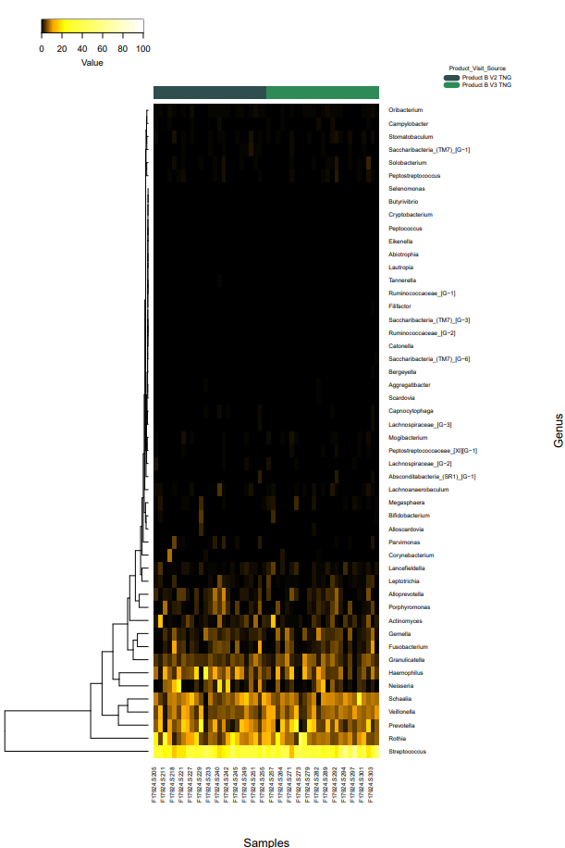
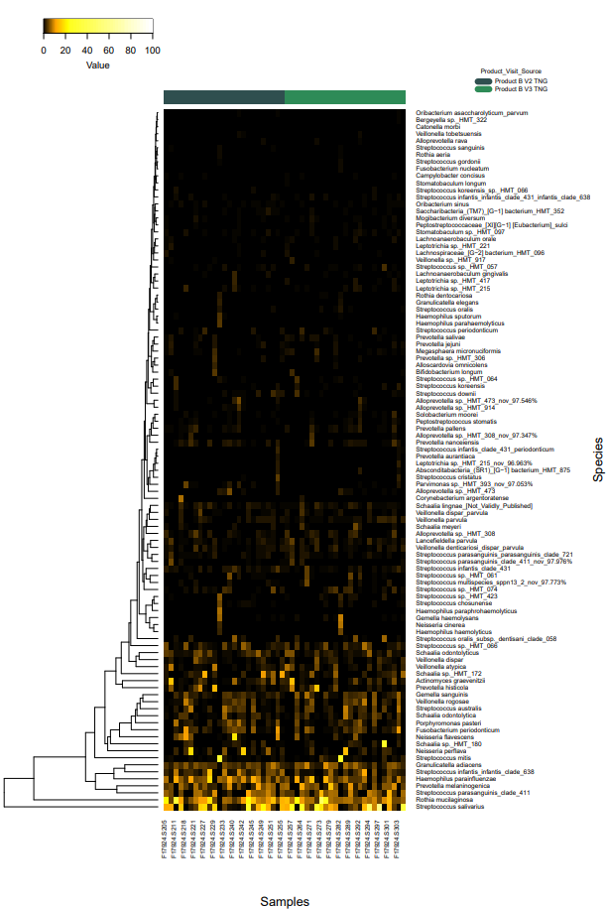

Comparison 11. Product A V2 TNG vs Product B V2 TNG

- Taxonomy bar graphs
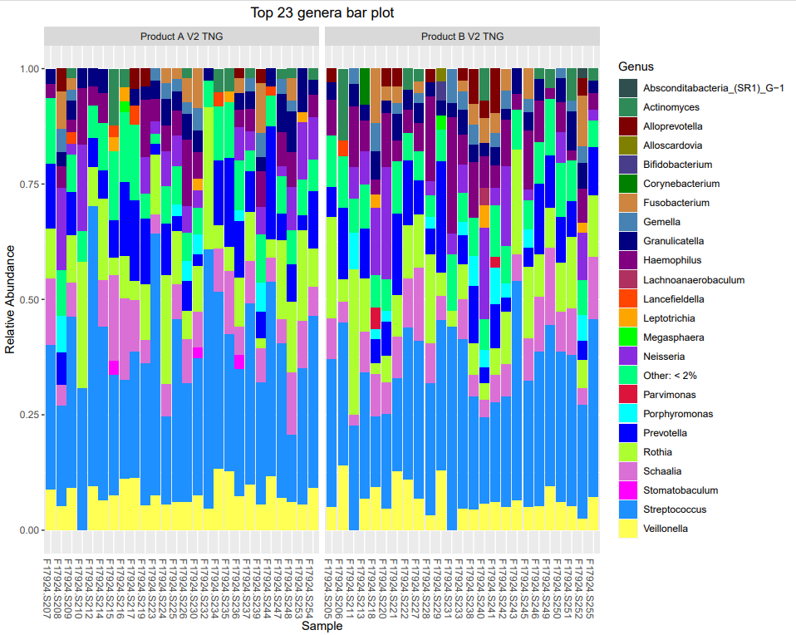

- Alpha
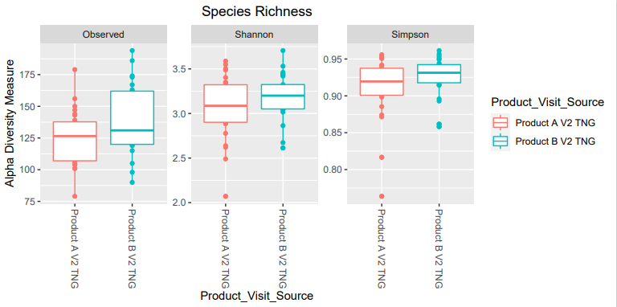
No significant differences

- Beta diversity

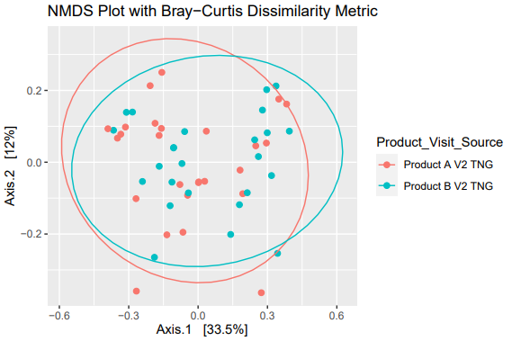

No significant differences

- Differential abundance

No statistical differences.

Data indicates that baseline subjects differ a little bit.

- Lefse

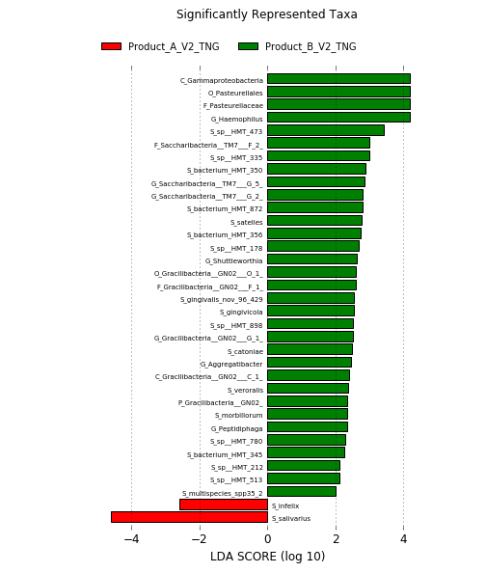 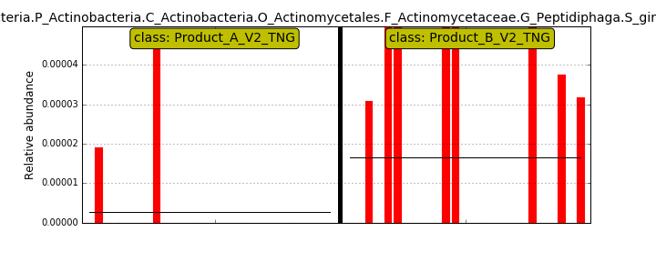very low levels 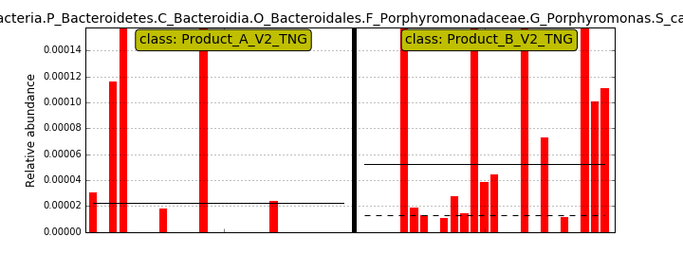 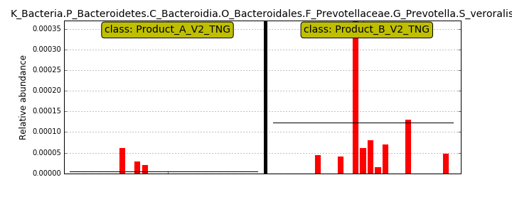 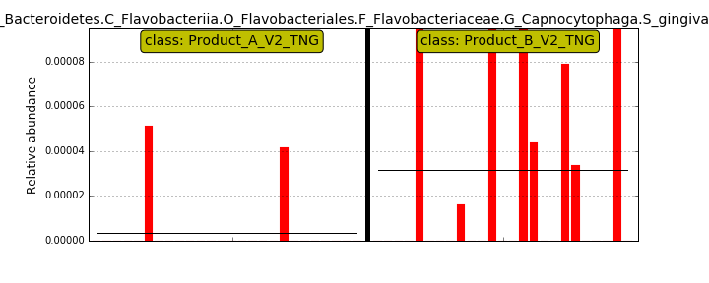 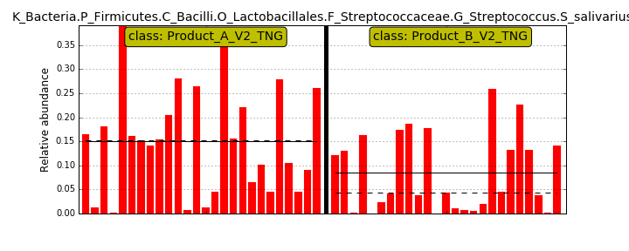 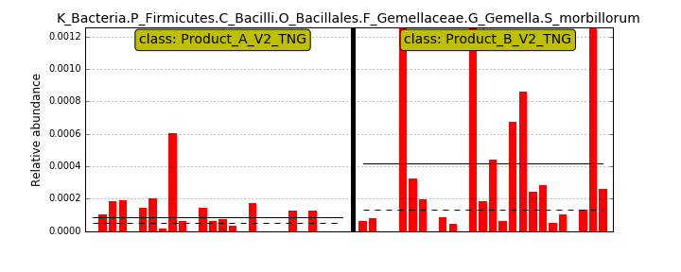 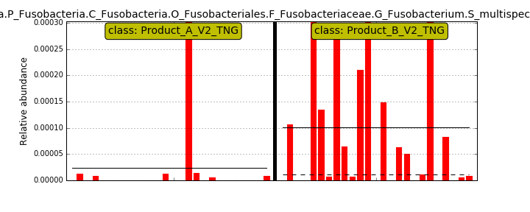 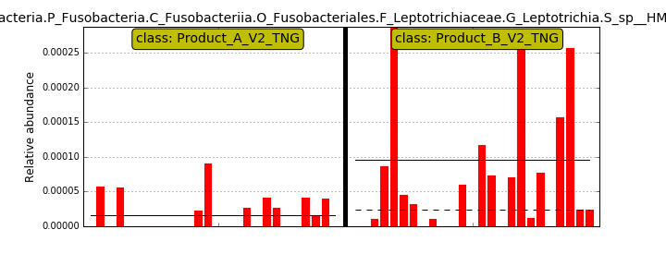 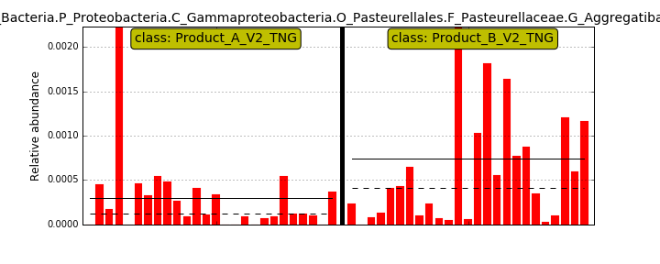 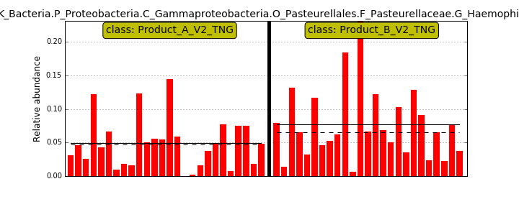

- Heat map.
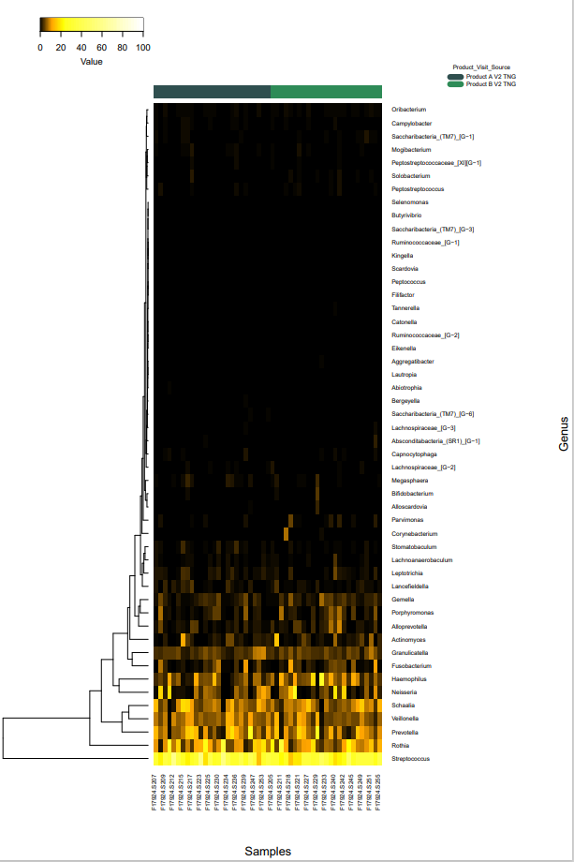
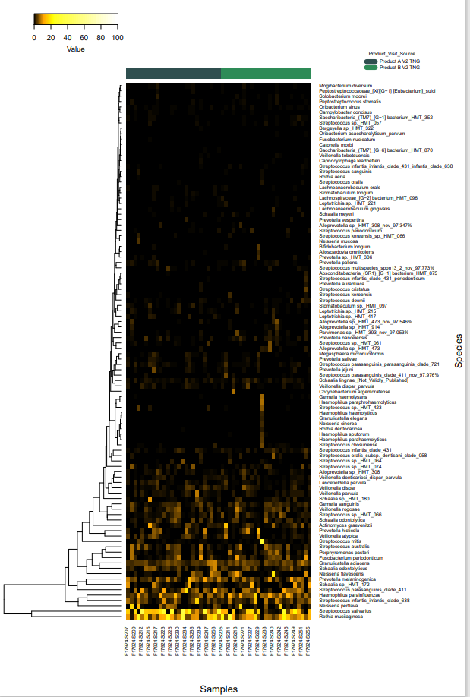

Comparison 12. Product A V3 TNG vs Product B V3 TNG

- Taxonomy bar graphs
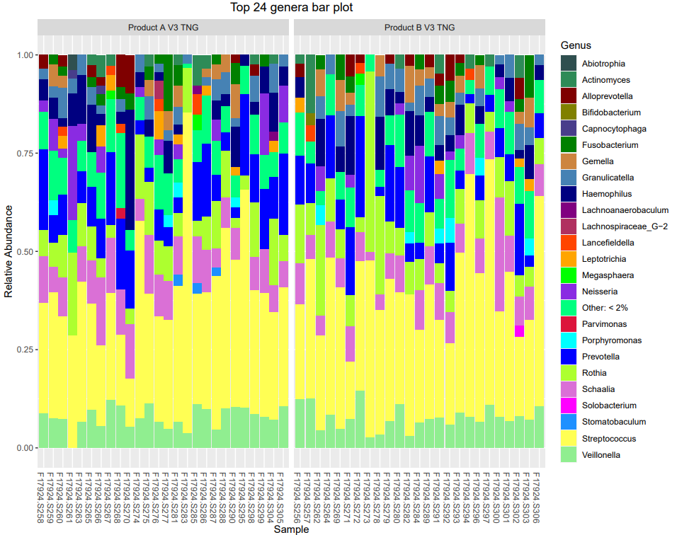

- Alpha
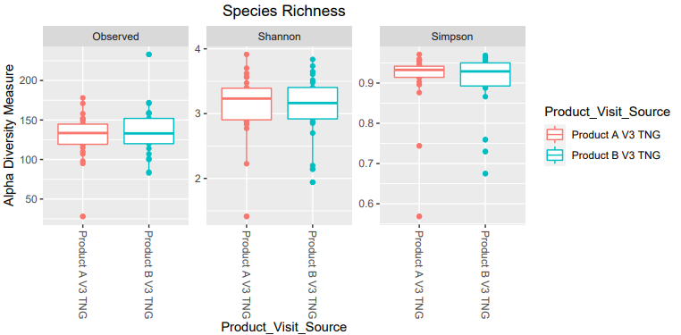
No significant differences

- Beta diversity

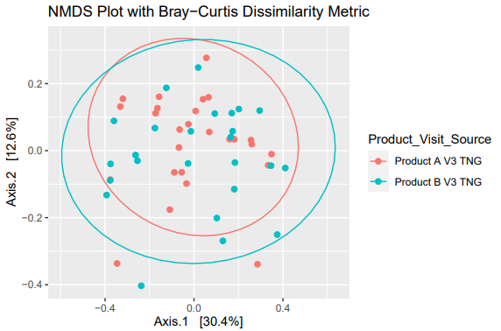

No significant differences

- Differential abundance

- Lefse

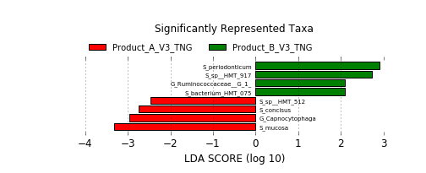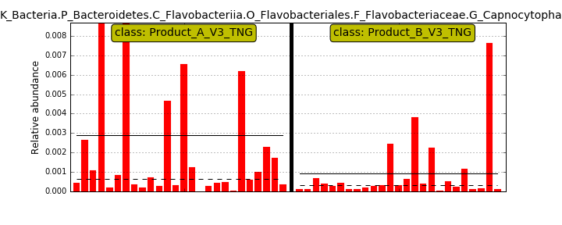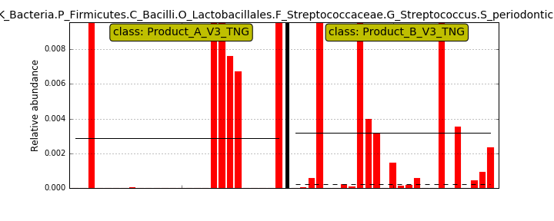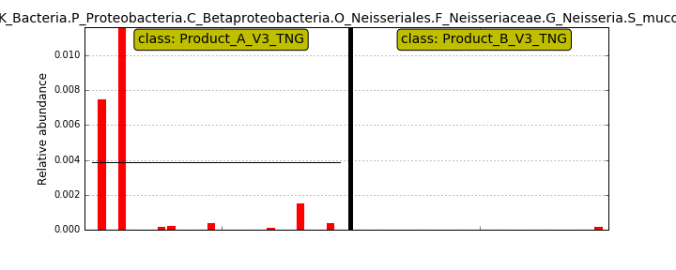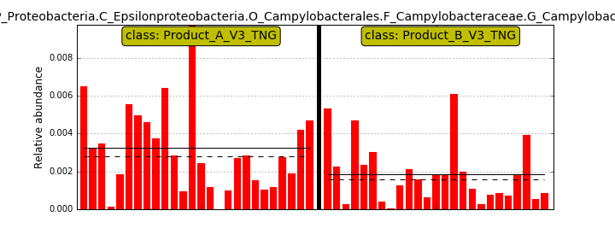

- Heat map.
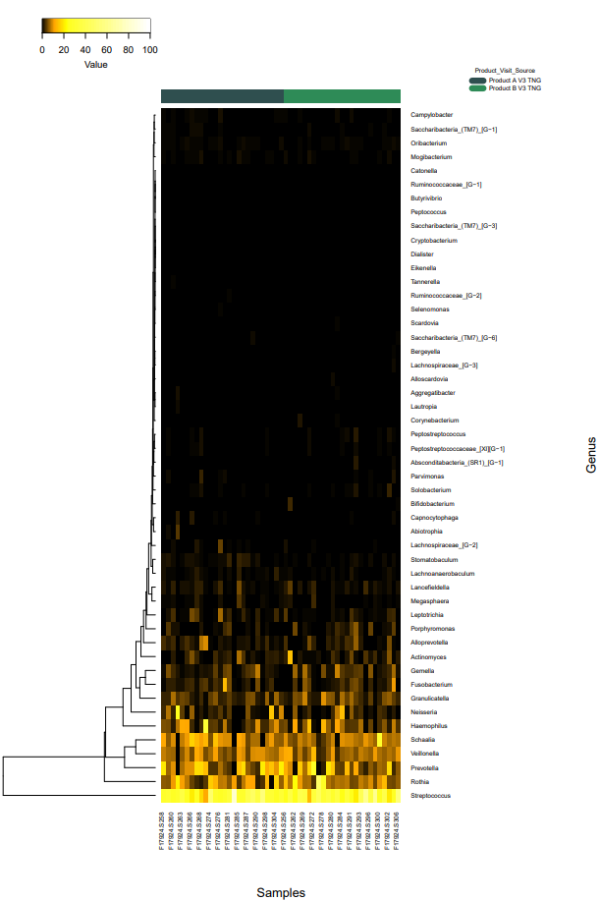
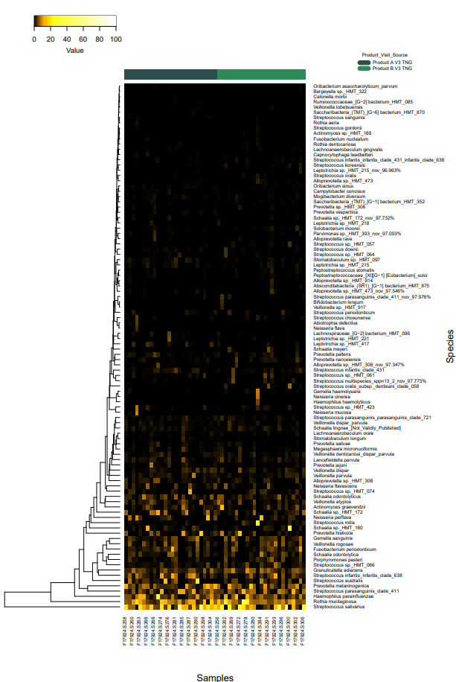

Comparison 13. Product A V2 SUPG vs Product A V3 SUPG

- Taxonomy bar graphs

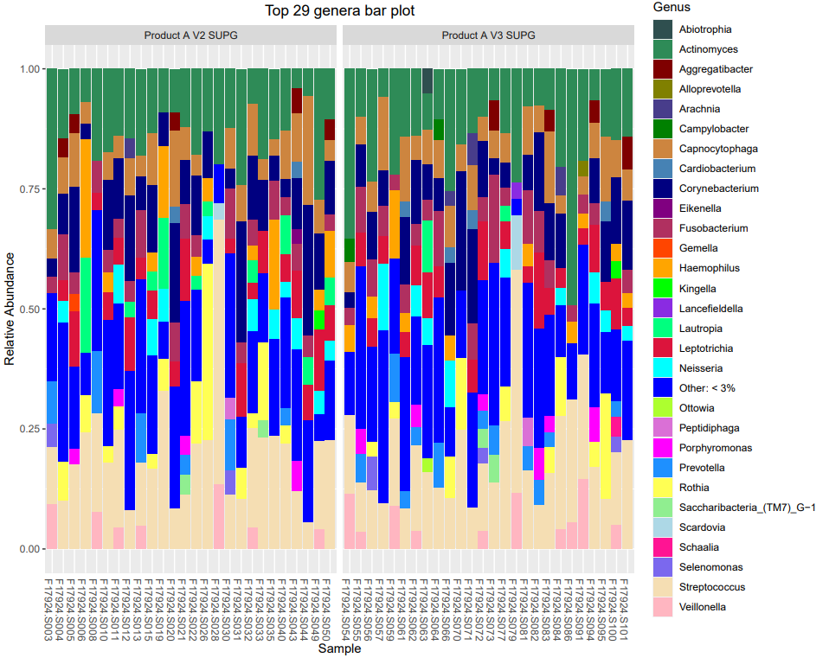
- Alpha

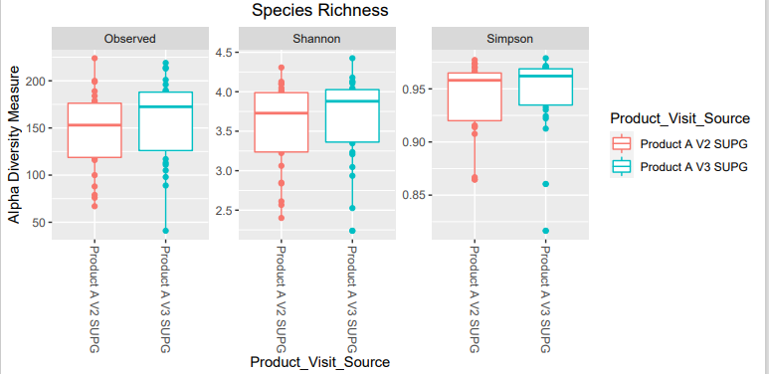
No significant differences

- Beta diversity

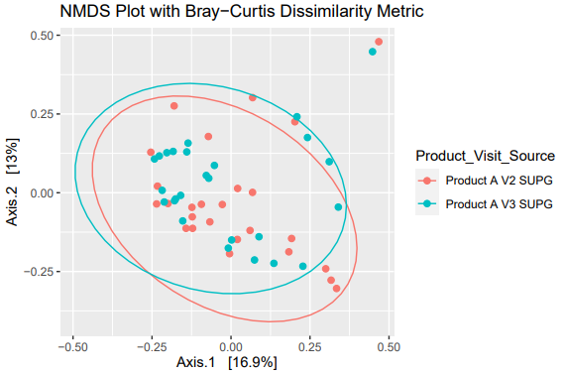
No significant differences

- Differential abundance

NO significant differences
- Lefse

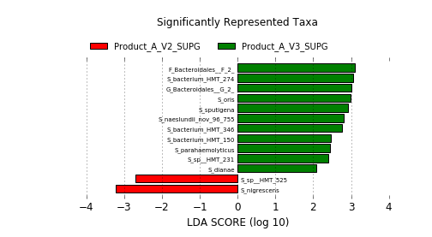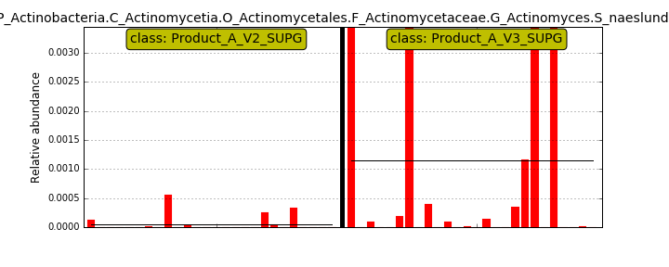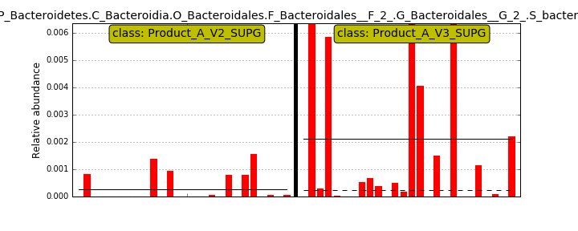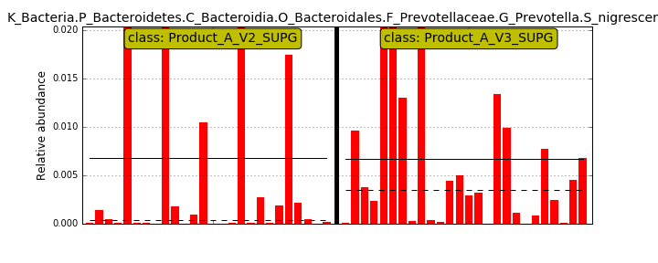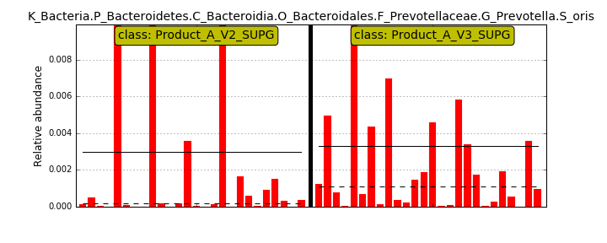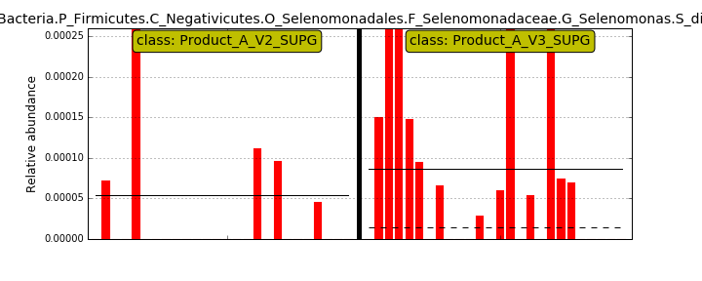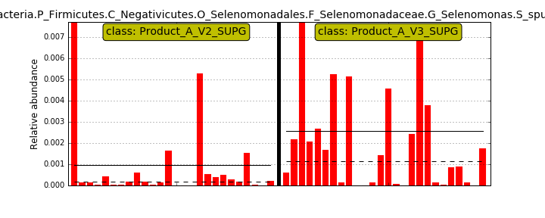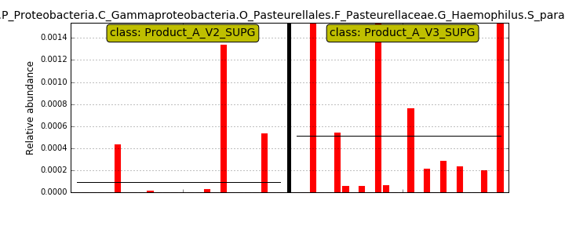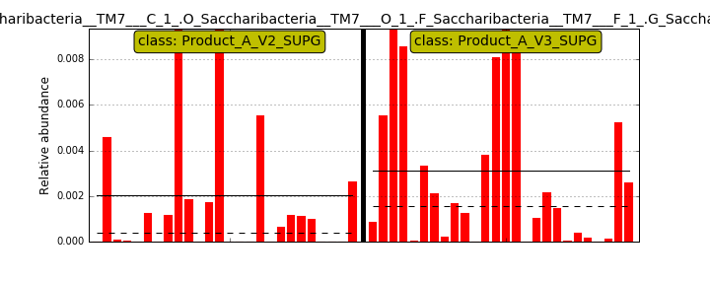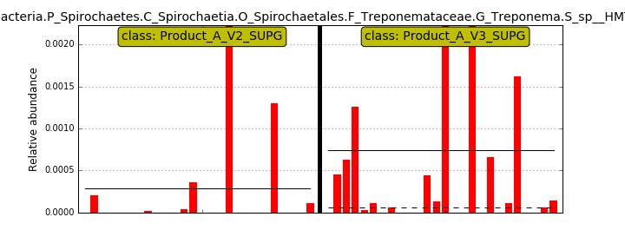
Treponema sp. HMT-231

- Heat map.
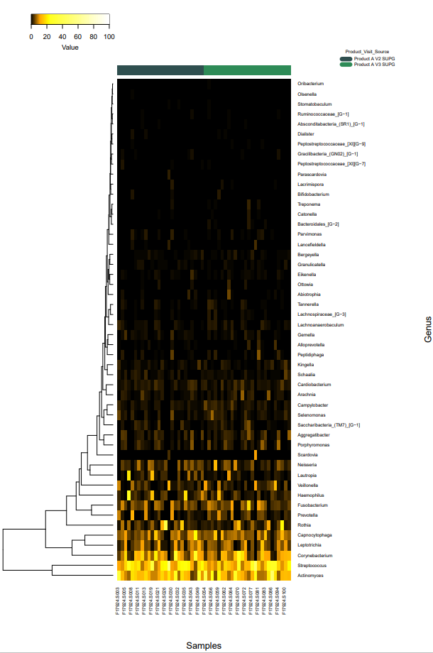
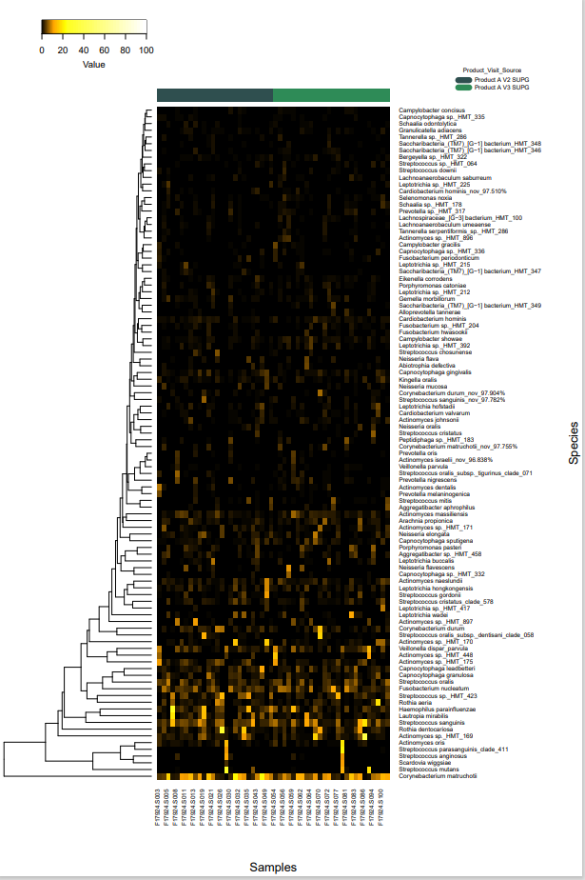

Comparison 14. Product B V2 SUPG vs Product B V3 SUPG

- Taxonomy bar graphs
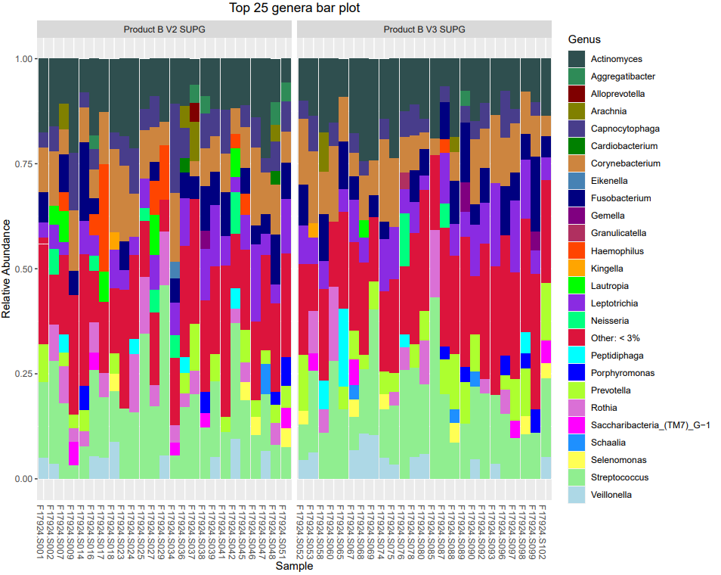
- Alpha

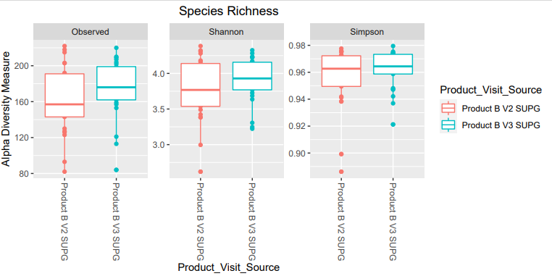
No significant differences

P value for Observed is 0.099

- Beta diversity

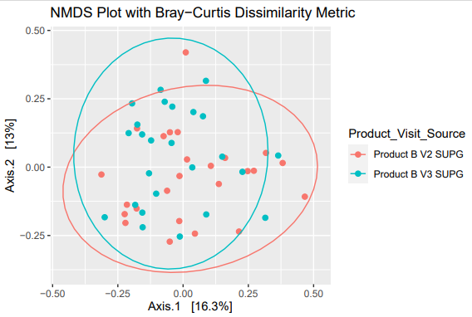

No significant differences but P = 0.09

- Differential abundance

H. influenzae is statistically different
Green, more prevalent in V3
Red, more prevalent in V2

- Lefse Many differences

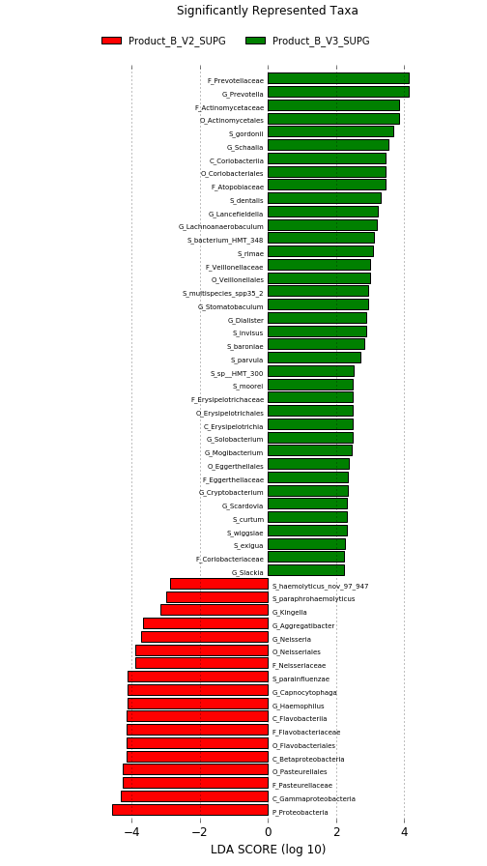

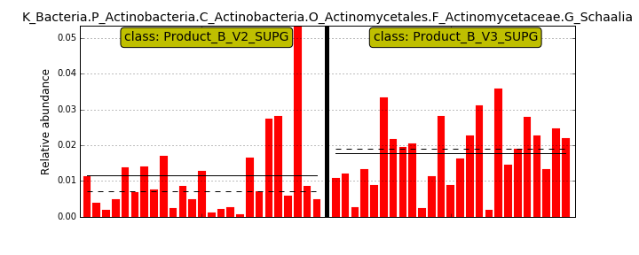
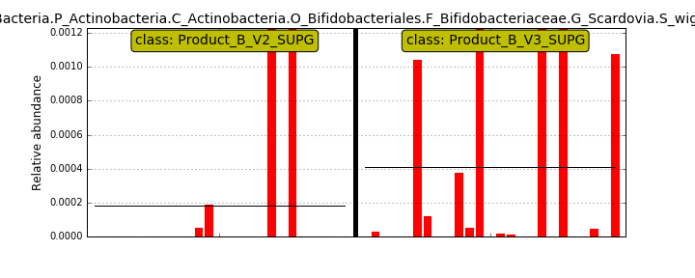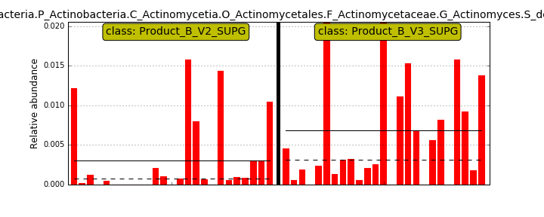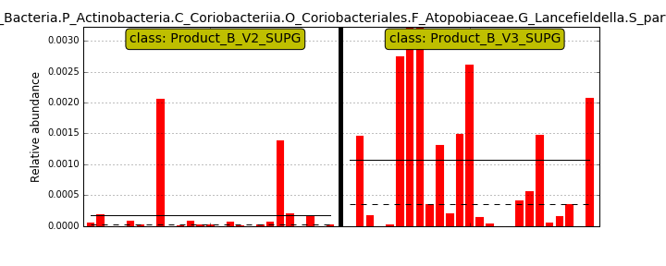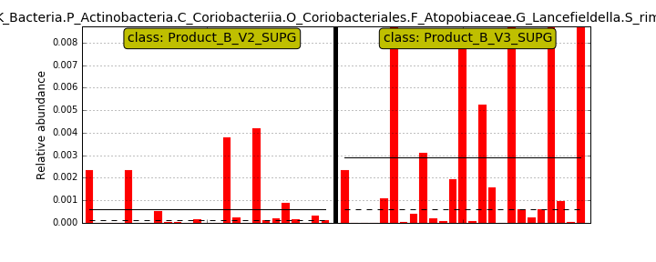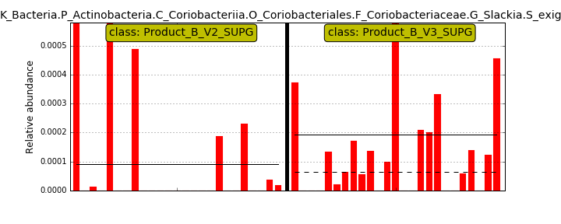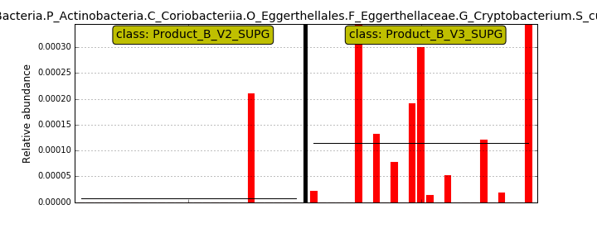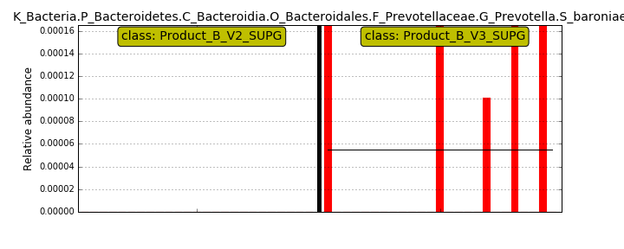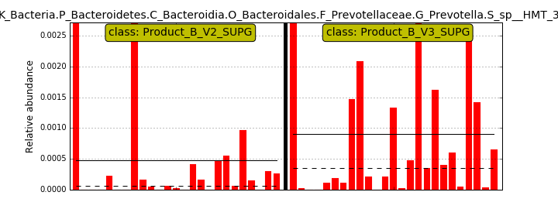HMT300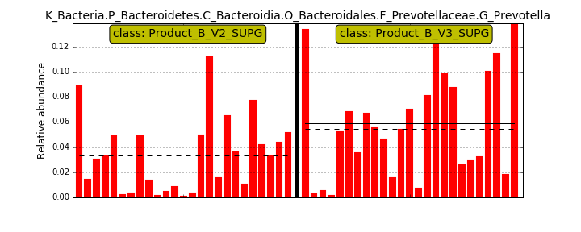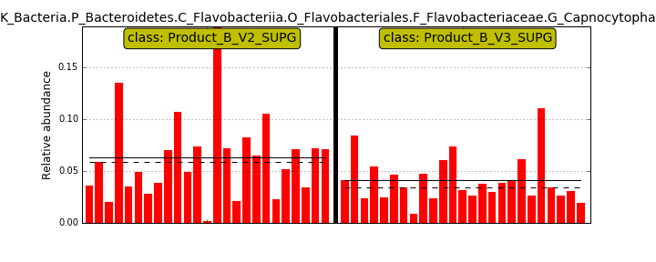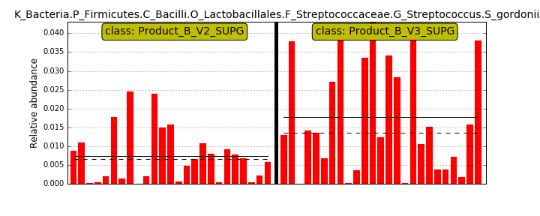#####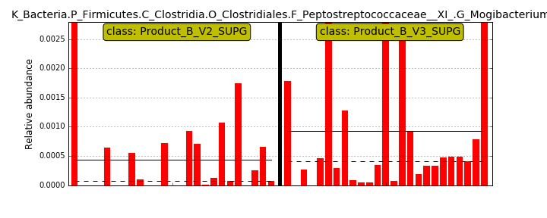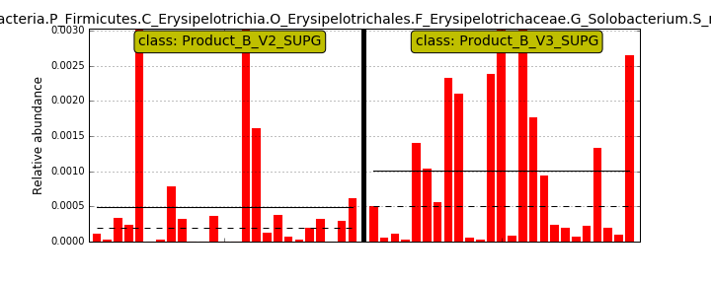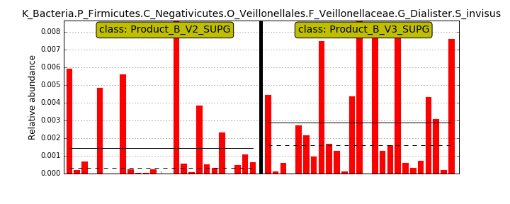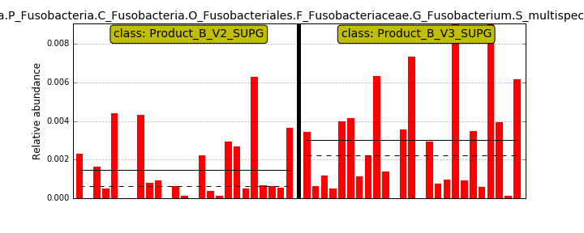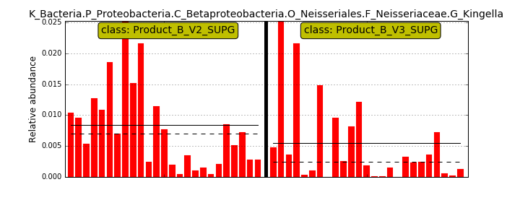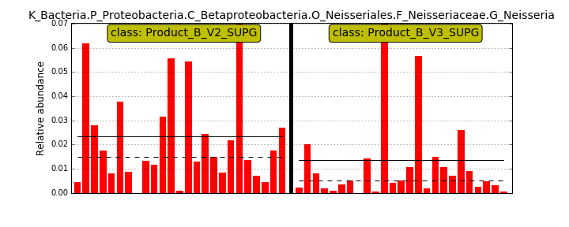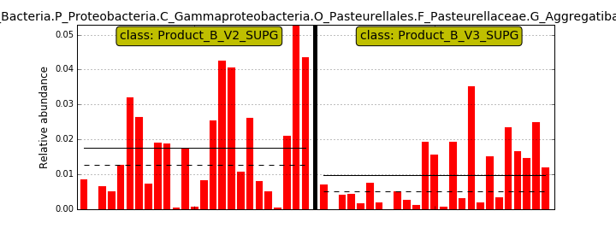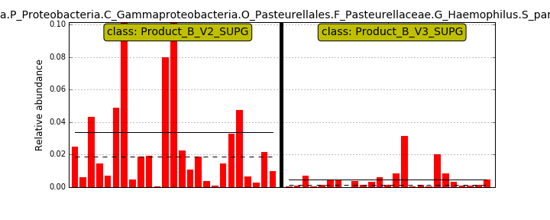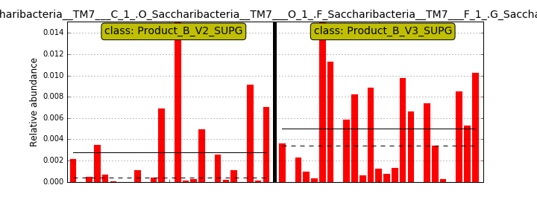

- Heat map.
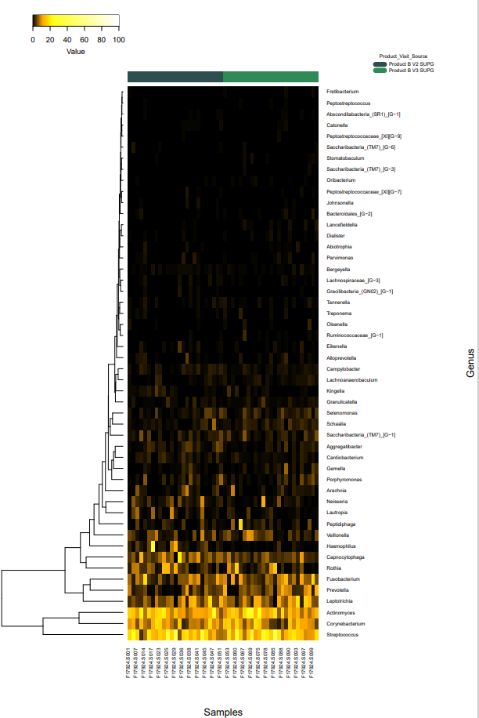
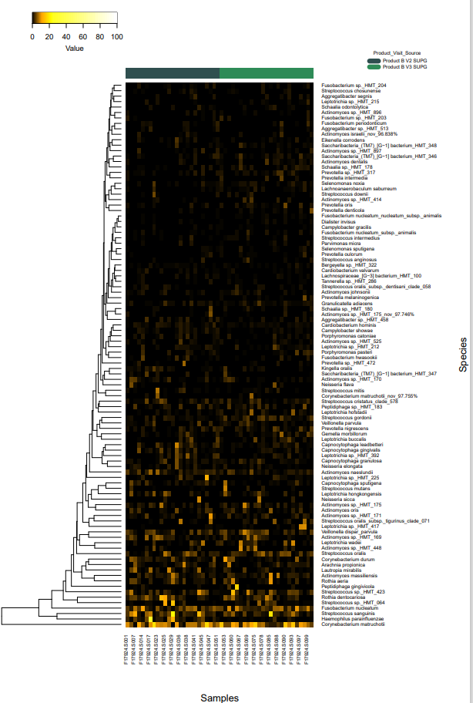

Comparison 15. Product A V2 SUPG vs Product B V2 SUPG

- Taxonomy bar graphs

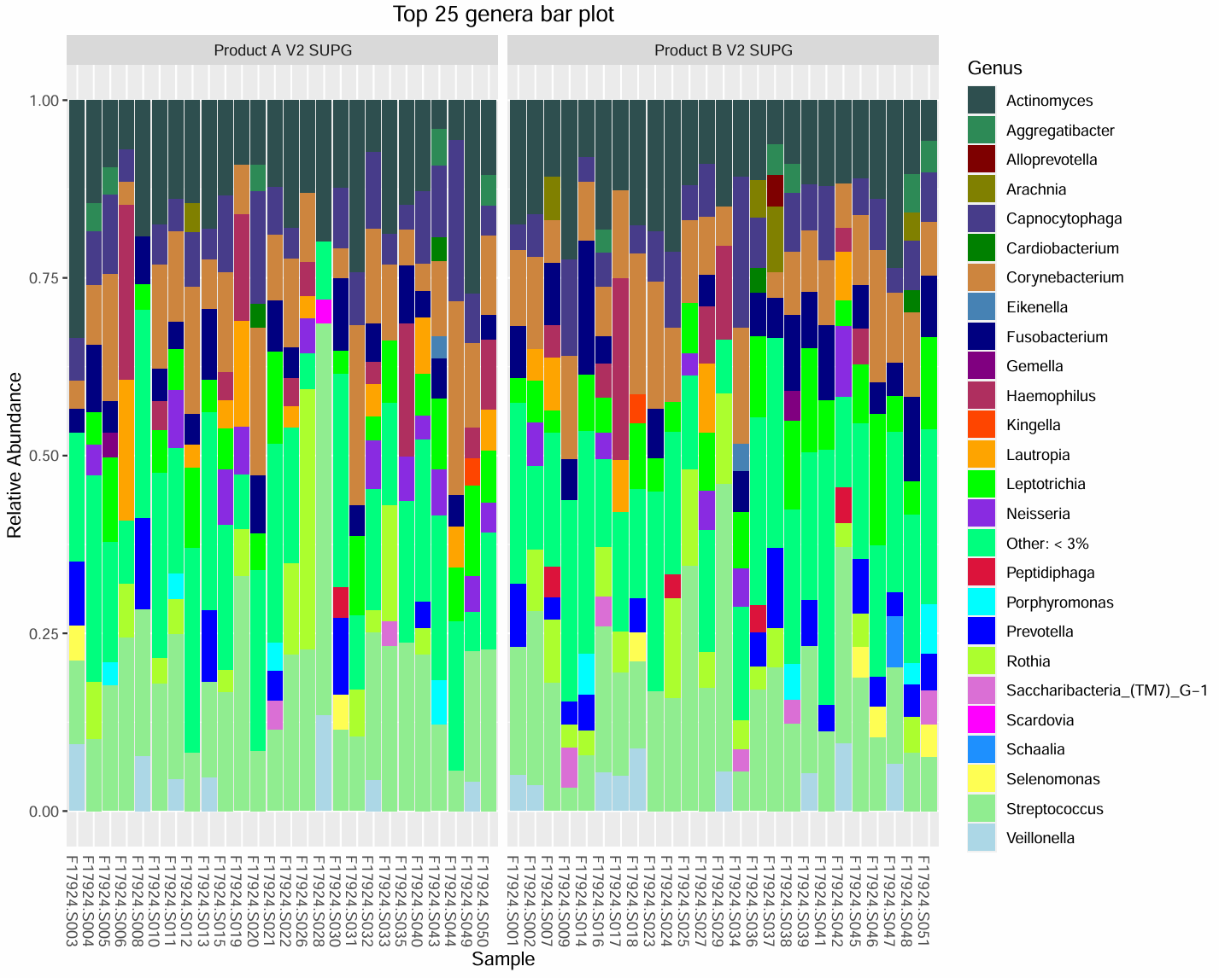

- Alpha
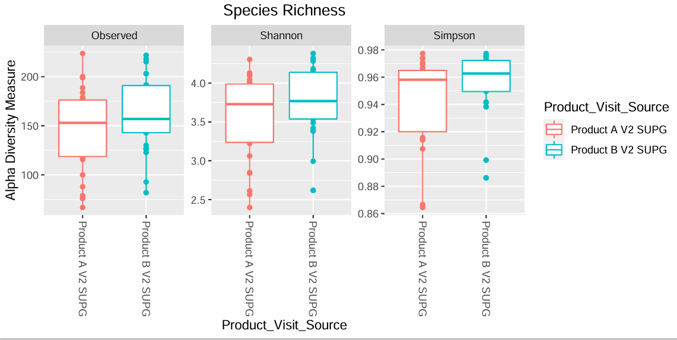
No significant differences

- Beta diversity

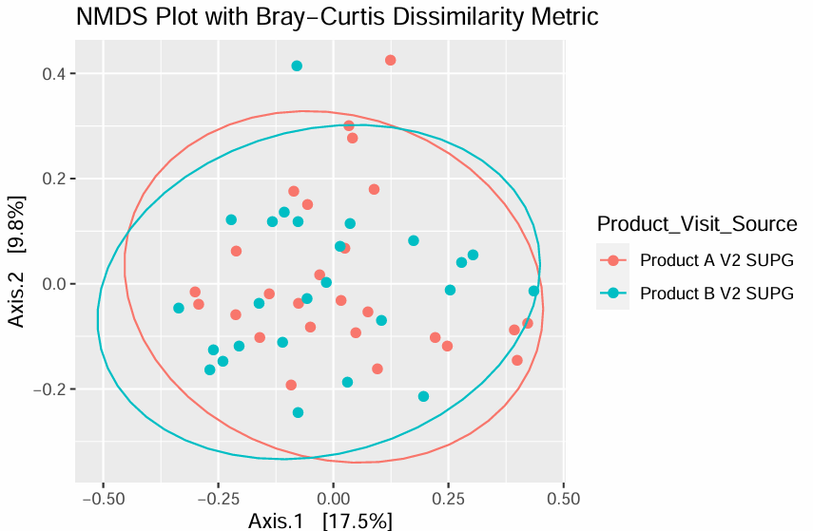

No significant differences

- Differential abundance

Red, more prevalent in A
Green, more prevalent in B

No statistical significance, lost after multiple comparisons.

- Lefse
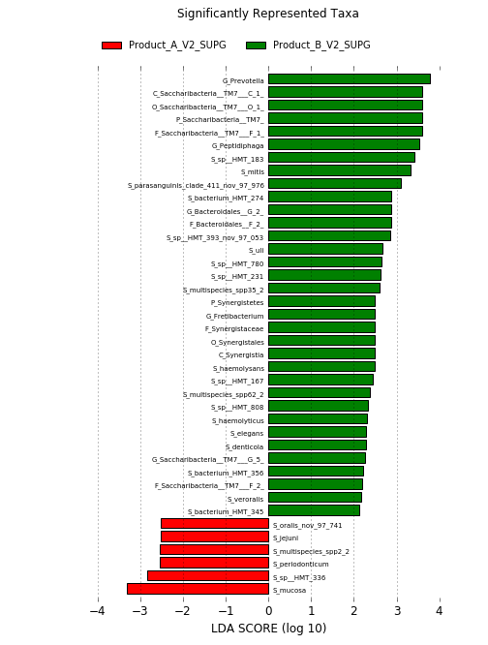
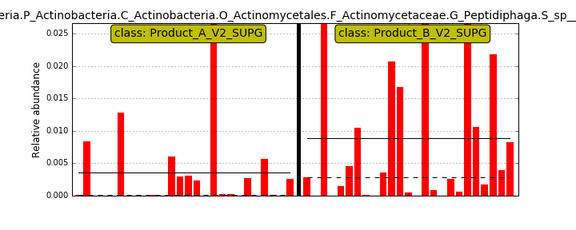HMT183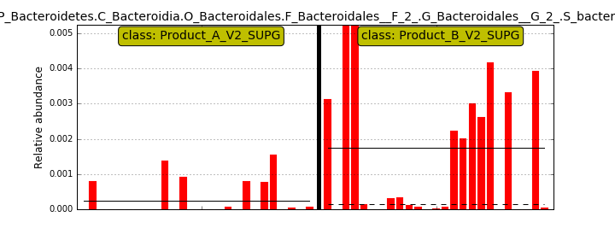HMT274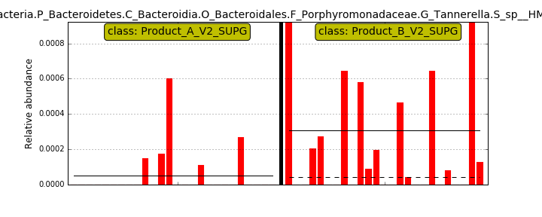HMT808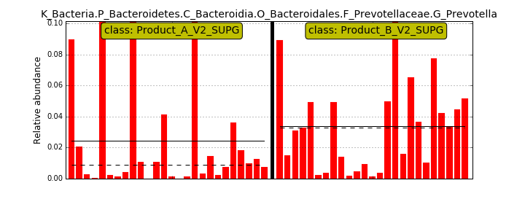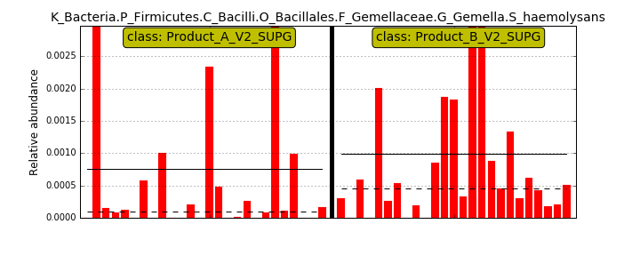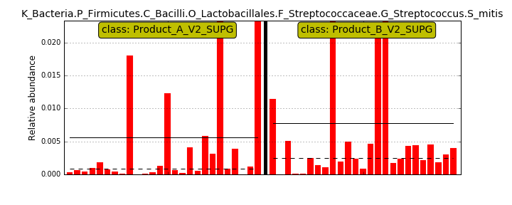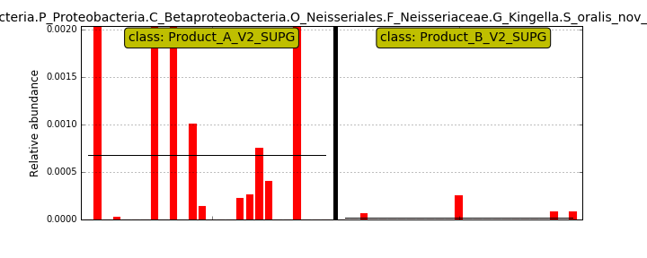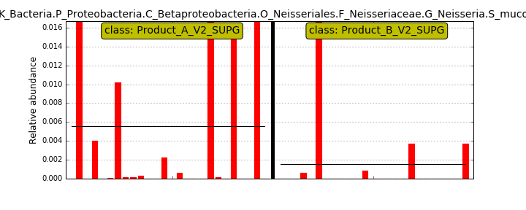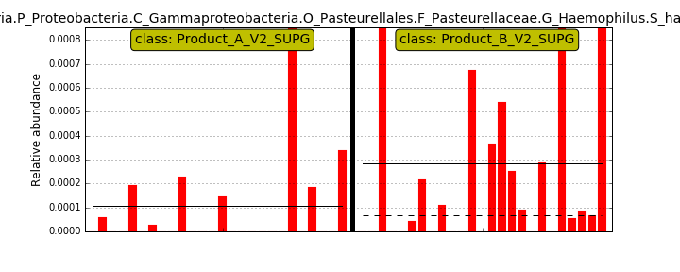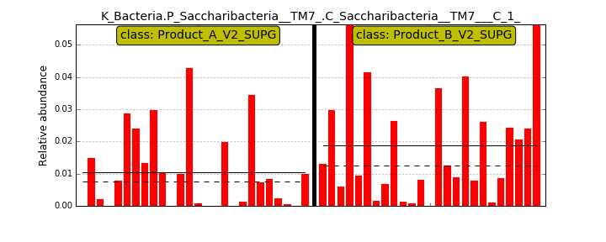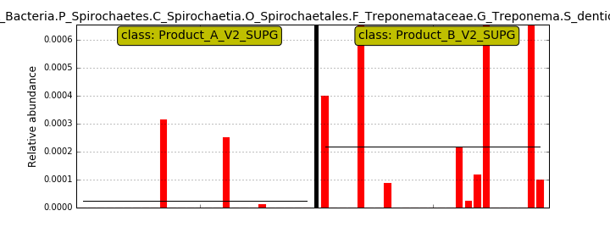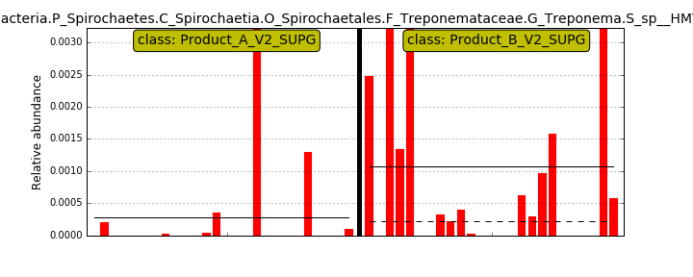HMT231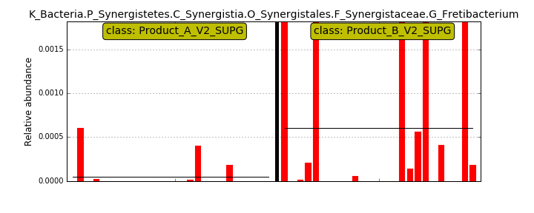

- Heat map.
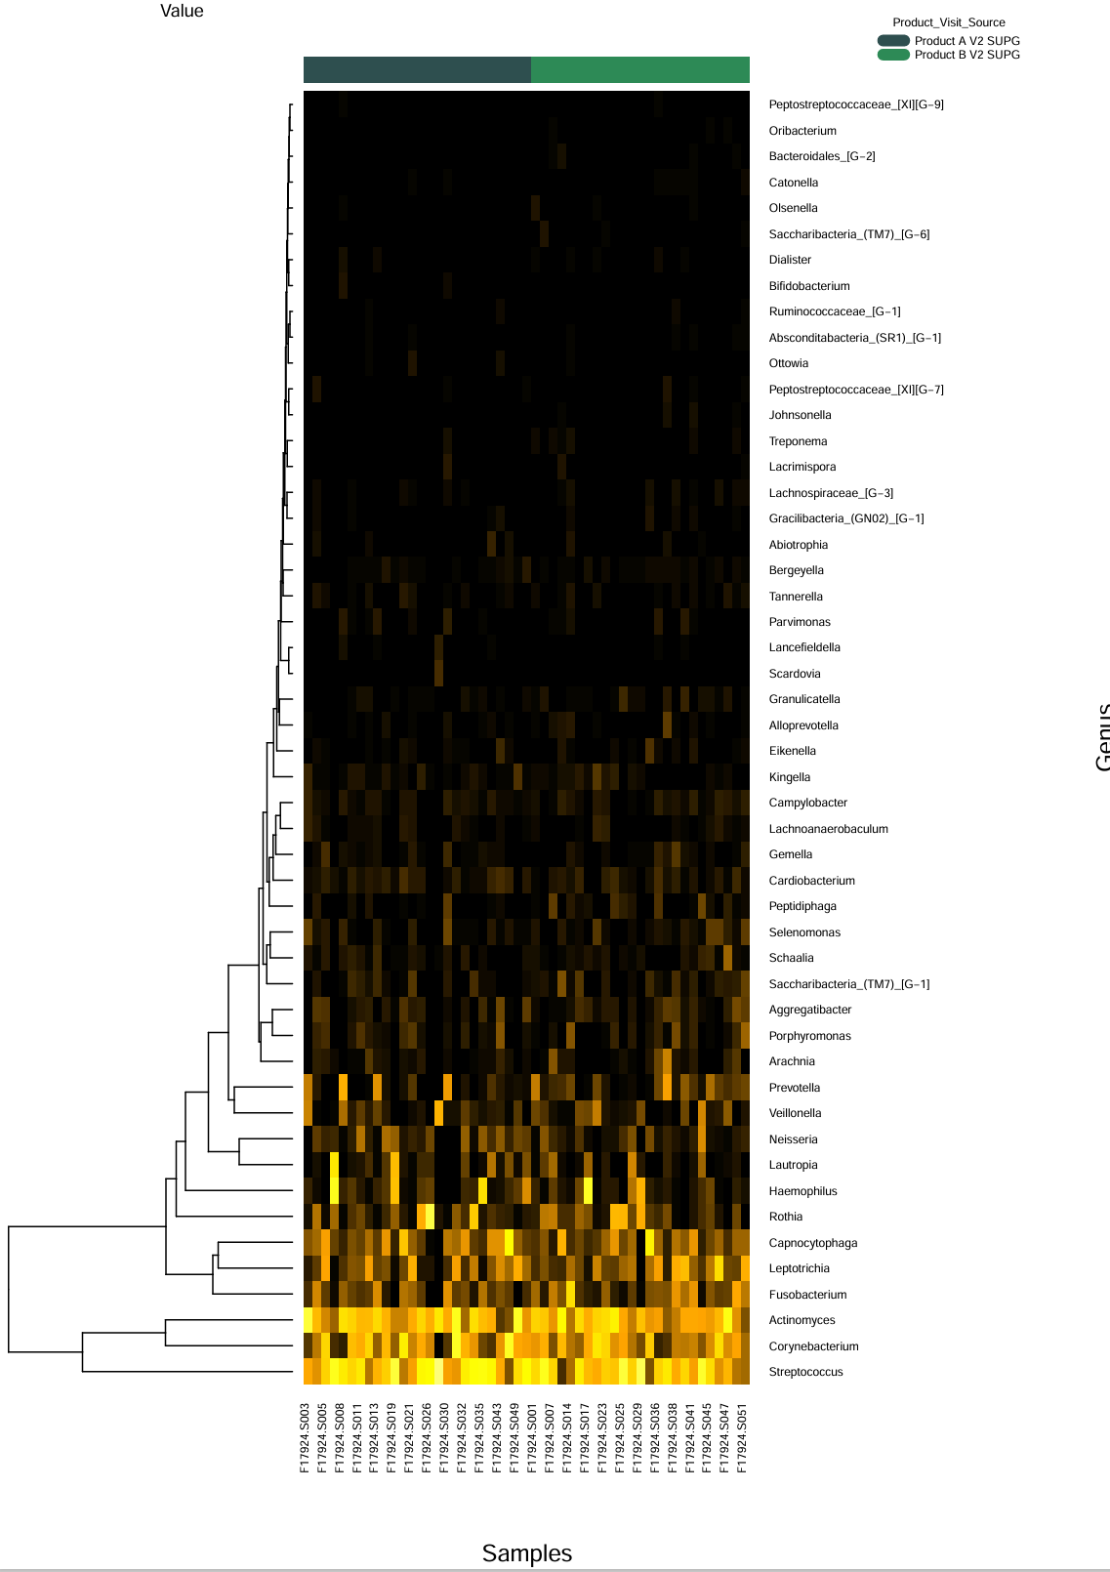
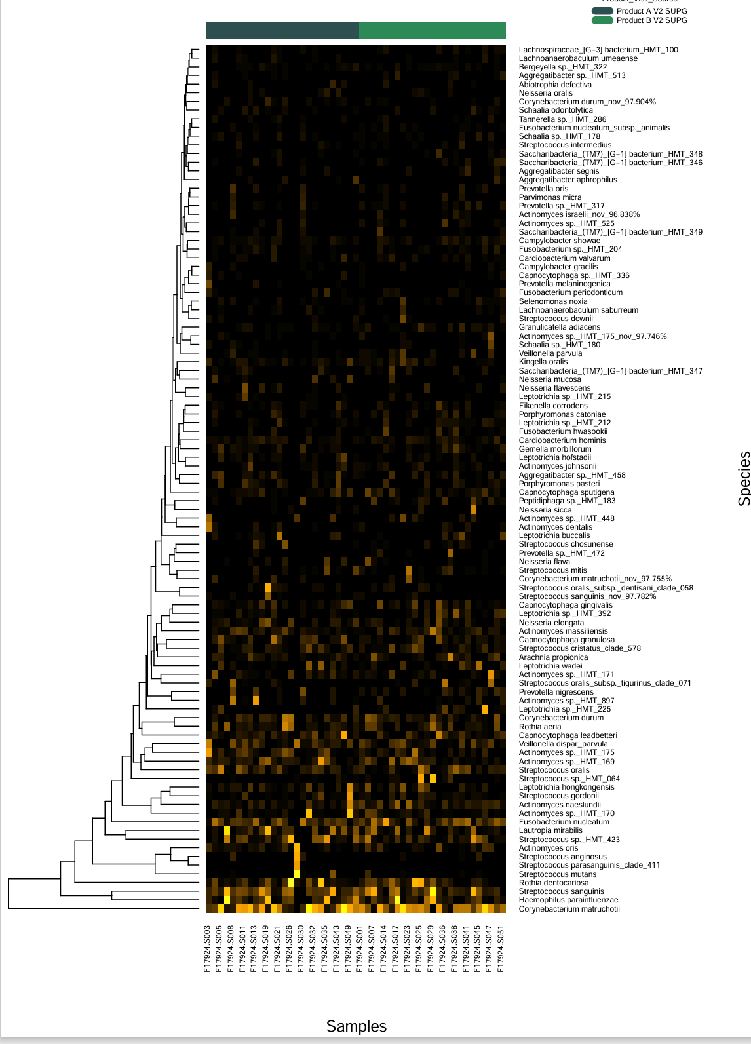

Comparison 16. Product A V3 SUPG vs Product B V3 SUPG

- Taxonomy bar graphs
- 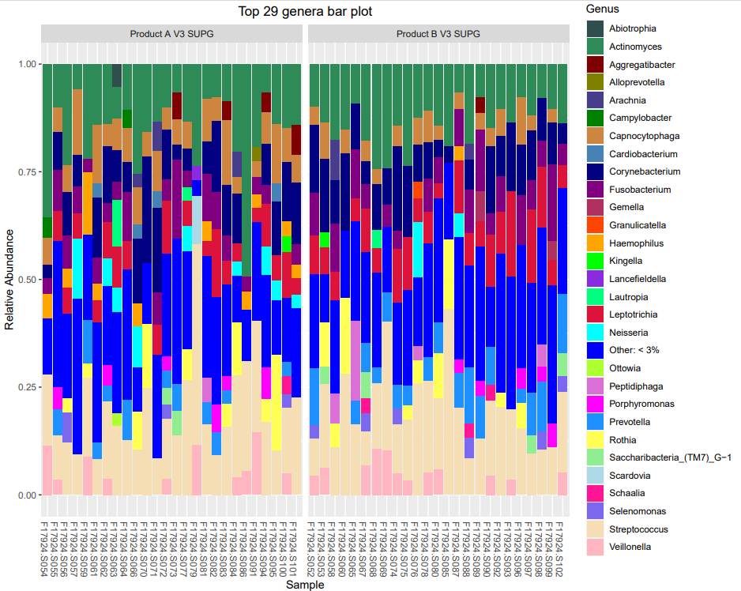

- Alpha
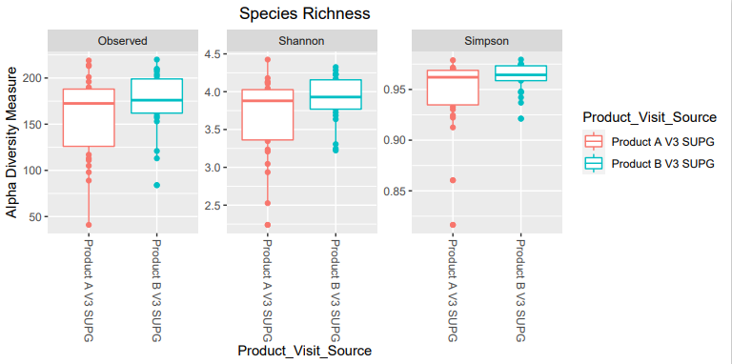
No significant differences

- Beta diversity

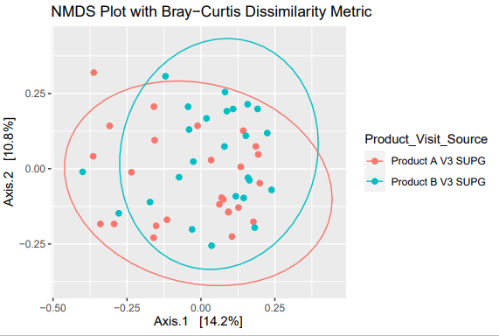

significant difference

- Differential abundance

Red, more prevalent in A
Green, more prevalent in B

- Lefse
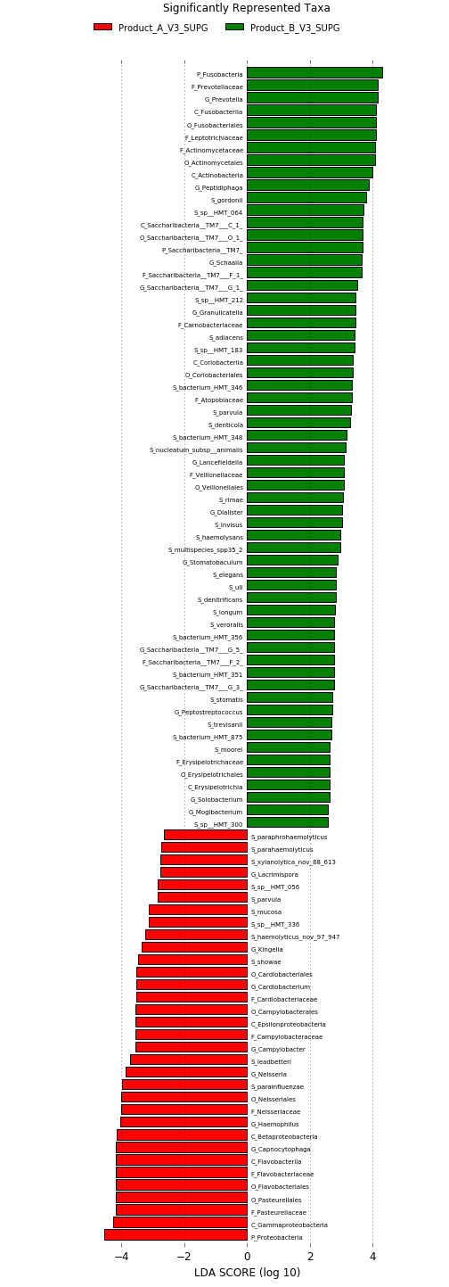

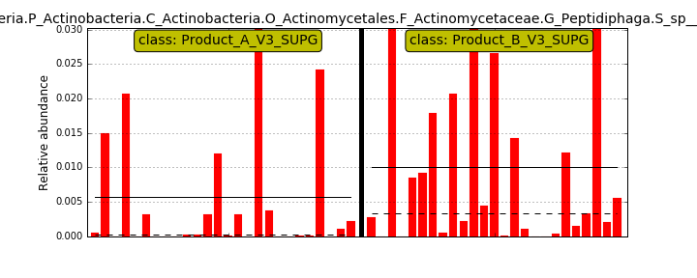HMT183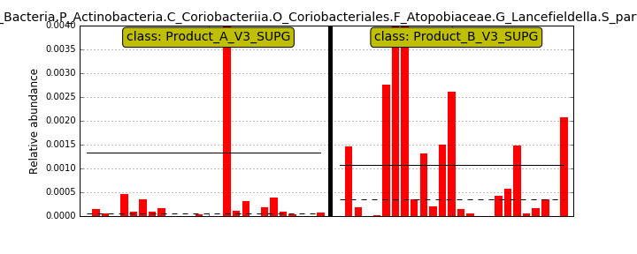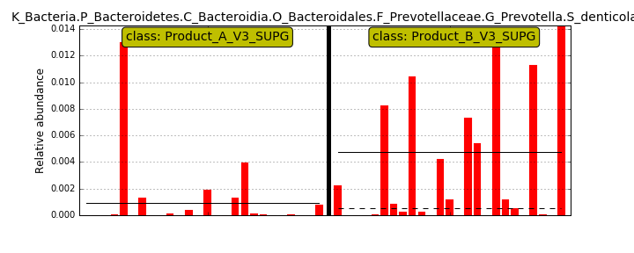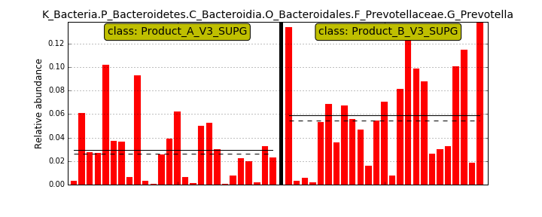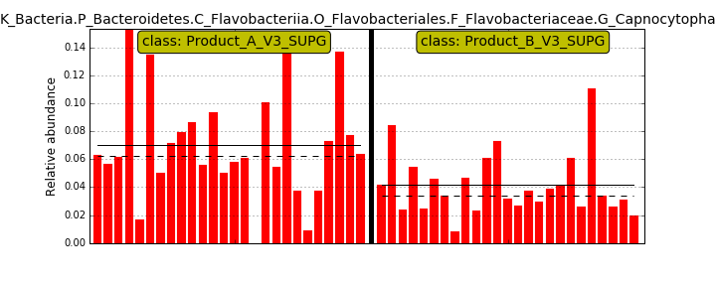High levels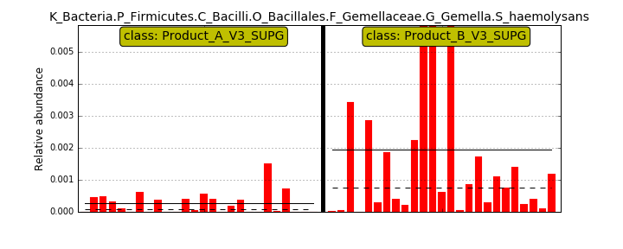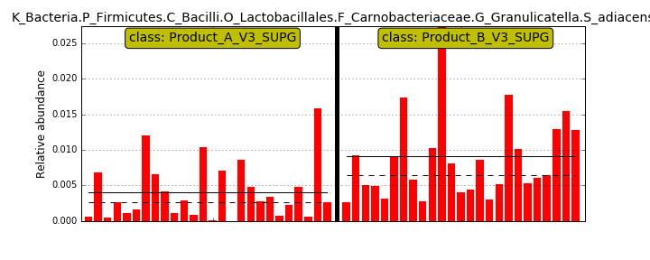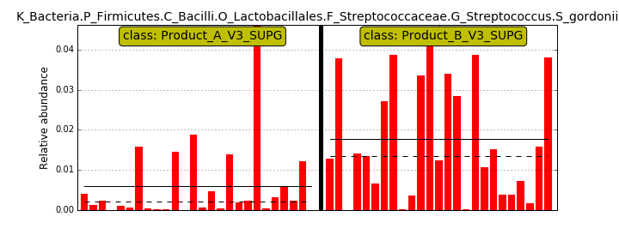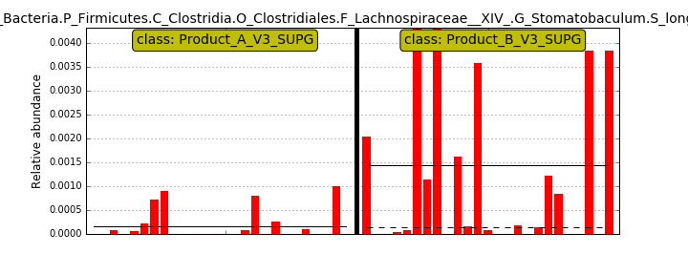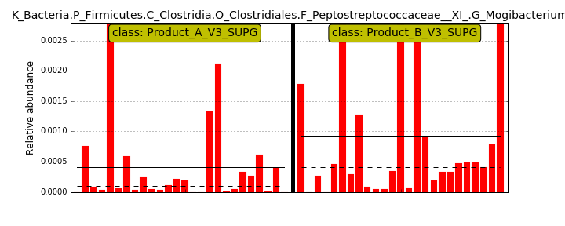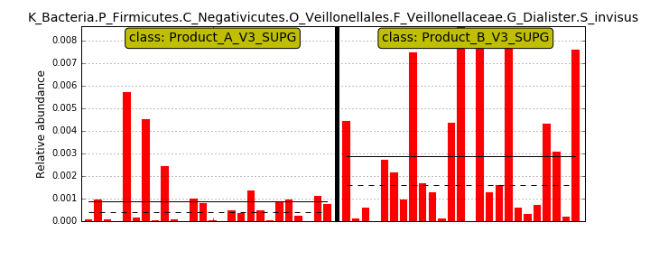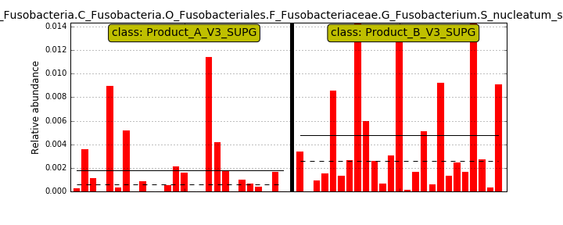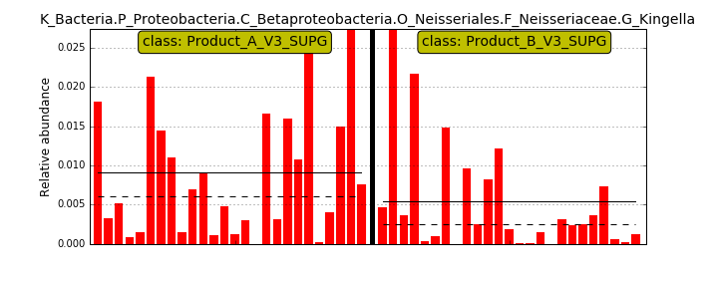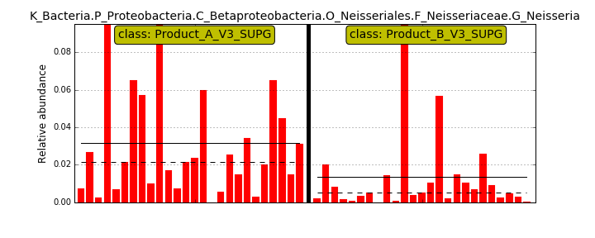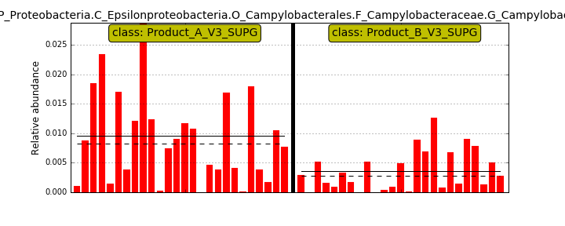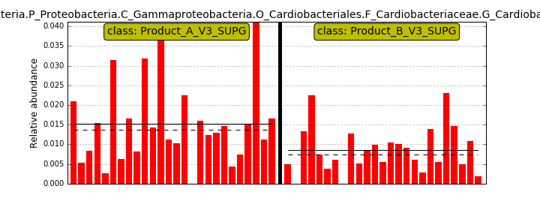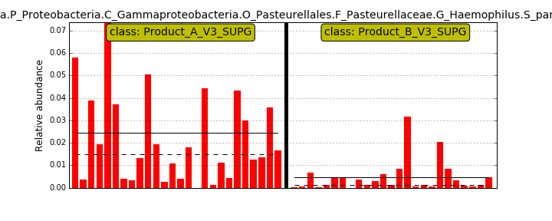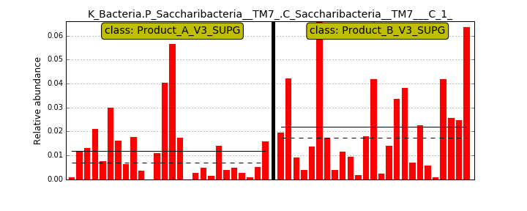
- Heat map.
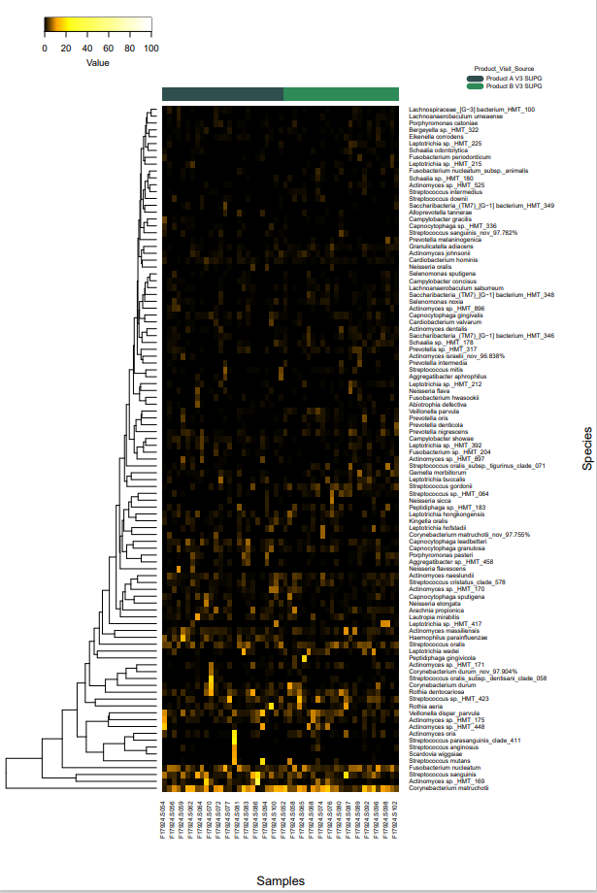

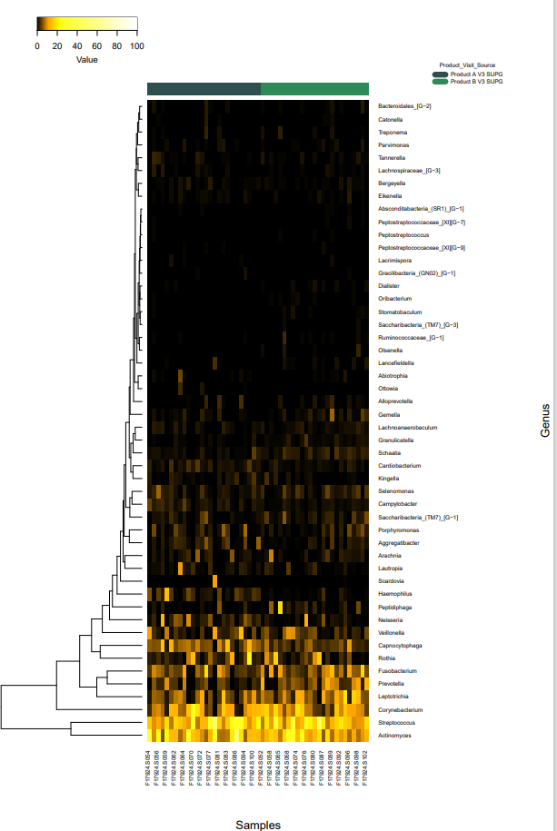

Comparison 17. Product A V2 SUBG vs Product A V3 SUBG

- Taxonomy bar graphs
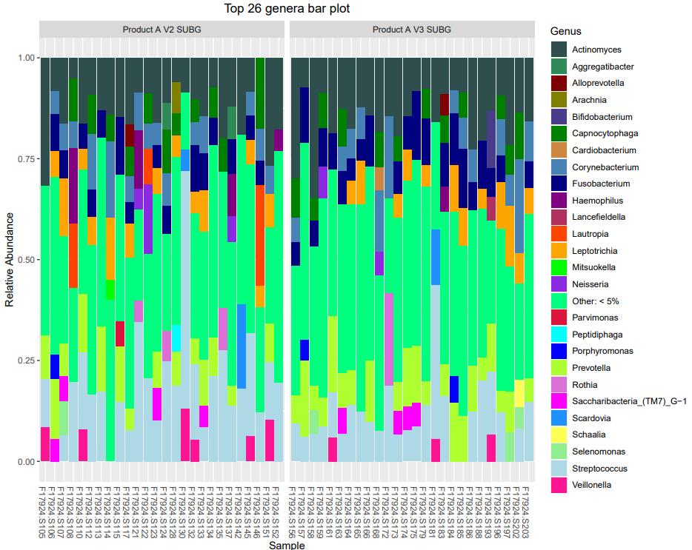

- Alpha
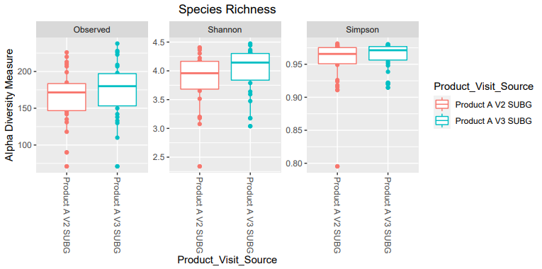
No significant differences

- Beta diversity

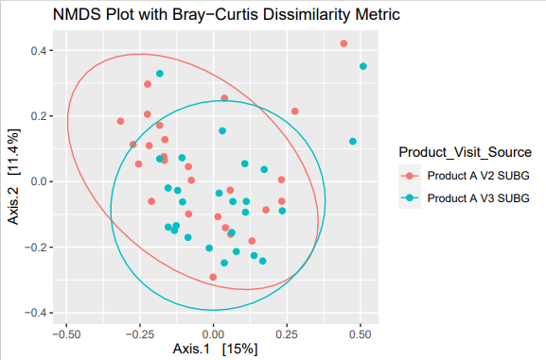

No significant differences

- Differential abundance

Green, more prevalent in V3
Red more prevalent in V2

Not much difference of baseline as compared to visit 3. No statistical difference.

- Lefse
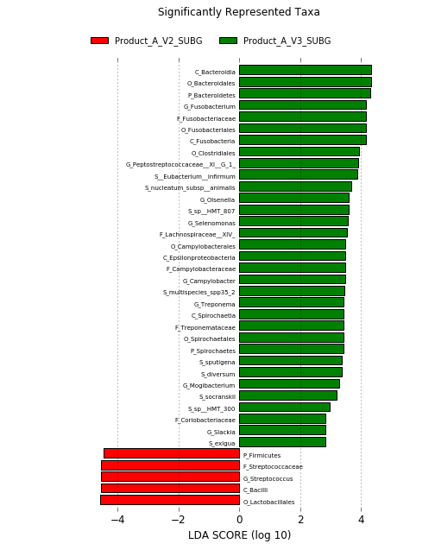

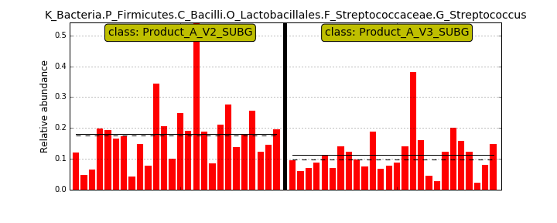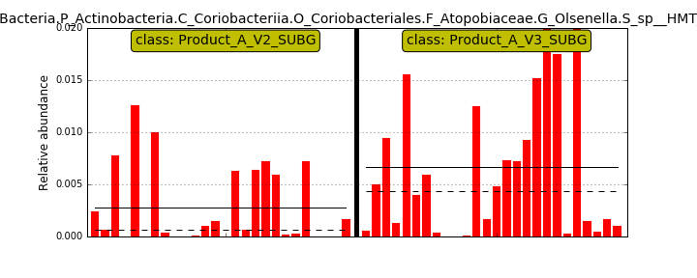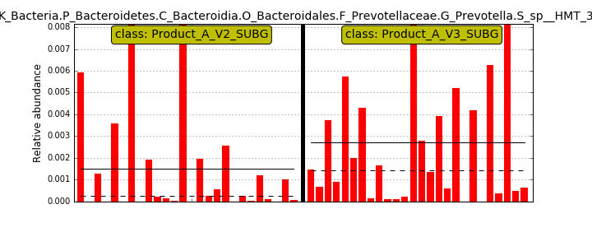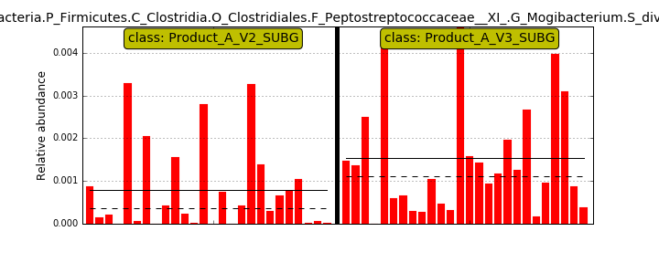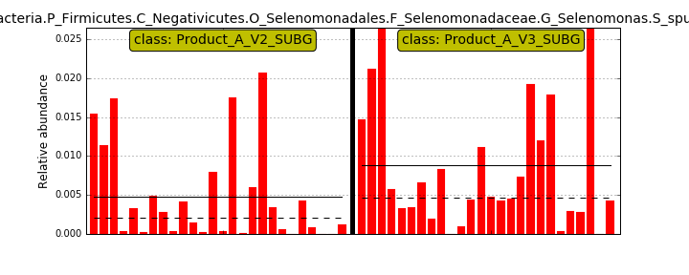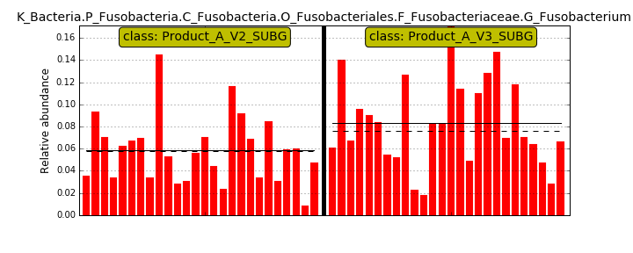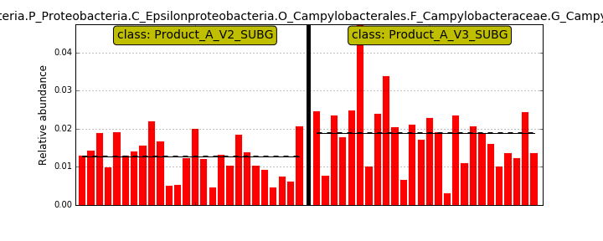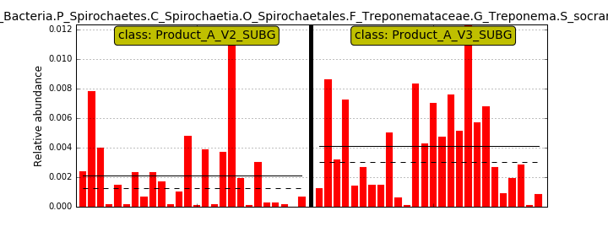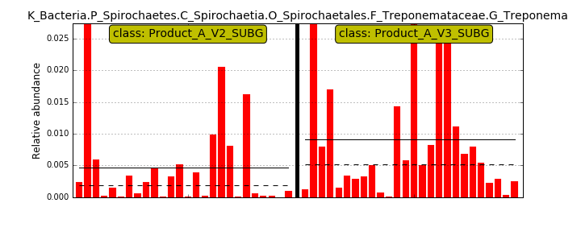

- Heat map.

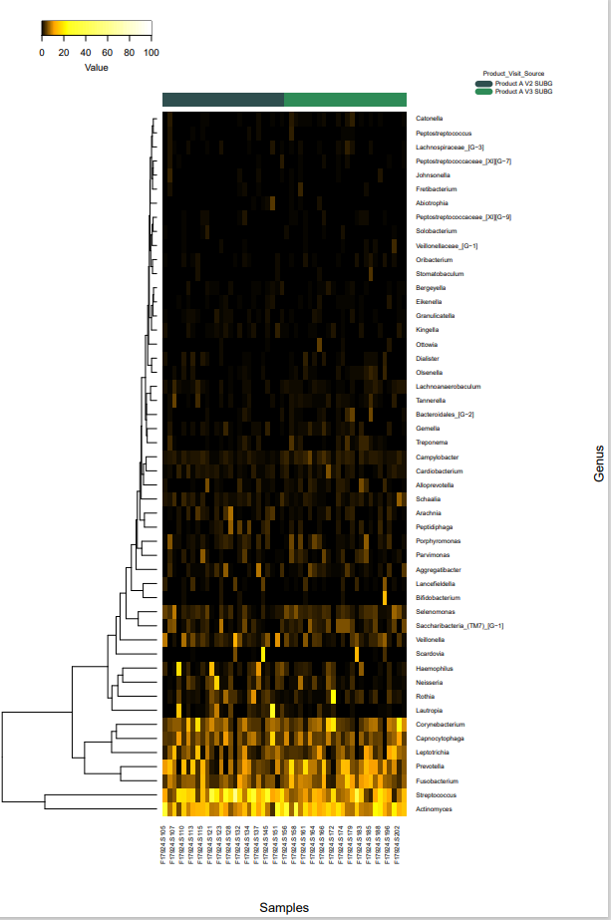
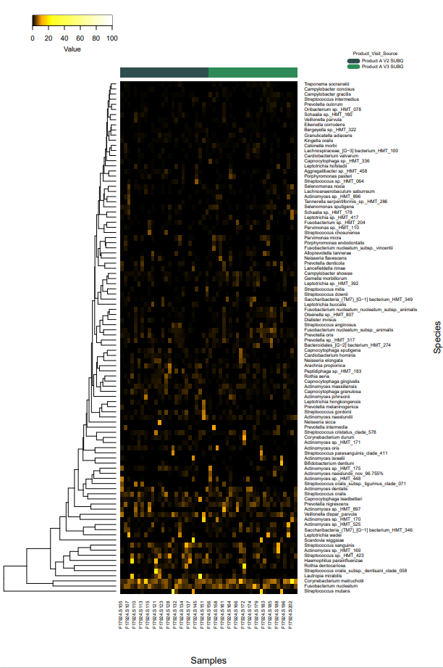

Comparison 18. Product B V2 SUBG vs Product B V3 SUBG

- Taxonomy bar graphs

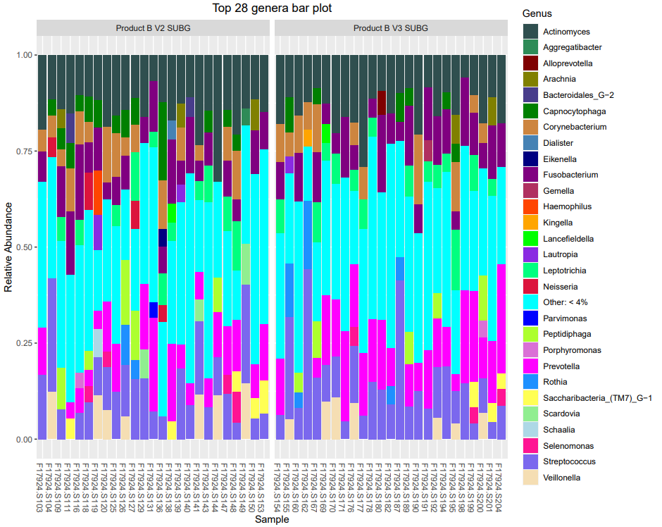

- Alpha

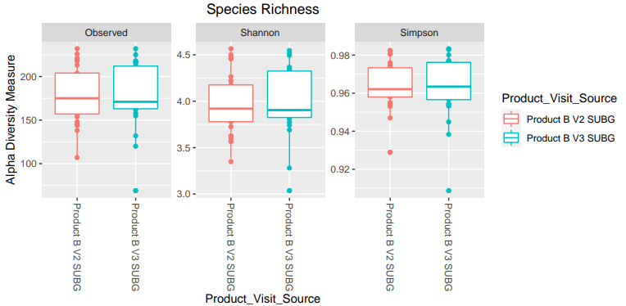
No significant differences

- Beta diversity

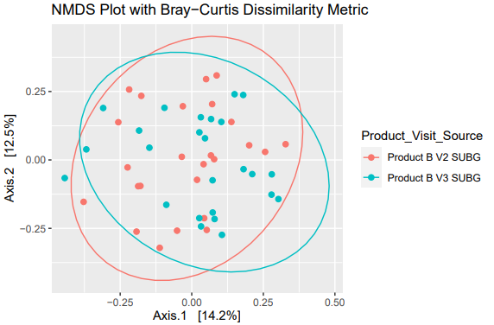

No significant differences

- Differential abundance

Red, more prevalent in baseline (V2)
Green, more prevalent in visit 3, after treatment.

- Lefse
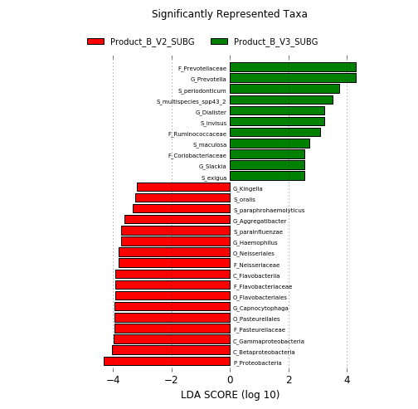

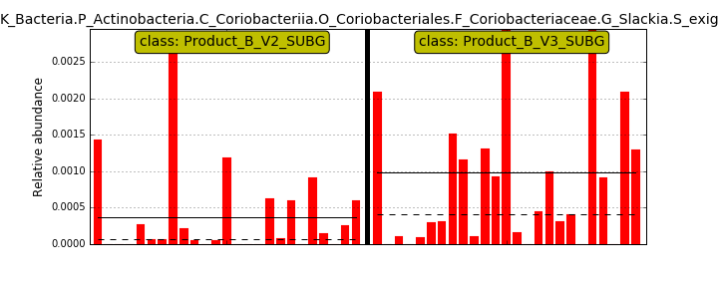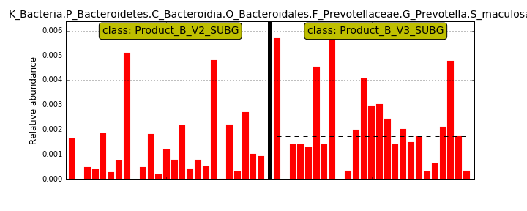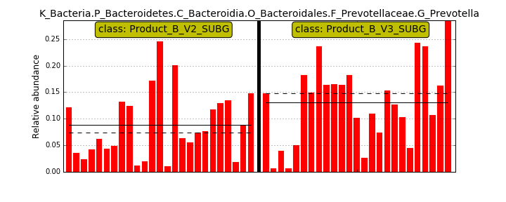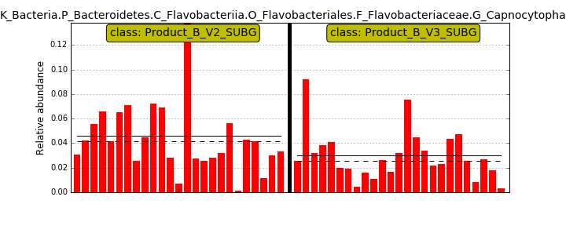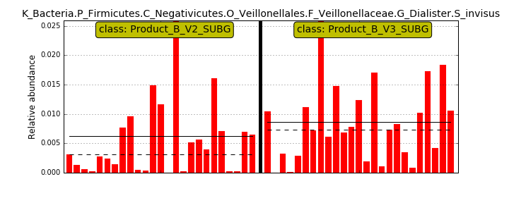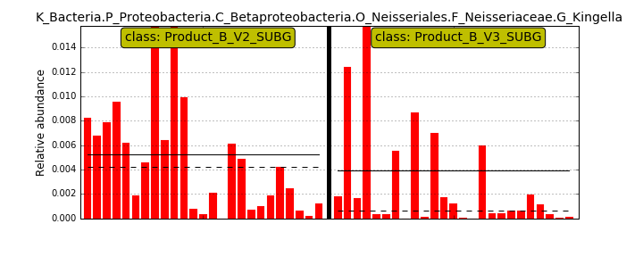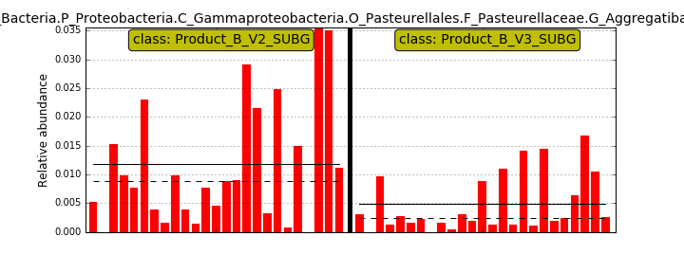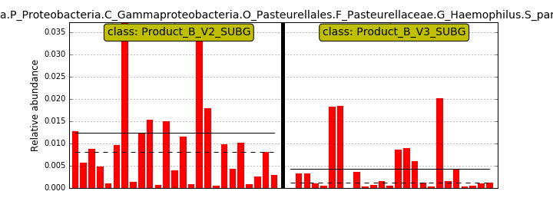

- Heat map.

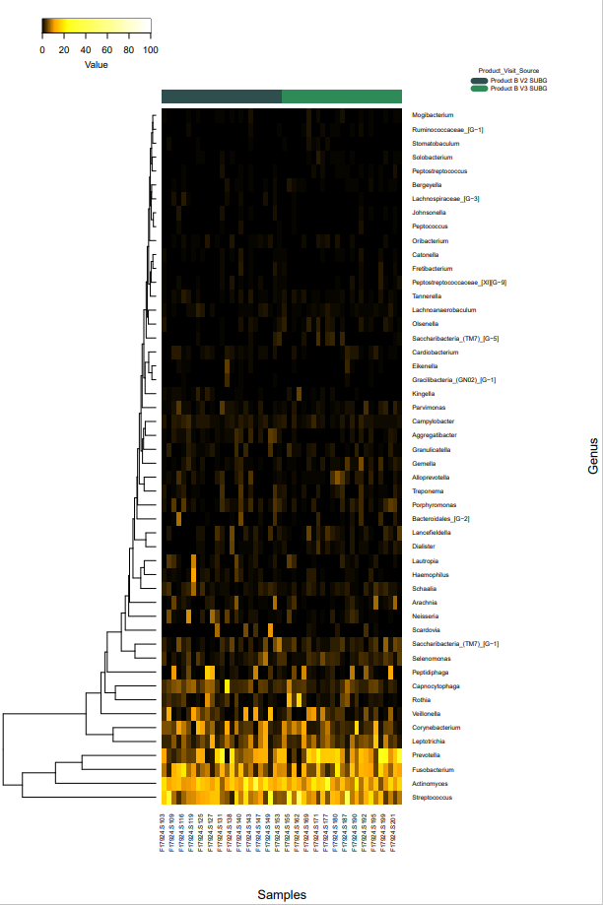

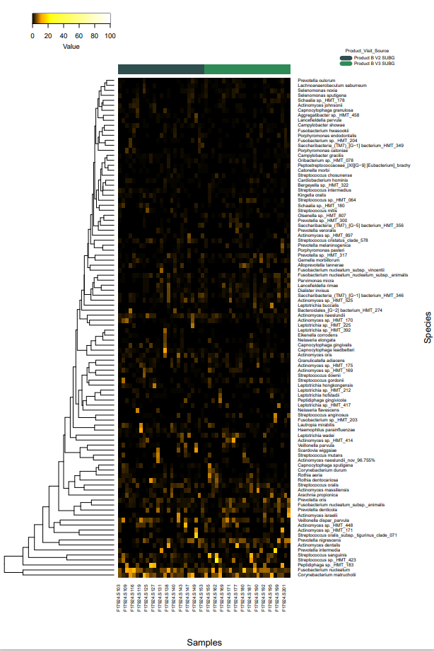

Comparison 19. Product A V2 SUBG vs Product B V2 SUBG

- Taxonomy bar graphs
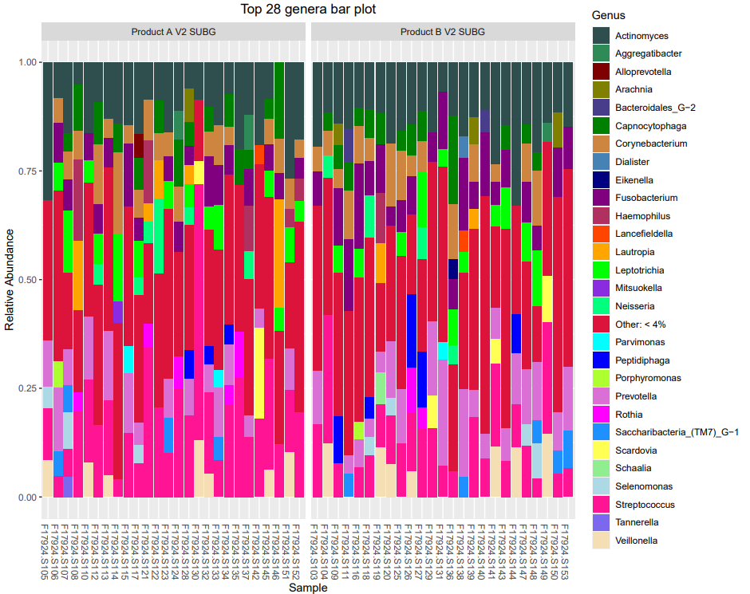

- Alpha
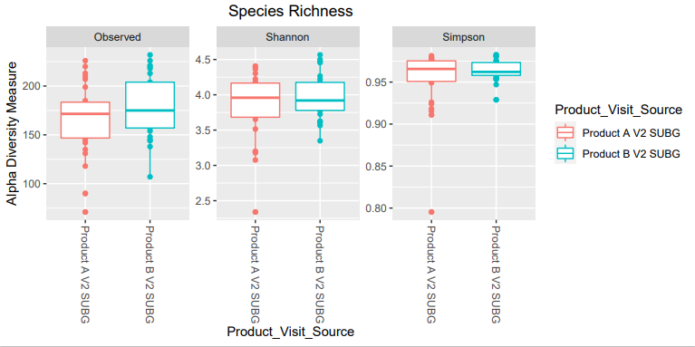
No significant differences

- Beta diversity

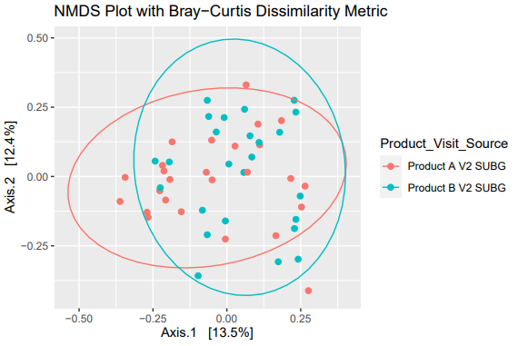

No significant differences

- Differential abundance

Red more prevalent in A
Green, more prevalent in B

- Lefse

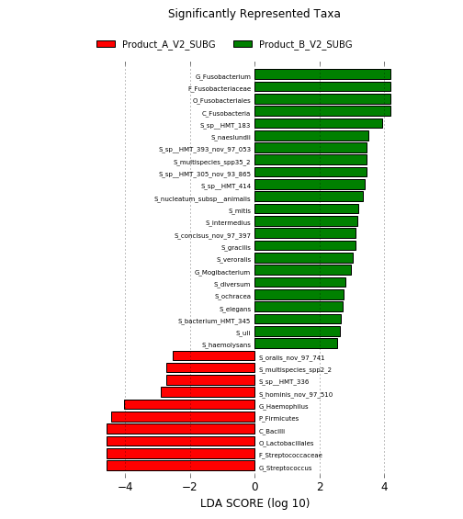
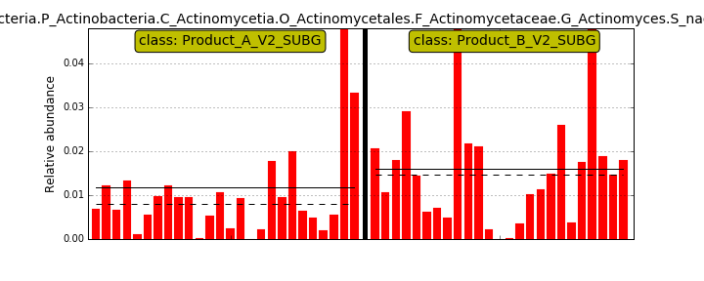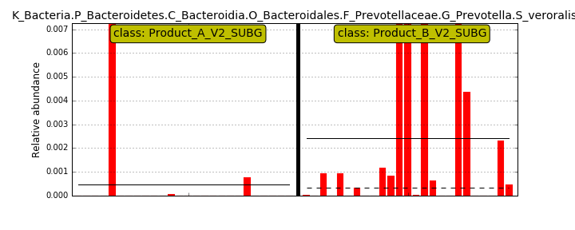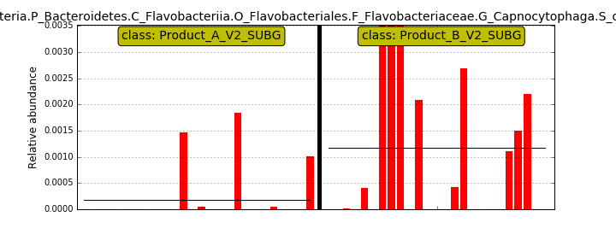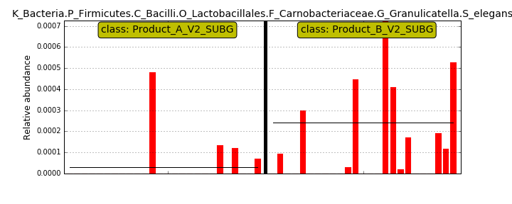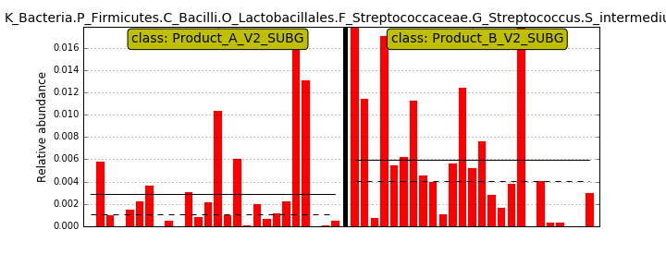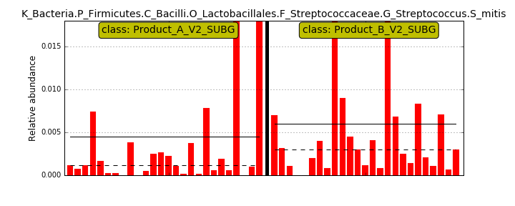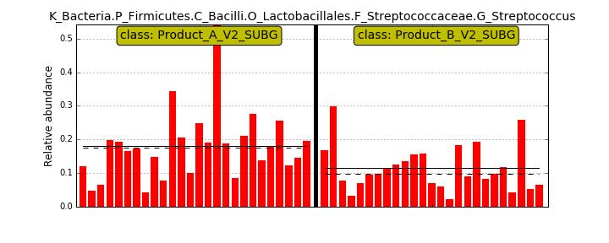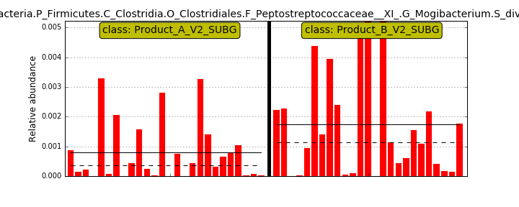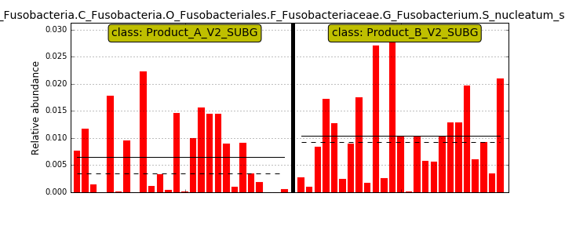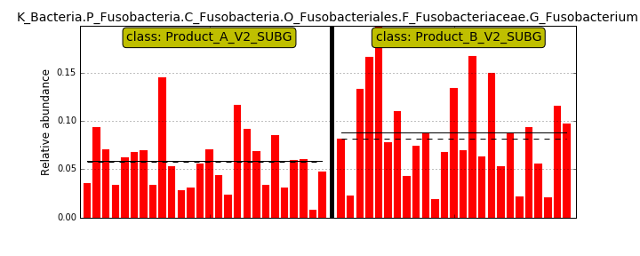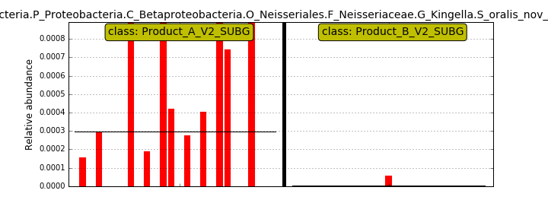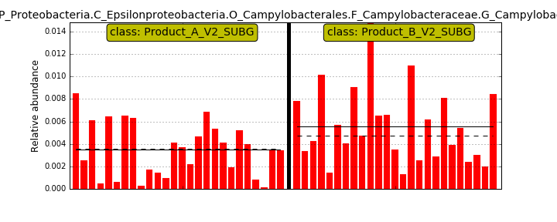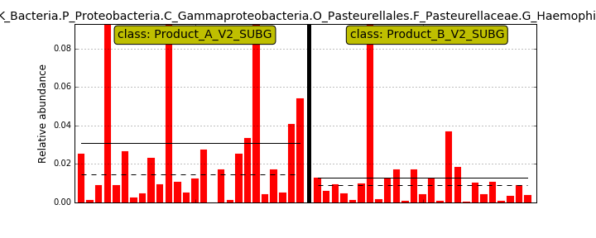

- Heat map.
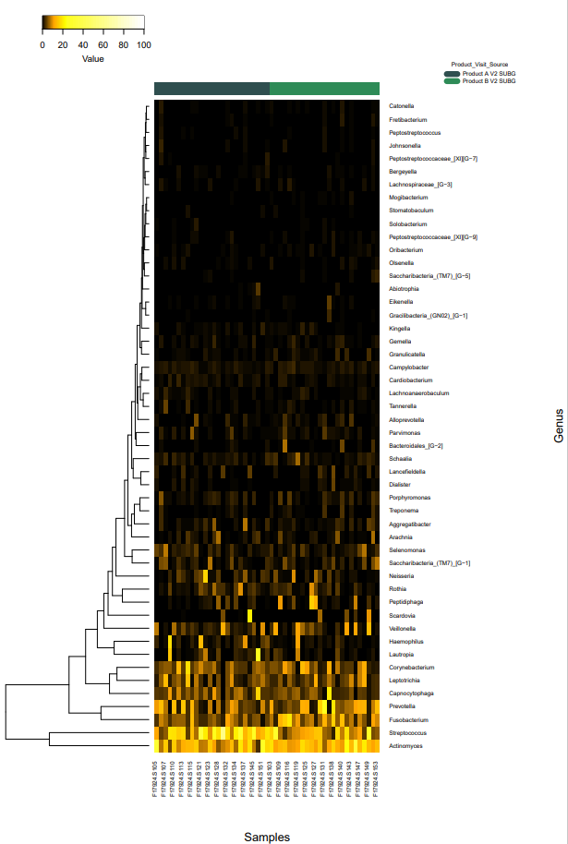

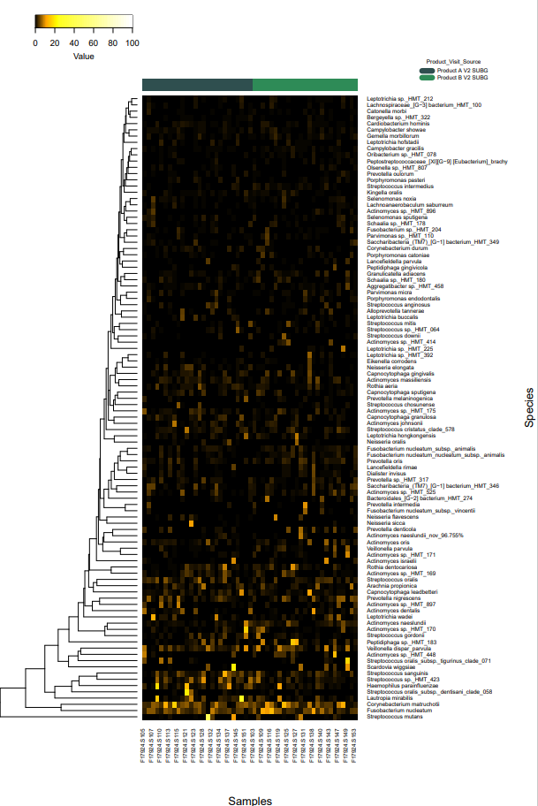

Comparison 20. Product A V3 SUBG vs Product B V3 SUBG

- Taxonomy bar graphs
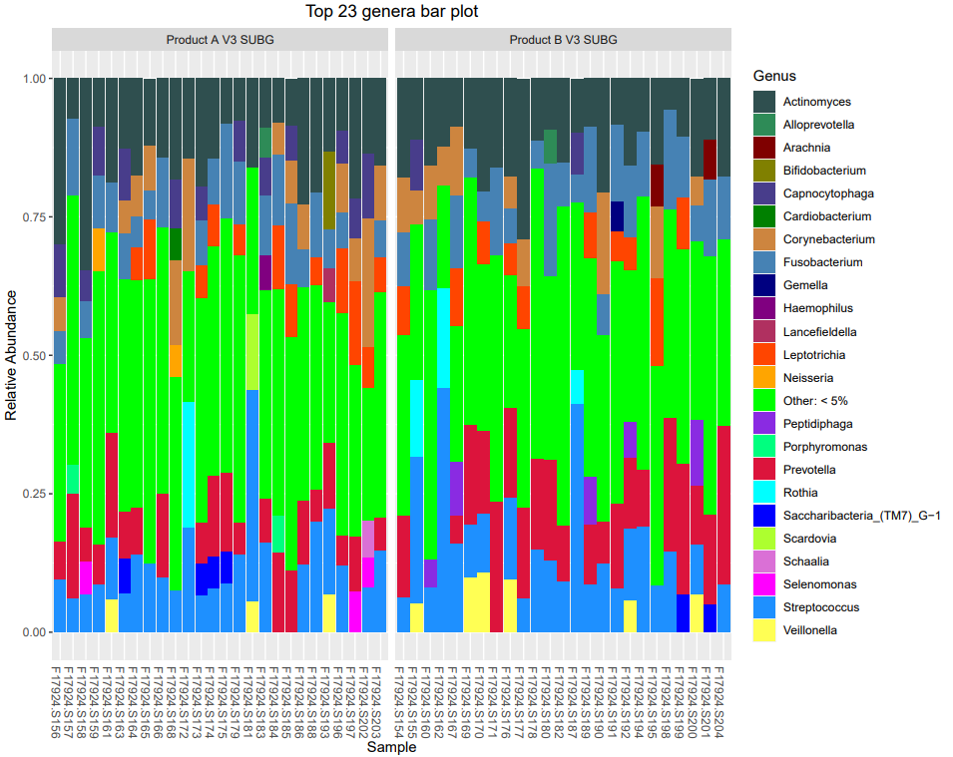

- Alpha

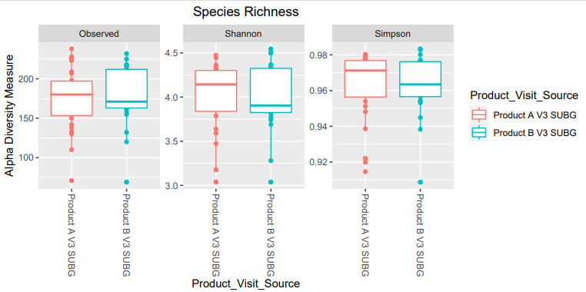
No significant differences

- Beta diversity

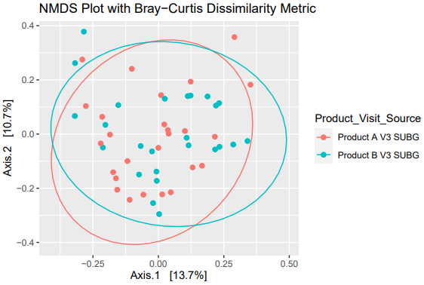

No significant differences

- Differential abundance

Green, more abundant in B
Red, more abundant in A

- Lefse

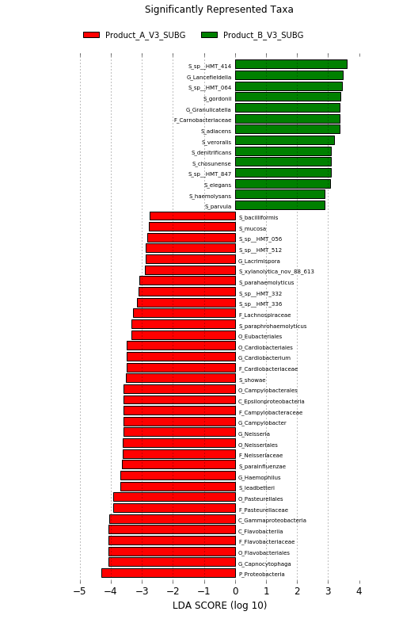

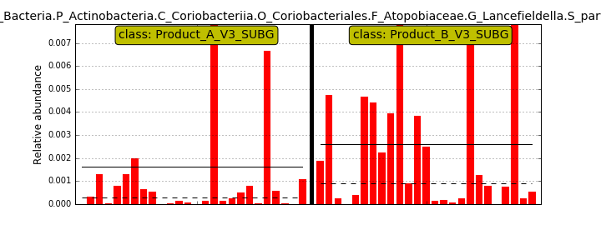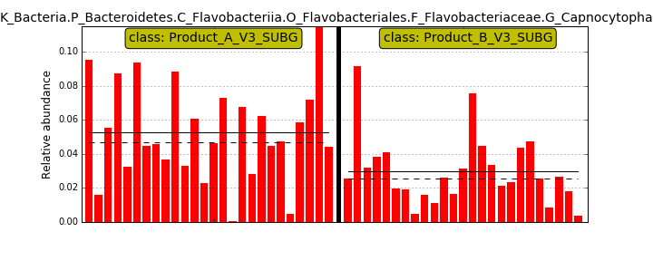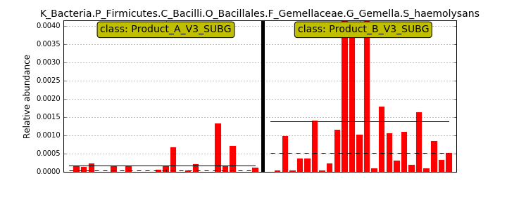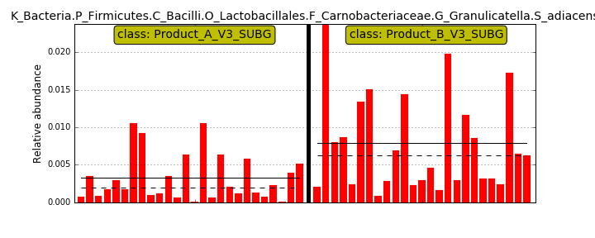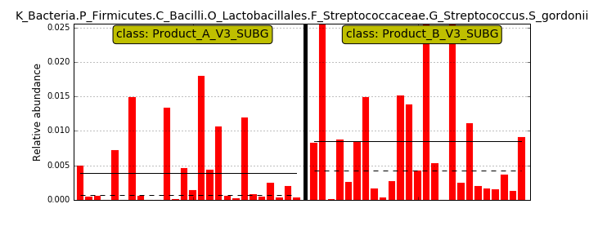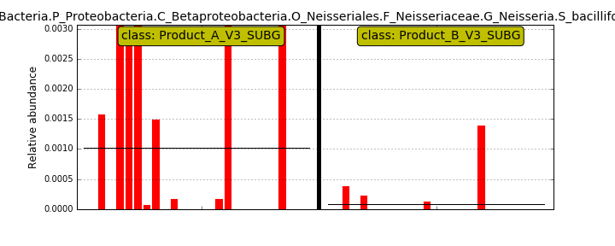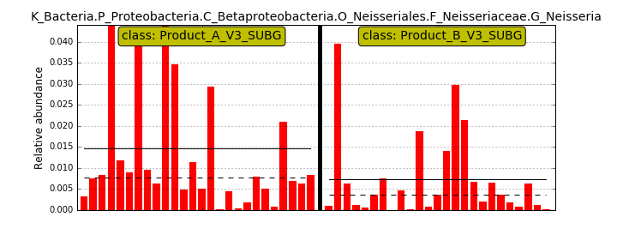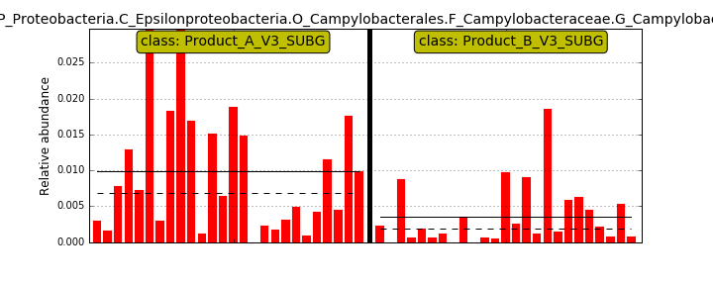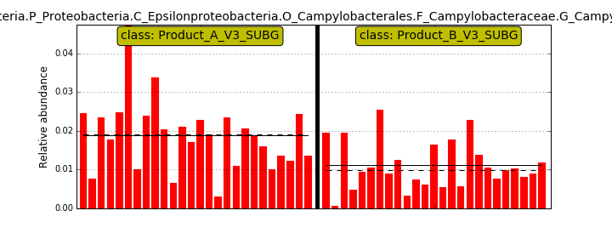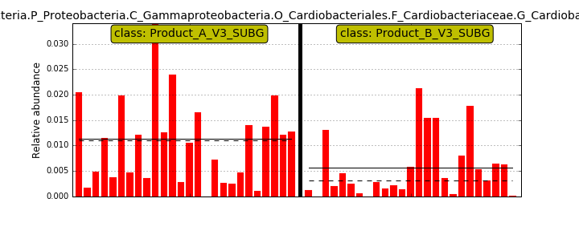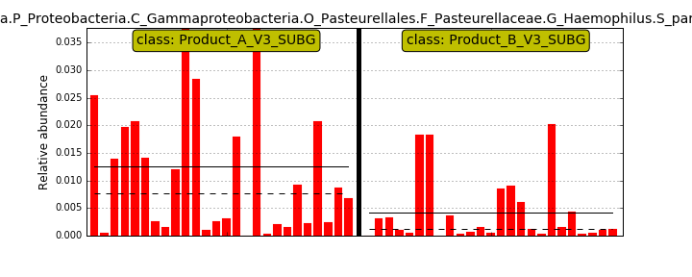

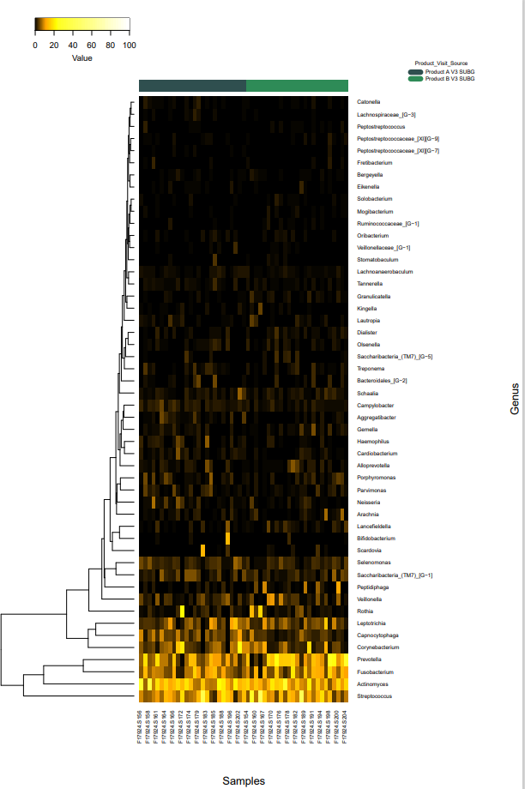
- Heat map 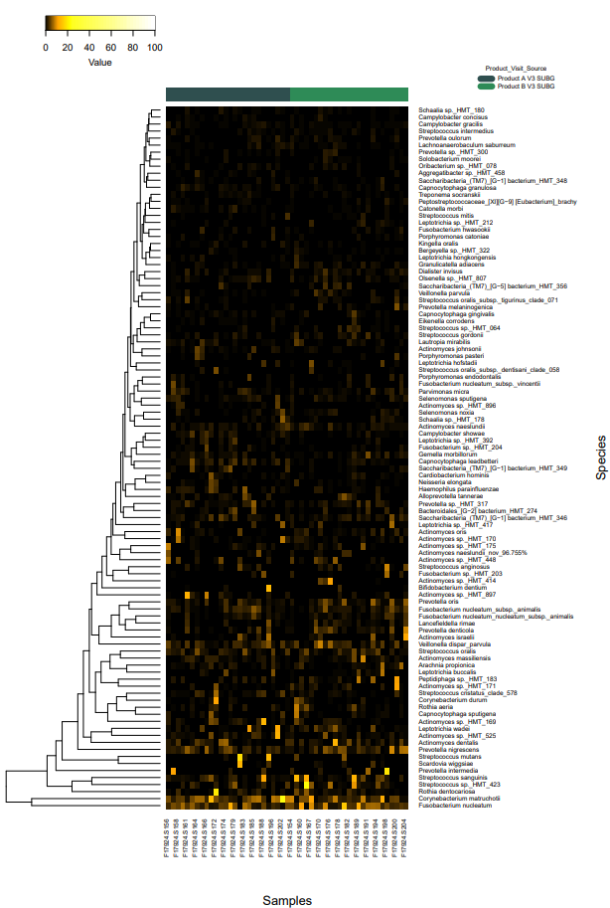

Appendix B. CosmosID-HUB Metatranscriptomic Analysis

Comparison 1: Product A V2 vs Product A V3

Gene Ontology

Alpha Diversity
Chao1 | 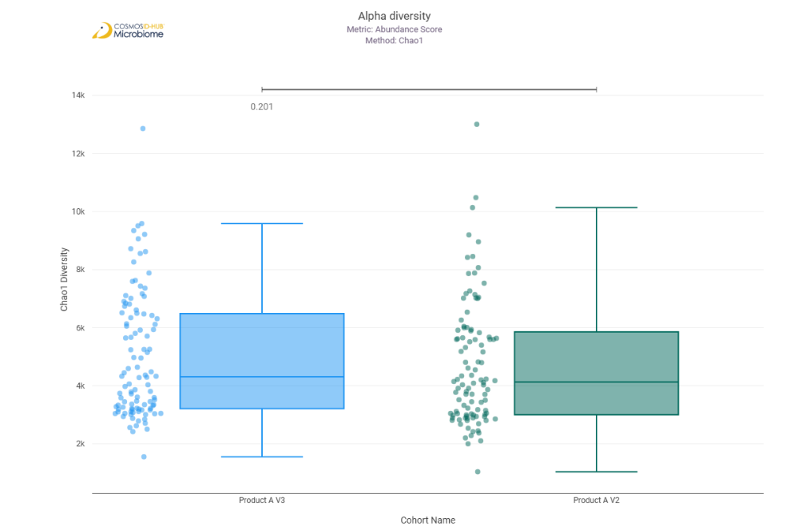
Shannon | 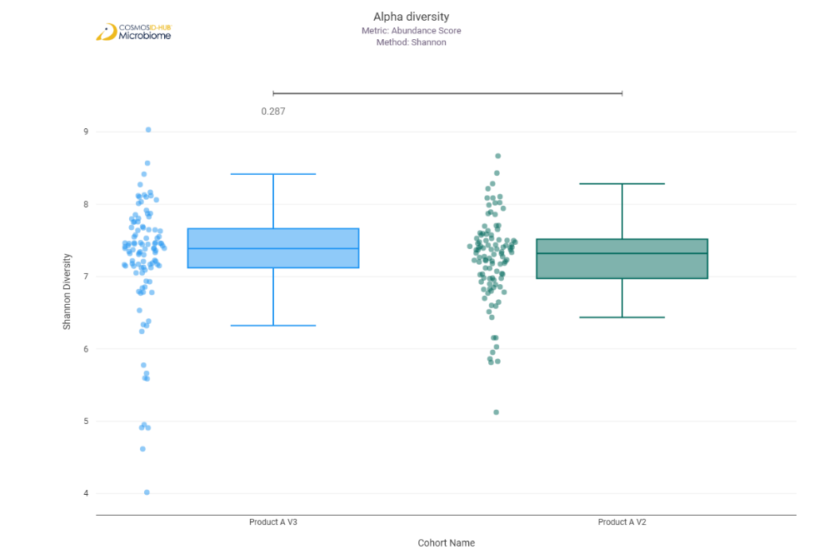
Simpson | 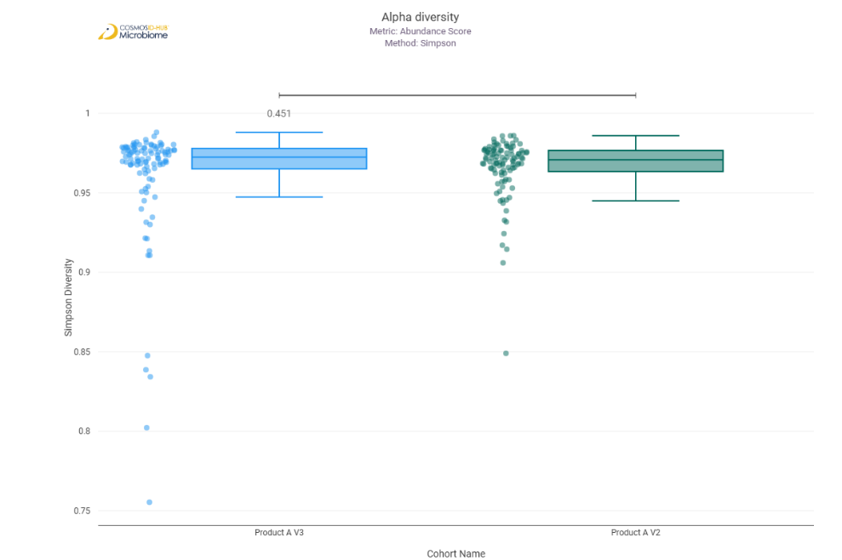

Beta Diversity
Bray-Curtis  PERMNOVA p = 0.542 | 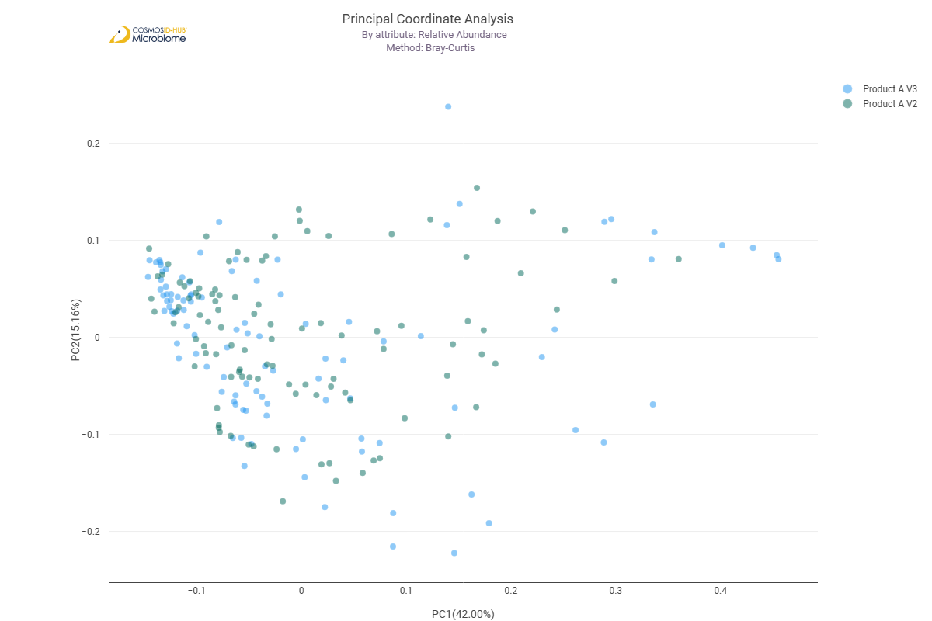

Differential Abundance (LEfSe)
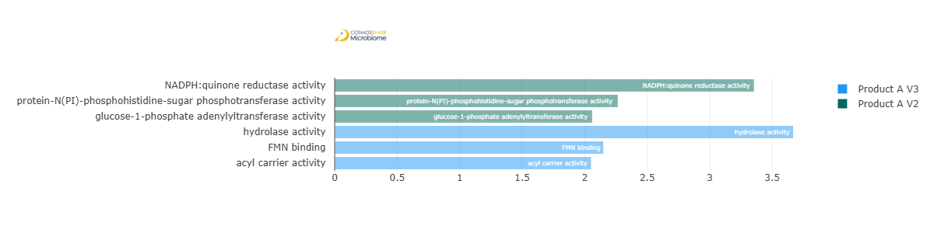
Feature | Enriched Cohort | LDA Score | P-value
NADPH:quinone reductase activity | Product A V2 | 3.354002146 | 2.53E-02
protein-N(PI)-phosphohistidine-sugar phosphotransferase activity | Product A V2 | 2.264785233 | 0.047799842
glucose-1-phosphate adenylyltransferase activity | Product A V2 | 2.059758242 | 0.048846674
hydrolase activity | Product A V3 | 3.667079616 | 0.024094148
FMN binding | Product A V3 | 2.148514318 | 0.004766408
acyl carrier activity | Product A V3 | 2.050417129 | 0.017748428

Enzyme Commission

Alpha Diversity (EC)
Chao1 | 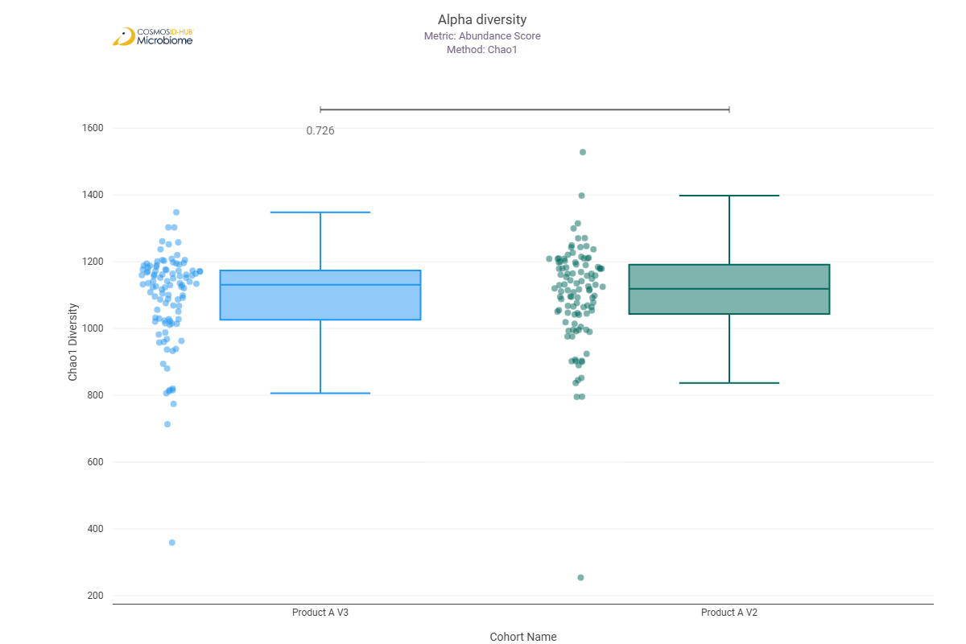
Shannon | 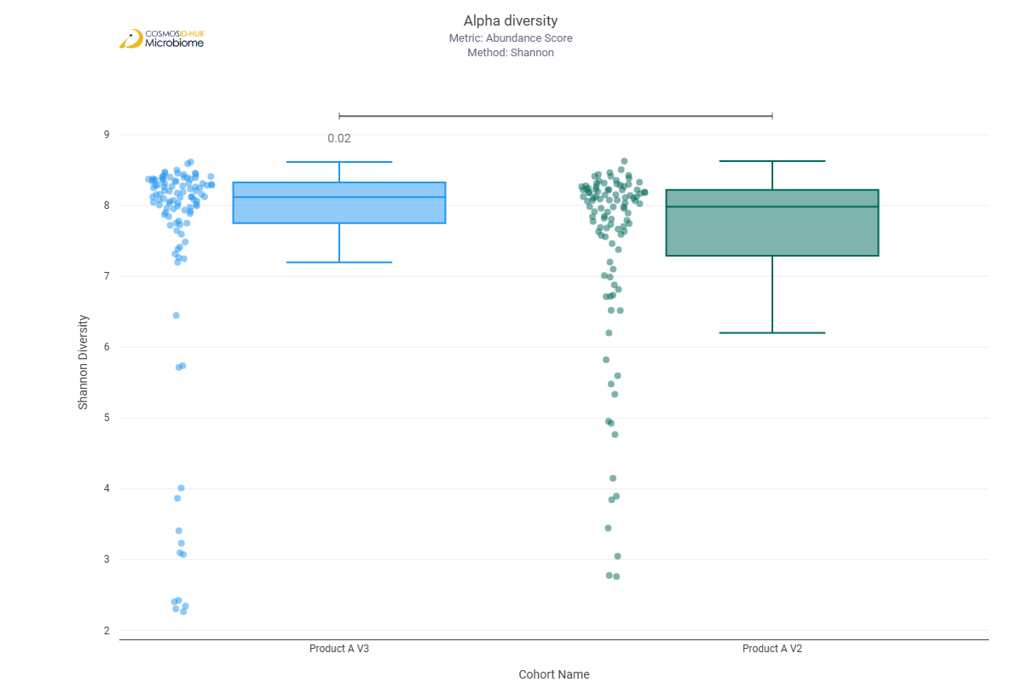
Simpson | 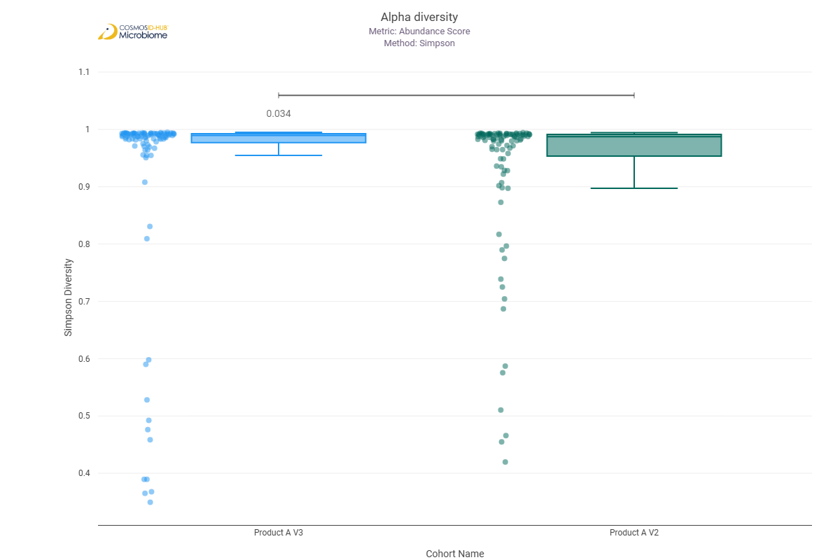

Beta Diversity (EC)
Bray-Curtis  PERMNOVA p = 0.280 | 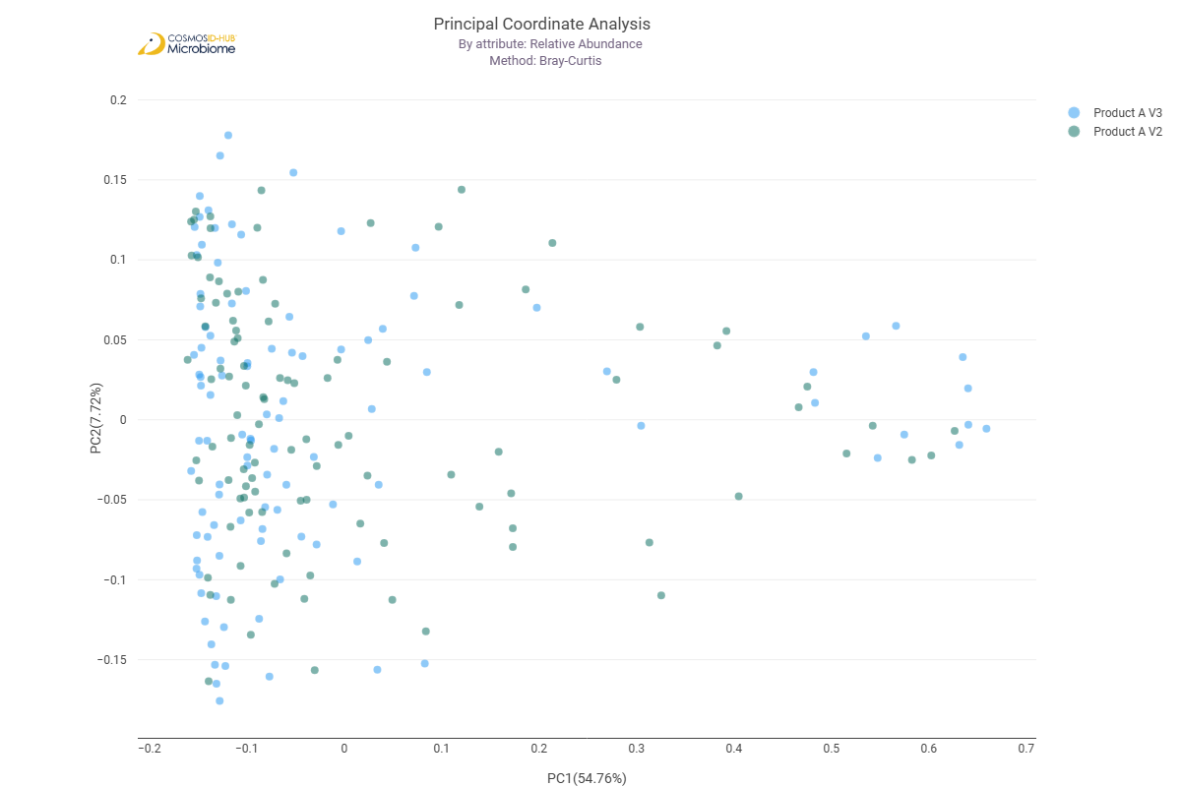

Differential Abundance (LEfSe) (EC)
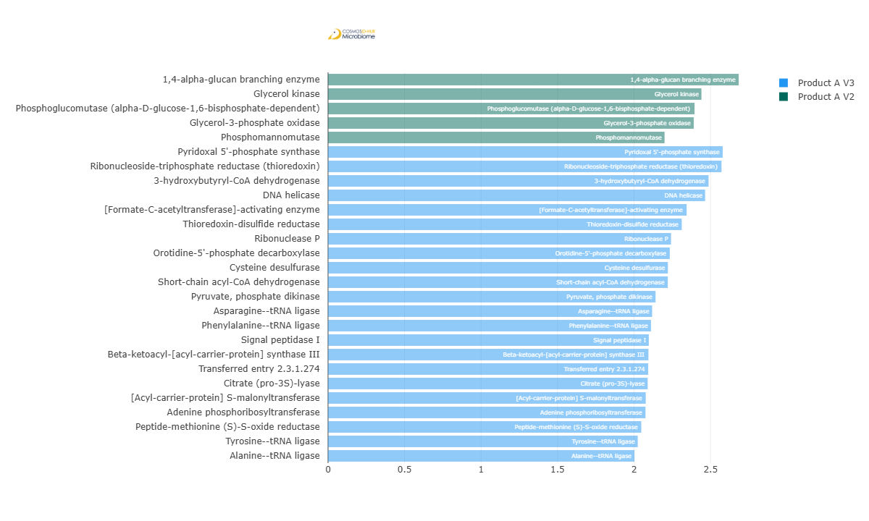
Feature | Enriched Cohort | LDA Score | P-value
1,4-alpha-glucan branching enzyme | Product A V2 | 2.684260612 | 2.44E-02
Glycerol kinase | Product A V2 | 2.440527929 | 0.013515178
Phosphoglucomutase (alpha-D-glucose-1,6-bisphosphate-dependent) | Product A V2 | 2.39543707 | 0.00904253
Glycerol-3-phosphate oxidase | Product A V2 | 2.390435287 | 0.031040567
Phosphomannomutase | Product A V2 | 2.199521301 | 0.007681948
Pyridoxal 5'-phosphate synthase | Product A V3 | 2.579541329 | 0.002826568
Ribonucleoside-triphosphate reductase (thioredoxin) | Product A V3 | 2.571583891 | 0.013256264
3-hydroxybutyryl-CoA dehydrogenase | Product A V3 | 2.486837375 | 0.029804167
DNA helicase | Product A V3 | 2.464351655 | 0.002198431
[Formate-C-acetyltransferase]-activating enzyme | Product A V3 | 2.343710979 | 0.036849101
Thioredoxin-disulfide reductase | Product A V3 | 2.311700333 | 0.037902094
Ribonuclease P | Product A V3 | 2.241667448 | 0.0029349
Orotidine-5'-phosphate decarboxylase | Product A V3 | 2.23363033 | 0.001957618
Cysteine desulfurase | Product A V3 | 2.221119485 | 0.042608467
Short-chain acyl-CoA dehydrogenase | Product A V3 | 2.220517395 | 0.011677397
Pyruvate, phosphate dikinase | Product A V3 | 2.140426457 | 0.019839554
Asparagine--tRNA ligase | Product A V3 | 2.118204505 | 0.007122062
Phenylalanine--tRNA ligase | Product A V3 | 2.110783168 | 0.00345801
Signal peptidase I | Product A V3 | 2.096427343 | 0.005695585
Beta-ketoacyl-[acyl-carrier-protein] synthase III | Product A V3 | 2.09399442 | 0.036849101
Transferred entry 2.3.1.274 | Product A V3 | 2.092424107 | 0.000331128
Citrate (pro-3S)-lyase | Product A V3 | 2.08887282 | 0.000953333
[Acyl-carrier-protein] S-malonyltransferase | Product A V3 | 2.076345774 | 0.023241053
Adenine phosphoribosyltransferase | Product A V3 | 2.074820233 | 0.011715972
Peptide-methionine (S)-S-oxide reductase | Product A V3 | 2.047296647 | 0.027783601
Tyrosine--tRNA ligase | Product A V3 | 2.024258503 | 0.034817712
Alanine--tRNA ligase | Product A V3 | 2.00263877 | 0.01535833

MetaCyc Pathways

Alpha Diversity (MetaCyc)
Chao1 | 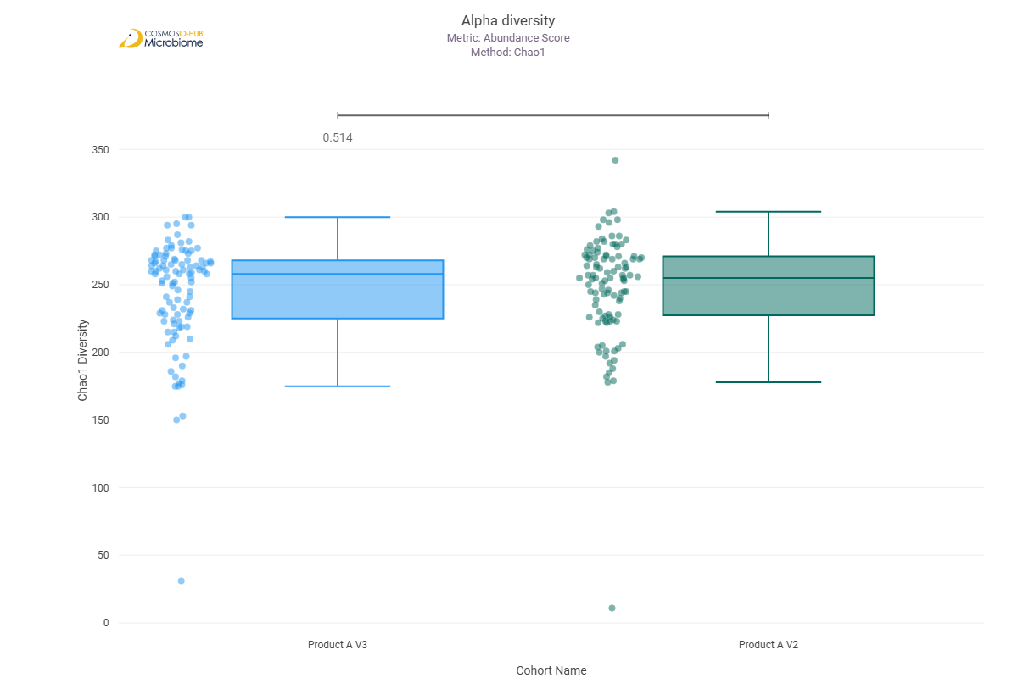
Shannon | 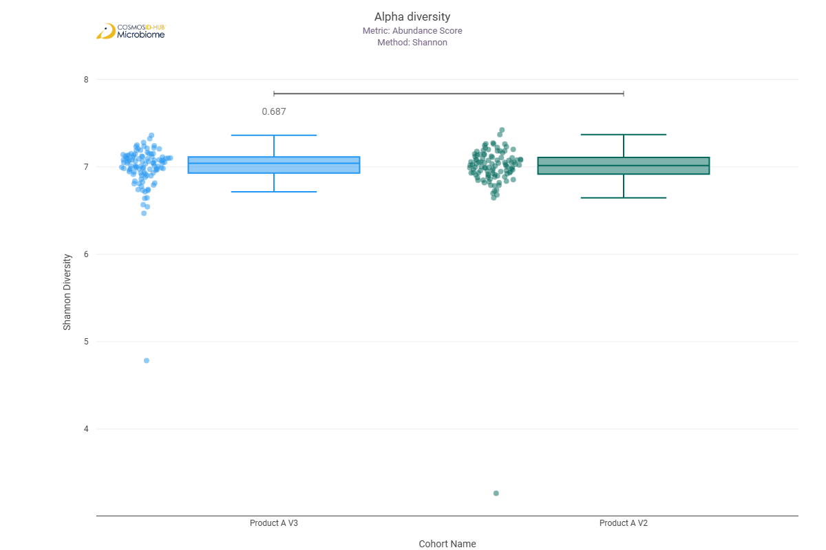
Simpson | 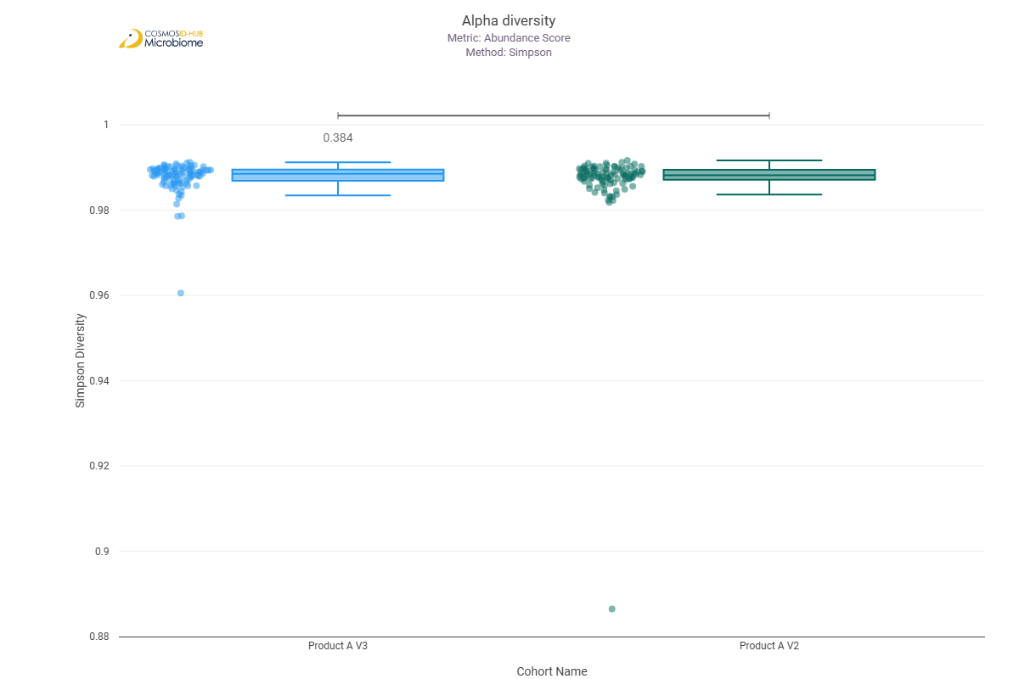

Beta Diversity (MetaCyc)
Bray-Curtis  PERMNOVA p = 0.087 | 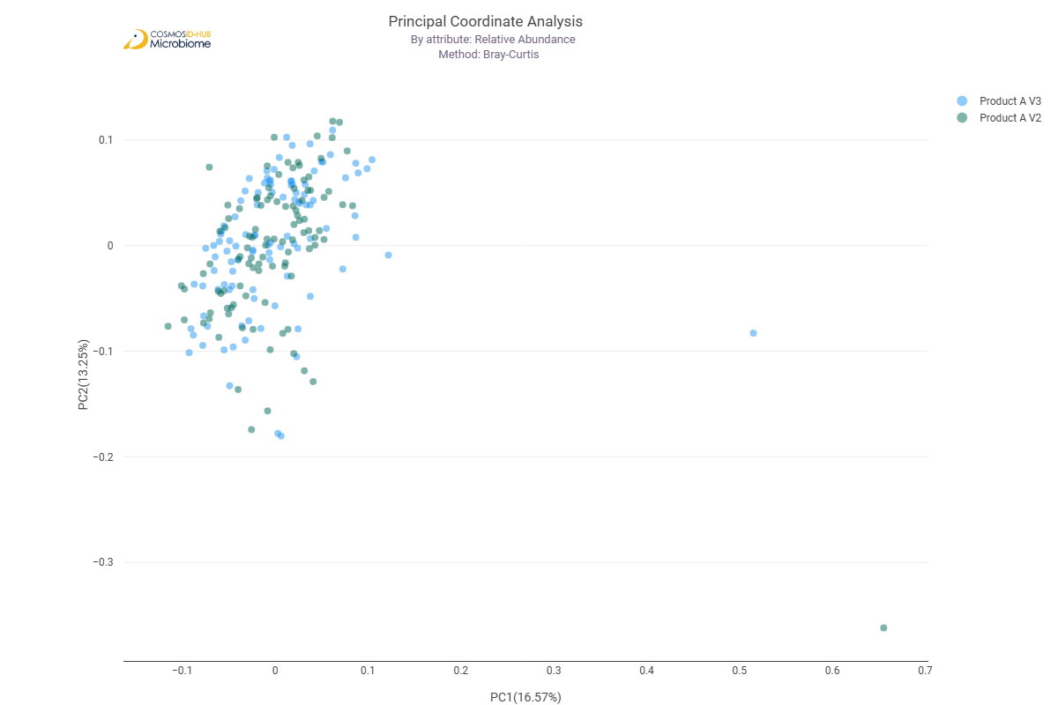

Differential Abundance (LEfSe) (MetaCyc)
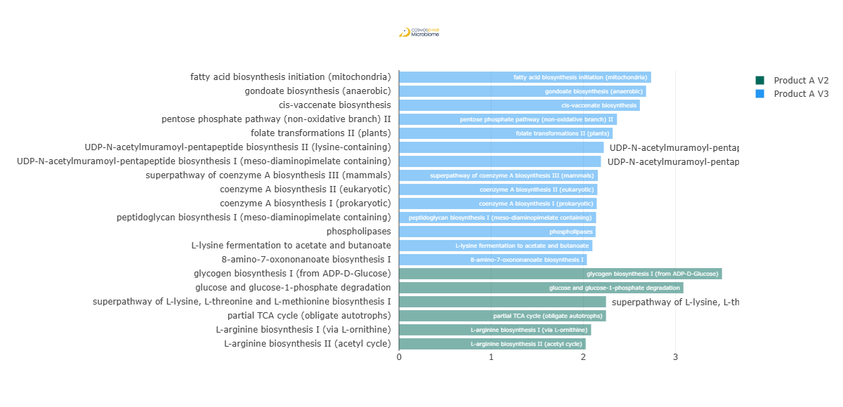
Feature | Enriched Cohort | LDA Score | P-value
fatty acid biosynthesis initiation (mitochondria) | Product A V3 | 2.735008255 | 0.039973314
gondoate biosynthesis (anaerobic) | Product A V3 | 2.68021462 | 0.015554288
cis-vaccenate biosynthesis | Product A V3 | 2.613361453 | 0.034227261
pentose phosphate pathway (non-oxidative branch) II | Product A V3 | 2.364544919 | 0.01871087
folate transformations II (plants) | Product A V3 | 2.31833131 | 0.038762815
UDP-N-acetylmuramoyl-pentapeptide biosynthesis II (lysine-containing) | Product A V3 | 2.221900027 | 0.024021987
UDP-N-acetylmuramoyl-pentapeptide biosynthesis I (meso-diaminopimelate containing) | Product A V3 | 2.191038313 | 0.020773626
superpathway of coenzyme A biosynthesis III (mammals) | Product A V3 | 2.157245055 | 0.001492812
coenzyme A biosynthesis II (eukaryotic) | Product A V3 | 2.151990248 | 0.001980554
coenzyme A biosynthesis I (prokaryotic) | Product A V3 | 2.145034758 | 0.006262567
peptidoglycan biosynthesis I (meso-diaminopimelate containing) | Product A V3 | 2.138440512 | 0.045141198
phospholipases | Product A V3 | 2.132849146 | 0.014251091
L-lysine fermentation to acetate and butanoate | Product A V3 | 2.098199076 | 0.02972225
Transferred entry 2.3.1.274 | Product A V3 | 2.092424107 | 0.000331128
Citrate (pro-3S)-lyase | Product A V3 | 2.08887282 | 0.000953333
[Acyl-carrier-protein] S-malonyltransferase | Product A V3 | 2.076345774 | 0.023241053
Adenine phosphoribosyltransferase | Product A V3 | 2.074820233 | 0.011715972
Peptide-methionine (S)-S-oxide reductase | Product A V3 | 2.047296647 | 0.027783601
8-amino-7-oxononanoate biosynthesis I | Product A V3 | 2.03838881 | 0.023770185
Tyrosine--tRNA ligase | Product A V3 | 2.024258503 | 0.034817712
Alanine--tRNA ligase | Product A V3 | 2.00263877 | 0.01535833
glycogen biosynthesis I (from ADP-D-Glucose) | Product A V2 | 3.504241049 | 7.47E-03
glucose and glucose-1-phosphate degradation | Product A V2 | 3.085696443 | 0.001014125
superpathway of L-lysine, L-threonine and L-methionine biosynthesis I | Product A V2 | 2.246128695 | 0.000192166
partial TCA cycle (obligate autotrophs) | Product A V2 | 2.245865551 | 0.012144606
L-arginine biosynthesis I (via L-ornithine) | Product A V2 | 2.084419907 | 0.008864648
L-arginine biosynthesis II (acetyl cycle) | Product A V2 | 2.025666773 | 0.007998331

Comparison 2: Product B V2 vs Product B V3

Gene Ontology

Alpha Diversity (GO)
Chao1 | 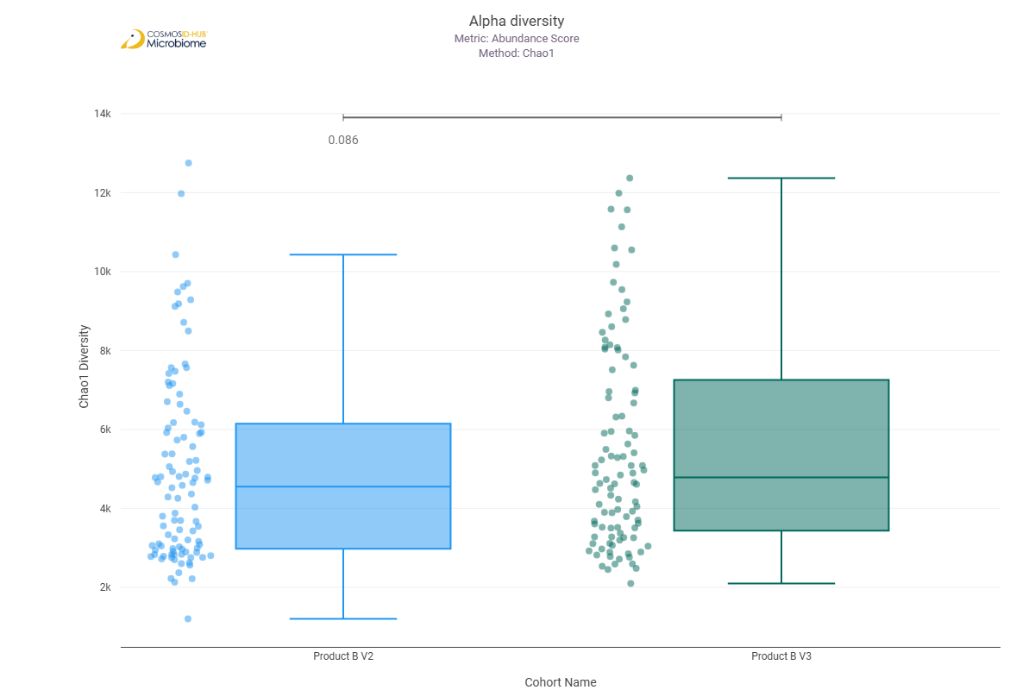
Shannon | 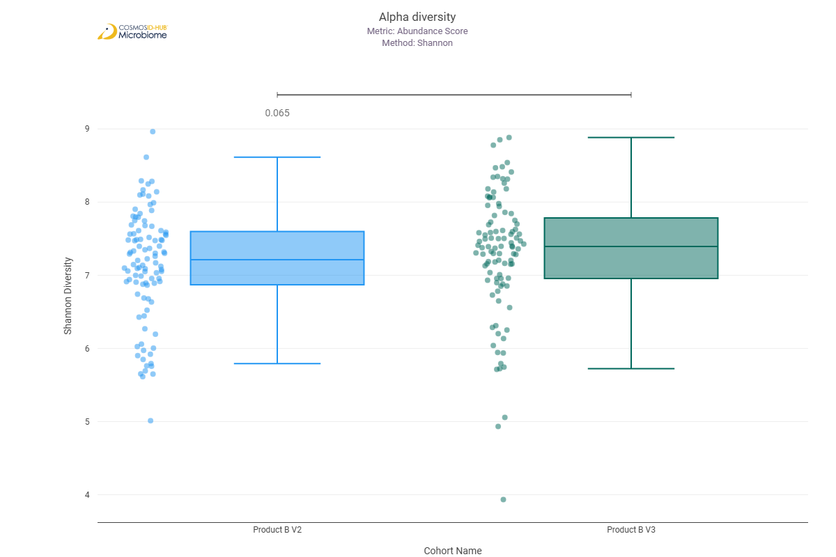
Simpson | 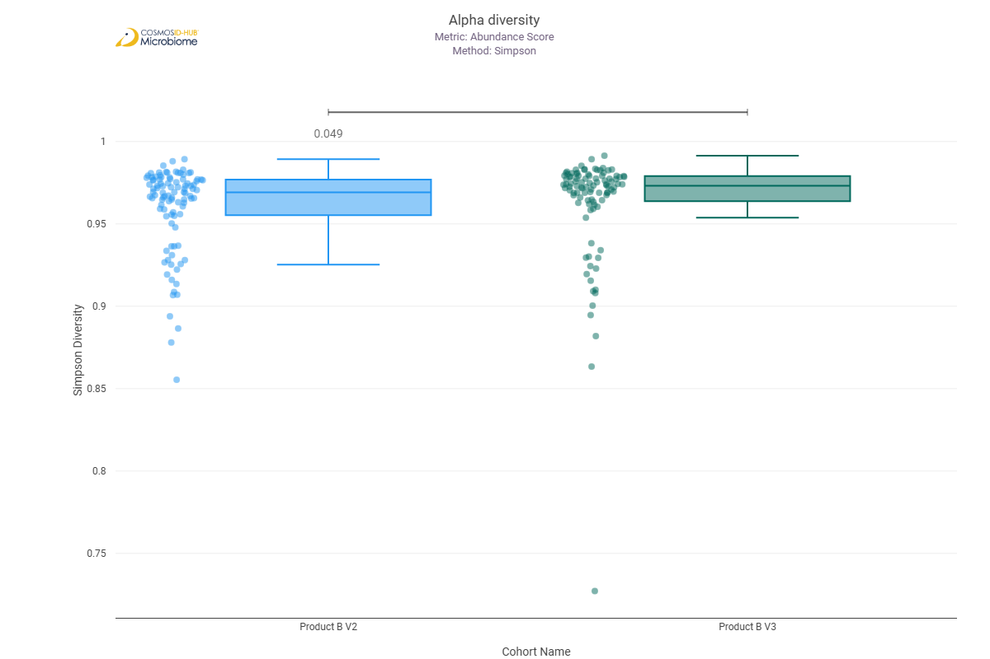

Beta Diversity (GO)
Bray-Curtis  PERMNOVA p = 0.271 | 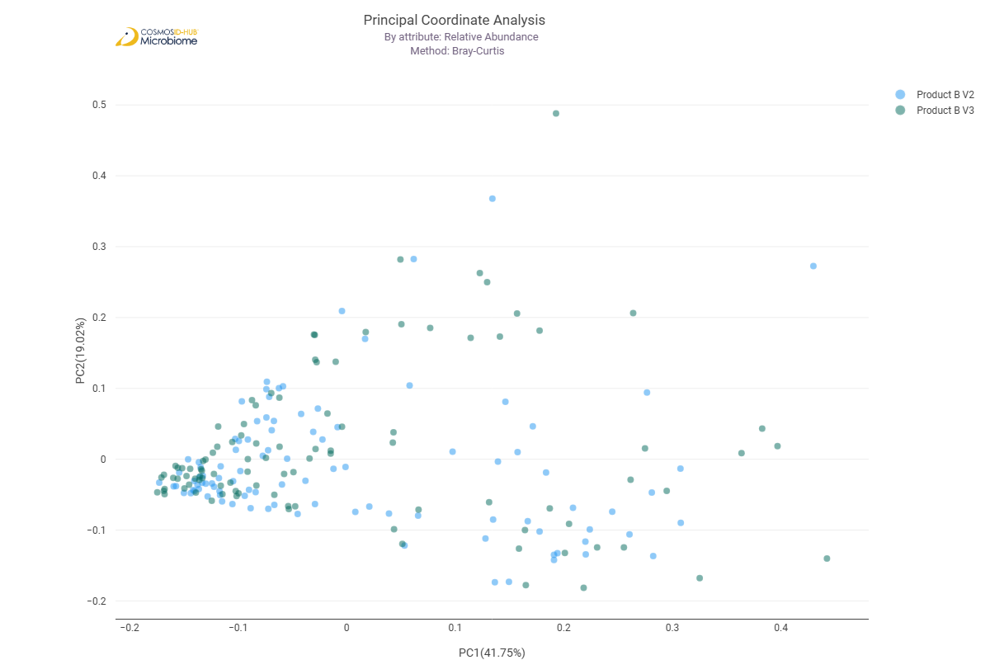

Differential Abundance (LEfSe) (GO)
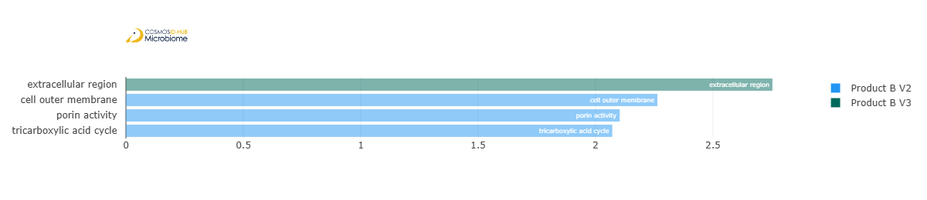
Feature | Enriched Cohort | LDA Score | P-value
extracellular region | Product B V3 | 2.753697521 | 0.026348219
cell outer membrane | Product B V2 | 2.263677165 | 0.043566353
porin activity | Product B V2 | 2.103296471 | 8.17E-08
tricarboxylic acid cycle | Product B V2 | 2.071505025 | 0.011602109

Enzyme Commission

Alpha Diversity (EC)
Chao1 | 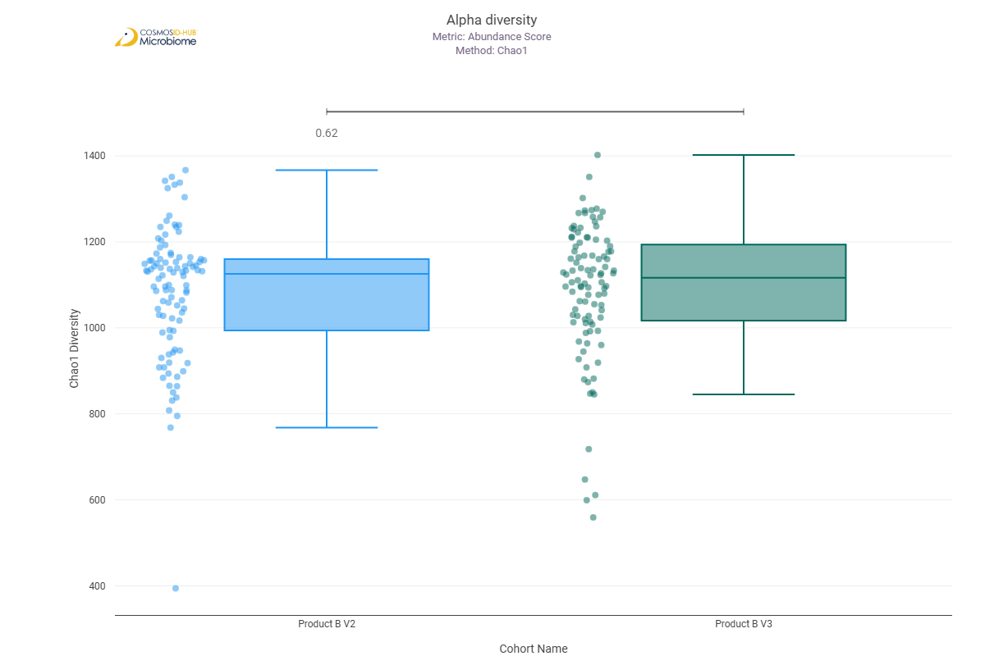
Shannon | 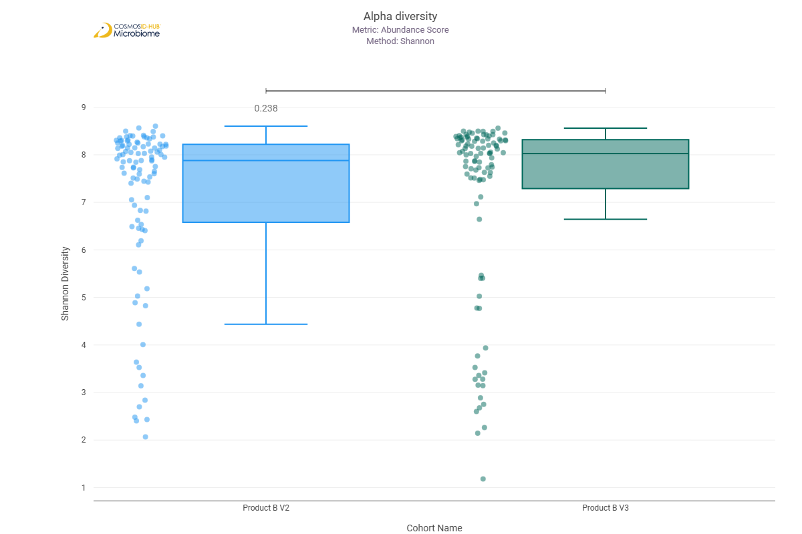
Simpson | 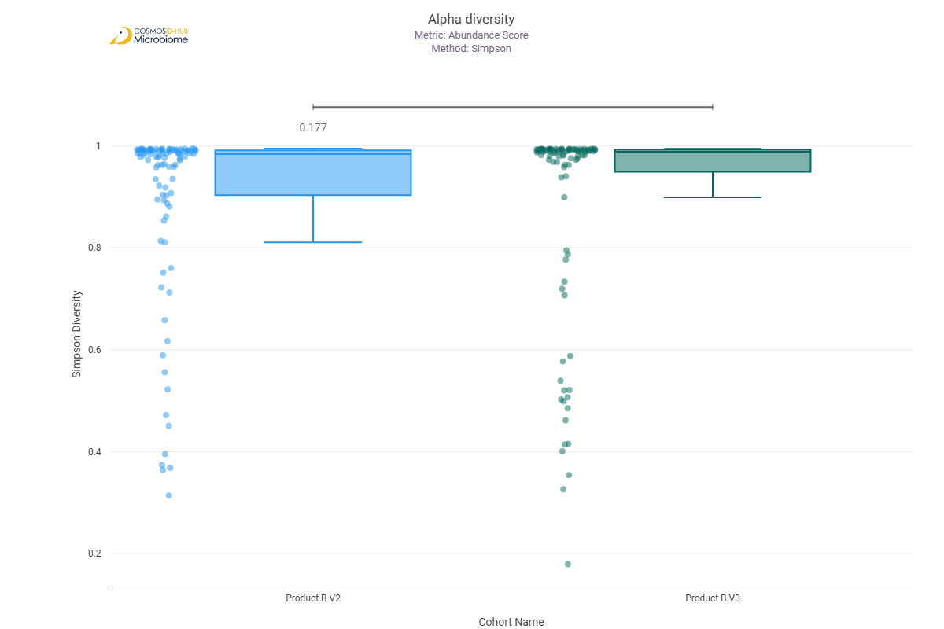

Beta Diversity (EC)
Bray-Curtis  PERMNOVA p = 0.476 | 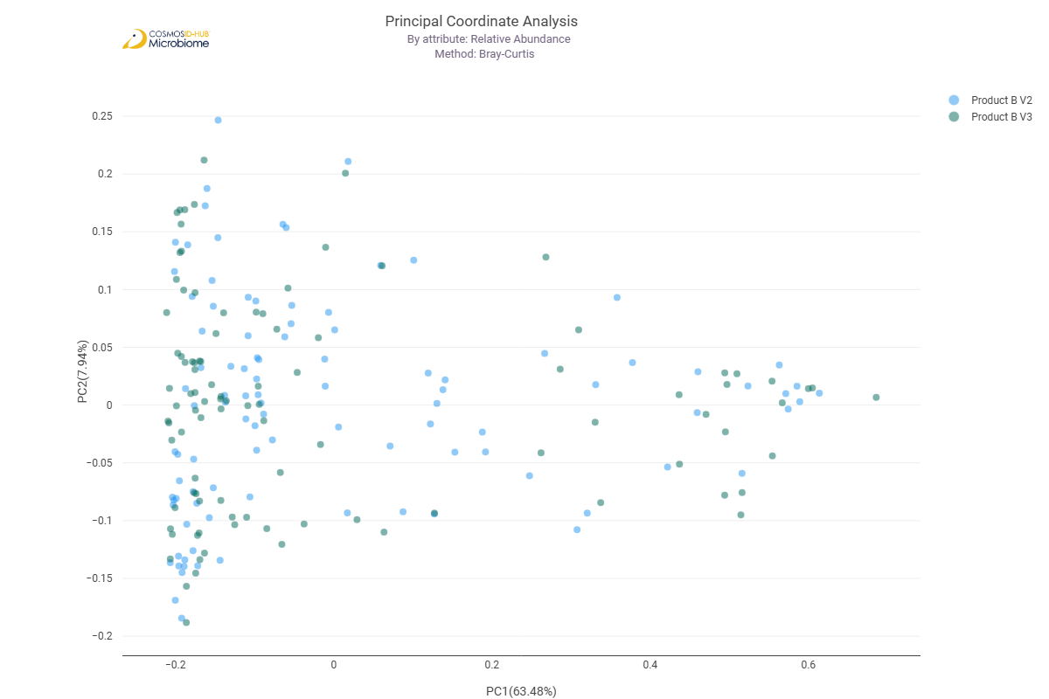

Differential Abundance (LEfSe) (EC)
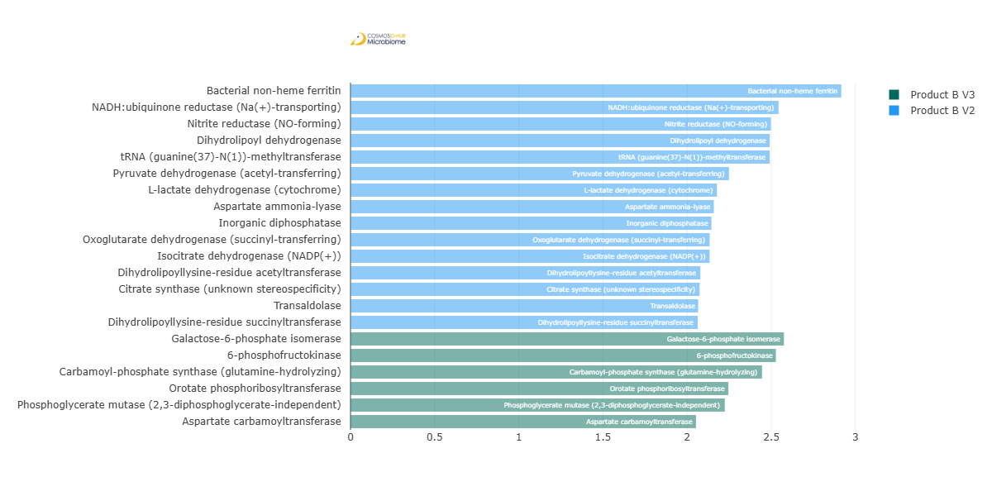
Feature | Enriched Cohort | LDA Score | P-value
Bacterial non-heme ferritin | Product B V2 | 2.916370778 | 0.008140404
NADH:ubiquinone reductase (Na(+)-transporting) | Product B V2 | 2.543316962 | 3.35E-02
Nitrite reductase (NO-forming) | Product B V2 | 2.497728264 | 0.000588206
Dihydrolipoyl dehydrogenase | Product B V2 | 2.491221448 | 0.007299969
tRNA (guanine(37)-N(1))-methyltransferase | Product B V2 | 2.491026824 | 0.001868126
Pyruvate dehydrogenase (acetyl-transferring) | Product B V2 | 2.248619249 | 0.023812891
L-lactate dehydrogenase (cytochrome) | Product B V2 | 2.176913806 | 3.15038E-05
Aspartate ammonia-lyase | Product B V2 | 2.158608668 | 0.006538231
Inorganic diphosphatase | Product B V2 | 2.144704717 | 0.047525328
Oxoglutarate dehydrogenase (succinyl-transferring) | Product B V2 | 2.133982099 | 0.000116559
Isocitrate dehydrogenase (NADP(+)) | Product B V2 | 2.13357857 | 0.007737888
Dihydrolipoyllysine-residue acetyltransferase | Product B V2 | 2.078756294 | 1.59585E-05
Citrate synthase (unknown stereospecificity) | Product B V2 | 2.074165128 | 0.014096561
Transaldolase | Product B V2 | 2.065814207 | 0.013686825
Dihydrolipoyllysine-residue succinyltransferase | Product B V2 | 2.063232884 | 0.001962993
Galactose-6-phosphate isomerase | Product B V3 | 2.575276965 | 0.040843374
6-phosphofructokinase | Product B V3 | 2.527683882 | 0.011764389
Carbamoyl-phosphate synthase (glutamine-hydrolyzing) | Product B V3 | 2.445328101 | 0.035613373
Orotate phosphoribosyltransferase | Product B V3 | 2.24538852 | 0.004285808
Phosphoglycerate mutase (2,3-diphosphoglycerate-independent) | Product B V3 | 2.224097039 | 0.038266022
Aspartate carbamoyltransferase | Product B V3 | 2.052876435 | 0.006116265

MetaCyc Pathways

Alpha Diversity (MetaCyc)
Chao1 | 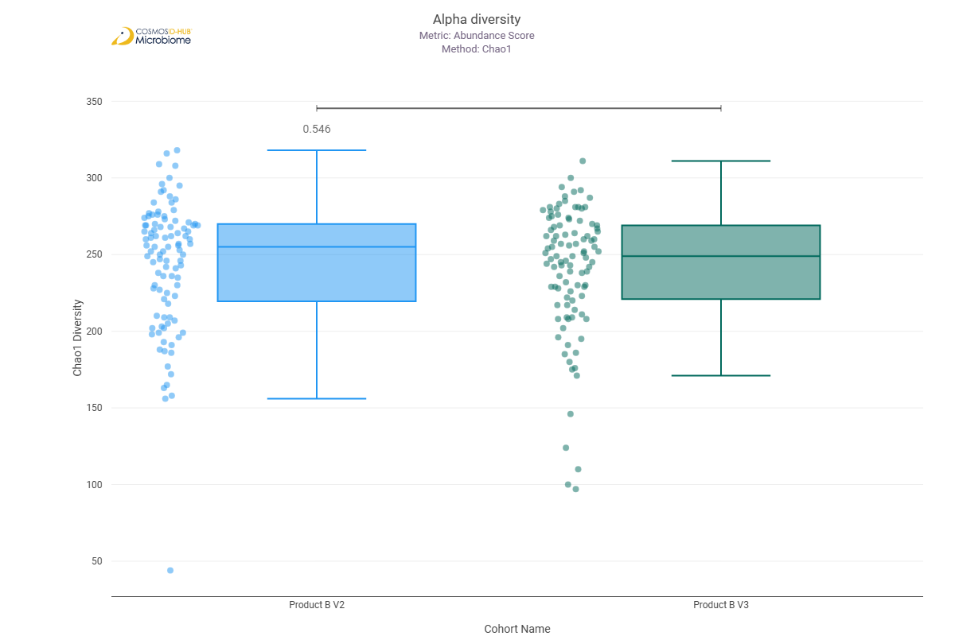
Shannon | 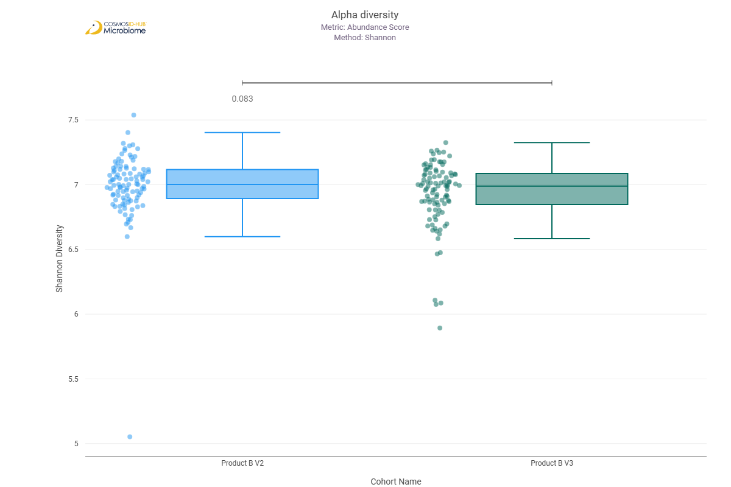
Simpson | 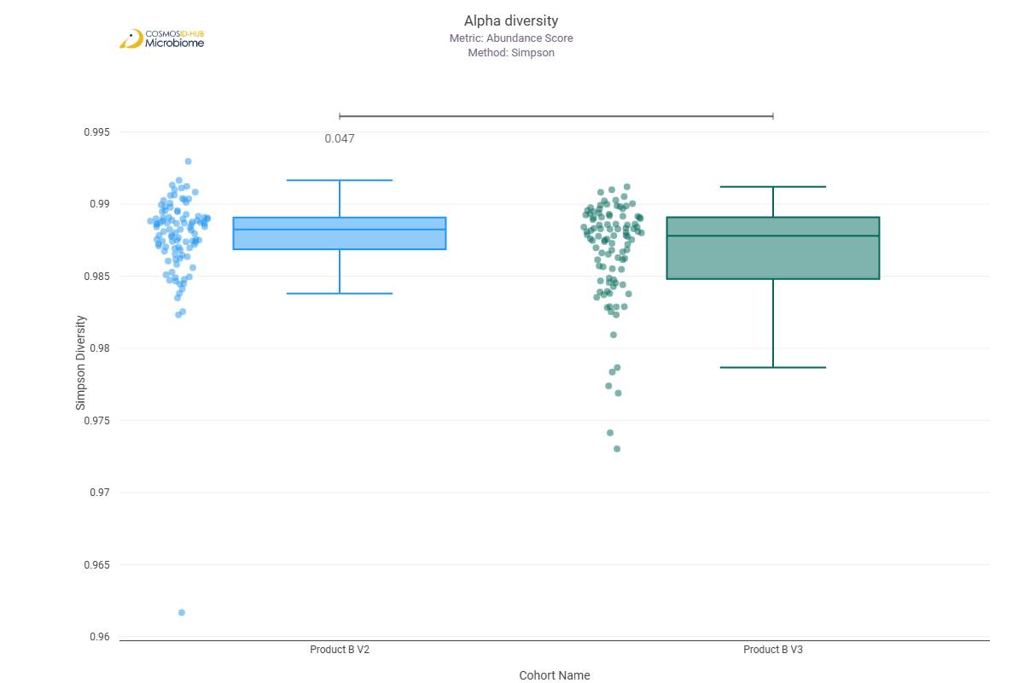

Beta Diversity (MetaCyc)
Bray-Curtis  PERMNOVA p = 0.007 | 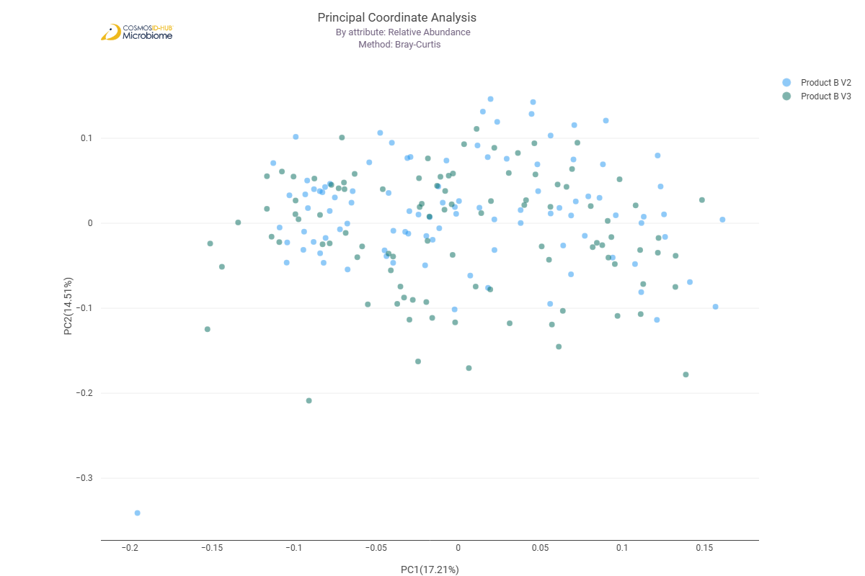

Differential Abundance (LEfSe) (MetaCyc)
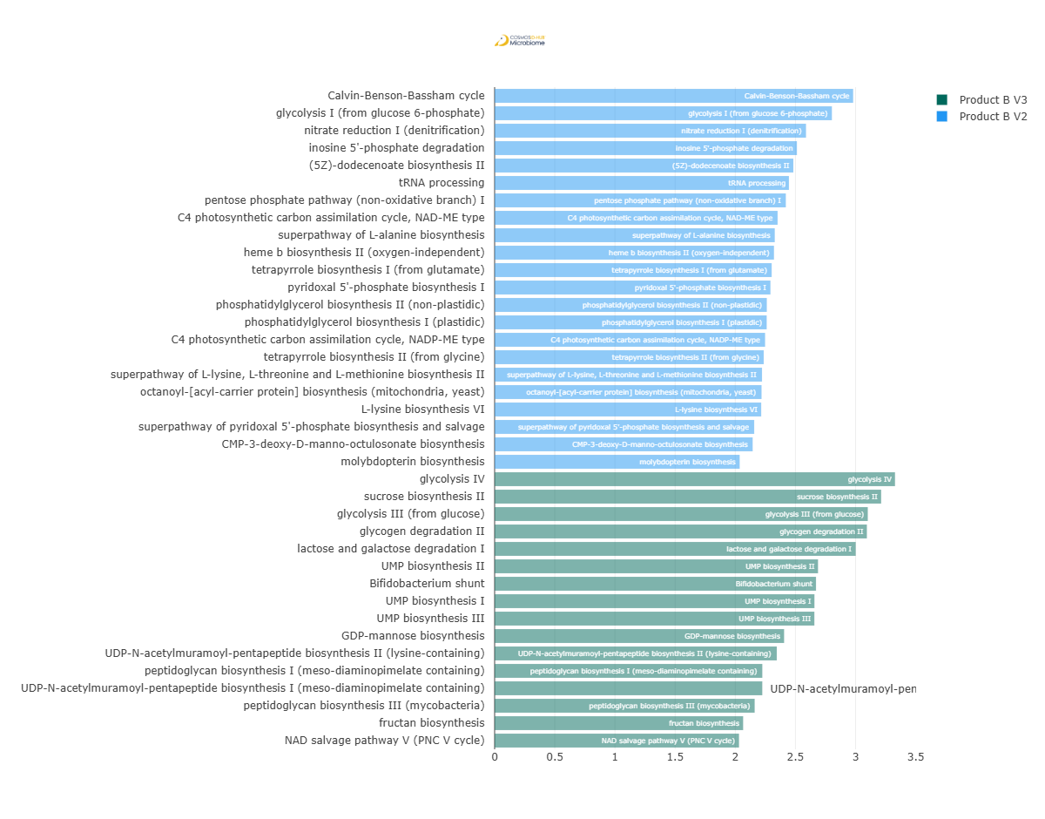
Feature | Enriched Cohort | LDA Score | P-value
Calvin-Benson-Bassham cycle | Product B V2 | 2.980017469 | 0.002293376
glycolysis I (from glucose 6-phosphate) | Product B V2 | 2.803147252 | 0.049050725
nitrate reduction I (denitrification) | Product B V2 | 2.588156927 | 0.00033841
inosine 5'-phosphate degradation | Product B V2 | 2.512470778 | 0.040843374
(5Z)-dodecenoate biosynthesis II | Product B V2 | 2.482703129 | 0.002215853
tRNA processing | Product B V2 | 2.446113576 | 0.000101039
pentose phosphate pathway (non-oxidative branch) I | Product B V2 | 2.420285883 | 0.014160637
C4 photosynthetic carbon assimilation cycle, NAD-ME type | Product B V2 | 2.352117478 | 0.002962847
superpathway of L-alanine biosynthesis | Product B V2 | 2.328429283 | 0.001134473
heme b biosynthesis II (oxygen-independent) | Product B V2 | 2.32188526 | 5.35921E-06
tetrapyrrole biosynthesis I (from glutamate) | Product B V2 | 2.302670791 | 2.31E-02
pyridoxal 5'-phosphate biosynthesis I | Product B V2 | 2.292538957 | 0.019224991
phosphatidylglycerol biosynthesis II (non-plastidic) | Product B V2 | 2.262213821 | 0.012475606
phosphatidylglycerol biosynthesis I (plastidic) | Product B V2 | 2.261336783 | 0.011763758
C4 photosynthetic carbon assimilation cycle, NADP-ME type | Product B V2 | 2.248031239 | 0.036917997
tetrapyrrole biosynthesis II (from glycine) | Product B V2 | 2.236665884 | 0.014840025
superpathway of L-lysine, L-threonine and L-methionine biosynthesis II | Product B V2 | 2.222294134 | 0.010593229
octanoyl-[acyl-carrier protein] biosynthesis (mitochondria, yeast) | Product B V2 | 2.218678927 | 0.02610799
L-lysine biosynthesis VI | Product B V2 | 2.215637736 | 0.011047972
superpathway of pyridoxal 5'-phosphate biosynthesis and salvage | Product B V2 | 2.157495637 | 0.01350269
CMP-3-deoxy-D-manno-octulosonate biosynthesis | Product B V2 | 2.144607845 | 0.004222717
molybdopterin biosynthesis | Product B V2 | 2.036690834 | 0.003881927
glycolysis IV | Product B V3 | 3.327911078 | 0.007851099
sucrose biosynthesis II | Product B V3 | 3.212667295 | 3.12E-02
glycolysis III (from glucose) | Product B V3 | 3.101708701 | 0.02351136
glycogen degradation II | Product B V3 | 3.09417983 | 0.035613373
lactose and galactose degradation I | Product B V3 | 3.001224899 | 0.038038729
UMP biosynthesis II | Product B V3 | 2.687935173 | 0.000363989
Bifidobacterium shunt | Product B V3 | 2.671196279 | 0.038942744
UMP biosynthesis I | Product B V3 | 2.658158059 | 0.000570683
UMP biosynthesis III | Product B V3 | 2.657607009 | 0.000565546
GDP-mannose biosynthesis | Product B V3 | 2.406080835 | 0.030213058
UDP-N-acetylmuramoyl-pentapeptide biosynthesis II (lysine-containing) | Product B V3 | 2.345372582 | 0.014748123
peptidoglycan biosynthesis I (meso-diaminopimelate containing) | Product B V3 | 2.224909222 | 0.031156435
UDP-N-acetylmuramoyl-pentapeptide biosynthesis I (meso-diaminopimelate containing) | Product B V3 | 2.224695184 | 0.040603143
peptidoglycan biosynthesis III (mycobacteria) | Product B V3 | 2.161540068 | 0.046039851
fructan biosynthesis | Product B V3 | 2.065573749 | 0.031928973
NAD salvage pathway V (PNC V cycle) | Product B V3 | 2.031437871 | 0.002049925

Comparison 3: Product A V2 vs Product B V2

Gene Ontology

Alpha Diversity (GO)
Chao1 | 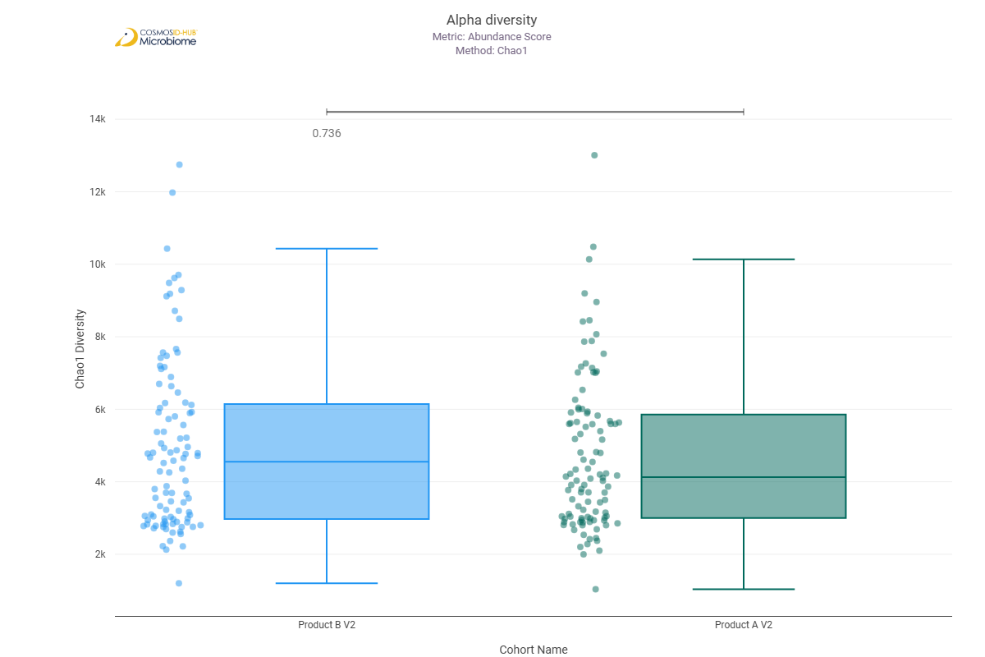
Shannon | 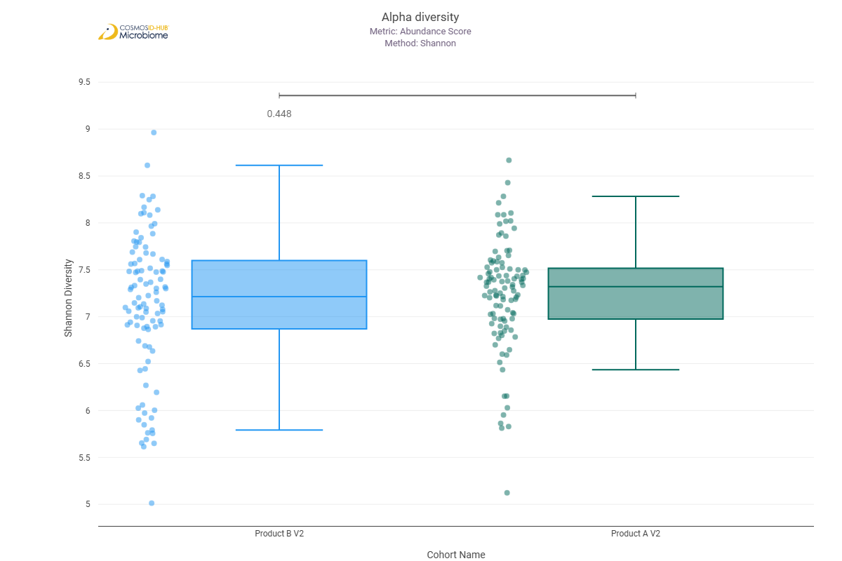
Simpson | 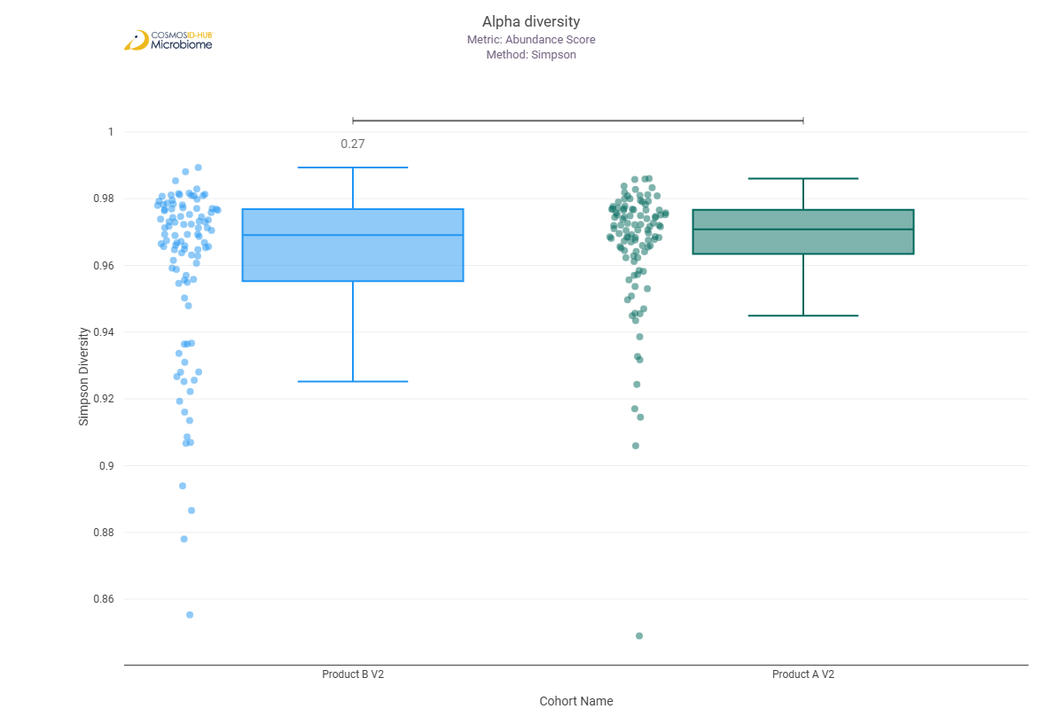

Beta Diversity (GO)
Bray-Curtis  PERMNOVA p = 0.044 | 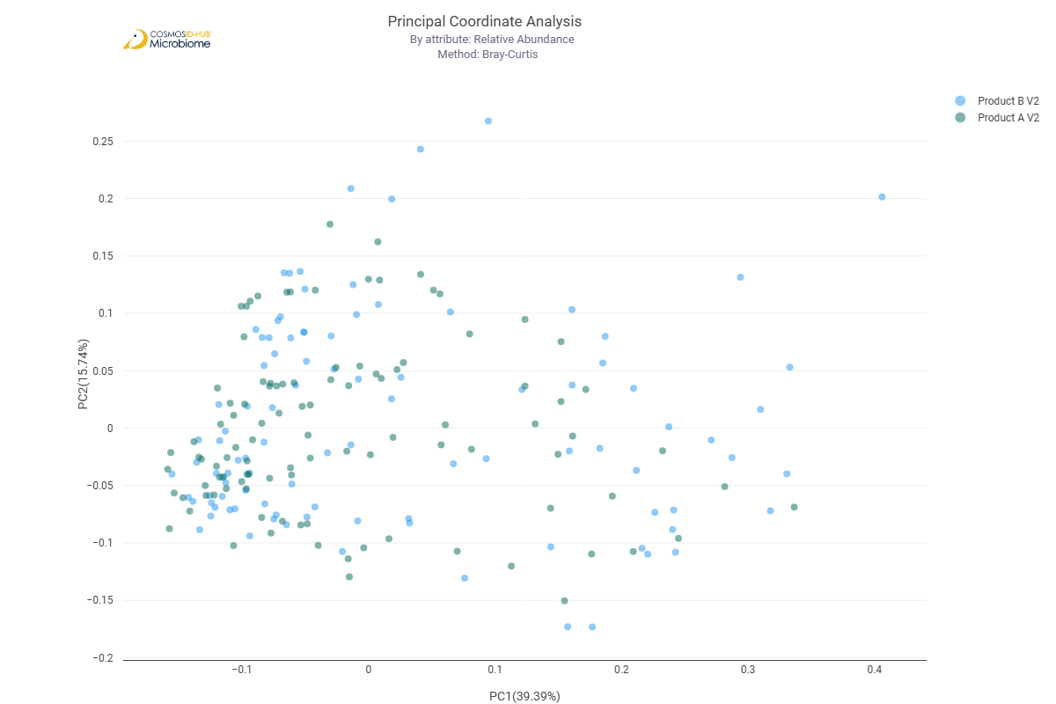

Differential Abundance (LEfSe) (GO)
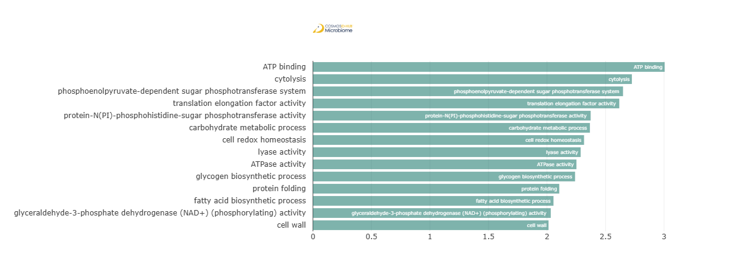
Feature | Enriched Cohort | LDA Score | P-value
ATP binding | Product A V2 | 3.005226801 | 0.031977275
cytolysis | Product A V2 | 2.725138877 | 0.000880468
phosphoenolpyruvate-dependent sugar phosphotransferase system | Product A V2 | 2.649451853 | 0.042757398
translation elongation factor activity | Product A V2 | 2.617507076 | 0.043739123
protein-N(PI)-phosphohistidine-sugar phosphotransferase activity | Product A V2 | 2.372987284 | 0.047591773
carbohydrate metabolic process | Product A V2 | 2.366604496 | 0.047858458
cell redox homeostasis | Product A V2 | 2.316574729 | 0.048395595
lyase activity | Product A V2 | 2.287508955 | 0.008162299
ATPase activity | Product A V2 | 2.251478935 | 0.040616459
glycogen biosynthetic process | Product A V2 | 2.2397374 | 0.035346801
protein folding | Product A V2 | 2.104787498 | 1.88E-02
fatty acid biosynthetic process | Product A V2 | 2.055382736 | 0.002140946
glyceraldehyde-3-phosphate dehydrogenase (NAD+) (phosphorylating) activity | Product A V2 | 2.032207372 | 0.010614864
cell wall | Product A V2 | 2.013176421 | 0.042273563

Enzyme Commission

Alpha Diversity (EC)
Chao1 | 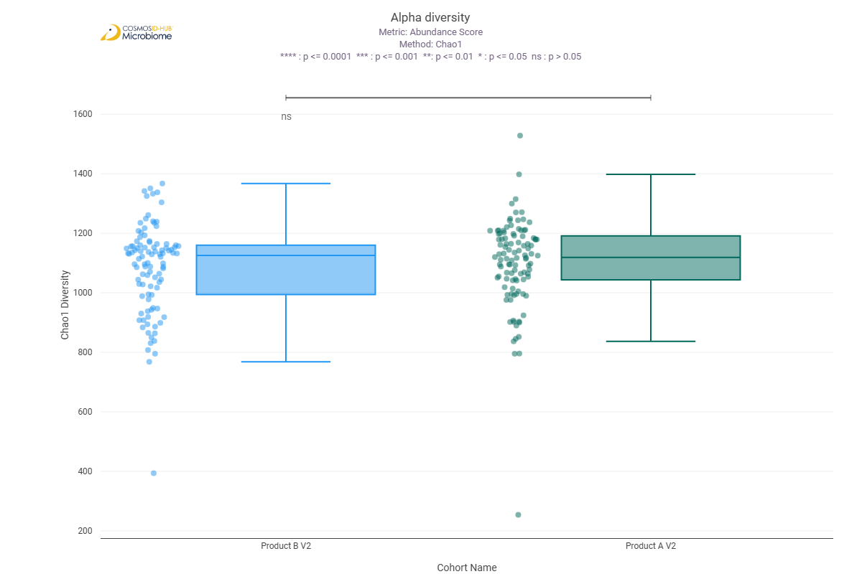
Shannon | 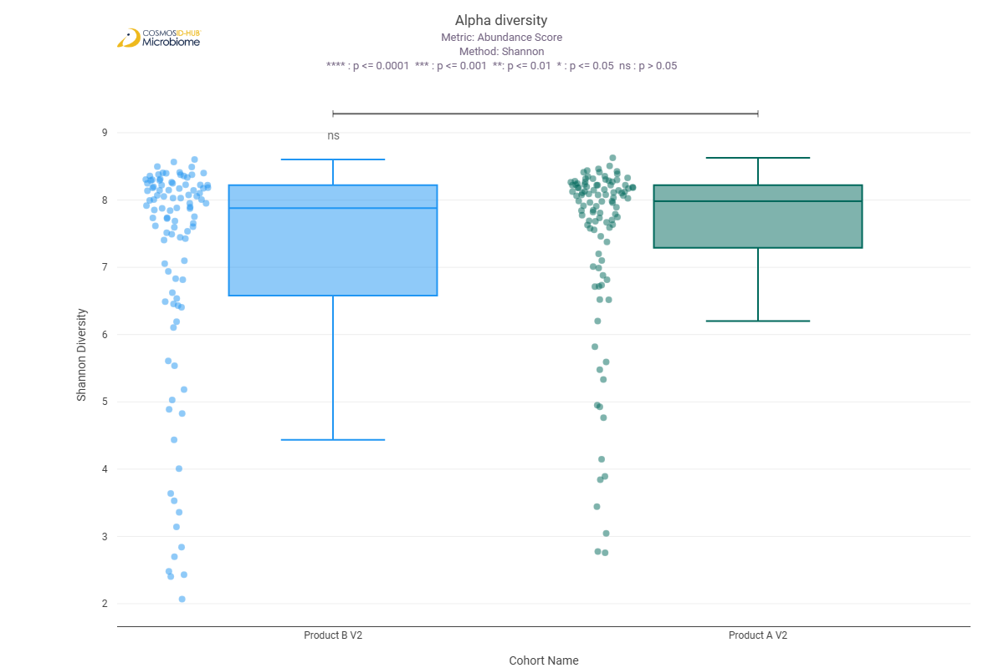
Simpson | 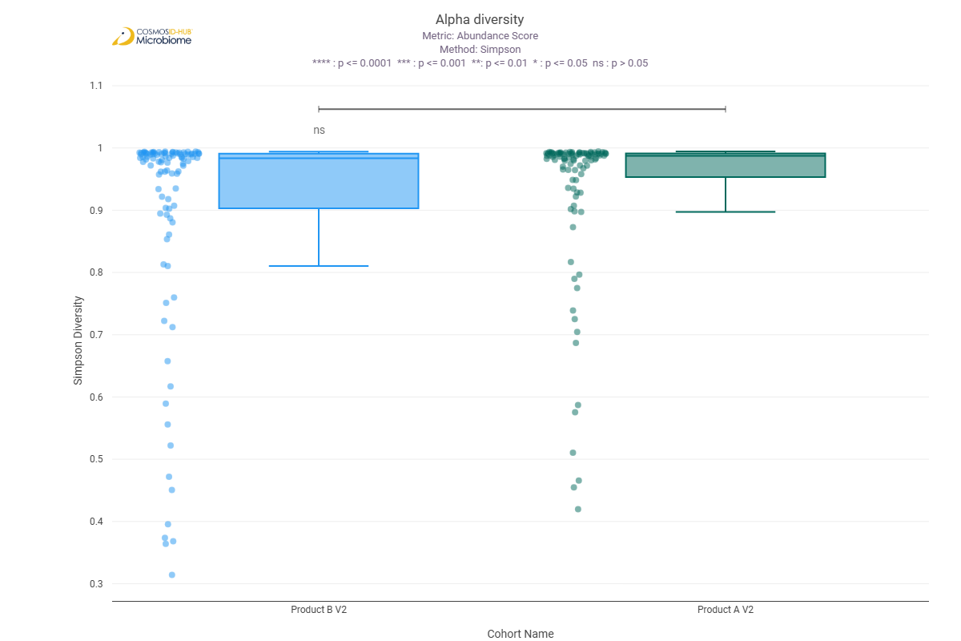

Beta Diversity (EC)
Bray-Curtis  PERMNOVA p = 0.091 | 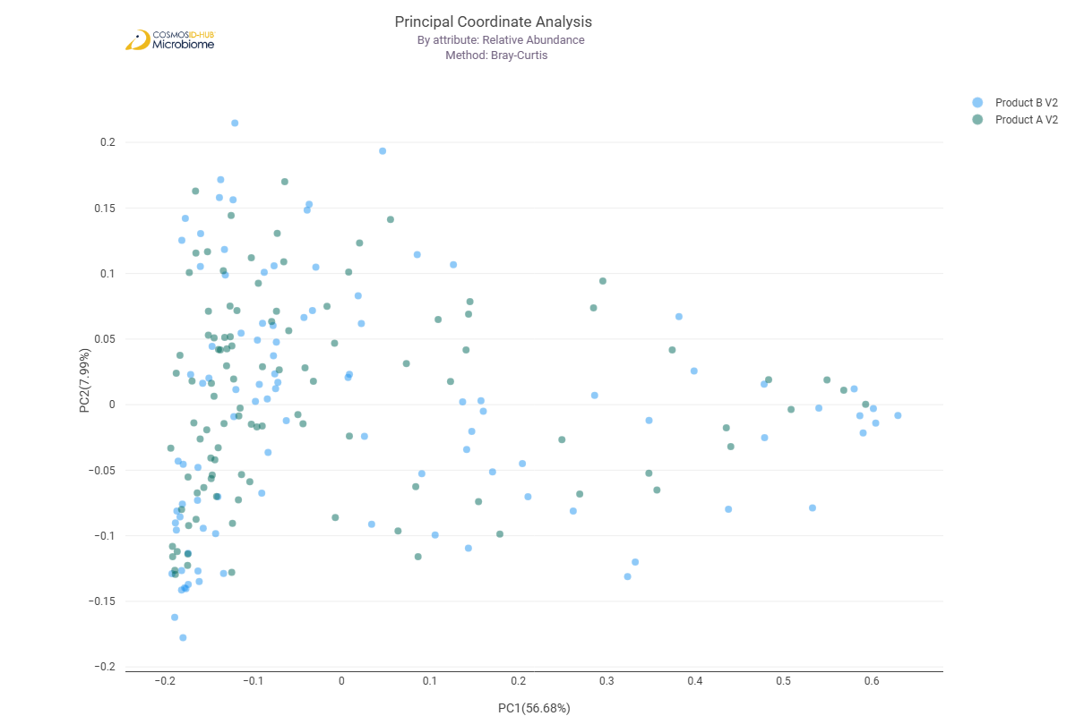

Differential Abundance (LEfSe) (EC)
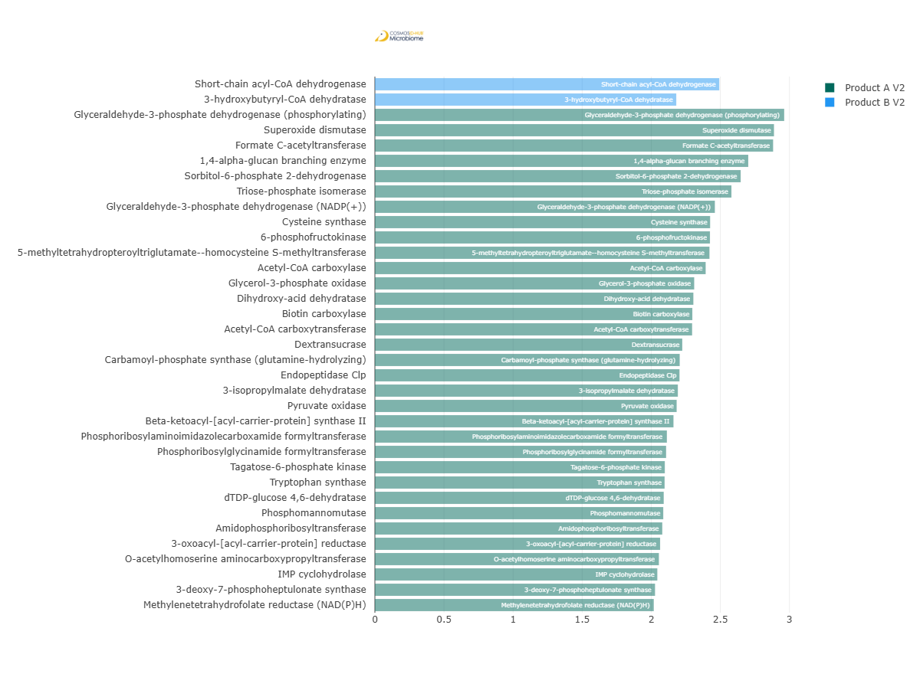
Feature | Enriched Cohort | LDA Score | P-value
Short-chain acyl-CoA dehydrogenase | Product B V2 | 2.49235307 | 0.047858458
3-hydroxybutyryl-CoA dehydratase | Product B V2 | 2.181214019 | 0.007008368
Glyceraldehyde-3-phosphate dehydrogenase (phosphorylating) | Product A V2 | 2.96240361 | 0.023181239
Superoxide dismutase | Product A V2 | 2.888470105 | 0.008512232
Formate C-acetyltransferase | Product A V2 | 2.882169725 | 0.049210789
1,4-alpha-glucan branching enzyme | Product A V2 | 2.702278422 | 0.01532342
Sorbitol-6-phosphate 2-dehydrogenase | Product A V2 | 2.647440049 | 0.009739743
Triose-phosphate isomerase | Product A V2 | 2.580449029 | 0.019446308
Glyceraldehyde-3-phosphate dehydrogenase (NADP(+)) | Product A V2 | 2.460621406 | 0.000147279
Cysteine synthase | Product A V2 | 2.426220942 | 0.000177076
6-phosphofructokinase | Product A V2 | 2.42502775 | 0.046277021
5-methyltetrahydropteroyltriglutamate--homocysteine S-methyltransferase | Product A V2 | 2.421501802 | 5.84E-03
Acetyl-CoA carboxylase | Product A V2 | 2.393966755 | 0.001383544
Glycerol-3-phosphate oxidase | Product A V2 | 2.311155395 | 0.047591773
Dihydroxy-acid dehydratase | Product A V2 | 2.305025521 | 0.004189269
Biotin carboxylase | Product A V2 | 2.297534048 | 0.006551378
Acetyl-CoA carboxytransferase | Product A V2 | 2.295974089 | 0.012071344
Dextransucrase | Product A V2 | 2.224701535 | 0.001199349
Carbamoyl-phosphate synthase (glutamine-hydrolyzing) | Product A V2 | 2.206170018 | 0.010399771
Endopeptidase Clp | Product A V2 | 2.204536759 | 0.026538437
3-isopropylmalate dehydratase | Product A V2 | 2.192743488 | 0.037794131
Pyruvate oxidase | Product A V2 | 2.184095944 | 0.041794368
Beta-ketoacyl-[acyl-carrier-protein] synthase II | Product A V2 | 2.161147246 | 0.032744287
Phosphoribosylaminoimidazolecarboxamide formyltransferase | Product A V2 | 2.11335053 | 3.97E-03
Phosphoribosylglycinamide formyltransferase | Product A V2 | 2.107677905 | 0.014829928
Tagatose-6-phosphate kinase | Product A V2 | 2.098303951 | 0.00984503
Tryptophan synthase | Product A V2 | 2.096956912 | 0.003188504
dTDP-glucose 4,6-dehydratase | Product A V2 | 2.090506399 | 0.010833904
Phosphomannomutase | Product A V2 | 2.086978462 | 0.027859375
Amidophosphoribosyltransferase | Product A V2 | 2.079994467 | 0.01522358
3-oxoacyl-[acyl-carrier-protein] reductase | Product A V2 | 2.064298956 | 0.010471034
O-acetylhomoserine aminocarboxypropyltransferase | Product A V2 | 2.055559479 | 0.000623736
IMP cyclohydrolase | Product A V2 | 2.044081157 | 0.009381425
3-deoxy-7-phosphoheptulonate synthase | Product A V2 | 2.027555519 | 0.044992985
Methylenetetrahydrofolate reductase (NAD(P)H) | Product A V2 | 2.018412166 | 0.040616459

MetaCyc Pathways

Alpha Diversity (MetaCyc)
Chao1 | 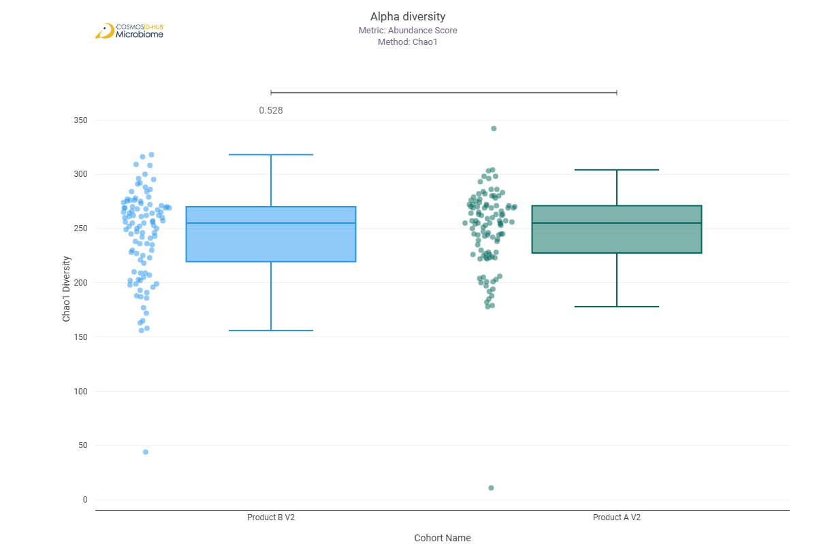
Shannon | 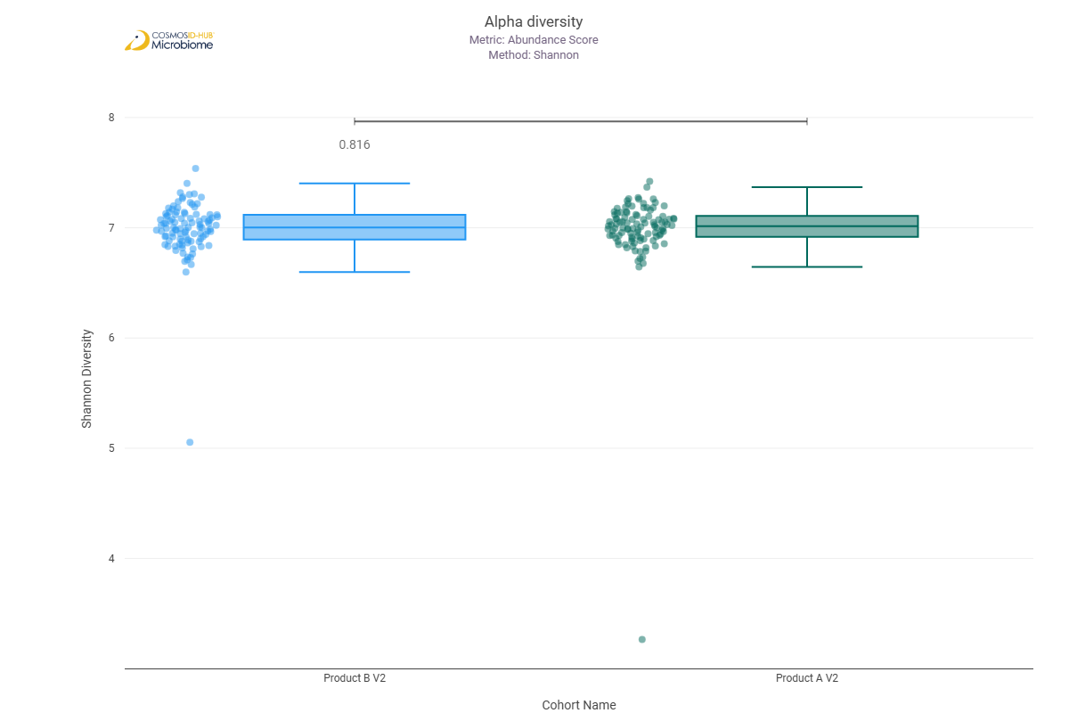
Simpson | 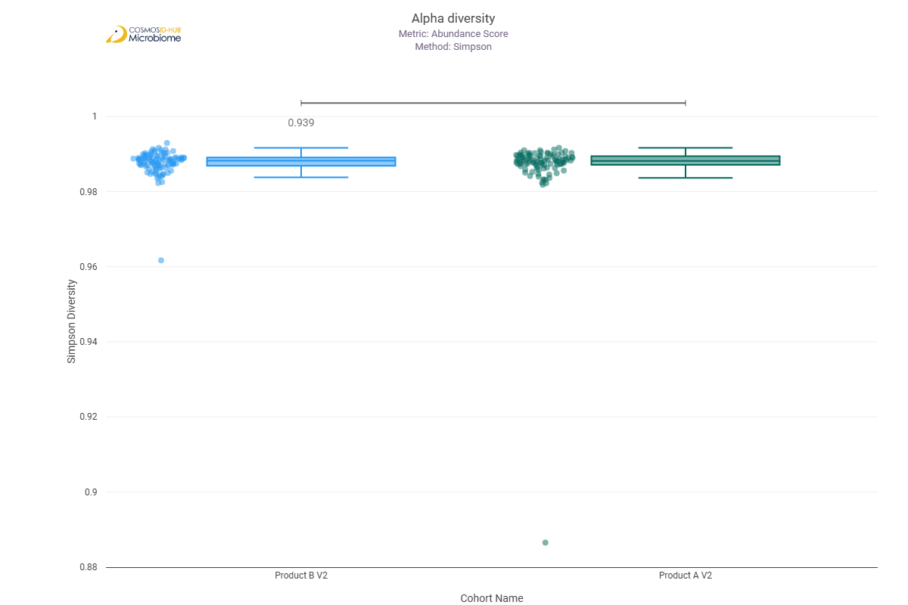

Beta Diversity (MetaCyc)
Bray-Curtis  PERMNOVA p = 0.003 | 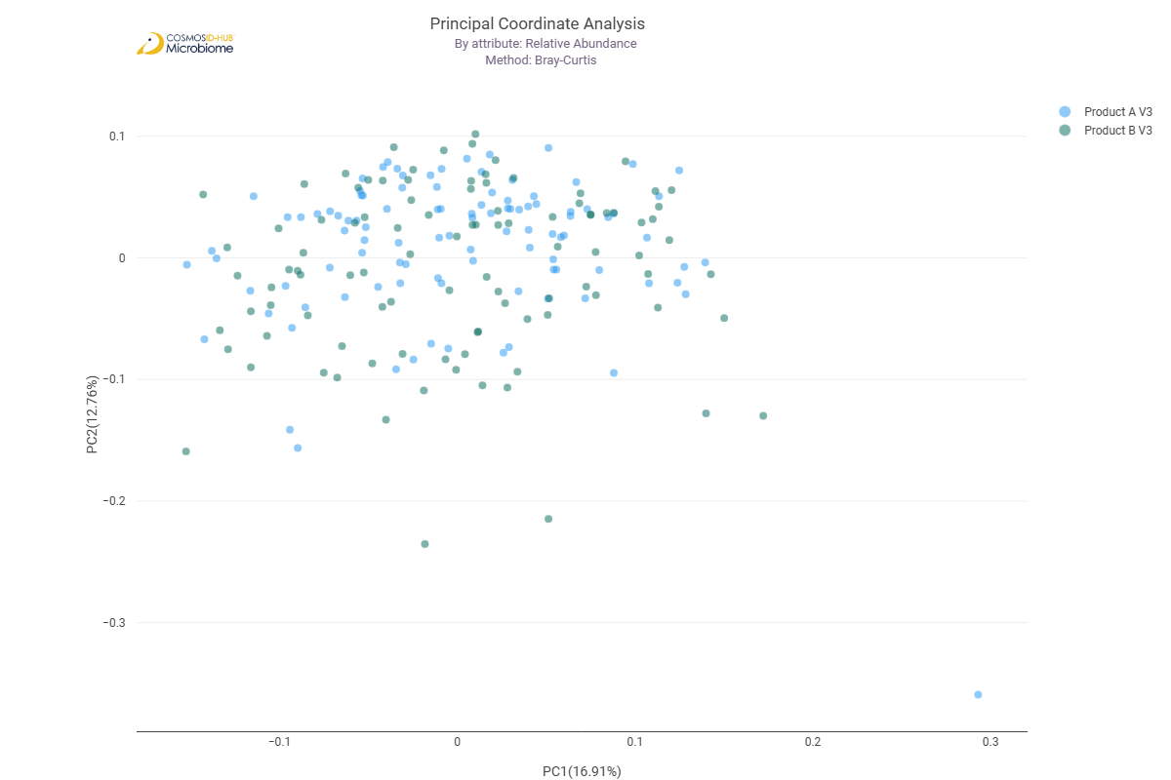

Differential Abundance (LEfSe) (MetaCyc)
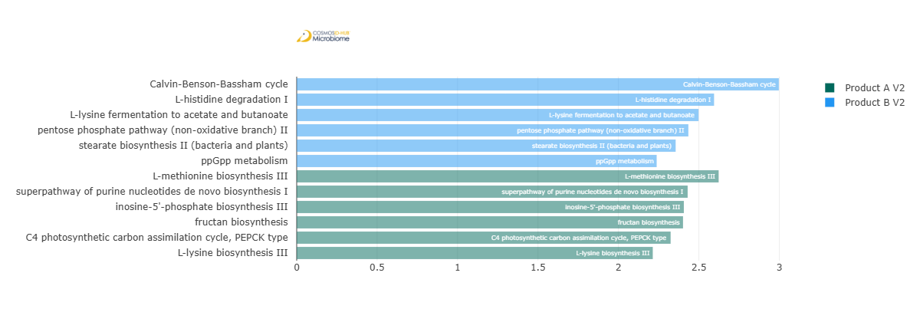
Feature | Enriched Cohort | LDA Score | P-value
Calvin-Benson-Bassham cycle | Product B V2 | 2.997196461 | 0.006693692
L-histidine degradation I | Product B V2 | 2.594507344 | 0.034935275
L-lysine fermentation to acetate and butanoate | Product B V2 | 2.498148123 | 0.033803124
pentose phosphate pathway (non-oxidative branch) II | Product B V2 | 2.434816755 | 0.002668748
stearate biosynthesis II (bacteria and plants) | Product B V2 | 2.355737355 | 0.018897851
ppGpp metabolism | Product B V2 | 2.23788823 | 0.032550826
L-methionine biosynthesis III | Product A V2 | 2.623137255 | 0.002918071
superpathway of purine nucleotides de novo biosynthesis I | Product A V2 | 2.430450703 | 0.037903528
inosine-5'-phosphate biosynthesis III | Product A V2 | 2.406751294 | 0.014349805
fructan biosynthesis | Product A V2 | 2.401680055 | 0.021736476
C4 photosynthetic carbon assimilation cycle, PEPCK type | Product A V2 | 2.324662591 | 0.029148795
L-lysine biosynthesis III | Product A V2 | 2.213631989 | 4.16E-02

Comparison 4: Product A V2 SAL vs Product A V3 SAL

Gene Ontology

Alpha Diversity (GO)
Chao1 | 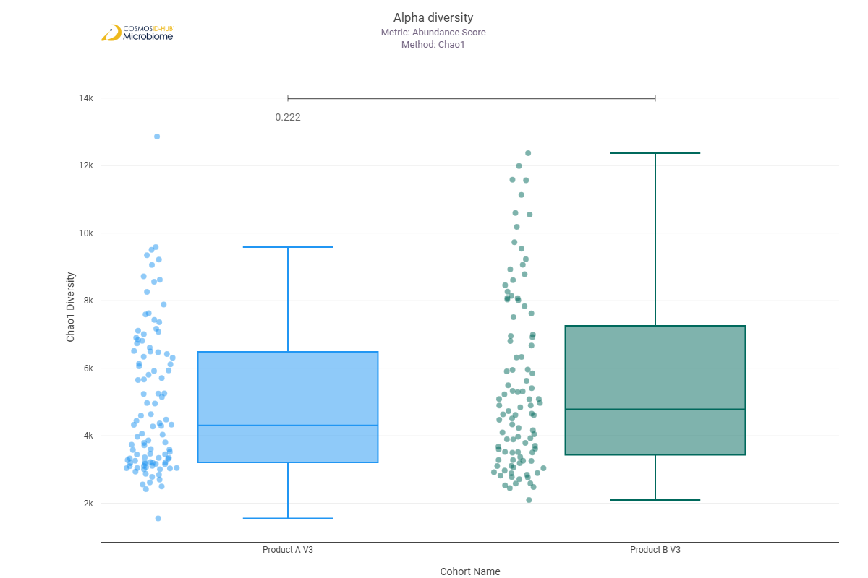
Shannon | 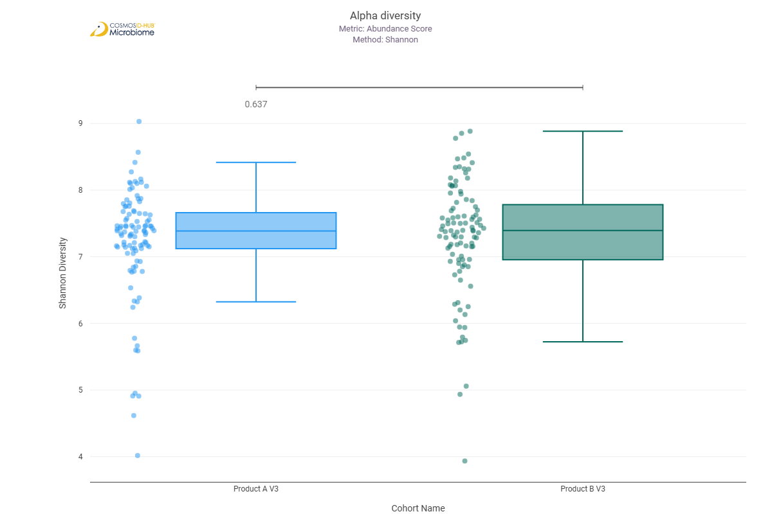
Simpson | 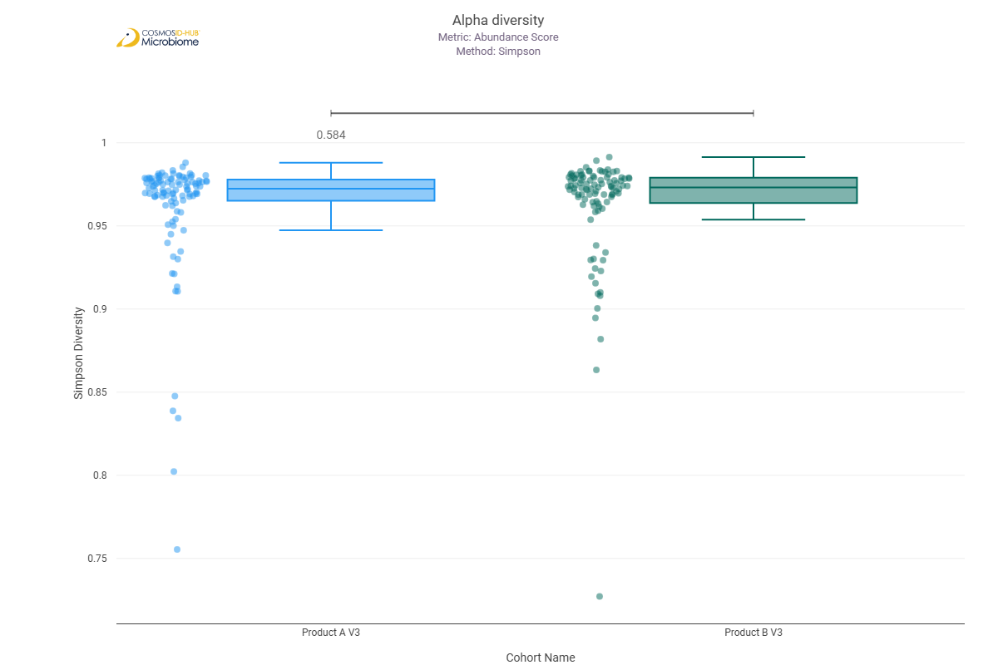

Beta Diversity (GO)
Bray-Curtis  PERMNOVA p = 0.107 | 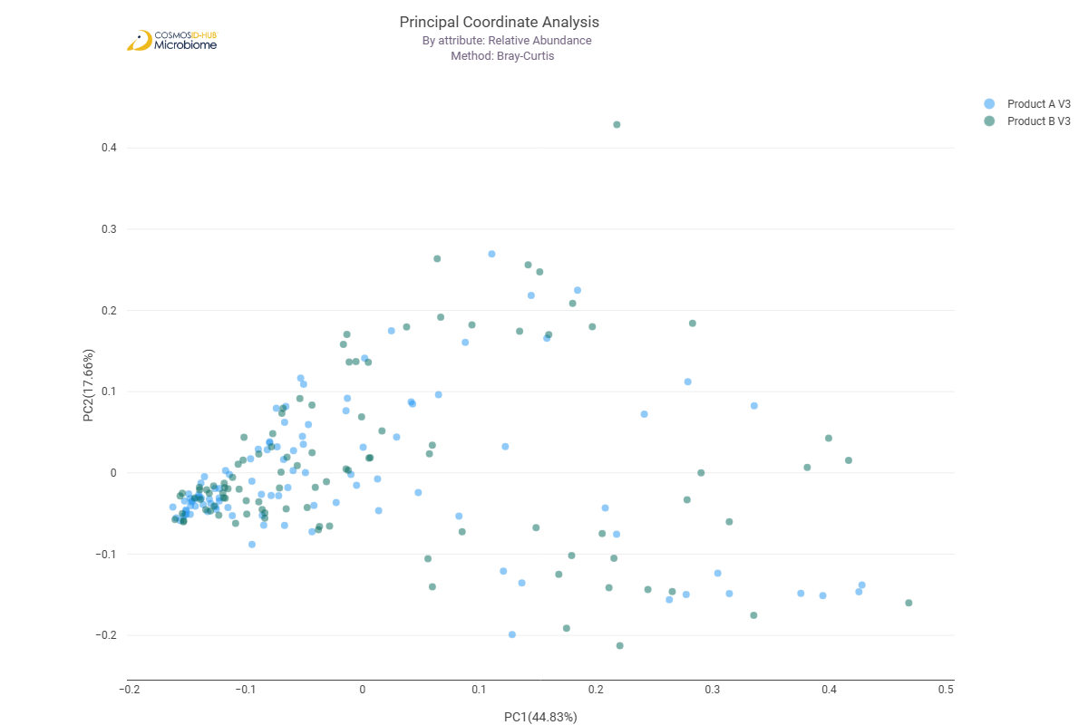

Differential Abundance (LEfSe) (GO)
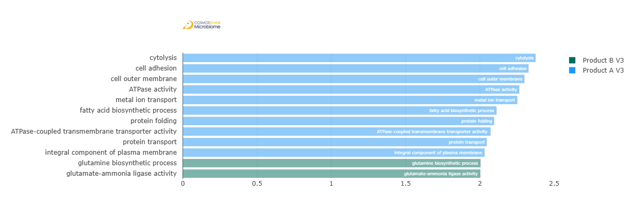
Feature | Enriched Cohort | LDA Score | P-value
cytolysis | Product A V3 | 2.375326591 | 0.014445134
cell adhesion | Product A V3 | 2.328189792 | 0.01744488
cell outer membrane | Product A V3 | 2.299945816 | 0.044739816
ATPase activity | Product A V3 | 2.265544054 | 0.025898504
metal ion transport | Product A V3 | 2.252289492 | 0.000698338
fatty acid biosynthetic process | Product A V3 | 2.112486859 | 0.001839284
protein folding | Product A V3 | 2.096102407 | 0.000359491
ATPase-coupled transmembrane transporter activity | Product A V3 | 2.072667654 | 0.004581458
protein transport | Product A V3 | 2.046545024 | 0.008571841
integral component of plasma membrane | Product A V3 | 2.032254996 | 0.008105245
glutamine biosynthetic process | Product B V3 | 2.004671978 | 2.19E-02
glutamate-ammonia ligase activity | Product B V3 | 2.00334107 | 0.025271957

Enzyme Commission

Alpha Diversity (EC)
Chao1 | 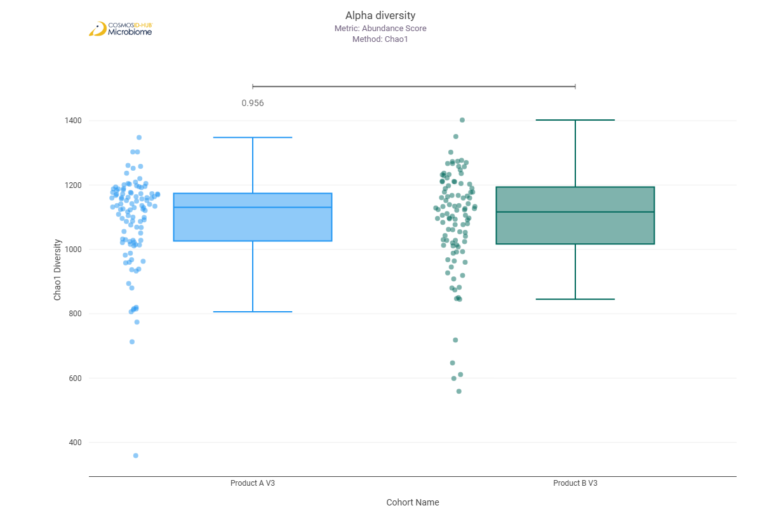
Shannon | 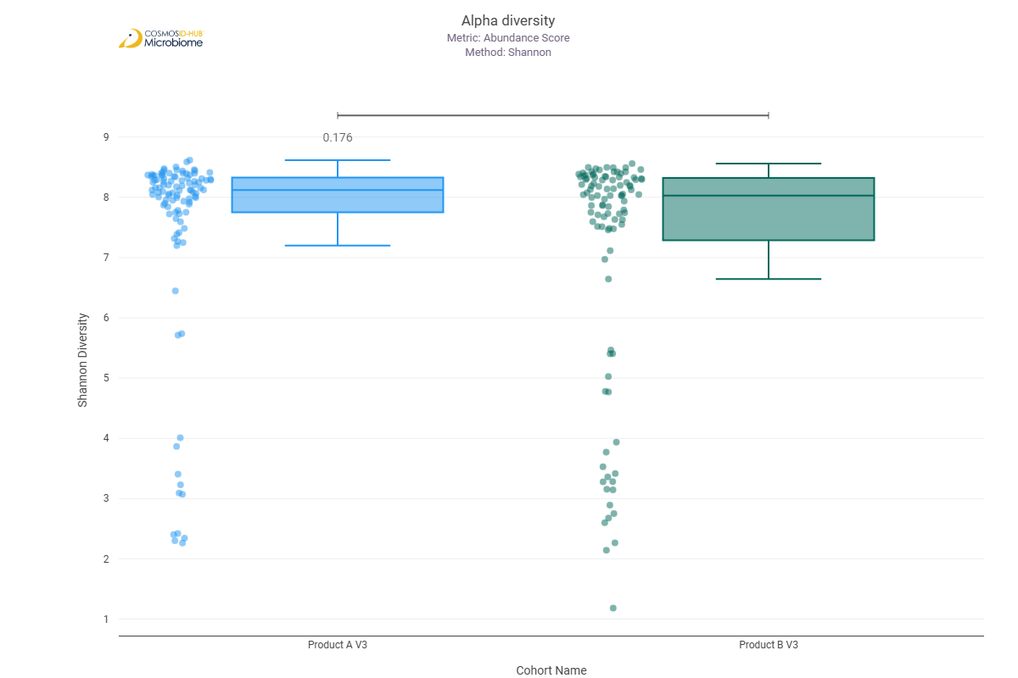
Simpson | 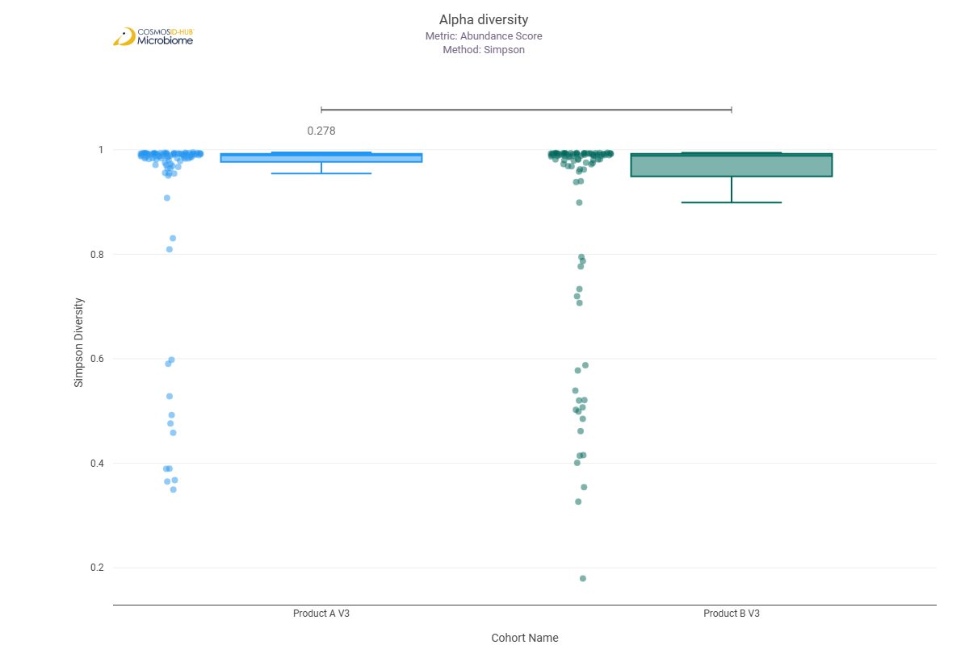

Beta Diversity (EC)
Bray-Curtis  PERMNOVA p = 0.072 | 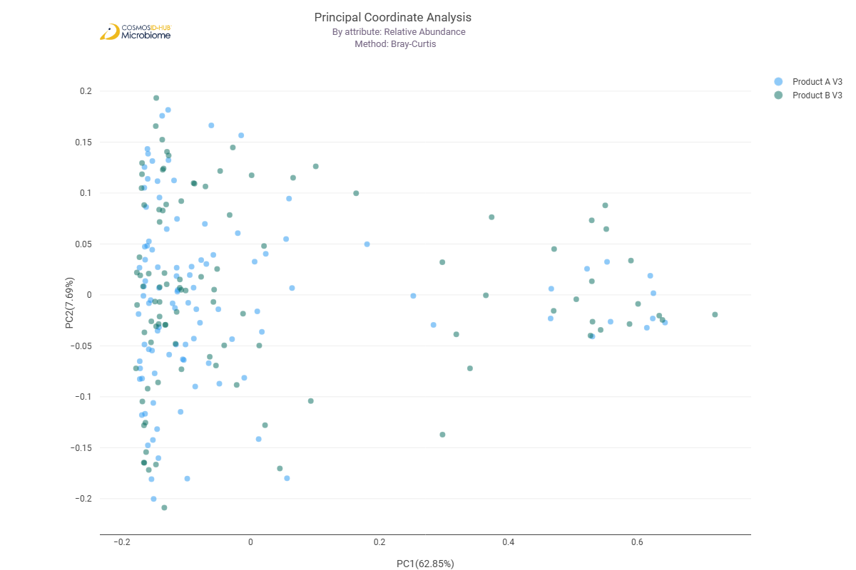

Differential Abundance (LEfSe) (EC)
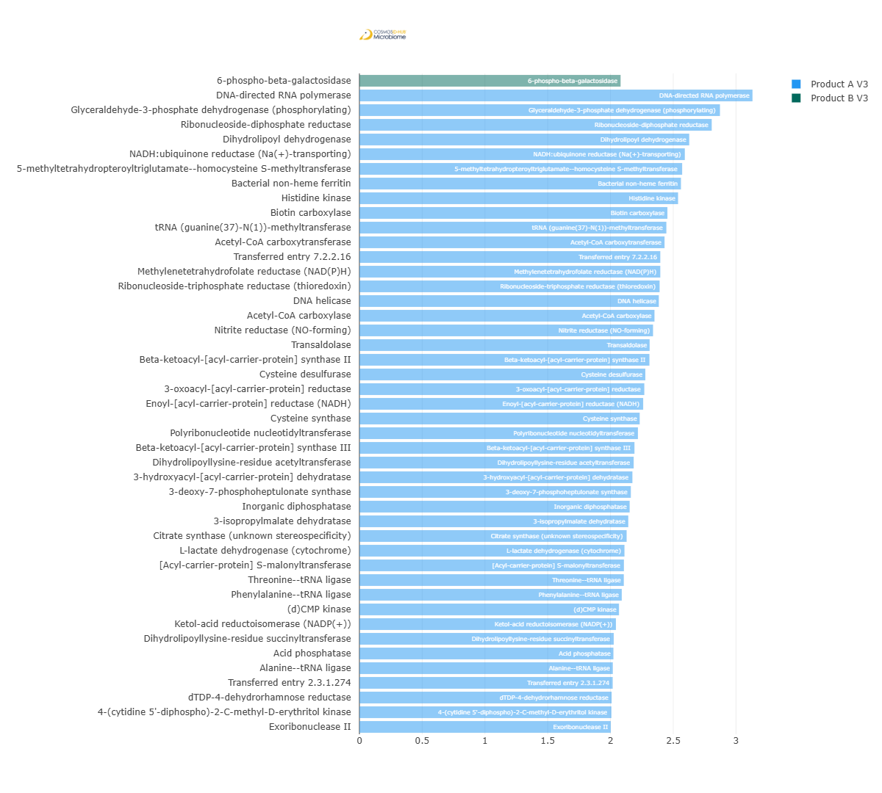
Feature | Enriched Cohort | LDA Score | P-value
6-phospho-beta-galactosidase | Product B V3 | 2.080727545 | 0.046385006
DNA-directed RNA polymerase | Product A V3 | 3.131684191 | 0.026538437
Glyceraldehyde-3-phosphate dehydrogenase (phosphorylating) | Product A V3 | 2.872341567 | 0.028198334
Ribonucleoside-diphosphate reductase | Product A V3 | 2.806603682 | 0.007770359
Dihydrolipoyl dehydrogenase | Product A V3 | 2.627544199 | 0.008937395
NADH:ubiquinone reductase (Na(+)-transporting) | Product A V3 | 2.59253101 | 0.013431321
5-methyltetrahydropteroyltriglutamate--homocysteine S-methyltransferase | Product A V3 | 2.571096295 | 0.012993227
Bacterial non-heme ferritin | Product A V3 | 2.561732858 | 0.022612184
Histidine kinase | Product A V3 | 2.53874264 | 0.017670566
Biotin carboxylase | Product A V3 | 2.453594887 | 0.002648014
tRNA (guanine(37)-N(1))-methyltransferase | Product A V3 | 2.445456033 | 0.000781151
Acetyl-CoA carboxytransferase | Product A V3 | 2.430837617 | 1.91E-03
Transferred entry 7.2.2.16 | Product A V3 | 2.397074415 | 0.03216757
Methylenetetrahydrofolate reductase (NAD(P)H) | Product A V3 | 2.397041877 | 0.027691217
Ribonucleoside-triphosphate reductase (thioredoxin) | Product A V3 | 2.391476364 | 0.009252593
DNA helicase | Product A V3 | 2.385246652 | 0.040384285
Acetyl-CoA carboxylase | Product A V3 | 2.350690765 | 0.014069443
Nitrite reductase (NO-forming) | Product A V3 | 2.339275293 | 0.006125811
Transaldolase | Product A V3 | 2.312003861 | 0.000815362
Beta-ketoacyl-[acyl-carrier-protein] synthase II | Product A V3 | 2.310457827 | 0.017001077
Cysteine desulfurase | Product A V3 | 2.277719109 | 0.003091956
3-oxoacyl-[acyl-carrier-protein] reductase | Product A V3 | 2.269677866 | 7.19E-03
Enoyl-[acyl-carrier-protein] reductase (NADH) | Product A V3 | 2.260621834 | 5.44775E-05
Cysteine synthase | Product A V3 | 2.232785492 | 0.011056954
Polyribonucleotide nucleotidyltransferase | Product A V3 | 2.218940509 | 0.00760761
Beta-ketoacyl-[acyl-carrier-protein] synthase III | Product A V3 | 2.191178527 | 0.016782914
Dihydrolipoyllysine-residue acetyltransferase | Product A V3 | 2.184992934 | 2.21596E-05
3-hydroxyacyl-[acyl-carrier-protein] dehydratase | Product A V3 | 2.174872472 | 0.006645961
3-deoxy-7-phosphoheptulonate synthase | Product A V3 | 2.162273672 | 0.000597086
Inorganic diphosphatase | Product A V3 | 2.152950641 | 0.028369142
3-isopropylmalate dehydratase | Product A V3 | 2.142110454 | 0.006693711
Citrate synthase (unknown stereospecificity) | Product A V3 | 2.128832033 | 0.047502293
L-lactate dehydrogenase (cytochrome) | Product A V3 | 2.111713408 | 0.000198287
[Acyl-carrier-protein] S-malonyltransferase | Product A V3 | 2.107247626 | 0.033133665
Threonine--tRNA ligase | Product A V3 | 2.106387094 | 0.01004989
Phenylalanine--tRNA ligase | Product A V3 | 2.090165423 | 0.01744488
(d)CMP kinase | Product A V3 | 2.068001372 | 0.007661517
Ketol-acid reductoisomerase (NADP(+)) | Product A V3 | 2.043610854 | 0.047858458
Dihydrolipoyllysine-residue succinyltransferase | Product A V3 | 2.026340003 | 0.028886698
Acid phosphatase | Product A V3 | 2.023639908 | 0.002648014
Alanine--tRNA ligase | Product A V3 | 2.018798405 | 0.02332543
Transferred entry 2.3.1.274 | Product A V3 | 2.017852023 | 0.003915394
dTDP-4-dehydrorhamnose reductase | Product A V3 | 2.009516698 | 0.005965544
4-(cytidine 5'-diphospho)-2-C-methyl-D-erythritol kinase | Product A V3 | 2.007683828 | 0.000111216
Exoribonuclease II | Product A V3 | 2.002632022 | 0.000131097

MetaCyc Pathways

Alpha Diversity (MetaCyc)
Chao1 | 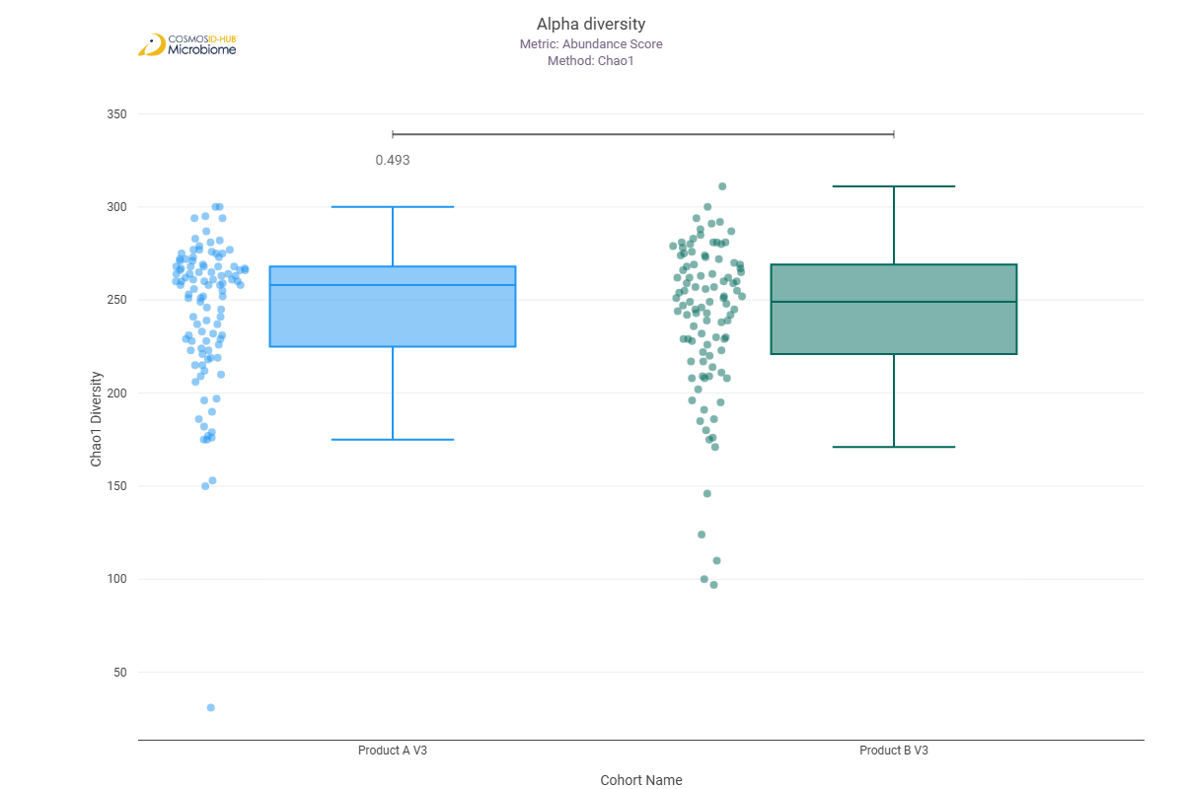
Shannon | 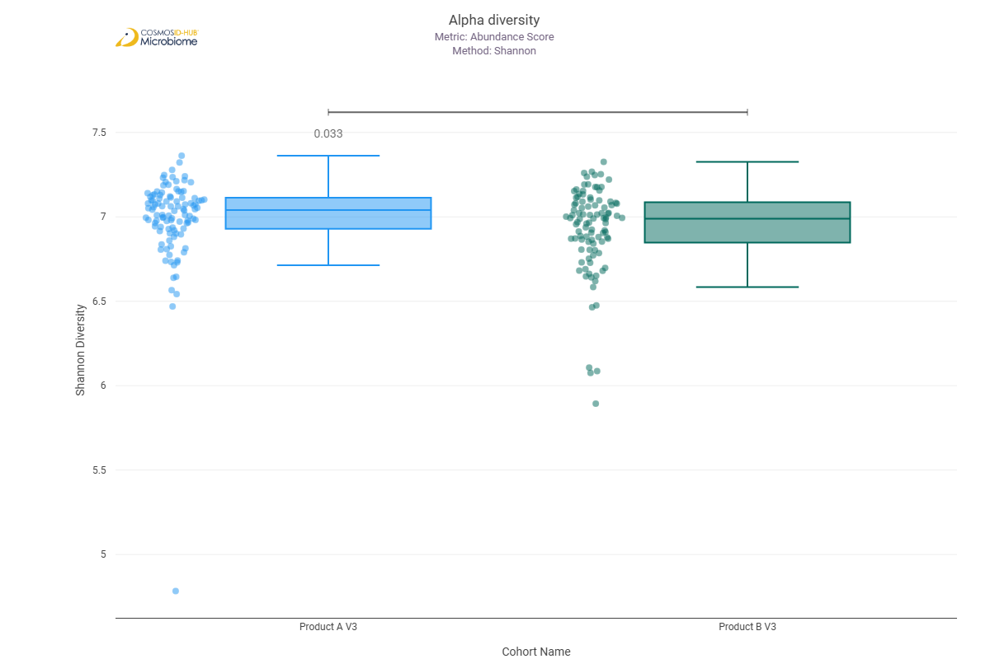
Simpson | 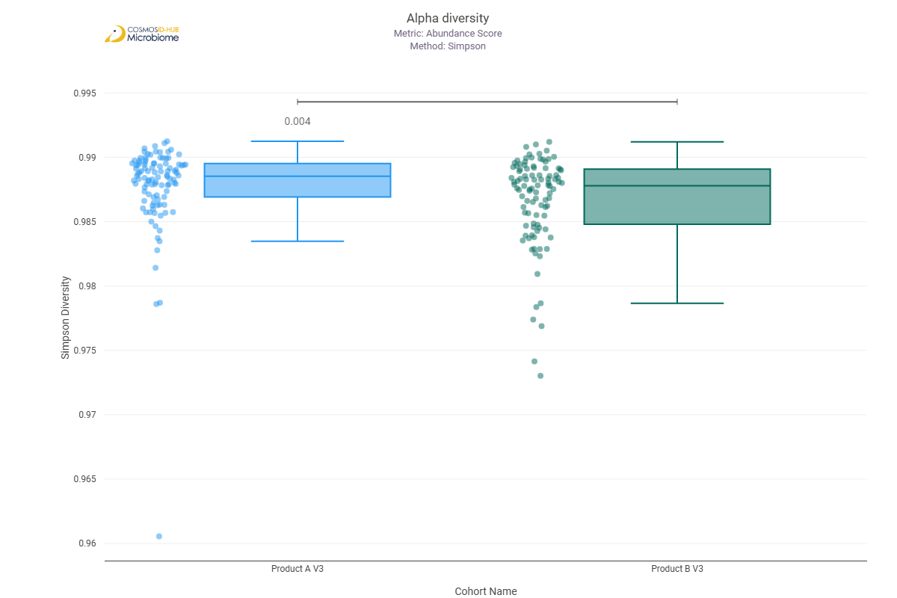

Beta Diversity (MetaCyc)
Bray-Curtis
PERMNOVA p = 0.003

Differential Abundance (LEfSe) (MetaCyc)
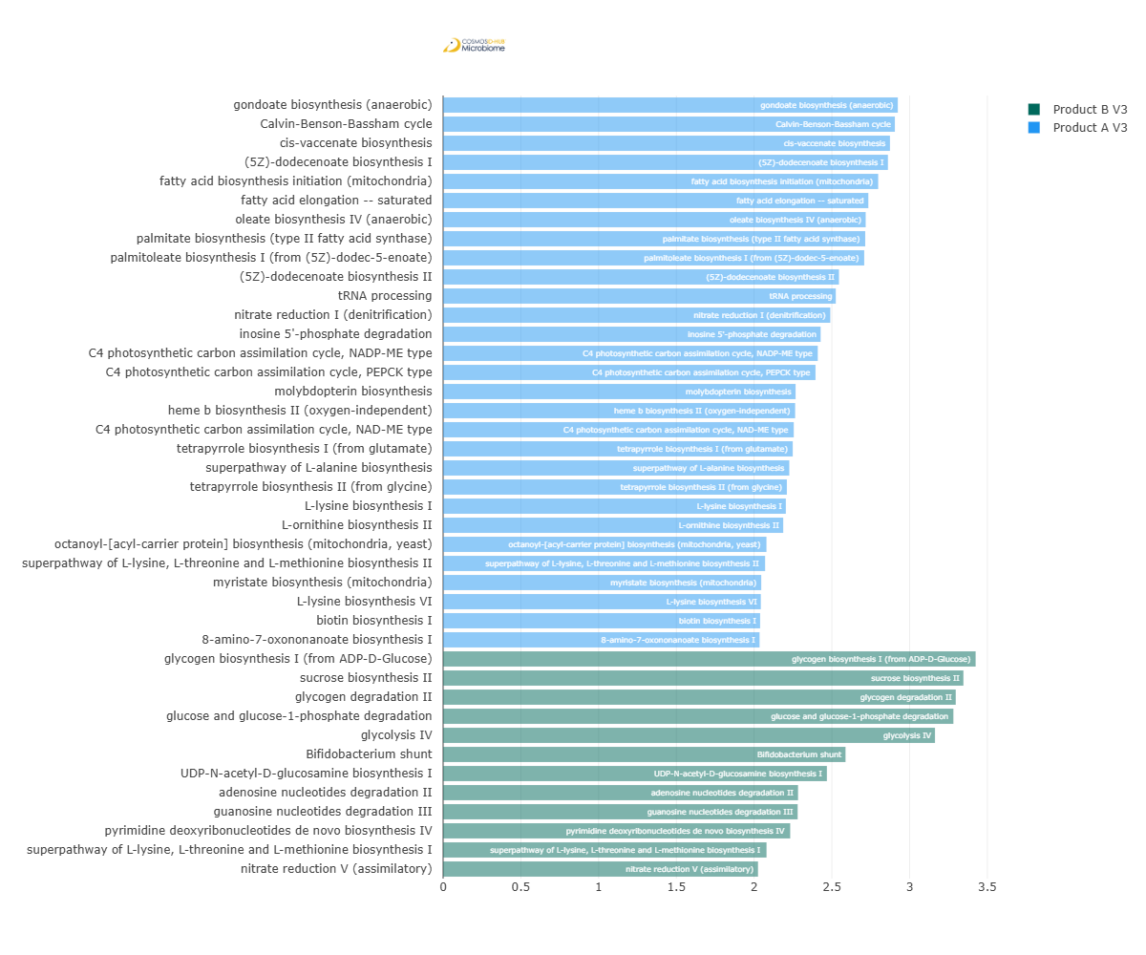
Feature | Enriched Cohort | LDA Score | P-value
gondoate biosynthesis (anaerobic) | Product A V3 | 2.924054289 | 1.71664E-05
Calvin-Benson-Bassham cycle | Product A V3 | 2.90518626 | 0.037034519
cis-vaccenate biosynthesis | Product A V3 | 2.873686051 | 0.000100888
(5Z)-dodecenoate biosynthesis I | Product A V3 | 2.860646941 | 0.000168085
fatty acid biosynthesis initiation (mitochondria) | Product A V3 | 2.798040194 | 0.014350494
fatty acid elongation -- saturated | Product A V3 | 2.734390918 | 0.000250374
oleate biosynthesis IV (anaerobic) | Product A V3 | 2.717536982 | 0.000364402
palmitate biosynthesis (type II fatty acid synthase) | Product A V3 | 2.714526789 | 0.007301725
palmitoleate biosynthesis I (from (5Z)-dodec-5-enoate) | Product A V3 | 2.708135225 | 0.000464298
(5Z)-dodecenoate biosynthesis II | Product A V3 | 2.545755648 | 0.000414729
tRNA processing | Product A V3 | 2.525229504 | 0.0003883
nitrate reduction I (denitrification) | Product A V3 | 2.489917921 | 0.001492854
inosine 5'-phosphate degradation | Product A V3 | 2.427780228 | 0.008219712
C4 photosynthetic carbon assimilation cycle, NADP-ME type | Product A V3 | 2.409347733 | 0.000732058
C4 photosynthetic carbon assimilation cycle, PEPCK type | Product A V3 | 2.394946465 | 0.012152566
molybdopterin biosynthesis | Product A V3 | 2.266745981 | 7.60264E-06
heme b biosynthesis II (oxygen-independent) | Product A V3 | 2.264050701 | 1.53555E-06
C4 photosynthetic carbon assimilation cycle, NAD-ME type | Product A V3 | 2.254910685 | 1.72E-03
tetrapyrrole biosynthesis I (from glutamate) | Product A V3 | 2.248434275 | 0.003468115
superpathway of L-alanine biosynthesis | Product A V3 | 2.226385681 | 0.004459743
tetrapyrrole biosynthesis II (from glycine) | Product A V3 | 2.210751712 | 0.011432973
L-lysine biosynthesis I | Product A V3 | 2.204168356 | 0.006050982
L-ornithine biosynthesis II | Product A V3 | 2.187087921 | 9.90522E-05
octanoyl-[acyl-carrier protein] biosynthesis (mitochondria, yeast) | Product A V3 | 2.079495823 | 0.004954342
superpathway of L-lysine, L-threonine and L-methionine biosynthesis II | Product A V3 | 2.070683632 | 0.014539384
myristate biosynthesis (mitochondria) | Product A V3 | 2.045732729 | 0.007144376
L-lysine biosynthesis VI | Product A V3 | 2.04325135 | 0.017109717
biotin biosynthesis I | Product A V3 | 2.038724205 | 0.00151055
8-amino-7-oxononanoate biosynthesis I | Product A V3 | 2.034984754 | 0.0141078
glycogen biosynthesis I (from ADP-D-Glucose) | Product B V3 | 3.424674828 | 0.041084202
sucrose biosynthesis II | Product B V3 | 3.34606056 | 0.011750774
glycogen degradation II | Product B V3 | 3.296799534 | 0.00049628
glucose and glucose-1-phosphate degradation | Product B V3 | 3.28145505 | 0.000621487
glycolysis IV | Product B V3 | 3.163269183 | 0.041319779
Bifidobacterium shunt | Product B V3 | 2.587848076 | 0.031218555
UDP-N-acetyl-D-glucosamine biosynthesis I | Product B V3 | 2.468183133 | 1.29E-02
adenosine nucleotides degradation II | Product B V3 | 2.282555947 | 0.031371437
guanosine nucleotides degradation III | Product B V3 | 2.280018501 | 0.0383138
pyrimidine deoxyribonucleotides de novo biosynthesis IV | Product B V3 | 2.232203919 | 0.020694587
superpathway of L-lysine, L-threonine and L-methionine biosynthesis I | Product B V3 | 2.079988259 | 0.003202322
nitrate reduction V (assimilatory) | Product B V3 | 2.025191349 | 0.026585987

Comparison 5: Product A V3 vs Product B V3

Gene Ontology

Alpha Diversity (GO)
Chao1 | 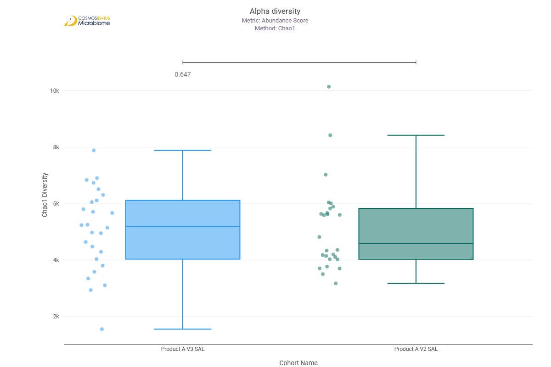
Shannon | 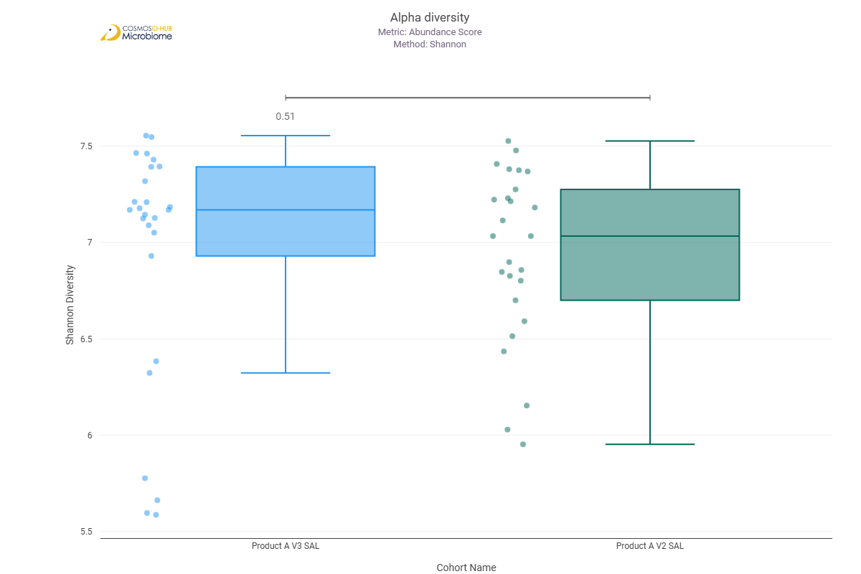
Simpson | 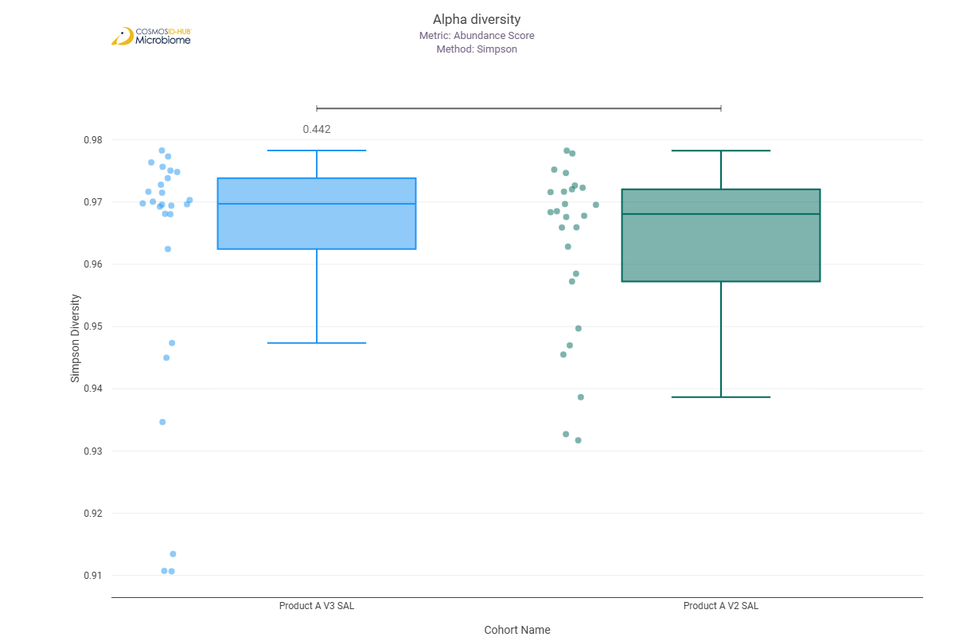

Beta Diversity (GO)
Bray-Curtis  PERMNOVA p = 0.473 | 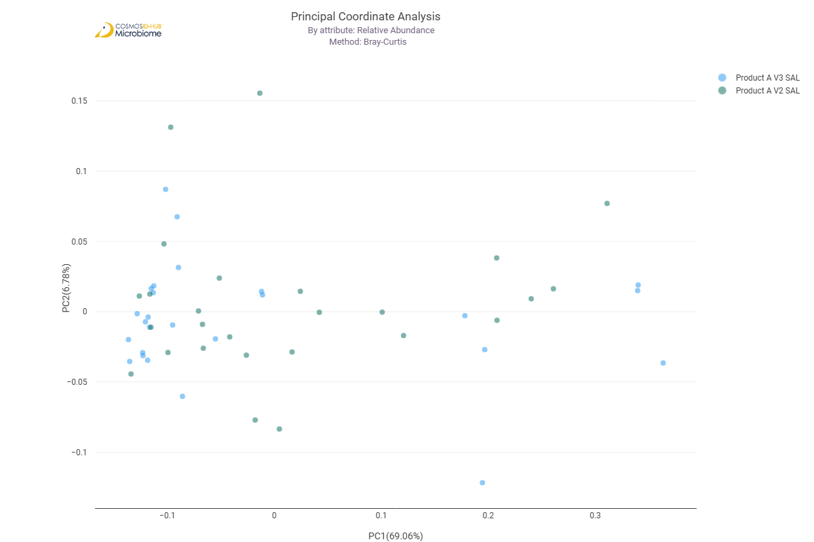

Differential Abundance (LEfSe) (GO)
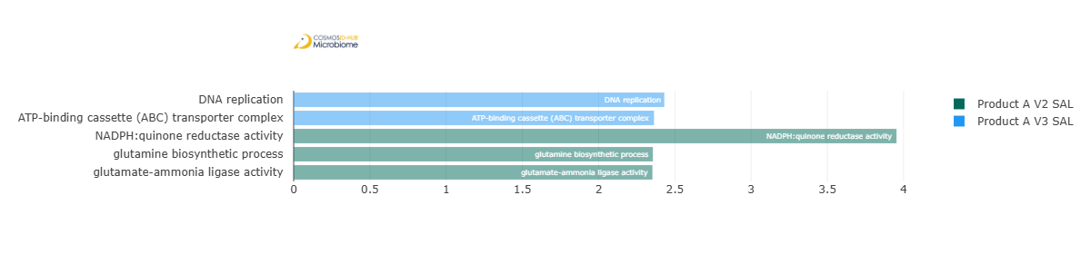
Feature | Enriched Cohort | LDA Score | P-value
DNA replication | Product A V3 SAL | 2.430760658 | 0.035322927
ATP-binding cassette (ABC) transporter complex | Product A V3 SAL | 2.362960966 | 0.032254747
NADPH:quinone reductase activity | Product A V2 SAL | 3.953508756 | 0.040390461
glutamine biosynthetic process | Product A V2 SAL | 2.355947932 | 0.007139316
glutamate-ammonia ligase activity | Product A V2 SAL | 2.353037259 | 0.02556575

Enzyme Commission

Alpha Diversity (EC)
Chao1 | 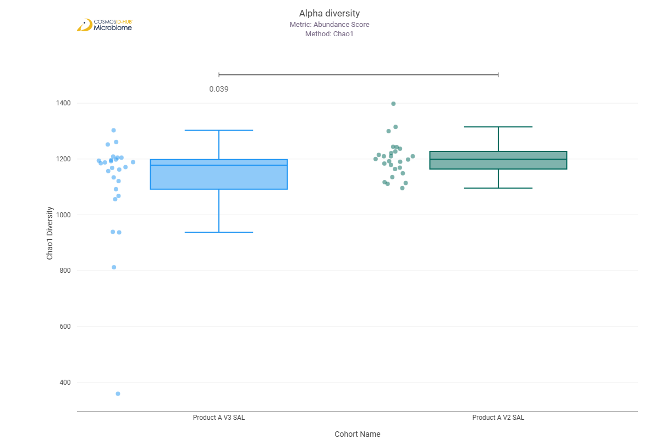
Shannon | 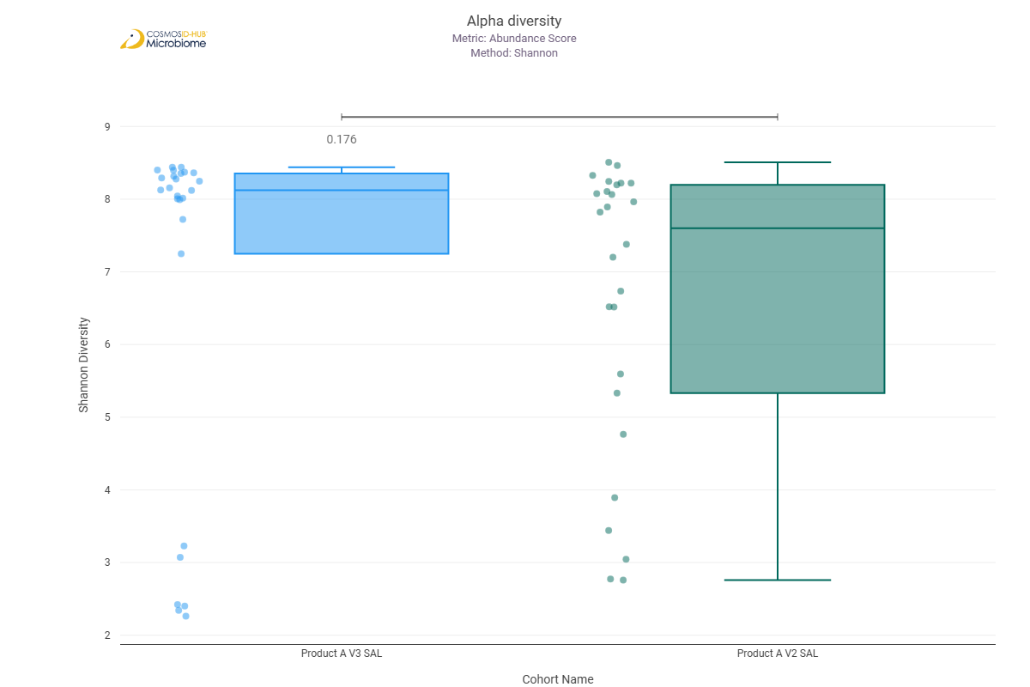
Simpson | 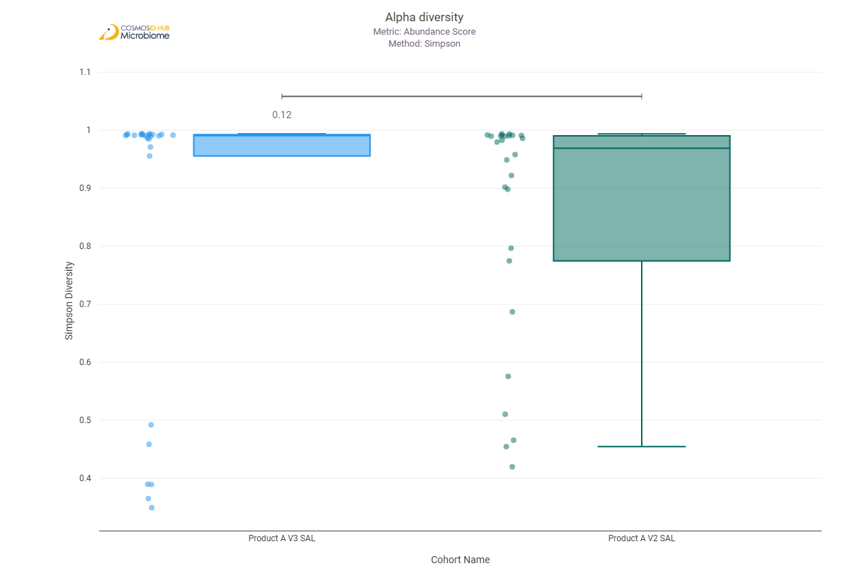

Beta Diversity (EC)
Bray-Curtis  PERMNOVA p = 0.412 | 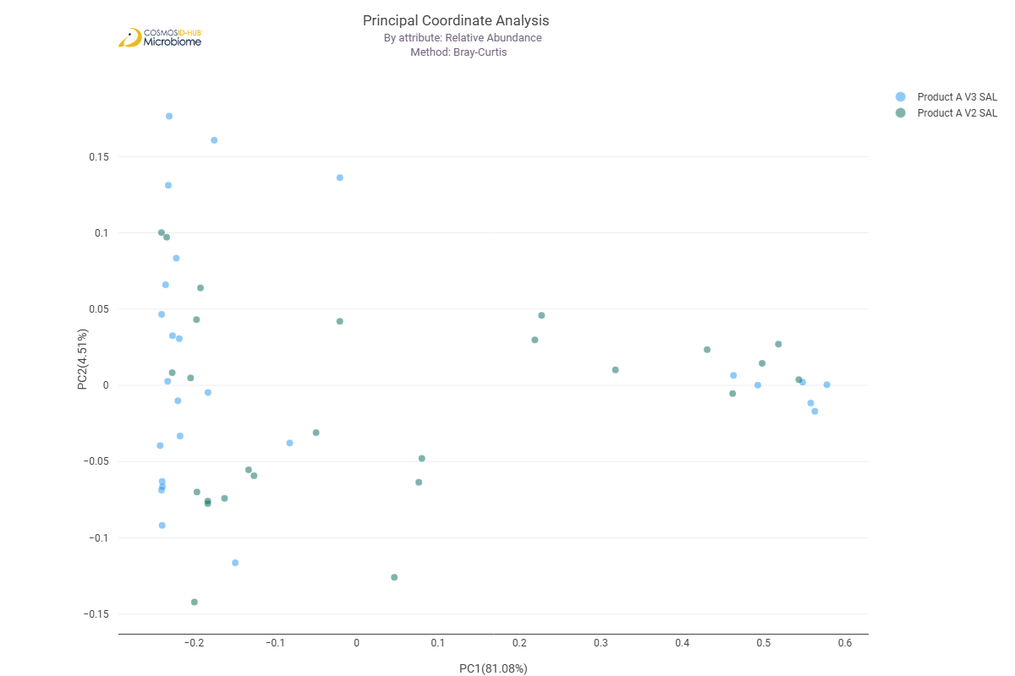

Differential Abundance (LEfSe) (EC)
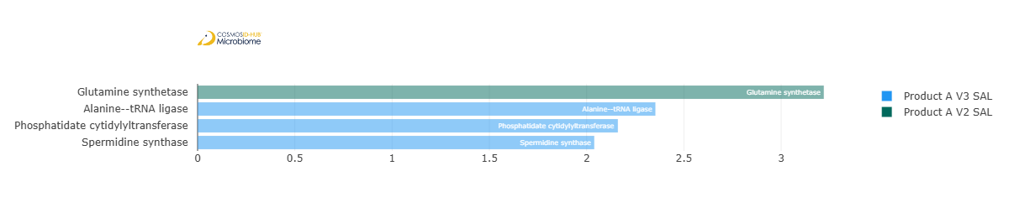
Feature | Enriched Cohort | LDA Score | P-value
Glutamine synthetase | Product A V2 SAL | 3.219463934 | 0.006393679
Alanine--tRNA ligase | Product A V3 SAL | 2.353669717 | 0.014192278
Phosphatidate cytidylyltransferase | Product A V3 SAL | 2.160690623 | 0.038636777
Spermidine synthase | Product A V3 SAL | 2.039315636 | 0.040390461

MetaCyc Pathways

Alpha Diversity (MetaCyc)
Chao1 | 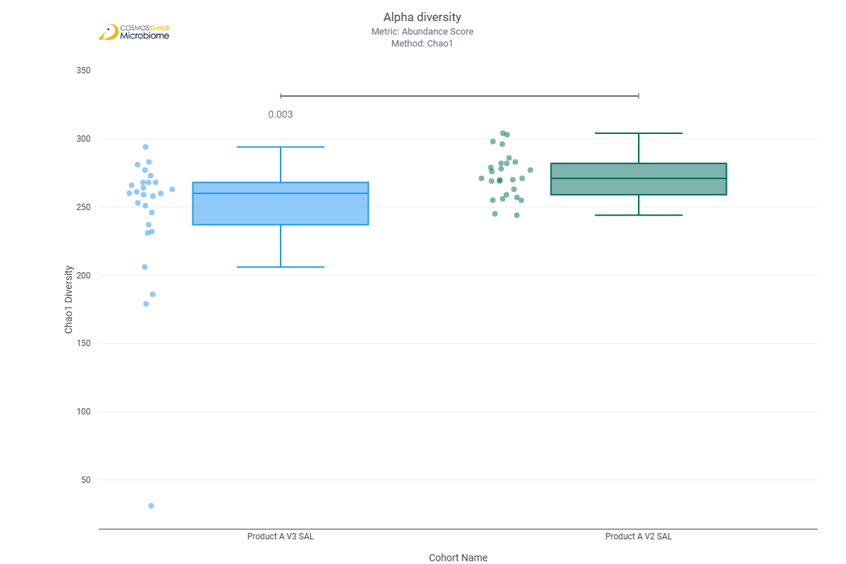
Shannon | 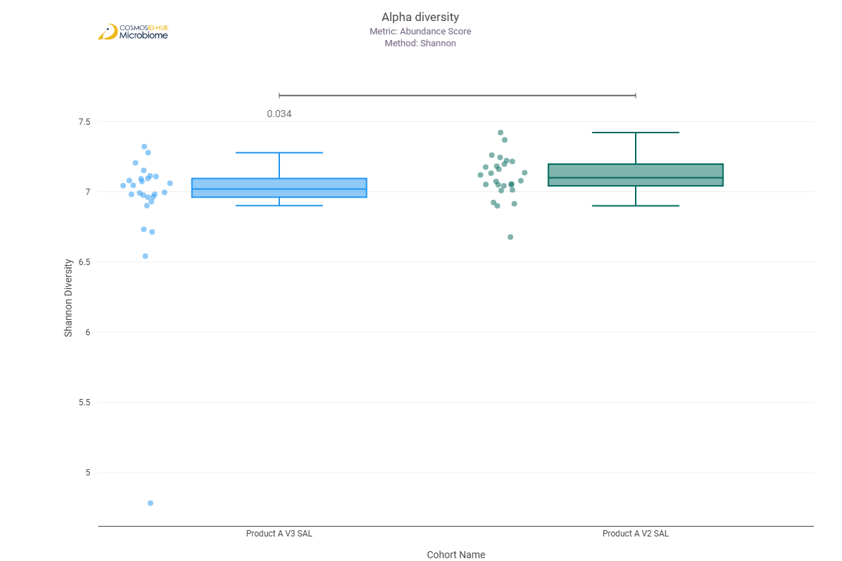
Simpson | 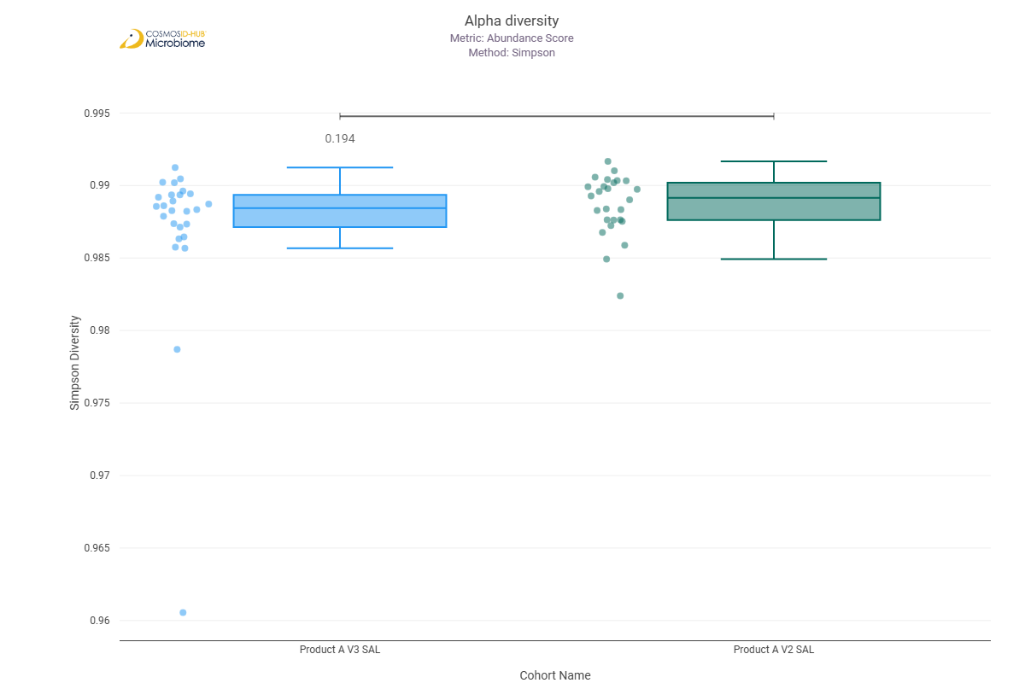

Beta Diversity (MetaCyc)
Bray-Curtis  PERMNOVA p = 0.401 | 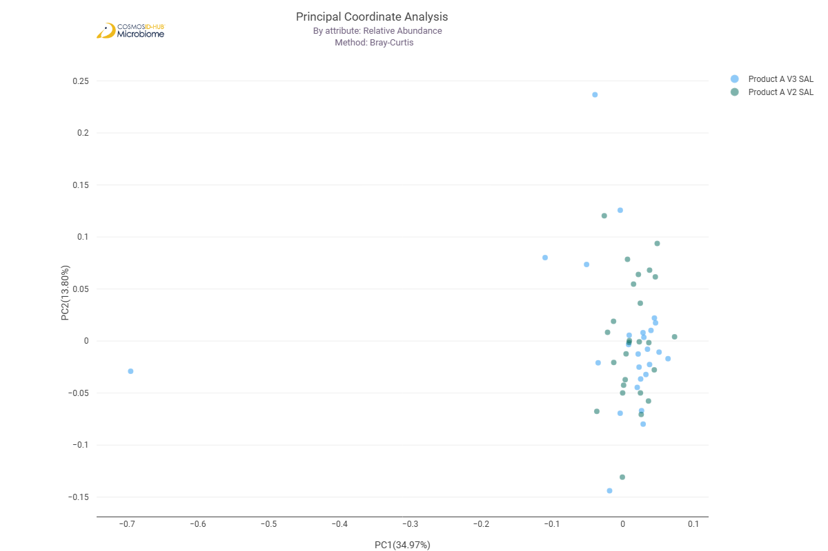

Differential Abundance (LEfSe) (MetaCyc)
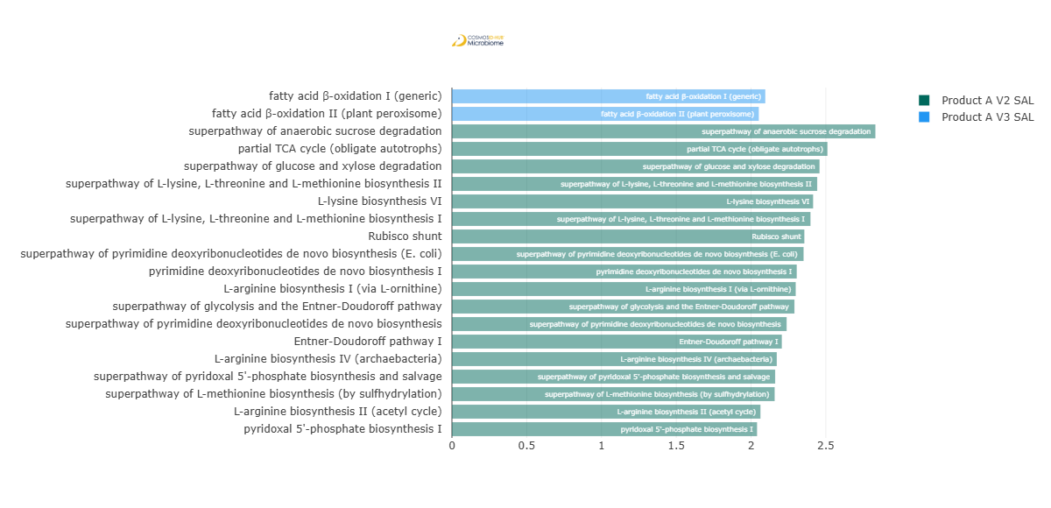
Feature | Enriched Cohort | LDA Score | P-value
fatty acid β-oxidation I (generic) | Product A V3 SAL | 2.095429545 | 0.022553634
fatty acid β-oxidation II (plant peroxisome) | Product A V3 SAL | 2.051853376 | 0.033983438
superpathway of anaerobic sucrose degradation | Product A V2 SAL | 2.831636712 | 0.046061451
partial TCA cycle (obligate autotrophs) | Product A V2 SAL | 2.510981802 | 0.014192278
superpathway of glucose and xylose degradation | Product A V2 SAL | 2.458074599 | 0.001825689
superpathway of L-lysine, L-threonine and L-methionine biosynthesis II | Product A V2 SAL | 2.442438549 | 0.02808172
L-lysine biosynthesis VI | Product A V2 SAL | 2.415101559 | 0.030808261
superpathway of L-lysine, L-threonine and L-methionine biosynthesis I | Product A V2 SAL | 2.397506712 | 0.002163783
Rubisco shunt | Product A V2 SAL | 2.356421973 | 0.030608442
superpathway of pyrimidine deoxyribonucleotides de novo biosynthesis (E. coli) | Product A V2 SAL | 2.351444885 | 0.004756827
pyrimidine deoxyribonucleotides de novo biosynthesis I | Product A V2 SAL | 2.305719888 | 0.013266719
L-arginine biosynthesis I (via L-ornithine) | Product A V2 SAL | 2.29886903 | 0.000911585
superpathway of glycolysis and the Entner-Doudoroff pathway | Product A V2 SAL | 2.290181726 | 0.004455412
superpathway of pyrimidine deoxyribonucleotides de novo biosynthesis | Product A V2 SAL | 2.237994675 | 2.09E-02
Entner-Doudoroff pathway I | Product A V2 SAL | 2.205795946 | 0.004718777
L-arginine biosynthesis IV (archaebacteria) | Product A V2 SAL | 2.17211688 | 0.004825811
superpathway of pyridoxal 5'-phosphate biosynthesis and salvage | Product A V2 SAL | 2.161332919 | 0.033683115
superpathway of L-methionine biosynthesis (by sulfhydrylation) | Product A V2 SAL | 2.158067819 | 0.002046016
L-arginine biosynthesis II (acetyl cycle) | Product A V2 SAL | 2.062786375 | 0.007905304
pyridoxal 5'-phosphate biosynthesis I | Product A V2 SAL | 2.040191452 | 0.013446627

Comparison 6: Product B V2 SAL vs Product B V3 SAL

Gene Ontology

Alpha Diversity (GO)
Chao1 | 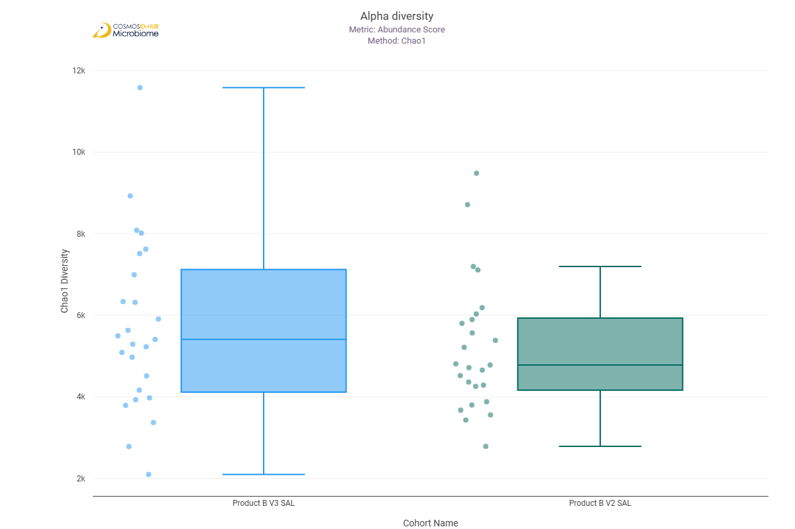
Shannon | 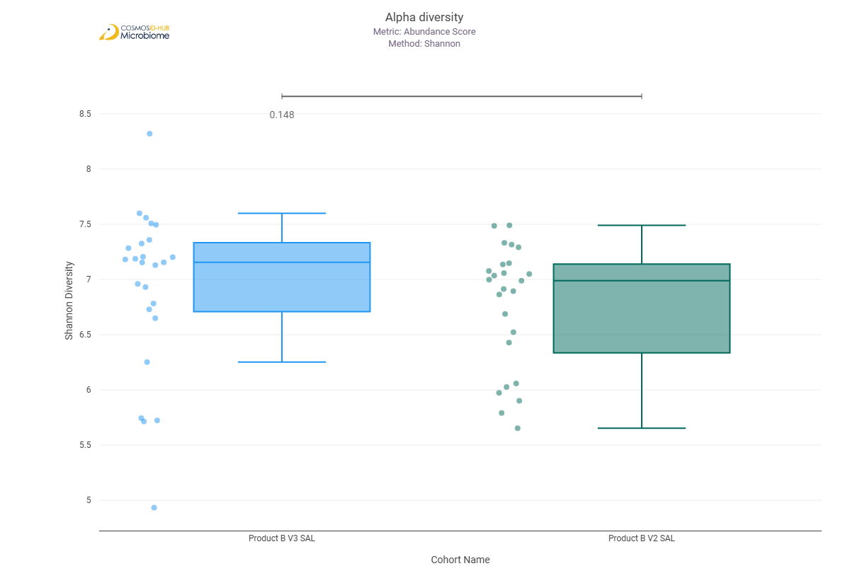
Simpson | 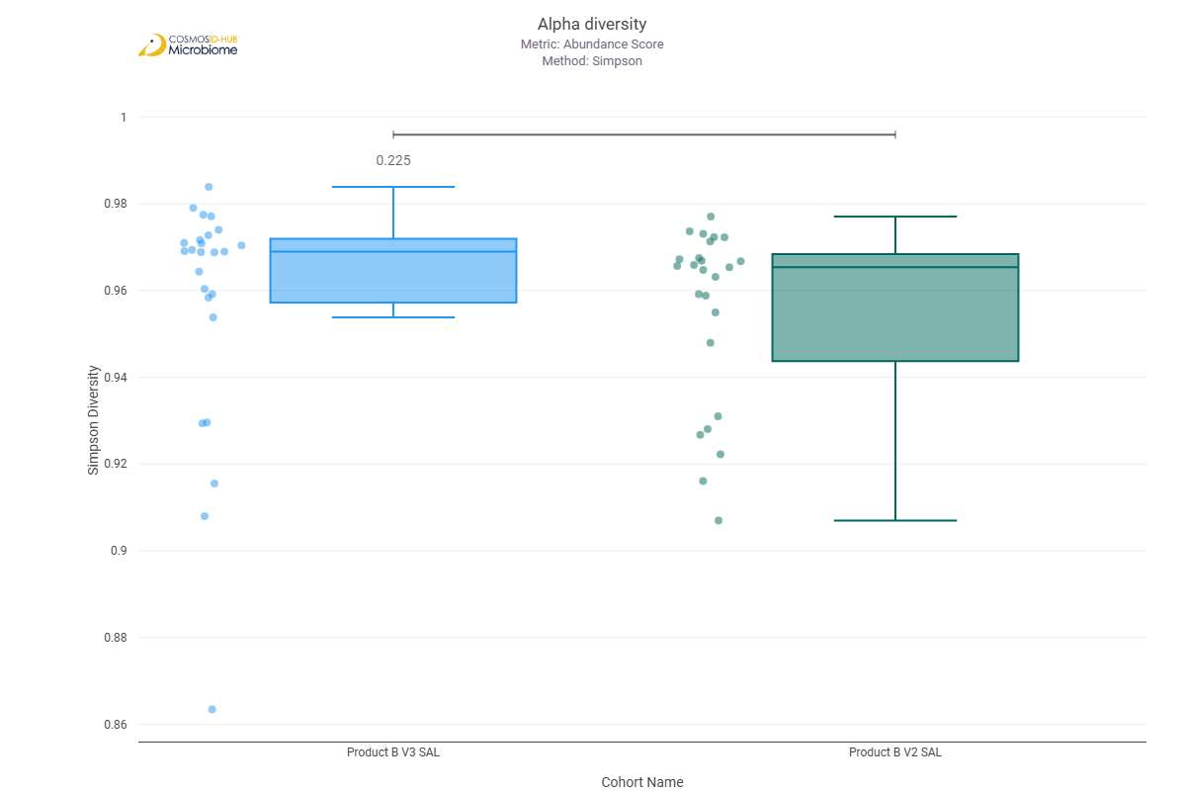

Beta Diversity (GO)
Bray-Curtis  PERMNOVA p = 0.526 | 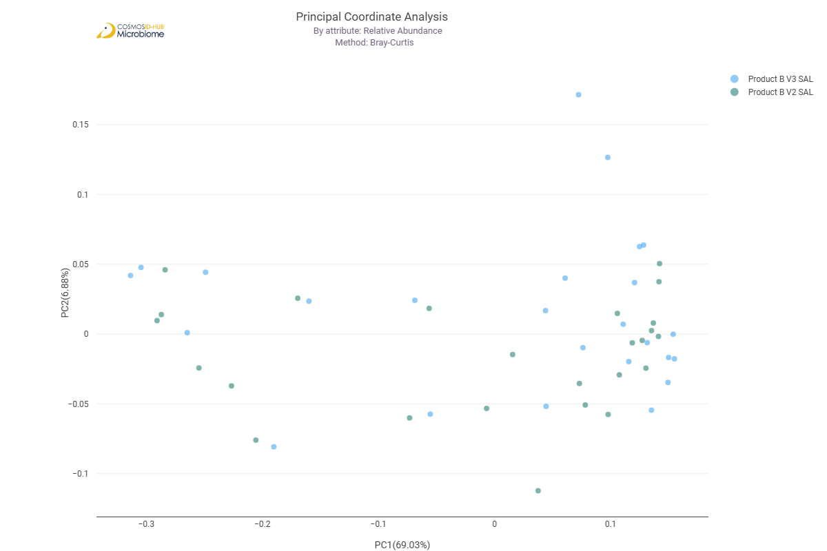

Differential Abundance (LEfSe) (GO)
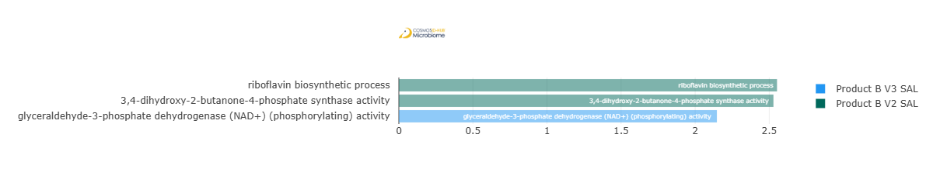
Feature | Enriched Cohort | LDA Score | P-value
glyceraldehyde-3-phosphate dehydrogenase (NAD+) (phosphorylating) activity | Product B V3 SAL | 2.14674601 | 0.026308569
riboflavin biosynthetic process | Product B V2 SAL | 2.552661472 | 0.0352731
3,4-dihydroxy-2-butanone-4-phosphate synthase activity | Product B V2 SAL | 2.528684256 | 0.0250207

Enzyme Commission

Alpha Diversity (EC)
Chao1 | 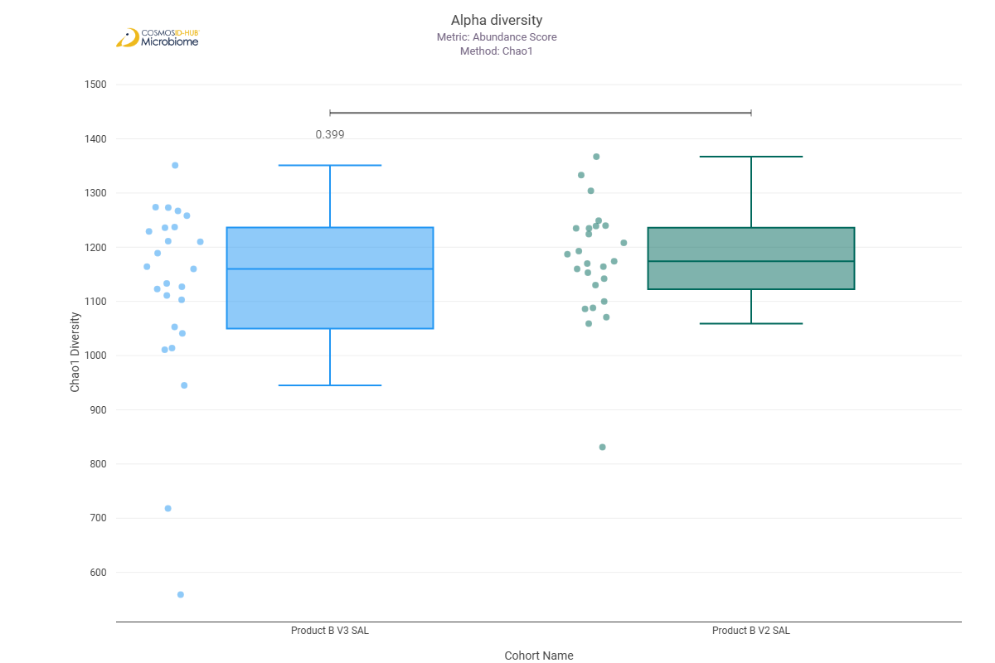
Shannon | 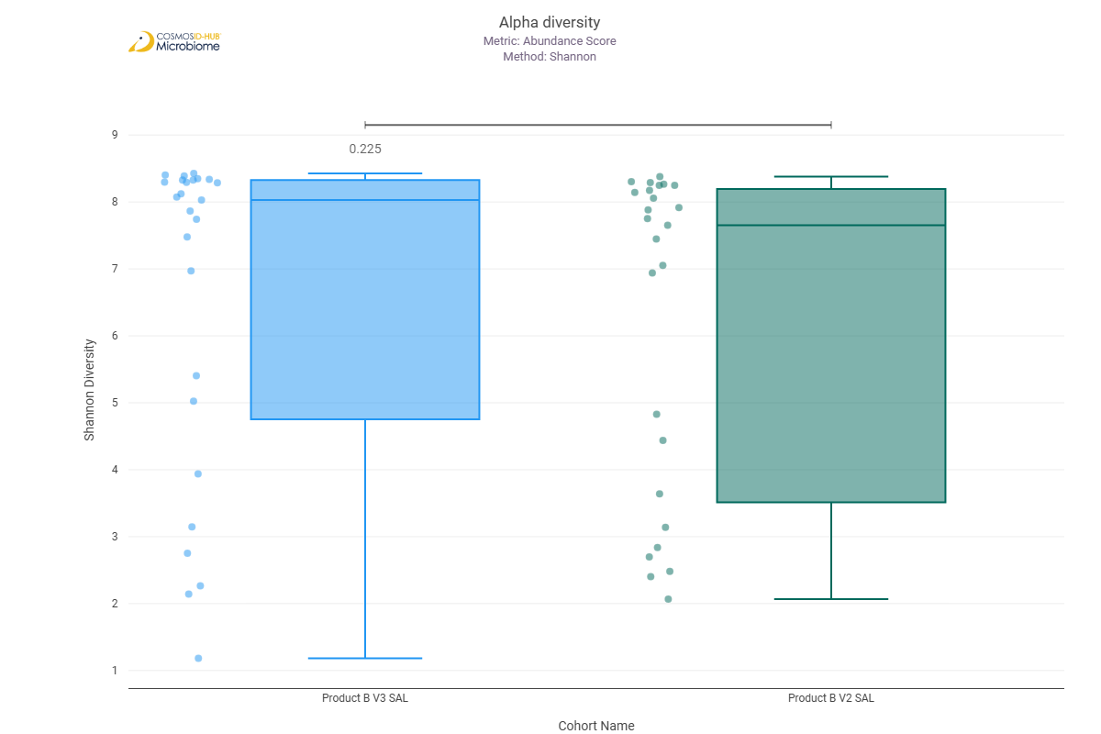
Simpson | 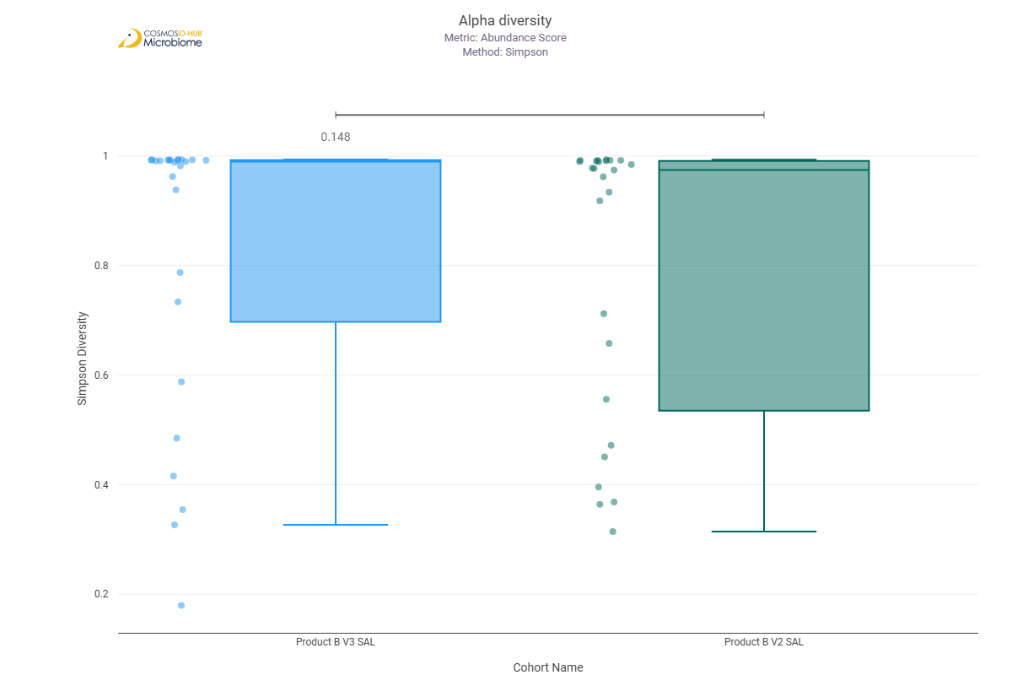

Beta Diversity (EC)
Bray-Curtis  PERMNOVA p = 0.440 | 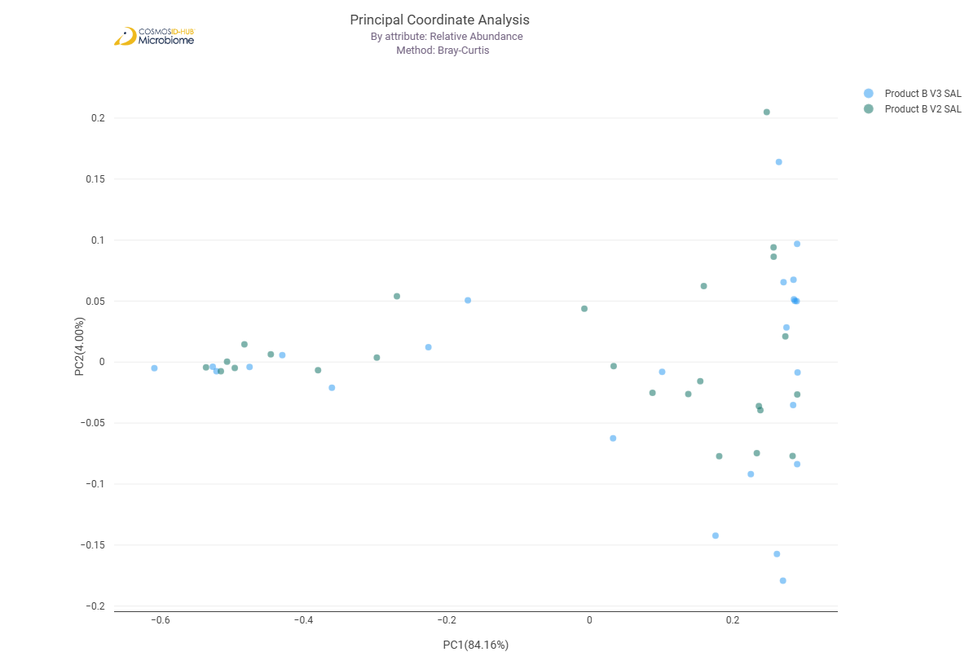

Differential Abundance (LEfSe) (EC)
No differentially abundant features detected

MetaCyc Pathways

Alpha Diversity (MetaCyc)
Chao1 | 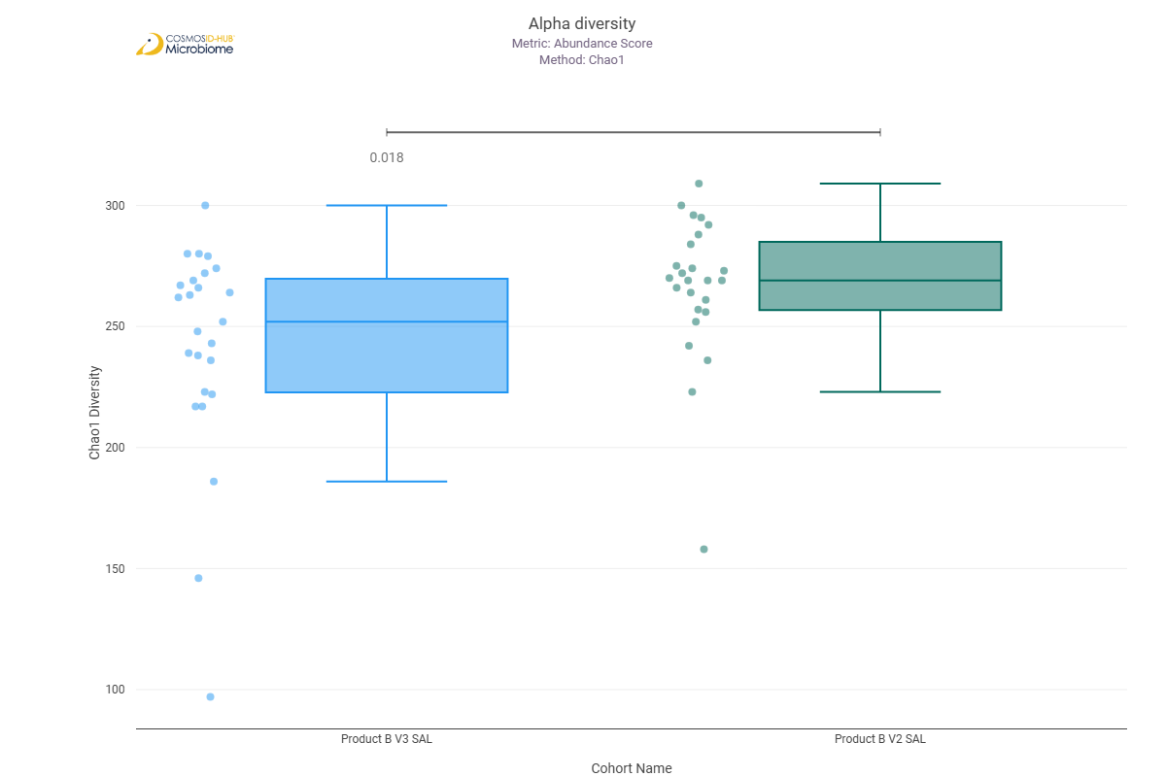
Shannon | 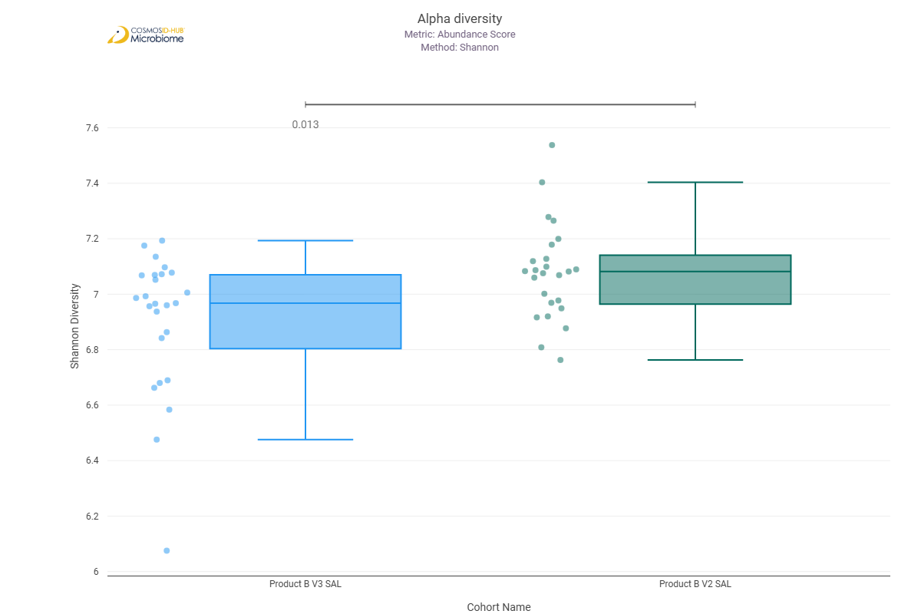
Simpson | 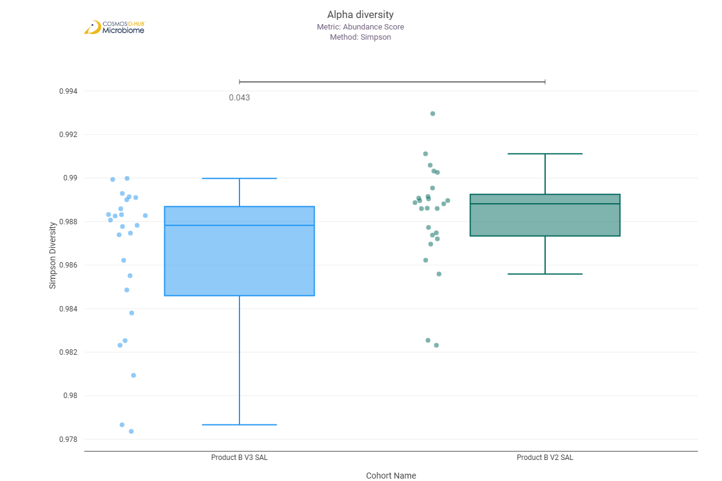

Beta Diversity (MetaCyc)
Bray-Curtis  PERMNOVA p = 0.040 | 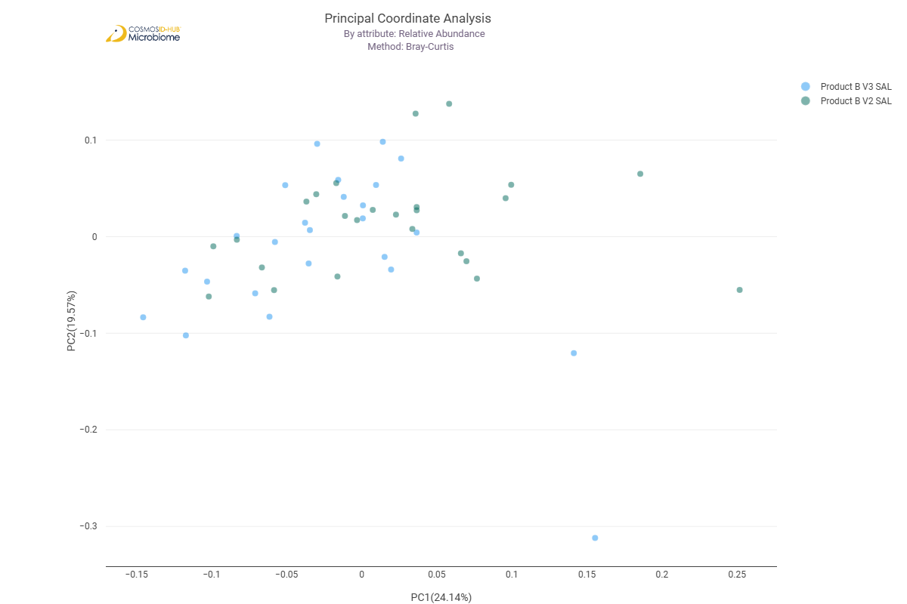

Differential Abundance (LEfSe) (MetaCyc)
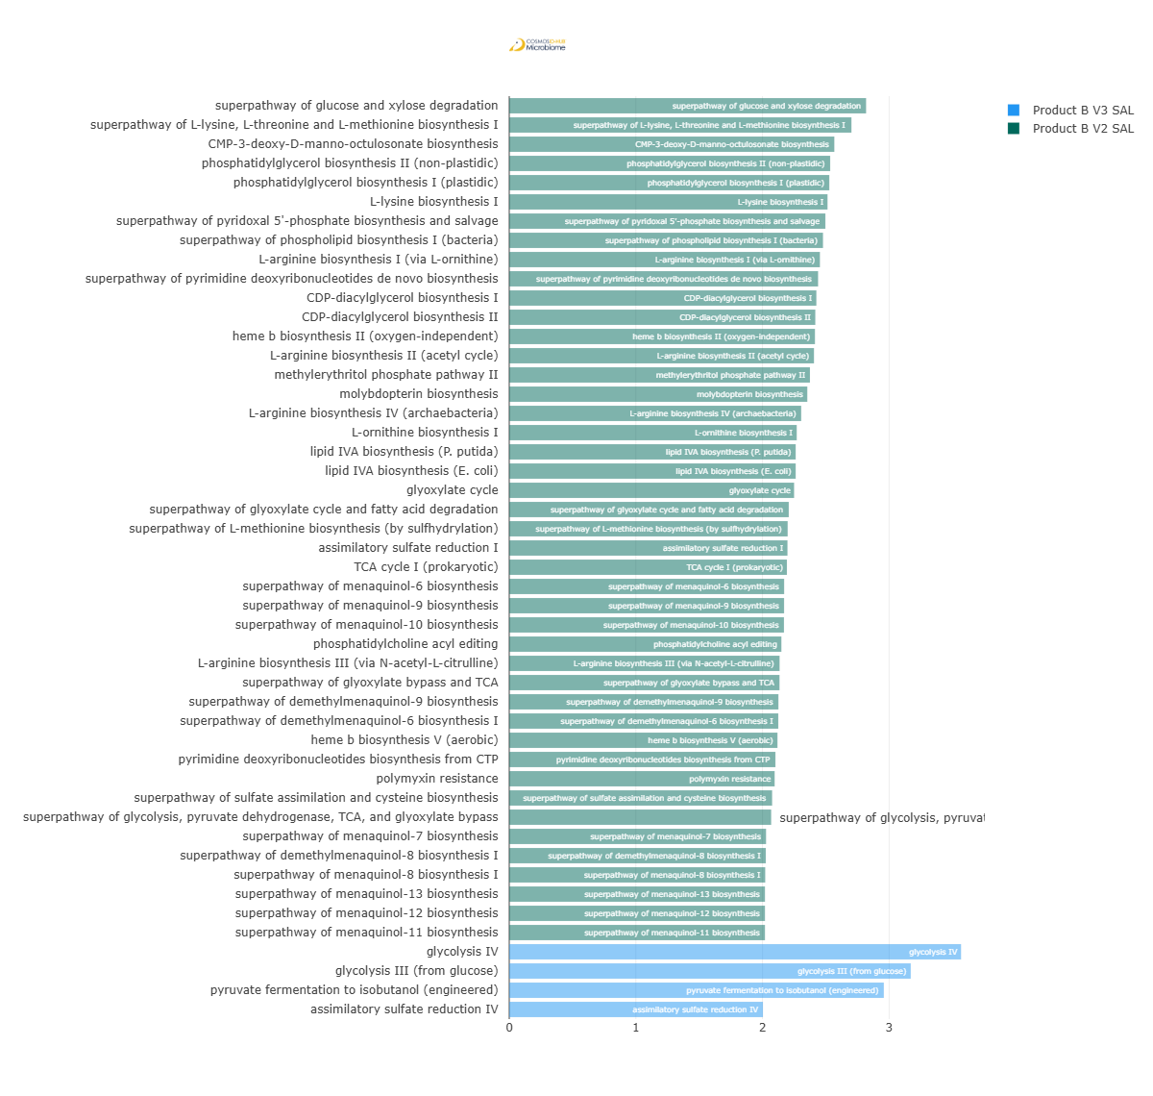
Feature | Enriched Cohort | LDA Score | P-value
superpathway of glucose and xylose degradation | Product B V2 SAL | 2.818172394 | 0.003199335
superpathway of L-lysine, L-threonine and L-methionine biosynthesis I | Product B V2 SAL | 2.702332952 | 0.001268472
CMP-3-deoxy-D-manno-octulosonate biosynthesis | Product B V2 SAL | 2.567217917 | 0.021478913
phosphatidylglycerol biosynthesis II (non-plastidic) | Product B V2 SAL | 2.534565735 | 0.011339073
phosphatidylglycerol biosynthesis I (plastidic) | Product B V2 SAL | 2.527633184 | 0.011339073
L-lysine biosynthesis I | Product B V2 SAL | 2.513475321 | 0.044617455
superpathway of pyridoxal 5'-phosphate biosynthesis and salvage | Product B V2 SAL | 2.496575918 | 0.045855823
superpathway of phospholipid biosynthesis I (bacteria) | Product B V2 SAL | 2.47795577 | 0.040658018
L-arginine biosynthesis I (via L-ornithine) | Product B V2 SAL | 2.453409033 | 0.028209048
superpathway of pyrimidine deoxyribonucleotides de novo biosynthesis | Product B V2 SAL | 2.43911832 | 0.035179233
CDP-diacylglycerol biosynthesis I | Product B V2 SAL | 2.425530852 | 4.07E-02
CDP-diacylglycerol biosynthesis II | Product B V2 SAL | 2.417219654 | 0.0352731
heme b biosynthesis II (oxygen-independent) | Product B V2 SAL | 2.414277056 | 0.009055969
L-arginine biosynthesis II (acetyl cycle) | Product B V2 SAL | 2.406610684 | 0.012881271
methylerythritol phosphate pathway II | Product B V2 SAL | 2.374746616 | 0.038785713
molybdopterin biosynthesis | Product B V2 SAL | 2.353869718 | 0.004474919
L-arginine biosynthesis IV (archaebacteria) | Product B V2 SAL | 2.30565784 | 0.046662482
L-ornithine biosynthesis I | Product B V2 SAL | 2.270426756 | 0.034286155
lipid IVA biosynthesis (E. coli) | Product B V2 SAL | 2.262174403 | 0.013543566
lipid IVA biosynthesis (P. putida) | Product B V2 SAL | 2.262174403 | 0.013543566
glyoxylate cycle | Product B V2 SAL | 2.249728953 | 1.84E-03
superpathway of glyoxylate cycle and fatty acid degradation | Product B V2 SAL | 2.20753772 | 0.030301371
superpathway of L-methionine biosynthesis (by sulfhydrylation) | Product B V2 SAL | 2.19885117 | 0.011392734
assimilatory sulfate reduction I | Product B V2 SAL | 2.197446182 | 0.010334085
TCA cycle I (prokaryotic) | Product B V2 SAL | 2.192838295 | 0.027140444
superpathway of menaquinol-6 biosynthesis | Product B V2 SAL | 2.171045532 | 6.09421E-05
superpathway of menaquinol-9 biosynthesis | Product B V2 SAL | 2.170593917 | 6.09421E-05
superpathway of menaquinol-10 biosynthesis | Product B V2 SAL | 2.169649613 | 6.09421E-05
phosphatidylcholine acyl editing | Product B V2 SAL | 2.149186255 | 0.043498937
L-arginine biosynthesis III (via N-acetyl-L-citrulline) | Product B V2 SAL | 2.134965514 | 0.031737021
superpathway of glyoxylate bypass and TCA | Product B V2 SAL | 2.134203058 | 0.044486372
superpathway of demethylmenaquinol-9 biosynthesis | Product B V2 SAL | 2.1257968 | 6.09421E-05
superpathway of demethylmenaquinol-6 biosynthesis I | Product B V2 SAL | 2.124841397 | 6.09421E-05
heme b biosynthesis V (aerobic) | Product B V2 SAL | 2.118223752 | 0.031887431
pyrimidine deoxyribonucleotides biosynthesis from CTP | Product B V2 SAL | 2.102099596 | 0.044416899
polymyxin resistance | Product B V2 SAL | 2.095875541 | 0.00741426
superpathway of sulfate assimilation and cysteine biosynthesis | Product B V2 SAL | 2.076167827 | 0.004912845
superpathway of glycolysis, pyruvate dehydrogenase, TCA, and glyoxylate bypass | Product B V2 SAL | 2.068575031 | 0.002366655
superpathway of menaquinol-7 biosynthesis | Product B V2 SAL | 2.028076494 | 0.030318736
superpathway of demethylmenaquinol-8 biosynthesis I | Product B V2 SAL | 2.026100386 | 0.013730328
superpathway of menaquinol-8 biosynthesis I | Product B V2 SAL | 2.021614503 | 0.009305995
superpathway of menaquinol-11 biosynthesis | Product B V2 SAL | 2.019480361 | 0.016137021
superpathway of menaquinol-12 biosynthesis | Product B V2 SAL | 2.019480361 | 0.016137021
superpathway of menaquinol-13 biosynthesis | Product B V2 SAL | 2.019480361 | 0.016137021
glycolysis IV | Product B V3 SAL | 3.567908932 | 0.002551693
glycolysis III (from glucose) | Product B V3 SAL | 3.170717244 | 0.011339073
pyruvate fermentation to isobutanol (engineered) | Product B V3 SAL | 2.958214564 | 0.036996166
assimilatory sulfate reduction IV | Product B V3 SAL | 2.00338347 | 0.006173676

Comparison 7: Product A V2 SAL vs Product B V2 SAL

Gene Ontology

Alpha Diversity (GO)
Chao1 | 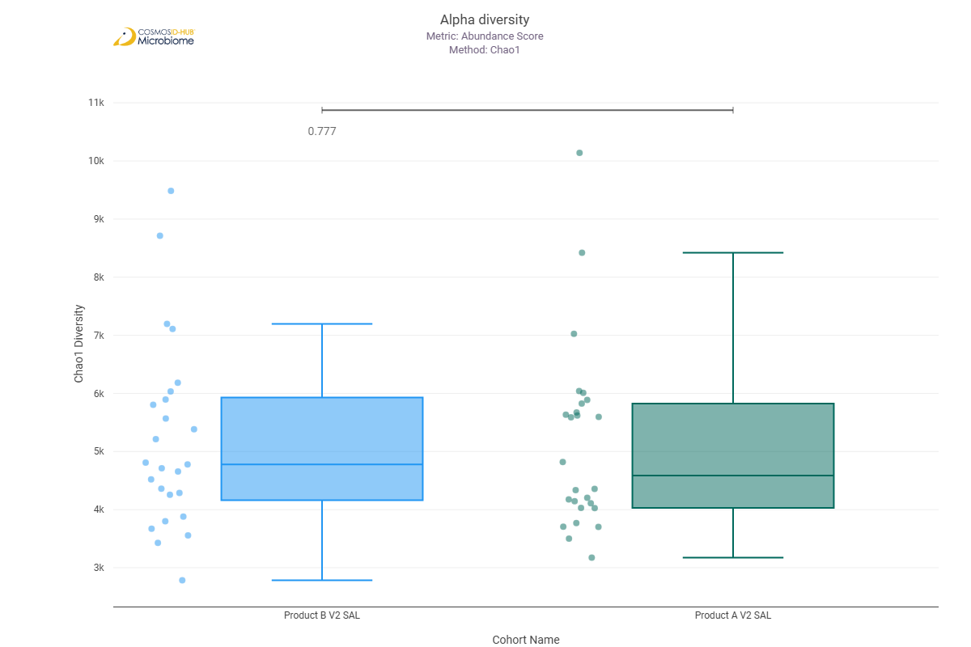
Shannon | 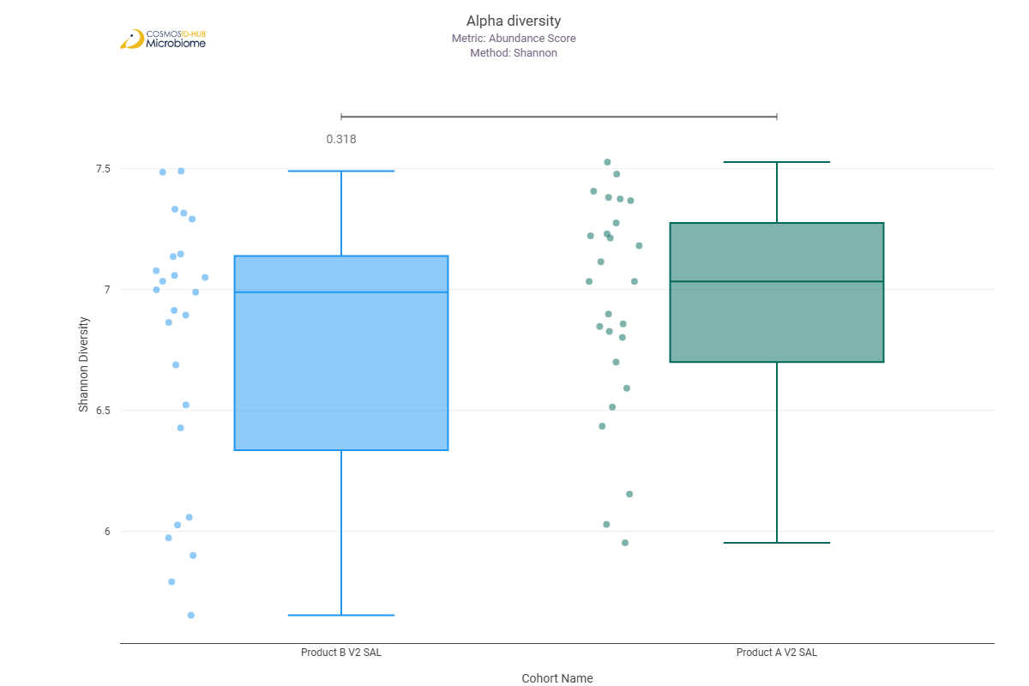
Simpson

Beta Diversity (GO)
Bray-Curtis  PERMNOVA p = 0.573 | 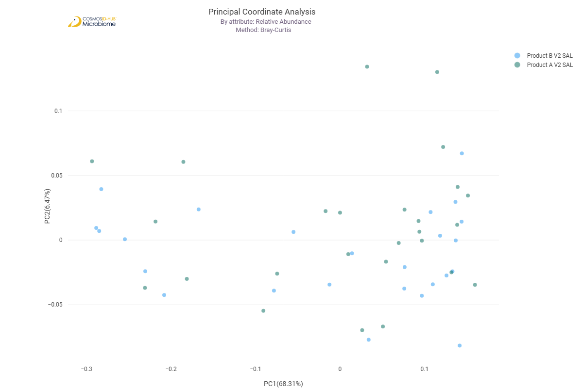

Differential Abundance (LEfSe) (GO)
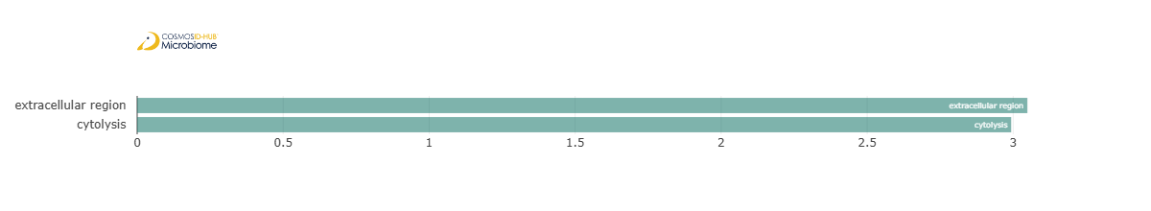
Feature | Enriched Cohort | LDA Score | P-value
extracellular region | Product A V2 SAL | 3.048793763 | 0.028837668
cytolysis | Product A V2 SAL | 2.99327891 | 0.021519031

Enzyme Commission

Alpha Diversity (EC)
Chao1 | 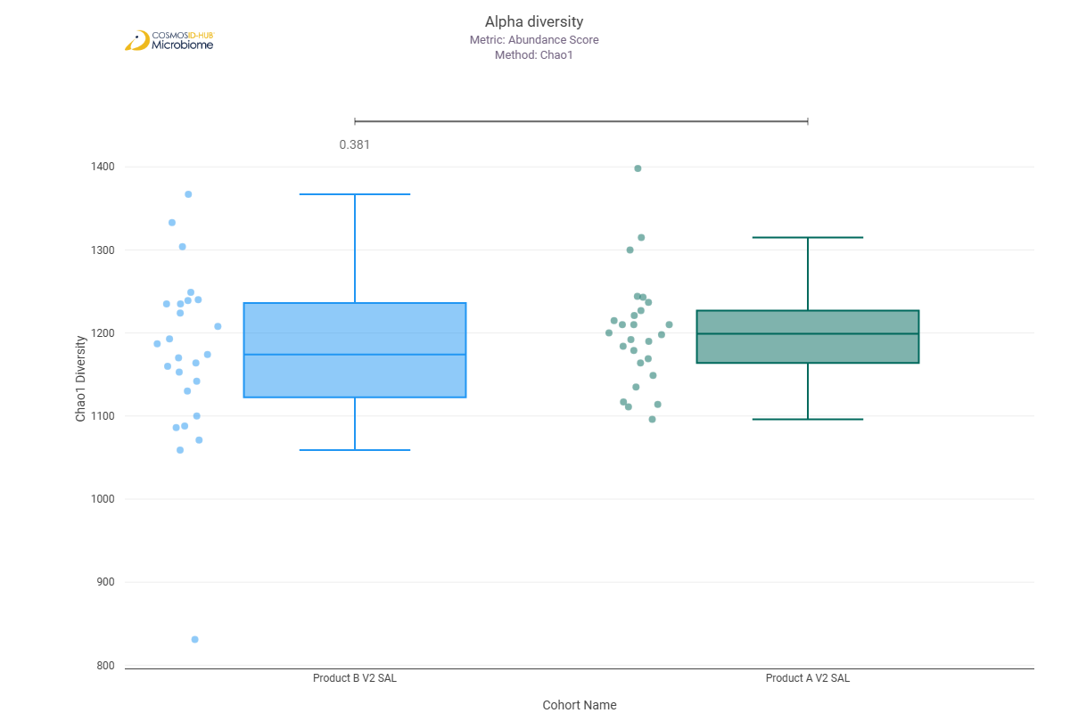
Shannon | 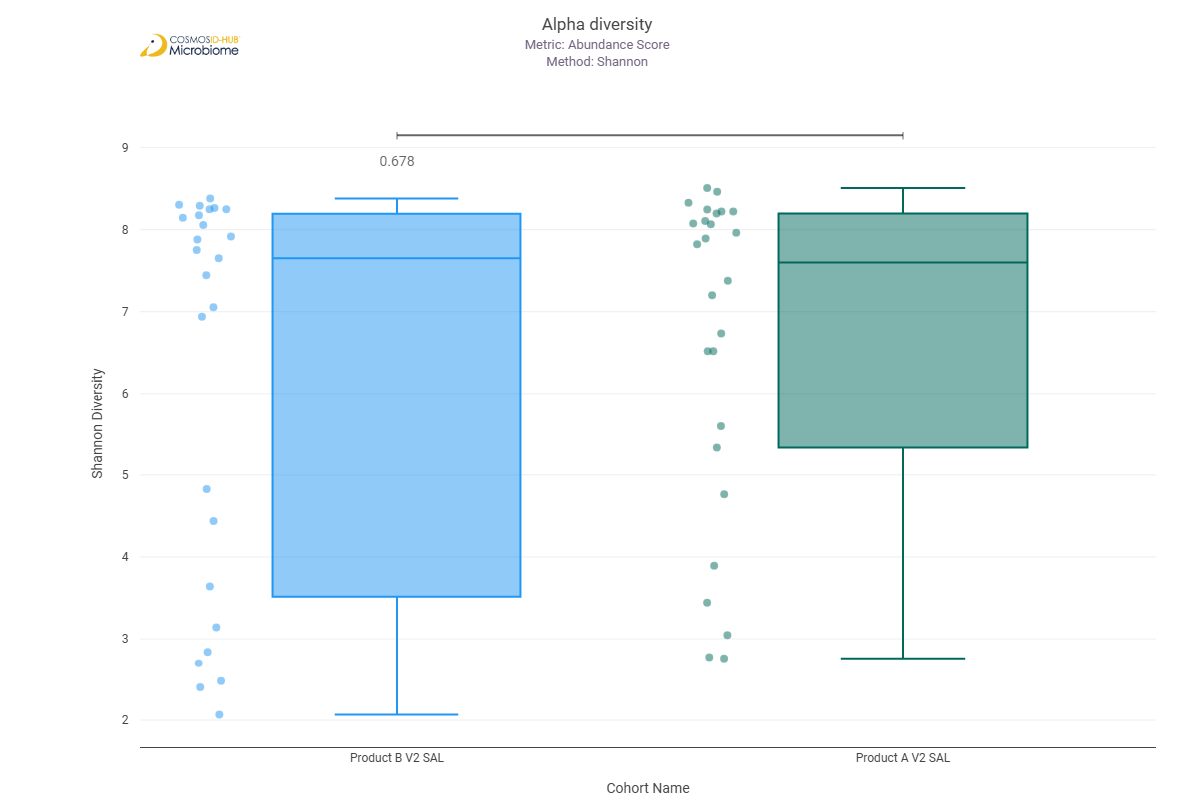
Simpson | 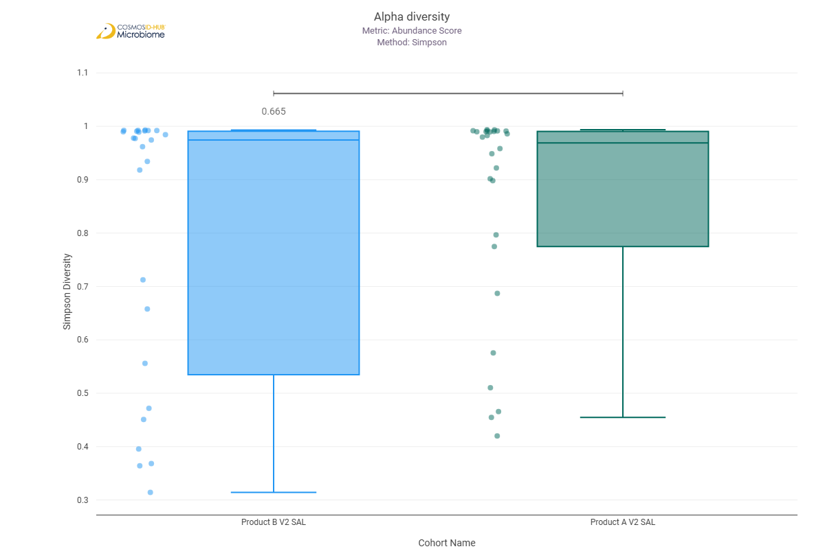

Beta Diversity (EC)
Bray-Curtis  PERMNOVA p = 0.514 | 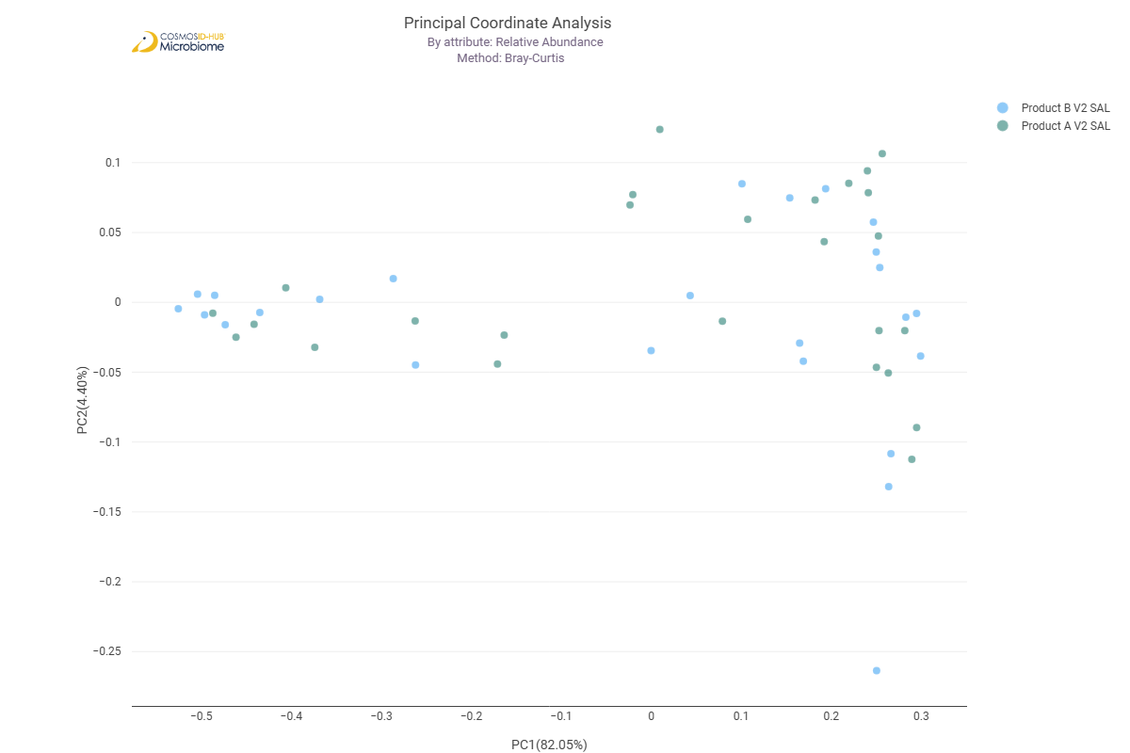

Differential Abundance (LEfSe) (EC)
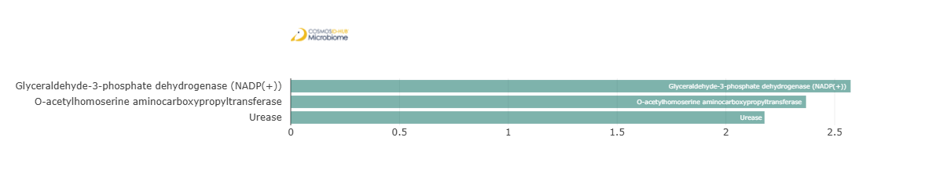
Feature | Enriched Cohort | LDA Score | P-value
Glyceraldehyde-3-phosphate dehydrogenase (NADP(+)) | Product A V2 SAL | 2.573441142 | 0.034813536
O-acetylhomoserine aminocarboxypropyltransferase | Product A V2 SAL | 2.368534336 | 0.039994768
Urease | Product A V2 SAL | 2.177716688 | 0.041854827

MetaCyc Pathways

Alpha Diversity (MetaCyc)
Chao1 | 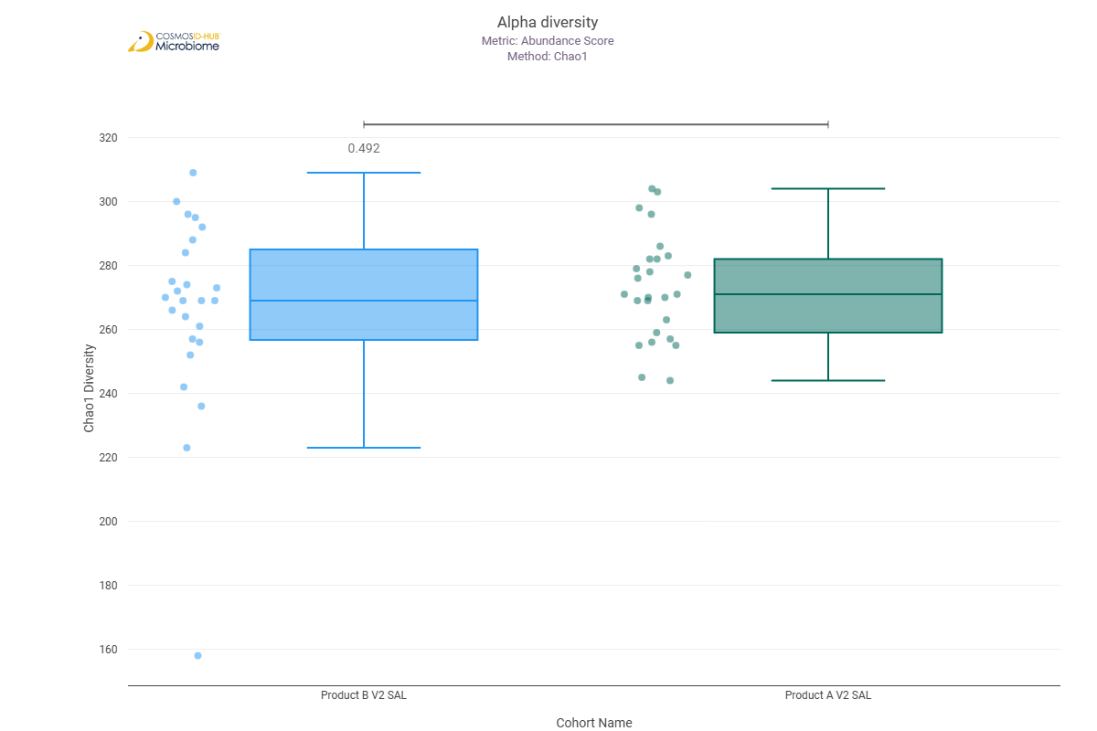
Shannon | 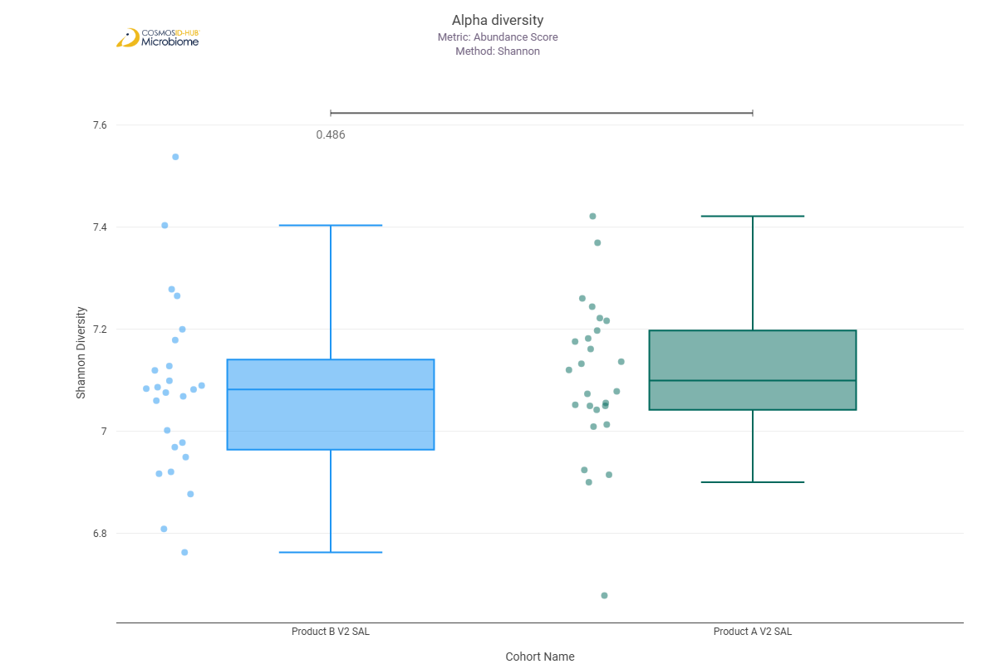
Simpson | 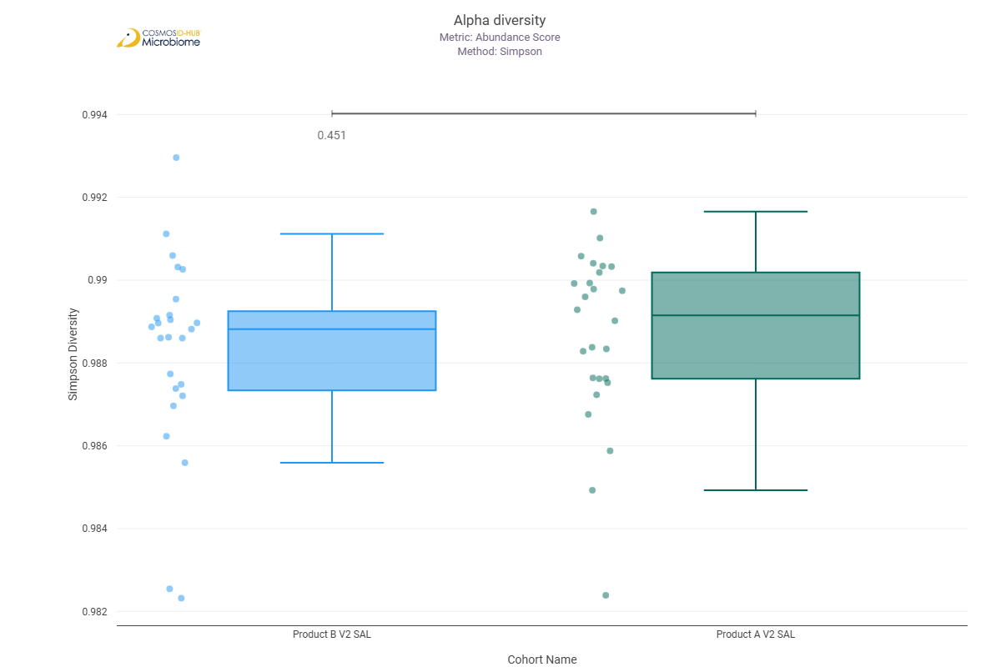

Beta Diversity (MetaCyc)
Bray-Curtis  PERMNOVA p = 0.588 | 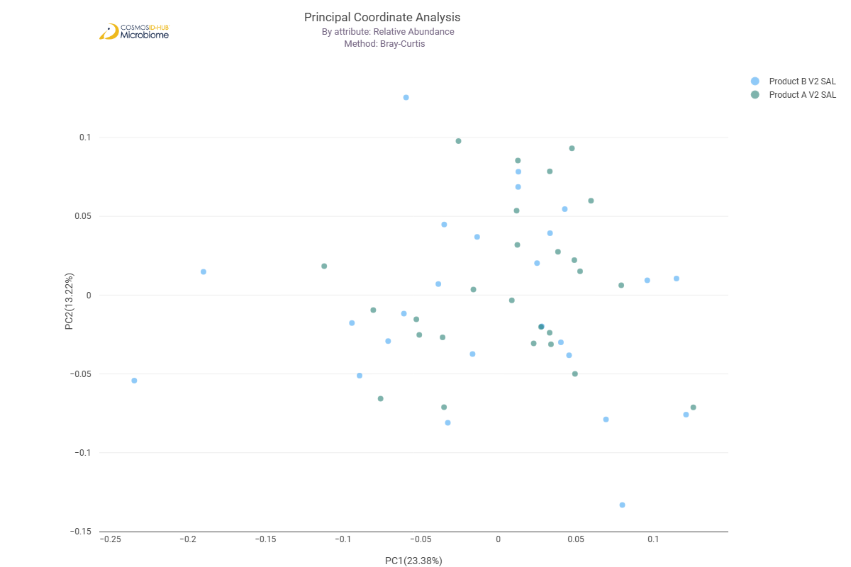

Differential Abundance (LEfSe) (MetaCyc)
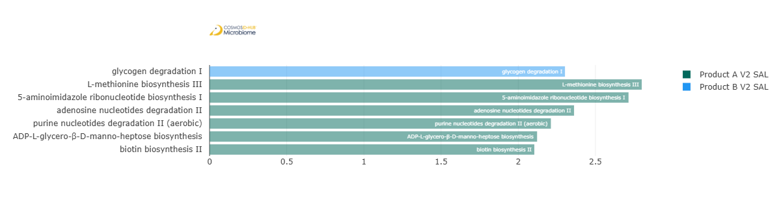
Feature | Enriched Cohort | LDA Score | P-value
glycogen degradation I | Product B V2 SAL | 2.302816818 | 0.038205314
L-methionine biosynthesis III | Product A V2 SAL | 2.800174369 | 0.028837668
5-aminoimidazole ribonucleotide biosynthesis I | Product A V2 SAL | 2.714616828 | 0.041854827
adenosine nucleotides degradation II | Product A V2 SAL | 2.361586069 | 0.033160392
purine nucleotides degradation II (aerobic) | Product A V2 SAL | 2.211547707 | 0.020887991
ADP-L-glycero-β-D-manno-heptose biosynthesis | Product A V2 SAL | 2.122101305 | 0.026186596
biotin biosynthesis II | Product A V2 SAL | 2.104231519 | 0.018951173

Comparison 8: Product A V3 SAL vs Product B V3 SAL

Gene Ontology

Alpha Diversity (GO)
Chao1 | 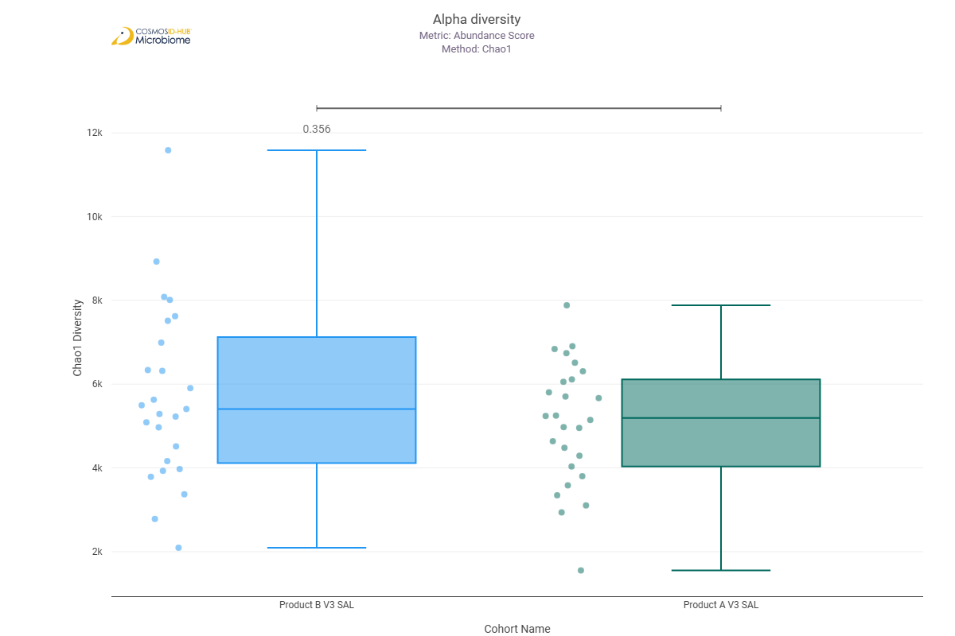
Shannon | 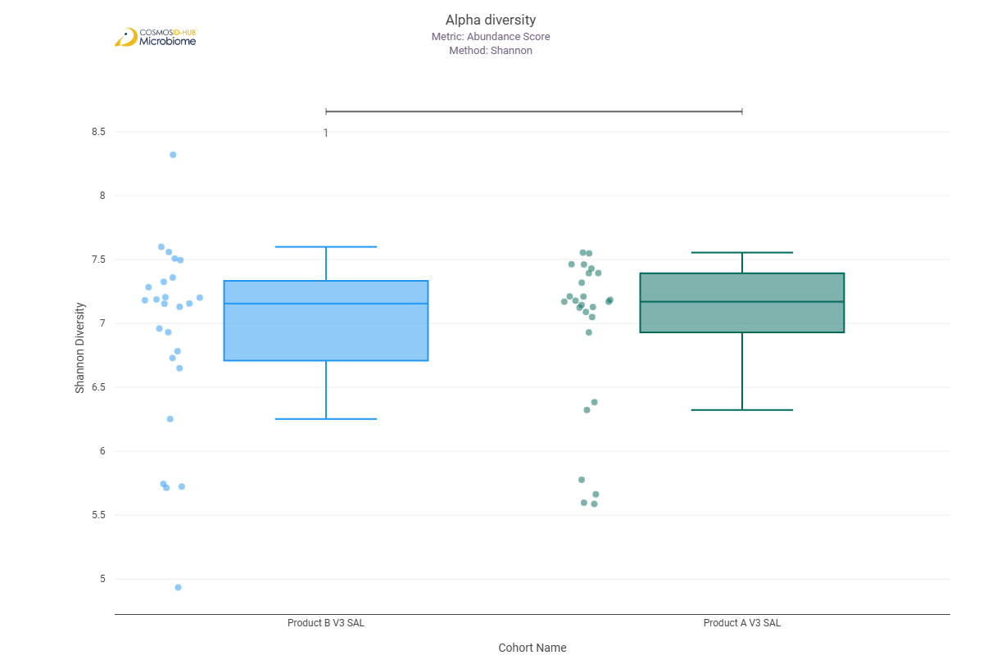
Simpson | 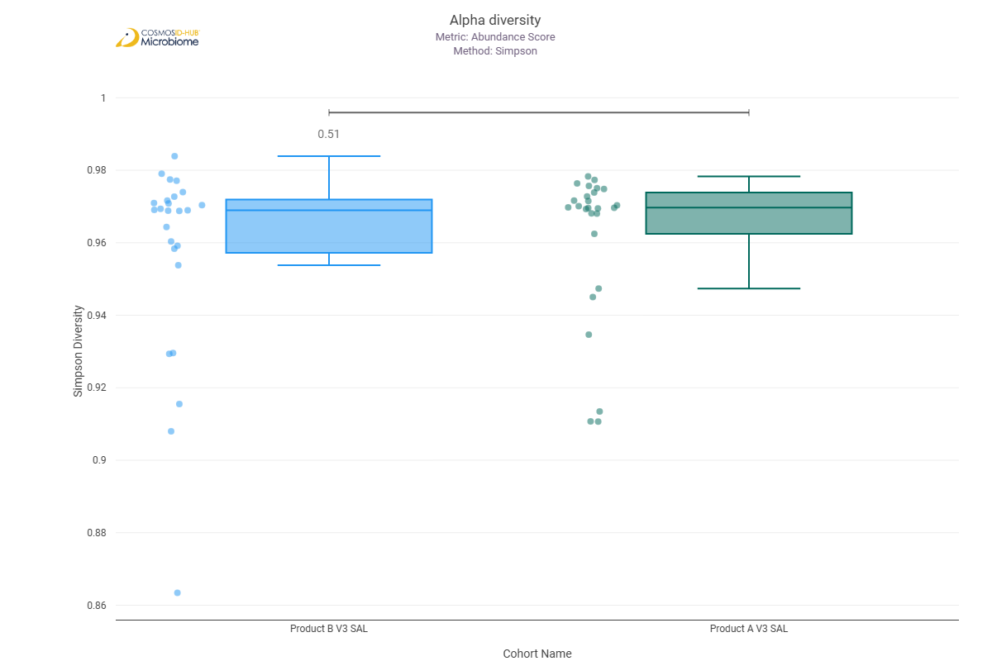

Beta Diversity (GO)
Bray-Curtis  PERMNOVA p = 0.505 | 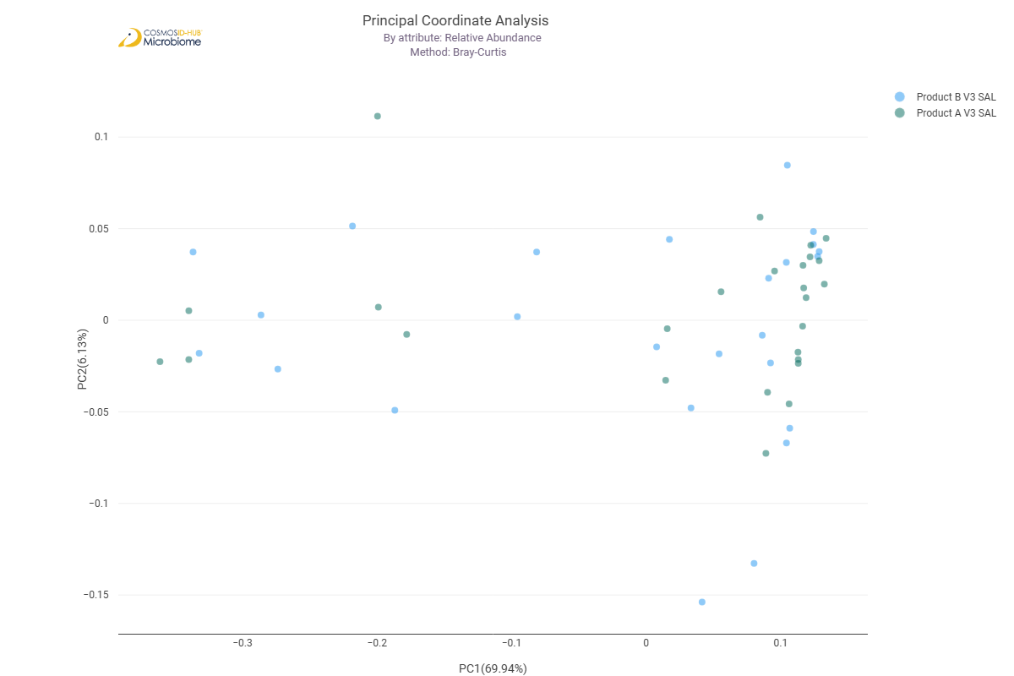

Differential Abundance (LEfSe) (GO)
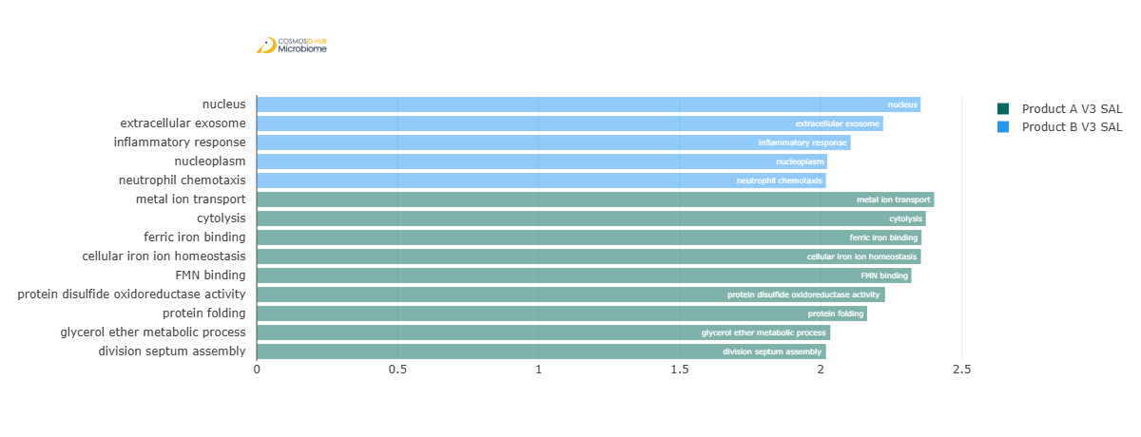
Feature | Enriched Cohort | LDA Score | P-value
nucleus | Product B V3 SAL | 2.354393027 | 0.030245812
extracellular exosome | Product B V3 SAL | 2.221604406 | 0.047879765
inflammatory response | Product B V3 SAL | 2.106087975 | 0.033240045
nucleoplasm | Product B V3 SAL | 2.023113821 | 0.038205314
neutrophil chemotaxis | Product B V3 SAL | 2.01875955 | 0.045795182
metal ion transport | Product A V3 SAL | 2.402291309 | 0.010390869
cytolysis | Product A V3 SAL | 2.372871937 | 0.024341408
ferric iron binding | Product A V3 SAL | 2.357375209 | 0.00745964
cellular iron ion homeostasis | Product A V3 SAL | 2.355615079 | 0.00881699
FMN binding | Product A V3 SAL | 2.321558848 | 0.028837668
protein disulfide oxidoreductase activity | Product A V3 SAL | 2.228239528 | 0.030245812
protein folding | Product A V3 SAL | 2.164657961 | 0.039994768
glycerol ether metabolic process | Product A V3 SAL | 2.034126856 | 0.045795182
division septum assembly | Product A V3 SAL | 2.018707201 | 0.009840467

Enzyme Commission

Alpha Diversity (EC)
Chao1 | 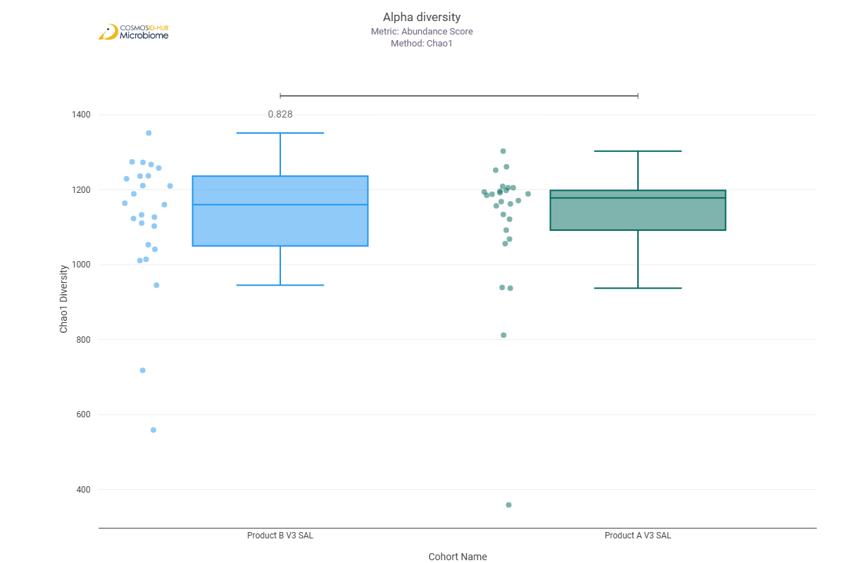
Shannon | 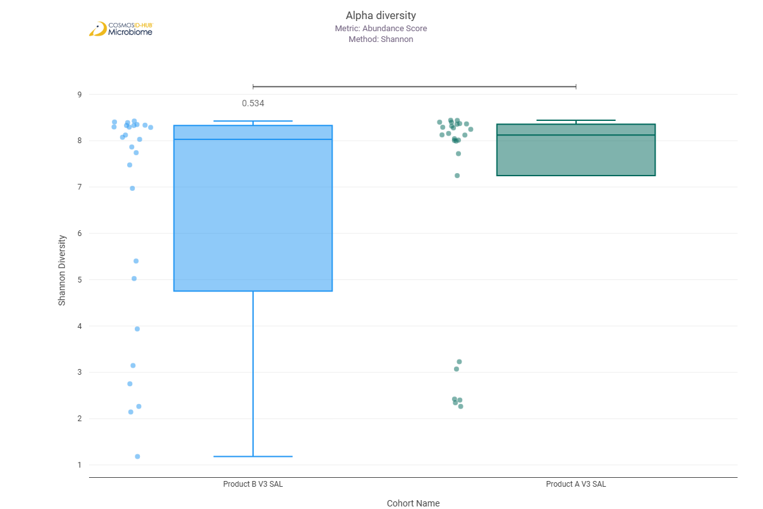
Simpson | 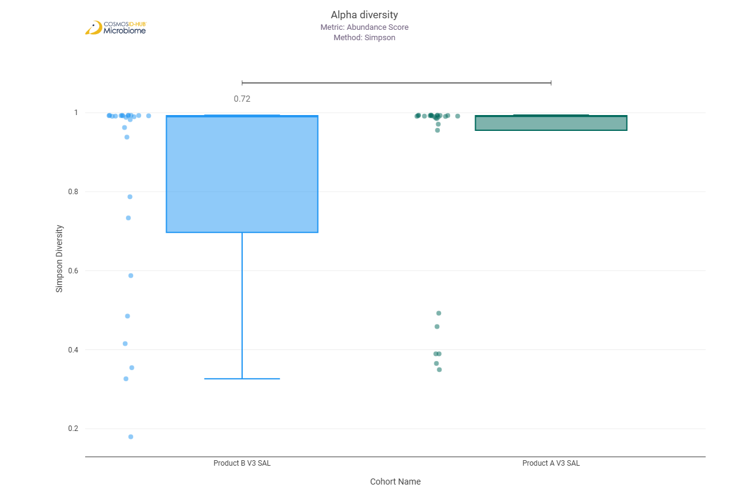

Beta Diversity (EC)
Bray-Curtis  PERMNOVA p = 0.676 | 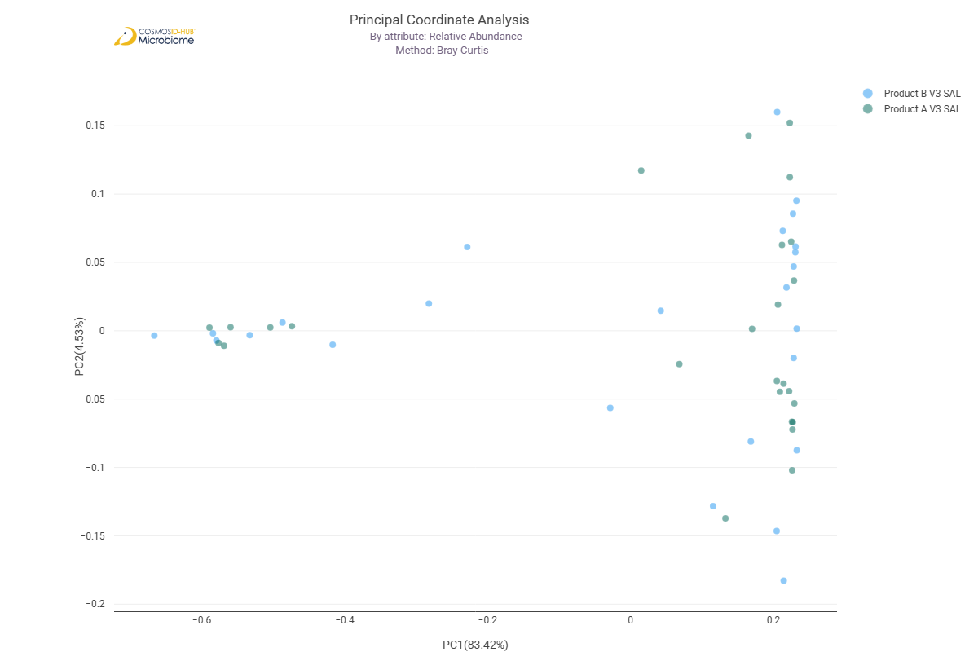

Differential Abundance (LEfSe) (EC)
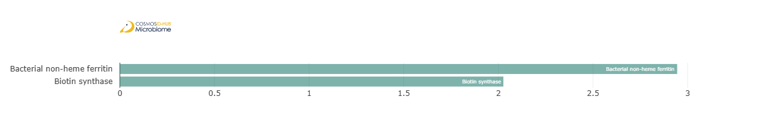
Feature | Enriched Cohort | LDA Score | P-value
Bacterial non-heme ferritin | Product A V3 SAL | 2.945043561 | 0.047879765
Biotin synthase | Product A V3 SAL | 2.02663125 | 0.01946851

MetaCyc Pathways

Alpha Diversity (MetaCyc)
Chao1 | 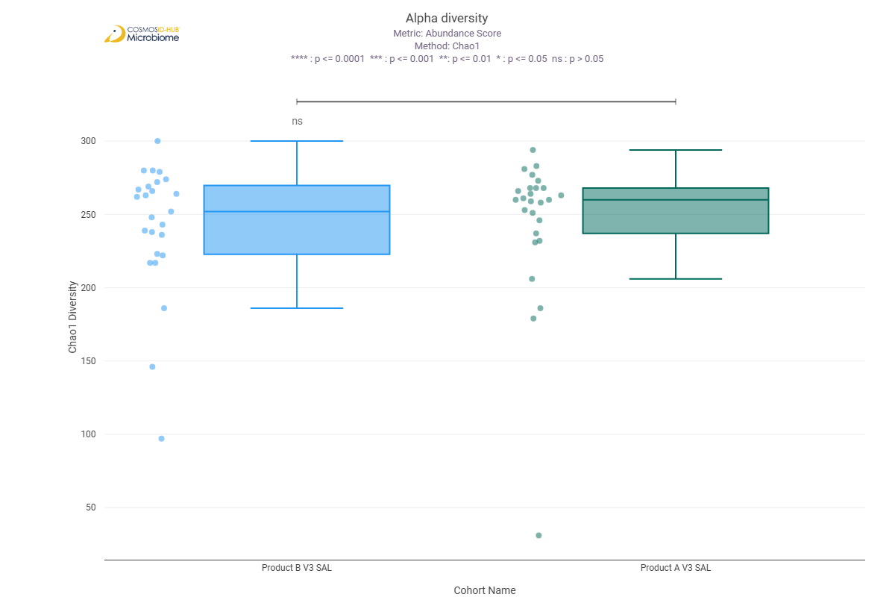
Shannon | 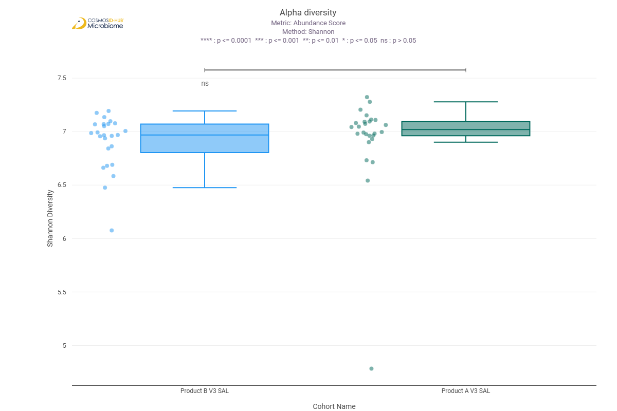
Simpson | 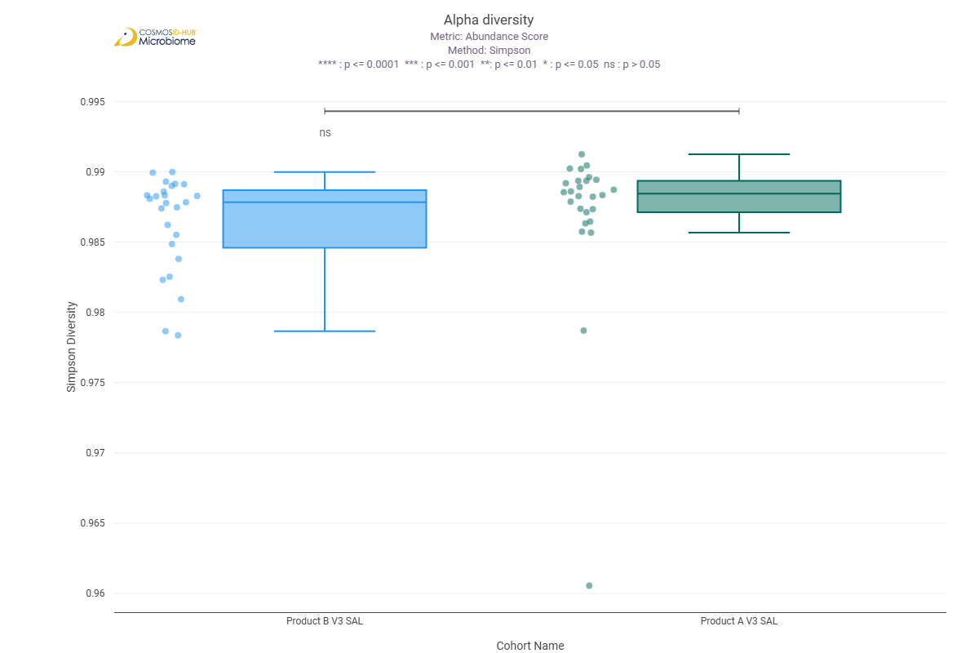

Beta Diversity (MetaCyc)
Bray-Curtis  PERMNOVA p = 0.534 | 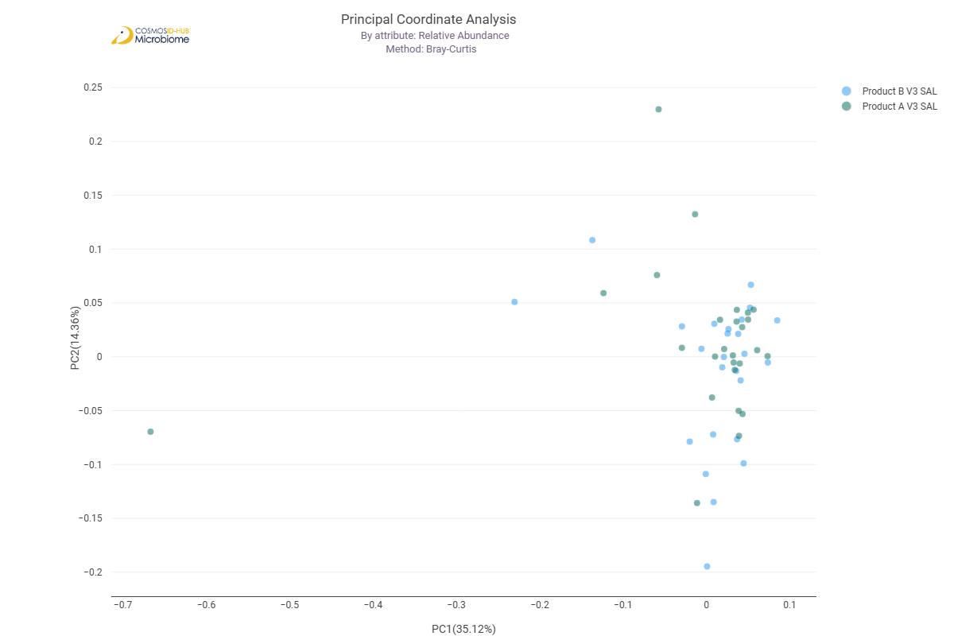

Differential Abundance (LEfSe) (MetaCyc)
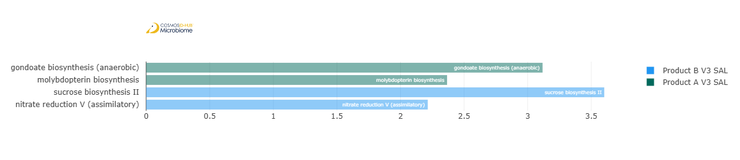
Feature | Enriched Cohort | LDA Score | P-value
gondoate biosynthesis (anaerobic) | Product A V3 SAL | 3.117262564 | 0.047879765
molybdopterin biosynthesis | Product A V3 SAL | 2.366346684 | 0.016703061
sucrose biosynthesis II | Product B V3 SAL | 3.602180306 | 0.02494682
nitrate reduction V (assimilatory) | Product B V3 SAL | 2.214455356 | 0.01756521

Comparison 9: Product A V2 TNG vs Product A V3 TNG

Gene Ontology

Alpha Diversity (GO)
Chao1 | 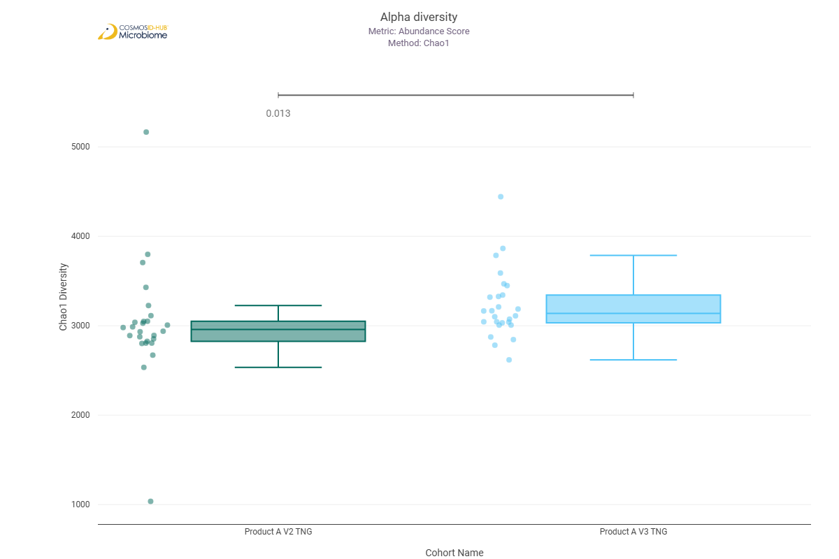
Shannon | 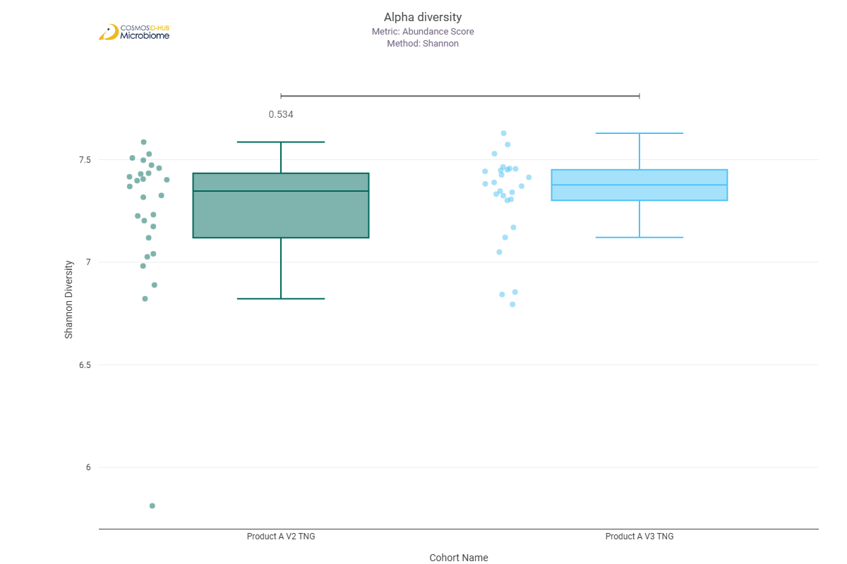
Simpson | 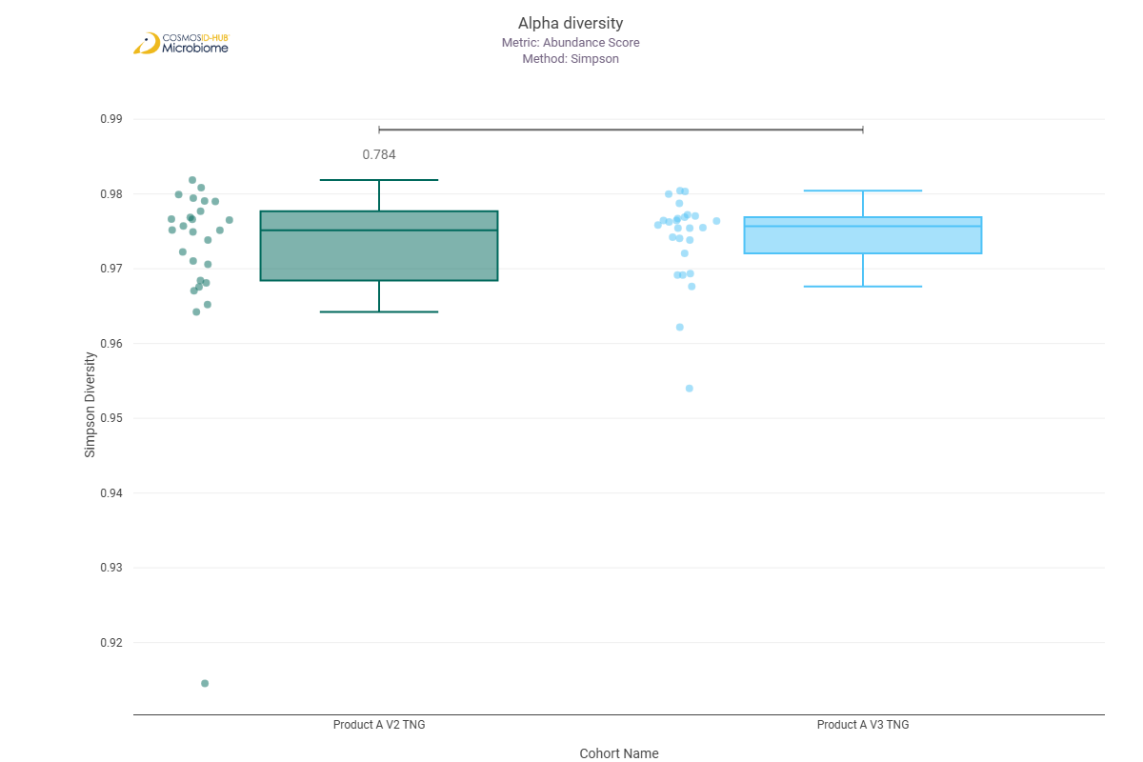

Beta Diversity (GO)
Bray-Curtis  PERMNOVA p = 0.170 | 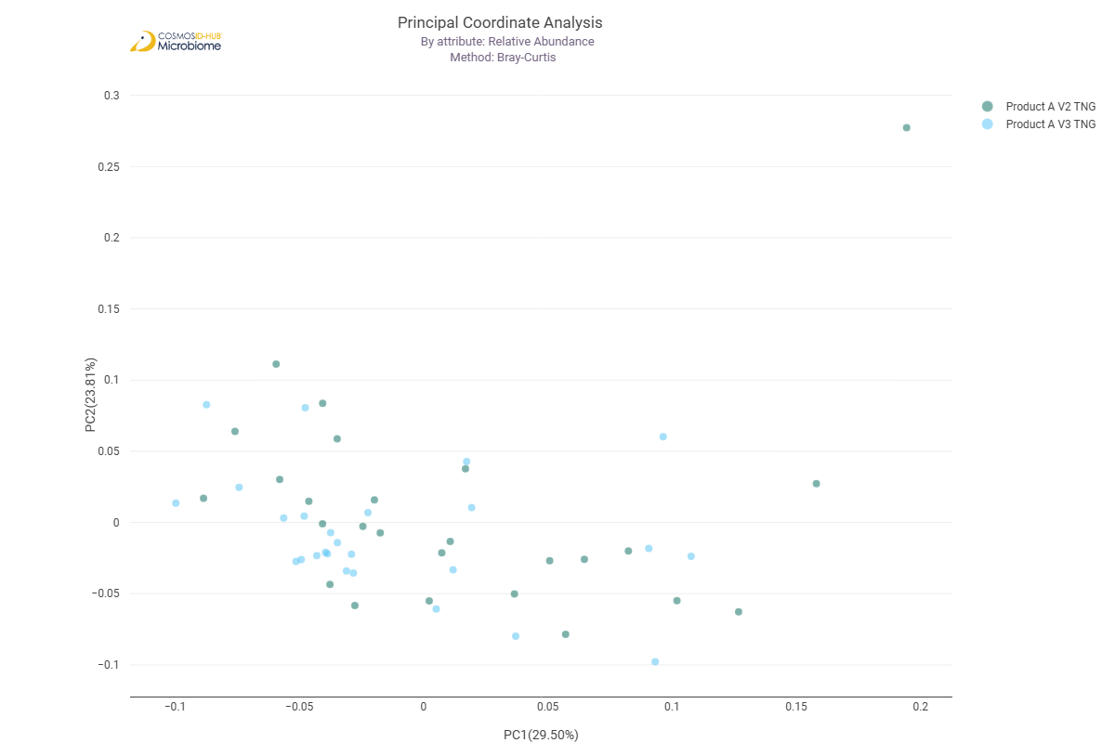

Differential Abundance (LEfSe) (GO)
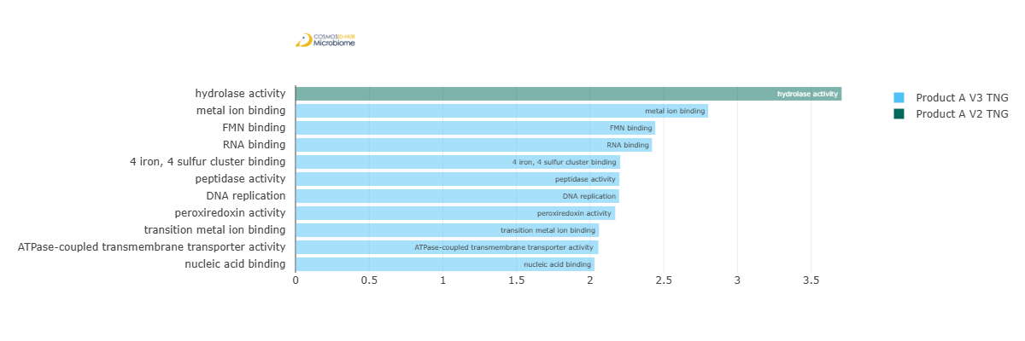
Feature | Enriched Cohort | LDA Score | P-value
hydrolase activity | Product A V2 TNG | 3.707495081 | 0.016509366
metal ion binding | Product A V3 TNG | 2.801446552 | 0.029417827
FMN binding | Product A V3 TNG | 2.442148744 | 0.005108961
RNA binding | Product A V3 TNG | 2.420090714 | 0.014930589
4 iron, 4 sulfur cluster binding | Product A V3 TNG | 2.20433213 | 0.024382597
peptidase activity | Product A V3 TNG | 2.198773629 | 0.003615568
DNA replication | Product A V3 TNG | 2.196261075 | 0.005108961
peroxiredoxin activity | Product A V3 TNG | 2.170304979 | 0.036948224
transition metal ion binding | Product A V3 TNG | 2.060247577 | 0.035322927
ATPase-coupled transmembrane transporter activity | Product A V3 TNG | 2.05653438 | 0.046061451
nucleic acid binding | Product A V3 TNG | 2.029809755 | 0.005108961

Enzyme Commission

Alpha Diversity (EC)
Chao1 | 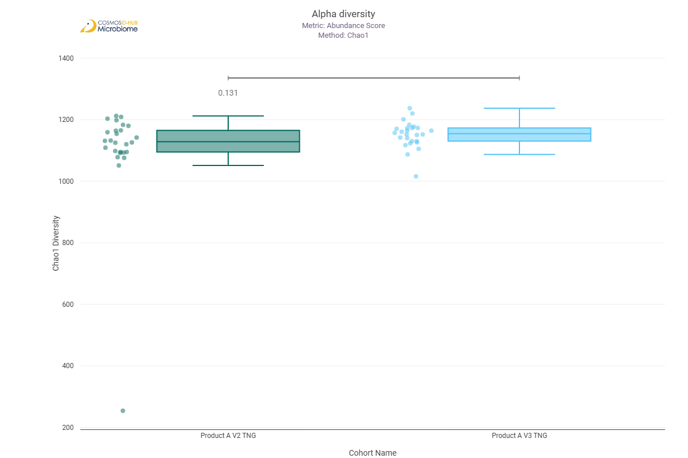
Shannon | 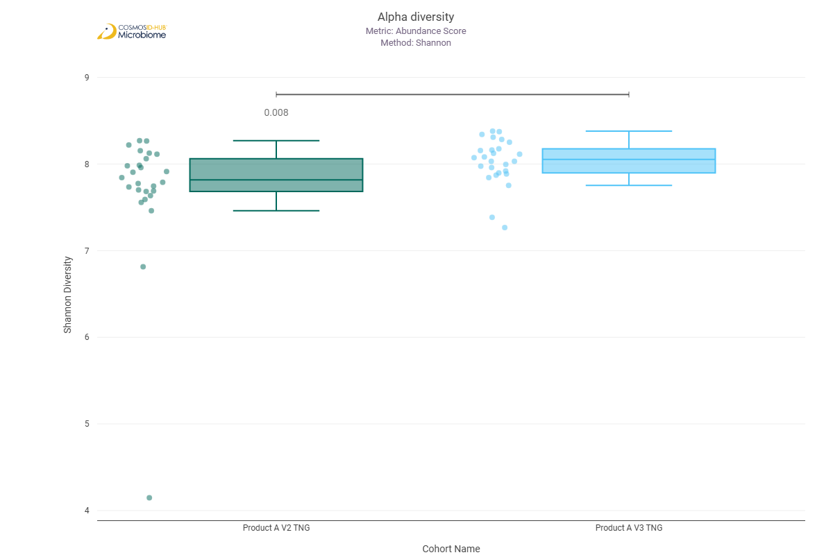
Simpson | 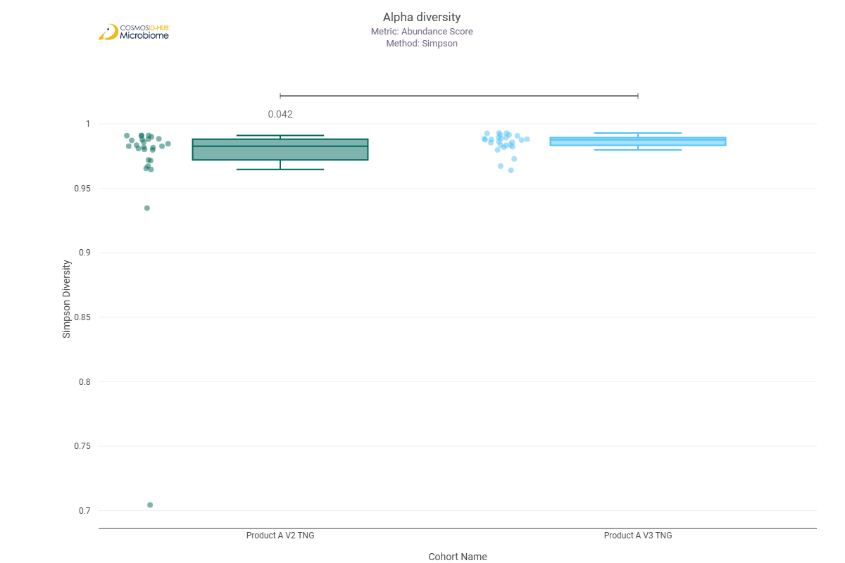

Beta Diversity (EC)
Bray-Curtis  PERMNOVA p = 0.053 | 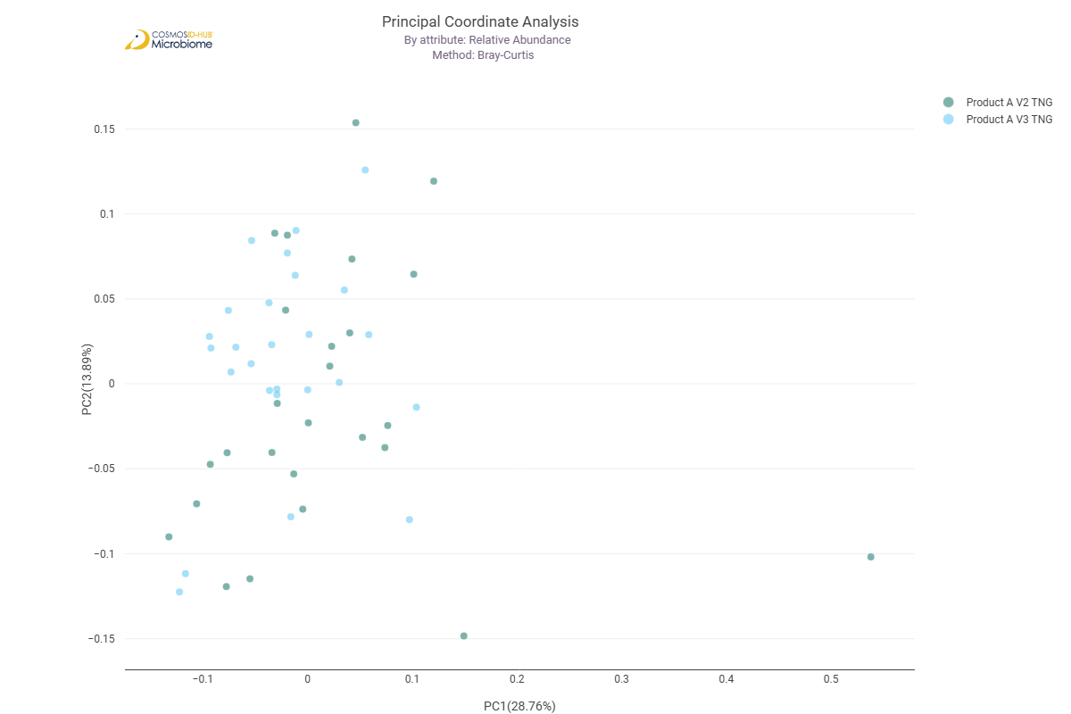

Differential Abundance (LEfSe) (EC)
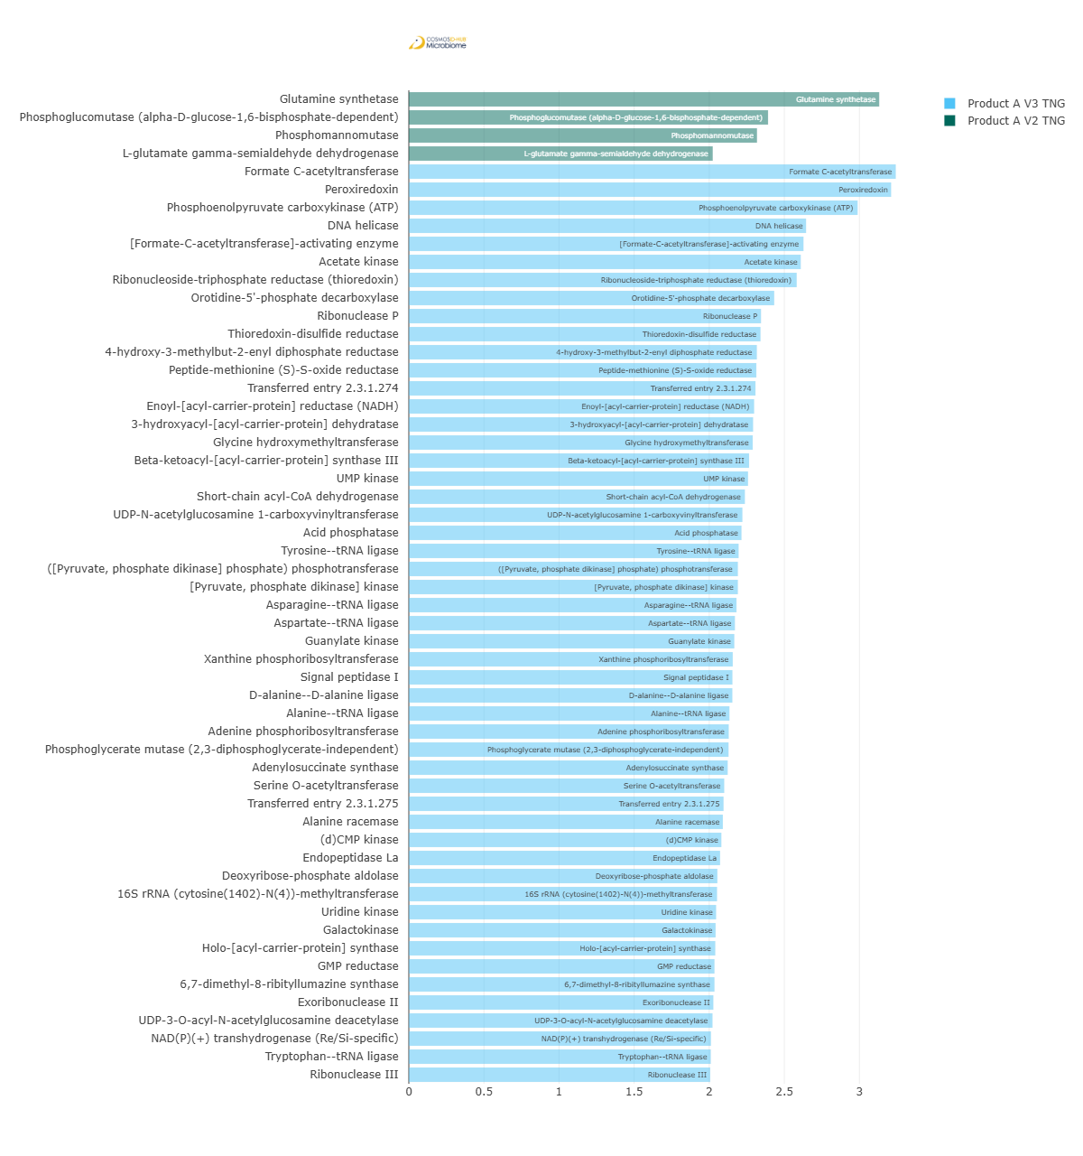
Feature | Enriched Cohort | LDA Score | P-value
Glutamine synthetase | Product A V2 TNG | 3.131773587 | 0.019152346
Phosphoglucomutase (alpha-D-glucose-1,6-bisphosphate-dependent) | Product A V2 TNG | 2.391780049 | 0.008404526
Phosphomannomutase | Product A V2 TNG | 2.318057666 | 0.013486371
L-glutamate gamma-semialdehyde dehydrogenase | Product A V2 TNG | 2.023541115 | 0.030808261
Formate C-acetyltransferase | Product A V3 TNG | 3.242142189 | 0.02808172
Peroxiredoxin | Product A V3 TNG | 3.210994816 | 0.036948224
Phosphoenolpyruvate carboxykinase (ATP) | Product A V3 TNG | 2.988111427 | 0.006393679
DNA helicase | Product A V3 TNG | 2.644863609 | 0.004826615
[Formate-C-acetyltransferase]-activating enzyme | Product A V3 TNG | 2.627544174 | 0.012167011
Acetate kinase | Product A V3 TNG | 2.609351455 | 0.036948224
Ribonucleoside-triphosphate reductase (thioredoxin) | Product A V3 TNG | 2.58250405 | 0.008404526
Orotidine-5'-phosphate decarboxylase | Product A V3 TNG | 2.432550553 | 0.020112035
Ribonuclease P | Product A V3 TNG | 2.344650231 | 0.006393679
Thioredoxin-disulfide reductase | Product A V3 TNG | 2.341433821 | 0.029417827
4-hydroxy-3-methylbut-2-enyl diphosphate reductase | Product A V3 TNG | 2.317067874 | 0.013486371
Peptide-methionine (S)-S-oxide reductase | Product A V3 TNG | 2.313771424 | 0.015702531
Transferred entry 2.3.1.274 | Product A V3 TNG | 2.307913789 | 2.77761E-05
Enoyl-[acyl-carrier-protein] reductase (NADH) | Product A V3 TNG | 2.299102917 | 0.024382597
3-hydroxyacyl-[acyl-carrier-protein] dehydratase | Product A V3 TNG | 2.29215255 | 8.40E-03
Glycine hydroxymethyltransferase | Product A V3 TNG | 2.289754924 | 0.020112035
Beta-ketoacyl-[acyl-carrier-protein] synthase III | Product A V3 TNG | 2.265318101 | 0.038636777
UMP kinase | Product A V3 TNG | 2.258348794 | 0.038636777
Short-chain acyl-CoA dehydrogenase | Product A V3 TNG | 2.237427668 | 0.046061451
UDP-N-acetylglucosamine 1-carboxyvinyltransferase | Product A V3 TNG | 2.221010504 | 0.012811669
Acid phosphatase | Product A V3 TNG | 2.214868777 | 0.003833001
Tyrosine--tRNA ligase | Product A V3 TNG | 2.195780873 | 0.038636777
[Pyruvate, phosphate dikinase] kinase | Product A V3 TNG | 2.190769448 | 0.048090171
([Pyruvate, phosphate dikinase] phosphate) phosphotransferase | Product A V3 TNG | 2.190769448 | 0.048090171
Asparagine--tRNA ligase | Product A V3 TNG | 2.18153077 | 0.013486371
Aspartate--tRNA ligase | Product A V3 TNG | 2.171000903 | 0.00675726
Guanylate kinase | Product A V3 TNG | 2.167070883 | 0.002853503
Xanthine phosphoribosyltransferase | Product A V3 TNG | 2.156672978 | 0.036948224
Signal peptidase I | Product A V3 TNG | 2.154503472 | 0.010402139
D-alanine--D-alanine ligase | Product A V3 TNG | 2.154118252 | 0.002381558
Alanine--tRNA ligase | Product A V3 TNG | 2.134582965 | 0.046061451
Adenine phosphoribosyltransferase | Product A V3 TNG | 2.130121973 | 0.026798248
Phosphoglycerate mutase (2,3-diphosphoglycerate-independent) | Product A V3 TNG | 2.128669083 | 1.92E-02
Adenylosuccinate synthase | Product A V3 TNG | 2.122998977 | 0.022157981
Serine O-acetyltransferase | Product A V3 TNG | 2.100032319 | 0.022157981
Transferred entry 2.3.1.275 | Product A V3 TNG | 2.09535326 | 0.003615568
Alanine racemase | Product A V3 TNG | 2.090745674 | 0.03375904
(d)CMP kinase | Product A V3 TNG | 2.080791026 | 0.014192278
Endopeptidase La | Product A V3 TNG | 2.072431 | 0.015702531
Deoxyribose-phosphate aldolase | Product A V3 TNG | 2.054306578 | 0.01096333
16S rRNA (cytosine(1402)-N(4))-methyltransferase | Product A V3 TNG | 2.05217557 | 0.042211177
Uridine kinase | Product A V3 TNG | 2.046121636 | 0.000865916
Galactokinase | Product A V3 TNG | 2.042511013 | 0.02808172
Holo-[acyl-carrier-protein] synthase | Product A V3 TNG | 2.040422943 | 0.036948224
GMP reductase | Product A V3 TNG | 2.035067493 | 0.029417827
6,7-dimethyl-8-ribityllumazine synthase | Product A V3 TNG | 2.035018511 | 0.038636777
Exoribonuclease II | Product A V3 TNG | 2.027495812 | 0.023247195
UDP-3-O-acyl-N-acetylglucosamine deacetylase | Product A V3 TNG | 2.022030905 | 0.008868809
NAD(P)(+) transhydrogenase (Re/Si-specific) | Product A V3 TNG | 2.011575686 | 0.01096333
Tryptophan--tRNA ligase | Product A V3 TNG | 2.010476434 | 0.016509366
Ribonuclease III | Product A V3 TNG | 2.006528818 | 0.024382597

MetaCyc Pathways

Alpha Diversity (MetaCyc)
Chao1 | 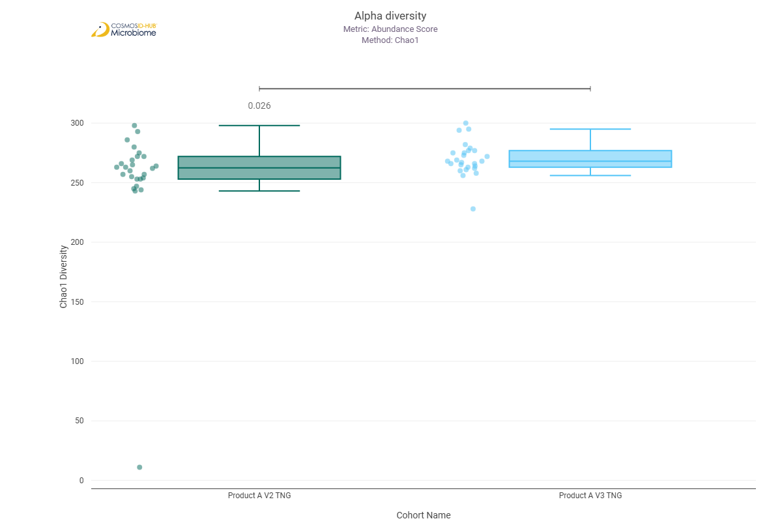
Shannon | 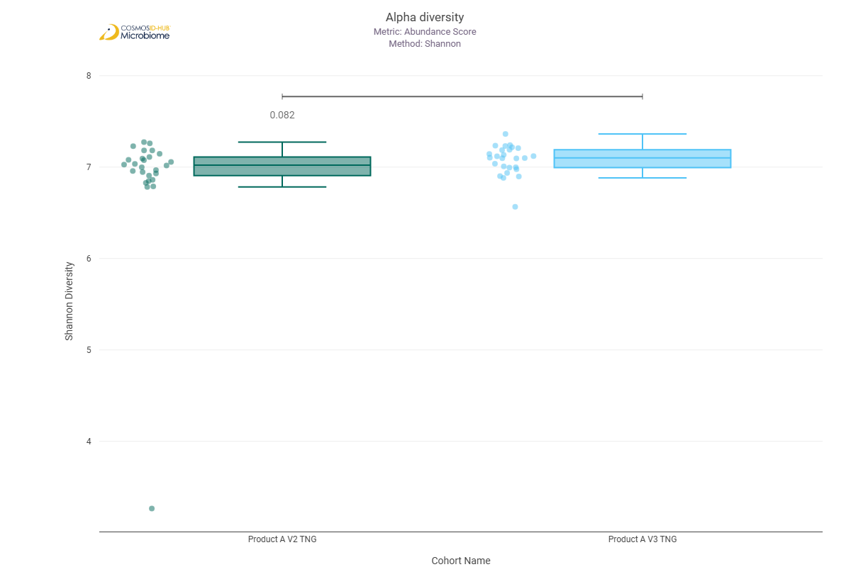
Simpson | 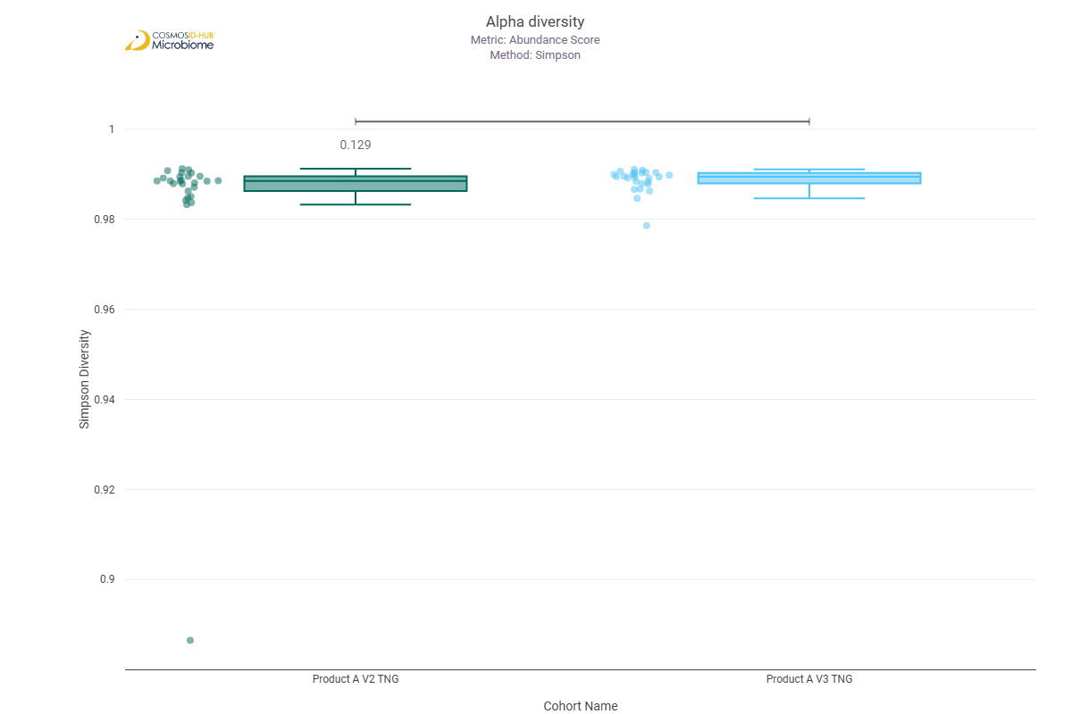

Beta Diversity (MetaCyc)
Bray-Curtis  PERMNOVA p = 0.164 | 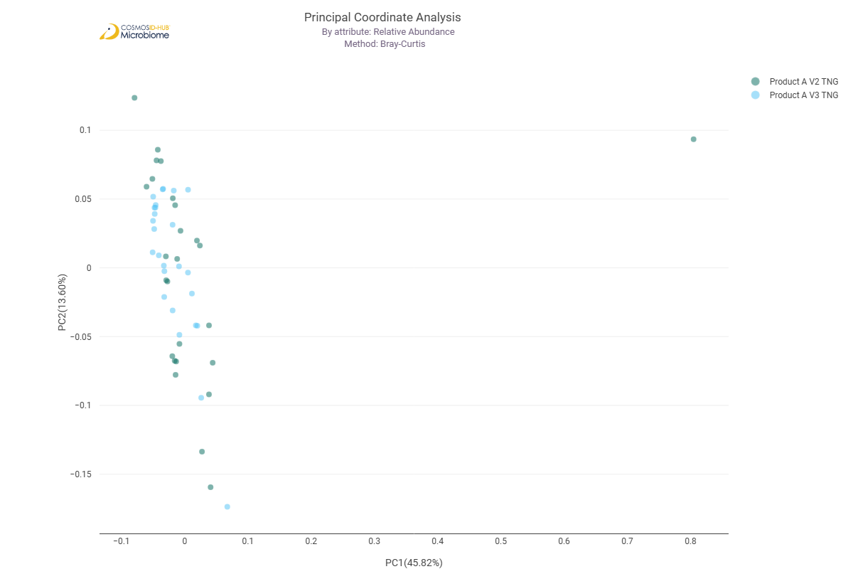

Differential Abundance (LEfSe) (MetaCyc)
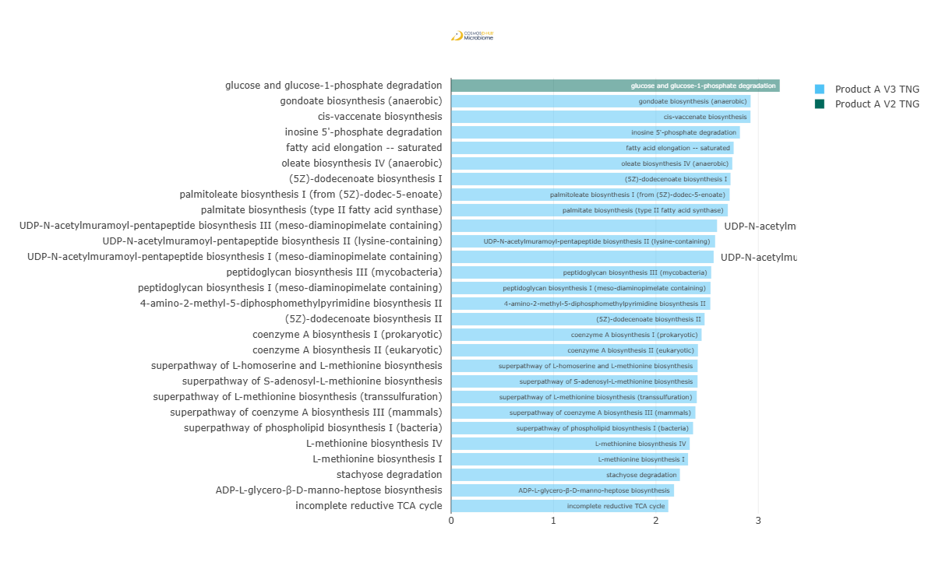
Feature | Enriched Cohort | LDA Score | P-value
glucose and glucose-1-phosphate degradation | Product A V2 TNG | 3.209559052 | 0.00340667
gondoate biosynthesis (anaerobic) | Product A V3 TNG | 2.924765578 | 0.012811669
cis-vaccenate biosynthesis | Product A V3 TNG | 2.923502255 | 0.024382597
inosine 5'-phosphate degradation | Product A V3 TNG | 2.820503146 | 0.007962104
fatty acid elongation -- saturated | Product A V3 TNG | 2.759343308 | 0.02808172
oleate biosynthesis IV (anaerobic) | Product A V3 TNG | 2.746062827 | 0.022157981
(5Z)-dodecenoate biosynthesis I | Product A V3 TNG | 2.728547812 | 0.024382597
palmitoleate biosynthesis I (from (5Z)-dodec-5-enoate) | Product A V3 TNG | 2.720034844 | 0.03375904
palmitate biosynthesis (type II fatty acid synthase) | Product A V3 TNG | 2.702281934 | 0.032254747
UDP-N-acetylmuramoyl-pentapeptide biosynthesis III (meso-diaminopimelate containing) | Product A V3 TNG | 2.597049045 | 0.008868809
UDP-N-acetylmuramoyl-pentapeptide biosynthesis II (lysine-containing) | Product A V3 TNG | 2.578363977 | 0.02556575
UDP-N-acetylmuramoyl-pentapeptide biosynthesis I (meso-diaminopimelate containing) | Product A V3 TNG | 2.563990058 | 0.019152346
peptidoglycan biosynthesis III (mycobacteria) | Product A V3 TNG | 2.540069927 | 0.036948224
peptidoglycan biosynthesis I (meso-diaminopimelate containing) | Product A V3 TNG | 2.533524177 | 0.026798248
4-amino-2-methyl-5-diphosphomethylpyrimidine biosynthesis II | Product A V3 TNG | 2.531429766 | 0.003615568
(5Z)-dodecenoate biosynthesis II | Product A V3 TNG | 2.475232712 | 0.030736851
coenzyme A biosynthesis I (prokaryotic) | Product A V3 TNG | 2.446066864 | 0.02808172
coenzyme A biosynthesis II (eukaryotic) | Product A V3 TNG | 2.410665002 | 0.00210785
superpathway of L-homoserine and L-methionine biosynthesis | Product A V3 TNG | 2.407228434 | 3.08E-02
superpathway of S-adenosyl-L-methionine biosynthesis | Product A V3 TNG | 2.406586807 | 0.014930589
superpathway of L-methionine biosynthesis (transsulfuration) | Product A V3 TNG | 2.399360615 | 0.038636777
superpathway of coenzyme A biosynthesis III (mammals) | Product A V3 TNG | 2.385903102 | 0.00406225
superpathway of phospholipid biosynthesis I (bacteria) | Product A V3 TNG | 2.363206689 | 0.000664015
L-methionine biosynthesis IV | Product A V3 TNG | 2.330041224 | 0.006393679
L-methionine biosynthesis I | Product A V3 TNG | 2.313741316 | 0.029417827
stachyose degradation | Product A V3 TNG | 2.234251147 | 0.044100855
ADP-L-glycero-β-D-manno-heptose biosynthesis | Product A V3 TNG | 2.177105902 | 0.011551265
incomplete reductive TCA cycle | Product A V3 TNG | 2.121158237 | 0.012466883

Comparison 10: Product B V2 TNG vs Product B V3 TNG

Gene Ontology

Alpha Diversity (GO)
Chao1 | 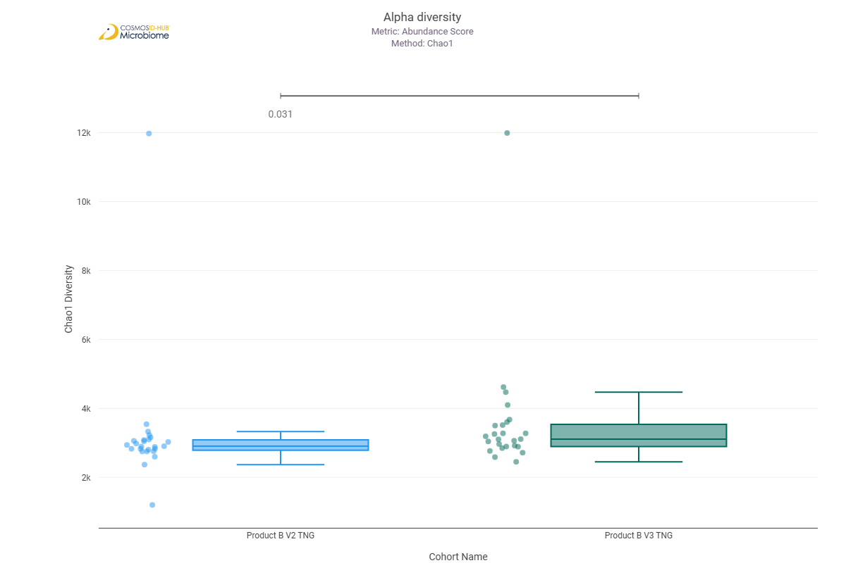
Shannon | 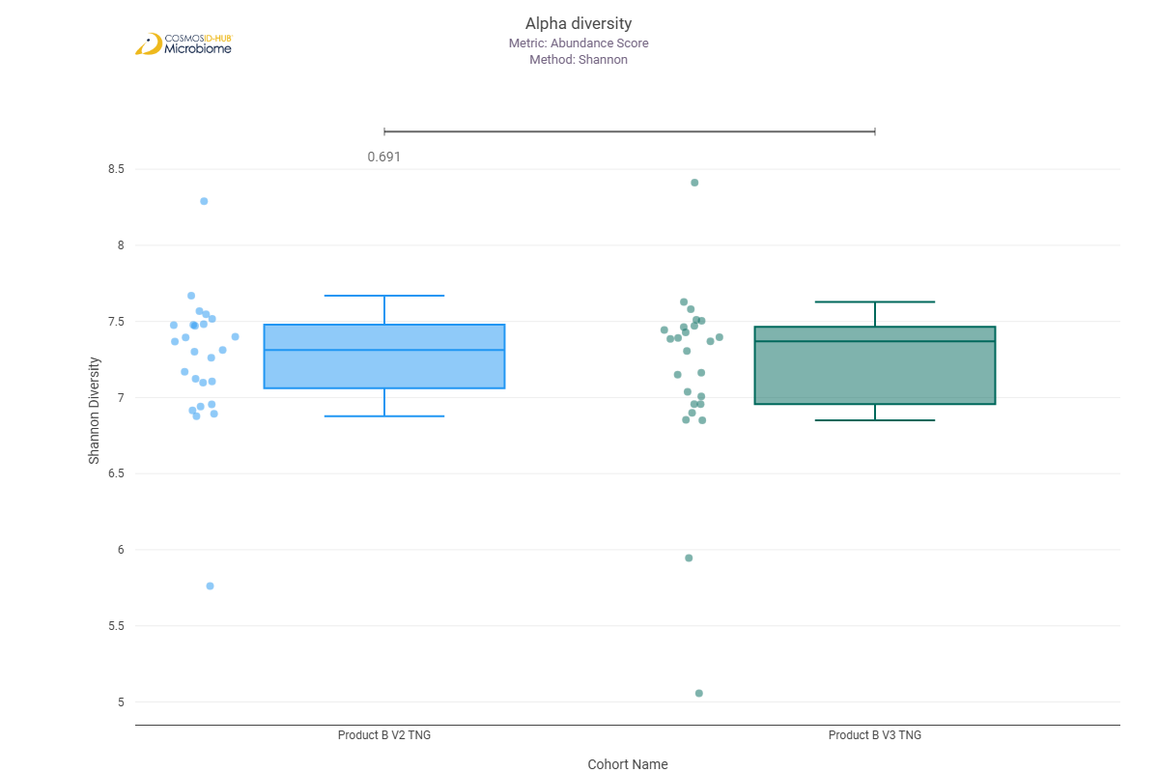
Simpson | 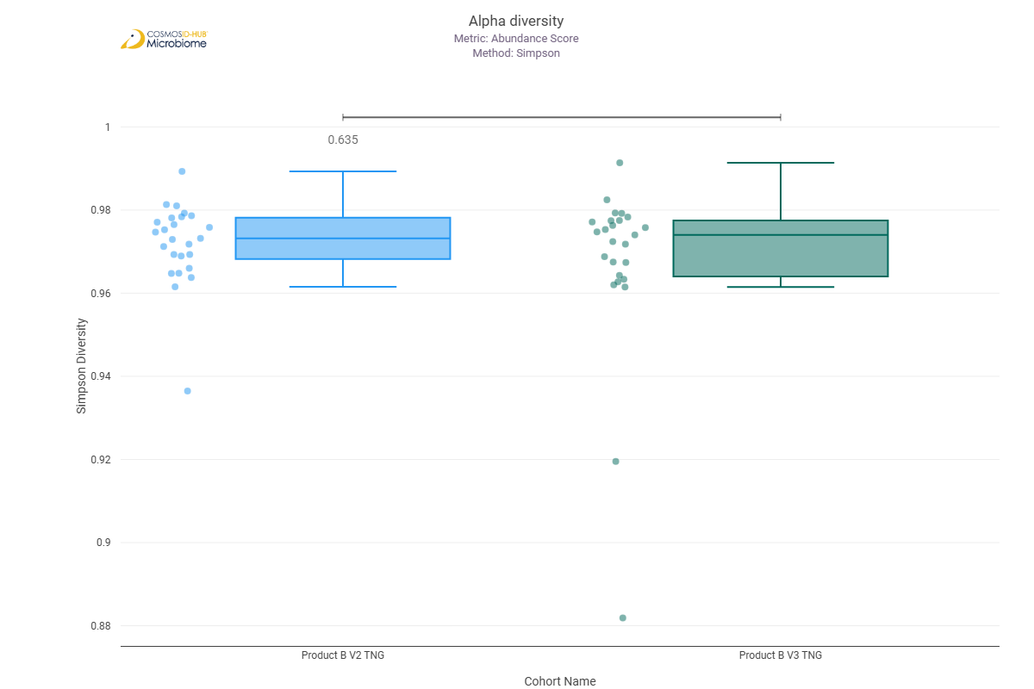

Beta Diversity (GO)
Bray-Curtis  PERMNOVA p = 0.724 | 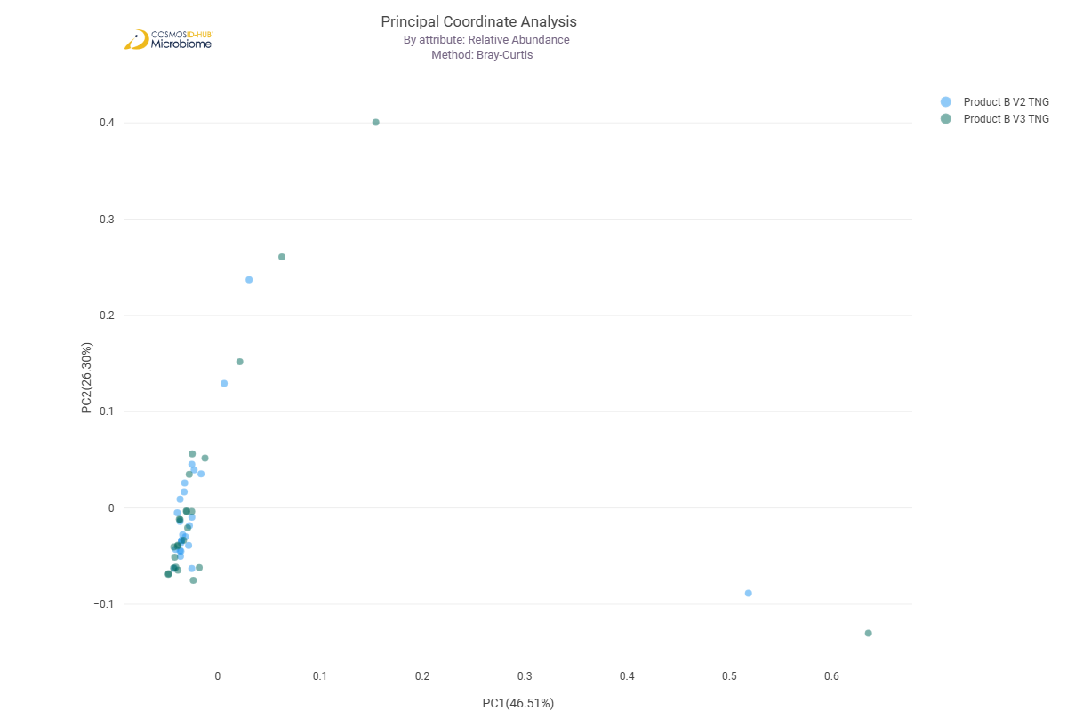

Differential Abundance (LEfSe) (GO)
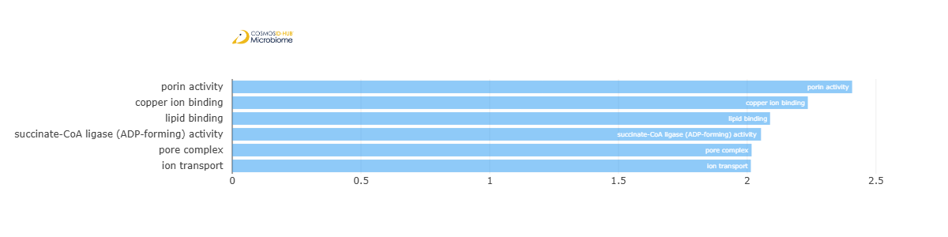
Feature | Enriched Cohort | LDA Score | P-value
porin activity | Product B V2 TNG | 2.40751192 | 0.019384996
copper ion binding | Product B V2 TNG | 2.2353981 | 0.010726809
lipid binding | Product B V2 TNG | 2.088755697 | 0.021491444
succinate-CoA ligase (ADP-forming) activity | Product B V2 TNG | 2.053577679 | 0.046724152
pore complex | Product B V2 TNG | 2.016987317 | 0.008561466
ion transport | Product B V2 TNG | 2.014120892 | 0.007632882

Enzyme Commission

Alpha Diversity (EC)
Chao1 | 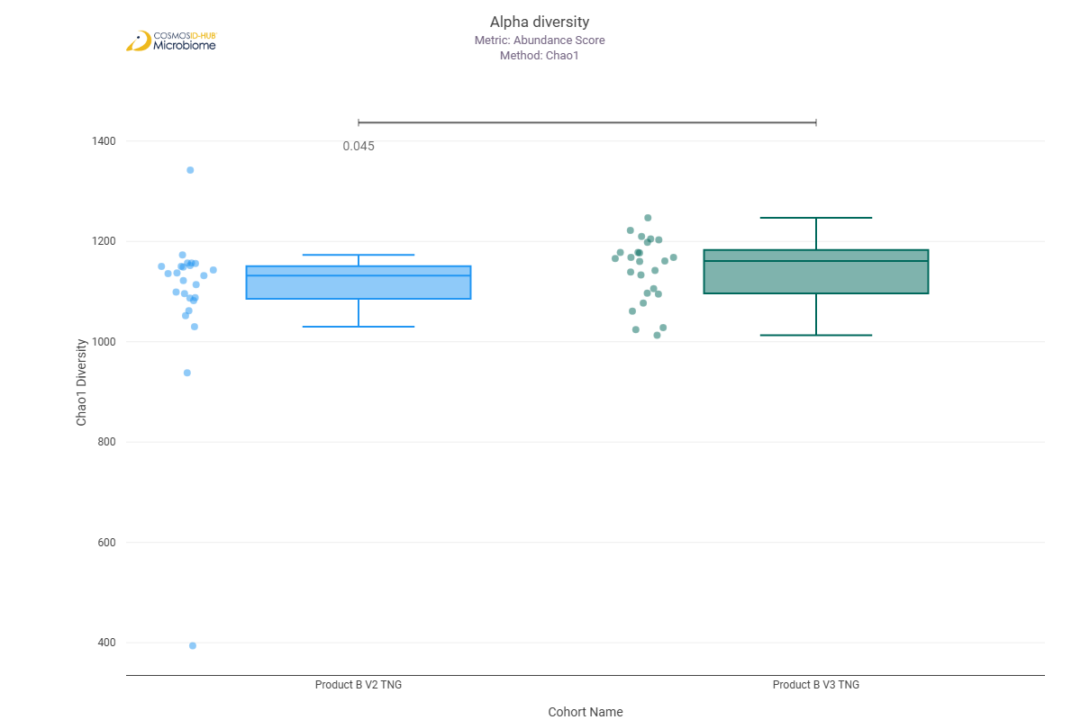
Shannon | 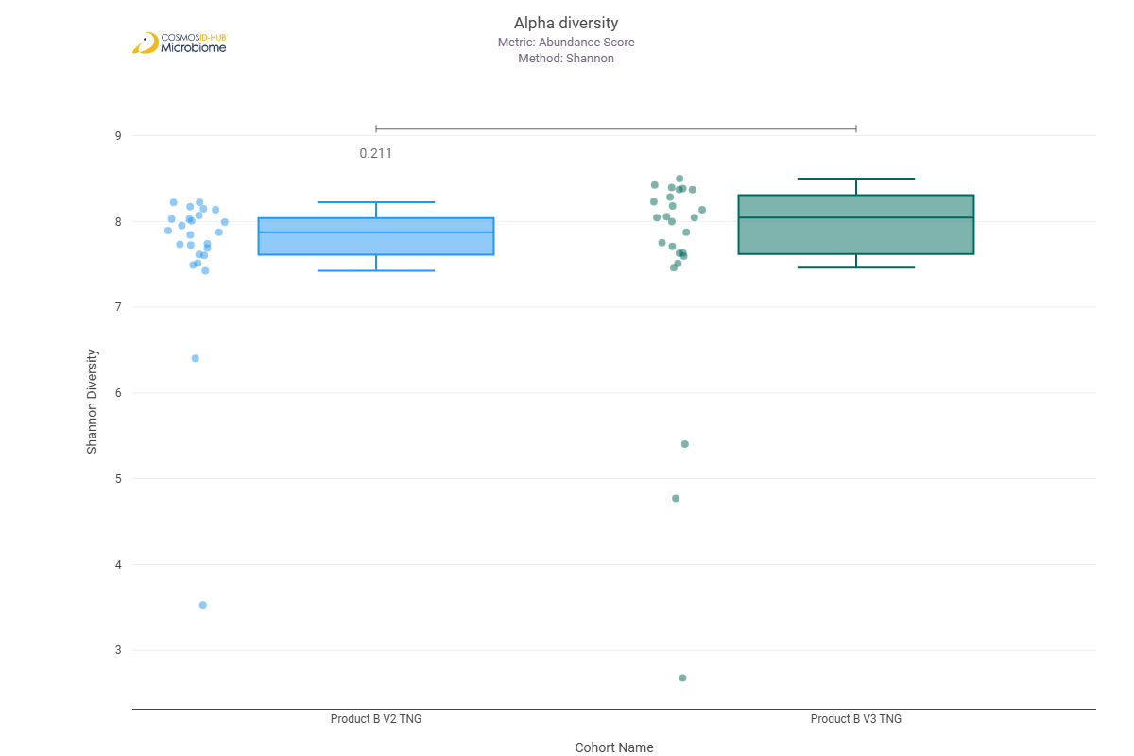
Simpson | 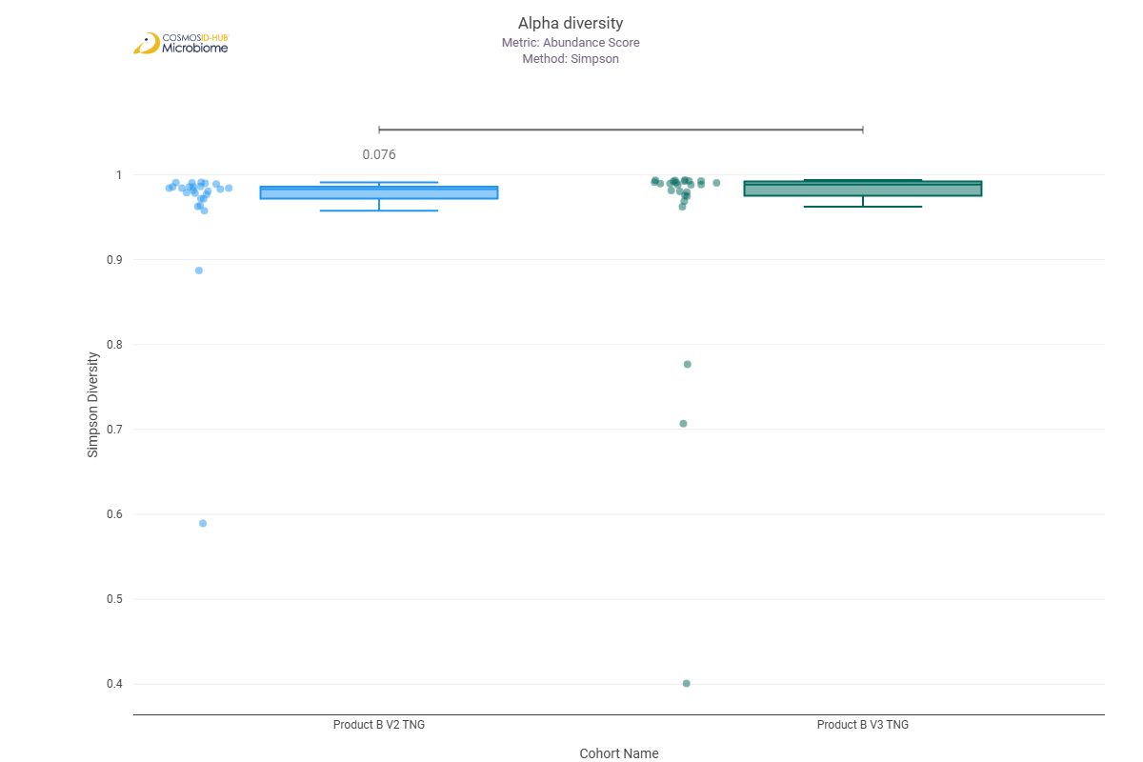

Beta Diversity (EC)
Bray-Curtis  PERMNOVA p = 0.450 | 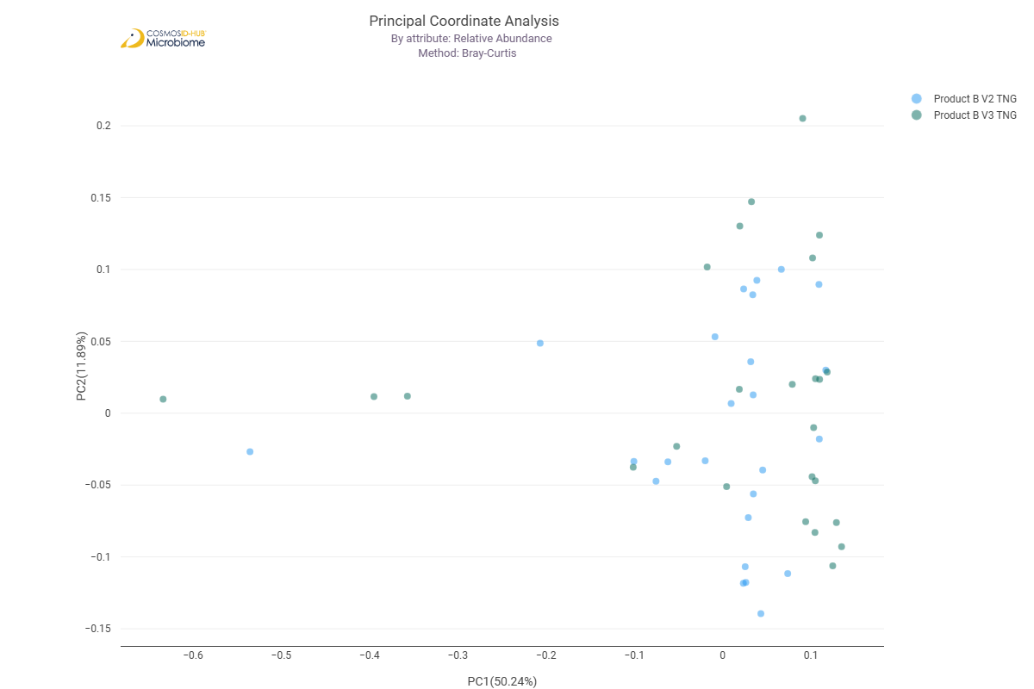

Differential Abundance (LEfSe) (EC)
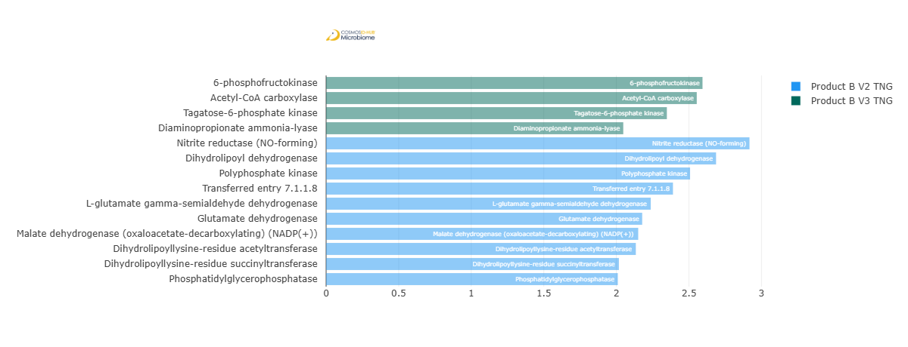
Feature | Enriched Cohort | LDA Score | P-value
6-phosphofructokinase | Product B V3 TNG | 2.593878204 | 0.046724152
Acetyl-CoA carboxylase | Product B V3 TNG | 2.554255826 | 0.023794451
Tagatose-6-phosphate kinase | Product B V3 TNG | 2.348108235 | 0.048908406
Diaminopropionate ammonia-lyase | Product B V3 TNG | 2.047738576 | 0.0250207
Nitrite reductase (NO-forming) | Product B V2 TNG | 2.917501423 | 0.011973973
Dihydrolipoyl dehydrogenase | Product B V2 TNG | 2.687051774 | 0.044622577
Polyphosphate kinase | Product B V2 TNG | 2.50802902 | 0.019384996
Transferred entry 7.1.1.8 | Product B V2 TNG | 2.390039535 | 0.0352731
L-glutamate gamma-semialdehyde dehydrogenase | Product B V2 TNG | 2.237146802 | 0.0352731
Glutamate dehydrogenase | Product B V2 TNG | 2.178088537 | 0.016563699
Malate dehydrogenase (oxaloacetate-decarboxylating) (NADP(+)) | Product B V2 TNG | 2.150718273 | 0.044622577
Dihydrolipoyllysine-residue acetyltransferase | Product B V2 TNG | 2.134159792 | 0.010726809
Dihydrolipoyllysine-residue succinyltransferase | Product B V2 TNG | 2.017575362 | 0.019384996
Phosphatidylglycerophosphatase | Product B V2 TNG | 2.010237144 | 0.001321949

MetaCyc Pathways

Alpha Diversity (MetaCyc)
Chao1 | 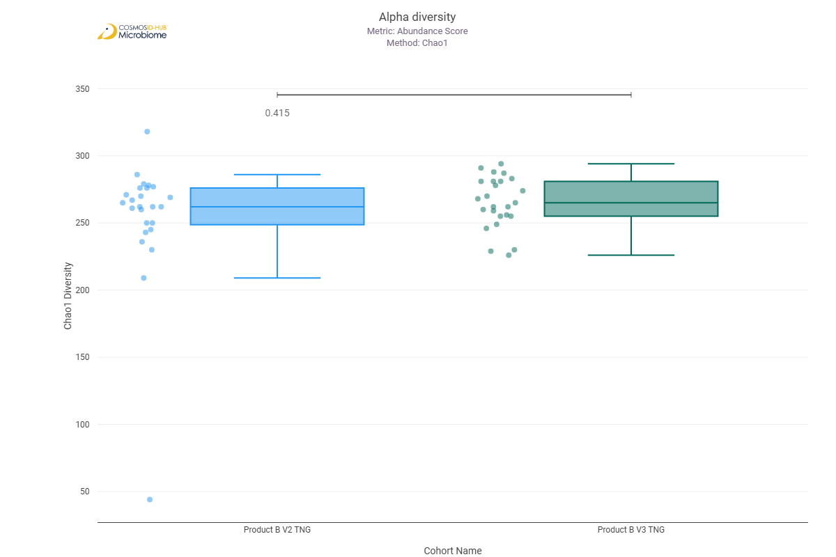
Shannon | 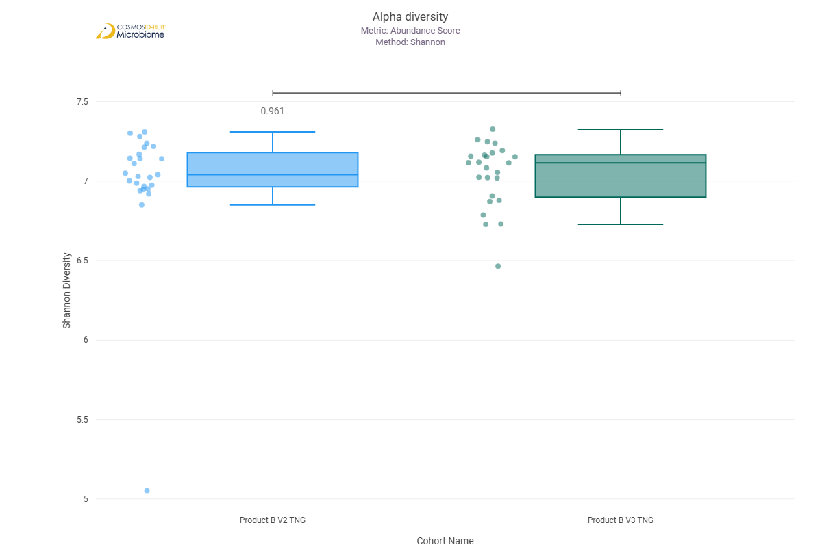
Simpson | 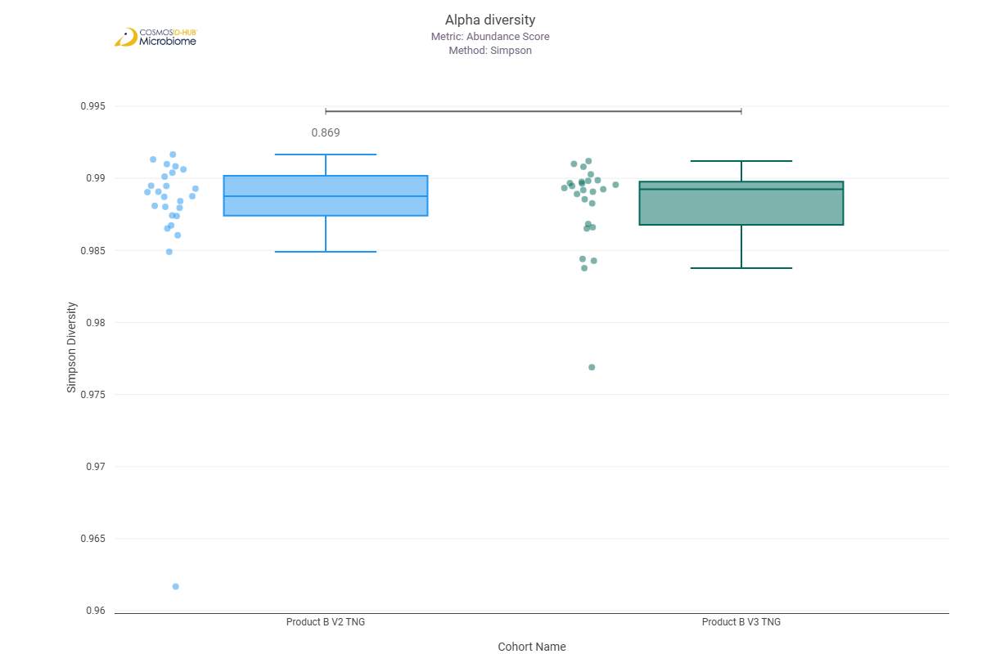

Beta Diversity (MetaCyc)
Bray-Curtis  PERMNOVA p = 0.638 | 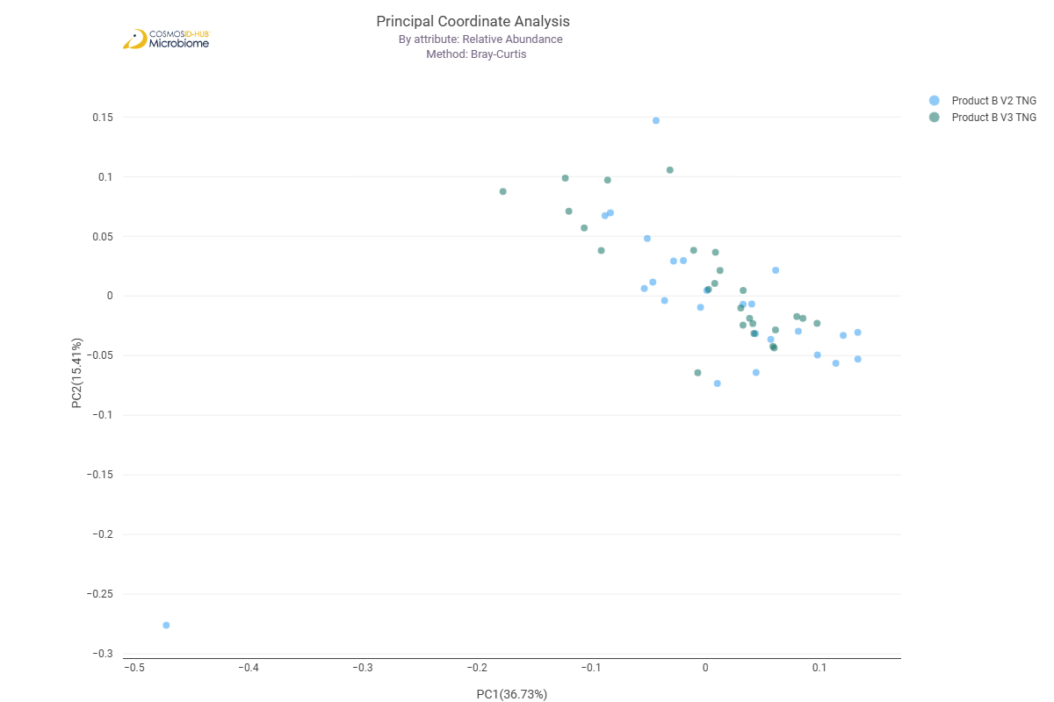

Differential Abundance (LEfSe) (MetaCyc)
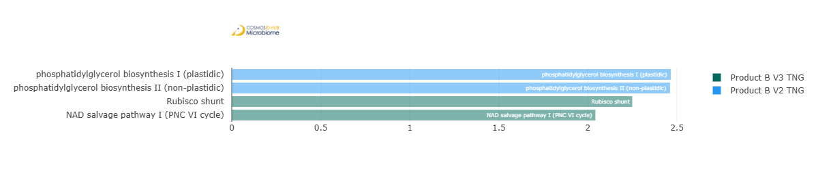
Feature | Enriched Cohort | LDA Score | P-value
phosphatidylglycerol biosynthesis I (plastidic) | Product B V2 TNG | 2.46589043 | 0.022617484
phosphatidylglycerol biosynthesis II (non-plastidic) | Product B V2 TNG | 2.461496298 | 0.022617484
Rubisco shunt | Product B V3 TNG | 2.249336154 | 0.038590299
NAD salvage pathway I (PNC VI cycle) | Product B V3 TNG | 2.04217463 | 0.042581422

Comparison 11: Product A V2 TNG vs Product B V2 TNG

Gene Ontology

Alpha Diversity (GO)
Chao1 | 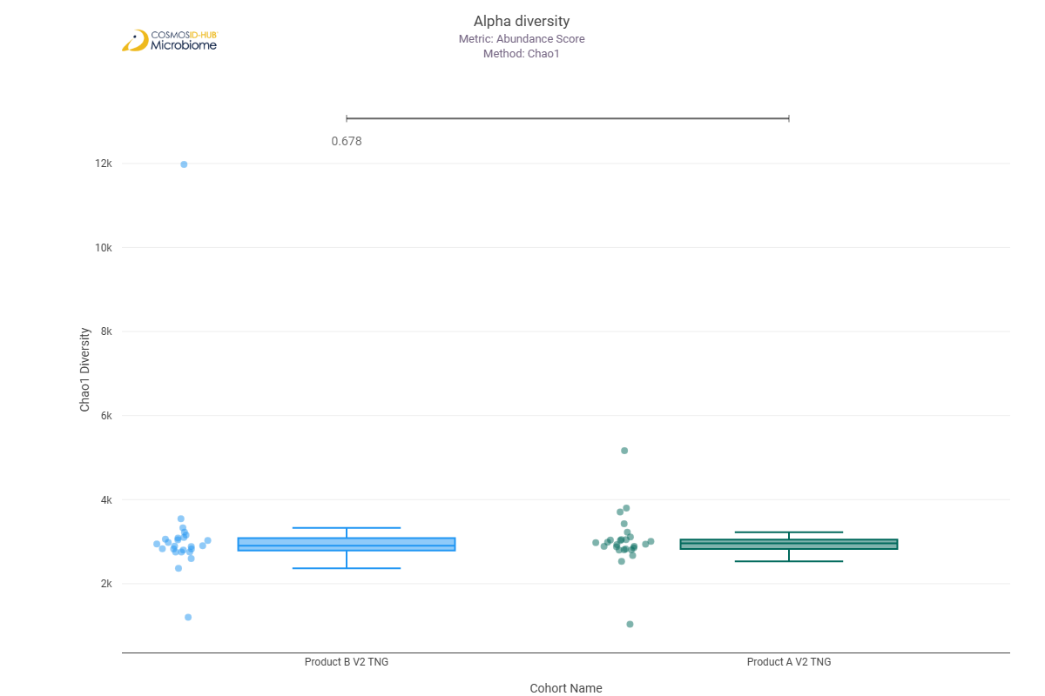
Shannon | 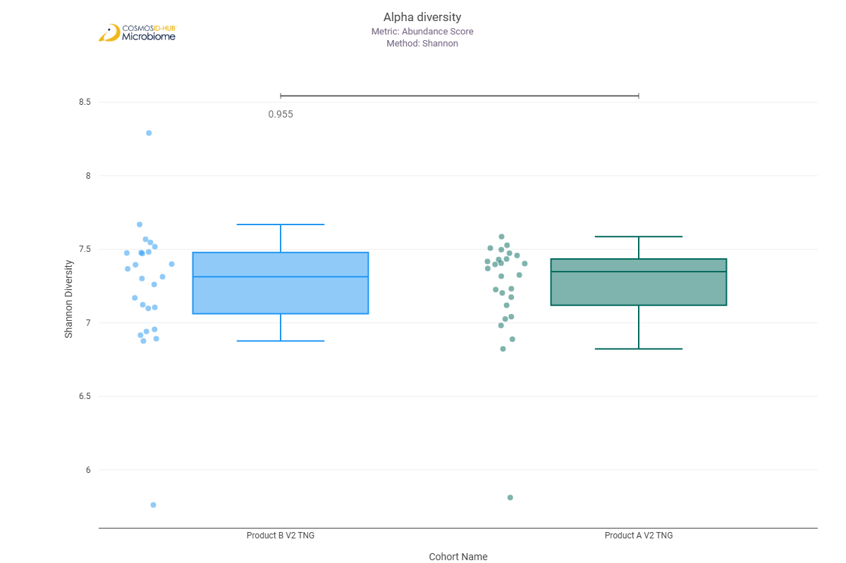
Simpson | 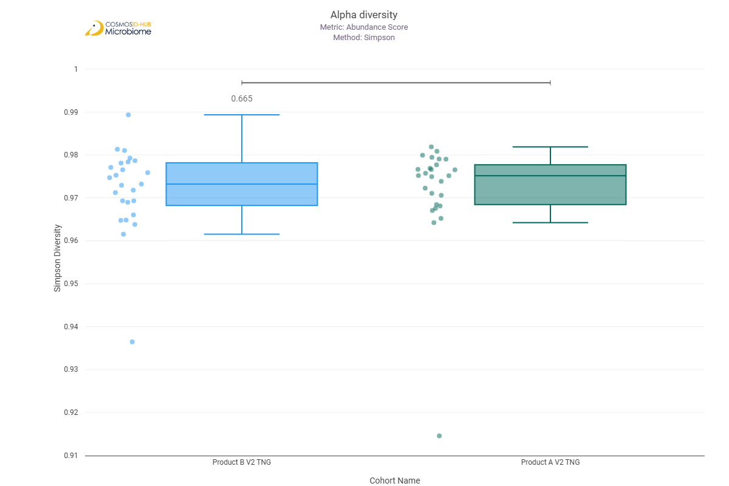

Beta Diversity (GO)
Bray-Curtis  PERMNOVA p = 0.651 | 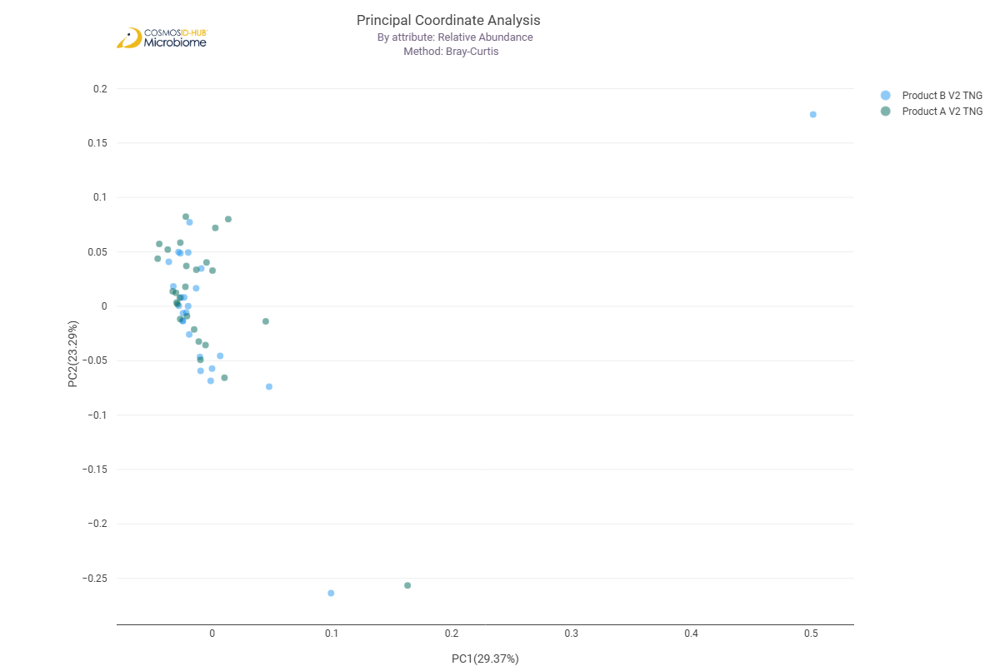

Differential Abundance (LEfSe) (GO)
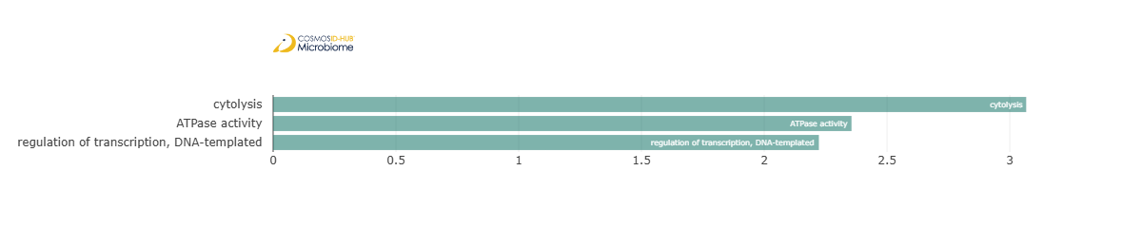
Feature | Enriched Cohort | LDA Score | P-value
cytolysis | Product A V2 TNG | 3.06689764 | 0.015071869
ATPase activity | Product A V2 TNG | 2.355539921 | 0.031712637
regulation of transcription, DNA-templated | Product A V2 TNG | 2.222731989 | 0.027486336

Enzyme Commission

Alpha Diversity (EC)
Chao1 | 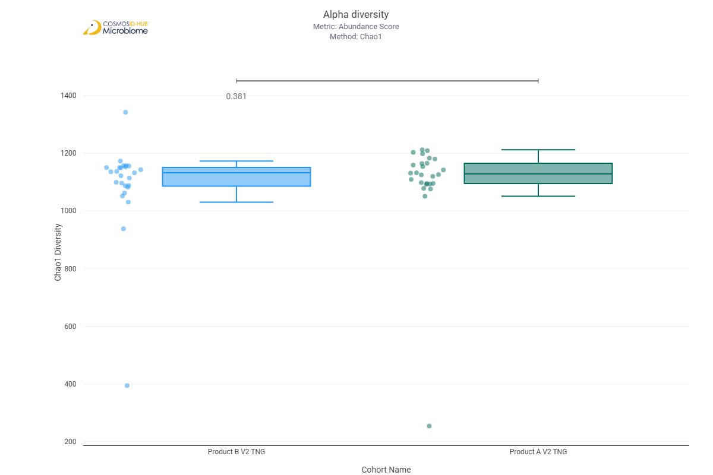
Shannon | 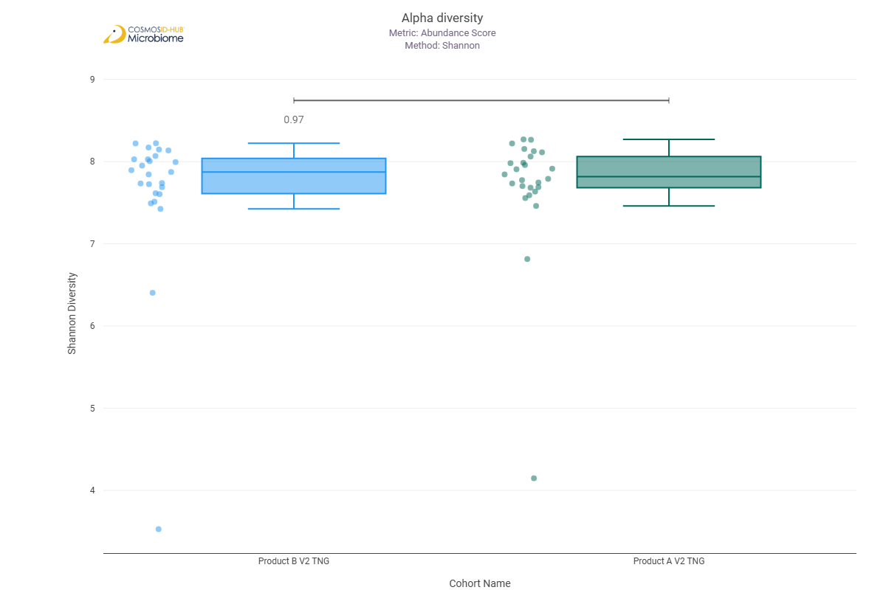
Simpson | 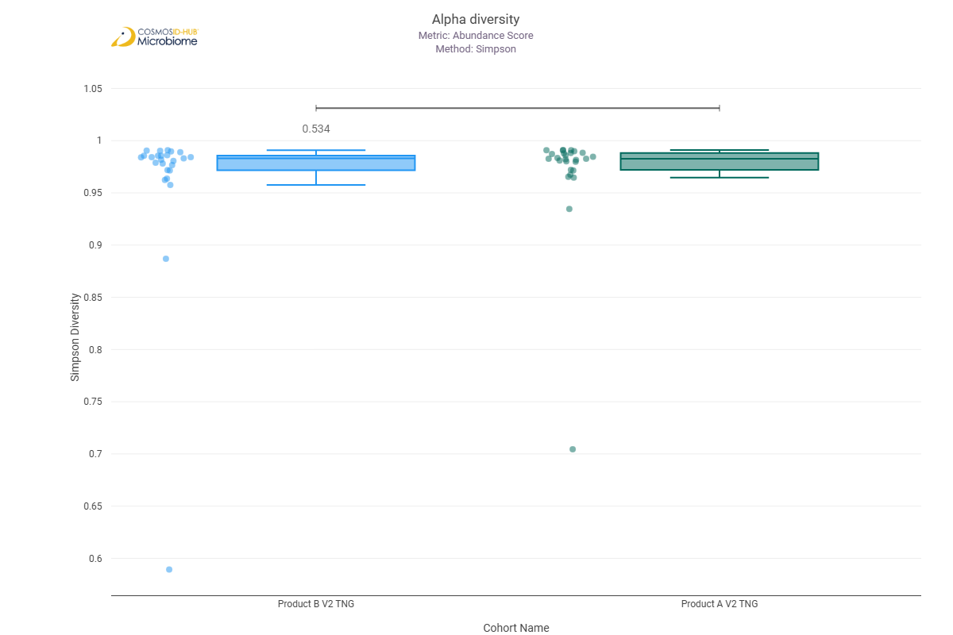

Beta Diversity (EC)
Bray-Curtis  PERMNOVA p = 0.494 | 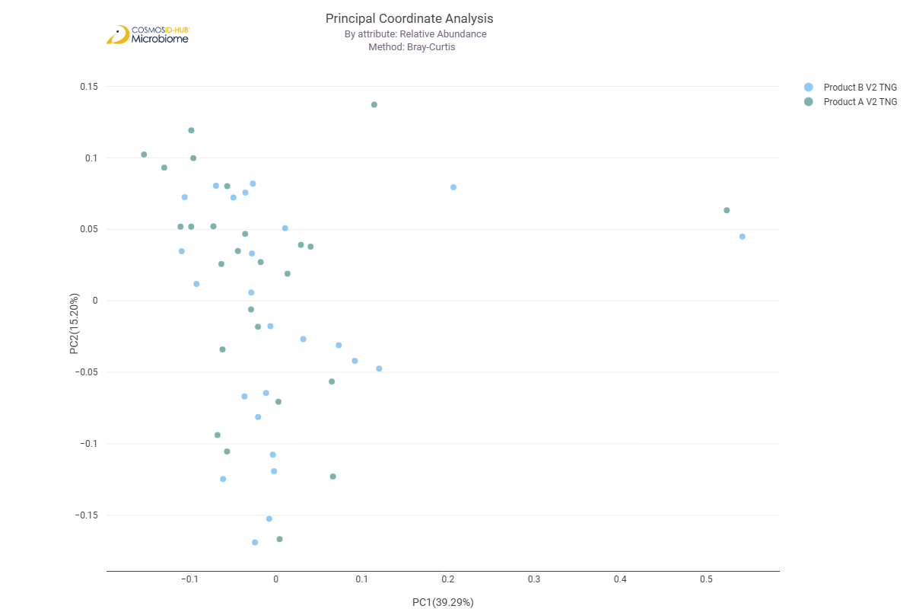

Differential Abundance (LEfSe) (EC)
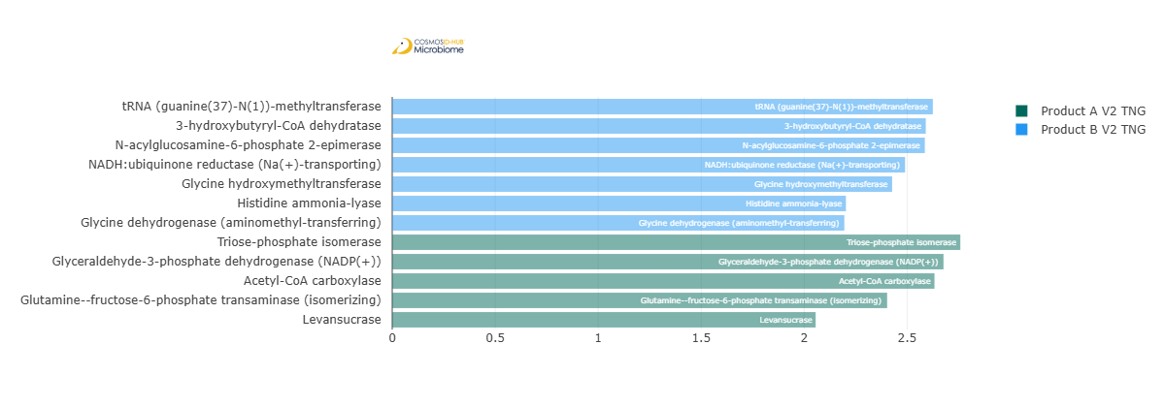
Feature | Enriched Cohort | LDA Score | P-value
tRNA (guanine(37)-N(1))-methyltransferase | Product B V2 TNG | 2.624857402 | 0.010968497
3-hydroxybutyryl-CoA dehydratase | Product B V2 TNG | 2.590594741 | 0.041854827
N-acylglucosamine-6-phosphate 2-epimerase | Product B V2 TNG | 2.585952682 | 0.017590793
NADH:ubiquinone reductase (Na(+)-transporting) | Product B V2 TNG | 2.489874734 | 0.026189985
Glycine hydroxymethyltransferase | Product B V2 TNG | 2.427217585 | 0.031712637
Histidine ammonia-lyase | Product B V2 TNG | 2.202715444 | 0.021519031
Glycine dehydrogenase (aminomethyl-transferring) | Product B V2 TNG | 2.195190326 | 0.036484395
Triose-phosphate isomerase | Product A V2 TNG | 2.758297723 | 0.030245812
Glyceraldehyde-3-phosphate dehydrogenase (NADP(+)) | Product A V2 TNG | 2.676691408 | 0.045697083
Acetyl-CoA carboxylase | Product A V2 TNG | 2.63288439 | 0.00745964
Glutamine--fructose-6-phosphate transaminase (isomerizing) | Product A V2 TNG | 2.403033073 | 0.045795182
Levansucrase | Product A V2 TNG | 2.055940637 | 0.017552852

MetaCyc Pathways

Alpha Diversity (MetaCyc)
Chao1 | 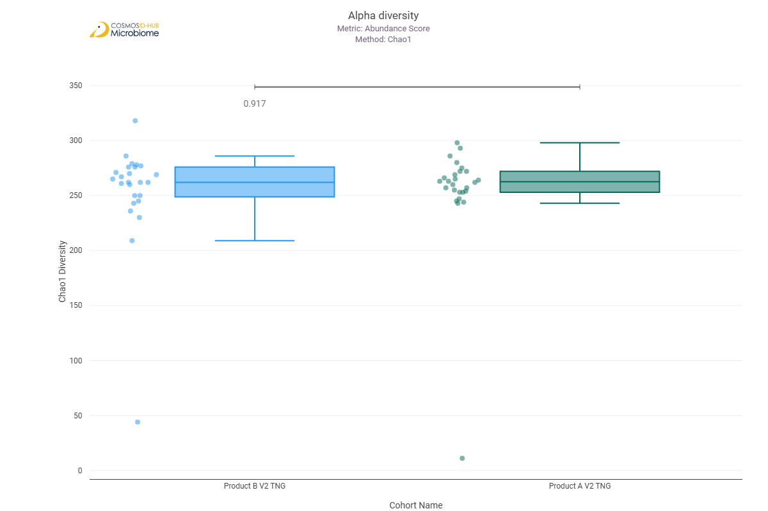
Shannon | 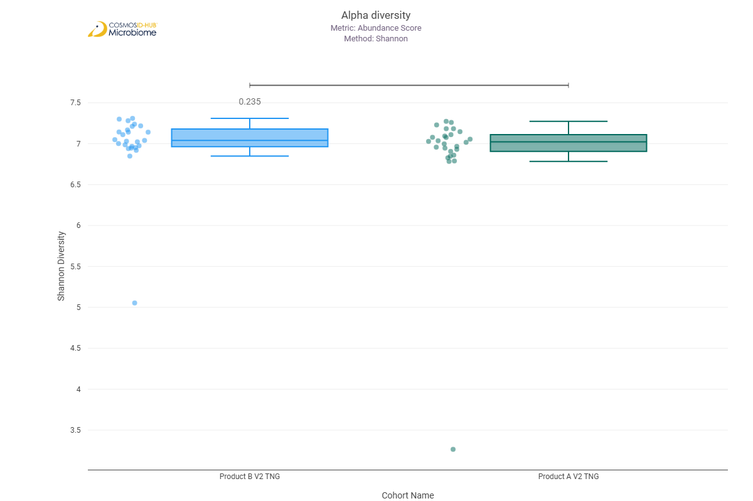
Simpson | 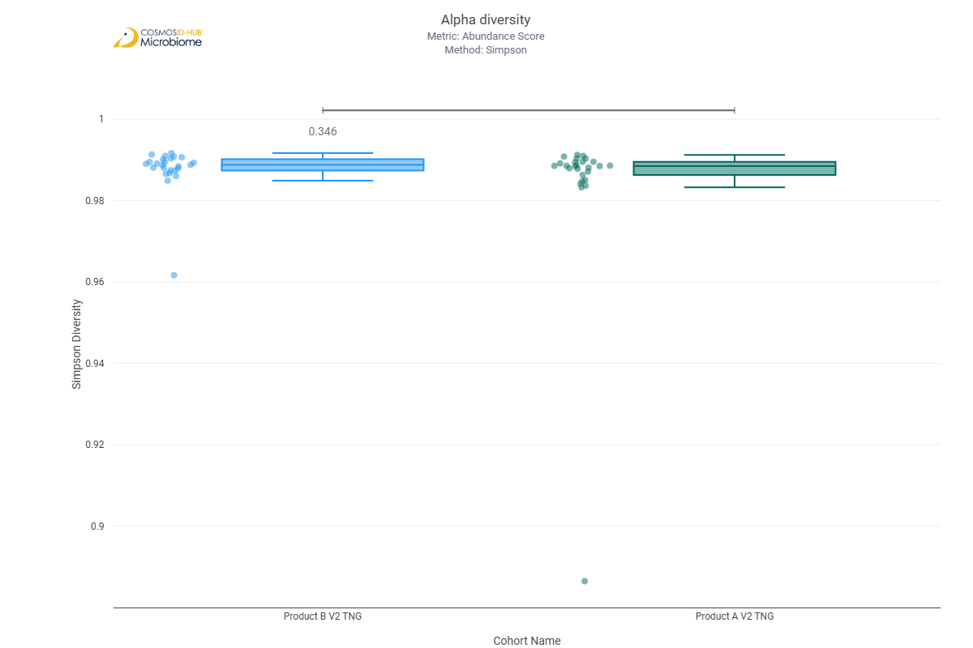

Beta Diversity (MetaCyc)
Bray-Curtis  PERMNOVA p = 0.666 | 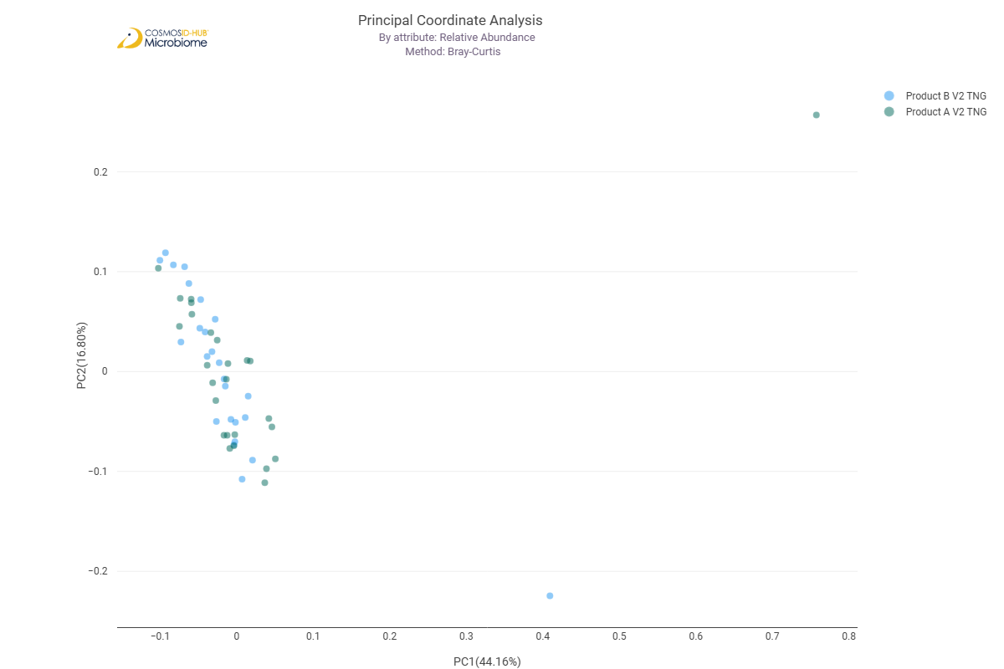

Differential Abundance (LEfSe) (MetaCyc)
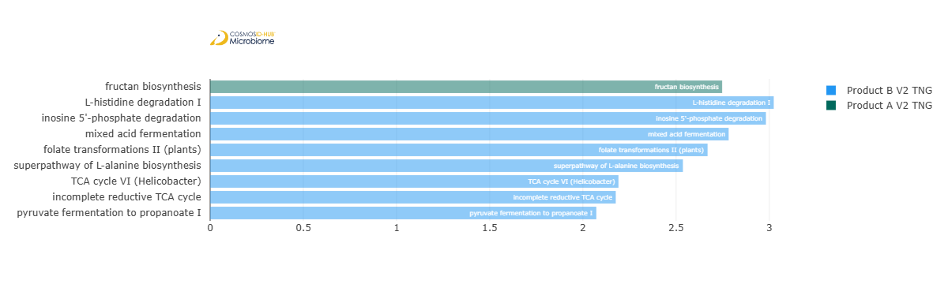
Feature | Enriched Cohort | LDA Score | P-value
fructan biosynthesis | Product A V2 TNG | 2.746991997 | 0.019443383
L-histidine degradation I | Product B V2 TNG | 3.02380233 | 0.021519031
inosine 5'-phosphate degradation | Product B V2 TNG | 2.981940294 | 0.002269883
mixed acid fermentation | Product B V2 TNG | 2.781796134 | 0.030967972
folate transformations II (plants) | Product B V2 TNG | 2.668838629 | 0.026189985
superpathway of L-alanine biosynthesis | Product B V2 TNG | 2.536575601 | 0.048946493
TCA cycle VI (Helicobacter) | Product B V2 TNG | 2.190843266 | 0.00083361
incomplete reductive TCA cycle | Product B V2 TNG | 2.17615078 | 0.018956342
pyruvate fermentation to propanoate I | Product B V2 TNG | 2.071955954 | 0.010899265

Comparison 12: Product A V3 TNG vs Product B V3 TNG

Gene Ontology

Alpha Diversity (GO)
Chao1 | 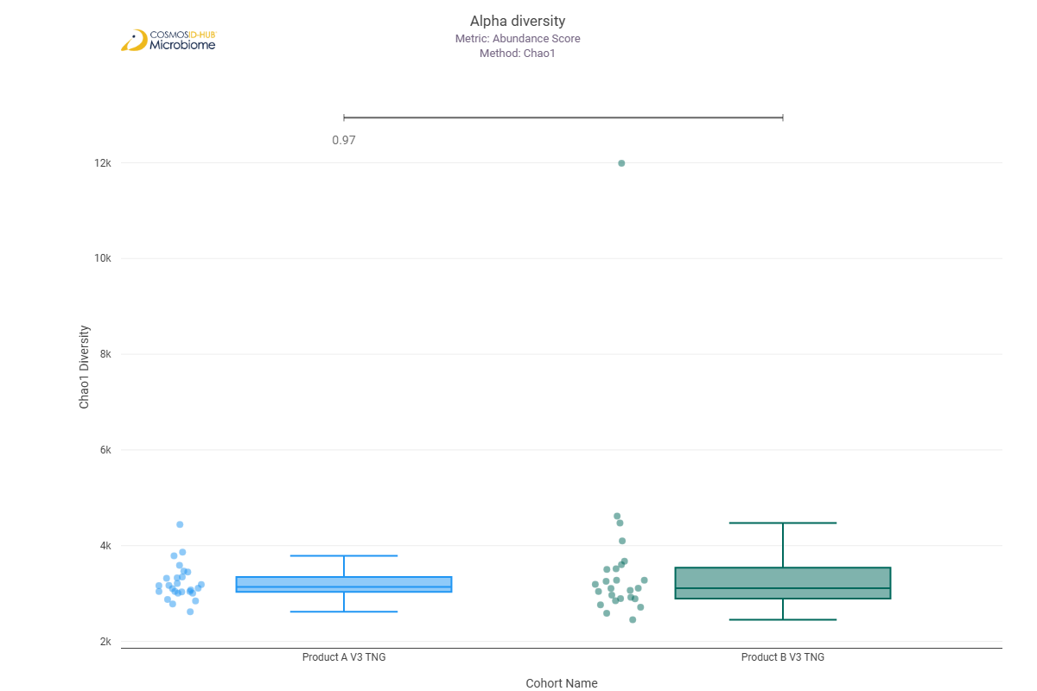
Shannon | 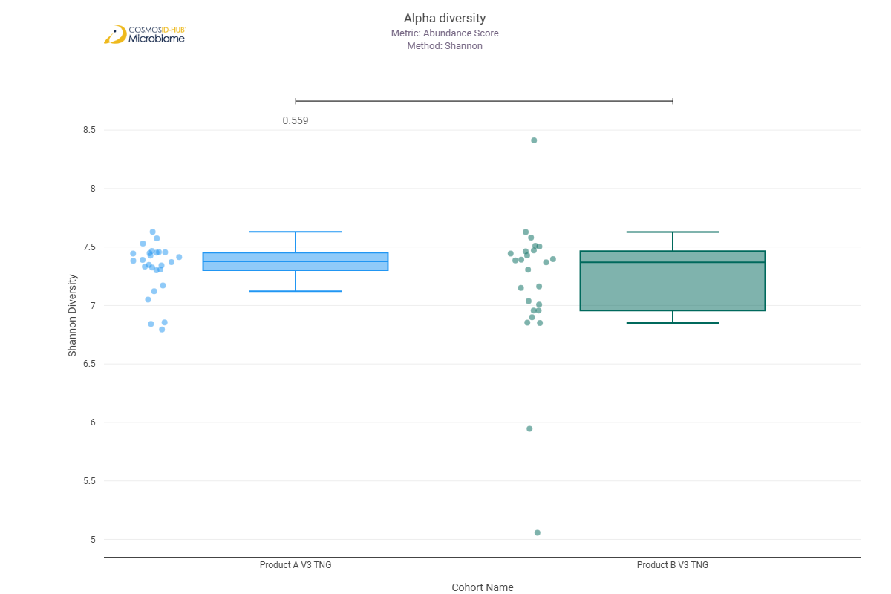
Simpson | 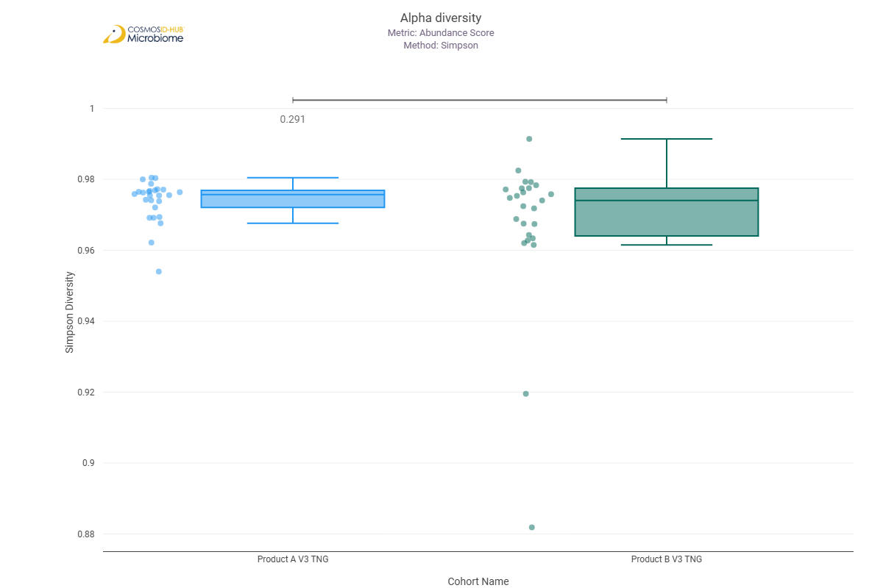

Beta Diversity (GO)
Bray-Curtis  PERMNOVA p = 0.053 | 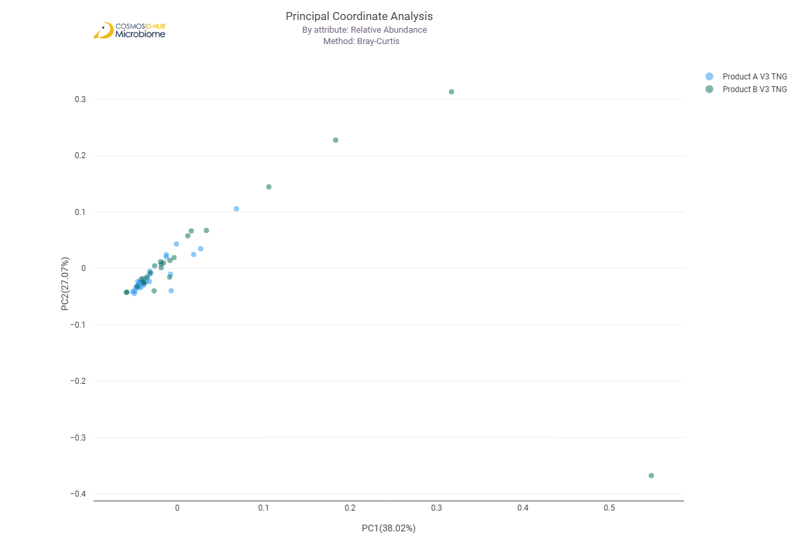

Differential Abundance (LEfSe) (GO)
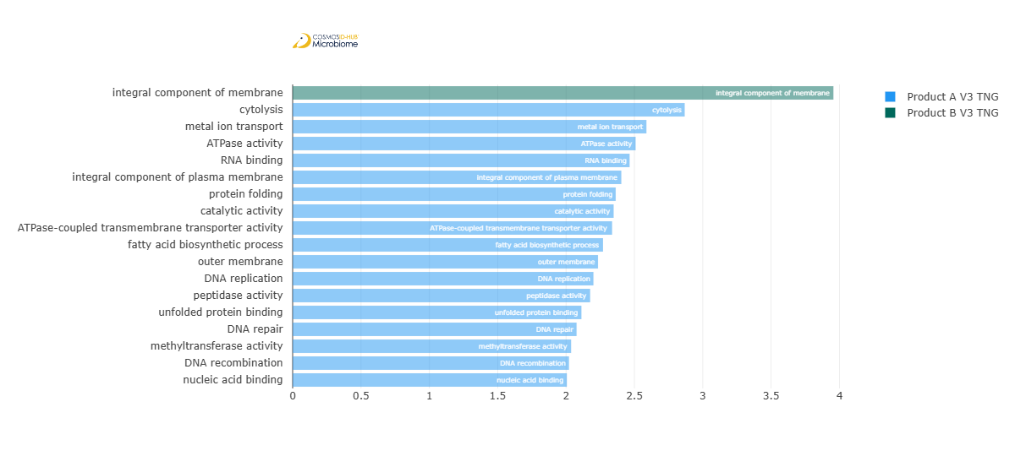
Feature | Enriched Cohort | LDA Score | P-value
integral component of membrane | Product B V3 TNG | 3.95594467 | 0.030245812
cytolysis | Product A V3 TNG | 2.86819902 | 0.043787588
metal ion transport | Product A V3 TNG | 2.588053047 | 0.000121136
ATPase activity | Product A V3 TNG | 2.509036589 | 0.031712637
RNA binding | Product A V3 TNG | 2.46499143 | 0.026189985
integral component of plasma membrane | Product A V3 TNG | 2.404445655 | 0.004992891
protein folding | Product A V3 TNG | 2.363291849 | 0.008341822
catalytic activity | Product A V3 TNG | 2.348315829 | 0.045795182
ATPase-coupled transmembrane transporter activity | Product A V3 TNG | 2.336885912 | 0.004438681
fatty acid biosynthetic process | Product A V3 TNG | 2.27062913 | 0.045795182
outer membrane | Product A V3 TNG | 2.233829492 | 0.030245812
DNA replication | Product A V3 TNG | 2.200445561 | 0.036484395
peptidase activity | Product A V3 TNG | 2.176299275 | 0.012209995
unfolded protein binding | Product A V3 TNG | 2.112611698 | 0.033240045
DNA repair | Product A V3 TNG | 2.07714937 | 0.026189985
methyltransferase activity | Product A V3 TNG | 2.037014259 | 0.027486336
DNA recombination | Product A V3 TNG | 2.02153966 | 0.00666206
nucleic acid binding | Product A V3 TNG | 2.005813652 | 0.041854827

Enzyme Commission

Alpha Diversity (EC)
Chao1 | 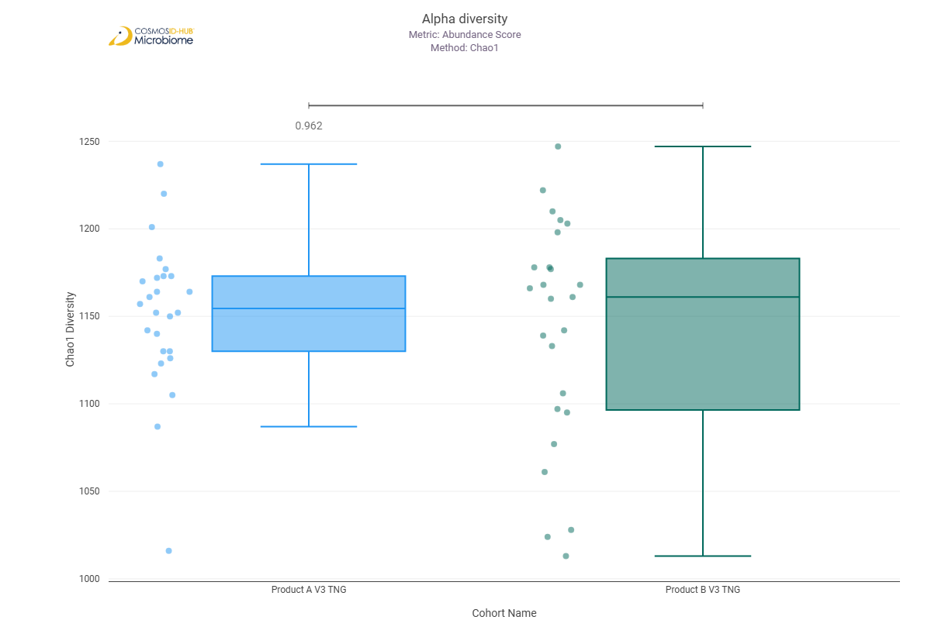
Shannon | 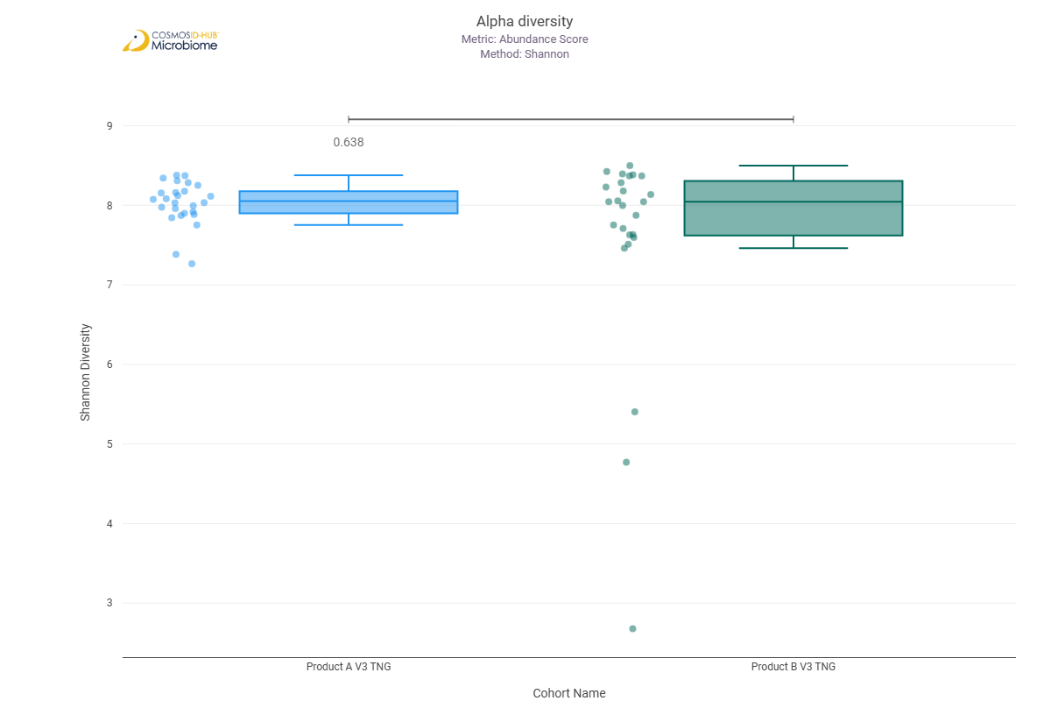
Simpson | 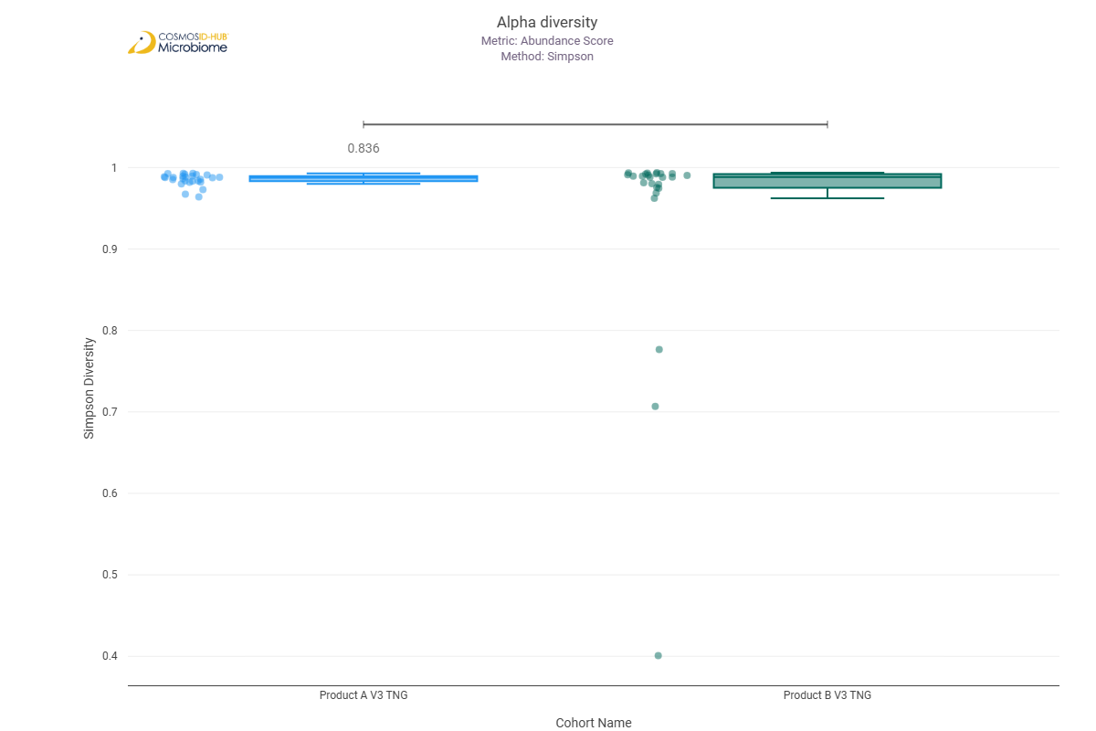

Beta Diversity (EC)
Bray-Curtis  PERMNOVA p = 0.232 | 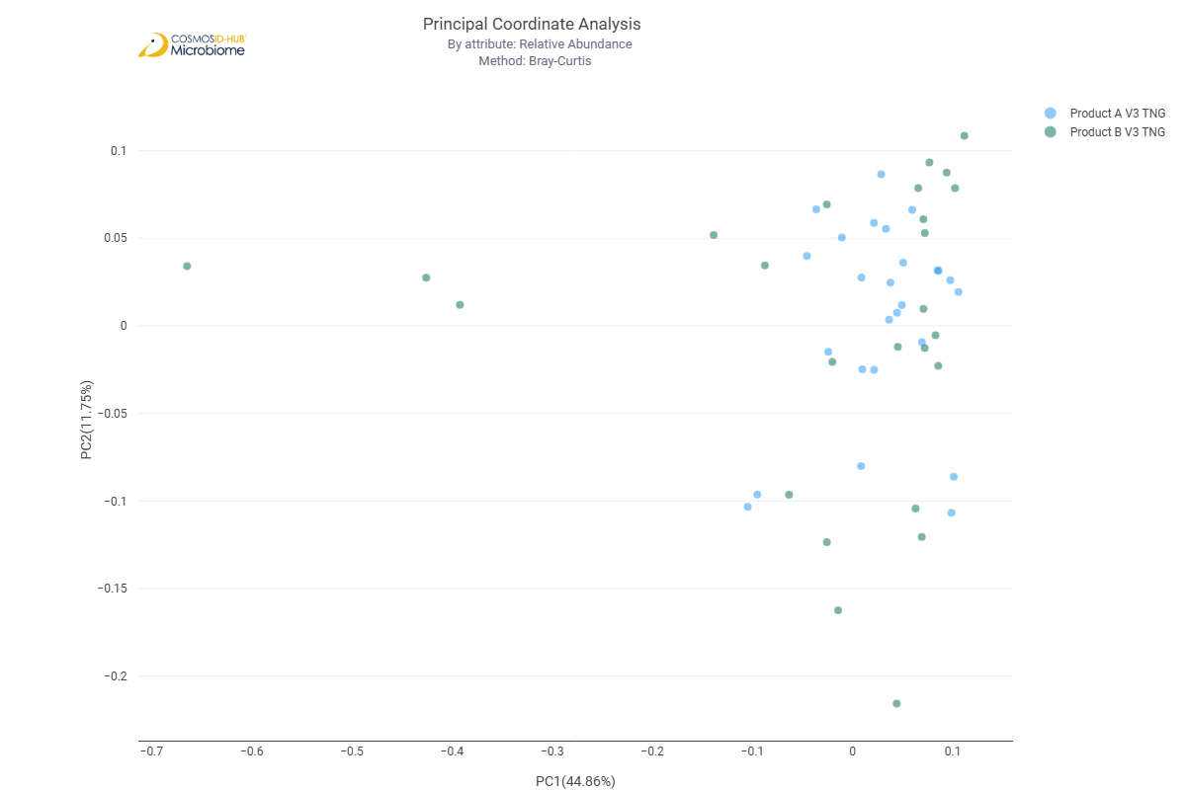

Differential Abundance (LEfSe) (EC)
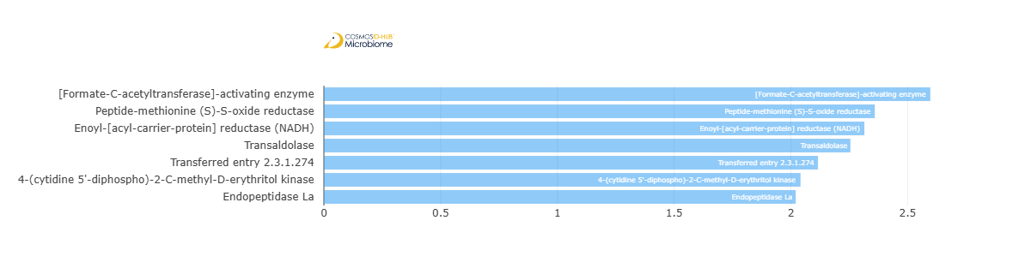
Feature | Enriched Cohort | LDA Score | P-value
[Formate-C-acetyltransferase]-activating enzyme | Product A V3 TNG | 2.597387363 | 0.021519031
Peptide-methionine (S)-S-oxide reductase | Product A V3 TNG | 2.359536073 | 0.009840467
Enoyl-[acyl-carrier-protein] reductase (NADH) | Product A V3 TNG | 2.31483187 | 0.033240045
Transaldolase | Product A V3 TNG | 2.254985266 | 0.033240045
Transferred entry 2.3.1.274 | Product A V3 TNG | 2.116157133 | 0.043787588
4-(cytidine 5'-diphospho)-2-C-methyl-D-erythritol kinase | Product A V3 TNG | 2.041454779 | 0.008341822
Endopeptidase La | Product A V3 TNG | 2.020895553 | 0.045795182

MetaCyc Pathways

Alpha Diversity (MetaCyc)
Chao1 | 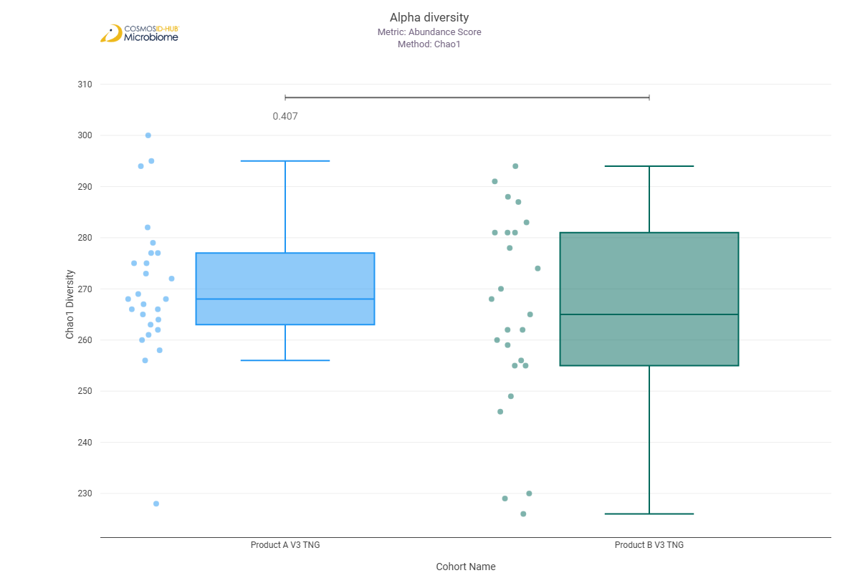
Shannon | 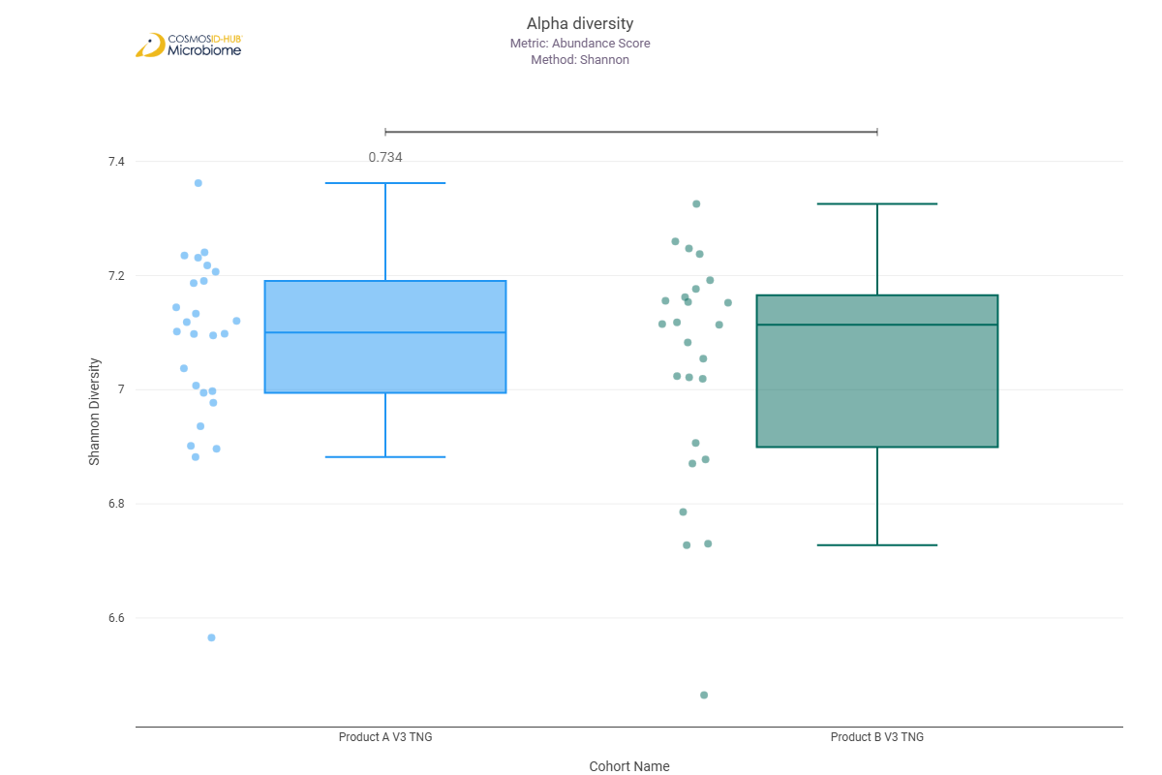
Simpson | 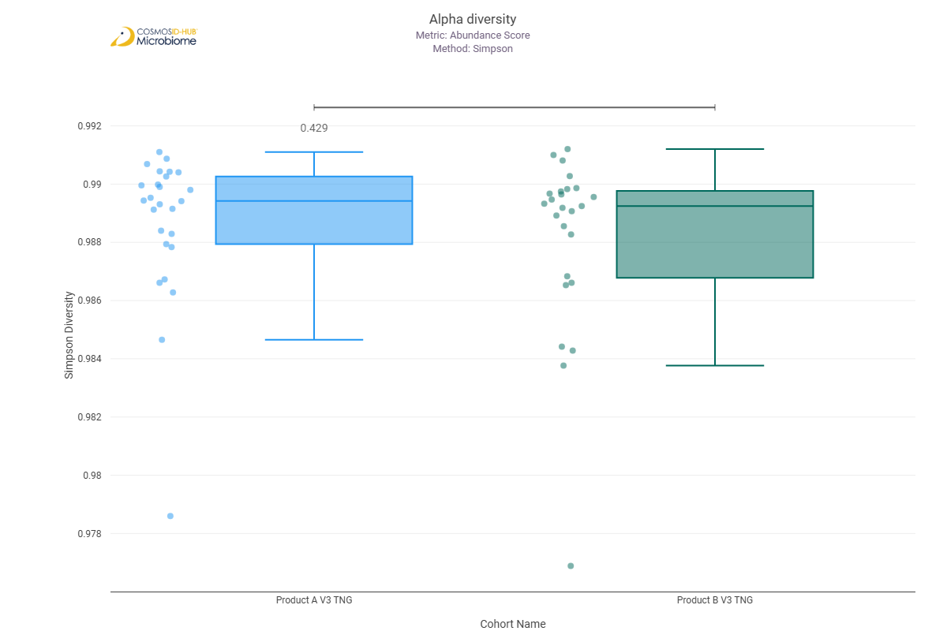

Beta Diversity (MetaCyc)
Bray-Curtis  PERMNOVA p = 0.529 | 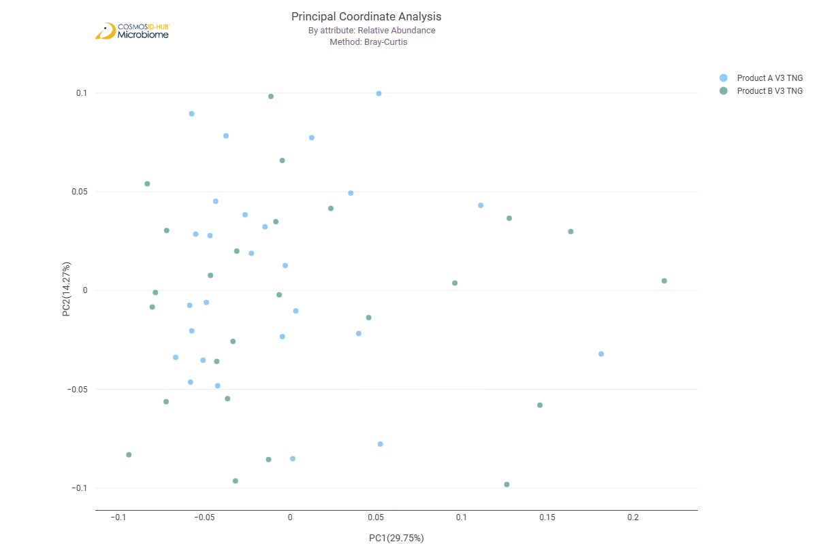

Differential Abundance (LEfSe) (MetaCyc)
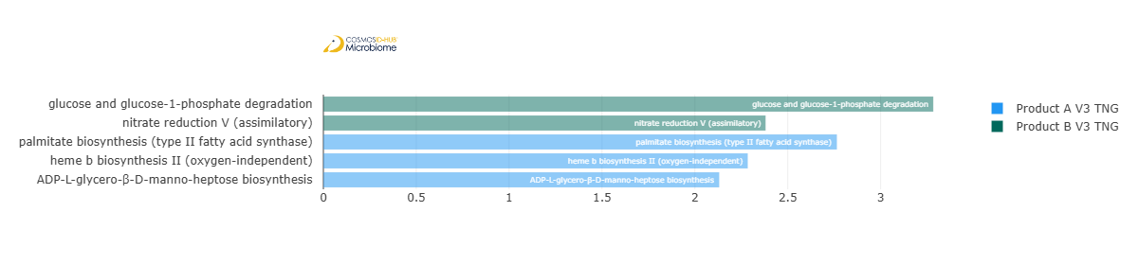
Feature | Enriched Cohort | LDA Score | P-value
glucose and glucose-1-phosphate degradation | Product B V3 TNG | 3.28329517 | 0.039994768
nitrate reduction V (assimilatory) | Product B V3 TNG | 2.380513641 | 0.027486336
palmitate biosynthesis (type II fatty acid synthase) | Product A V3 TNG | 2.764475862 | 0.038200947
heme b biosynthesis II (oxygen-independent) | Product A V3 TNG | 2.284637925 | 0.013574437
ADP-L-glycero-β-D-manno-heptose biosynthesis | Product A V3 TNG | 2.130957279 | 0.045795182

Comparison 13: Product A V2 SUPG vs Product A V3 SUPG

Gene Ontology

Alpha Diversity (GO)
Chao1 | 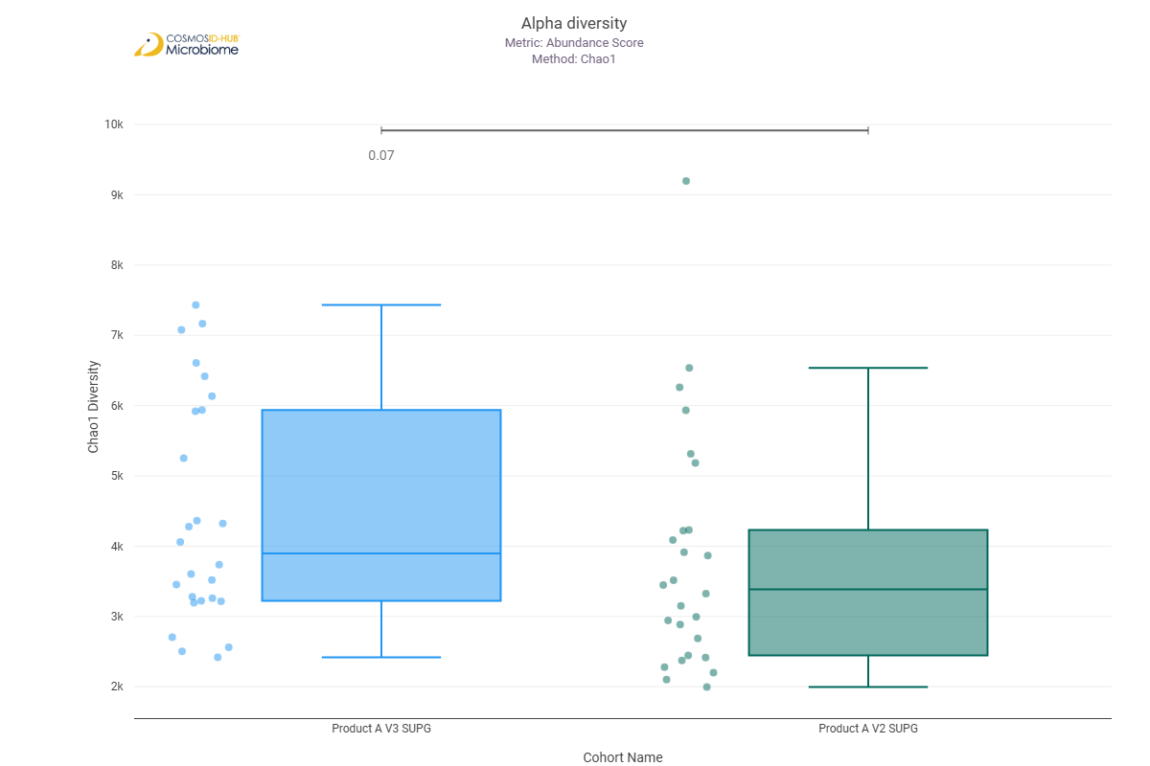
Shannon | 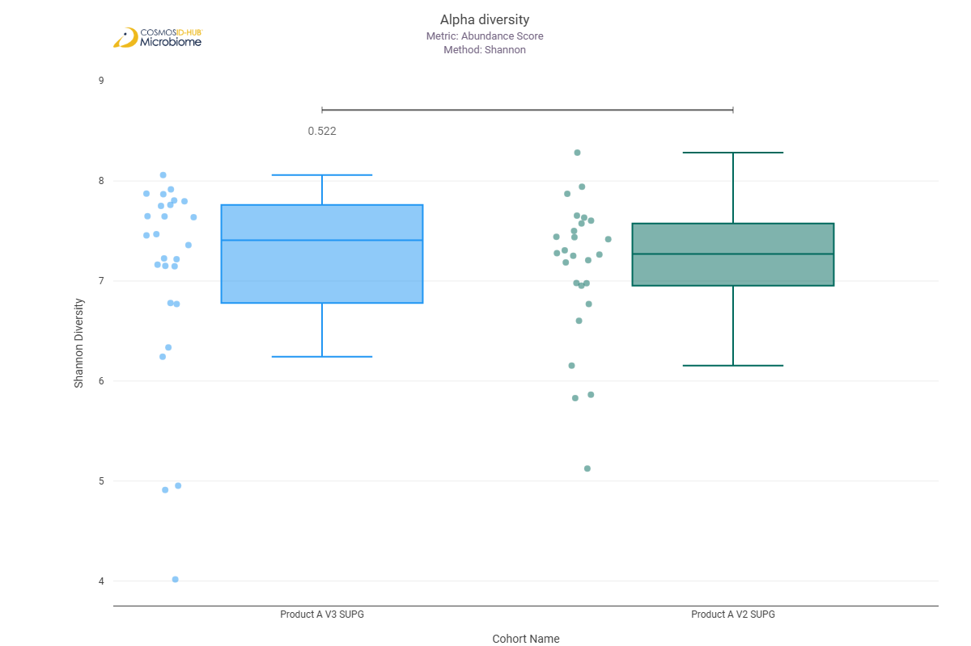
Simpson | 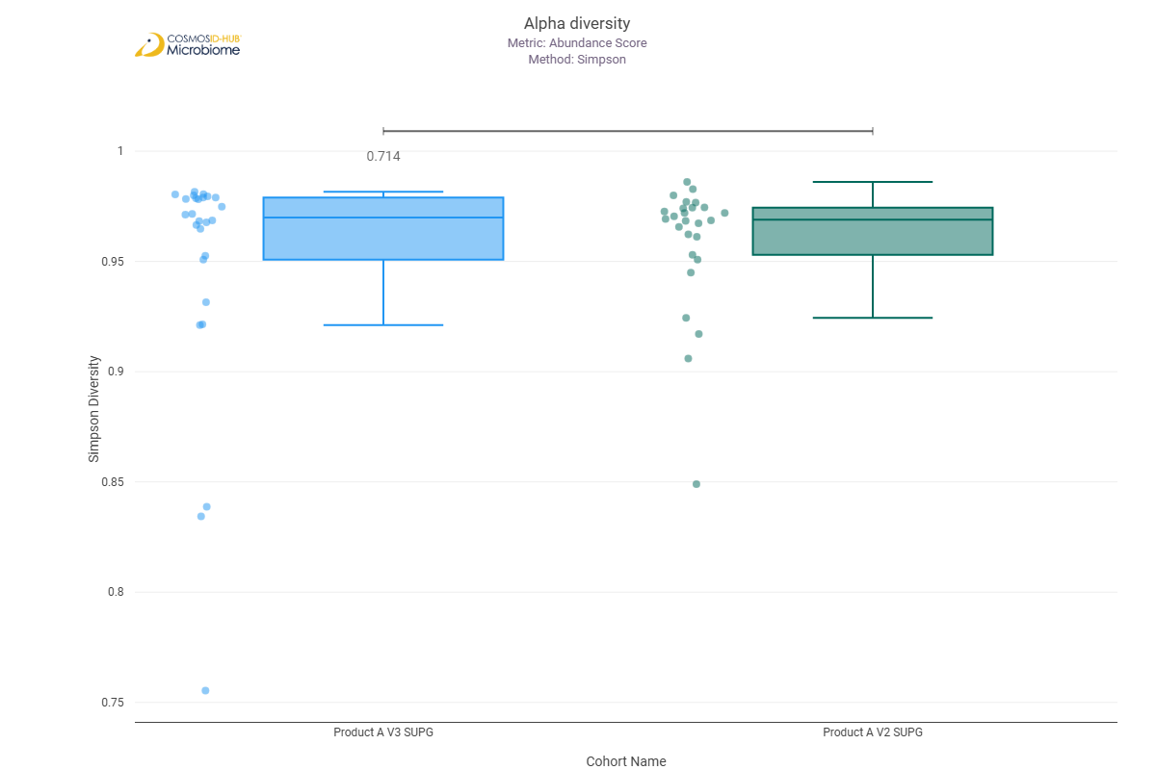

Beta Diversity (GO)
Bray-Curtis  PERMNOVA p = 0.402 | 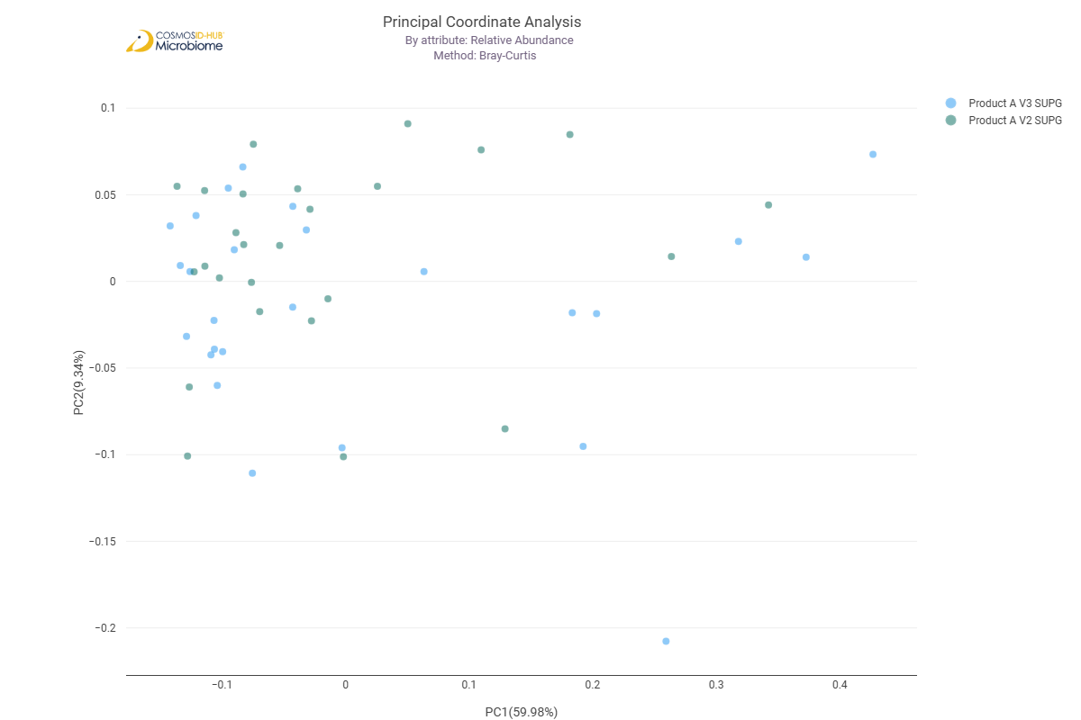

Differential Abundance (LEfSe) (GO)
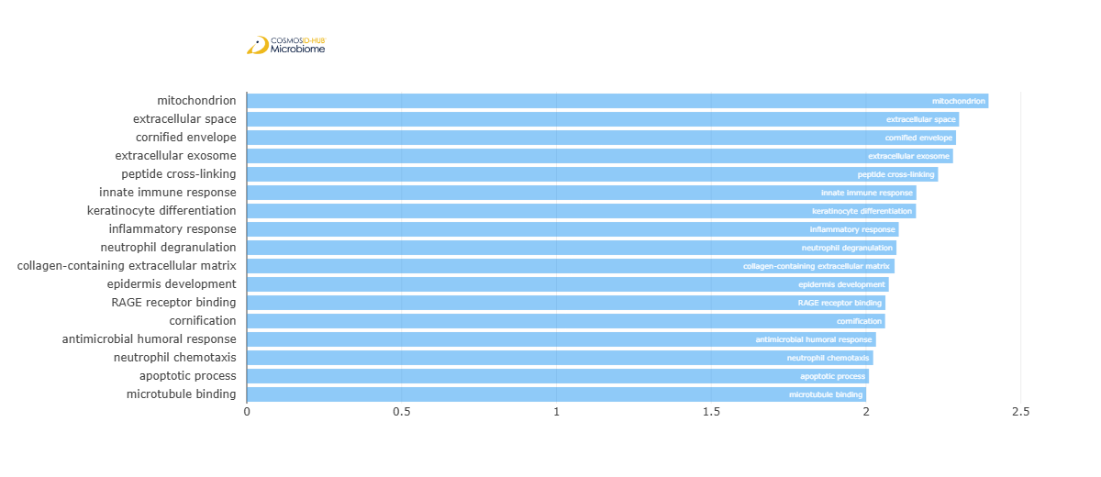
Feature | Enriched Cohort | LDA Score | P-value
mitochondrion | Product A V3 SUPG | 2.395593333 | 0.044100855
extracellular space | Product A V3 SUPG | 2.30062659 | 0.044100855
cornified envelope | Product A V3 SUPG | 2.290652157 | 0.036807215
extracellular exosome | Product A V3 SUPG | 2.280967867 | 0.035244686
peptide cross-linking | Product A V3 SUPG | 2.232724206 | 0.042057434
innate immune response | Product A V3 SUPG | 2.162582759 | 0.03077255
keratinocyte differentiation | Product A V3 SUPG | 2.161426341 | 0.042057434
inflammatory response | Product A V3 SUPG | 2.105579409 | 0.022101093
neutrophil degranulation | Product A V3 SUPG | 2.098179782 | 0.028014666
collagen-containing extracellular matrix | Product A V3 SUPG | 2.092271978 | 0.038553793
epidermis development | Product A V3 SUPG | 2.073464904 | 0.03686763
RAGE receptor binding | Product A V3 SUPG | 2.062537534 | 0.030683327
cornification | Product A V3 SUPG | 2.06157641 | 0.036807215
antimicrobial humoral response | Product A V3 SUPG | 2.032144347 | 0.033626203
neutrophil chemotaxis | Product A V3 SUPG | 2.023076006 | 0.026684643
apoptotic process | Product A V3 SUPG | 2.009510989 | 0.026684643
microtubule binding | Product A V3 SUPG | 2.000388259 | 0.026684643

Enzyme Commission

Alpha Diversity (EC)
Chao1 | 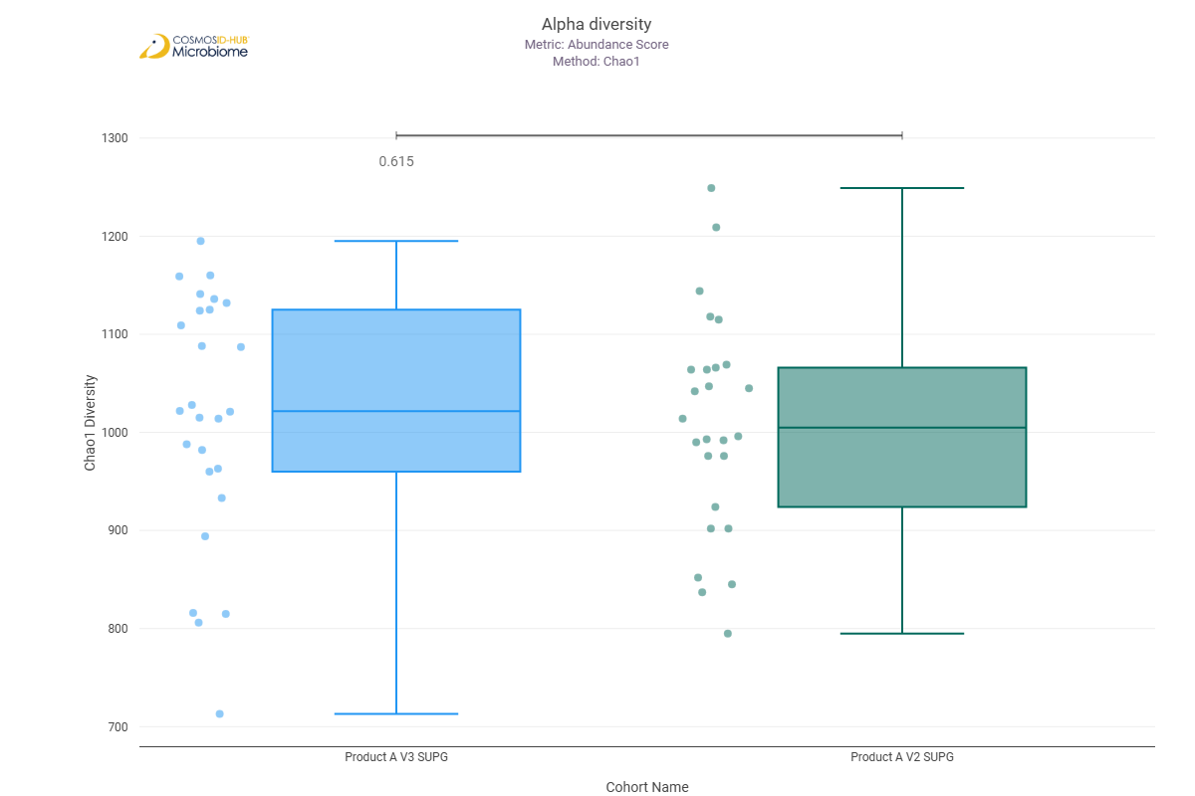
Shannon | 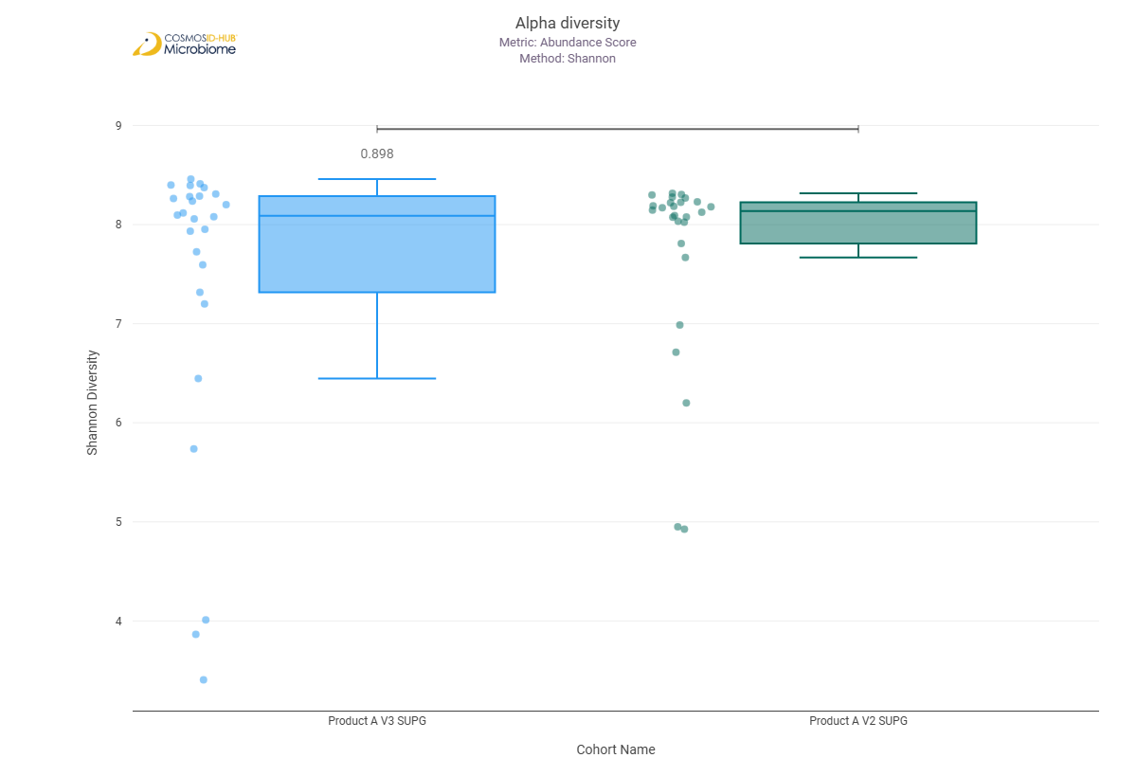
Simpson | 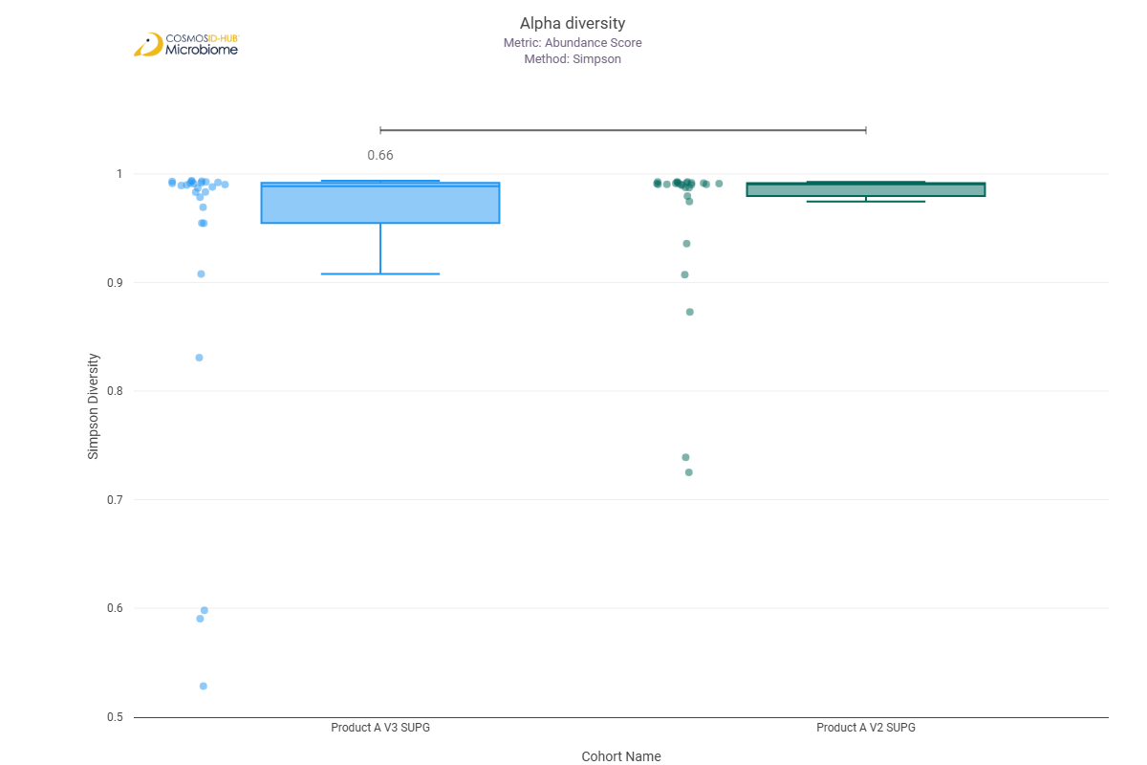

Beta Diversity (EC)
Bray-Curtis  PERMNOVA p = 0.609 | 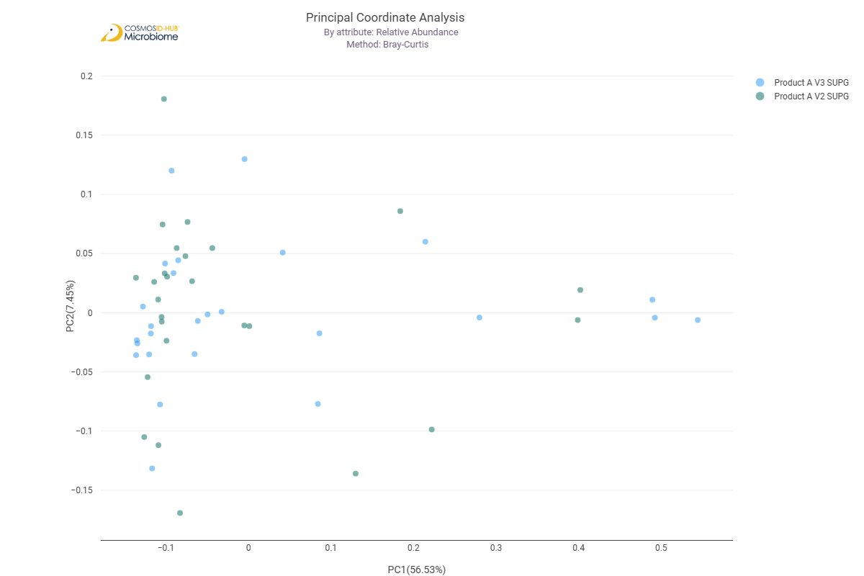

Differential Abundance (LEfSe) (EC)
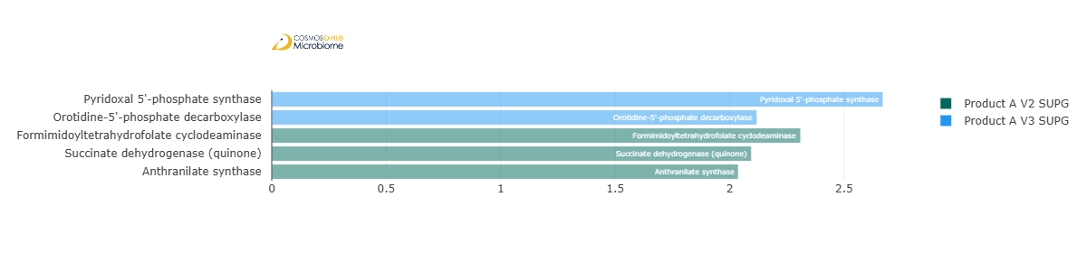
Feature | Enriched Cohort | LDA Score | P-value
Pyridoxal 5'-phosphate synthase | Product A V3 SUPG | 2.668823124 | 0.042211177
Orotidine-5'-phosphate decarboxylase | Product A V3 SUPG | 2.117963651 | 0.035322927
Formimidoyltetrahydrofolate cyclodeaminase | Product A V2 SUPG | 2.308922282 | 0.042211177
Succinate dehydrogenase (quinone) | Product A V2 SUPG | 2.094121479 | 0.035322927
Anthranilate synthase | Product A V2 SUPG | 2.036878376 | 0.030808261

MetaCyc Pathways

Alpha Diversity (MetaCyc)
Chao1 | 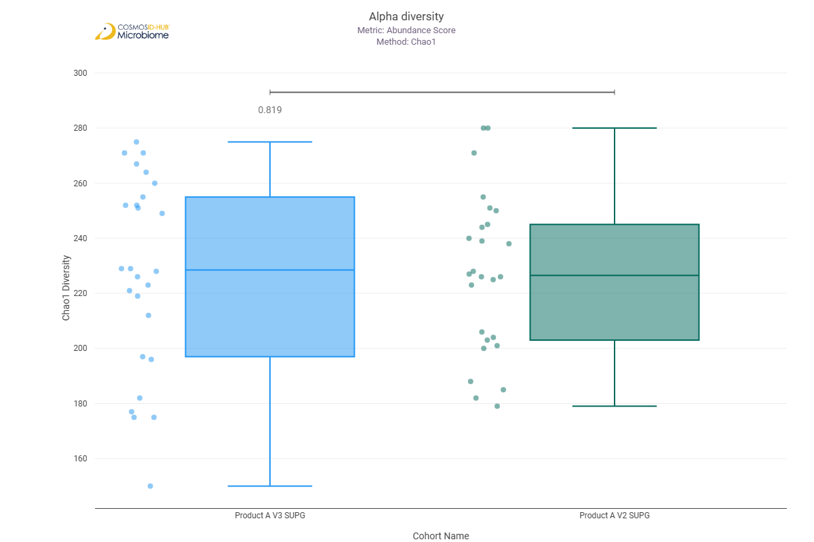
Shannon | 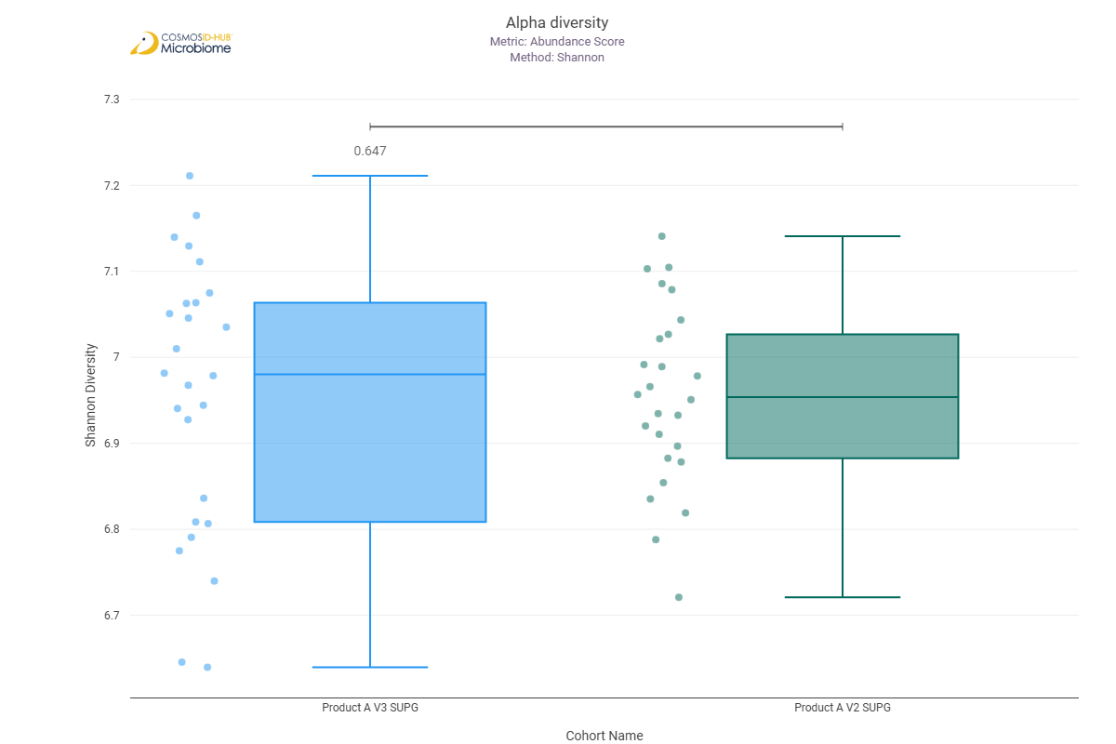
Simpson | 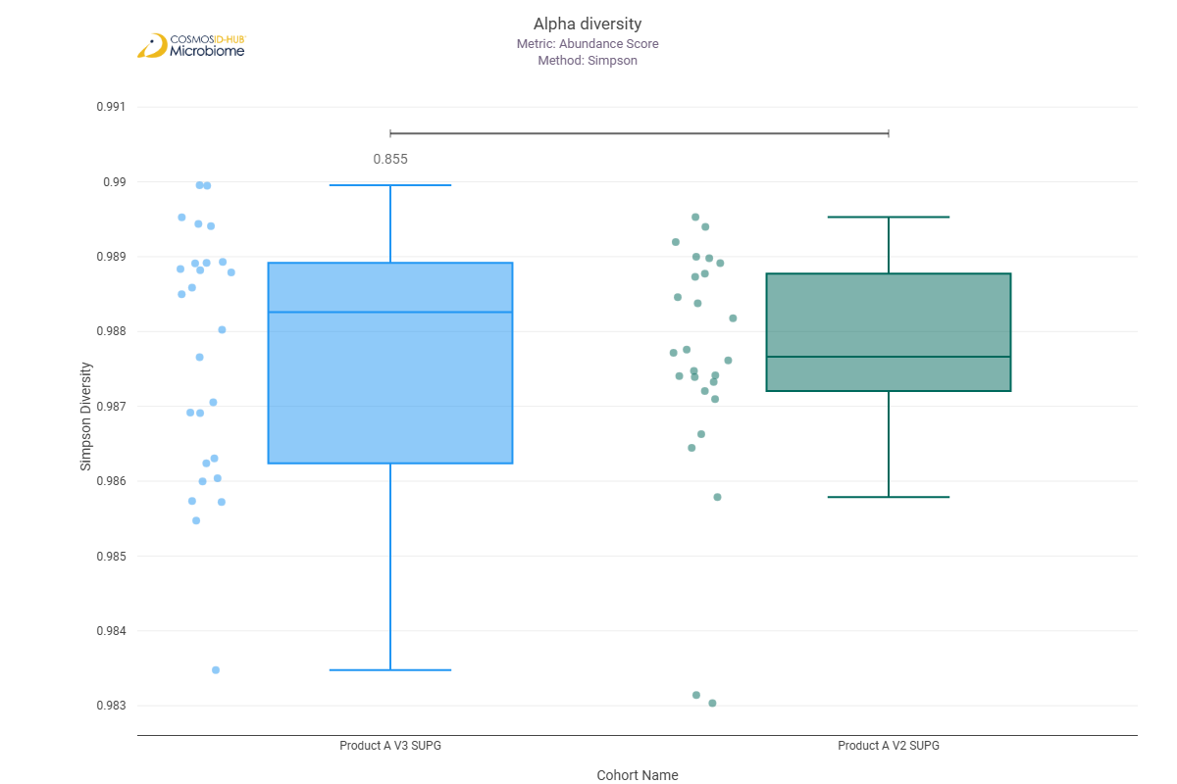

Beta Diversity (MetaCyc)
Bray-Curtis  PERMNOVA p = 0.851 | 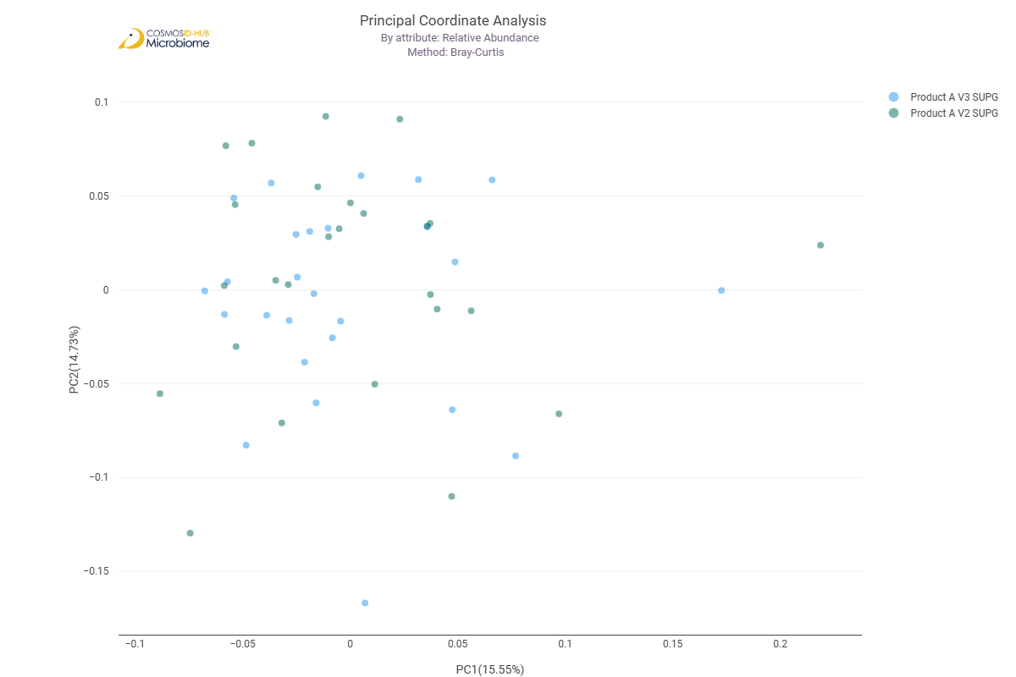

Differential Abundance (LEfSe) (MetaCyc)
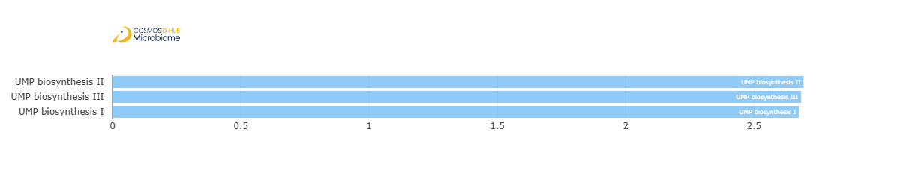
Feature | Enriched Cohort | LDA Score | P-value
UMP biosynthesis II | Product A V3 SUPG | 2.693855617 | 0.014192278
UMP biosynthesis III | Product A V3 SUPG | 2.684091372 | 0.016509366
UMP biosynthesis I | Product A V3 SUPG | 2.675675228 | 0.022157981

Comparison 14: Product B V2 SUPG vs Product B V3 SUPG

Gene Ontology

Alpha Diversity (GO)
Chao1 | 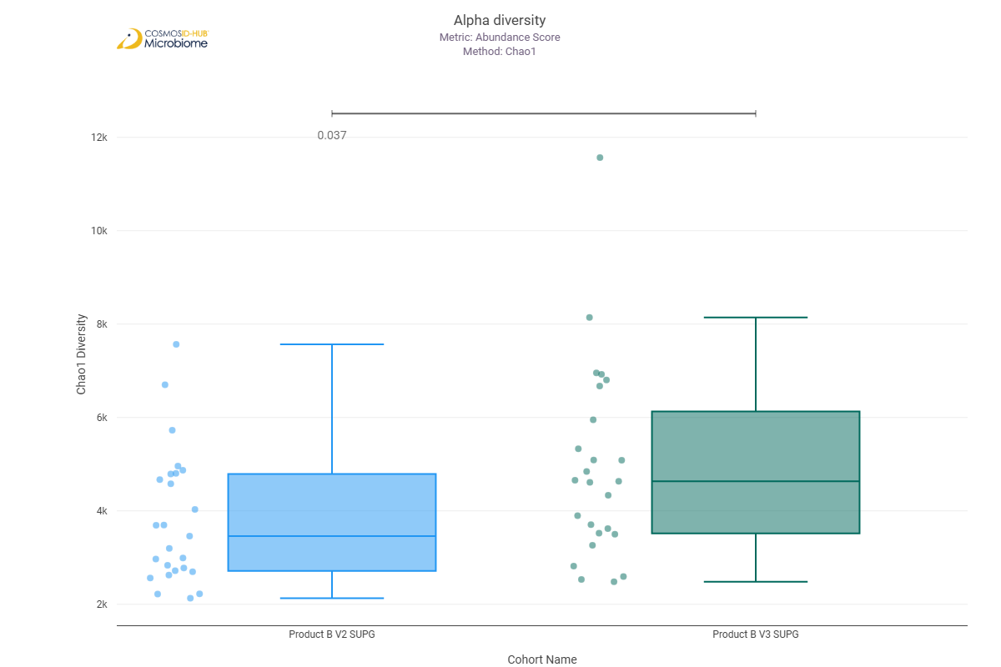
Shannon | 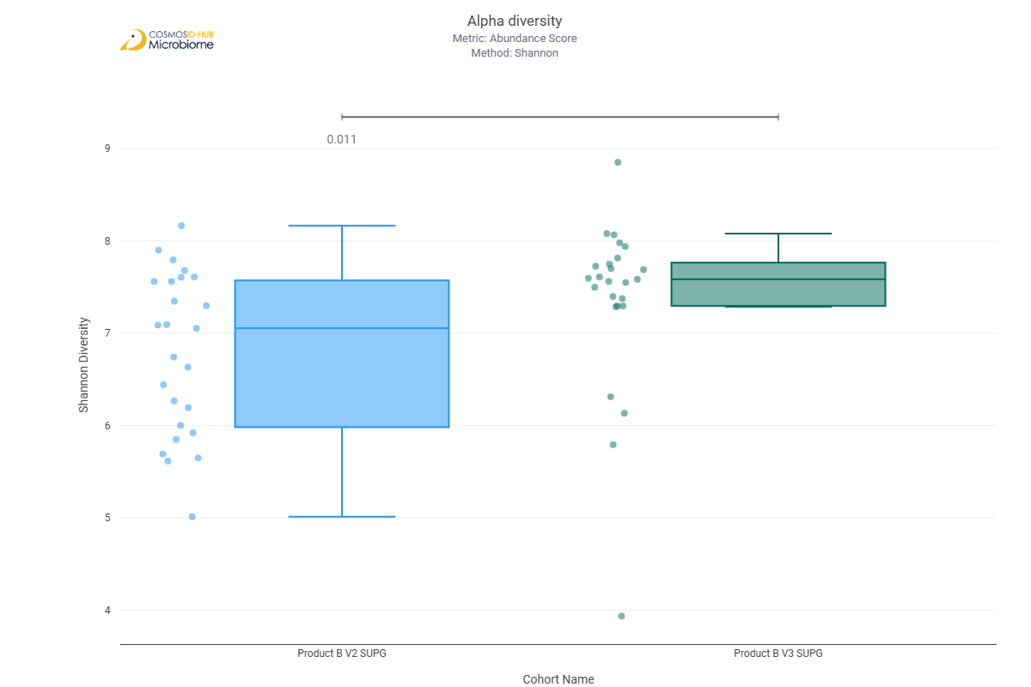
Simpson | 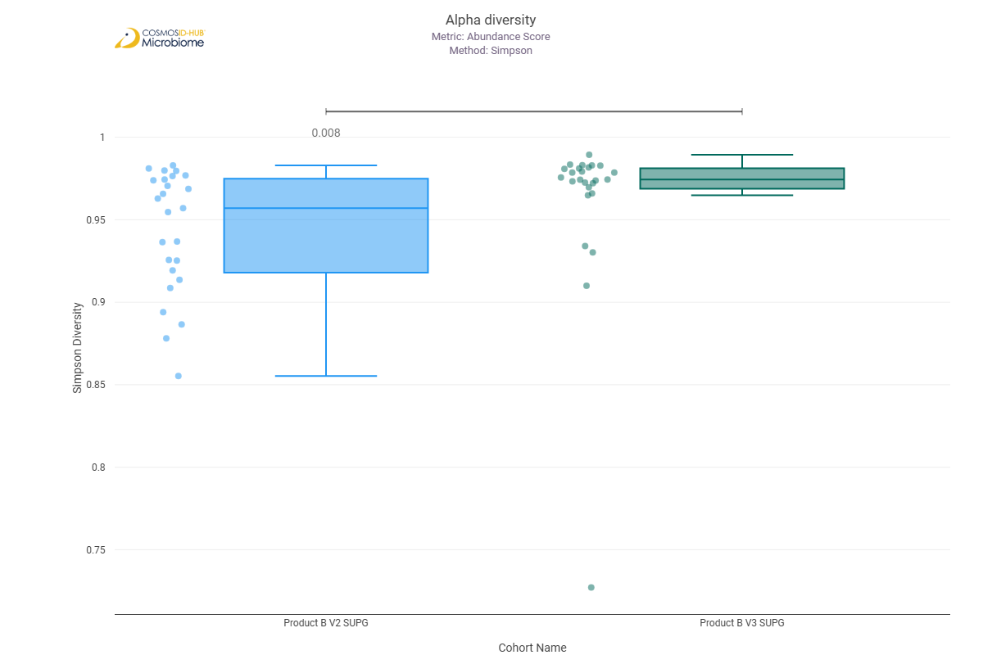

Beta Diversity (GO)
Bray-Curtis  PERMNOVA p = 0.031 | 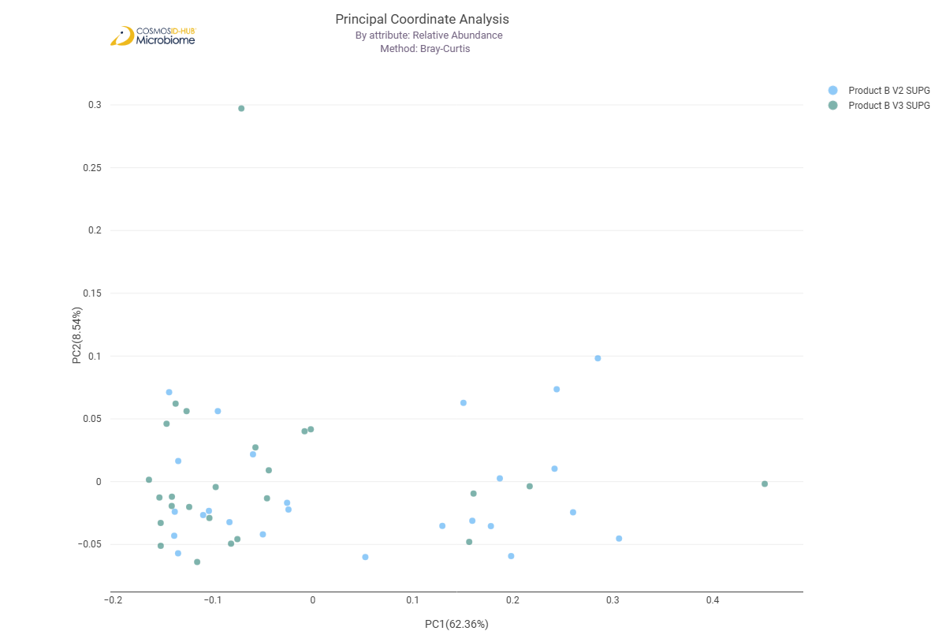

Differential Abundance (LEfSe) (GO)
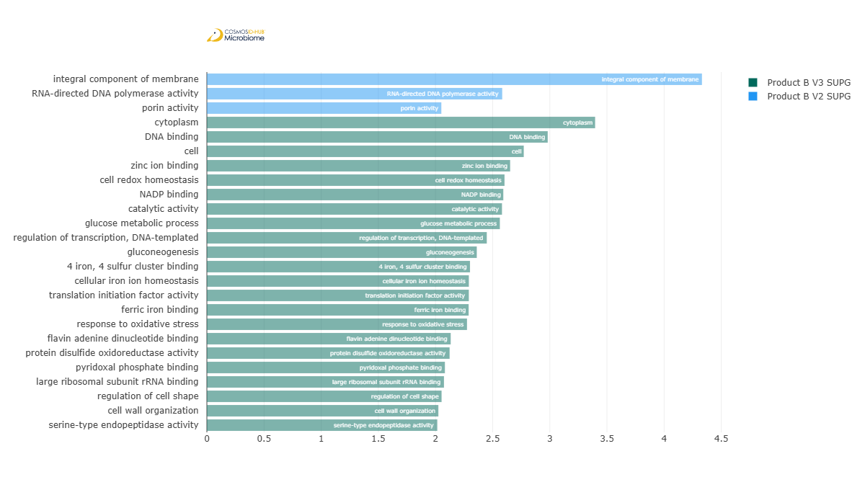
Feature | Enriched Cohort | LDA Score | P-value
integral component of membrane | Product B V2 SUPG | 4.331239388 | 0.000876011
RNA-directed DNA polymerase activity | Product B V2 SUPG | 2.583794457 | 0.021491444
porin activity | Product B V2 SUPG | 2.051060432 | 0.000370258
cytoplasm | Product B V3 SUPG | 3.396749929 | 0.009589776
DNA binding | Product B V3 SUPG | 2.981994326 | 0.048908406
cell | Product B V3 SUPG | 2.772339093 | 0.004210827
zinc ion binding | Product B V3 SUPG | 2.653236004 | 0.033618995
cell redox homeostasis | Product B V3 SUPG | 2.604058534 | 0.011982167
NADP binding | Product B V3 SUPG | 2.593277033 | 0.044622577
catalytic activity | Product B V3 SUPG | 2.581800698 | 0.014109615
glucose metabolic process | Product B V3 SUPG | 2.563245358 | 0.048908406
regulation of transcription, DNA-templated | Product B V3 SUPG | 2.448756977 | 0.029049022
gluconeogenesis | Product B V3 SUPG | 2.361417944 | 0.046724152
4 iron, 4 sulfur cluster binding | Product B V3 SUPG | 2.301918482 | 0.005364191
cellular iron ion homeostasis | Product B V3 SUPG | 2.291981249 | 0.01265739
translation initiation factor activity | Product B V3 SUPG | 2.291727599 | 0.010144117
ferric iron binding | Product B V3 SUPG | 2.290111 | 0.010726809
response to oxidative stress | Product B V3 SUPG | 2.275933055 | 0.019384996
flavin adenine dinucleotide binding | Product B V3 SUPG | 2.133201392 | 0.038790393
protein disulfide oxidoreductase activity | Product B V3 SUPG | 2.12366867 | 6.80E-03
pyridoxal phosphate binding | Product B V3 SUPG | 2.082319369 | 0.0352731
large ribosomal subunit rRNA binding | Product B V3 SUPG | 2.074326848 | 0.027649527
regulation of cell shape | Product B V3 SUPG | 2.053444527 | 0.015706943
cell wall organization | Product B V3 SUPG | 2.025283891 | 0.021491444
serine-type endopeptidase activity | Product B V3 SUPG | 2.015887339 | 0.006795613

Enzyme Commission

Alpha Diversity (EC)
Chao1 | 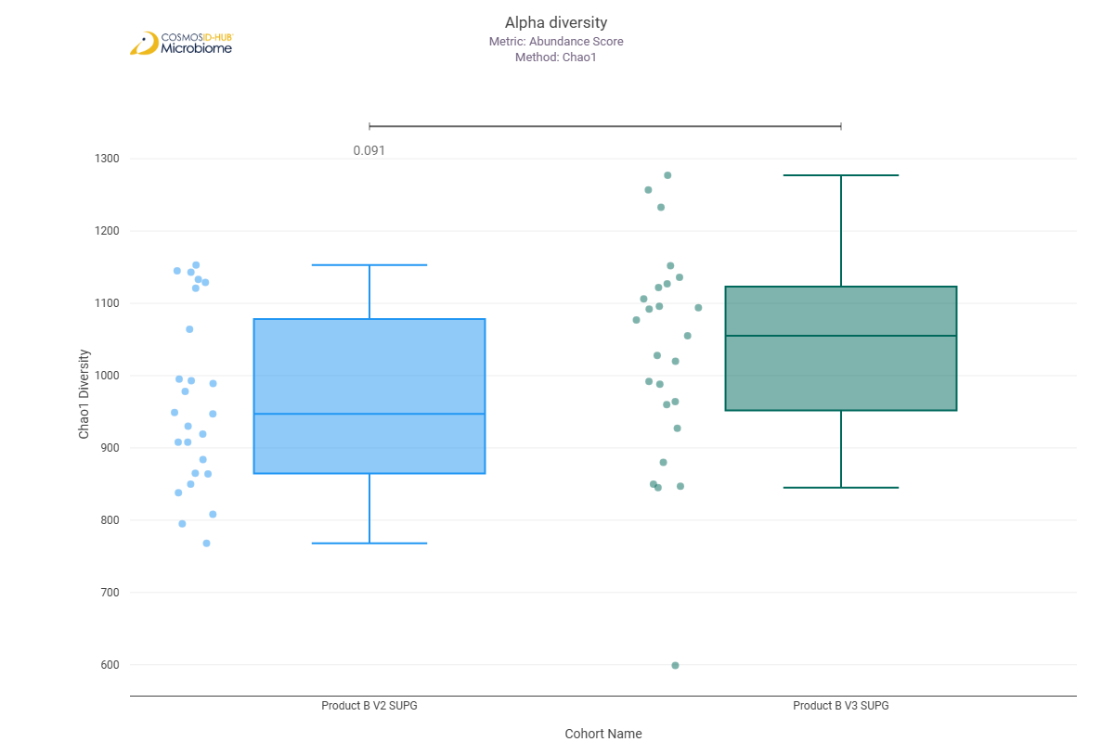
Shannon | 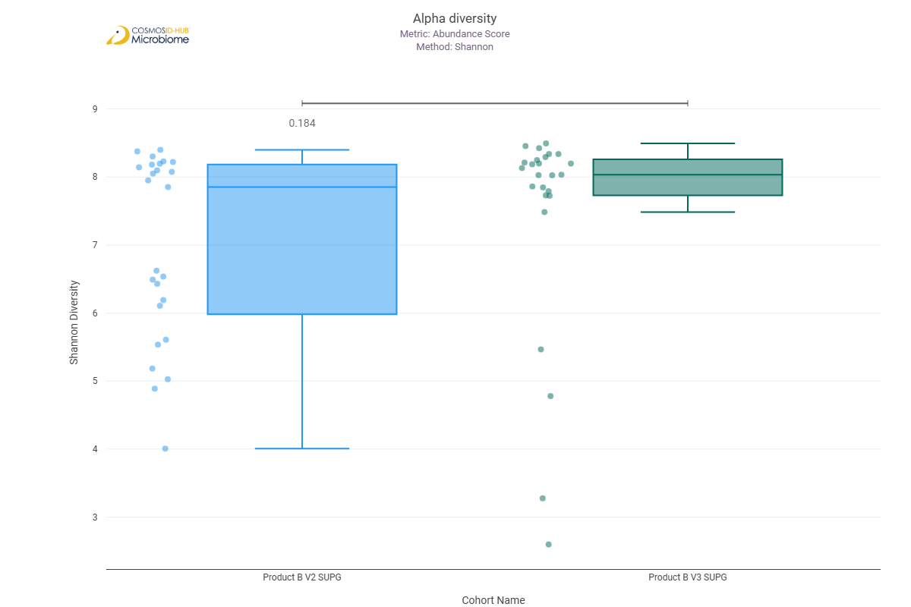
Simpson | 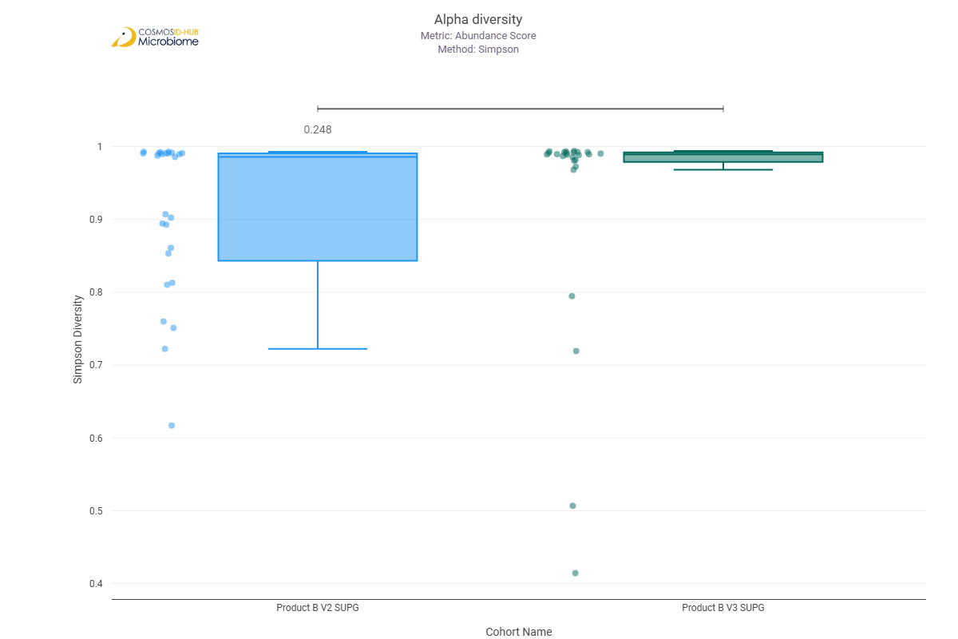

Beta Diversity (EC)
Bray-Curtis  PERMNOVA p = 0.166 | 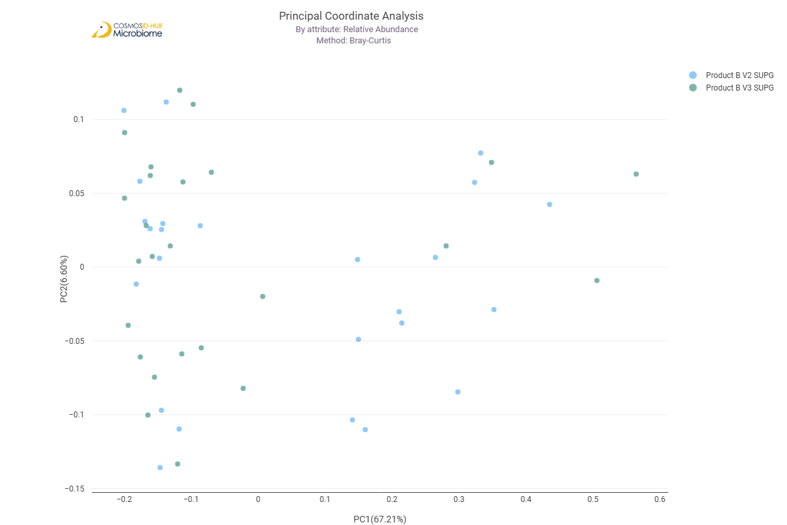

Differential Abundance (LEfSe) (EC)
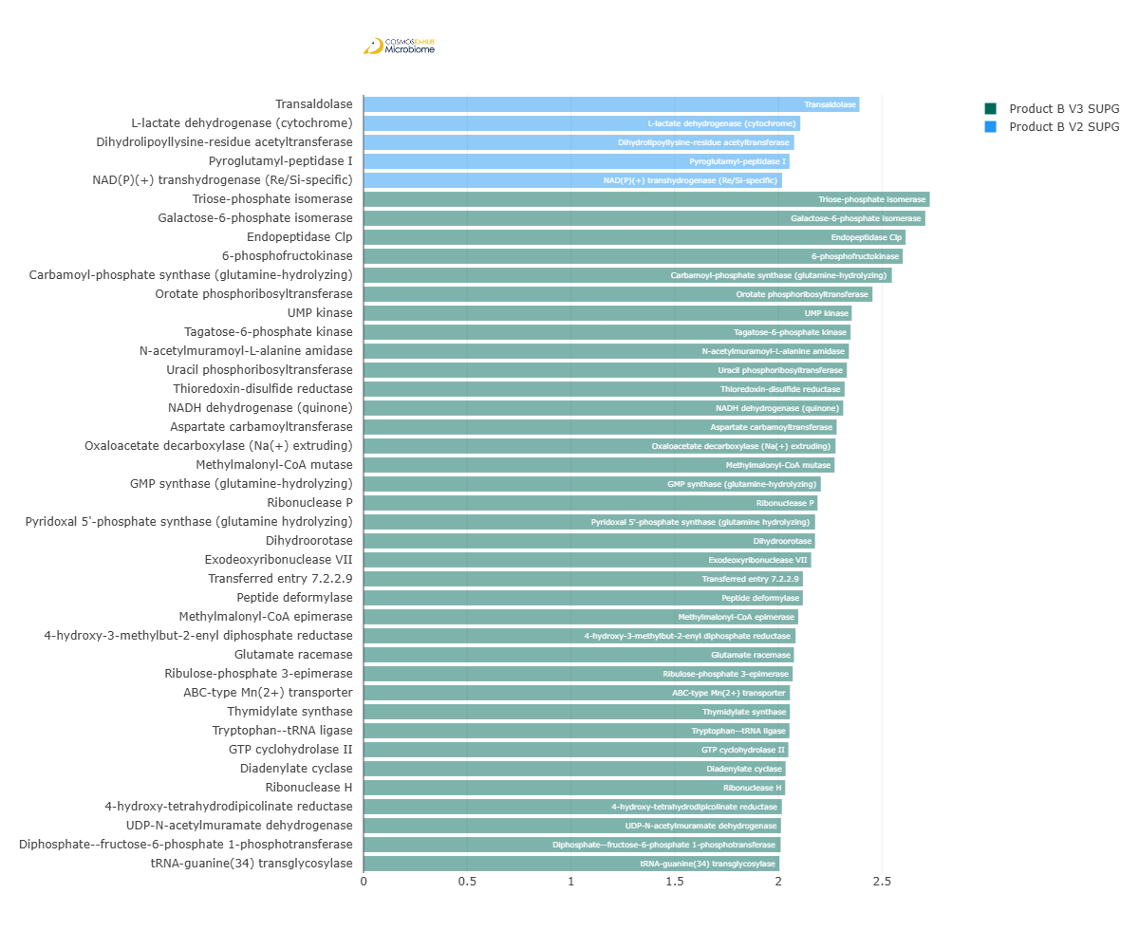
Feature | Enriched Cohort | LDA Score | P-value
Transaldolase | Product B V2 SUPG | 2.390769552 | 0.042601311
L-lactate dehydrogenase (cytochrome) | Product B V2 SUPG | 2.105776673 | 0.005364191
Dihydrolipoyllysine-residue acetyltransferase | Product B V2 SUPG | 2.07600155 | 0.0352731
Pyroglutamyl-peptidase I | Product B V2 SUPG | 2.053847965 | 0.033618995
NAD(P)(+) transhydrogenase (Re/Si-specific) | Product B V2 SUPG | 2.017837527 | 1.72E-04
Triose-phosphate isomerase | Product B V3 SUPG | 2.729787667 | 0.042601311
Galactose-6-phosphate isomerase | Product B V3 SUPG | 2.708214701 | 0.048908406
Endopeptidase Clp | Product B V3 SUPG | 2.613478253 | 0.000428923
6-phosphofructokinase | Product B V3 SUPG | 2.599739158 | 0.033618995
Carbamoyl-phosphate synthase (glutamine-hydrolyzing) | Product B V3 SUPG | 2.547124164 | 0.010726809
Orotate phosphoribosyltransferase | Product B V3 SUPG | 2.453677511 | 0.003722992
UMP kinase | Product B V3 SUPG | 2.353643566 | 0.006795613
Tagatose-6-phosphate kinase | Product B V3 SUPG | 2.348135378 | 0.040658018
N-acetylmuramoyl-L-alanine amidase | Product B V3 SUPG | 2.34005959 | 0.008085247
Uracil phosphoribosyltransferase | Product B V3 SUPG | 2.330251985 | 0.009062607
Thioredoxin-disulfide reductase | Product B V3 SUPG | 2.319357948 | 0.032031691
NADH dehydrogenase (quinone) | Product B V3 SUPG | 2.312617351 | 0.008085247
Aspartate carbamoyltransferase | Product B V3 SUPG | 2.281069066 | 0.000709718
Oxaloacetate decarboxylase (Na(+) extruding) | Product B V3 SUPG | 2.275653684 | 0.014889416
Methylmalonyl-CoA mutase | Product B V3 SUPG | 2.271006675 | 0.004210827
GMP synthase (glutamine-hydrolyzing) | Product B V3 SUPG | 2.204584616 | 0.044622577
Ribonuclease P | Product B V3 SUPG | 2.188896914 | 0.046724152
Pyridoxal 5'-phosphate synthase (glutamine hydrolyzing) | Product B V3 SUPG | 2.177234182 | 0.021491444
Dihydroorotase | Product B V3 SUPG | 2.176732496 | 2.38E-02
Exodeoxyribonuclease VII | Product B V3 SUPG | 2.158007478 | 0.032031691
Transferred entry 7.2.2.9 | Product B V3 SUPG | 2.118208671 | 0.042601311
Peptide deformylase | Product B V3 SUPG | 2.118113302 | 0.00640875
Methylmalonyl-CoA epimerase | Product B V3 SUPG | 2.095581121 | 0.040658018
4-hydroxy-3-methylbut-2-enyl diphosphate reductase | Product B V3 SUPG | 2.082886492 | 0.016563699
Glutamate racemase | Product B V3 SUPG | 2.075228413 | 0.019384996
Ribulose-phosphate 3-epimerase | Product B V3 SUPG | 2.069042333 | 0.015706943
ABC-type Mn(2+) transporter | Product B V3 SUPG | 2.055859209 | 0.021460122
Thymidylate synthase | Product B V3 SUPG | 2.055573227 | 0.003722992
Tryptophan--tRNA ligase | Product B V3 SUPG | 2.053341932 | 0.033618995
GTP cyclohydrolase II | Product B V3 SUPG | 2.047958835 | 0.011339073
Diadenylate cyclase | Product B V3 SUPG | 2.034732305 | 0.015706943
Ribonuclease H | Product B V3 SUPG | 2.032716664 | 0.017461229
4-hydroxy-tetrahydrodipicolinate reductase | Product B V3 SUPG | 2.017088339 | 0.006041816
UDP-N-acetylmuramate dehydrogenase | Product B V3 SUPG | 2.012642411 | 0.023794451
Diphosphate--fructose-6-phosphate 1-phosphotransferase | Product B V3 SUPG | 2.010879805 | 0.01265739
tRNA-guanine(34) transglycosylase | Product B V3 SUPG | 2.005209166 | 0.018401118

MetaCyc Pathways

Alpha Diversity (MetaCyc)
Chao1 | 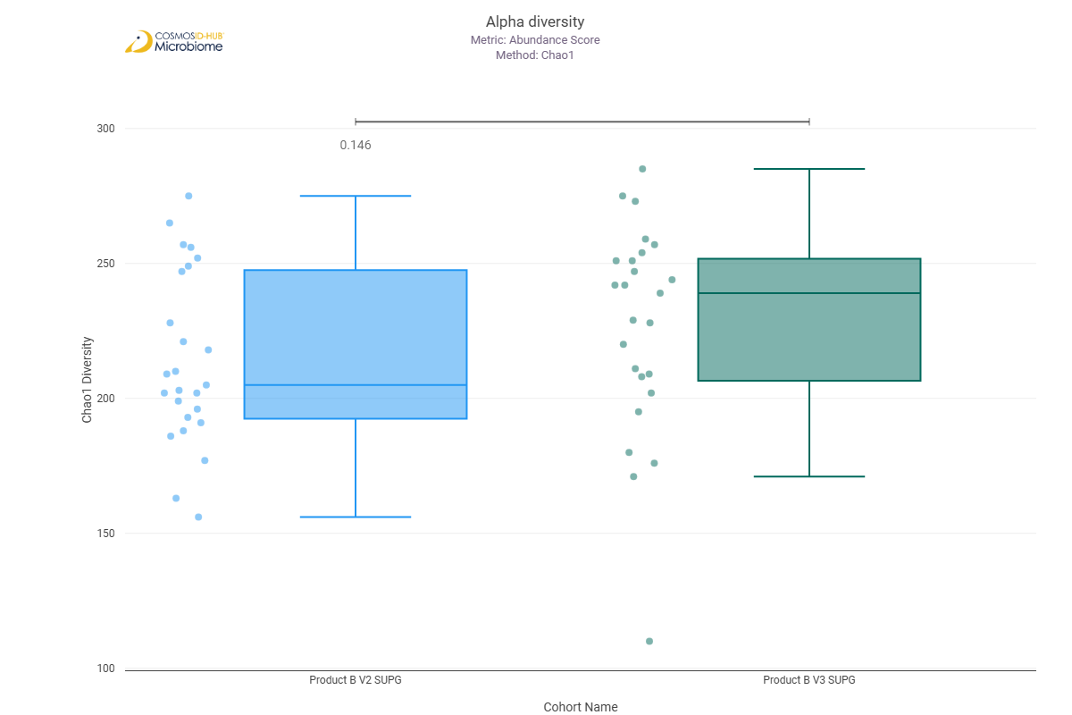
Shannon | 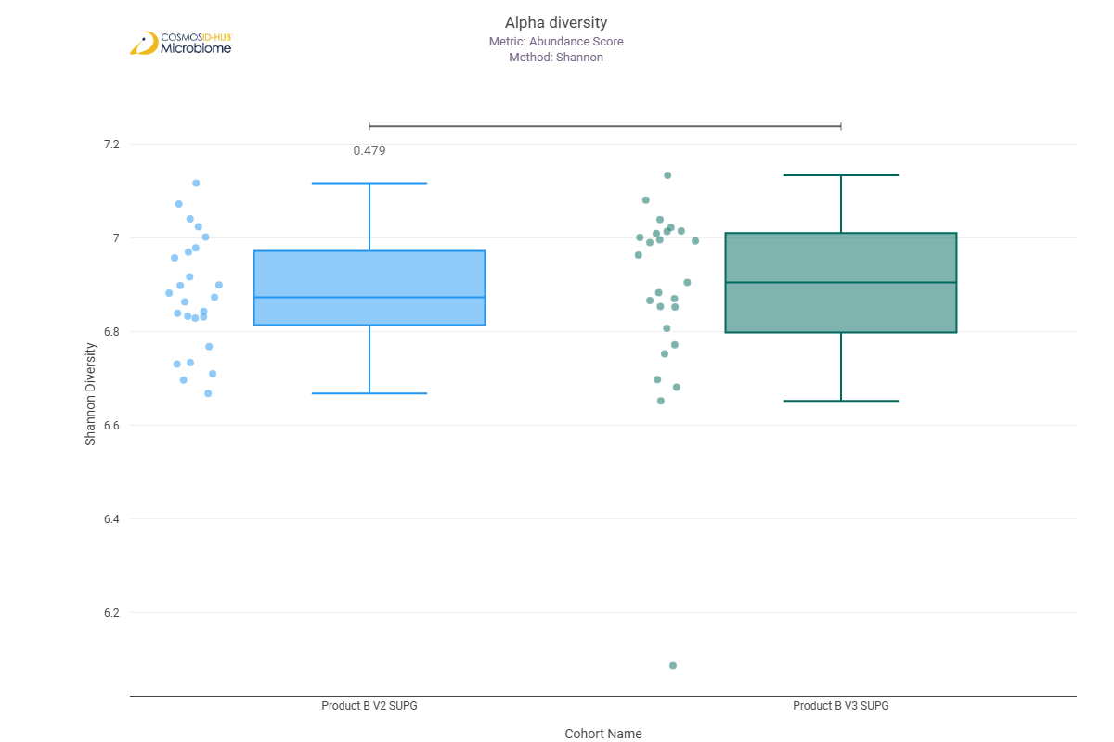
Simpson | 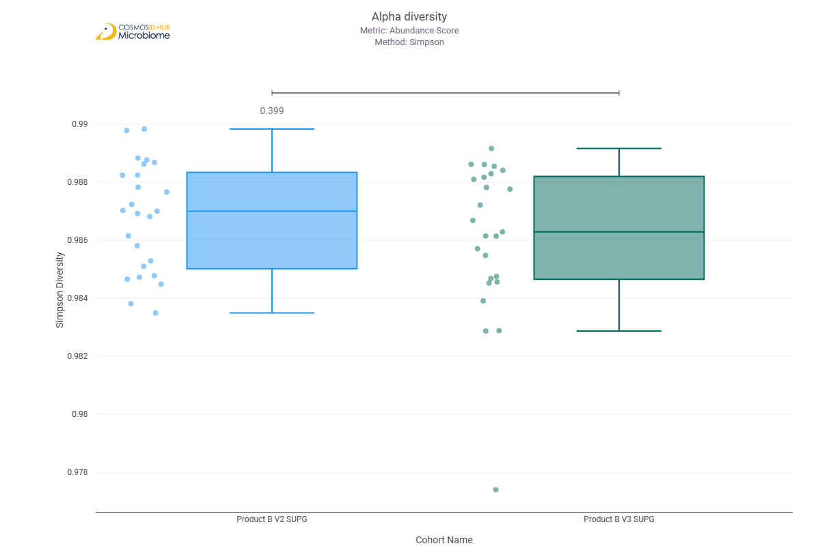

Beta Diversity (MetaCyc)
Bray-Curtis  PERMNOVA p = 0.044 | 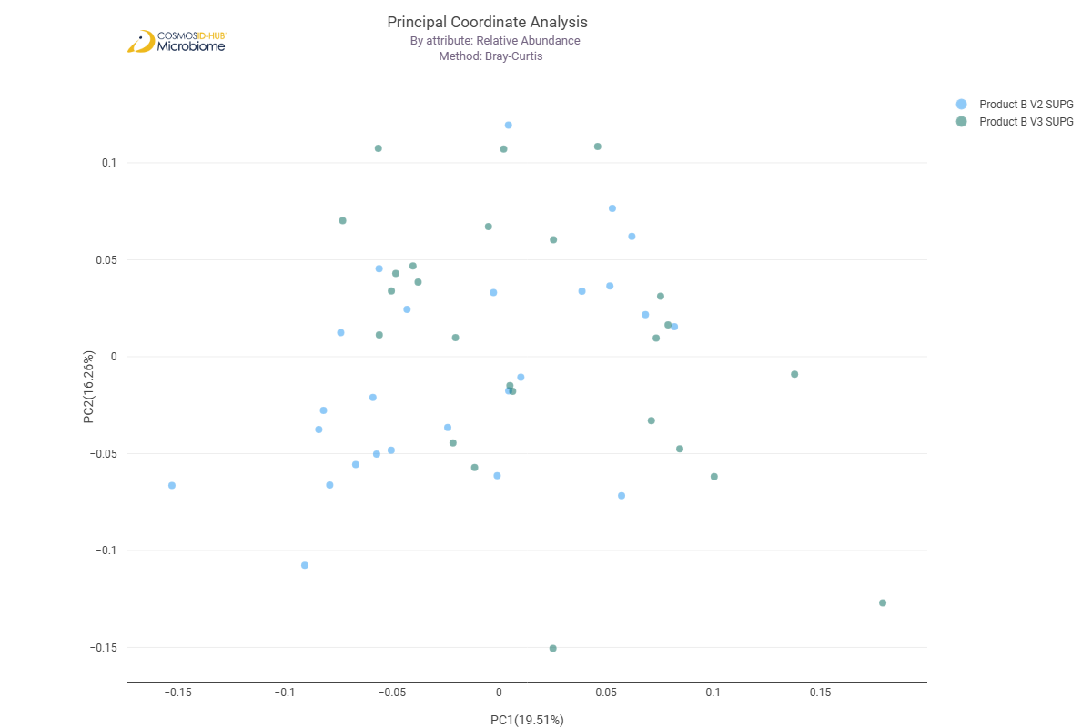

Differential Abundance (LEfSe) (MetaCyc)
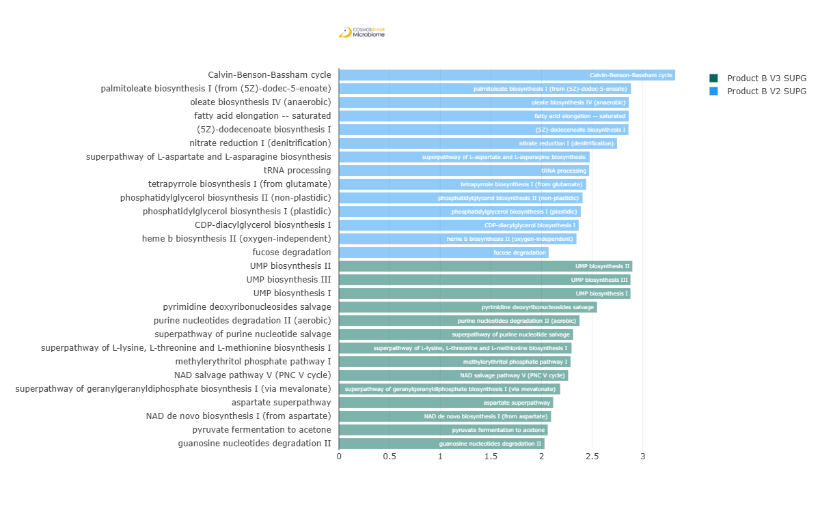
Feature | Enriched Cohort | LDA Score | P-value
Calvin-Benson-Bassham cycle | Product B V2 SUPG | 3.318964082 | 0.002102544
palmitoleate biosynthesis I (from (5Z)-dodec-5-enoate) | Product B V2 SUPG | 2.883013913 | 0.018401118
oleate biosynthesis IV (anaerobic) | Product B V2 SUPG | 2.86144877 | 0.020414533
fatty acid elongation -- saturated | Product B V2 SUPG | 2.861077094 | 0.022617484
(5Z)-dodecenoate biosynthesis I | Product B V2 SUPG | 2.857405063 | 0.025024185
nitrate reduction I (denitrification) | Product B V2 SUPG | 2.744568111 | 0.022585015
superpathway of L-aspartate and L-asparagine biosynthesis | Product B V2 SUPG | 2.474947946 | 0.026308569
tRNA processing | Product B V2 SUPG | 2.469238055 | 0.029067013
tetrapyrrole biosynthesis I (from glutamate) | Product B V2 SUPG | 2.440540879 | 0.039710137
phosphatidylglycerol biosynthesis II (non-plastidic) | Product B V2 SUPG | 2.404869686 | 0.044602091
phosphatidylglycerol biosynthesis I (plastidic) | Product B V2 SUPG | 2.387244196 | 0.048902981
CDP-diacylglycerol biosynthesis I | Product B V2 SUPG | 2.366479671 | 0.048902981
heme b biosynthesis II (oxygen-independent) | Product B V2 SUPG | 2.344926162 | 0.013357193
fucose degradation | Product B V2 SUPG | 2.069795282 | 0.032608192
UMP biosynthesis II | Product B V3 SUPG | 2.896161476 | 0.001077834
UMP biosynthesis I | Product B V3 SUPG | 2.877911888 | 0.002243495
UMP biosynthesis III | Product B V3 SUPG | 2.877911888 | 2.24E-03
pyrimidine deoxyribonucleosides salvage | Product B V3 SUPG | 2.548343874 | 0.020414533
purine nucleotides degradation II (aerobic) | Product B V3 SUPG | 2.374685324 | 0.012279495
superpathway of purine nucleotide salvage | Product B V3 SUPG | 2.311473792 | 0.021218334
superpathway of L-lysine, L-threonine and L-methionine biosynthesis I | Product B V3 SUPG | 2.296487754 | 0.042729021
methylerythritol phosphate pathway I | Product B V3 SUPG | 2.286396655 | 0.033576403
NAD salvage pathway V (PNC V cycle) | Product B V3 SUPG | 2.262555783 | 0.007877552
superpathway of geranylgeranyldiphosphate biosynthesis I (via mevalonate) | Product B V3 SUPG | 2.183446506 | 0.037096259
aspartate superpathway | Product B V3 SUPG | 2.114483365 | 1.29E-02
NAD de novo biosynthesis I (from aspartate) | Product B V3 SUPG | 2.094212339 | 0.018497446
pyruvate fermentation to acetone | Product B V3 SUPG | 2.061285087 | 0.040706043
guanosine nucleotides degradation II | Product B V3 SUPG | 2.029587133 | 0.011292706

Comparison 15: Product A V2 SUPG vs Product B V2 SUPG

Gene Ontology

Alpha Diversity (GO)
Chao1 | 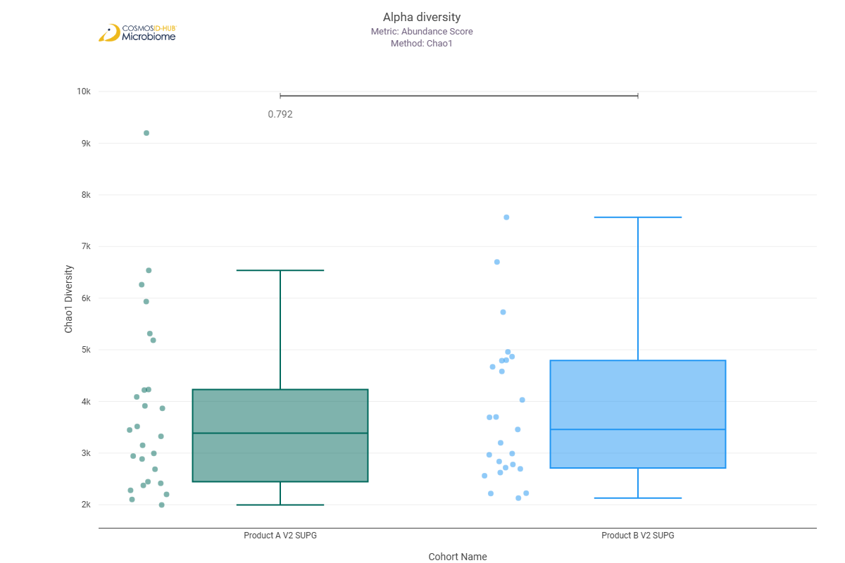
Shannon | 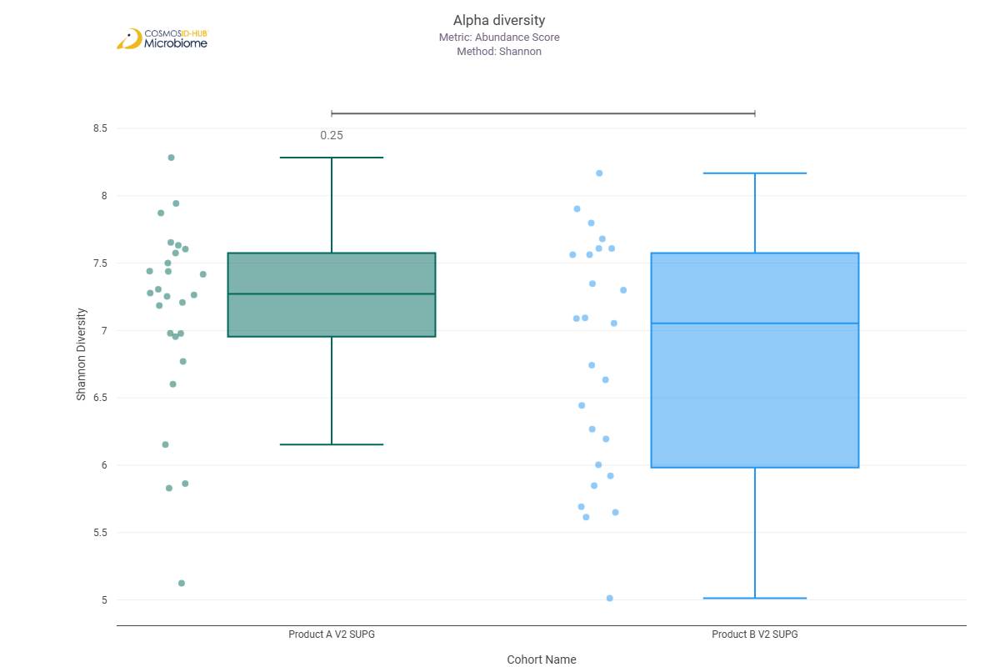
Simpson | 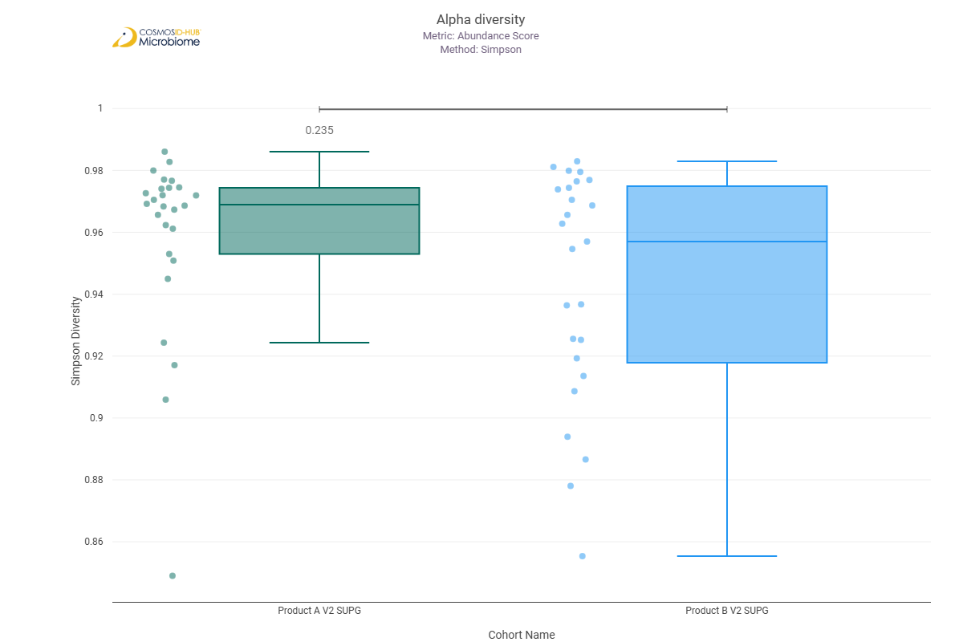

Beta Diversity (GO)
Bray-Curtis  PERMNOVA p = 0.067 | 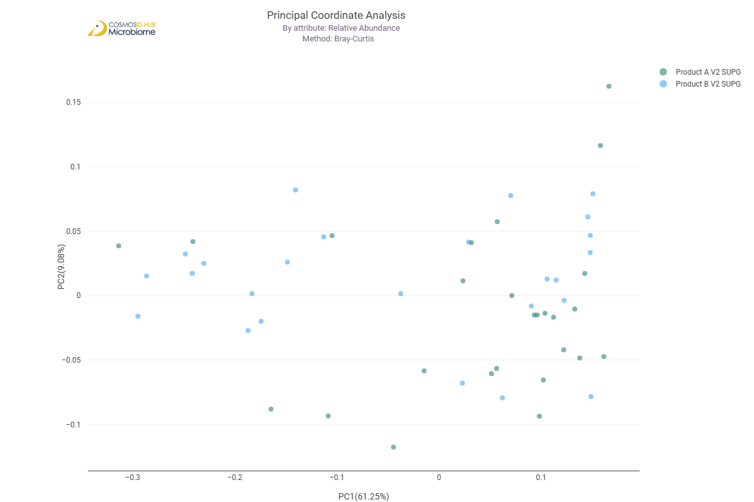

Differential Abundance (LEfSe) (GO)
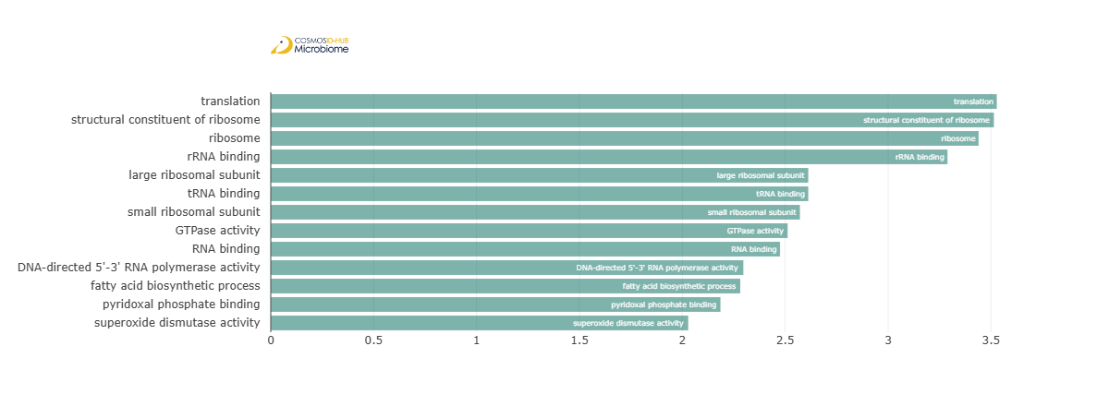
Feature | Enriched Cohort | LDA Score | P-value
translation | Product A V2 SUPG | 3.528322109 | 0.020471389
structural constituent of ribosome | Product A V2 SUPG | 3.514165407 | 0.022613046
ribosome | Product A V2 SUPG | 3.439853578 | 0.017590793
rRNA binding | Product A V2 SUPG | 3.288581331 | 0.033240045
large ribosomal subunit | Product A V2 SUPG | 2.612173486 | 0.02494682
tRNA binding | Product A V2 SUPG | 2.612099379 | 0.047879765
small ribosomal subunit | Product A V2 SUPG | 2.571517429 | 0.034829974
GTPase activity | Product A V2 SUPG | 2.511887932 | 0.036484395
RNA binding | Product A V2 SUPG | 2.474828575 | 0.022613046
DNA-directed 5'-3' RNA polymerase activity | Product A V2 SUPG | 2.296592301 | 0.038205314
fatty acid biosynthetic process | Product A V2 SUPG | 2.281471017 | 0.009840467
pyridoxal phosphate binding | Product A V2 SUPG | 2.185362531 | 0.036484395
superoxide dismutase activity | Product A V2 SUPG | 2.028763107 | 0.020471389

Enzyme Commission

Alpha Diversity (EC)
Chao1 | 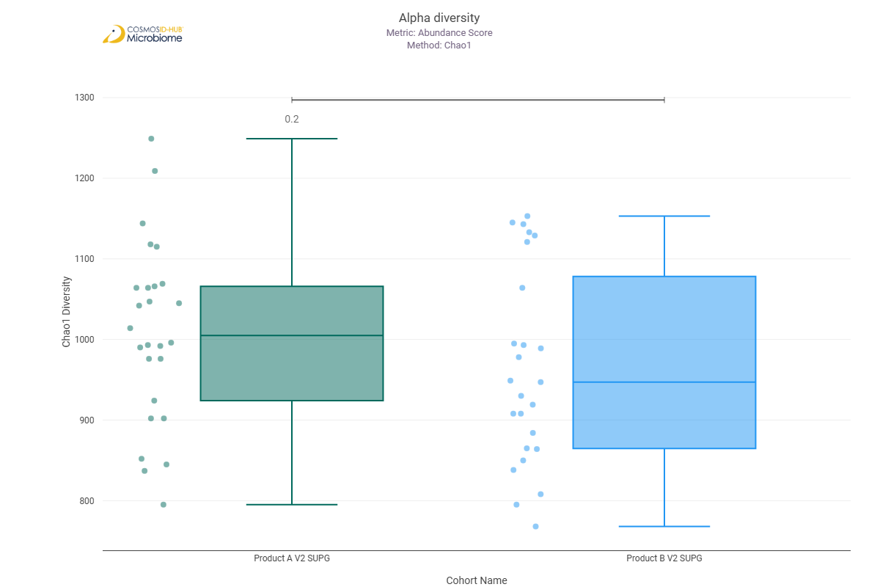
Shannon | 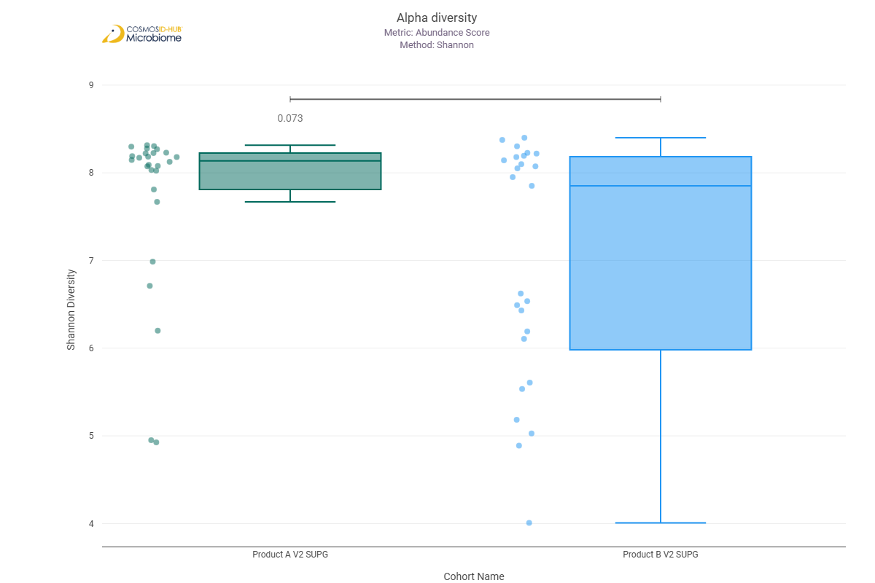
Simpson | 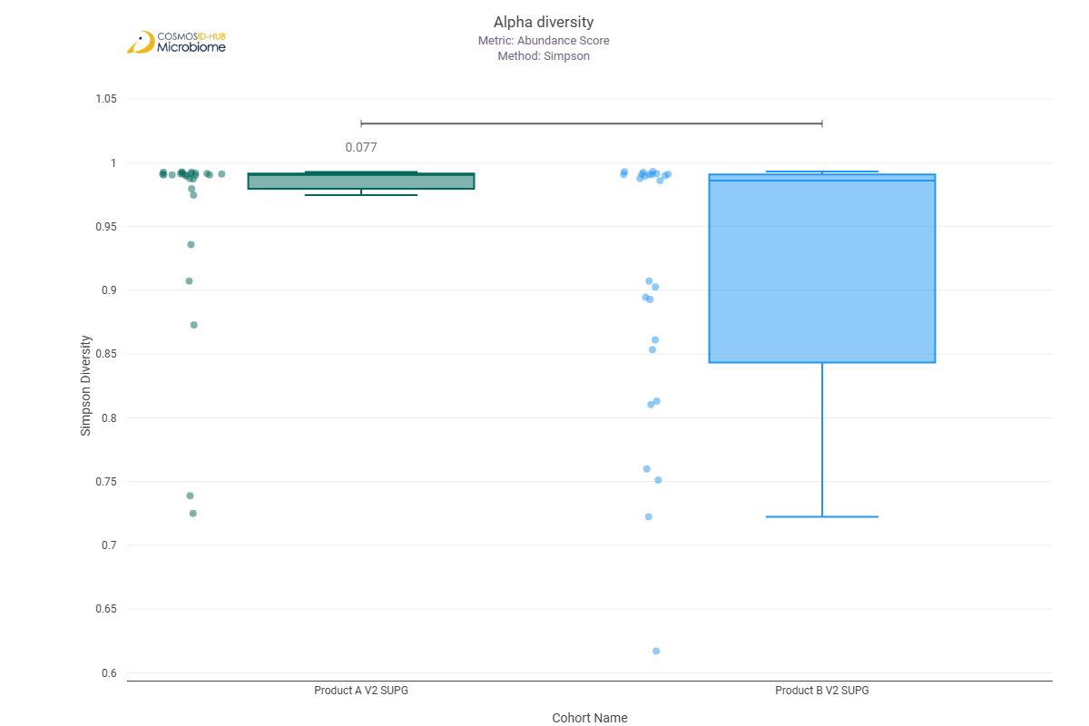

Beta Diversity (EC)
Bray-Curtis  PERMNOVA p = 0.036 | 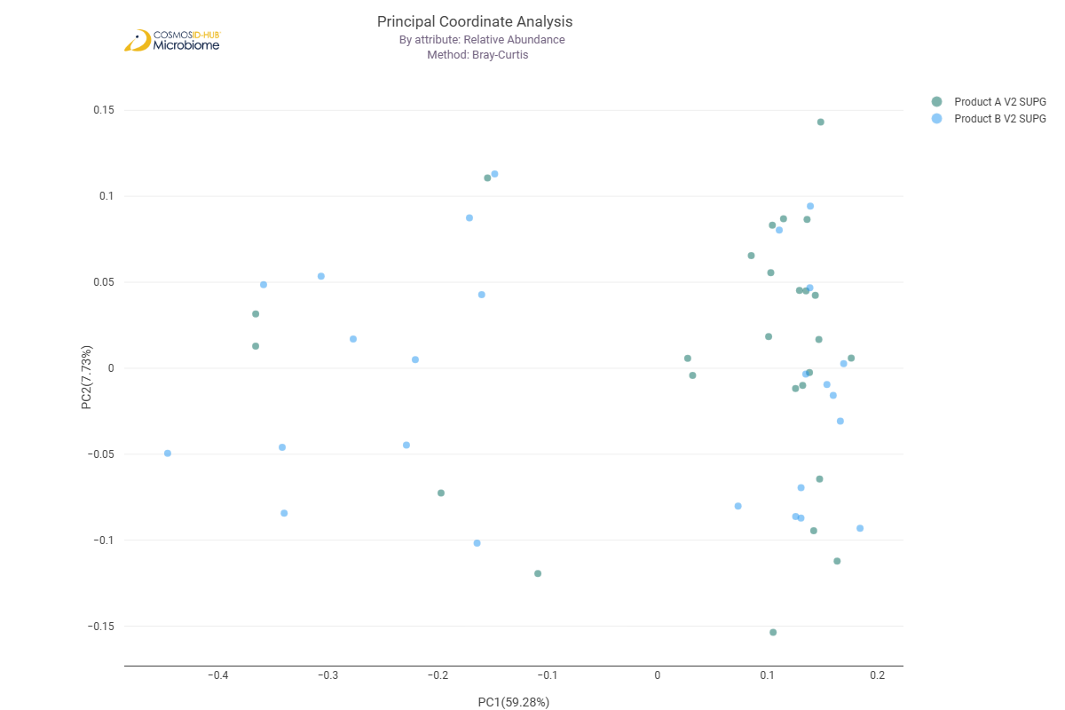

Differential Abundance (LEfSe) (EC)
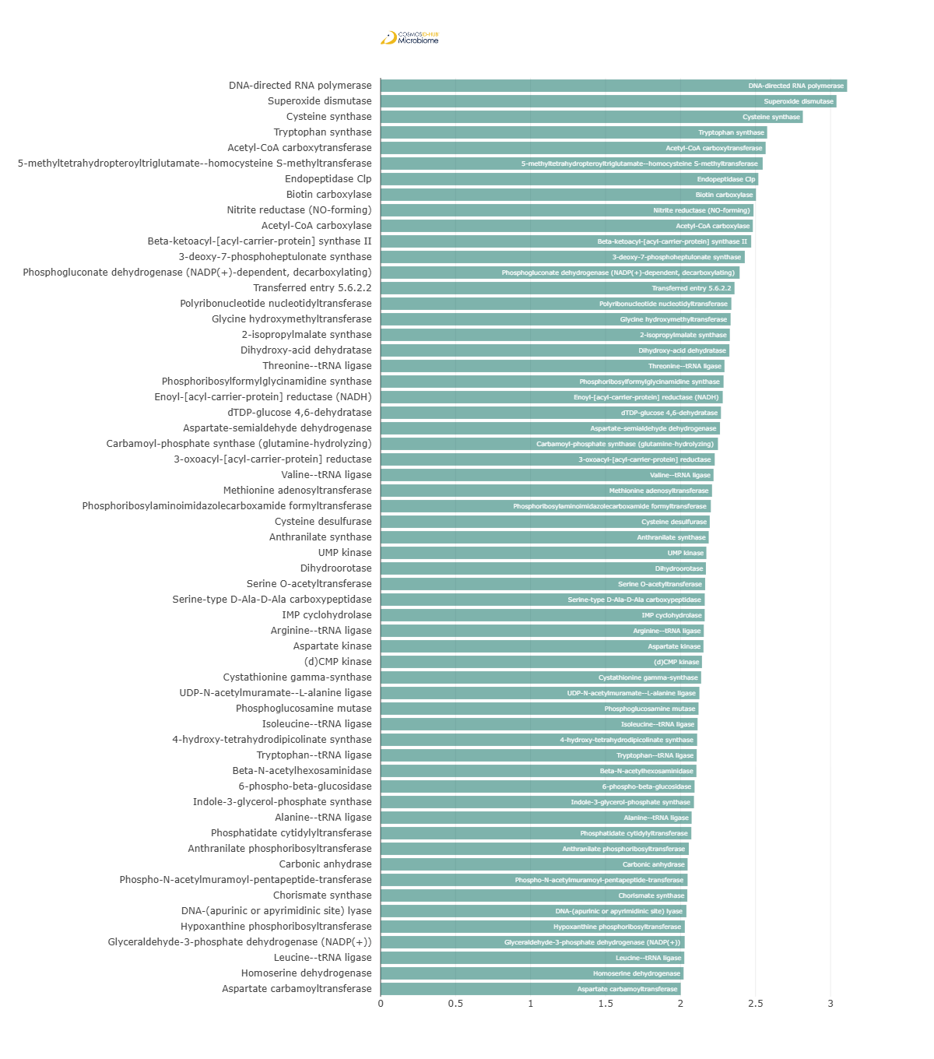
Feature | Enriched Cohort | LDA Score | P-value
DNA-directed RNA polymerase | Product A V2 SUPG | 3.111020333 | 0.02375508
Superoxide dismutase | Product A V2 SUPG | 3.040013385 | 0.011574483
Cysteine synthase | Product A V2 SUPG | 2.815737109 | 0.001548196
Tryptophan synthase | Product A V2 SUPG | 2.577744157 | 0.000276314
Acetyl-CoA carboxytransferase | Product A V2 SUPG | 2.567719746 | 0.007889693
5-methyltetrahydropteroyltriglutamate--homocysteine S-methyltransferase | Product A V2 SUPG | 2.547962006 | 0.036484395
Endopeptidase Clp | Product A V2 SUPG | 2.518826283 | 0.006292761
Biotin carboxylase | Product A V2 SUPG | 2.502821472 | 0.015873756
Nitrite reductase (NO-forming) | Product A V2 SUPG | 2.486578655 | 0.030245812
Acetyl-CoA carboxylase | Product A V2 SUPG | 2.482112113 | 0.038205314
Beta-ketoacyl-[acyl-carrier-protein] synthase II | Product A V2 SUPG | 2.471132956 | 0.016712924
3-deoxy-7-phosphoheptulonate synthase | Product A V2 SUPG | 2.428626553 | 0.020471389
Phosphogluconate dehydrogenase (NADP(+)-dependent, decarboxylating) | Product A V2 SUPG | 2.393945069 | 0.039994768
Transferred entry 5.6.2.2 | Product A V2 SUPG | 2.360090893 | 0.010968497
Polyribonucleotide nucleotidyltransferase | Product A V2 SUPG | 2.339073295 | 0.034829974
Glycine hydroxymethyltransferase | Product A V2 SUPG | 2.334029314 | 0.038205314
2-isopropylmalate synthase | Product A V2 SUPG | 2.328902169 | 1.43E-02
Dihydroxy-acid dehydratase | Product A V2 SUPG | 2.325621312 | 0.015873756
Threonine--tRNA ligase | Product A V2 SUPG | 2.293236056 | 0.016712924
Phosphoribosylformylglycinamidine synthase | Product A V2 SUPG | 2.287096387 | 0.02375508
Enoyl-[acyl-carrier-protein] reductase (NADH) | Product A V2 SUPG | 2.281565459 | 0.013574437
dTDP-glucose 4,6-dehydratase | Product A V2 SUPG | 2.269477405 | 0.005941992
Aspartate-semialdehyde dehydrogenase | Product A V2 SUPG | 2.263052348 | 0.012209995
Carbamoyl-phosphate synthase (glutamine-hydrolyzing) | Product A V2 SUPG | 2.249725795 | 0.010968497
3-oxoacyl-[acyl-carrier-protein] reductase | Product A V2 SUPG | 2.228019455 | 4.58E-02
Valine--tRNA ligase | Product A V2 SUPG | 2.220189052 | 0.005608941
Methionine adenosyltransferase | Product A V2 SUPG | 2.210159621 | 0.002416555
Phosphoribosylaminoimidazolecarboxamide formyltransferase | Product A V2 SUPG | 2.202152483 | 0.00881699
Cysteine desulfurase | Product A V2 SUPG | 2.194846541 | 0.015873756
Anthranilate synthase | Product A V2 SUPG | 2.188027235 | 0.000177114
UMP kinase | Product A V2 SUPG | 2.17234657 | 0.038205314
Dihydroorotase | Product A V2 SUPG | 2.169410392 | 0.02375508
Serine O-acetyltransferase | Product A V2 SUPG | 2.164156919 | 0.031712637
Serine-type D-Ala-D-Ala carboxypeptidase | Product A V2 SUPG | 2.161571218 | 0.026189985
IMP cyclohydrolase | Product A V2 SUPG | 2.161164207 | 0.012209995
Arginine--tRNA ligase | Product A V2 SUPG | 2.15520944 | 0.038205314
Aspartate kinase | Product A V2 SUPG | 2.15326488 | 0.014305878
(d)CMP kinase | Product A V2 SUPG | 2.143007637 | 0.017590793
Cystathionine gamma-synthase | Product A V2 SUPG | 2.137563453 | 0.007889693
UDP-N-acetylmuramate--L-alanine ligase | Product A V2 SUPG | 2.125778796 | 0.02375508
Phosphoglucosamine mutase | Product A V2 SUPG | 2.120102518 | 0.028837668
Isoleucine--tRNA ligase | Product A V2 SUPG | 2.113675052 | 0.002000719
4-hydroxy-tetrahydrodipicolinate synthase | Product A V2 SUPG | 2.111127915 | 0.015071869
Tryptophan--tRNA ligase | Product A V2 SUPG | 2.108140128 | 0.003711399
Beta-N-acetylhexosaminidase | Product A V2 SUPG | 2.106142229 | 0.011574483
6-phospho-beta-glucosidase | Product A V2 SUPG | 2.093597012 | 0.015873756
Indole-3-glycerol-phosphate synthase | Product A V2 SUPG | 2.089718618 | 0.004183032
Alanine--tRNA ligase | Product A V2 SUPG | 2.074156106 | 0.007050729
Phosphatidate cytidylyltransferase | Product A V2 SUPG | 2.071961346 | 0.003711399
Anthranilate phosphoribosyltransferase | Product A V2 SUPG | 2.055331504 | 0.002910155
Carbonic anhydrase | Product A V2 SUPG | 2.047193511 | 0.01946851
Phospho-N-acetylmuramoyl-pentapeptide-transferase | Product A V2 SUPG | 2.04715419 | 0.045795182
Chorismate synthase | Product A V2 SUPG | 2.045269032 | 0.034829974
DNA-(apurinic or apyrimidinic site) lyase | Product A V2 SUPG | 2.039280143 | 0.015071869
Hypoxanthine phosphoribosyltransferase | Product A V2 SUPG | 2.028740275 | 0.039994768
Glyceraldehyde-3-phosphate dehydrogenase (NADP(+)) | Product A V2 SUPG | 2.027884467 | 0.012762404
Leucine--tRNA ligase | Product A V2 SUPG | 2.025092427 | 0.028837668
Homoserine dehydrogenase | Product A V2 SUPG | 2.020459585 | 0.010390869
Aspartate carbamoyltransferase | Product A V2 SUPG | 2.001420241 | 0.00745964

MetaCyc Pathways

Alpha Diversity (MetaCyc)
Chao1 | 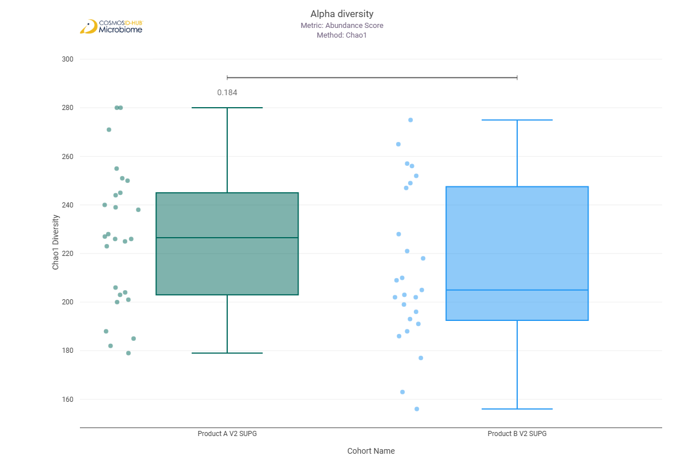
Shannon | 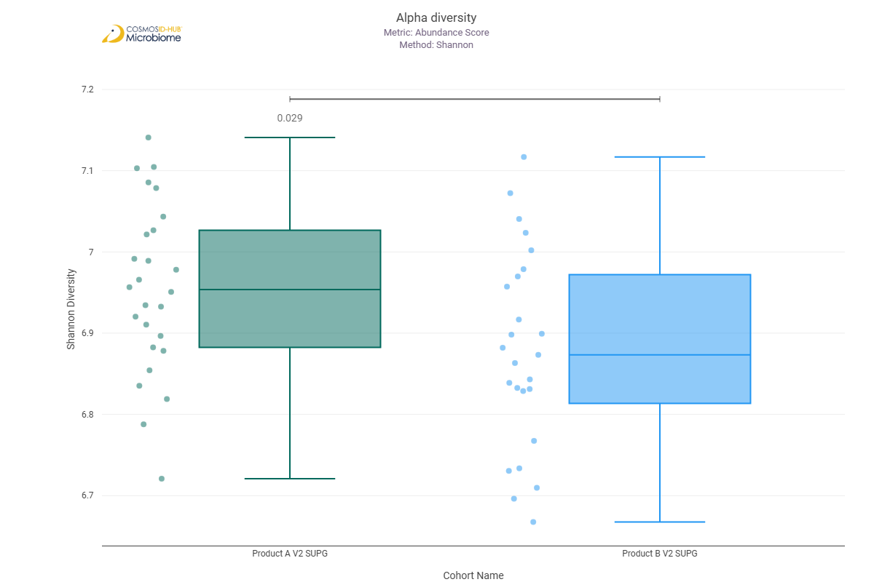
Simpson | 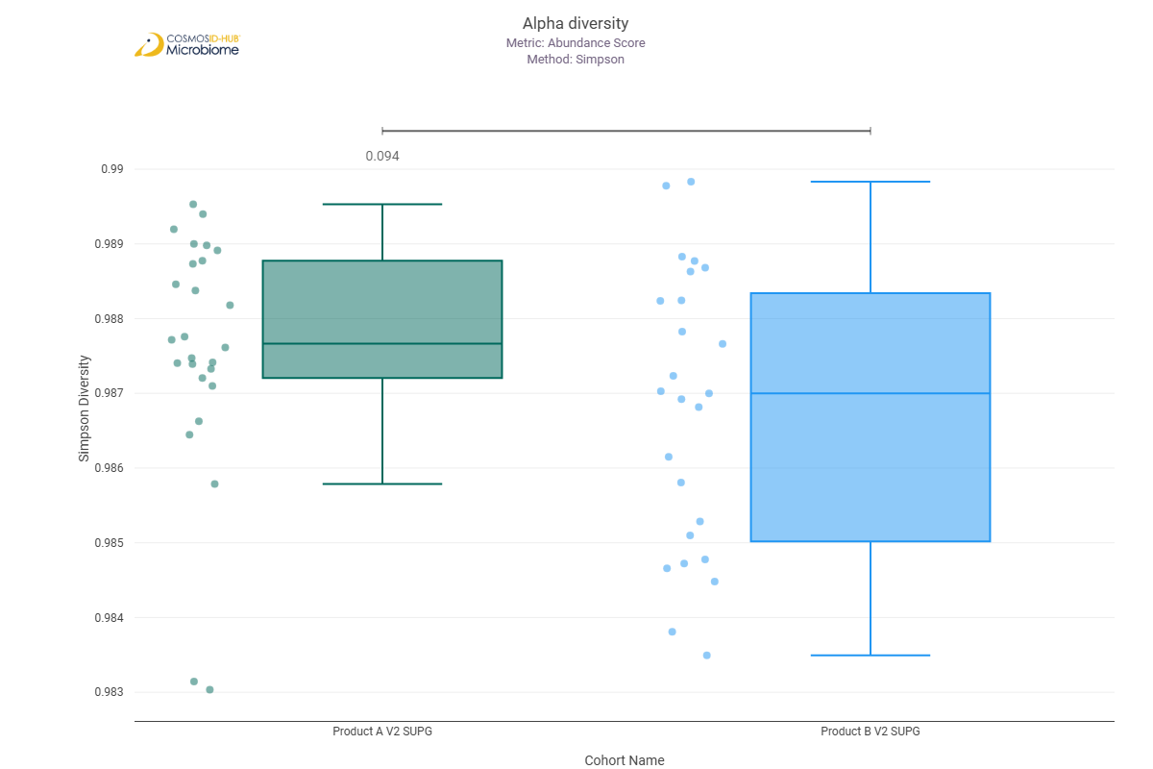

Beta Diversity (MetaCyc)
Bray-Curtis  PERMNOVA p = 0.654 | 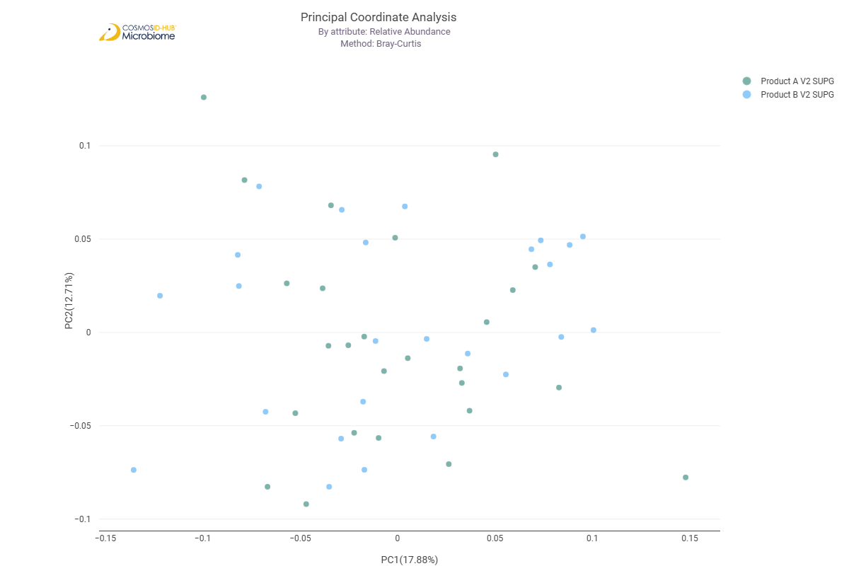

Differential Abundance (LEfSe) (MetaCyc)
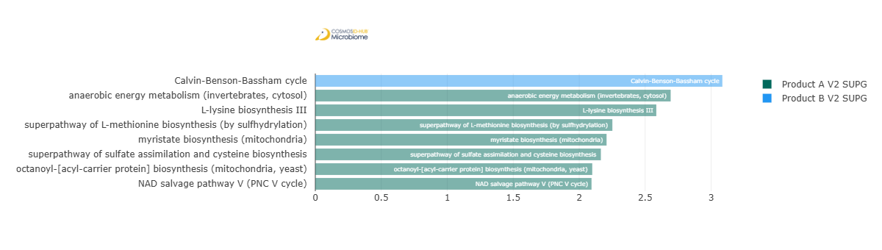
Feature | Enriched Cohort | LDA Score | P-value
Calvin-Benson-Bassham cycle | Product B V2 SUPG | 3.085510466 | 0.047879765
anaerobic energy metabolism (invertebrates, cytosol) | Product A V2 SUPG | 2.693616266 | 0.018508823
L-lysine biosynthesis III | Product A V2 SUPG | 2.584864736 | 0.012209995
superpathway of L-methionine biosynthesis (by sulfhydrylation) | Product A V2 SUPG | 2.251777445 | 0.005206458
myristate biosynthesis (mitochondria) | Product A V2 SUPG | 2.207702327 | 0.001041621
superpathway of sulfate assimilation and cysteine biosynthesis | Product A V2 SUPG | 2.164724922 | 0.003030685
octanoyl-[acyl-carrier protein] biosynthesis (mitochondria, yeast) | Product A V2 SUPG | 2.099384673 | 0.005433155
NAD salvage pathway V (PNC V cycle) | Product A V2 SUPG | 2.093878625 | 0.03882039

Comparison 16: Product A V3 SUPG vs Product B V3 SUPG

Gene Ontology

Alpha Diversity (GO)
Chao1 | 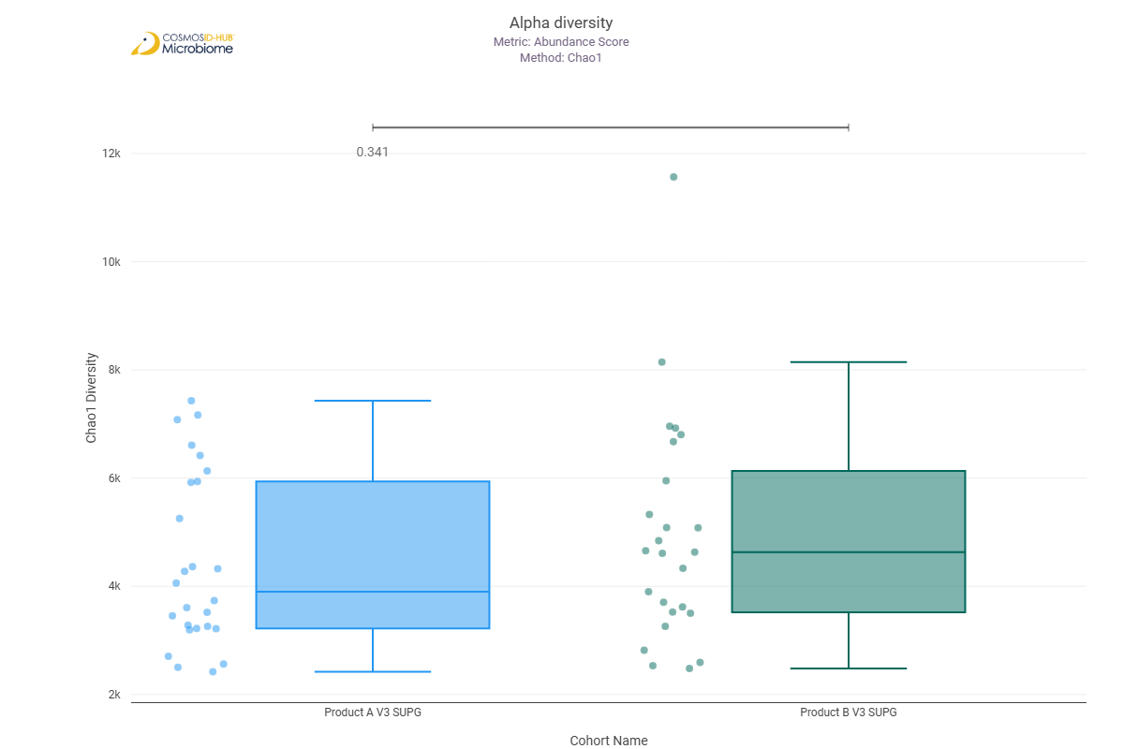
Shannon | 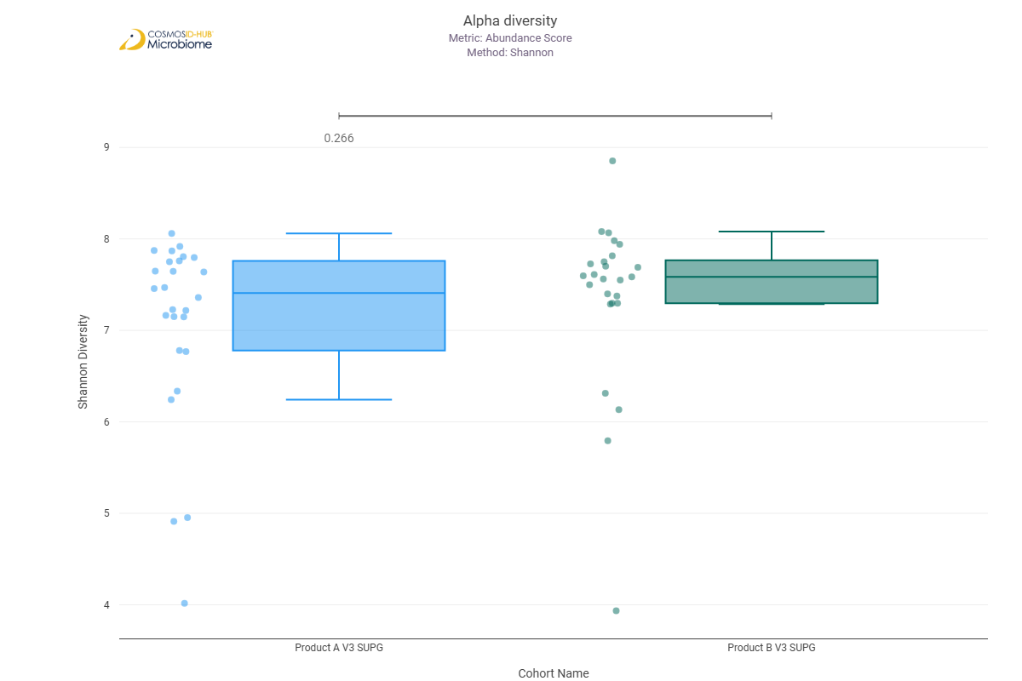
Simpson | 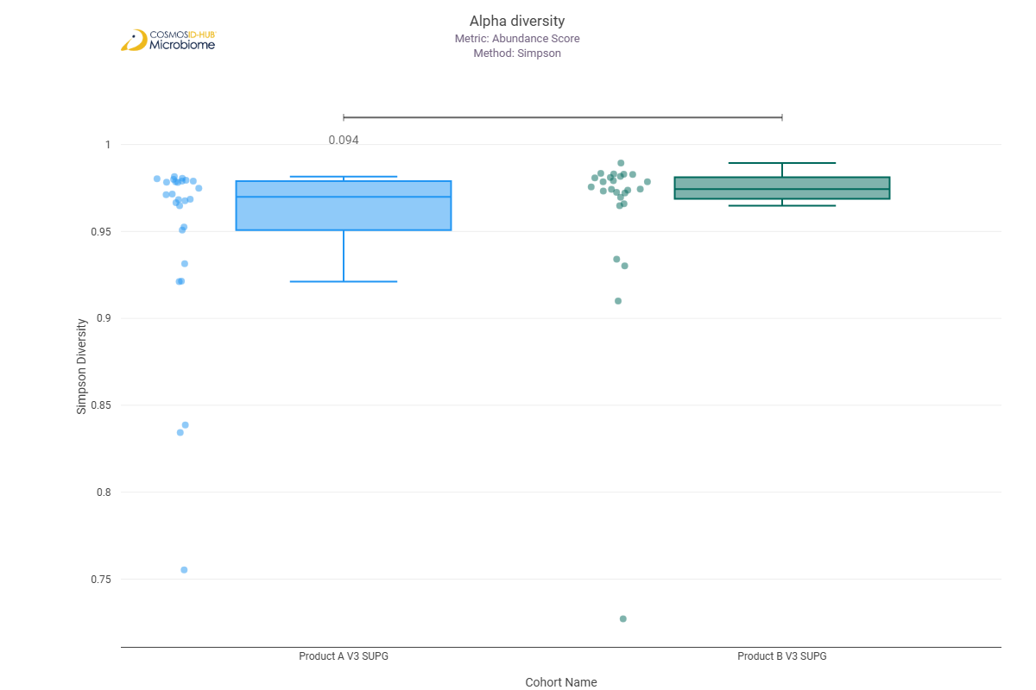

Beta Diversity (GO)
Bray-Curtis  PERMNOVA p = 0.323 | 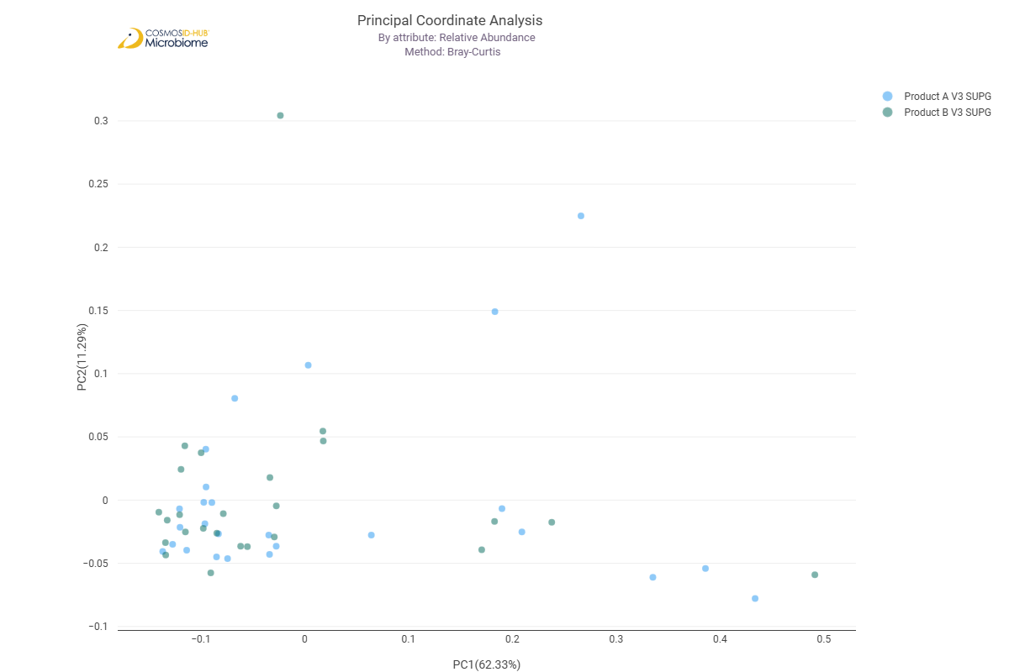

Differential Abundance (LEfSe) (GO)
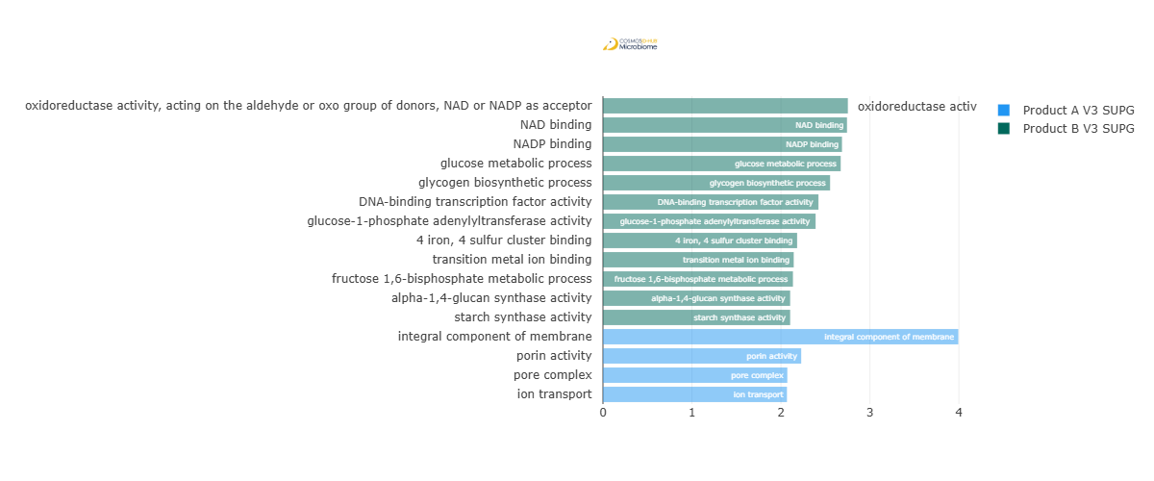
Feature | Enriched Cohort | LDA Score | P-value
oxidoreductase activity, acting on the aldehyde or oxo group of donors, NAD or NADP as acceptor | Product B V3 SUPG | 2.752474797 | 0.012209995
NAD binding | Product B V3 SUPG | 2.742648085 | 0.027486336
NADP binding | Product B V3 SUPG | 2.686305478 | 0.013574437
glucose metabolic process | Product B V3 SUPG | 2.671540978 | 0.015071869
glycogen biosynthetic process | Product B V3 SUPG | 2.552404183 | 0.015873756
DNA-binding transcription factor activity | Product B V3 SUPG | 2.42153675 | 0.020471389
glucose-1-phosphate adenylyltransferase activity | Product B V3 SUPG | 2.389556209 | 0.011574483
4 iron, 4 sulfur cluster binding | Product B V3 SUPG | 2.182217095 | 0.031712637
transition metal ion binding | Product B V3 SUPG | 2.143807206 | 0.022613046
fructose 1,6-bisphosphate metabolic process | Product B V3 SUPG | 2.135242629 | 0.02494682
starch synthase activity | Product B V3 SUPG | 2.103901259 | 0.010390869
alpha-1,4-glucan synthase activity | Product B V3 SUPG | 2.103901259 | 0.010390869
integral component of membrane | Product A V3 SUPG | 3.993290893 | 0.030245812
porin activity | Product A V3 SUPG | 2.227729313 | 0.000425892
pore complex | Product A V3 SUPG | 2.071930111 | 0.004438681
ion transport | Product A V3 SUPG | 2.067516171 | 0.004438681

Enzyme Commission

Alpha Diversity (EC)
Chao1 | 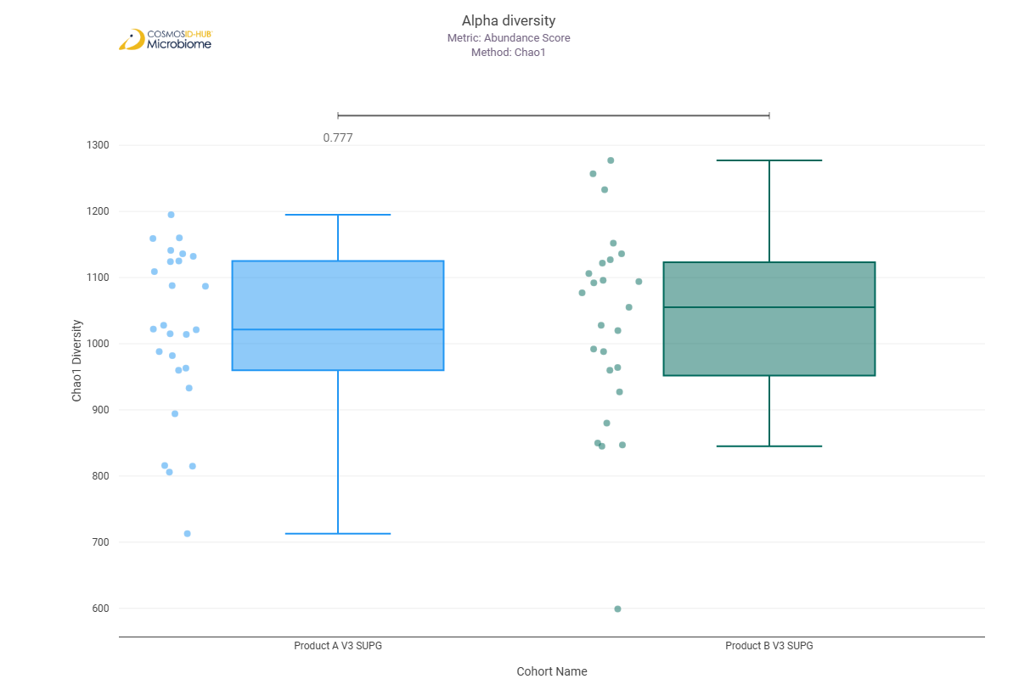
Shannon | 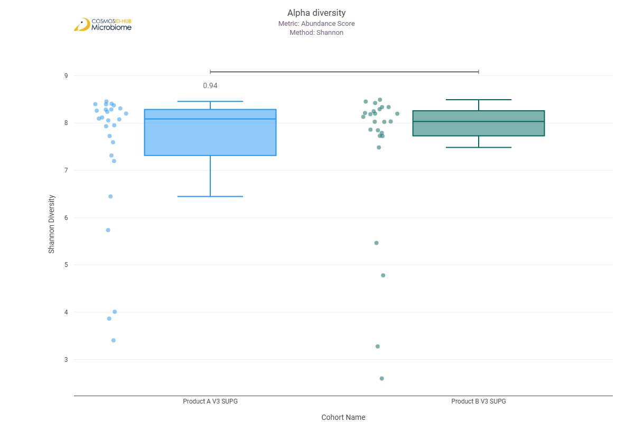
Simpson | 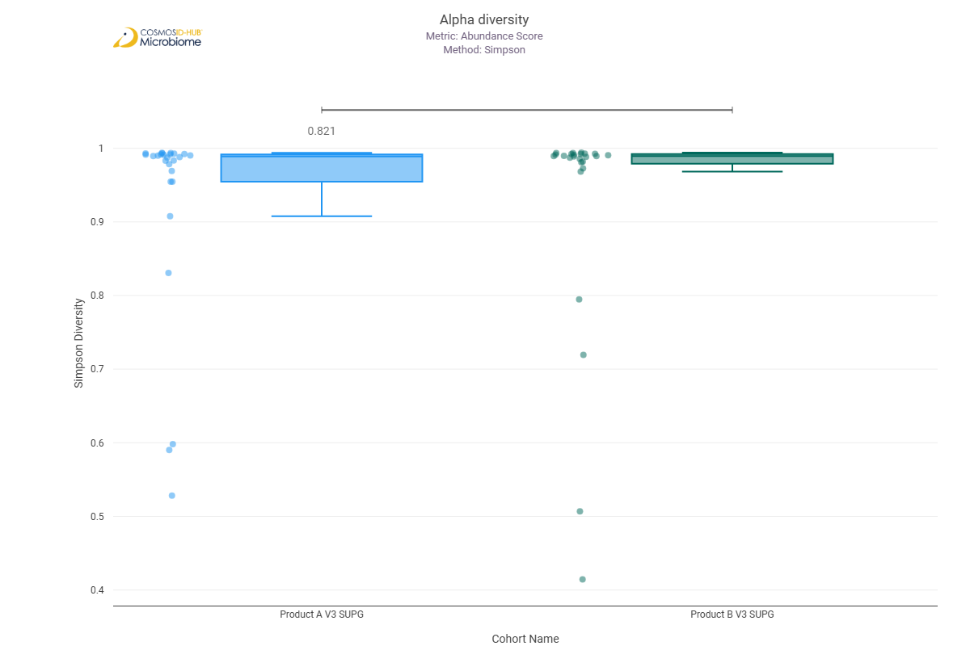

Beta Diversity (EC)
Bray-Curtis  PERMNOVA p = 0.444 | 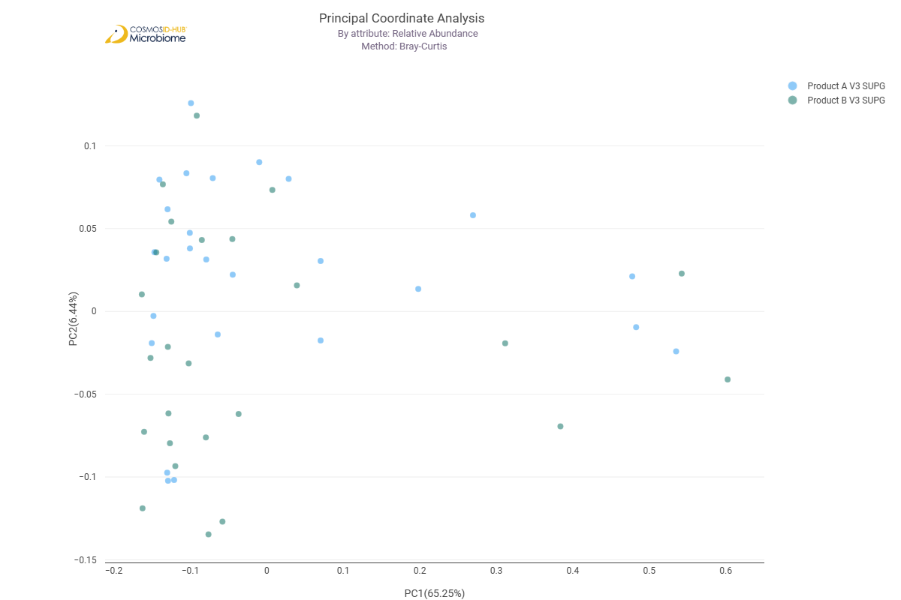

Differential Abundance (LEfSe) (EC)
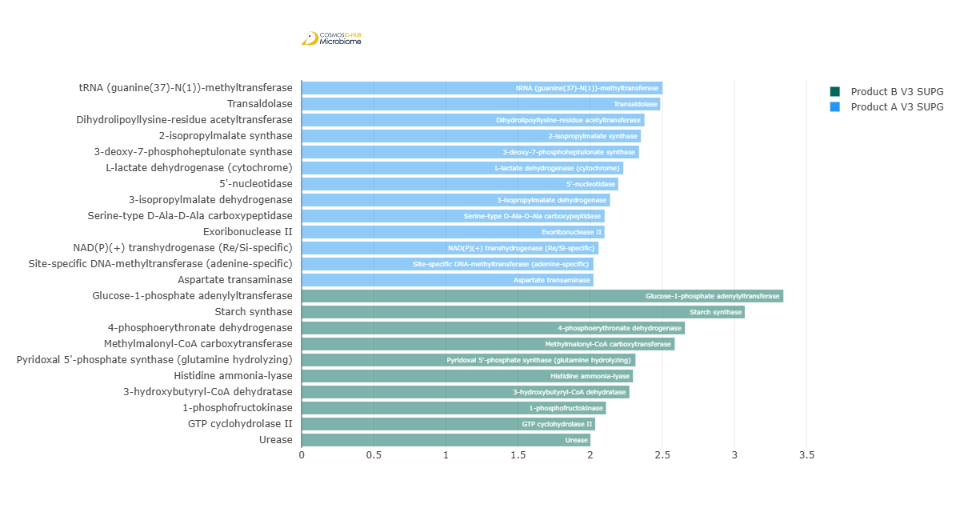
Feature | Enriched Cohort | LDA Score | P-value
tRNA (guanine(37)-N(1))-methyltransferase | Product A V3 SUPG | 2.500264278 | 0.01946851
Transaldolase | Product A V3 SUPG | 2.484762088 | 0.018508823
Dihydrolipoyllysine-residue acetyltransferase | Product A V3 SUPG | 2.375737852 | 0.002269883
2-isopropylmalate synthase | Product A V3 SUPG | 2.350585213 | 0.009316196
3-deoxy-7-phosphoheptulonate synthase | Product A V3 SUPG | 2.337189254 | 0.012209995
L-lactate dehydrogenase (cytochrome) | Product A V3 SUPG | 2.228905441 | 0.000975879
5'-nucleotidase | Product A V3 SUPG | 2.193891563 | 0.017590793
3-isopropylmalate dehydrogenase | Product A V3 SUPG | 2.136461137 | 0.034829974
Serine-type D-Ala-D-Ala carboxypeptidase | Product A V3 SUPG | 2.099533029 | 3.65E-02
Exoribonuclease II | Product A V3 SUPG | 2.098730123 | 0.00666206
NAD(P)(+) transhydrogenase (Re/Si-specific) | Product A V3 SUPG | 2.057129937 | 9.12086E-05
Site-specific DNA-methyltransferase (adenine-specific) | Product A V3 SUPG | 2.022241583 | 0.004708409
Aspartate transaminase | Product A V3 SUPG | 2.022013886 | 0.007889693
Glucose-1-phosphate adenylyltransferase | Product B V3 SUPG | 3.338057083 | 0.014305878
Starch synthase | Product B V3 SUPG | 3.070387876 | 0.010390869
4-phosphoerythronate dehydrogenase | Product B V3 SUPG | 2.655965123 | 0.02375508
Methylmalonyl-CoA carboxytransferase | Product B V3 SUPG | 2.585105624 | 0.030245812
Pyridoxal 5'-phosphate synthase (glutamine hydrolyzing) | Product B V3 SUPG | 2.3131954 | 0.009840467
Histidine ammonia-lyase | Product B V3 SUPG | 2.295994799 | 0.041854827
3-hydroxybutyryl-CoA dehydratase | Product B V3 SUPG | 2.271443172 | 0.027416296
1-phosphofructokinase | Product B V3 SUPG | 2.108726986 | 0.026189985
GTP cyclohydrolase II | Product B V3 SUPG | 2.034218049 | 0.032464726
Urease | Product B V3 SUPG | 2.000448337 | 0.036484395

MetaCyc Pathways

Alpha Diversity (MetaCyc)
Chao1 | 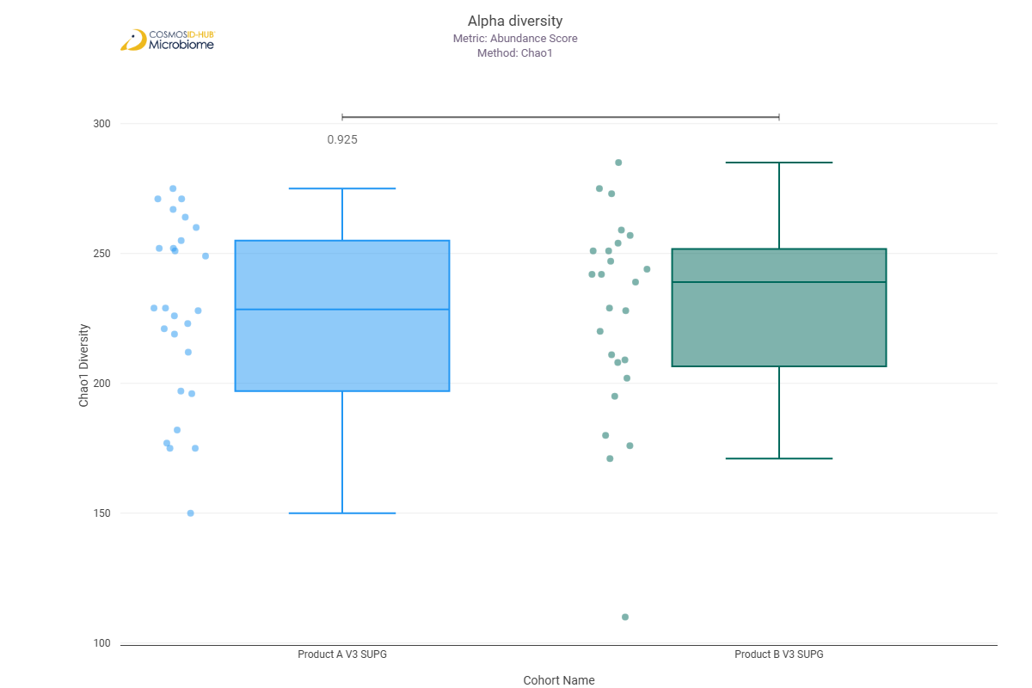
Shannon | 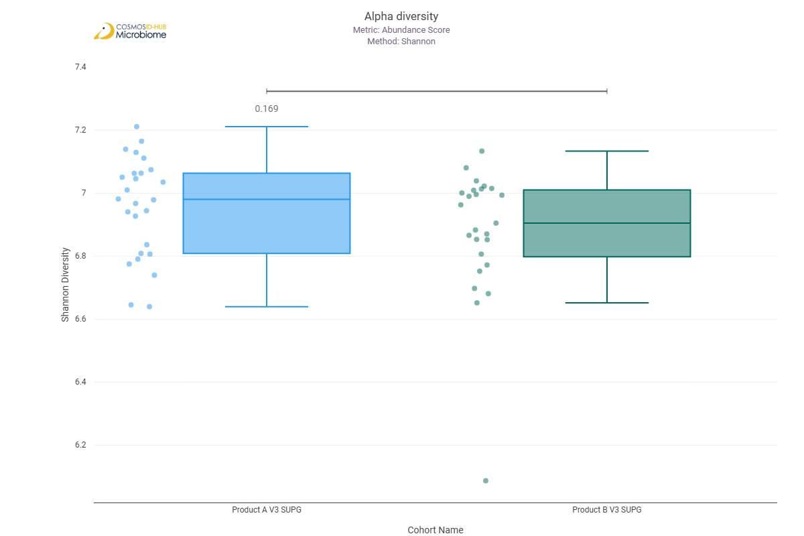
Simpson | 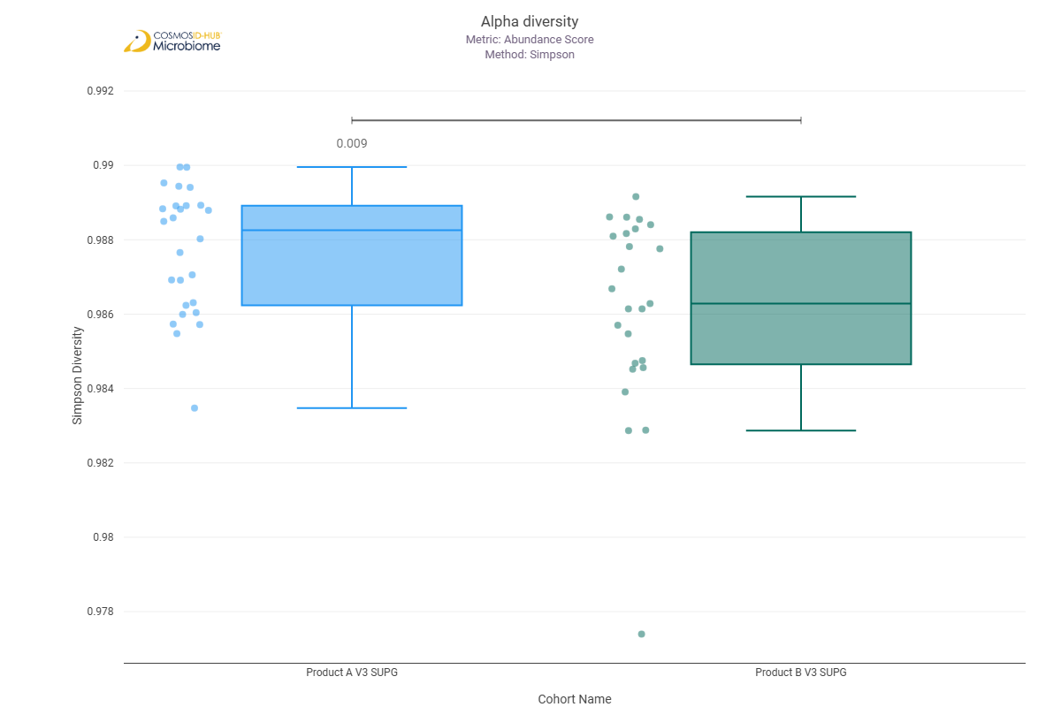

Beta Diversity (MetaCyc)
Bray-Curtis  PERMNOVA p = 0.003 | 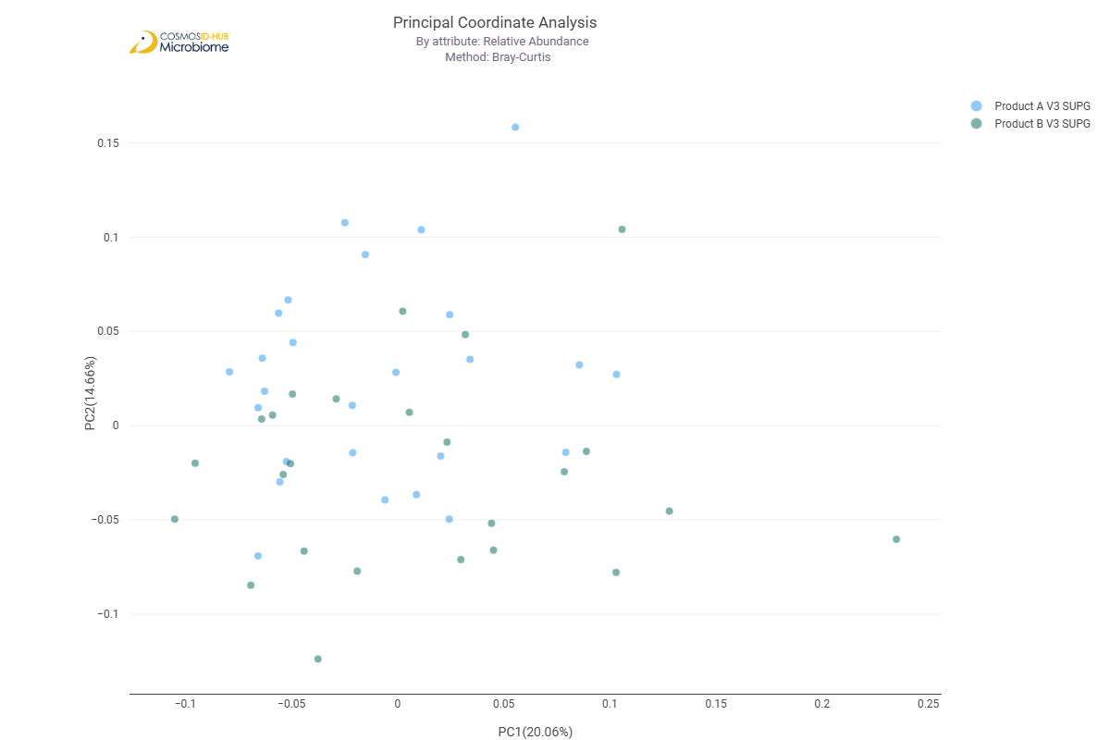

Differential Abundance (LEfSe) (MetaCyc)
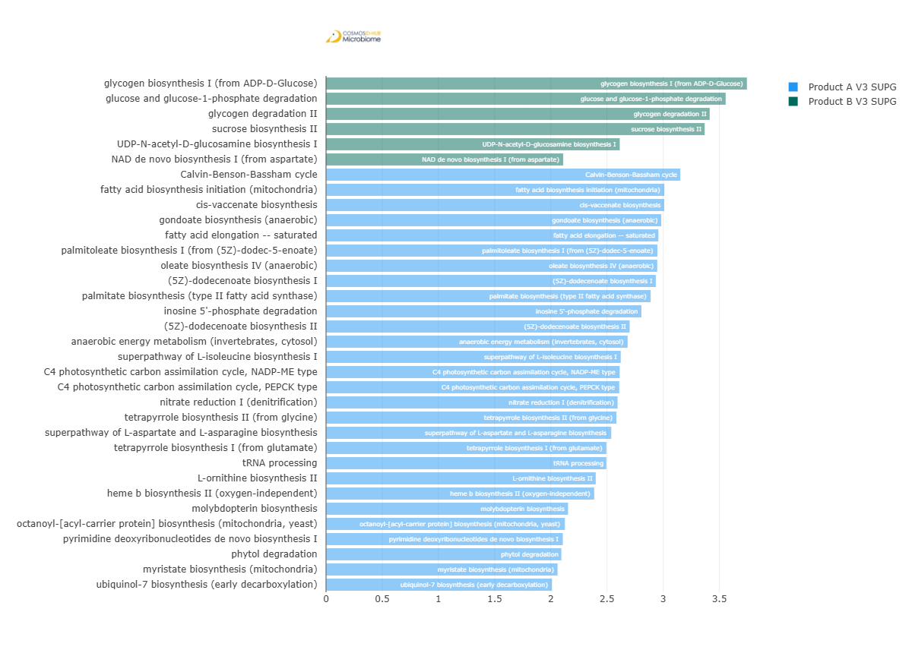
Feature | Enriched Cohort | LDA Score | P-value
glycogen biosynthesis I (from ADP-D-Glucose) | Product B V3 SUPG | 3.745453908 | 0.004992891
glucose and glucose-1-phosphate degradation | Product B V3 SUPG | 3.556342772 | 0.001185563
glycogen degradation II | Product B V3 SUPG | 3.414064751 | 0.002416555
sucrose biosynthesis II | Product B V3 SUPG | 3.369416045 | 0.043787588
UDP-N-acetyl-D-glucosamine biosynthesis I | Product B V3 SUPG | 2.613767033 | 0.038205314
NAD de novo biosynthesis I (from aspartate) | Product B V3 SUPG | 2.11061315 | 0.022998367
Calvin-Benson-Bassham cycle | Product A V3 SUPG | 3.152784189 | 0.014305878
fatty acid biosynthesis initiation (mitochondria) | Product A V3 SUPG | 3.01039182 | 0.045795182
cis-vaccenate biosynthesis | Product A V3 SUPG | 3.009160863 | 0.002131408
gondoate biosynthesis (anaerobic) | Product A V3 SUPG | 2.982772569 | 0.001651513
fatty acid elongation -- saturated | Product A V3 SUPG | 2.957467752 | 1.55E-03
palmitoleate biosynthesis I (from (5Z)-dodec-5-enoate) | Product A V3 SUPG | 2.9484708 | 0.001548196
oleate biosynthesis IV (anaerobic) | Product A V3 SUPG | 2.947646008 | 0.001548196
(5Z)-dodecenoate biosynthesis I | Product A V3 SUPG | 2.934424036 | 0.001450862
palmitate biosynthesis (type II fatty acid synthase) | Product A V3 SUPG | 2.888494581 | 0.031388853
inosine 5'-phosphate degradation | Product A V3 SUPG | 2.80641503 | 0.005608941
(5Z)-dodecenoate biosynthesis II | Product A V3 SUPG | 2.70155732 | 0.001546672
anaerobic energy metabolism (invertebrates, cytosol) | Product A V3 SUPG | 2.683835359 | 0.00176114
superpathway of L-isoleucine biosynthesis I | Product A V3 SUPG | 2.622456465 | 0.00745964
C4 photosynthetic carbon assimilation cycle, NADP-ME type | Product A V3 SUPG | 2.612696215 | 0.005608941
C4 photosynthetic carbon assimilation cycle, PEPCK type | Product A V3 SUPG | 2.609269035 | 0.003940813
nitrate reduction I (denitrification) | Product A V3 SUPG | 2.594250369 | 0.038117995
tetrapyrrole biosynthesis II (from glycine) | Product A V3 SUPG | 2.583988202 | 0.002736233
superpathway of L-aspartate and L-asparagine biosynthesis | Product A V3 SUPG | 2.537954679 | 0.01946851
tetrapyrrole biosynthesis I (from glutamate) | Product A V3 SUPG | 2.494703731 | 0.021519031
tRNA processing | Product A V3 SUPG | 2.494482922 | 3.04E-03
L-ornithine biosynthesis II | Product A V3 SUPG | 2.400005683 | 0.001710728
heme b biosynthesis II (oxygen-independent) | Product A V3 SUPG | 2.386491358 | 0.01038393
molybdopterin biosynthesis | Product A V3 SUPG | 2.153352631 | 0.042764988
octanoyl-[acyl-carrier protein] biosynthesis (mitochondria, yeast) | Product A V3 SUPG | 2.125495299 | 0.007588752
pyrimidine deoxyribonucleotides de novo biosynthesis I | Product A V3 SUPG | 2.107076766 | 0.022483275
phytol degradation | Product A V3 SUPG | 2.093939151 | 0.020872668
myristate biosynthesis (mitochondria) | Product A V3 SUPG | 2.060356177 | 0.015762918
ubiquinol-7 biosynthesis (early decarboxylation) | Product A V3 SUPG | 2.010244202 | 0.034572268

Comparison 17: Product A V2 SUBG vs Product A V3 SUBG

Gene Ontology

Alpha Diversity (GO)
Chao1 | 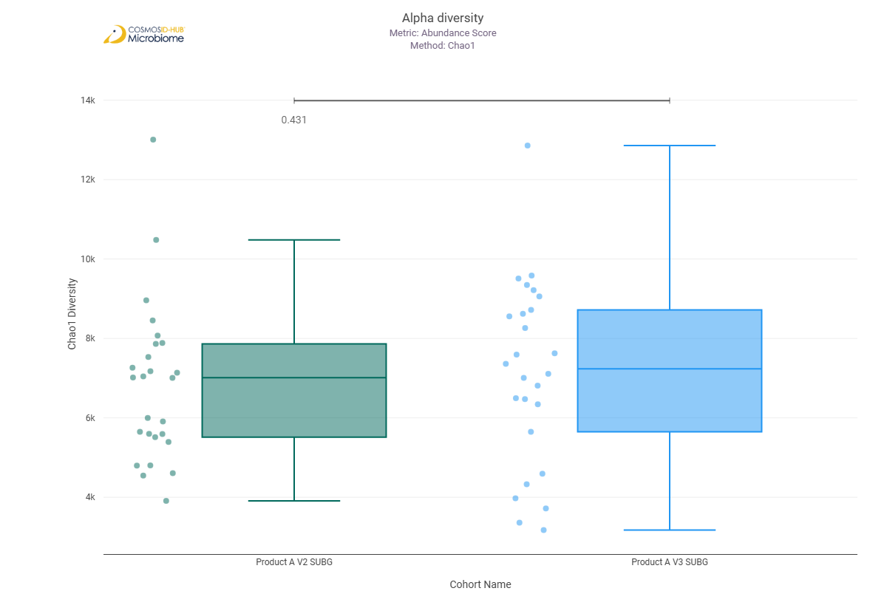
Shannon | 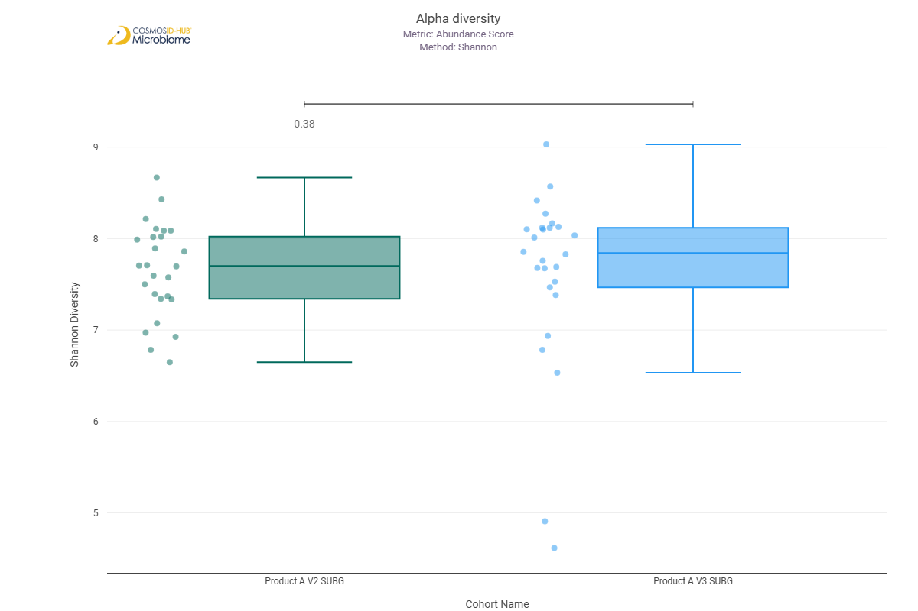
Simpson | 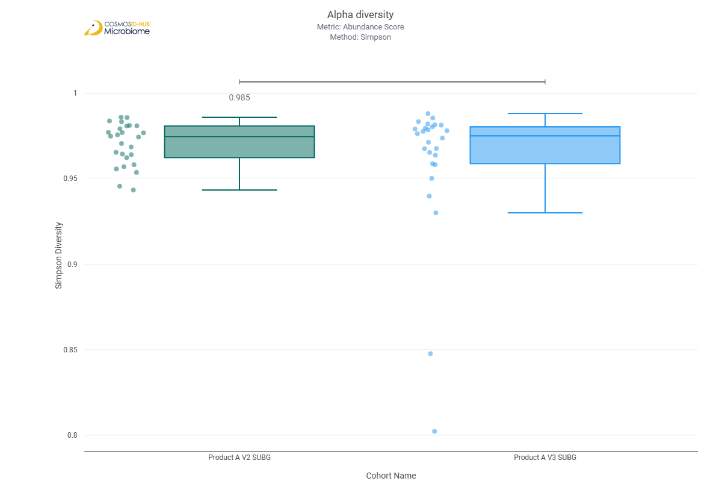

Beta Diversity (GO)
Bray-Curtis  PERMNOVA p = 0.221 | 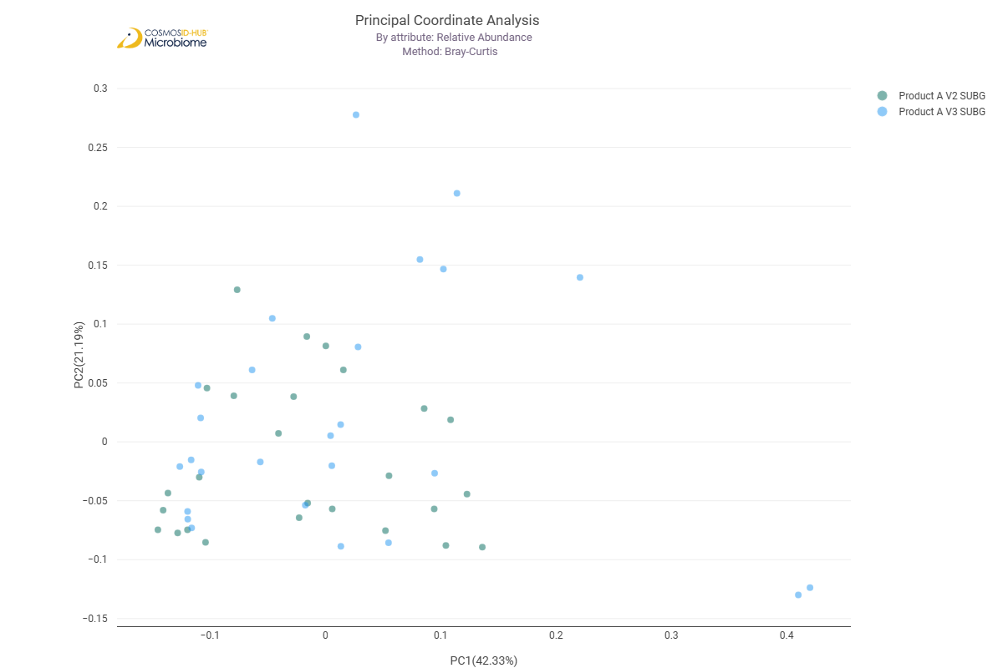

Differential Abundance (LEfSe) (GO)
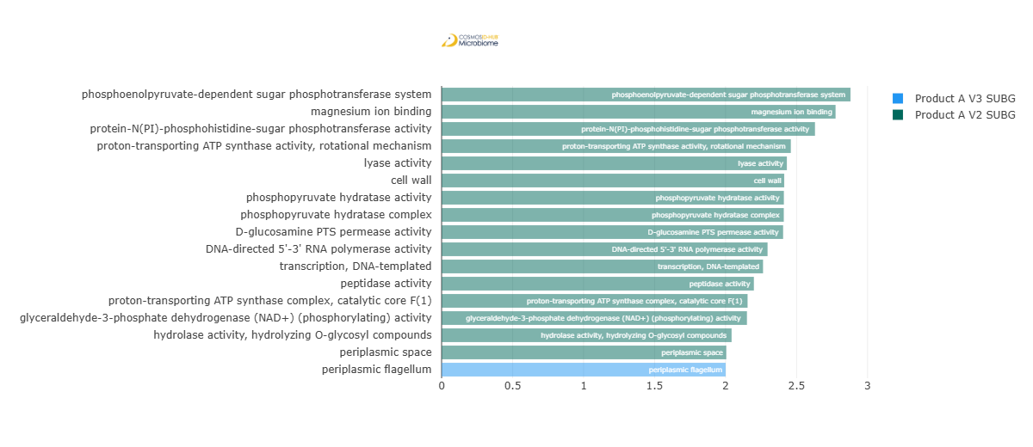
Feature | Enriched Cohort | LDA Score | P-value
phosphoenolpyruvate-dependent sugar phosphotransferase system | Product A V2 SUBG | 2.879797903 | 0.032254747
magnesium ion binding | Product A V2 SUBG | 2.774888442 | 0.036948224
protein-N(PI)-phosphohistidine-sugar phosphotransferase activity | Product A V2 SUBG | 2.629946921 | 0.019152346
proton-transporting ATP synthase activity, rotational mechanism | Product A V2 SUBG | 2.459822872 | 0.035322927
lyase activity | Product A V2 SUBG | 2.431775521 | 0.020112035
cell wall | Product A V2 SUBG | 2.413162378 | 0.00935587
phosphopyruvate hydratase activity | Product A V2 SUBG | 2.410854956 | 0.029417827
phosphopyruvate hydratase complex | Product A V2 SUBG | 2.410229337 | 0.032254747
D-glucosamine PTS permease activity | Product A V2 SUBG | 2.405537558 | 0.030808261
DNA-directed 5'-3' RNA polymerase activity | Product A V2 SUBG | 2.295963259 | 0.019152346
transcription, DNA-templated | Product A V2 SUBG | 2.26404028 | 1.65E-02
peptidase activity | Product A V2 SUBG | 2.199570388 | 0.044100855
proton-transporting ATP synthase complex, catalytic core F(1) | Product A V2 SUBG | 2.155169223 | 0.030808261
glyceraldehyde-3-phosphate dehydrogenase (NAD+) (phosphorylating) activity | Product A V2 SUBG | 2.150756046 | 0.01096333
hydrolase activity, hydrolyzing O-glycosyl compounds | Product A V2 SUBG | 2.042624495 | 0.044100855
periplasmic space | Product A V2 SUBG | 2.005080067 | 0.046061451
periplasmic flagellum | Product A V3 SUBG | 2.000494506 | 0.029983145

Enzyme Commission

Alpha Diversity (EC)
Chao1 | 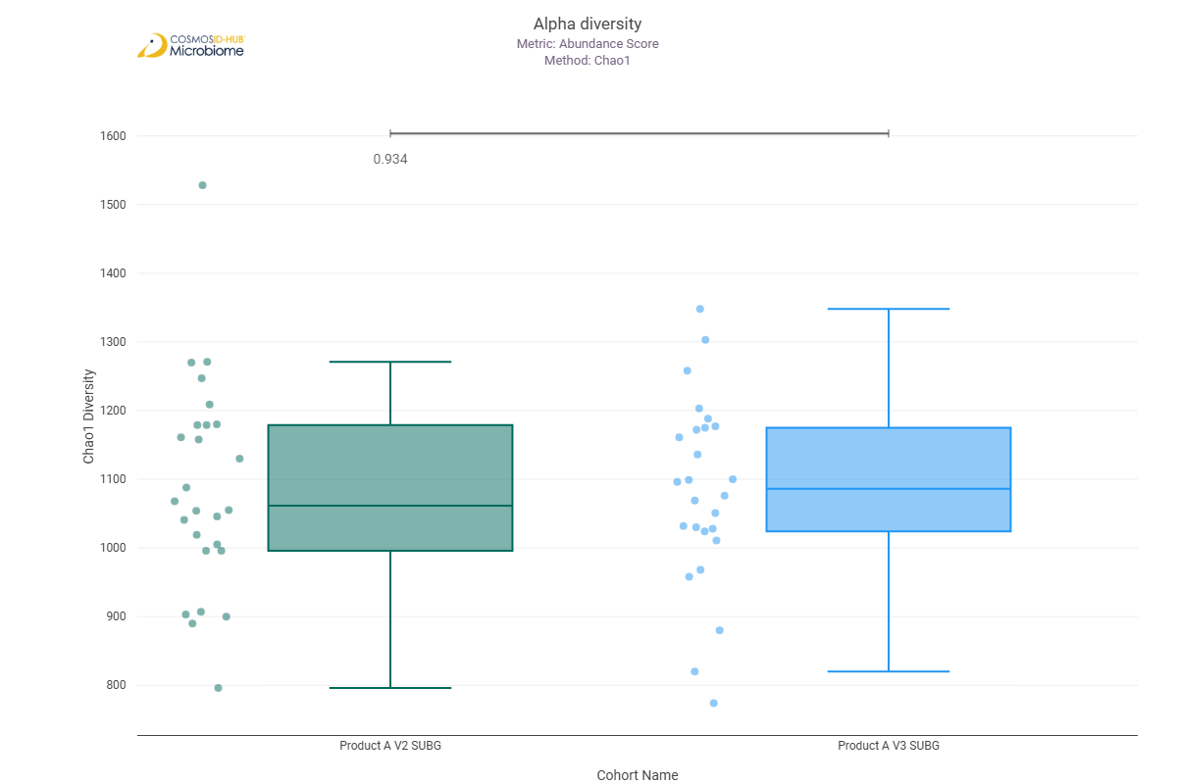
Shannon | 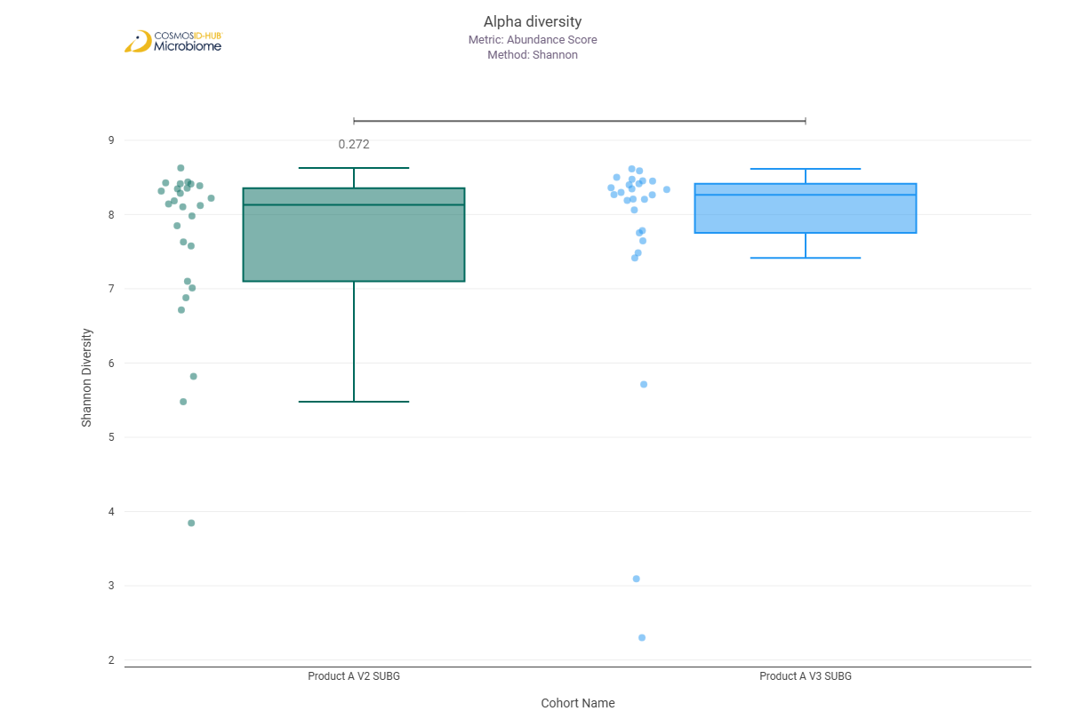
Simpson | 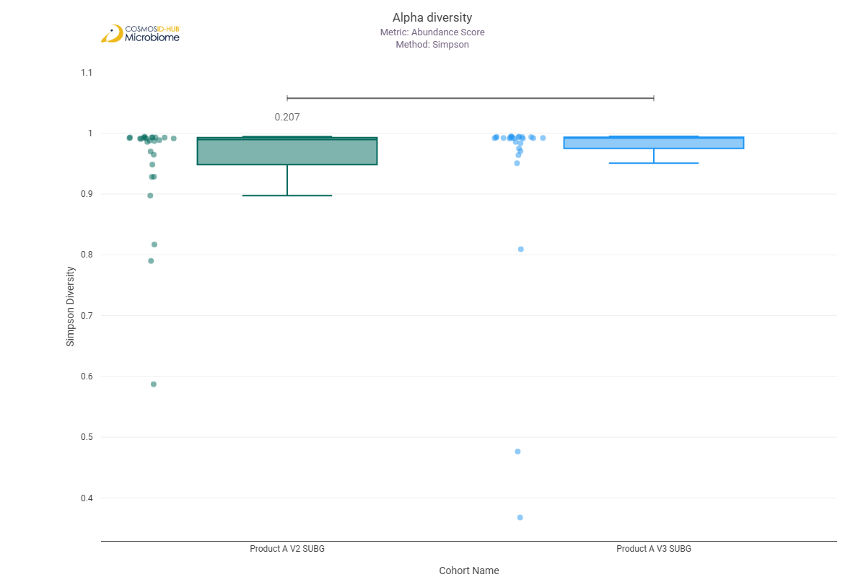

Beta Diversity (EC)
Bray-Curtis  PERMNOVA p = 0.477 | 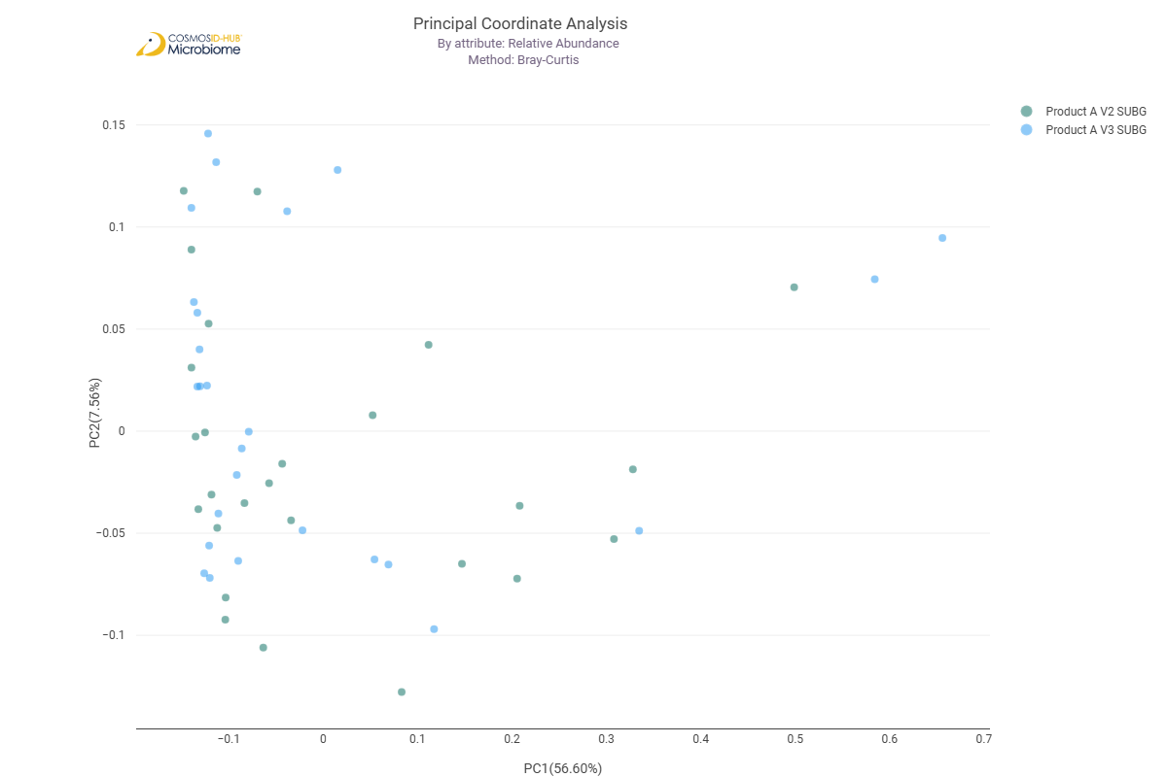

Differential Abundance (LEfSe) (EC)
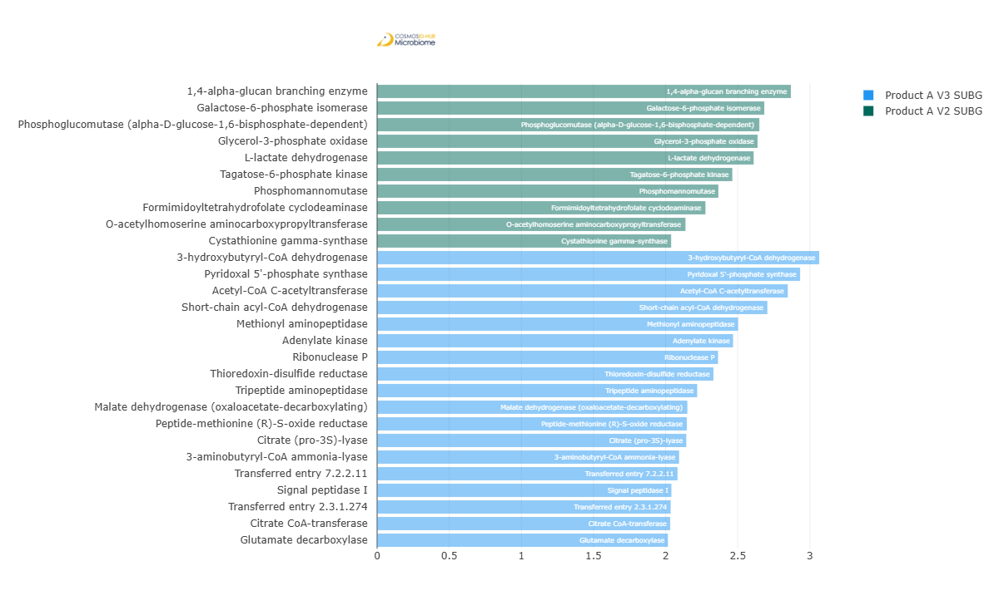
Feature | Enriched Cohort | LDA Score | P-value
1,4-alpha-glucan branching enzyme | Product A V2 SUBG | 2.868316426 | 0.03375904
Galactose-6-phosphate isomerase | Product A V2 SUBG | 2.684149527 | 0.030808261
Phosphoglucomutase (alpha-D-glucose-1,6-bisphosphate-dependent) | Product A V2 SUBG | 2.649842397 | 0.02808172
Glycerol-3-phosphate oxidase | Product A V2 SUBG | 2.637420912 | 0.016509366
L-lactate dehydrogenase | Product A V2 SUBG | 2.610313421 | 0.040390461
Tagatose-6-phosphate kinase | Product A V2 SUBG | 2.462341427 | 0.008404526
Phosphomannomutase | Product A V2 SUBG | 2.365644114 | 0.026798248
Formimidoyltetrahydrofolate cyclodeaminase | Product A V2 SUBG | 2.27631209 | 0.041248997
O-acetylhomoserine aminocarboxypropyltransferase | Product A V2 SUBG | 2.137713911 | 0.004826615
Cystathionine gamma-synthase | Product A V2 SUBG | 2.038346401 | 0.044100855
3-hydroxybutyryl-CoA dehydrogenase | Product A V3 SUBG | 3.064708375 | 0.040390461
Pyridoxal 5'-phosphate synthase | Product A V3 SUBG | 2.932292833 | 0.001450508
Acetyl-CoA C-acetyltransferase | Product A V3 SUBG | 2.846871144 | 0.040390461
Short-chain acyl-CoA dehydrogenase | Product A V3 SUBG | 2.705416934 | 0.023247195
Methionyl aminopeptidase | Product A V3 SUBG | 2.502082155 | 0.03375904
Adenylate kinase | Product A V3 SUBG | 2.467441243 | 4.04E-02
Ribonuclease P | Product A V3 SUBG | 2.363351826 | 0.013486371
Thioredoxin-disulfide reductase | Product A V3 SUBG | 2.331473944 | 0.029417827
Tripeptide aminopeptidase | Product A V3 SUBG | 2.218866344 | 0.008404526
Malate dehydrogenase (oxaloacetate-decarboxylating) | Product A V3 SUBG | 2.150705321 | 0.044100855
Peptide-methionine (R)-S-oxide reductase | Product A V3 SUBG | 2.147252427 | 0.046061451
Citrate (pro-3S)-lyase | Product A V3 SUBG | 2.143123658 | 0.019152346
3-aminobutyryl-CoA ammonia-lyase | Product A V3 SUBG | 2.093593451 | 0.004825711
Transferred entry 7.2.2.11 | Product A V3 SUBG | 2.082564986 | 0.046061451
Signal peptidase I | Product A V3 SUBG | 2.040245909 | 0.036948224
Transferred entry 2.3.1.274 | Product A V3 SUBG | 2.034991023 | 6.05E-03
Citrate CoA-transferase | Product A V3 SUBG | 2.031605498 | 0.036948224
Glutamate decarboxylase | Product A V3 SUBG | 2.016312006 | 0.042211177

MetaCyc Pathways

Alpha Diversity (MetaCyc)
Chao1 | 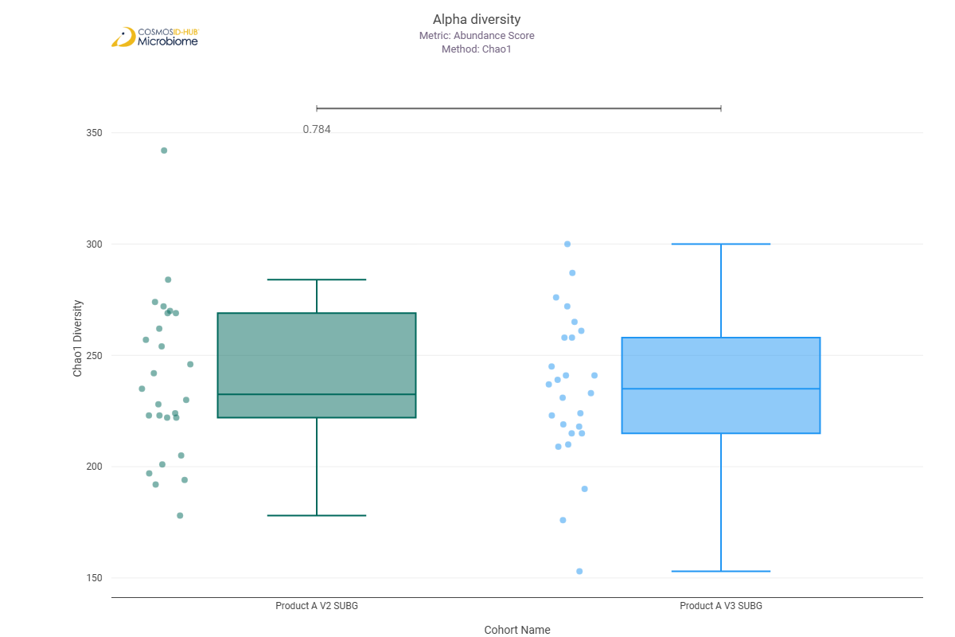
Shannon | 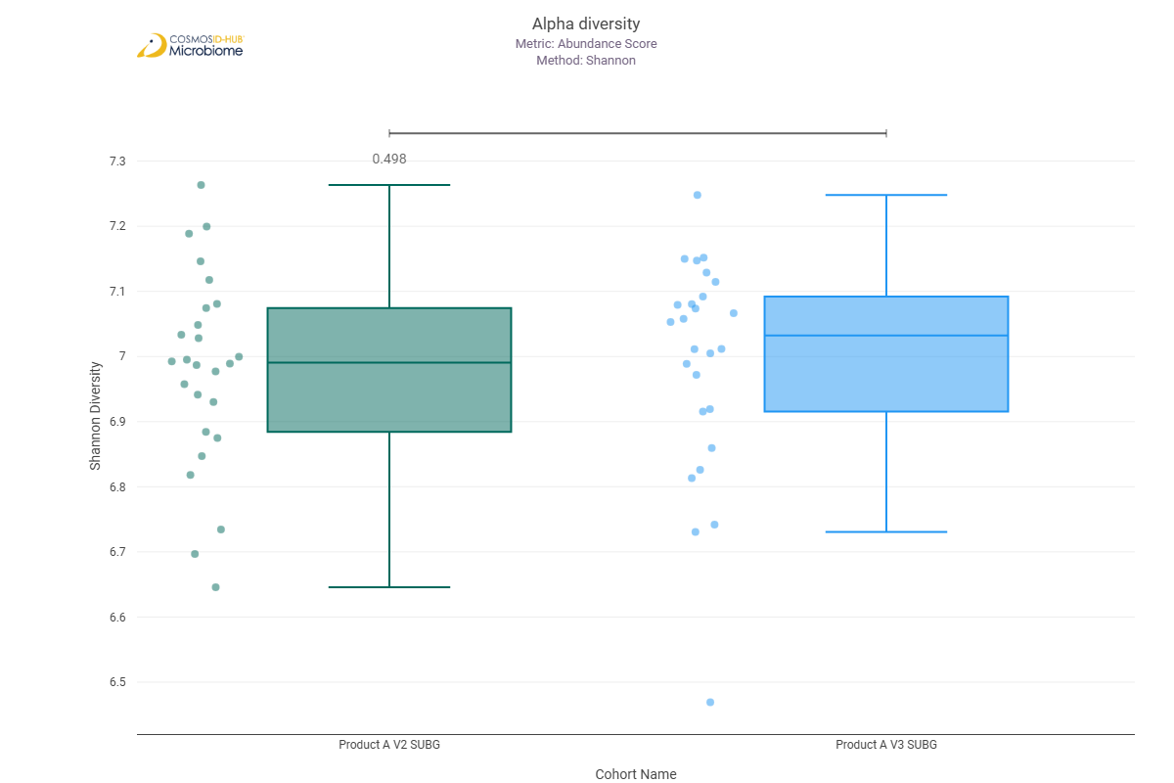
Simpson | 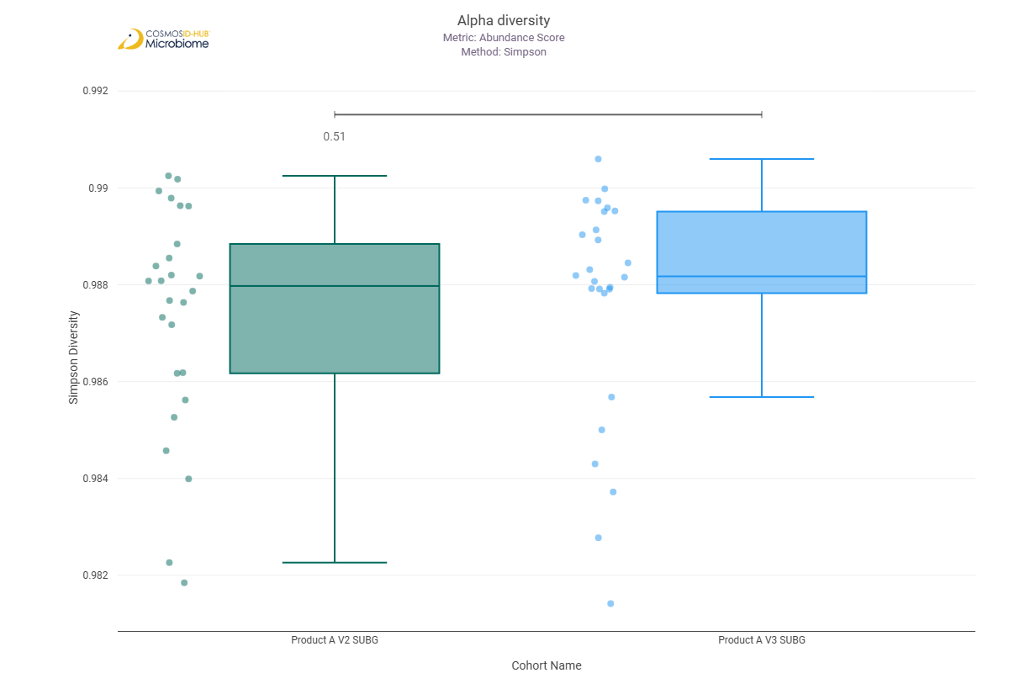

Beta Diversity (MetaCyc)
Bray-Curtis  PERMNOVA p = 0.351 | 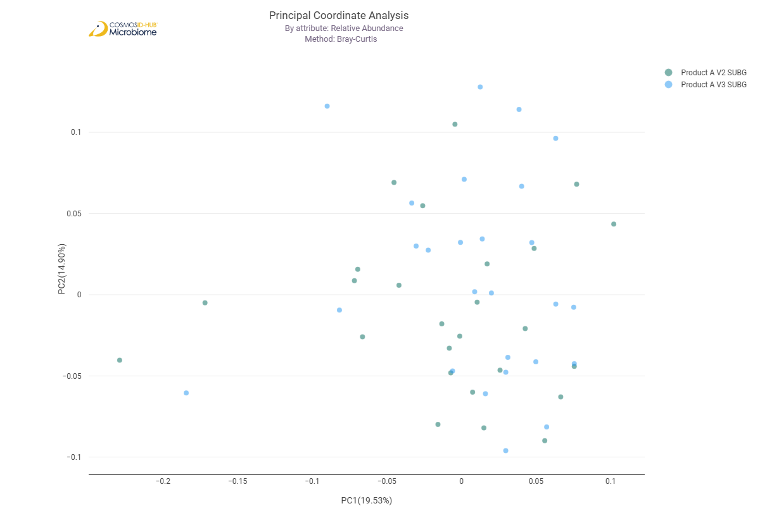

Differential Abundance (LEfSe) (MetaCyc)
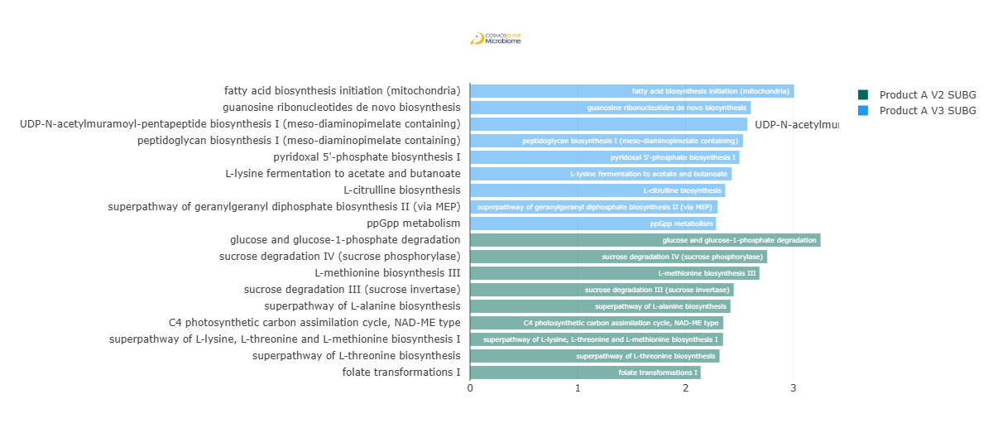
Feature | Enriched Cohort | LDA Score | P-value
fatty acid biosynthesis initiation (mitochondria) | Product A V3 SUBG | 3.005949407 | 0.019152346
guanosine ribonucleotides de novo biosynthesis | Product A V3 SUBG | 2.605116224 | 0.020112035
UDP-N-acetylmuramoyl-pentapeptide biosynthesis I (meso-diaminopimelate containing) | Product A V3 SUBG | 2.572950032 | 0.023247195
peptidoglycan biosynthesis I (meso-diaminopimelate containing) | Product A V3 SUBG | 2.53279651 | 0.032254747
pyridoxal 5'-phosphate biosynthesis I | Product A V3 SUBG | 2.500028395 | 0.048970397
L-lysine fermentation to acetate and butanoate | Product A V3 SUBG | 2.42853662 | 0.025907733
L-citrulline biosynthesis | Product A V3 SUBG | 2.368319134 | 0.011551265
superpathway of geranylgeranyl diphosphate biosynthesis II (via MEP) | Product A V3 SUBG | 2.29634489 | 4.91E-02
ppGpp metabolism | Product A V3 SUBG | 2.281827361 | 0.044100855
glucose and glucose-1-phosphate degradation | Product A V2 SUBG | 3.252312629 | 0.022595697
sucrose degradation IV (sucrose phosphorylase) | Product A V2 SUBG | 2.757431708 | 0.015702531
L-methionine biosynthesis III | Product A V2 SUBG | 2.685167724 | 0.026798248
sucrose degradation III (sucrose invertase) | Product A V2 SUBG | 2.446760597 | 0.019152346
superpathway of L-alanine biosynthesis | Product A V2 SUBG | 2.416704919 | 0.046061451
C4 photosynthetic carbon assimilation cycle, NAD-ME type | Product A V2 SUBG | 2.350104694 | 0.026798248
superpathway of L-lysine, L-threonine and L-methionine biosynthesis I | Product A V2 SUBG | 2.347295262 | 0.013505326
superpathway of L-threonine biosynthesis | Product A V2 SUBG | 2.315420543 | 0.046061451
folate transformations I | Product A V2 SUBG | 2.139570387 | 0.03927407

Comparison 18: Product B V2 SUBG vs Product B V3 SUBG

Gene Ontology

Alpha Diversity (GO)
Chao1 | 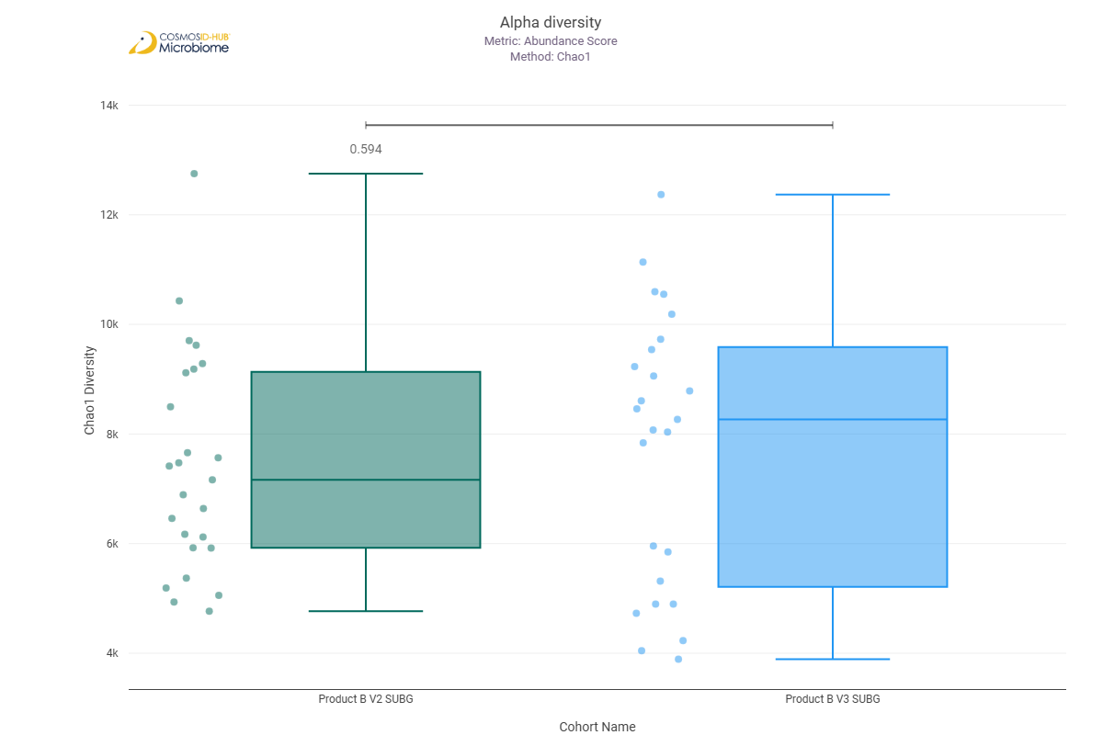
Shannon | 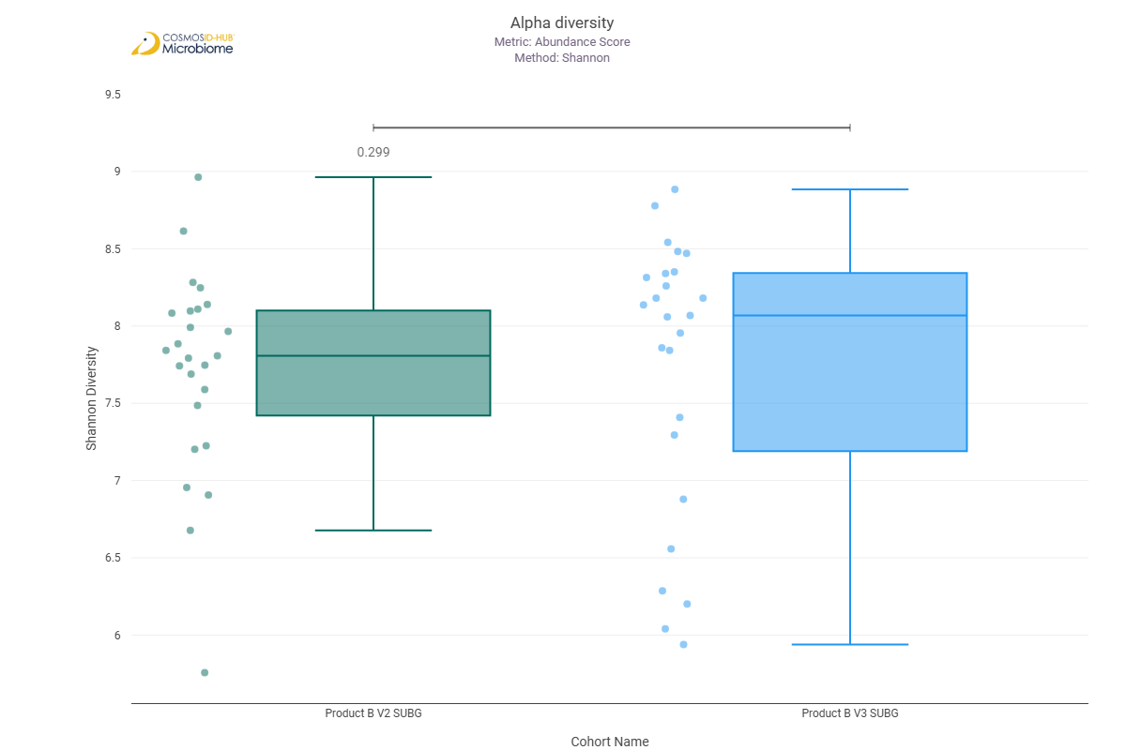
Simpson | 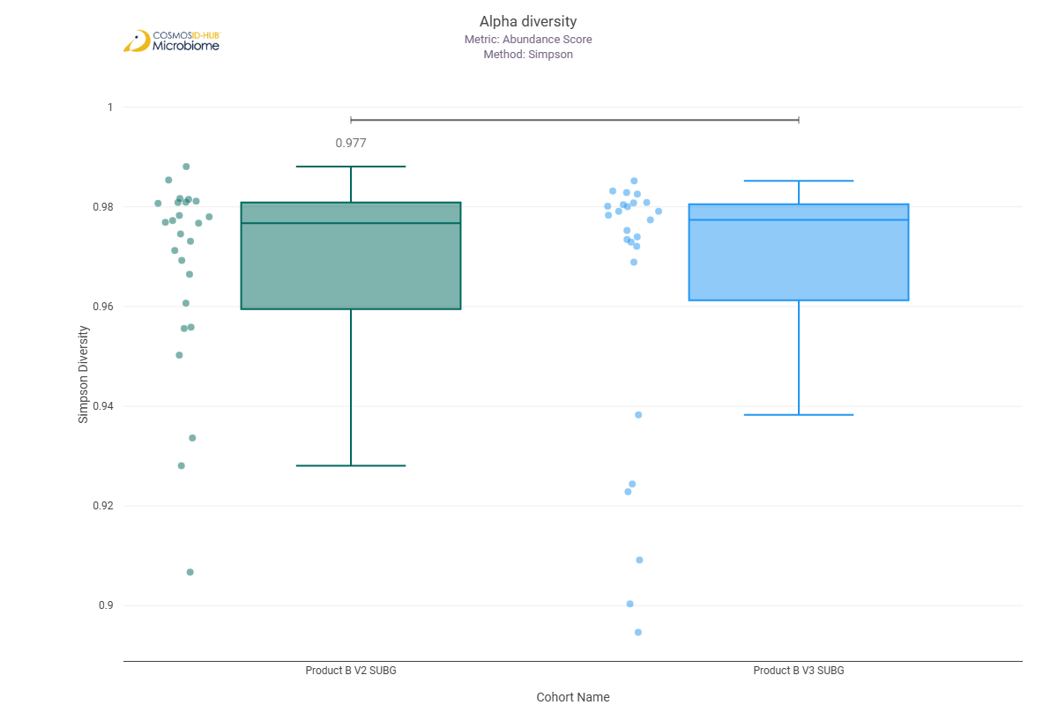

Beta Diversity (GO)
Bray-Curtis  PERMNOVA p = 0.052 | 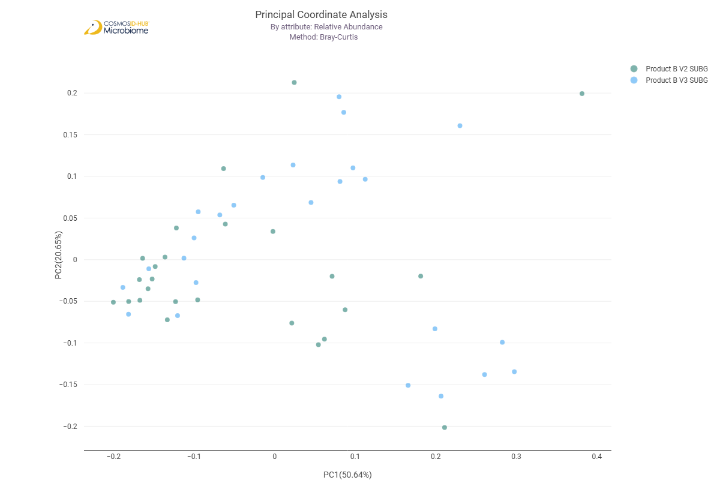

Differential Abundance (LEfSe) (GO)
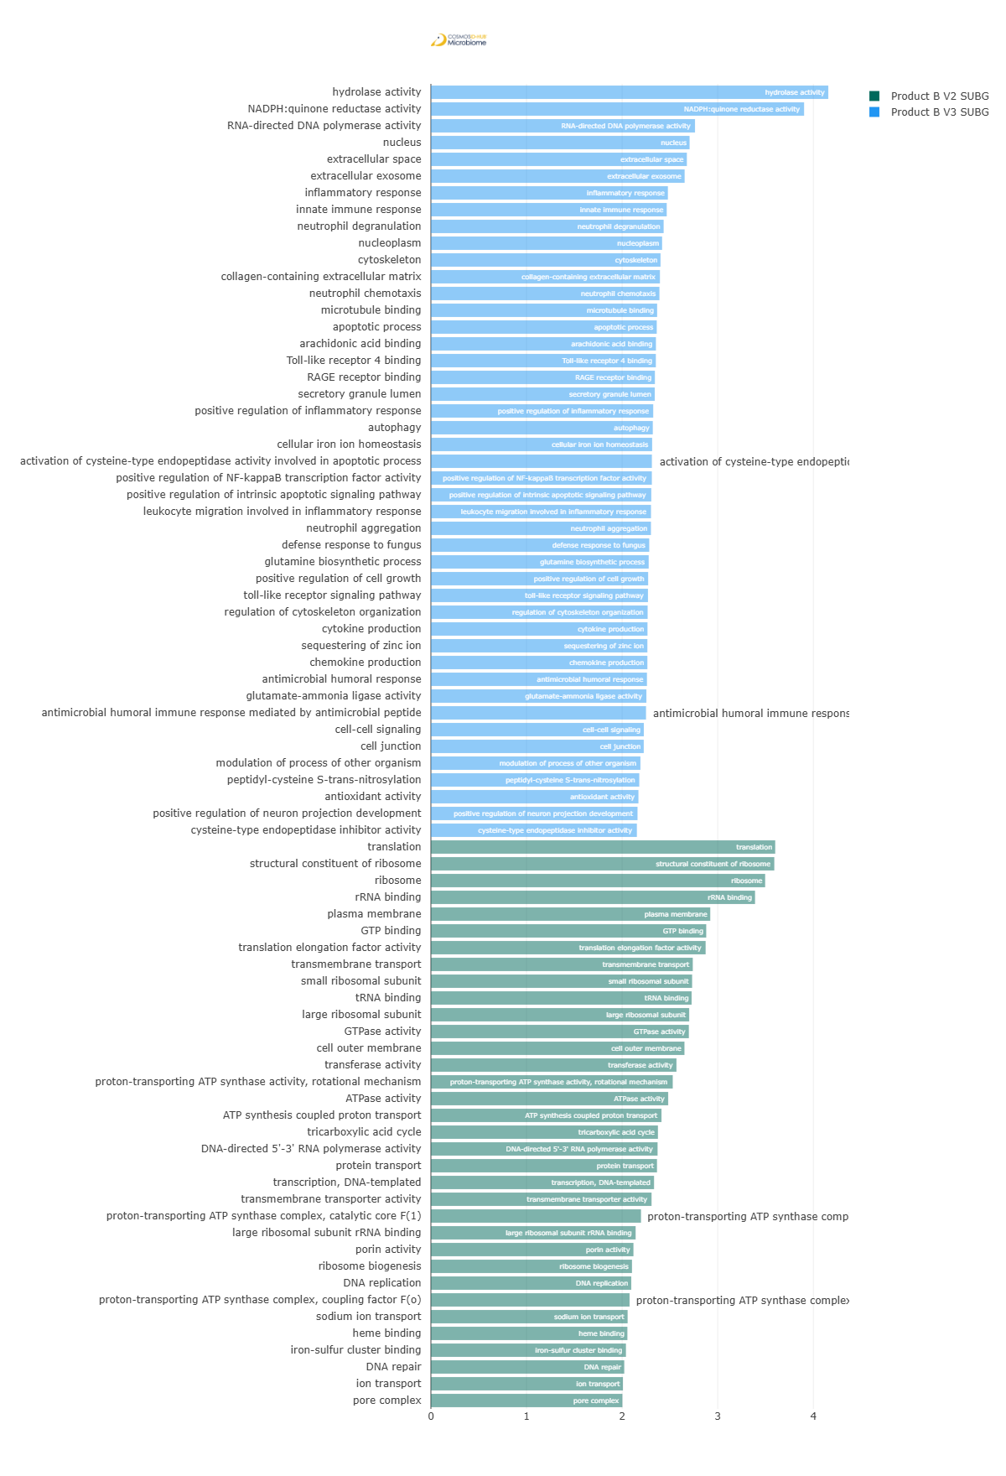
Feature | Enriched Cohort | LDA Score | P-value
hydrolase activity | Product B V3 SUBG | 4.156534105 | 0.046724152
NADPH:quinone reductase activity | Product B V3 SUBG | 3.903411192 | 0.038790393
RNA-directed DNA polymerase activity | Product B V3 SUBG | 2.762516384 | 0.010144117
nucleus | Product B V3 SUBG | 2.705824935 | 0.044622577
extracellular space | Product B V3 SUBG | 2.677161463 | 0.032031691
extracellular exosome | Product B V3 SUBG | 2.654055757 | 0.030509062
inflammatory response | Product B V3 SUBG | 2.479045769 | 0.022617484
innate immune response | Product B V3 SUBG | 2.466561032 | 0.025024185
neutrophil degranulation | Product B V3 SUBG | 2.434546953 | 0.022617484
nucleoplasm | Product B V3 SUBG | 2.418583258 | 1.84E-02
cytoskeleton | Product B V3 SUBG | 2.402056268 | 0.007632882
collagen-containing extracellular matrix | Product B V3 SUBG | 2.395453748 | 0.027649527
neutrophil chemotaxis | Product B V3 SUBG | 2.390410925 | 0.020414533
microtubule binding | Product B V3 SUBG | 2.366393497 | 0.014109615
apoptotic process | Product B V3 SUBG | 2.362287574 | 0.014889416
arachidonic acid binding | Product B V3 SUBG | 2.35381107 | 0.01265739
Toll-like receptor 4 binding | Product B V3 SUBG | 2.352803461 | 0.01265739
RAGE receptor binding | Product B V3 SUBG | 2.342847827 | 0.022617484
secretory granule lumen | Product B V3 SUBG | 2.341644066 | 0.014109615
positive regulation of inflammatory response | Product B V3 SUBG | 2.325368311 | 0.010144117
autophagy | Product B V3 SUBG | 2.321122165 | 0.010144117
cellular iron ion homeostasis | Product B V3 SUBG | 2.314227493 | 0.040658018
activation of cysteine-type endopeptidase activity involved in apoptotic process | Product B V3 SUBG | 2.311541194 | 0.009589776
positive regulation of NF-kappaB transcription factor activity | Product B V3 SUBG | 2.3110923 | 0.01265739
positive regulation of intrinsic apoptotic signaling pathway | Product B V3 SUBG | 2.305115842 | 0.009062607
leukocyte migration involved in inflammatory response | Product B V3 SUBG | 2.302179173 | 0.009062607
neutrophil aggregation | Product B V3 SUBG | 2.301823987 | 0.009062607
defense response to fungus | Product B V3 SUBG | 2.283744629 | 0.009589776
glutamine biosynthetic process | Product B V3 SUBG | 2.27825556 | 0.014889416
positive regulation of cell growth | Product B V3 SUBG | 2.272313134 | 0.009589776
toll-like receptor signaling pathway | Product B V3 SUBG | 2.270650056 | 0.009062607
regulation of cytoskeleton organization | Product B V3 SUBG | 2.267159509 | 0.010144117
cytokine production | Product B V3 SUBG | 2.265455874 | 0.009589776
sequestering of zinc ion | Product B V3 SUBG | 2.264105441 | 0.009062607
chemokine production | Product B V3 SUBG | 2.264080101 | 0.009062607
antimicrobial humoral response | Product B V3 SUBG | 2.260004794 | 0.027649527
glutamate-ammonia ligase activity | Product B V3 SUBG | 2.253778074 | 0.019384996
antimicrobial humoral immune response mediated by antimicrobial peptide | Product B V3 SUBG | 2.25017464 | 0.017461229
cell-cell signaling | Product B V3 SUBG | 2.227194438 | 0.011339073
cell junction | Product B V3 SUBG | 2.226507863 | 0.01336608
modulation of process of other organism | Product B V3 SUBG | 2.191713031 | 0.007632882
peptidyl-cysteine S-trans-nitrosylation | Product B V3 SUBG | 2.179649634 | 0.00640875
antioxidant activity | Product B V3 SUBG | 2.170911949 | 0.003722992
positive regulation of neuron projection development | Product B V3 SUBG | 2.161135069 | 0.007203336
cysteine-type endopeptidase inhibitor activity | Product B V3 SUBG | 2.154679366 | 0.042601311
translation | Product B V2 SUBG | 3.601581062 | 0.010726809
structural constituent of ribosome | Product B V2 SUBG | 3.592047496 | 0.011339073
ribosome | Product B V2 SUBG | 3.496305651 | 0.005051804
rRNA binding | Product B V2 SUBG | 3.390564483 | 0.018401118
plasma membrane | Product B V2 SUBG | 2.921973878 | 0.042601311
GTP binding | Product B V2 SUBG | 2.880037294 | 1.84E-02
translation elongation factor activity | Product B V2 SUBG | 2.873885039 | 0.01336608
transmembrane transport | Product B V2 SUBG | 2.73919936 | 0.01265739
small ribosomal subunit | Product B V2 SUBG | 2.732488352 | 0.010726809
tRNA binding | Product B V2 SUBG | 2.727081355 | 0.044622577
large ribosomal subunit | Product B V2 SUBG | 2.701633795 | 0.006041816
GTPase activity | Product B V2 SUBG | 2.698296247 | 0.023794451
cell outer membrane | Product B V2 SUBG | 2.652317031 | 0.027649527
transferase activity | Product B V2 SUBG | 2.568598356 | 0.048908406
proton-transporting ATP synthase activity, rotational mechanism | Product B V2 SUBG | 2.529987281 | 0.009062607
ATPase activity | Product B V2 SUBG | 2.482085992 | 0.048908406
ATP synthesis coupled proton transport | Product B V2 SUBG | 2.411899998 | 0.006041816
tricarboxylic acid cycle | Product B V2 SUBG | 2.375045571 | 0.000148684
DNA-directed 5'-3' RNA polymerase activity | Product B V2 SUBG | 2.371051842 | 0.003287086
protein transport | Product B V2 SUBG | 2.365132113 | 0.030509062
transcription, DNA-templated | Product B V2 SUBG | 2.334049907 | 0.005364191
transmembrane transporter activity | Product B V2 SUBG | 2.307915949 | 0.030509062
proton-transporting ATP synthase complex, catalytic core F(1) | Product B V2 SUBG | 2.197913979 | 0.01265739
large ribosomal subunit rRNA binding | Product B V2 SUBG | 2.141433642 | 0.030509062
porin activity | Product B V2 SUBG | 2.118878001 | 9.24207E-05
ribosome biogenesis | Product B V2 SUBG | 2.103632447 | 0.022617484
DNA replication | Product B V2 SUBG | 2.095886808 | 0.046724152
proton-transporting ATP synthase complex, coupling factor F(o) | Product B V2 SUBG | 2.078331122 | 0.011982167
sodium ion transport | Product B V2 SUBG | 2.057929399 | 0.001616222
heme binding | Product B V2 SUBG | 2.055269007 | 0.001321949
iron-sulfur cluster binding | Product B V2 SUBG | 2.040464006 | 0.044622577
DNA repair | Product B V2 SUBG | 2.022758739 | 0.032031691
ion transport | Product B V2 SUBG | 2.008697679 | 8.52725E-05
pore complex | Product B V2 SUBG | 2.003123056 | 0.000160745

Enzyme Commission

Alpha Diversity (EC)
Chao1 | 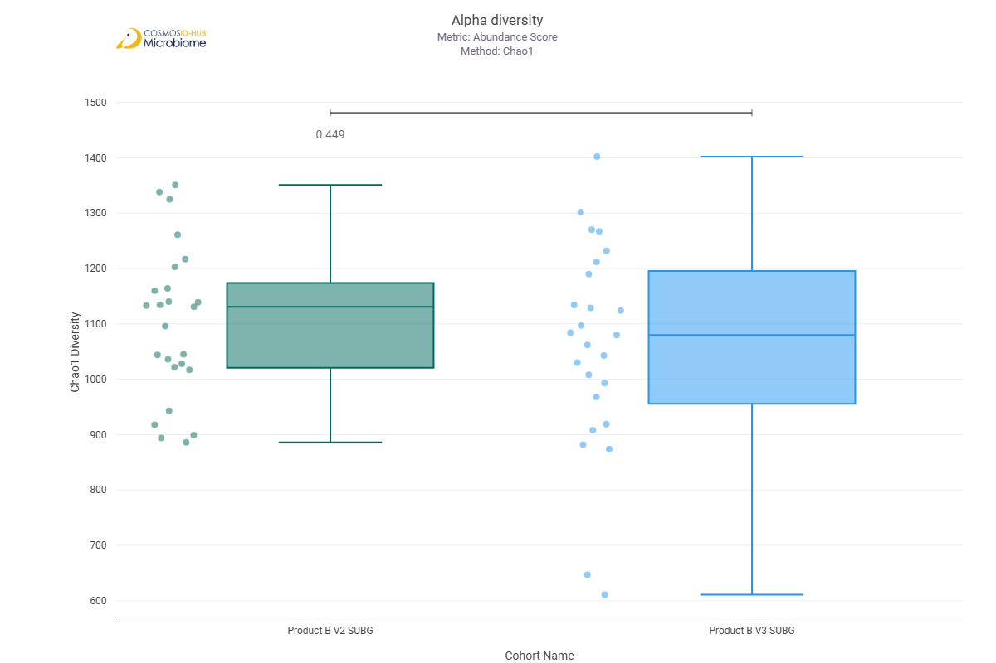
Shannon | 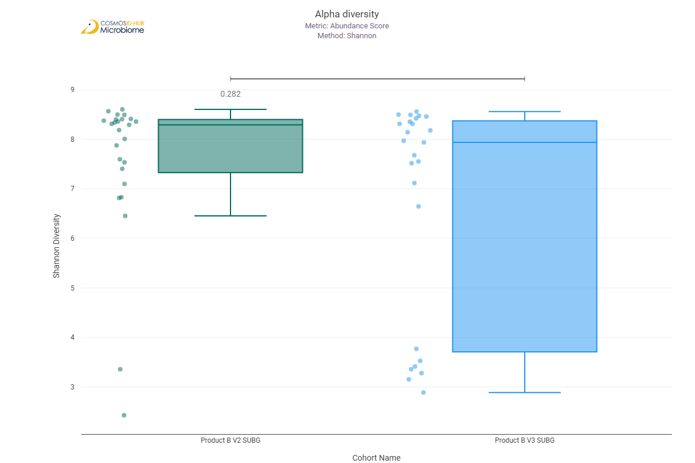
Simpson | 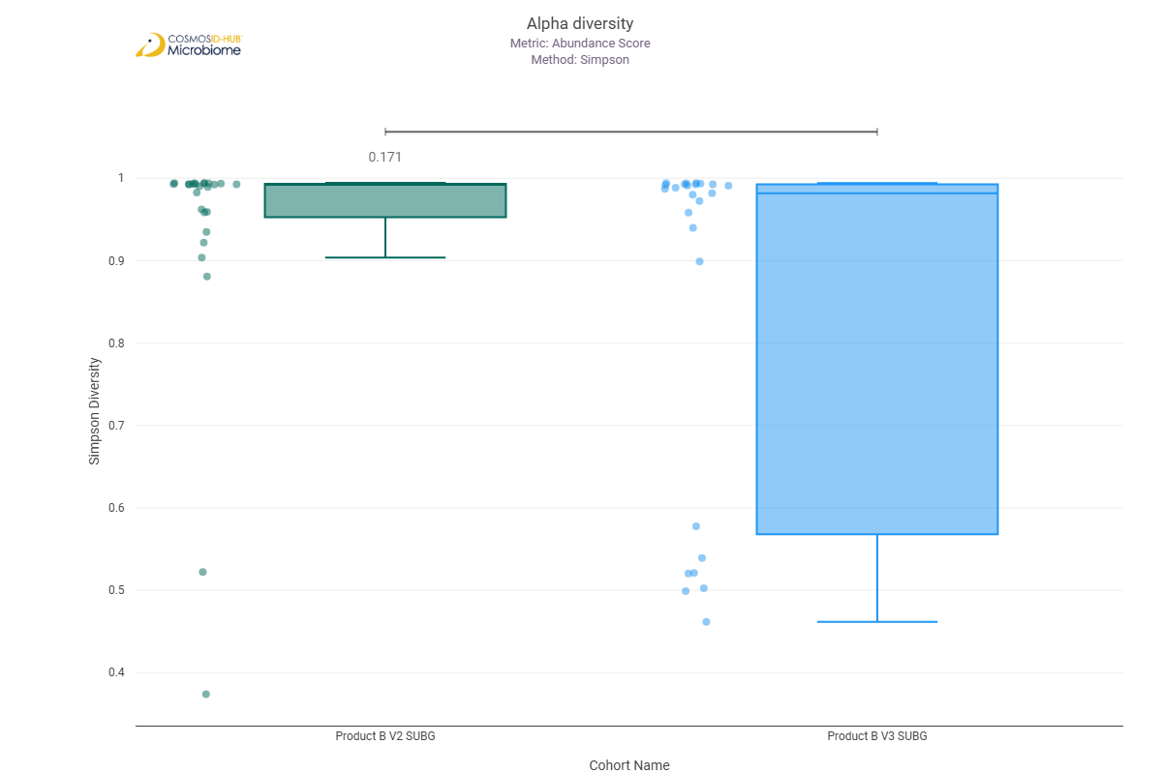

Beta Diversity (EC)
Bray-Curtis  PERMNOVA p = 0.093 | 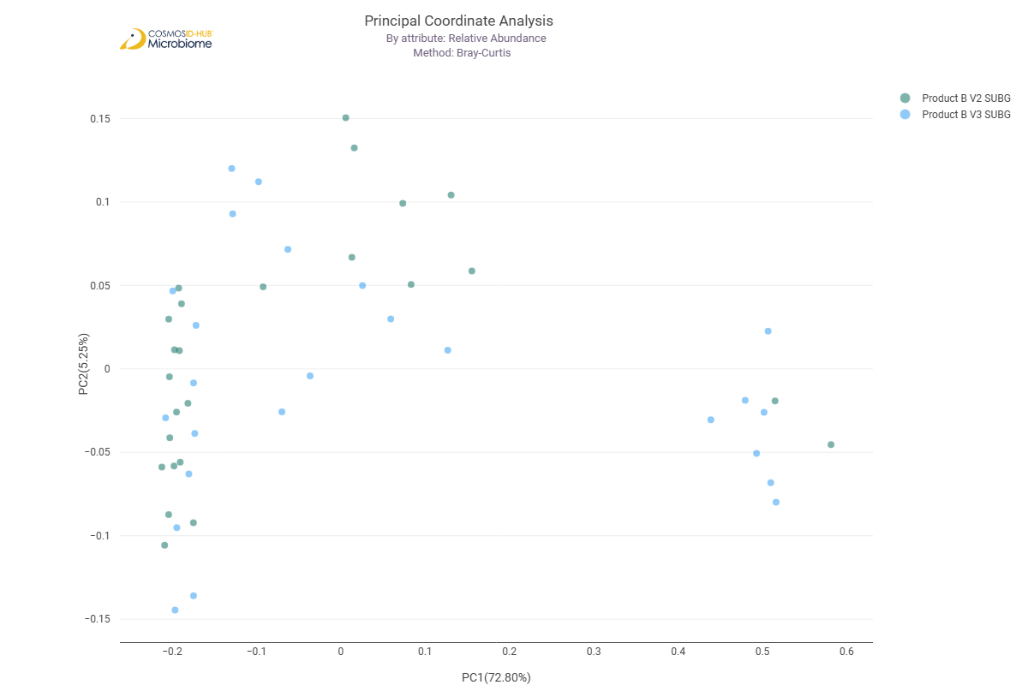

Differential Abundance (LEfSe) (EC)
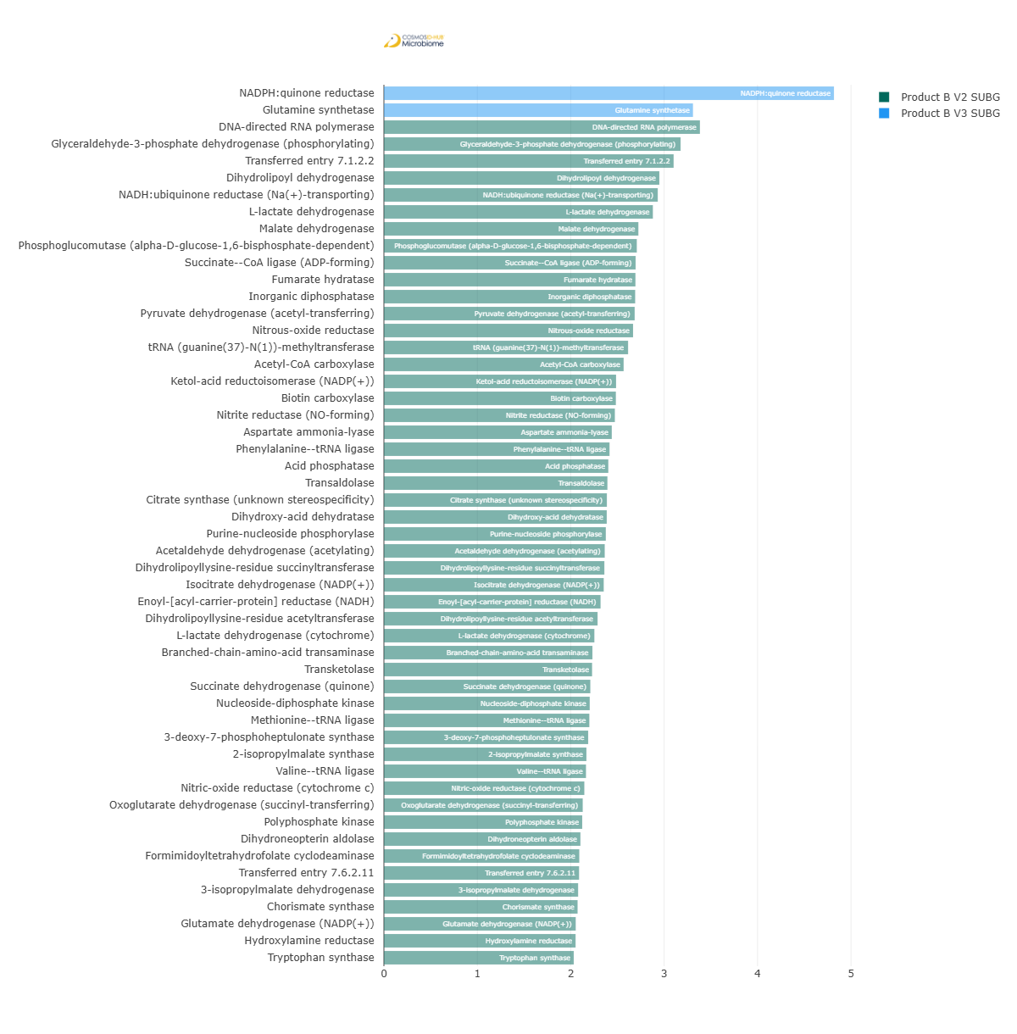
Feature | Enriched Cohort | LDA Score | P-value
NADPH:quinone reductase | Product B V3 SUBG | 4.817843052 | 0.032031691
Glutamine synthetase | Product B V3 SUBG | 3.308540704 | 0.022617484
DNA-directed RNA polymerase | Product B V2 SUBG | 3.383240925 | 0.019384996
Glyceraldehyde-3-phosphate dehydrogenase (phosphorylating) | Product B V2 SUBG | 3.176211311 | 0.025024185
Transferred entry 7.1.2.2 | Product B V2 SUBG | 3.10148784 | 0.004210827
Dihydrolipoyl dehydrogenase | Product B V2 SUBG | 2.948469076 | 5.22129E-05
NADH:ubiquinone reductase (Na(+)-transporting) | Product B V2 SUBG | 2.931691645 | 0.004210827
L-lactate dehydrogenase | Product B V2 SUBG | 2.879235232 | 0.048908406
Malate dehydrogenase | Product B V2 SUBG | 2.724100617 | 0.005051804
Phosphoglucomutase (alpha-D-glucose-1,6-bisphosphate-dependent) | Product B V2 SUBG | 2.707465232 | 1.27E-02
Succinate--CoA ligase (ADP-forming) | Product B V2 SUBG | 2.694617006 | 0.023794451
Fumarate hydratase | Product B V2 SUBG | 2.692816588 | 0.000160745
Inorganic diphosphatase | Product B V2 SUBG | 2.690026587 | 0.003960093
Pyruvate dehydrogenase (acetyl-transferring) | Product B V2 SUBG | 2.684685914 | 0.000187679
Nitrous-oxide reductase | Product B V2 SUBG | 2.667384781 | 0.018884597
tRNA (guanine(37)-N(1))-methyltransferase | Product B V2 SUBG | 2.613982445 | 0.005364191
Acetyl-CoA carboxylase | Product B V2 SUBG | 2.566500044 | 0.027649527
Ketol-acid reductoisomerase (NADP(+)) | Product B V2 SUBG | 2.485521905 | 0.046724152
Biotin carboxylase | Product B V2 SUBG | 2.483332615 | 0.014889416
Nitrite reductase (NO-forming) | Product B V2 SUBG | 2.47269739 | 0.005363085
Aspartate ammonia-lyase | Product B V2 SUBG | 2.439522177 | 0.006795613
Phenylalanine--tRNA ligase | Product B V2 SUBG | 2.415369545 | 0.030509062
Acid phosphatase | Product B V2 SUBG | 2.402431779 | 0.003087046
Transaldolase | Product B V2 SUBG | 2.392902202 | 0.007203336
Citrate synthase (unknown stereospecificity) | Product B V2 SUBG | 2.38705336 | 0.003087046
Dihydroxy-acid dehydratase | Product B V2 SUBG | 2.385655877 | 0.023794451
Purine-nucleoside phosphorylase | Product B V2 SUBG | 2.375667367 | 0.040658018
Acetaldehyde dehydrogenase (acetylating) | Product B V2 SUBG | 2.364135485 | 0.033618995
Dihydrolipoyllysine-residue succinyltransferase | Product B V2 SUBG | 2.360073425 | 0.002719251
Isocitrate dehydrogenase (NADP(+)) | Product B V2 SUBG | 2.353143276 | 0.001152876
Enoyl-[acyl-carrier-protein] reductase (NADH) | Product B V2 SUBG | 2.319528322 | 0.008561466
Dihydrolipoyllysine-residue acetyltransferase | Product B V2 SUBG | 2.287414831 | 0.000319162
L-lactate dehydrogenase (cytochrome) | Product B V2 SUBG | 2.253134982 | 5.67117E-05
Branched-chain-amino-acid transaminase | Product B V2 SUBG | 2.232227272 | 0.036996166
Transketolase | Product B V2 SUBG | 2.228748237 | 0.046724152
Succinate dehydrogenase (quinone) | Product B V2 SUBG | 2.209898248 | 0.033618995
Nucleoside-diphosphate kinase | Product B V2 SUBG | 2.203567512 | 0.026308569
Methionine--tRNA ligase | Product B V2 SUBG | 2.199231134 | 0.033618995
3-deoxy-7-phosphoheptulonate synthase | Product B V2 SUBG | 2.186770799 | 0.032031691
2-isopropylmalate synthase | Product B V2 SUBG | 2.168032589 | 0.016563699
Valine--tRNA ligase | Product B V2 SUBG | 2.16348786 | 0.046724152
Nitric-oxide reductase (cytochrome c) | Product B V2 SUBG | 2.145805026 | 0.002884661
Oxoglutarate dehydrogenase (succinyl-transferring) | Product B V2 SUBG | 2.12864016 | 0.000614953
Polyphosphate kinase | Product B V2 SUBG | 2.122994623 | 0.001512023
Dihydroneopterin aldolase | Product B V2 SUBG | 2.103839331 | 0.01336608
Formimidoyltetrahydrofolate cyclodeaminase | Product B V2 SUBG | 2.091690116 | 0.044622577
Transferred entry 7.6.2.11 | Product B V2 SUBG | 2.089287505 | 0.010726809
3-isopropylmalate dehydrogenase | Product B V2 SUBG | 2.079230739 | 0.008085247
Chorismate synthase | Product B V2 SUBG | 2.073624143 | 0.01265739
Glutamate dehydrogenase (NADP(+)) | Product B V2 SUBG | 2.053517587 | 0.010144117
Hydroxylamine reductase | Product B V2 SUBG | 2.052101267 | 3.70E-02
Tryptophan synthase | Product B V2 SUBG | 2.032594664 | 0.036996166

MetaCyc Pathway

Alpha Diversity (MetaCyc)
Chao1 | 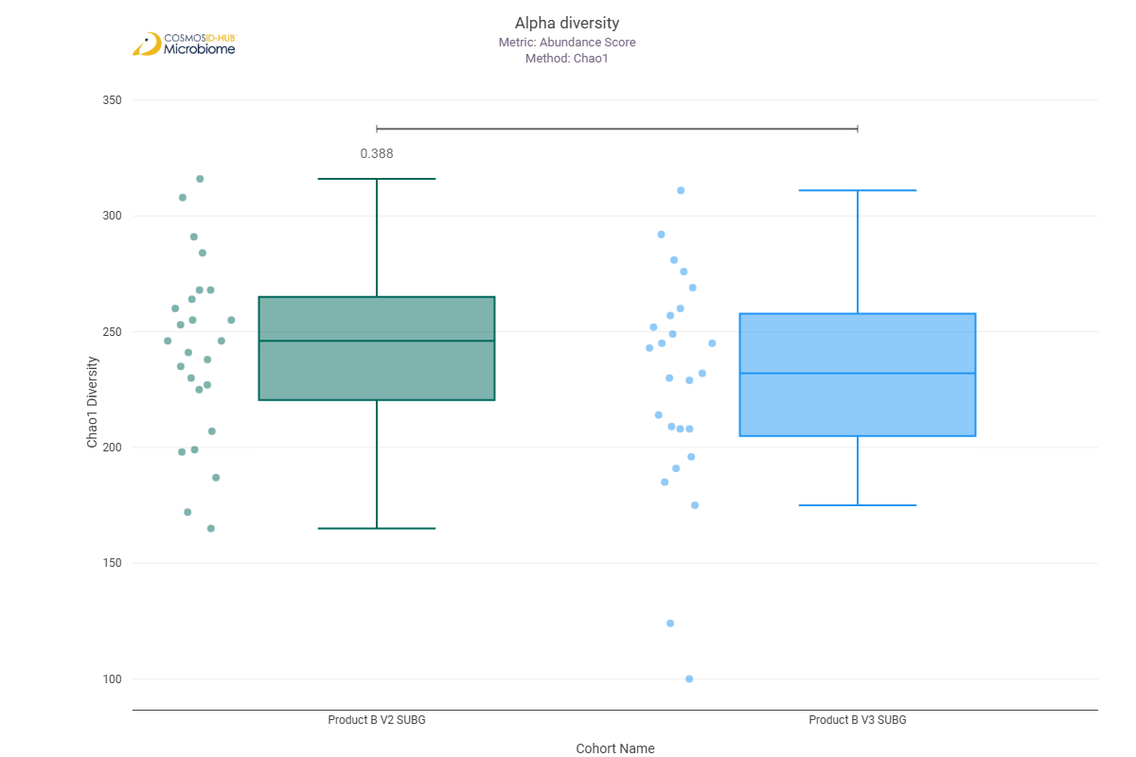
Shannon | 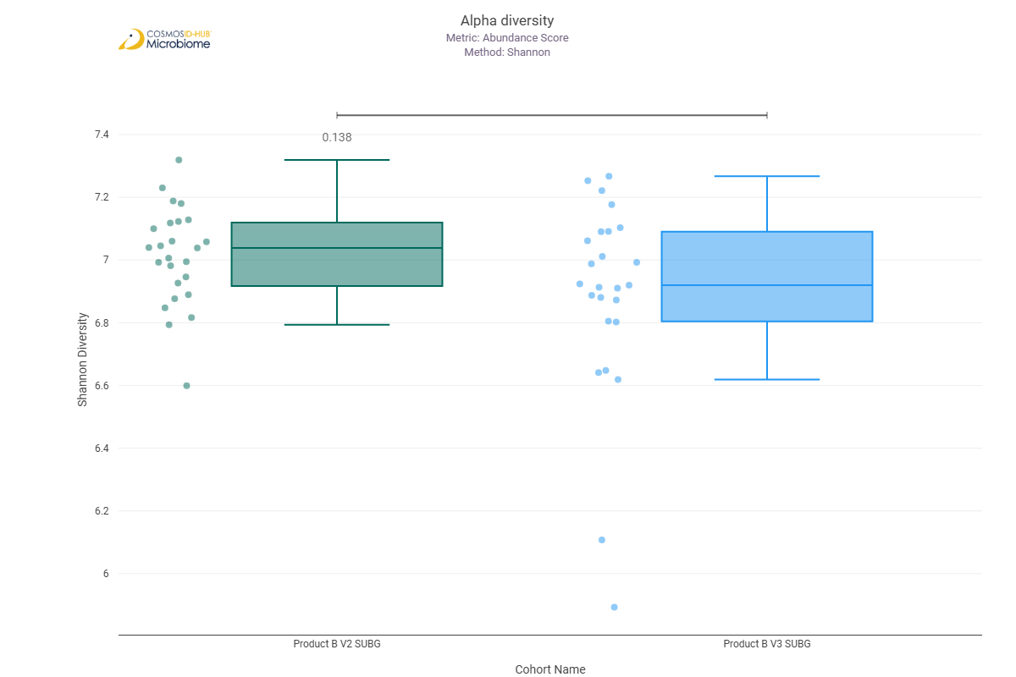
Simpson | 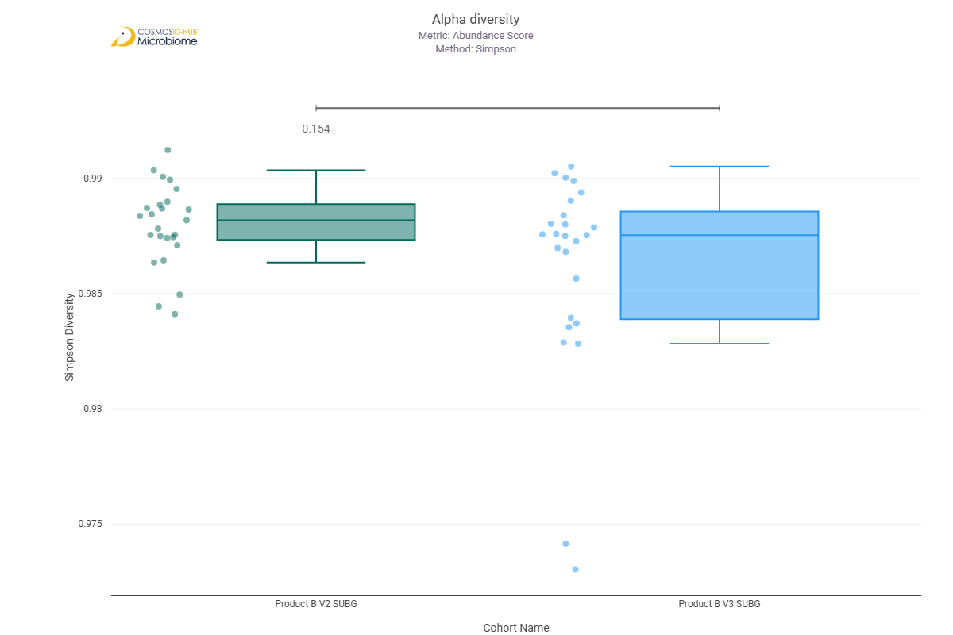

Beta Diversity (MetaCyc)
Bray-Curtis  PERMNOVA p = 0.107 | 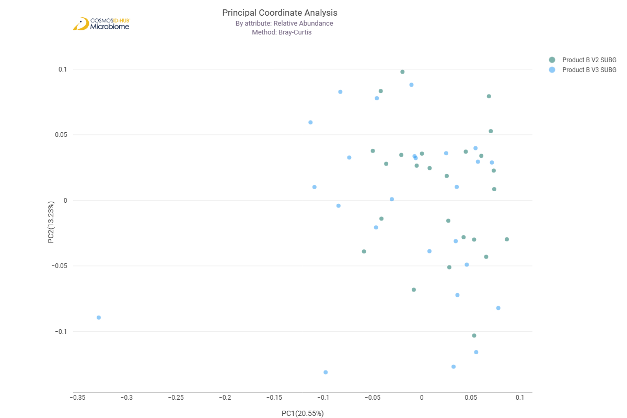

Differential Abundance (LEfSe) (MetaCyc)
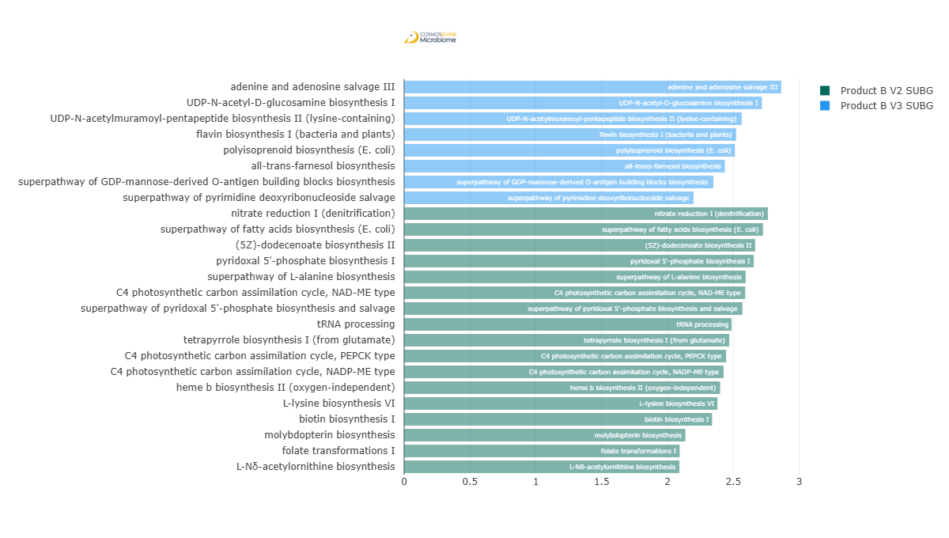
Feature | Enriched Cohort | LDA Score | P-value
adenine and adenosine salvage III | Product B V3 SUBG | 2.863969812 | 0.048908406
UDP-N-acetyl-D-glucosamine biosynthesis I | Product B V3 SUBG | 2.717396176 | 0.036996166
UDP-N-acetylmuramoyl-pentapeptide biosynthesis II (lysine-containing) | Product B V3 SUBG | 2.564005299 | 2.15E-02
flavin biosynthesis I (bacteria and plants) | Product B V3 SUBG | 2.521691982 | 0.021478913
polyisoprenoid biosynthesis (E. coli) | Product B V3 SUBG | 2.511972274 | 0.009321172
all-trans-farnesol biosynthesis | Product B V3 SUBG | 2.435974793 | 0.009321172
superpathway of GDP-mannose-derived O-antigen building blocks biosynthesis | Product B V3 SUBG | 2.348650203 | 0.007288006
superpathway of pyrimidine deoxyribonucleoside salvage | Product B V3 SUBG | 2.198461861 | 0.042804512
nitrate reduction I (denitrification) | Product B V2 SUBG | 2.76268097 | 0.028209048
superpathway of fatty acids biosynthesis (E. coli) | Product B V2 SUBG | 2.725110183 | 0.015664854
(5Z)-dodecenoate biosynthesis II | Product B V2 SUBG | 2.666038782 | 0.000376802
pyridoxal 5'-phosphate biosynthesis I | Product B V2 SUBG | 2.655506221 | 0.007401096
superpathway of L-alanine biosynthesis | Product B V2 SUBG | 2.593947019 | 0.001489919
C4 photosynthetic carbon assimilation cycle, NAD-ME type | Product B V2 SUBG | 2.590401904 | 0.000990491
superpathway of pyridoxal 5'-phosphate biosynthesis and salvage | Product B V2 SUBG | 2.56884596 | 0.002984314
tRNA processing | Product B V2 SUBG | 2.486859617 | 0.000545225
tetrapyrrole biosynthesis I (from glutamate) | Product B V2 SUBG | 2.469081125 | 0.026304962
C4 photosynthetic carbon assimilation cycle, PEPCK type | Product B V2 SUBG | 2.445053069 | 0.044617455
C4 photosynthetic carbon assimilation cycle, NADP-ME type | Product B V2 SUBG | 2.426092745 | 0.018401118
heme b biosynthesis II (oxygen-independent) | Product B V2 SUBG | 2.399730809 | 0.011910559
L-lysine biosynthesis VI | Product B V2 SUBG | 2.379651672 | 0.046703062
biotin biosynthesis I | Product B V2 SUBG | 2.338785942 | 0.02096431
molybdopterin biosynthesis | Product B V2 SUBG | 2.136102637 | 0.02751897
folate transformations I | Product B V2 SUBG | 2.092205713 | 0.011137717
L-Nδ-acetylornithine biosynthesis | Product B V2 SUBG | 2.090649307 | 0.006724272

Comparison 19: Product A V2 SUBG vs Product B V2 SUBG

Gene Ontology

Alpha Diversity (GO)
Chao1 | 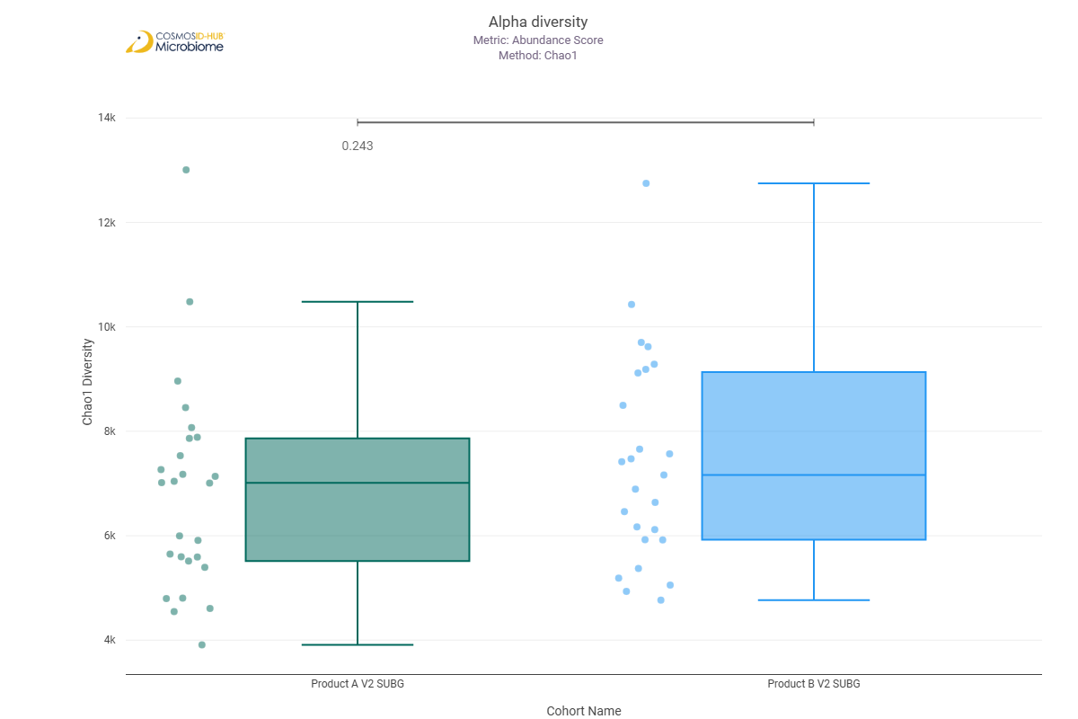
Shannon | 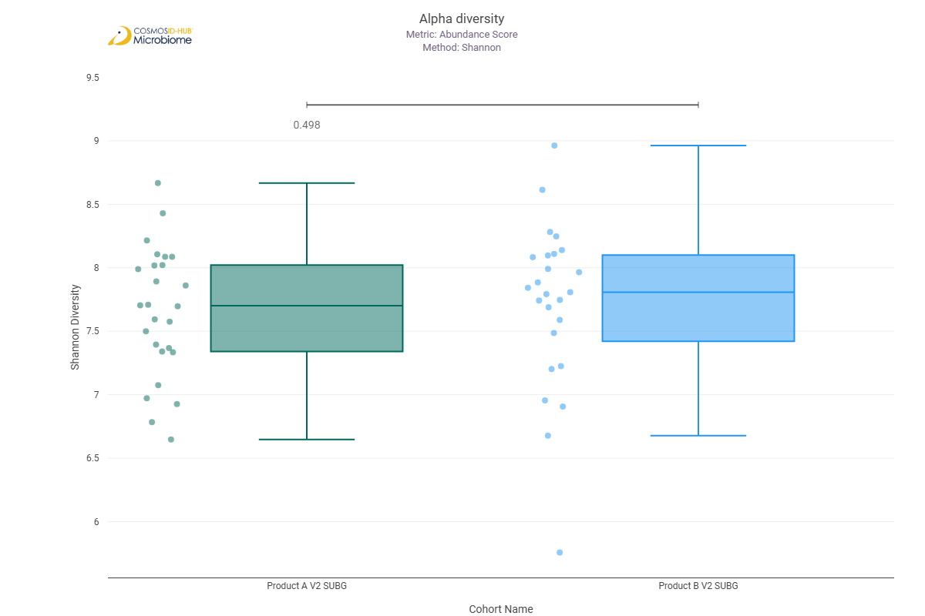
Simpson | 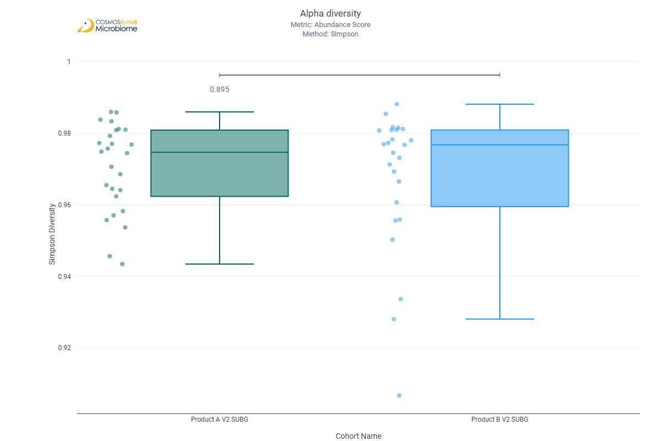

Beta Diversity (GO)
Bray-Curtis  PERMNOVA p = 0.224 | 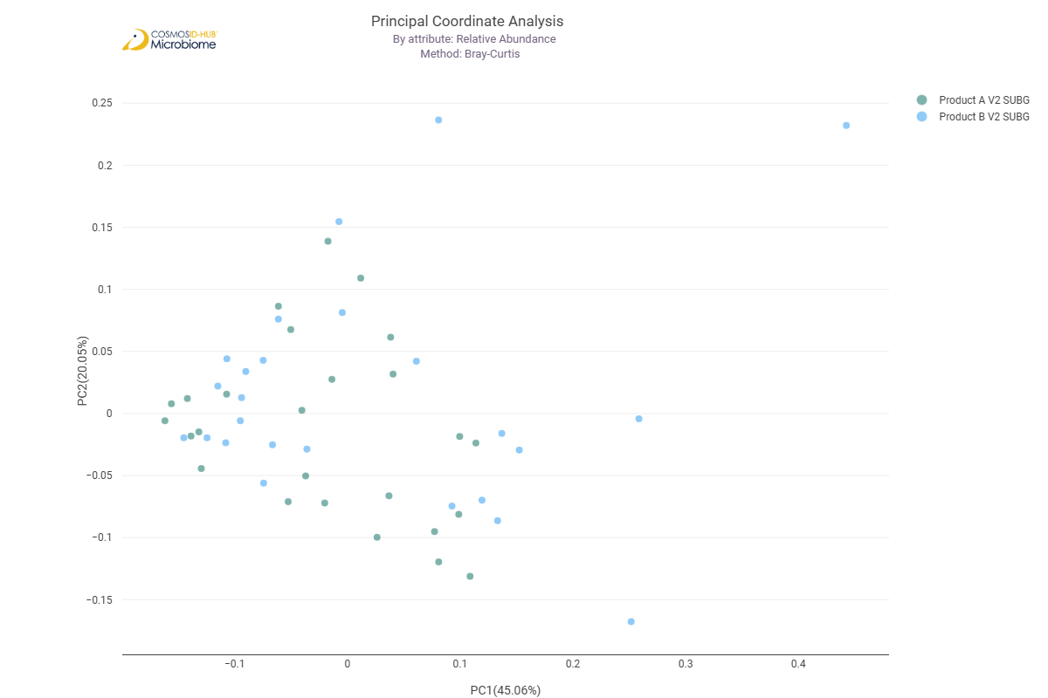

Differential Abundance (LEfSe) (GO)
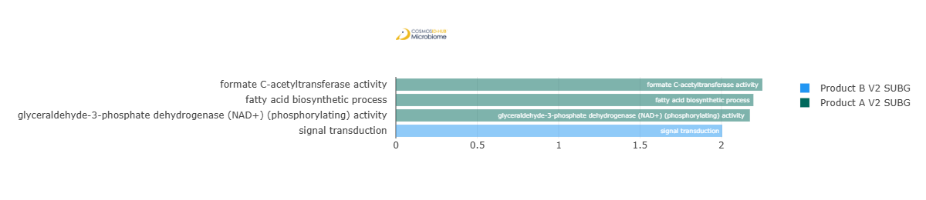
Feature | Enriched Cohort | LDA Score | P-value
formate C-acetyltransferase activity | Product A V2 SUBG | 2.251730741 | 0.02494682
fatty acid biosynthetic process | Product A V2 SUBG | 2.196641523 | 0.016712924
glyceraldehyde-3-phosphate dehydrogenase (NAD+) (phosphorylating) activity | Product A V2 SUBG | 2.175052685 | 1.36E-02
signal transduction | Product B V2 SUBG | 2.005231571 | 0.045795182

Enzyme Commission

Alpha Diversity (EC)
Chao1 | 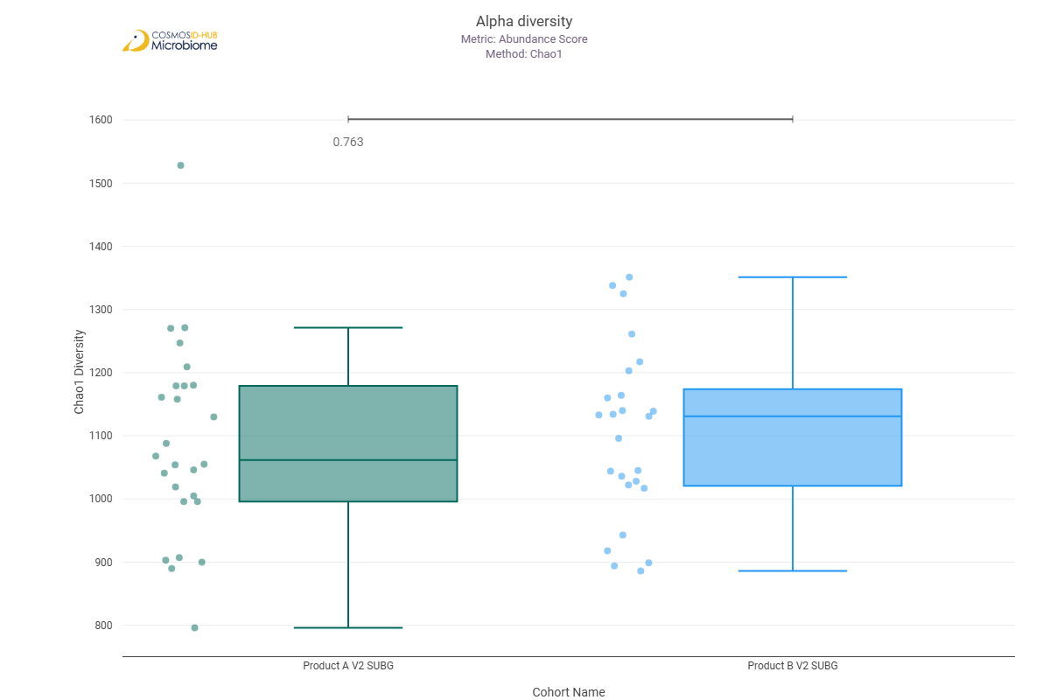
Shannon | 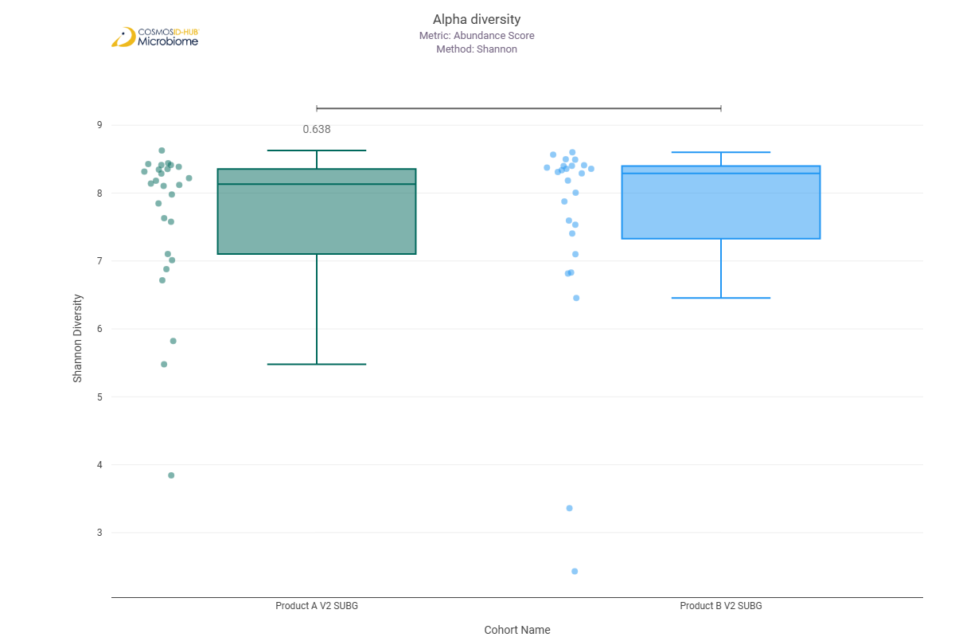
Simpson | 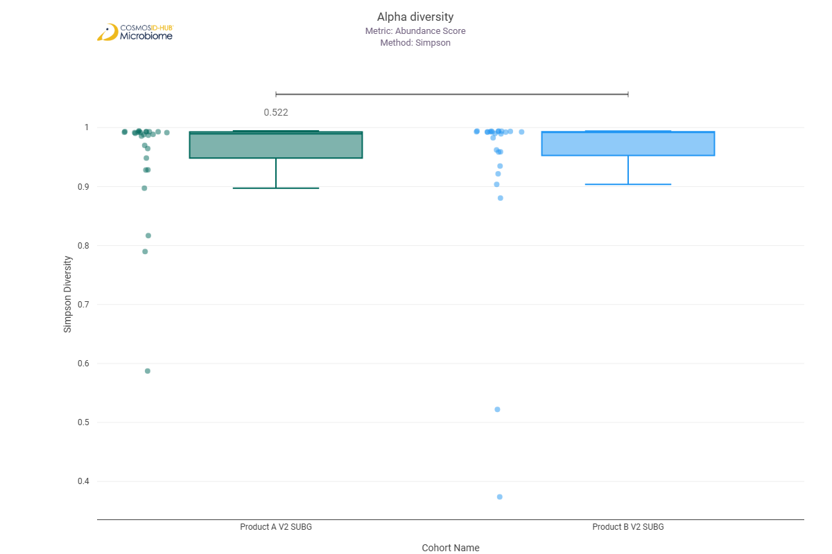

Beta Diversity (EC)
Bray-Curtis  PERMNOVA p = 0.594 | 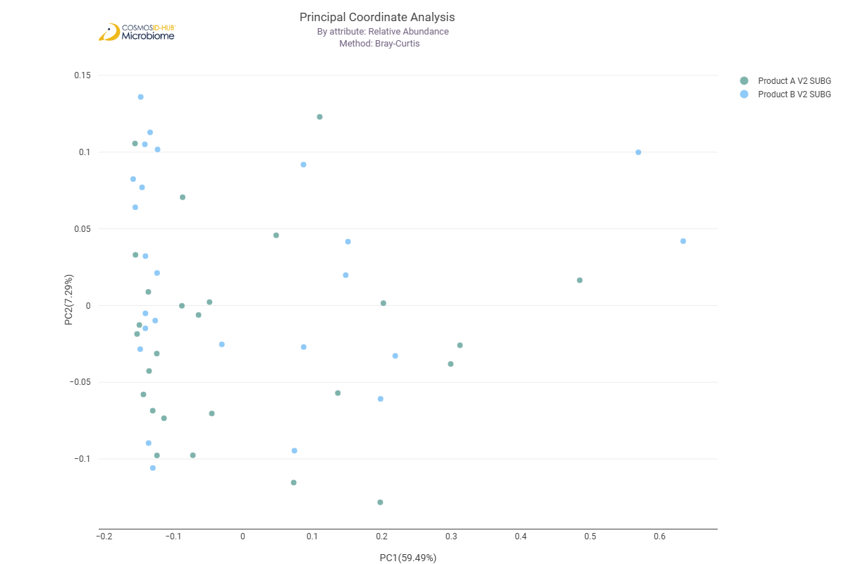

Differential Abundance (LEfSe) (EC)
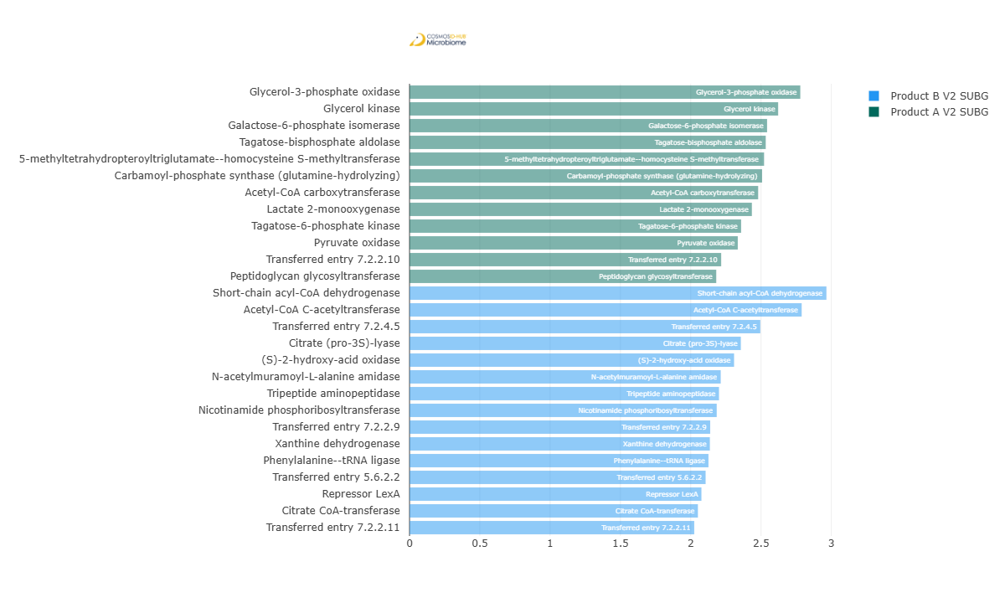
Feature | Enriched Cohort | LDA Score | P-value
Glycerol-3-phosphate oxidase | Product A V2 SUBG | 2.779339307 | 7.46E-03
Glycerol kinase | Product A V2 SUBG | 2.621793949 | 0.047879765
Galactose-6-phosphate isomerase | Product A V2 SUBG | 2.543170681 | 0.033240045
Tagatose-bisphosphate aldolase | Product A V2 SUBG | 2.53337838 | 0.02375508
5-methyltetrahydropteroyltriglutamate--homocysteine S-methyltransferase | Product A V2 SUBG | 2.521588181 | 0.038205314
Carbamoyl-phosphate synthase (glutamine-hydrolyzing) | Product A V2 SUBG | 2.507544424 | 0.026189985
Acetyl-CoA carboxytransferase | Product A V2 SUBG | 2.47958498 | 0.033240045
Lactate 2-monooxygenase | Product A V2 SUBG | 2.434912862 | 0.026189985
Tagatose-6-phosphate kinase | Product A V2 SUBG | 2.358412568 | 0.033240045
Pyruvate oxidase | Product A V2 SUBG | 2.334779041 | 0.014305878
Transferred entry 7.2.2.10 | Product A V2 SUBG | 2.216544388 | 0.041854827
Peptidoglycan glycosyltransferase | Product A V2 SUBG | 2.181459596 | 0.045795182
Short-chain acyl-CoA dehydrogenase | Product B V2 SUBG | 2.965051957 | 0.007050729
Acetyl-CoA C-acetyltransferase | Product B V2 SUBG | 2.788900518 | 0.031712637
Transferred entry 7.2.4.5 | Product B V2 SUBG | 2.494901524 | 0.045795182
Citrate (pro-3S)-lyase | Product B V2 SUBG | 2.356485921 | 0.01946851
(S)-2-hydroxy-acid oxidase | Product B V2 SUBG | 2.308306569 | 0.00104233
N-acetylmuramoyl-L-alanine amidase | Product B V2 SUBG | 2.213349132 | 0.015873756
Tripeptide aminopeptidase | Product B V2 SUBG | 2.201081091 | 0.010390869
Nicotinamide phosphoribosyltransferase | Product B V2 SUBG | 2.184897207 | 0.047879765
Transferred entry 7.2.2.9 | Product B V2 SUBG | 2.138310427 | 0.039994768
Xanthine dehydrogenase | Product B V2 SUBG | 2.136104068 | 0.045795182
Phenylalanine--tRNA ligase | Product B V2 SUBG | 2.126179549 | 0.041854827
Transferred entry 5.6.2.2 | Product B V2 SUBG | 2.105945207 | 0.043787588
Repressor LexA | Product B V2 SUBG | 2.076192914 | 0.045795182
Citrate CoA-transferase | Product B V2 SUBG | 2.051022929 | 0.020471389
Transferred entry 7.2.2.11 | Product B V2 SUBG | 2.024983551 | 0.015071869

MetaCyc Pathways

Alpha Diversity (MetaCyc)
Chao1 | 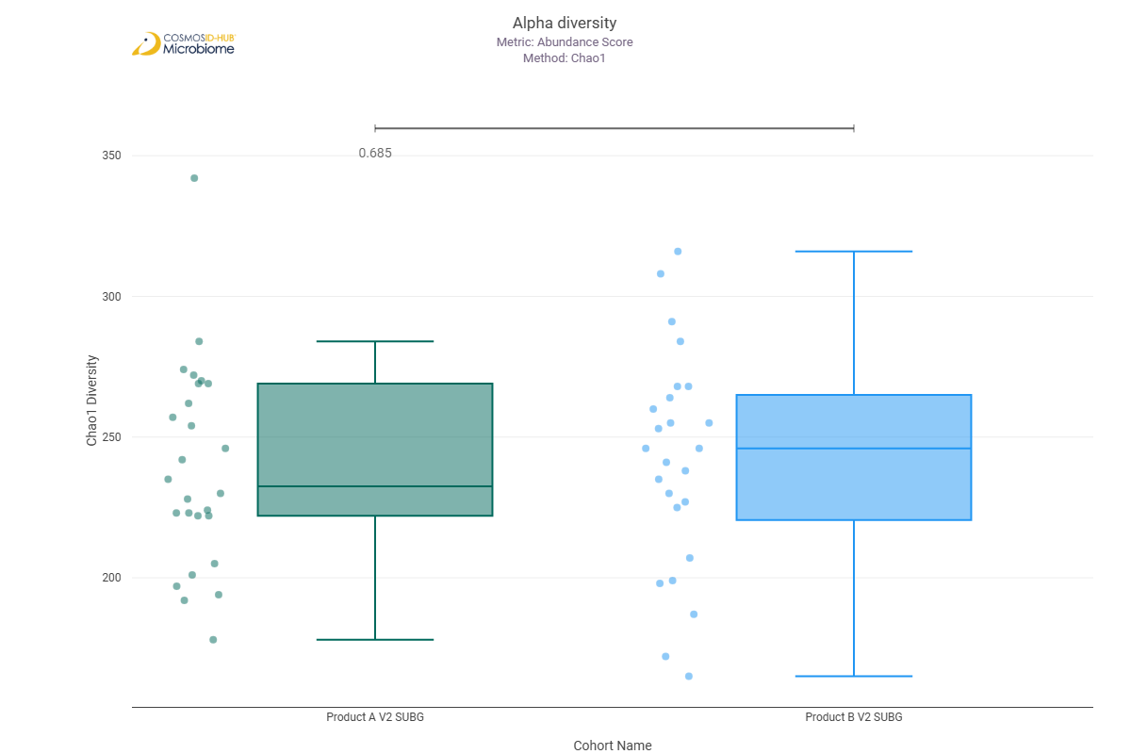
Shannon | 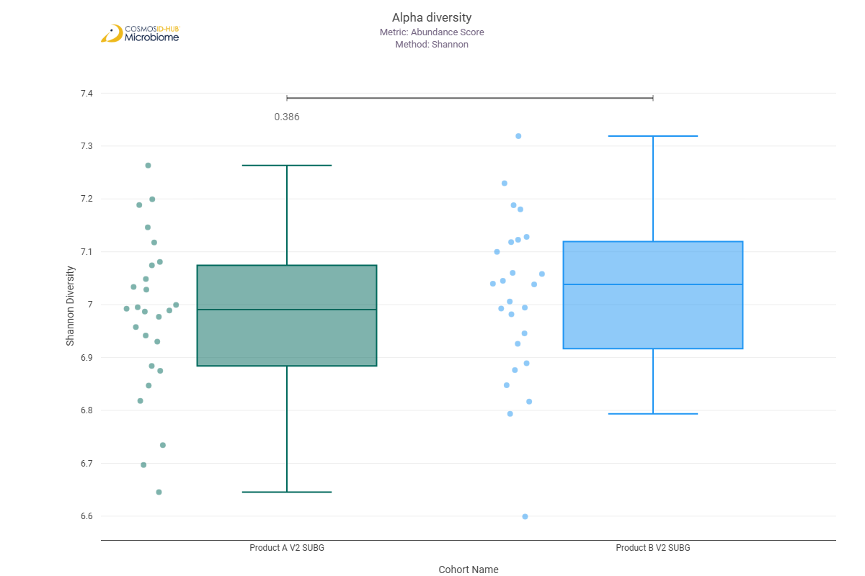
Simpson | 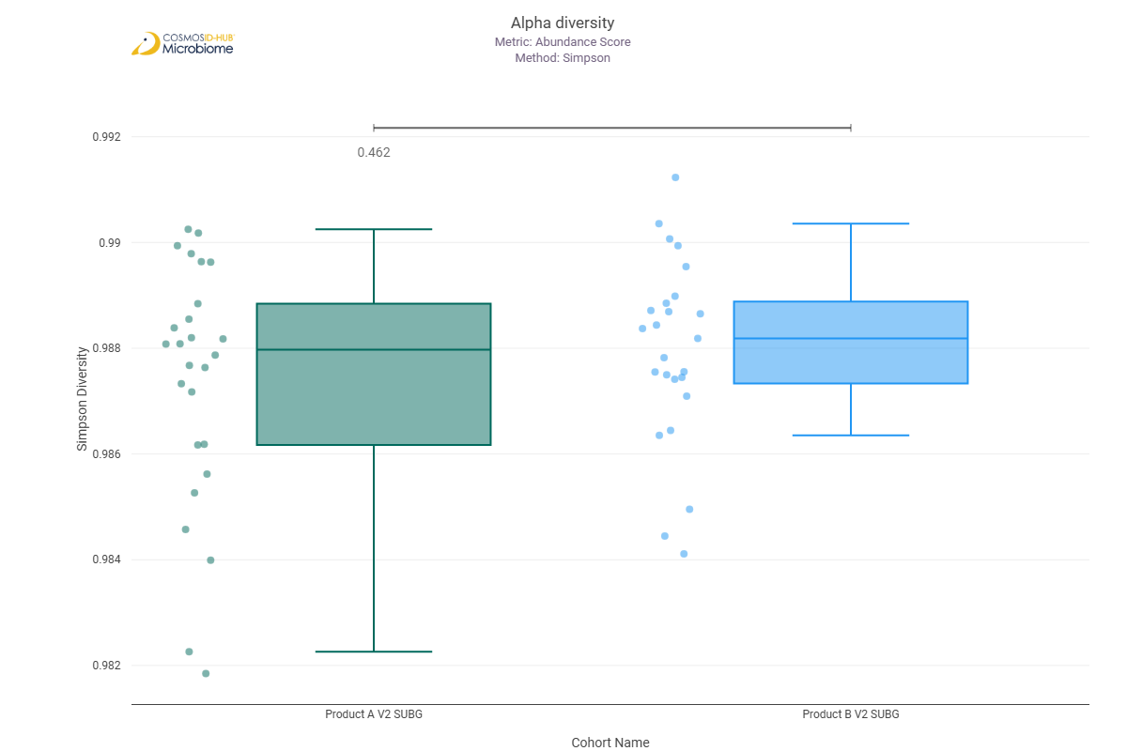

Beta Diversity (MetaCyc)
Bray-Curtis  PERMNOVA p = 0.374 | 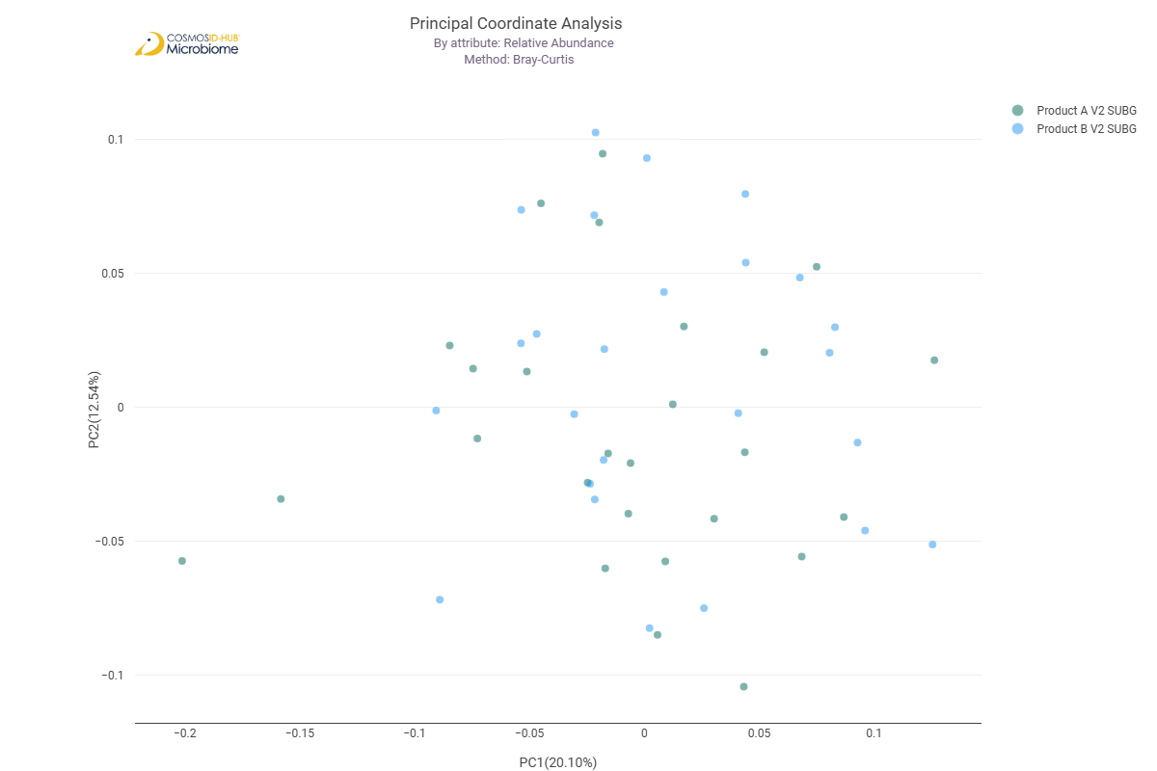

Differential Abundance (LEfSe) (MetaCyc)
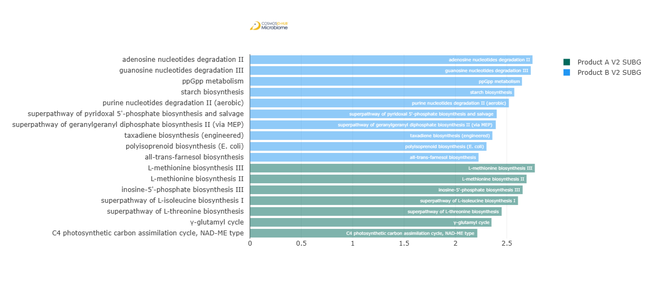
Feature | Enriched Cohort | LDA Score | P-value
adenosine nucleotides degradation II | Product B V2 SUBG | 2.750057755 | 0.038205314
guanosine nucleotides degradation III | Product B V2 SUBG | 2.733312194 | 0.047879765
ppGpp metabolism | Product B V2 SUBG | 2.647451783 | 0.021519031
starch biosynthesis | Product B V2 SUBG | 2.572844723 | 0.034763054
purine nucleotides degradation II (aerobic) | Product B V2 SUBG | 2.520017744 | 0.018888853
superpathway of pyridoxal 5'-phosphate biosynthesis and salvage | Product B V2 SUBG | 2.401578989 | 0.032429435
superpathway of geranylgeranyl diphosphate biosynthesis II (via MEP) | Product B V2 SUBG | 2.392576475 | 0.003816582
taxadiene biosynthesis (engineered) | Product B V2 SUBG | 2.359588815 | 0.005256809
polyisoprenoid biosynthesis (E. coli) | Product B V2 SUBG | 2.302252108 | 0.015864256
all-trans-farnesol biosynthesis | Product B V2 SUBG | 2.224778884 | 0.031697196
L-methionine biosynthesis III | Product A V2 SUBG | 2.772698362 | 1.36E-02
L-methionine biosynthesis II | Product A V2 SUBG | 2.692264645 | 0.039994768
inosine-5'-phosphate biosynthesis III | Product A V2 SUBG | 2.65398707 | 0.008340354
superpathway of L-isoleucine biosynthesis I | Product A V2 SUBG | 2.608969913 | 0.009840467
superpathway of L-threonine biosynthesis | Product A V2 SUBG | 2.449856176 | 0.028837668
γ-glutamyl cycle | Product A V2 SUBG | 2.35086058 | 0.03174462
C4 photosynthetic carbon assimilation cycle, NAD-ME type | Product A V2 SUBG | 2.213100244 | 0.022057133

Comparison 20: Product A V3 SUBG vs Product B V3 SUBG

Gene Ontology

Alpha Diversity (GO)
Chao1 | 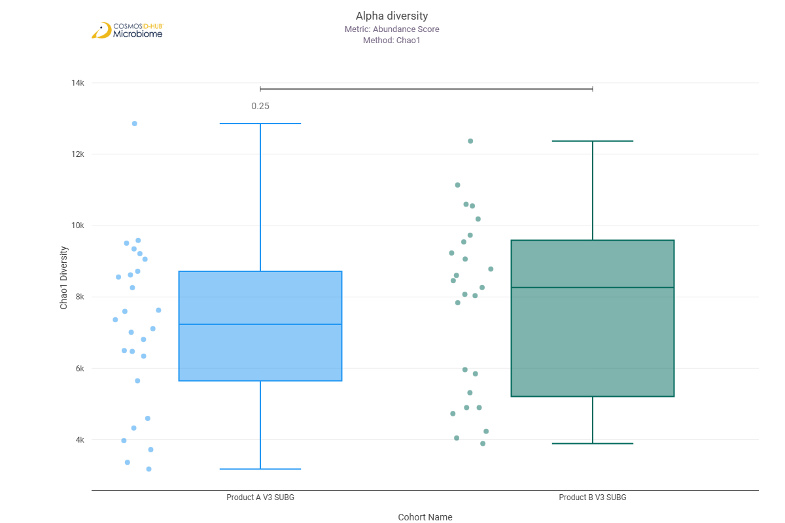
Shannon | 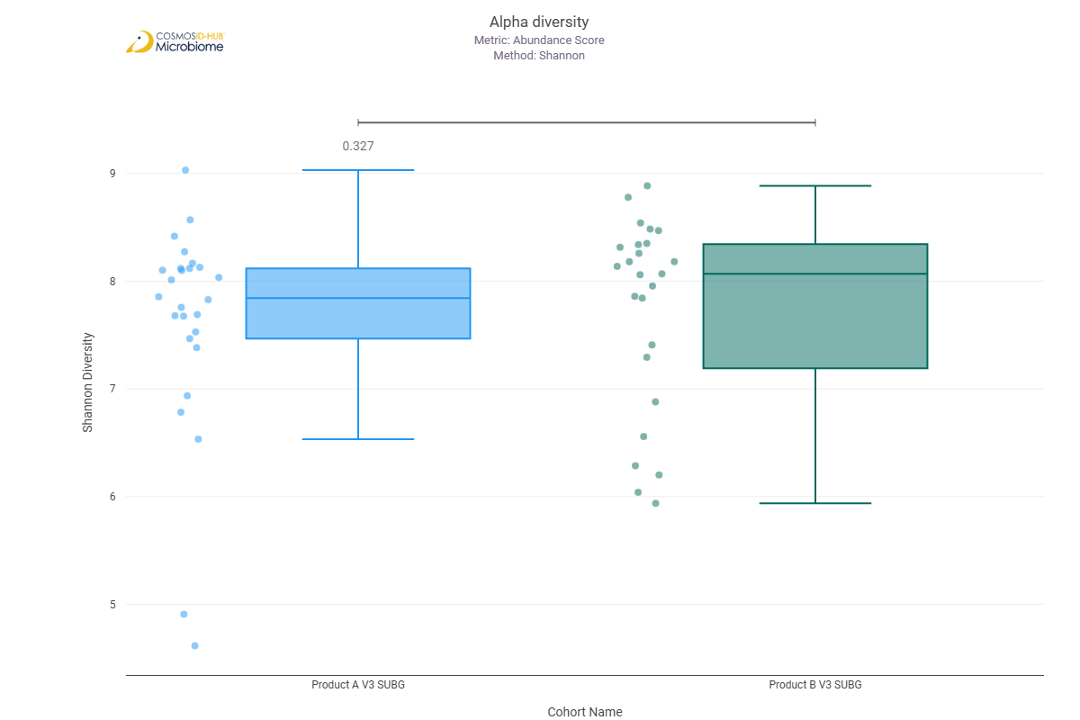
Simpson | 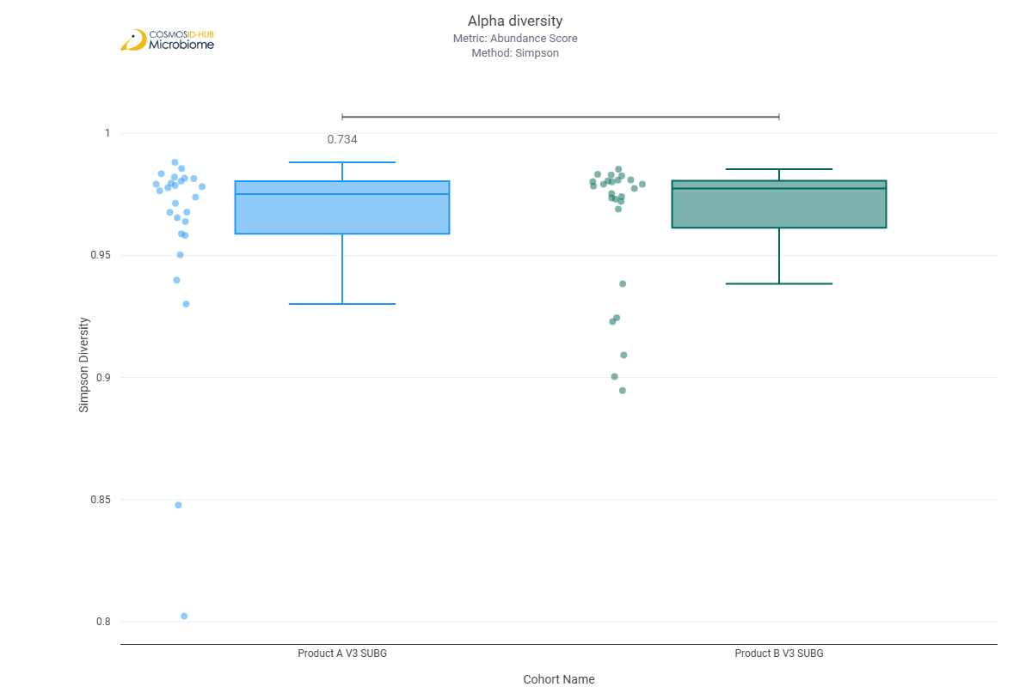

Beta Diversity (GO)
Bray-Curtis  PERMNOVA p = 0.080 | 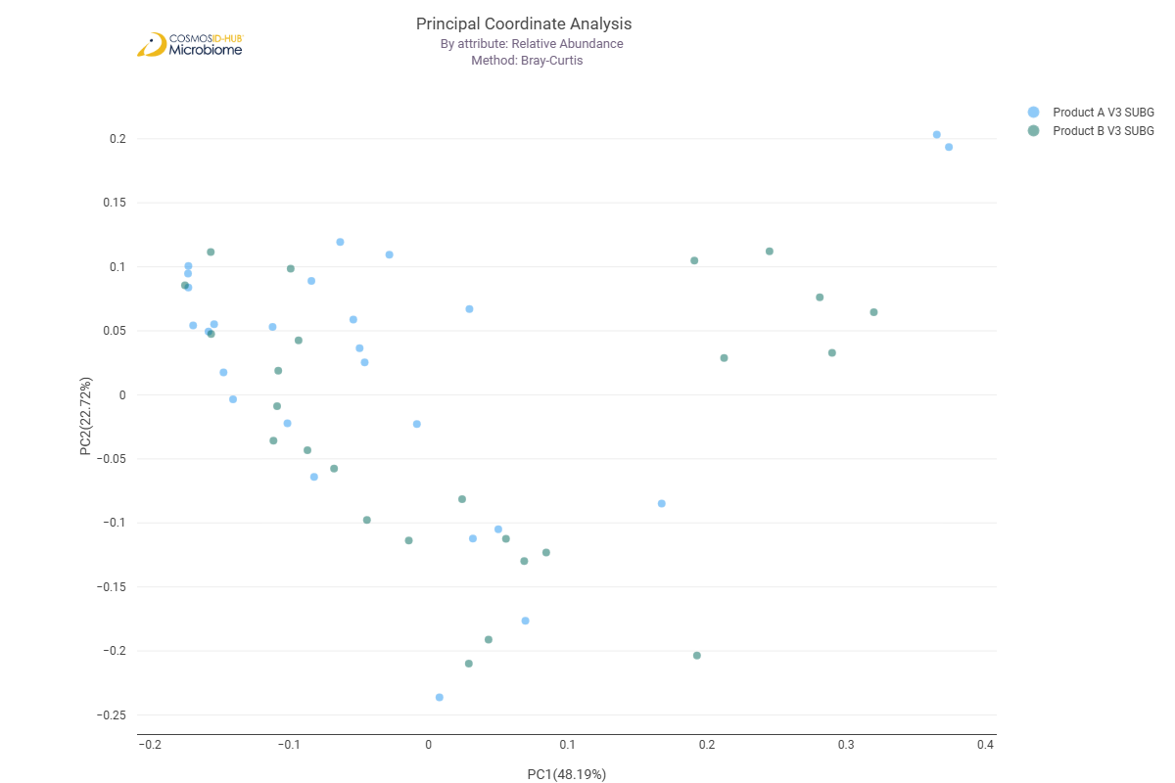

Differential Abundance (LEfSe) (GO)
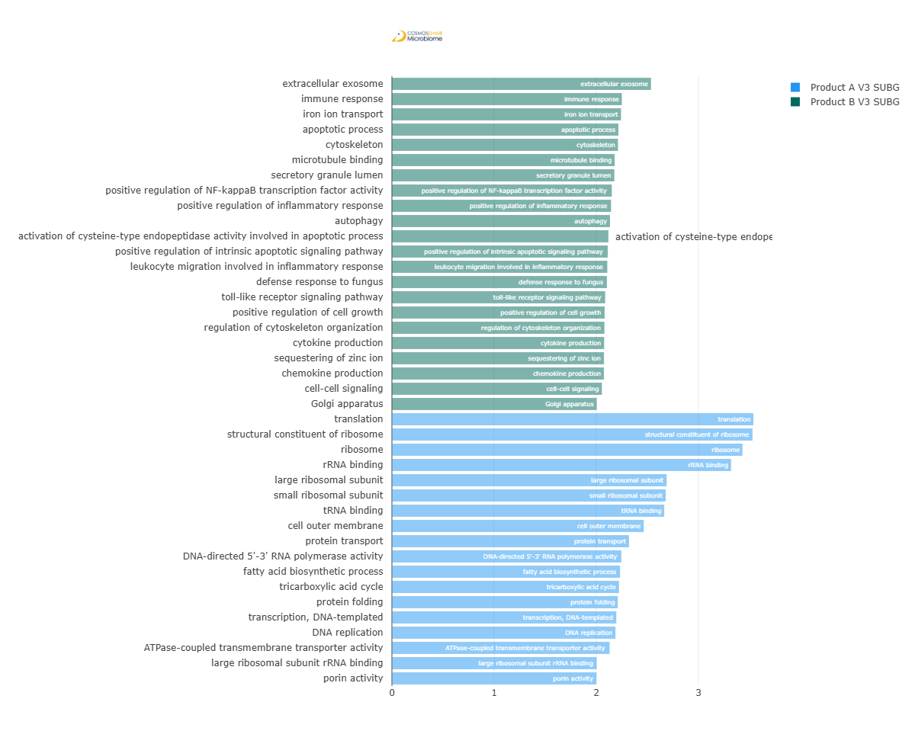
Feature | Enriched Cohort | LDA Score | P-value
translation | Product A V3 SUBG | 3.536687332 | 0.020471389
structural constituent of ribosome | Product A V3 SUBG | 3.528572939 | 0.022613046
ribosome | Product A V3 SUBG | 3.430131346 | 0.012876233
rRNA binding | Product A V3 SUBG | 3.318350314 | 0.01946851
large ribosomal subunit | Product A V3 SUBG | 2.688003944 | 0.008341822
small ribosomal subunit | Product A V3 SUBG | 2.678502093 | 0.012876233
tRNA binding | Product A V3 SUBG | 2.664213181 | 0.041854827
cell outer membrane | Product A V3 SUBG | 2.463894606 | 0.041854827
protein transport | Product A V3 SUBG | 2.319737363 | 0.016712924
DNA-directed 5'-3' RNA polymerase activity | Product A V3 SUBG | 2.244648568 | 0.021519031
fatty acid biosynthetic process | Product A V3 SUBG | 2.23219525 | 0.004183032
tricarboxylic acid cycle | Product A V3 SUBG | 2.221672233 | 0.002000719
protein folding | Product A V3 SUBG | 2.210436333 | 0.028837668
transcription, DNA-templated | Product A V3 SUBG | 2.195364258 | 0.036484395
DNA replication | Product A V3 SUBG | 2.187269297 | 0.033240045
ATPase-coupled transmembrane transporter activity | Product A V3 SUBG | 2.130170003 | 0.028837668
large ribosomal subunit rRNA binding | Product A V3 SUBG | 2.003191729 | 0.041854827
porin activity | Product A V3 SUBG | 2.000393644 | 0.000744191
extracellular exosome | Product B V3 SUBG | 2.535130566 | 0.039994768
immune response | Product B V3 SUBG | 2.249850104 | 4.38E-02
iron ion transport | Product B V3 SUBG | 2.241435289 | 0.012209995
apoptotic process | Product B V3 SUBG | 2.216215889 | 0.045795182
cytoskeleton | Product B V3 SUBG | 2.212010433 | 0.039994768
microtubule binding | Product B V3 SUBG | 2.179482504 | 0.045795182
secretory granule lumen | Product B V3 SUBG | 2.176539587 | 0.034829974
positive regulation of NF-kappaB transcription factor activity | Product B V3 SUBG | 2.151381348 | 0.038205314
positive regulation of inflammatory response | Product B V3 SUBG | 2.144302779 | 0.039994768
autophagy | Product B V3 SUBG | 2.133749546 | 0.039994768
activation of cysteine-type endopeptidase activity involved in apoptotic process | Product B V3 SUBG | 2.1181929 | 0.043787588
positive regulation of intrinsic apoptotic signaling pathway | Product B V3 SUBG | 2.112289442 | 0.043787588
leukocyte migration involved in inflammatory response | Product B V3 SUBG | 2.107427716 | 0.047879765
defense response to fungus | Product B V3 SUBG | 2.103586985 | 0.039994768
toll-like receptor signaling pathway | Product B V3 SUBG | 2.086746471 | 0.043787588
positive regulation of cell growth | Product B V3 SUBG | 2.081484217 | 0.047879765
regulation of cytoskeleton organization | Product B V3 SUBG | 2.079085603 | 0.047879765
cytokine production | Product B V3 SUBG | 2.076455901 | 0.047879765
sequestering of zinc ion | Product B V3 SUBG | 2.074832793 | 0.045795182
chemokine production | Product B V3 SUBG | 2.074720372 | 0.045795182
cell-cell signaling | Product B V3 SUBG | 2.054731602 | 0.038205314
Golgi apparatus | Product B V3 SUBG | 2.003938769 | 0.038205314

Enzyme Commission

Alpha Diversity (EC)
Chao1 | 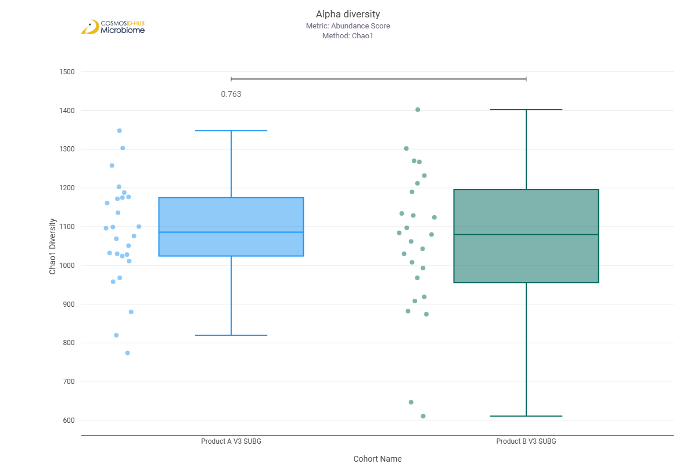
Shannon | 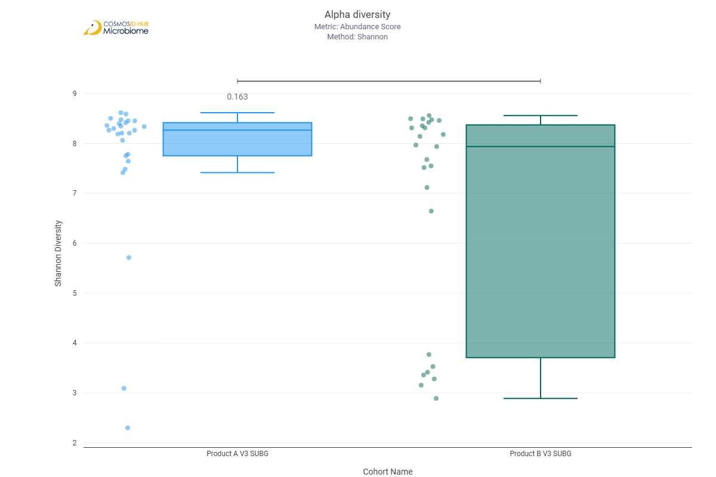
Simpson | 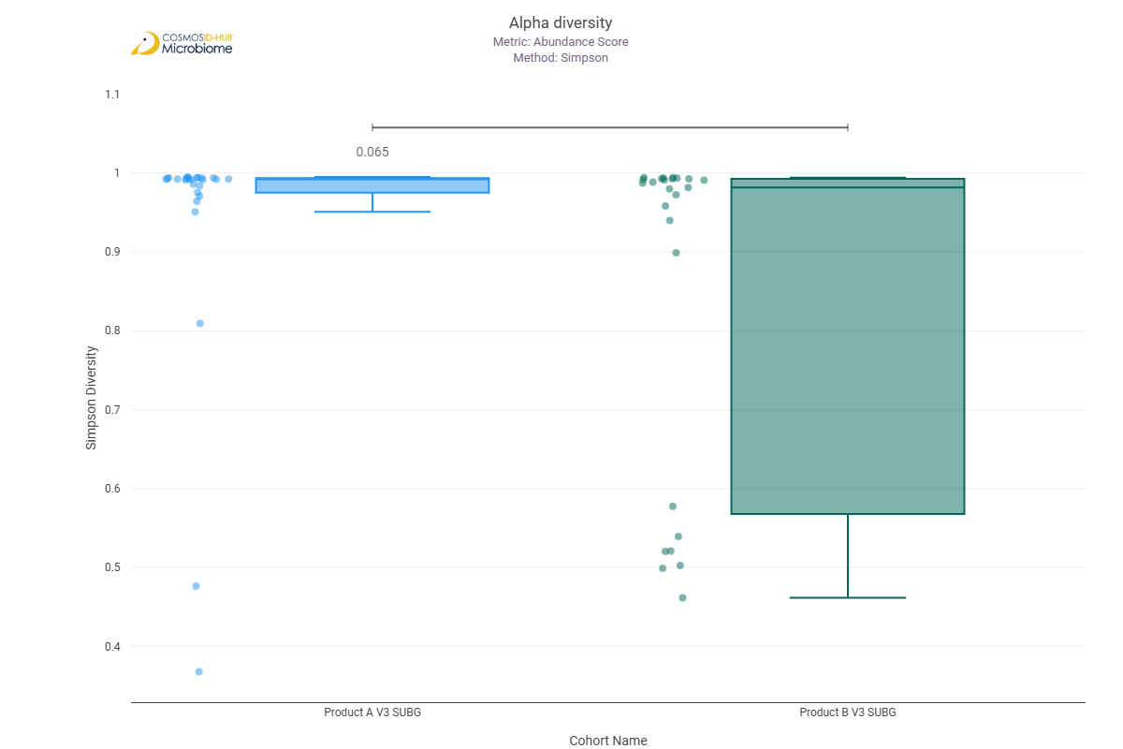

Beta Diversity (EC)
Bray-Curtis  PERMNOVA p = 0.073 | 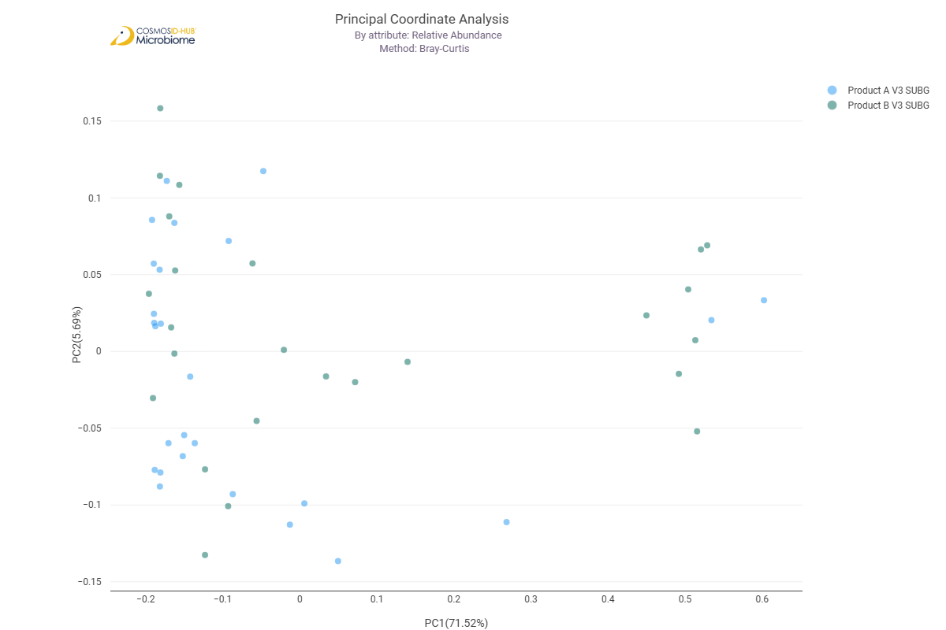

Differential Abundance (LEfSe) (EC)
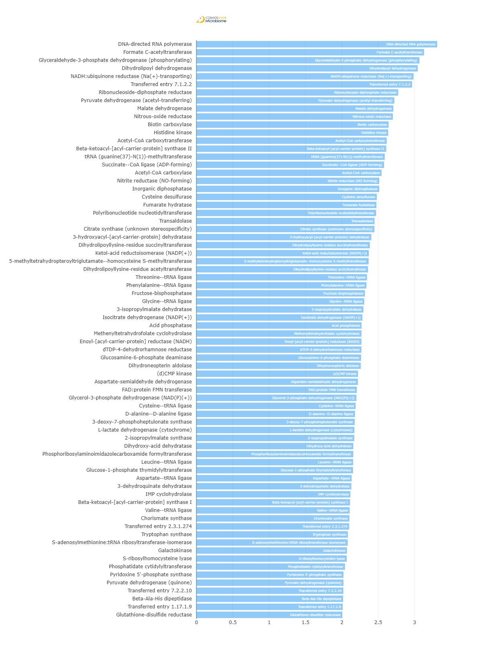
Feature | Enriched Cohort | LDA Score | P-value
DNA-directed RNA polymerase | Product A V3 SUBG | 3.312199282 | 0.007889693
Formate C-acetyltransferase | Product A V3 SUBG | 3.13215656 | 0.039994768
Glyceraldehyde-3-phosphate dehydrogenase (phosphorylating) | Product A V3 SUBG | 3.068813313 | 0.031712637
Dihydrolipoyl dehydrogenase | Product A V3 SUBG | 3.045630912 | 1.46616E-05
NADH:ubiquinone reductase (Na(+)-transporting) | Product A V3 SUBG | 2.986963277 | 0.000605172
Transferred entry 7.1.2.2 | Product A V3 SUBG | 2.966871817 | 0.020471389
Ribonucleoside-diphosphate reductase | Product A V3 SUBG | 2.776516943 | 0.016712924
Pyruvate dehydrogenase (acetyl-transferring) | Product A V3 SUBG | 2.723062614 | 0.000605172
Malate dehydrogenase | Product A V3 SUBG | 2.709053579 | 0.005941992
Nitrous-oxide reductase | Product A V3 SUBG | 2.702720573 | 0.021507212
Biotin carboxylase | Product A V3 SUBG | 2.644235086 | 0.000852766
Histidine kinase | Product A V3 SUBG | 2.638292954 | 0.041854827
Acetyl-CoA carboxytransferase | Product A V3 SUBG | 2.617952144 | 0.002736233
Beta-ketoacyl-[acyl-carrier-protein] synthase II | Product A V3 SUBG | 2.611822632 | 0.015071869
tRNA (guanine(37)-N(1))-methyltransferase | Product A V3 SUBG | 2.591202435 | 0.000694855
Succinate--CoA ligase (ADP-forming) | Product A V3 SUBG | 2.581609521 | 0.02494682
Acetyl-CoA carboxylase | Product A V3 SUBG | 2.546806449 | 0.004438681
Nitrite reductase (NO-forming) | Product A V3 SUBG | 2.515556565 | 0.00628096
Inorganic diphosphatase | Product A V3 SUBG | 2.515254374 | 0.020471389
Cysteine desulfurase | Product A V3 SUBG | 2.48170098 | 1.88E-03
Fumarate hydratase | Product A V3 SUBG | 2.475987752 | 0.008341822
Polyribonucleotide nucleotidyltransferase | Product A V3 SUBG | 2.472260598 | 0.012876233
Transaldolase | Product A V3 SUBG | 2.450906966 | 0.005292825
Citrate synthase (unknown stereospecificity) | Product A V3 SUBG | 2.448881882 | 0.002269883
3-hydroxyacyl-[acyl-carrier-protein] dehydratase | Product A V3 SUBG | 2.406150454 | 0.02494682
Dihydrolipoyllysine-residue succinyltransferase | Product A V3 SUBG | 2.386412108 | 0.00097562
Ketol-acid reductoisomerase (NADP(+)) | Product A V3 SUBG | 2.372178573 | 0.047879765
5-methyltetrahydropteroyltriglutamate--homocysteine S-methyltransferase | Product A V3 SUBG | 2.369261081 | 0.028837668
Dihydrolipoyllysine-residue acetyltransferase | Product A V3 SUBG | 2.360242064 | 0.000319608
Threonine--tRNA ligase | Product A V3 SUBG | 2.347096758 | 0.02494682
Phenylalanine--tRNA ligase | Product A V3 SUBG | 2.339465697 | 0.028837668
Fructose-bisphosphatase | Product A V3 SUBG | 2.318793495 | 0.016712924
Glycine--tRNA ligase | Product A V3 SUBG | 2.308480299 | 0.038205314
3-isopropylmalate dehydratase | Product A V3 SUBG | 2.297290891 | 0.01946851
Isocitrate dehydrogenase (NADP(+)) | Product A V3 SUBG | 2.28378722 | 0.000852534
Acid phosphatase | Product A V3 SUBG | 2.272511228 | 0.009316196
Methenyltetrahydrofolate cyclohydrolase | Product A V3 SUBG | 2.271222446 | 0.043787588
Enoyl-[acyl-carrier-protein] reductase (NADH) | Product A V3 SUBG | 2.27078058 | 0.00881699
dTDP-4-dehydrorhamnose reductase | Product A V3 SUBG | 2.270338236 | 0.004708409
Glucosamine-6-phosphate deaminase | Product A V3 SUBG | 2.26535543 | 0.013574437
Dihydroneopterin aldolase | Product A V3 SUBG | 2.260965749 | 0.001043427
(d)CMP kinase | Product A V3 SUBG | 2.222871162 | 0.010390869
Aspartate-semialdehyde dehydrogenase | Product A V3 SUBG | 2.222116087 | 0.036484395
FAD:protein FMN transferase | Product A V3 SUBG | 2.207303025 | 0.021519031
Glycerol-3-phosphate dehydrogenase (NAD(P)(+)) | Product A V3 SUBG | 2.201487687 | 0.015071869
Cysteine--tRNA ligase | Product A V3 SUBG | 2.191170276 | 0.004992891
D-alanine--D-alanine ligase | Product A V3 SUBG | 2.181747657 | 0.027486336
3-deoxy-7-phosphoheptulonate synthase | Product A V3 SUBG | 2.178294885 | 0.002571856
L-lactate dehydrogenase (cytochrome) | Product A V3 SUBG | 2.173648975 | 0.000975879
2-isopropylmalate synthase | Product A V3 SUBG | 2.172001333 | 0.010390869
Dihydroxy-acid dehydratase | Product A V3 SUBG | 2.15868405 | 2.49E-02
Phosphoribosylaminoimidazolecarboxamide formyltransferase | Product A V3 SUBG | 2.158625201 | 0.022613046
Leucine--tRNA ligase | Product A V3 SUBG | 2.156558873 | 0.021519031
Glucose-1-phosphate thymidylyltransferase | Product A V3 SUBG | 2.154769362 | 0.018508823
Aspartate--tRNA ligase | Product A V3 SUBG | 2.135805728 | 0.031712637
3-dehydroquinate dehydratase | Product A V3 SUBG | 2.131724086 | 0.013574437
IMP cyclohydrolase | Product A V3 SUBG | 2.118278512 | 0.028837668
Beta-ketoacyl-[acyl-carrier-protein] synthase I | Product A V3 SUBG | 2.113359831 | 0.018508823
Valine--tRNA ligase | Product A V3 SUBG | 2.108822781 | 0.033240045
Chorismate synthase | Product A V3 SUBG | 2.104886081 | 0.00176114
Transferred entry 2.3.1.274 | Product A V3 SUBG | 2.101880318 | 0.030245812
Tryptophan synthase | Product A V3 SUBG | 2.084119262 | 0.018508823
S-adenosylmethionine:tRNA ribosyltransferase-isomerase | Product A V3 SUBG | 2.081182245 | 0.020471389
Galactokinase | Product A V3 SUBG | 2.071628618 | 0.014305878
S-ribosylhomocysteine lyase | Product A V3 SUBG | 2.06704668 | 0.030245812
Phosphatidate cytidylyltransferase | Product A V3 SUBG | 2.043892086 | 0.016712924
Pyridoxine 5'-phosphate synthase | Product A V3 SUBG | 2.023792626 | 0.000275433
Pyruvate dehydrogenase (quinone) | Product A V3 SUBG | 2.023536332 | 0.003703627
Transferred entry 7.2.2.10 | Product A V3 SUBG | 2.021427948 | 0.018506169
Beta-Ala-His dipeptidase | Product A V3 SUBG | 2.018269524 | 0.015850009
Transferred entry 1.17.1.9 | Product A V3 SUBG | 2.012359892 | 0.008810865
Glutathione-disulfide reductase | Product A V3 SUBG | 2.007145806 | 0.009316196

MetaCyc Pathways

Alpha Diversity (MetaCyc)
Chao1 | 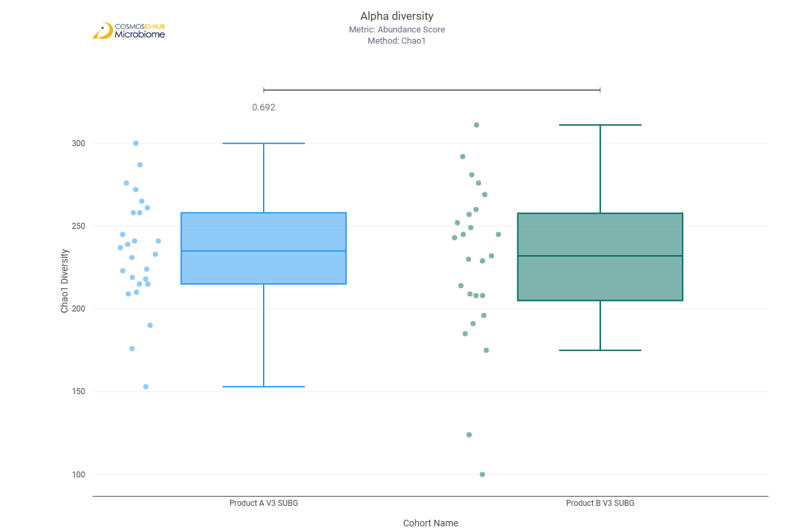
Shannon | 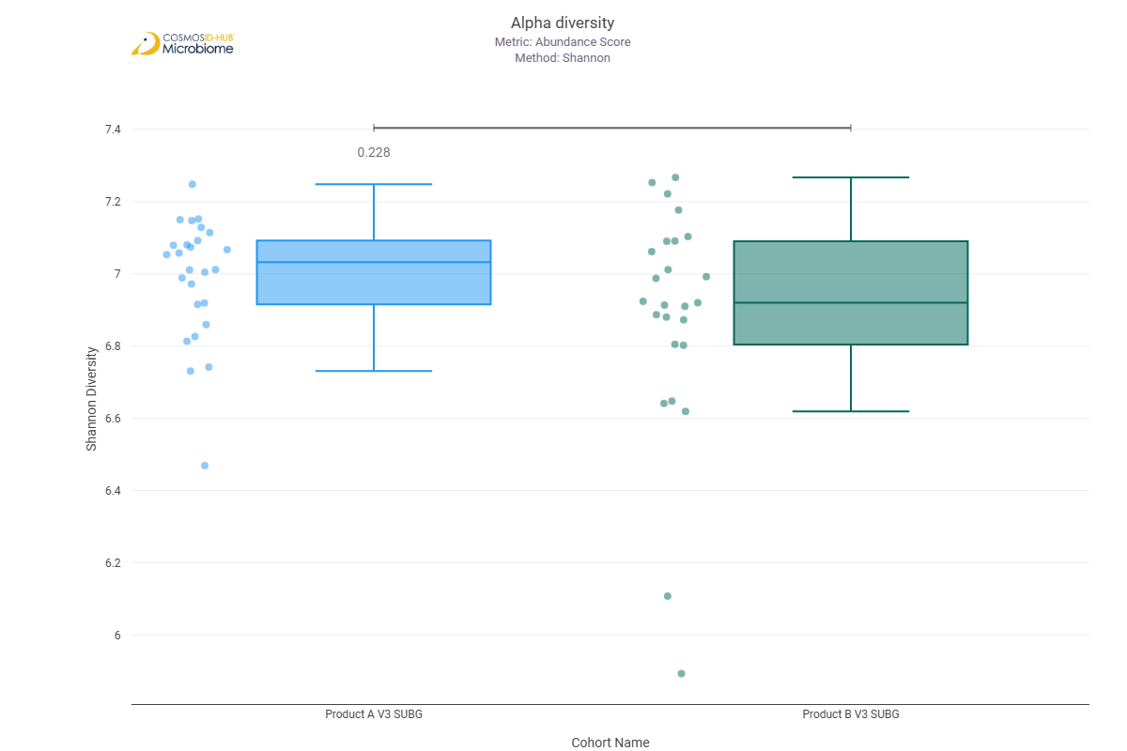
Simpson | 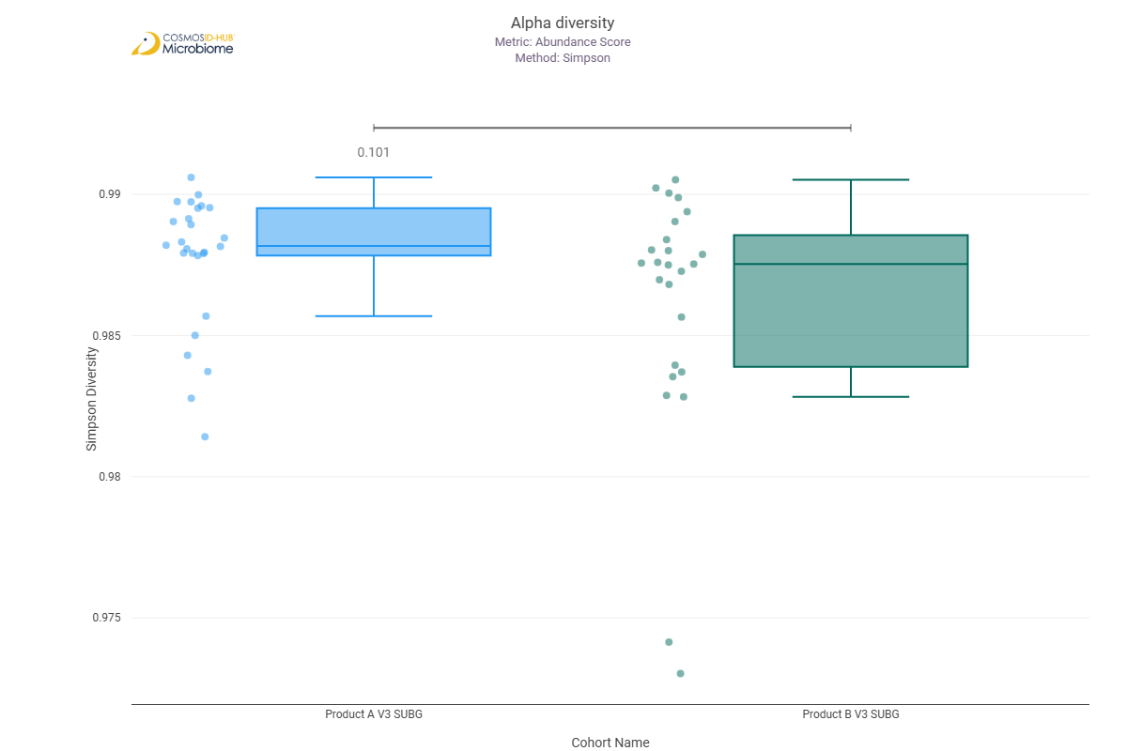

Beta Diversity (MetaCyc)
Bray-Curtis  PERMNOVA p = 0.058 | 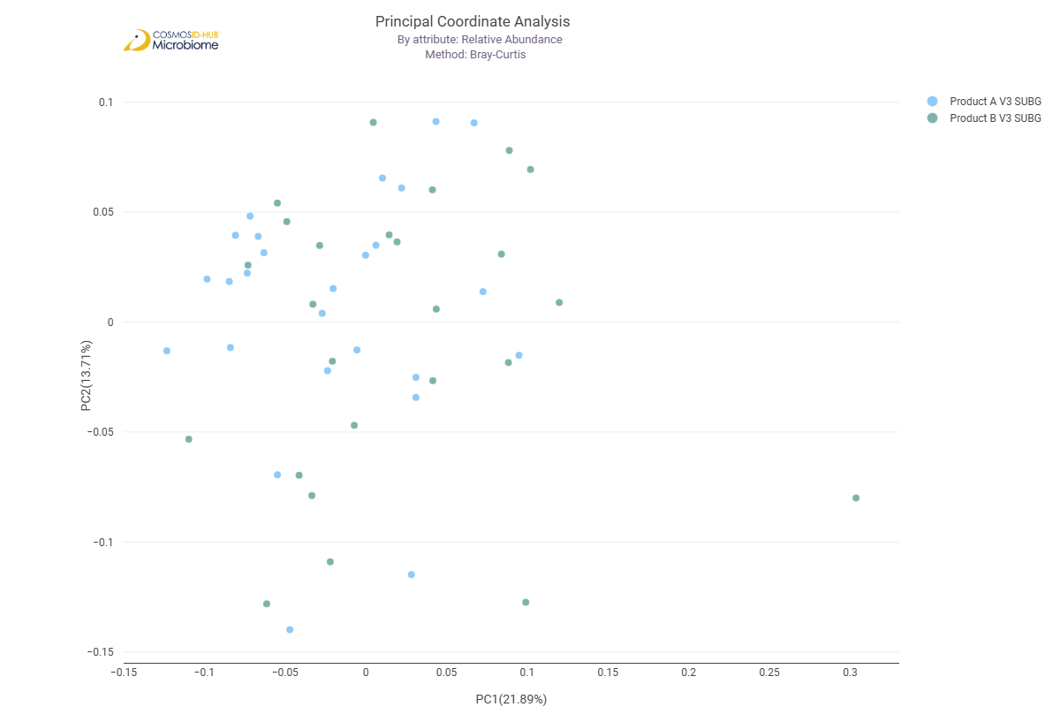

Differential Abundance (LEfSe) (MetaCyc)
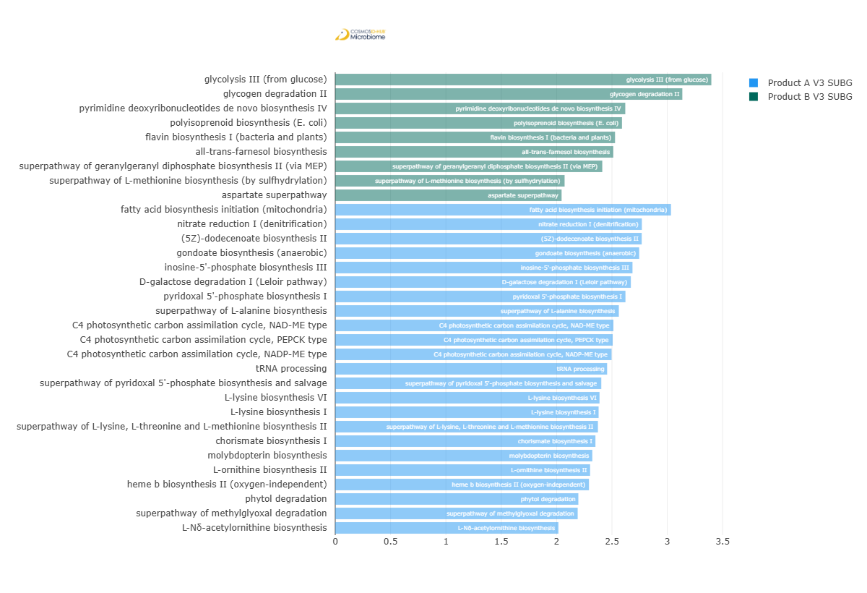
Feature | Enriched Cohort | LDA Score | P-value
glycolysis III (from glucose) | Product B V3 SUBG | 3.398008161 | 0.038205314
glycogen degradation II | Product B V3 SUBG | 3.135718597 | 0.043787588
pyrimidine deoxyribonucleotides de novo biosynthesis IV | Product B V3 SUBG | 2.620523396 | 0.008561476
polyisoprenoid biosynthesis (E. coli) | Product B V3 SUBG | 2.590644283 | 0.002064632
flavin biosynthesis I (bacteria and plants) | Product B V3 SUBG | 2.527895481 | 0.020459981
all-trans-farnesol biosynthesis | Product B V3 SUBG | 2.512006003 | 0.002199138
superpathway of geranylgeranyl diphosphate biosynthesis II (via MEP) | Product B V3 SUBG | 2.412732939 | 0.022030076
superpathway of L-methionine biosynthesis (by sulfhydrylation) | Product B V3 SUBG | 2.072286136 | 0.038070937
aspartate superpathway | Product B V3 SUBG | 2.044846563 | 0.035123508
fatty acid biosynthesis initiation (mitochondria) | Product A V3 SUBG | 3.03335721 | 0.043787588
nitrate reduction I (denitrification) | Product A V3 SUBG | 2.770074976 | 0.017447725
(5Z)-dodecenoate biosynthesis II | Product A V3 SUBG | 2.768822004 | 0.000357175
gondoate biosynthesis (anaerobic) | Product A V3 SUBG | 2.745818707 | 0.039994768
inosine-5'-phosphate biosynthesis III | Product A V3 SUBG | 2.685496558 | 0.004437784
D-galactose degradation I (Leloir pathway) | Product A V3 SUBG | 2.670583482 | 0.026189985
pyridoxal 5'-phosphate biosynthesis I | Product A V3 SUBG | 2.621986388 | 0.00336473
superpathway of L-alanine biosynthesis | Product A V3 SUBG | 2.562183598 | 0.003070652
C4 photosynthetic carbon assimilation cycle, NAD-ME type | Product A V3 SUBG | 2.513144729 | 0.00186182
C4 photosynthetic carbon assimilation cycle, PEPCK type | Product A V3 SUBG | 2.506672461 | 0.023751913
C4 photosynthetic carbon assimilation cycle, NADP-ME type | Product A V3 SUBG | 2.496833971 | 0.034829974
tRNA processing | Product A V3 SUBG | 2.456212513 | 0.000875251
superpathway of pyridoxal 5'-phosphate biosynthesis and salvage | Product A V3 SUBG | 2.403555807 | 3.55E-02
L-lysine biosynthesis VI | Product A V3 SUBG | 2.38774424 | 0.036480158
L-lysine biosynthesis I | Product A V3 SUBG | 2.379557703 | 0.012835527
superpathway of L-lysine, L-threonine and L-methionine biosynthesis II | Product A V3 SUBG | 2.373267579 | 0.039990269
chorismate biosynthesis I | Product A V3 SUBG | 2.350578747 | 0.041854827
molybdopterin biosynthesis | Product A V3 SUBG | 2.322613992 | 0.003924514
L-ornithine biosynthesis II | Product A V3 SUBG | 2.302634401 | 0.002370652
heme b biosynthesis II (oxygen-independent) | Product A V3 SUBG | 2.292271137 | 0.014121484
phytol degradation | Product A V3 SUBG | 2.196476941 | 0.005851078
superpathway of methylglyoxal degradation | Product A V3 SUBG | 2.190473884 | 0.033160392
L-Nδ-acetylornithine biosynthesis | Product A V3 SUBG | 2.016218191 | 0.006620791

